3GPP TSG-RAN WG2 Meeting #116 electronic R2-2111392
Electronic Meeting, Nov 1 – 12, 2021

Agenda item: 7.3
Source: CMCC
Title: Offline discussion on the issue for Random Access on multicarrier for NB-IoT
Document for: Discussion and Decision

Introduction
* [AT116-e][302][NBIOT R16] Random access on multiCarrier in NB-IoT (CMCC)
Scope: Discuss issues in R2-2110240. Agreement of CRs in R2-2110241 and R2-2110762.
Intended outcome: Phase 1: Poll for support and comments with report in R2-2111392. Phase 2: Agreed CRs (TBD)
Deadline: Phase 1: Wed 3 Nov, 1200 UTC, Phase 2: TBD depending on comments.
Status: started

Contact list
Company and Name | Email

Discussion
Deployment scenario:
In contribution [1], Figure 1 shows a typical deployment scenario for multi-carrier NB-IoT in real network. In order to reduce intra-frequency interference, the neighbouring anchor carriers are deployed on different frequencies. And the downlink narrowband reference-signal EPRE (Energy Per Resource Element) of the non-anchor carriers is generally lower than EPRE of the intra-frequency anchor carrier, in order to reduce the intra-frequency interference. This results to the coverage of non-anchor carriers smaller than anchor carrier.
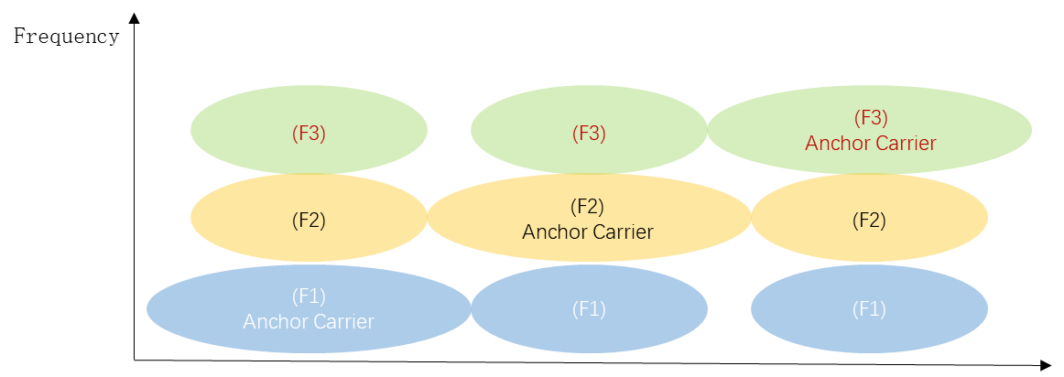
Figure 1 The deployment of NB-IoT multi-carrier
Issue description:
There is the overlapping area that the CE levels is different between the anchor carrier and non-anchor carriers, and CE level of the non-anchor carriers is usually worse than the CE level of the anchor carrier. Take CE0 coverage area as an example shown as Figure 2.
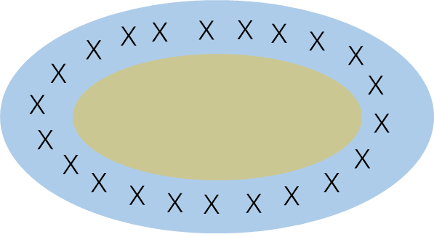
CE0 coverage area of the non-anchor carriers
CE0 coverage area of the anchor carriers
X
The overlapping annular area that the anchor carrier is CE0 and the non-anchor carriers is CE 1
Figure 2 the coverage area of the anchor carrier and the non-anchor carriers
In the overlapping annular area, due to lower RSRP on non-anchor carrier, the actual CE level of the non-anchor carriers is worse than the CE level of the anchor carrier, which results to random access issue.
But, according to the specification, the NPRACH CE level for the non-anchor carriers is determined by the RSRP on anchor carrier and RSRP threshold. For UEs in the overlapping annular area and performing RA to non-anchor carrier, due to repetition for NPDCCH in current CE level is not suitable for the UE, the UE suffered from longer RA time or even RACH failure.
Q1: Do you agree the following two issues may happen in scenario of different EPRE for anchor and non-anchor carriers, as shown in figure 1&2?
Issue 1: UEs may select the inappropriate nprach resource (such as number of nprach repetitions) and fail to access the cell on the non-anchor carriers if the UEs utilize the same NPRACH CE level of the anchor carrier in the overlapping annular area that the actual CE level determined by RSRP measurement of the non-anchor carrier is worse than the CE level of the anchor carrier.
Issue 2: The UE may select the carrier with worse CE level by the legacy selection probability for anchor nprach resource when the CE levels are different between the anchor carrier and the non-anchor carriers. It may increase network traffic and more resource consumption, and affect UEs’ service experience.
Company | Yes/No | Comment

To address the issue 1&2, the following solutions are proposed, companies are invited to share views on which one would you prefer?
Q2: Which solution is preferred to address issue 1 & 2?
Solution 1a and 1b are provided to address issue 1:
Solution 1a：introduce a new RSRP Threshold list for each non-anchor carrier. The NPRACH CE level on the non-anchor carrier is determined based on comparison between NRSRP measurement results and the RSRP threshold of the non-anchor carrier.
Solution 1b: The CE level of the non-anchor carrier is estimated by UE with the NRSRP measurment results, the RSRP threshold of the anchor carrier, and the downlink narrowband reference-signal EPRE offset of the non-anchor carrier relative to the downlink narrowband reference-signal EPRE of the anchor carrier.
Solution 1c: Other solutions
Solution 2a and 2b are provided to address issue 2:
Solution 2a：Introduce a new selection probability for the anchor carrier NPRACH resource, which the UE should apply when the CE level of the non-anchor carriers is different from that of the anchor carrier in the IE SystemInformationBlockType22-NB.
Solution 2b: The UE appropriately raises the selction probability for the anchor carrier, if the CE level of the non-anchor carrier is worse than that of the anchor carrier.
Solution 2c: Other solutions
Company | Which solution to address issue 1? | Which solution to address issue 2? | Comments

Conclusions
TBD

Reference
[1] R2-2110240 Discussion on the issue for Random Access on multicarrier for NB-IoT CMCC discussion
[2] R2-2110241 Solving the issue for random access on multiCarrier in NB-IoT CMCC draftCR Rel-16 36.331 16.6.0 B NB_IOTenh3-Core
[3] R2-2110762 Solving the issue for random access on multiCarrier in NB-IoT CMCC draftCR Rel-16 36.321 16.6.0 F NB_IOTenh3-Core Late

