3GPP TSG-RAN WG2 Meeting #116 electronic R2-211xxx
Electronic meeting, 1st-12th November 2021
Agenda Item: 8.4.3
Source: Huawei, HiSilicon
Title: Summary of [AT116-e][047][eIAB] Routing and re-routing continued
Document for: Discussion and Decision

Introduction
This paper aims at capturing the summary of email discussion.
- [AT116-e][047][eIAB] Routing and re-routing continued (Huawei)
Scope: Attempt offline agreement of remaining proposals in R2-2111266.
Intended outcome: Report
Deadline: Tuesday W2

RAN2 related agreements:
- For inter-donor-DU re-routing, support the “previous routing ID to new routing ID” BAP header rewriting.
- For intra-CU cases, Support inter-donor-DU re-routing at least in the scenarios of NR-DC among donor-DUs, inter-donor-DU recovery and inter-donor-DU migration.
- Support inter-CU re-routing, i.e. IAB-node re-routes the data to its original donor-CU via the alternative BAP path over the topology in target CU.
- As baseline, support the 1:1 and N:1 mapping from “previous routing ID” to “new routing ID” for BAP header rewriting at the boundary node, in inter-CU routing.
- As baseline, support the 1:1 and N:1 mapping from “ingress BH link + ingress BH RLC ID” to “egress BH link + egress BH RLC ID” for bearer mapping at the boundary node, in inter-CU routing.

RAN3 related agreements:
- One common inter-donor topology transport mechanism should be defined for all scenarios where traffic between a donor and an IAB DU traverses the network under another donor; FFS whether it is possible to achieve a common signaling design for all scenarios
- RAN3 prefers that the boundary node processes access traffic in the same manner as the non-boundary access IAB-node.
- RAN3 prefers that the boundary node performs BAP header rewriting only for traffic routed on BAP layer from a BH link in one topology to a BH link in the adjacent topology, for both UL and DL traffic.
- FFS: In addition to BAP header rewriting, performs routing and bearer mapping in the same manner as the non-boundary intermediate IAB-node.
- RAN3 assumes that the boundary node has only one BAP address in each topology.
- RAN3 assumes that for each topology, the boundary node’s BAP address for that topology is only used to identify packets that have to be passed to upper layers.
- For DL traffic, the configurations of BAP routing entry and BAP-routing-ID mapping at the boundary node need to indicate the ingress topology they refer to. For UL traffic, they need to indicate the egress topology they refer to. The indications may be implicit.

New RAN2 agreement
Inter Topology Routing
- Go with B, including the following:
- If BAP address matches, deliver to upper layer;
Else:
- If routing ID matches rewriting table, perform the header rewriting;
- perform routing and mapping to BH RLC CH.
- For downstream, the boundary node is able to identify/differentiate the traffic routed from inter-topology vs. the traffic routed from intra-topology, based on the ingress link.
- For downstream at the boundary node, for any received data from inter-topology identified by the ingress link:
The data is delivered to upper layer, if the BAP address in the header is same as the boundary node BAP address configured in the topology of the ingress link (of this packet); otherwise, the data is determined as to be header rewritten (assumes support only of topology where decedent nodes belong to same topology).
(This requires that traffic not terminated at the boundary node should not use the BAP address in header same as the boundary node BAP address configured in the topology of the ingress link.)
Perform the header rewriting based on the configured rewriting table, and then perform routing and mapping to BH RLC CH.
- For upstream at the boundary node, for any received data from lower layer:
We may keep the ingress BAP text of R16 (that is intended for donor DU but general in Stage-3), i.e. if the BAP address in header match the boundary node BAP address configured in the topology of the ingress link, deliver to upper layer.
The data is determined as to be header rewritten and perform the header rewriting accordingly, if routing ID in header matches any “previous routing ID” in the rewriting table; and then perform routing and mapping to BH RLC CH.

- For Upstream, The pre-condition/criteria of “BAP header rewriting for re-routing” is that there is no available next hop found based on BAP routing ID and based on BAP address in the routing table (e.g. due to BH RLF, congestion or type2 indication, etc.), as in R16.

Discussion

2.1 Issues on re-routing
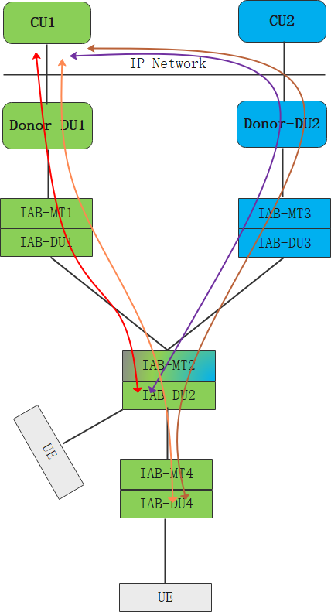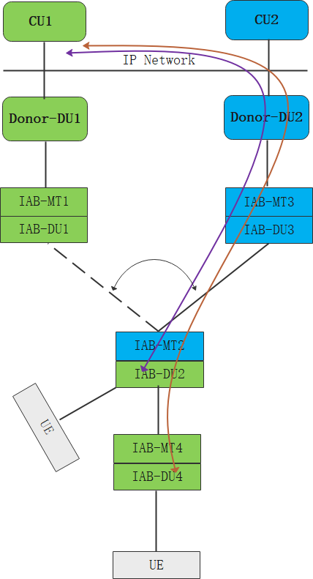
Inter-CU topology redundancy Inter-CU partial migration

Proposal 2: [Easy] [13 vs. 2] Once the “BAP header rewriting based re-routing” is triggered, BAP routes the data to the available egress link, if there is an matched entry in the Header rewriting table for re-routing. FFS egress link selection is performed before or after header rewriting (can be discussed in running CR).
Rapporteur wants to clarify one concern in the post email discussion. Based on the R2 agreement “For inter-donor-DU re-routing, support the “previous routing ID to new routing ID” BAP header rewriting”, the mapping/table for header rewriting should be the consequence.
Question 1a: Do you have concern on the above proposal or wording suggestion?
Companies | Yes or No? | Comments
ZTE | Yes | For the header rewriting table for re-routing, it is suggested to clarify whether it is a new table with new and old routing ID or the legacy routing table with BAP routing ID and next hop BAP address. If we design a new re-writing table for re-routing, it may cause additional specification efforts and a lot of signalling overhead. Since the CU is not aware which BAProuting ID may suffer the RLF/congestion, it has to configure the re-writing entry for all the possible UL BAP routing IDs.  On the other hand, we think the legacy routing table can be used for the header rewriting purpose for re-routing. For example, when no routing entry with matched BAP routing ID and matched BAP address but a routing entry which indicate an available next hop egress link can be found, the data packet can be re-routed via this available next hop egress link and the corresponding BAP routing ID can be used to rewrite the BAP header.  Actually, in Rel-16, the re-routing path is selected based on routing table instead of a new re-routing table, it is suggested to follow the Rel-16 principle and change the proposal as follows:  Once the “BAP header rewriting based re-routing” is triggered, BAP routes the data to the available egress link, if there is an matched entry whose egress link corresponding to the Next Hop BAP Address is available in the routing tableHeader rewriting table for re-routing. FFS egress link selection is performed before or after header rewriting (can be discussed in running CR)
LG | Yes | Same understanding as ZTE. We also think that routing table can be used in case of “BAP header rewriting based re-routing” and the updated wording by ZTE is also ok to us.
Question 1b: In the above proposal, do you prefer egress link selection is performed before or after header rewriting?
Companies | egress link selection first, or header rewriting first? | Comments
ZTE | Egress link selection first | For re-routing BAP routing ID selection, the IAB node need to first ensure the corresponding egress link is available. Once the available egress link is selected, the IAB node may perform the header rewriting and then route the packet via this available egress link.
LG | see comments | “Egress link selection first” may be misled, in our understanding, egress link status check first is more correct wording.  If header rewriting is performed first, but the corresponding egress link is not available, we wonder whether IAB node performs one more header rewriting which is transferred to available egress link. This unnecessary rewriting step should be avoided. Thus, we think that availability of egress link of each entry for header rewriting should be check first and then select the entry for header rewriting among entries of corresponding egress link available.

Proposal 3: [Easy][14 vs. 1] For upstream at the boundary node, it is supported to local re-route the data to CU1 topology, due to RLF/congestion/etc., which was from CU1 topology and originally to be forwarded via CU2 topology.
Question 2: Do you have concern on the above proposal or wording suggestion?
Companies | Yes or No? | Comments
ZTE | No | We agree with this proposal.
LG | No

Proposal 4’: [Easy][14 vs. 1] For upstream at the boundary node, it is FFS whether the BAP header rewriting operations/steps due to inter-topology routing and inter-topology re-routing are done in one step or separate steps.
Based on the new agreements for inter-topology routing, companies now may have clear understanding on how to handle the case in P3.
Question 3: Which option do you prefer on the above proposal?
Option 1: Keep it as FFS for this meeting;
Option 2: Use separate steps as baseline;
Option 3: Use one step.
Companies | Option? | Comments
ZTE | 1 or 2 | We prefer option 2 which presents more clear routing procedure. However, if it can not reach consensus, option 1 is also acceptable for this meeting.
LG | 2 | We think that BAP header rewriting due to inter-topology routing is performed before routing check-up, but BAP header rewriting due to inter-topology re-routing is performed after routing check-up. So, we prefer option 2, but option 1 is also ok to us if majority want.

2.2 Issues on configurations
Proposal 10’: FFS: At least for upstream, the routing table configuration (or its entry) at the boundary node should be able to indicate whether it is for intra-topology or inter-topology (e.g. separate routing tables/entries). Namely that the boundary node must know which topology the routing ID and the next hop BAP address in the routing configuration refers to. Signaling details can be discussed later by RAN2 and RAN3.
The motivation is:
- The two parent nodes in different topology of the boundary node may have the same BAP address (e.g. IAB-1 and IAB-3), which makes the “Next Hop BAP Address” of routing entry ambiguous for concatenated and non-concatenated traffic, in upstream.
- In upstream, the routing IDs (the one of non-concatenated traffic and the new one after header rewriting of concatenated traffic) may be same for the data to be routed to the two different egress topologies. It means there may be two entries with same routing ID, if the routing tables are merged as one.
Proposal 11a’: It is FFS on whether the routing table configuration (or its entry) at the boundary node should be able to indicate whether it is for upstream toward inter-topology or downstream from inter-topology (e.g. separate routing tables/entries), after more progress in RAN2 and RAN3.
- Since there is no assumption on the routing ID coordination between CUs, the routing ID used in the different topologies may be same. Also, R16 assumes the routing table configuration does not differentiate the upstream and downstream.
- For concatenated traffic, one routing ID used in the 2nd topology for downstream may be same as one routing ID used in 2nd topology for upstream. There may be routing ID collision in the routing table configuration at the boundary node (i.e. one upstream routing ID may be same as one downstream routing ID).
- Therefore, the routing table should be separate for upstream and downstream for concatenated traffic. Otherwise, there will be two entries with same routing IDs (i.e. one upstream routing ID may be same as one downstream routing ID.)
Proposal 11b’: It is FFS on whether the header rewriting configuration (or its entry) at the boundary node should be able to indicate whether it is for upstream toward inter-topology or downstream from inter-topology (e.g. separate routing tables/entries), after more progress in RAN2 and RAN3. Namely that the boundary node must know to which topology each BAP routing ID in the header rewriting configuration refers to.
The same issue occurs for the BAP header rewriting table. For concatenate traffic, one previous routing ID for upstream may be same as one previous routing ID for downstream. If the upstream and downstream have the merged one BAP header rewriting table, there may be two entries in the table with the same Previous Routing ID.
Proposal 11c’: FFS: The BH RLC Channel Mapping Configuration (or its entry) at the boundary node should be able to indicate the egress/ingress topology, i.e. whether it is for upstream toward inter-topology or downstream from inter-topology (e.g. separate tables/entries). Signaling details can be discussed later by RAN2 and RAN3. Namely that the boundary node must know to which topology each BH RLC channel in the BH RLC Channel Mapping Configuration refers to.
The similar issue occurs for the bearer mapping table. The parent node of the boundary node in CU2’s topology (IAB-3) may have the same BAP address with the child node of the boundary node (IAB-4). In that case, one entry of the BH RLC CH mapping table can be “BAP add1+ BH RLC ID1=>BAP add1 + BH RLC ID2”. It is ambiguous on whether it is “RLC1 of IAB-3=>RLC2 of IAB-4” as downstream or “RLC1 of IAB-4=>RLC2 of IAB-3” as upstream.

Instead of keeping all those proposals as FFS, rapporteur would like to propose to agree on the high-level principle and leave the configuration details to later RAN2/3 meeting.
Proposal 12: The boundary node must know which topology the below information refers to:
1: each routing ID and each next hop BAP address in the routing configuration;
2: each BAP routing ID in the header rewriting configuration;
3: each BH RLC channel in the BH RLC Channel Mapping Configuration;
Question 4: Do you agree on the above proposal 12?
Companies | Yes or No? | Comments
ZTE | See comments | For the routing configuration at boundary node, it is suggested to have a separate routing table specific for UL concatenated traffic forwarding in CU2 topology. For the other DL concatenated traffic, DL non concatenated traffic and UL non concatenated traffic, another routing table may be configured for these traffic.  For BAP routing ID in the header rewriting configuration, it only need to indicate whether it is for DL or UL.  For the BH RLC channel in the BH RLC channel mapping configuration at boundary node, we think it is necessary to indicate whether it is for concatenated traffic or non-concatenated traffic.
LG | see comments | All FFSes above considers all fields of configuration, but now the question asks only about a specific field of configuration. We think that if routing table at the boundary node is able to indicate whether it is for concatenated or non-concatenated traffic, all information in the routing table can be separately identified.  With this understanding, what is the intention of the question? The rapporteur wants that only a part of information in configuration can be separately identified as concatenated or non-concatenated traffic, and others not.  We basically think that separate routing and rewriting table for concatenated or non-concatenated traffic is sufficient, but no need to have separate routing/rewriting table for upstream and downstream. However, BH RLC Channel Mapping Configuration at the boundary node may need to be able to indicate whether it is for upstream or downstream traffic.

Conclusion and proposals
Based on the above summary, following proposals are given.

Reference
- R2-2107251 Summary of [Post114-e][075][eIAB] Open Issues on Re-routing Huawei, HiSilicon
- R2-2107170 BAP-layer traffic processing at the boundary node Qualcomm
- R2-2107253 Inter-donor routing, local rerouting and RLF indication for R17-IAB Huawei,
- R2-2107445 Inter-donor CU Topology migration Intel
- R2-2107648 Open issues on (re-)routing Fujitsu
- R2-2108026 Topology adaptation enhancements Samsung
- R2-2108141 Discussion on inter-donor topology redundancy ZTE, Sanechips
- R2-2108422 Boundary IAB node behaviour for partial and full inter-donor migration Ericsson
- R2-2108482 Solutions for Inter-Donor Routing and Bearer Mapping Futurewei Technologies

