3GPP TSG-RAN WG2 Meeting #115-e R2-210xxxx
E-meeting, August 16 – 27, 2021
Agenda item: 8.4.2
Source: Interdigital (WI rapporteur)
Title: Feature summary of 8.4.2 (Rel-17 IAB contributions on fairness, latency and congestion)
Document for: Discussion

Introduction
The topic of enhancements to improve IAB topology-wide fairness, multi-hop latency, and congestion mitigation were discussed in previous meetings and some high-level agreements were made (see Annex).
This paper aims to provide a summary of the contributions to R2#115-e, AI 8.4.2 on fairness, latency and congestion (contributions: see References section). Proposals where the majority of the companies seems to be in agreement are also provided.
NOTE 1: Only enhancements that are raised by 3 or more companies are considered in this summary.
NOTE 2: Some enhancements can fall into multiple categories (E.g., hop count can be used for fairness or latency enhancements), but for the sake of readability, the enhancements are discussed in one category only.
NOTE 3: The aim for this summary is on proposing high level agreements. As such, some detailed proposals may not have been included in the summary. Based on the progress during online discussion, the relevant ones can be brought up later for further discussion.

Fairness

Bearer related information
To help the scheduling to be fair in case a BH RLC channel is aggregating multiple bearers, some companies have proposed the BH RLC channel to be configured with additional information regarding the multiplexed bearers. The proposed information includes bearer-ID, number of bearers and QoS of the bearers.
- Bearer-ID: [3], [6], and [13] propose the bearer-ID to be included in the BAP header, while [1] and [15] proposes not to ([1] indicating that 1:1 mapping to be used for those bearers that have strict requirements and N:1 to be used for non GBR bearers, [15] indicating that would cause an overhead and no real benefit expected from it)
- Number of bearers: [3], [11], and [18] proposes to include this information, while [1], [6] and [15] propose not to. In [6], it is indicated that if the bearer ID information is there, there is no need to configure the number of bearers. In [1] the same argument was given as for the case of bearer-ID (i.e.,1:1 mapping used for GBR bearers). In [15], it is indicated that the number of bearers does not reflect the characteristics of the traffic conveyed in the BH RLC channel.
- QoS of bearers: [11] and [13] propose the IAB node to be configured with the QoS information of the aggregated bearers
From the above, it is clear there is an interest in introducing some additional bearer related information for N:1 mapped BH RLC channels, but there was no majority support regarding which information should be supported. Thus, the rapporteur proposes this to be discussed further online.
Proposal 1: RAN2 to further discuss whether the bearer-ID is to be included in the BAP header of a packet belonging to an N:1 mapped BH RLC channel.
Proposal 2: RAN2 to further discuss whether IAB nodes are configured about the number of bearers and the QoS of the bearers that are aggregated over an N:1 mapped BH RLC channel.

Latency enhancements

Number of LCGs
In [1], [5], [9] and [10], a 256 LCG space is proposed. In [11] and [15], it is proposed to further discuss the optimal number of LCGs, considering the trade-off between the overhead of many LCGs and the scheduling granularity/flexibility that it allows.
Based on these, the rapporteur proposes:
Proposal 3: The length of LCG to be extended to 8 bits (i.e., at most 256 LCGs).

New BSR formats
To support the extended LCG, new BSR formats are proposed in [1], [4], [5], [9], and [10].
For the short BSR, there is a consensus among these companies to have the following format:
Figure 1: Short BSR and Extended Short Truncated BSR MAC CE

For the long BSR, in [1] the following is proposed:
Figure 2(a): Extended Long BSR, Extended Long Truncated BSR

While in [5], [9] and [10], it is proposed to use the following:
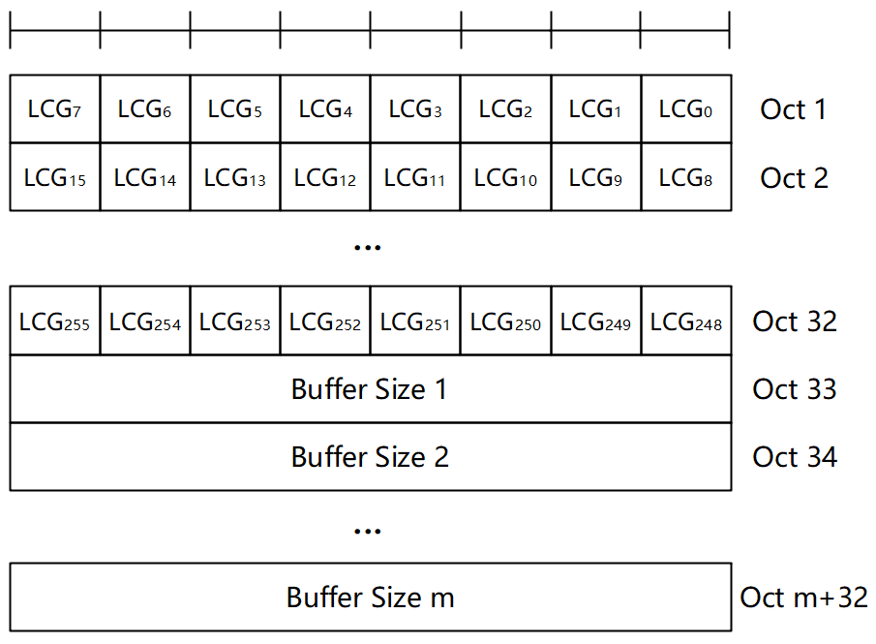
Figure 3(b): Extended Long BSR, Extended Long Truncated BSR

Additionally, in [1], it was also proposed to use new eLCIDs to indicate the extended short/long BSR MAC CEs, while [4], it was recommended for RAN2 to discuss it further.
Based on these, the rapporteur proposes:
Proposal 4: New Short (Truncated) BSR format to specified that has a fixed size and consists of an 8-bit LCG ID field and an 8-bit Buffer Size field.

Proposal 5: New Long (Truncated) BSR format to be specified which should be selected from one of below two formats:
- Option 1: it has a variable size and consists of 256 LCG_{i} and the Buffer Size(s) fields.
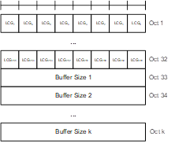
- Option 2: 8-bit LCG ID+8-bit Buffer Size for each LCG
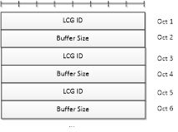
Proposal 6: RAN2 to choose between reserved LCIDs or eLCIDs for the new format Short/Long BSR formats
- Option 1: LCID.
- Option 2: eLCID.

Number of hops
Six companies ([1][3][6][9][12][18]) proposed informing IAB nodes regarding the remaining hops in the UL/DL direction. All these companies support the IAB nodes to be configured the remaining hops in the UL and DL direction, per destination (e.g., as part of the routing configuration). In [18], it has been proposed this information is also relevant for the donor DU. In [6], it is proposed to include the number of hops the packet has traversed in the BAP header to be used instead of a timestamp or remaining PDB information. In [12], it is proposed that IAB nodes broadcast their hop count (i.e., how many hops to the donor) and that information can be used in routing decisions of the child nodes.
Based on these, the rapporteur proposes:
Proposal 7.a: IAB-node and donor DU can be configured with downstream number of hops per routing ID.
Proposal 7.b: IAB-node can be configured with downstream number of hops per routing ID.

Packet delay budget
The issue of packet delay budget enforcement was discussed in several contributions [3][6][7][8][9][13][15][17-20].
In [3], it was proposed not have a timestamp in the BAP header that represents the total elapsed time, but instead consider other timing information such as validity/expiry time of the packet, recommended/expected per-hop delay, recommended/expected remaining delay budget.
In [6], instead of using a timestamp, it is proposed to include the number of hops the packet has already traversed in the BAP header, and the IAB node can use that information for scheduling/routing purposes.
In [7], instead of using a timestamp, it is proposed to use a configured per hop PDB, which is not applicable for packet level control unless the BH RLC channel is mapped 1:1.
In [8], it is proposed to have a centralized solution as baseline solution where a PDB value is configured per BH RLC channel per destination, and optionally consider a decentralized solution where a timestamp information is added to the BAP (corresponding to the remaining packet delay or expected expiry time).
In [9], it is proposed to have a timing information in the BAP header, corresponding to the absolute time where the packet was generated (instead of the remaining PDB, which would have required intermediate nodes to update the header before forwarding the packet). It is also proposed for the IAB node to establish a set of BH RLC channels corresponding to different total PDB values (where the mapping of a packet on such a channel implicitly indicating the E2E PDB of the packet).
In [13], it is suggested to have the timestamp information of the packet (instead of the remaining delay budget). It is also assumed that the bearer ID is included and that the intermediate IAB nodes are aware of the E2E PDB of each bearer in order to utilize this information.
In [15], it is proposed, as in [8], to have a PDB per BH RLC channel per destination to be configured. Additionally, an additional indication on the BAP header is proposed that indicates any remaining PDB left at previous hop (i.e., in case the packet was delivered before the PDB on that hop expired).
In [17], it is proposed to have the remaining PDB to be included in the BAP header.
In [18], it is proposed to configure IAB nodes and the donor DU to become aware of the E2E PDB of the bearers (one value for 1:1 mapped BH RLC channels, average value or a range of value for a N:1 mapped BH RLC channels).
In [19], it is stated that the current mechanisms in rel-16 are sufficient and proposed not to have any new PDB management functionalities introduced in rel-17 IAB.
In [20], it is proposed to have a timestamp on BAP packet header.
As can be there is a clear interest in introducing a solution to help the enforcement of the PDB of a packet, but there is no solution that has a majority support. A slight majority of companies (([9][13][20][3][17]) support some timing/timestamp related information (packet creation time or remaining delay). However, these solutions, especially those including the full timestamp of the packet creation time, will have a high overhead, as pointed out by the opponents of this solution. The remaining packet delay solution will require less overhead, but it will lead to implementation complexity, the donor DU and each IAB node has to recalculate the remaining PDB.
Whether the solution is based on the full timestamp or the remaining delay budget, IAB nodes (at least the access IAB node, for the remaining delay solution) and donor DU have to be aware of the E2E PDB of the packet
Thus, the rapporteur proposes:
Proposal 8: RAN2 to introduce a timing related information in the BAP header to help in enforcing the packet delay budget in a multi-hop IAB network. Details of the timing information are FFS (e.g., a timestamp corresponding to the time of the packet creation, a timestamp corresponding to the time of the packet expiry, the remaining PDB, etc)

Pre-emptive BSR
Proposals to standardize the pre-emptive BSR buffer size calculation and triggering conditions are given in [3], [4], [5], [6], [7], [11], and [19], while [13], [14] and [15] propose to leave it for network implementation as in rel-16. There is a majority support to standardize the enhancements for pre-emptive BSR, even though the details of the proposals from the companies are not completely aligned.
Thus, the rapporteur proposes:
Proposal 9: RAN2 will standardize buffer size calculation for pre-emptive BSR. The details are FFS.
Proposal 10: RAN2 will standardize triggering conditions for pre-emptive BSR. The details are FFS.

Congestion mitigation

UL Flow Control
In [6], [14] and [18], UL hop-by-hop flow control is proposed for better congestion mitigation via improved UL scheduling and resource utilization (including the case of DC where only the MCG or SCG is congested), while [3][13][15] and [19] propose not to introduce UL flow control as current mechanisms (parent controlling child’s UL traffic flow based on BSR received and grants provided in response to that).
Since a slight majority of companies do not support the UL hop-by-hop flow control and considering this is not a critical issue, the rapporteur proposes:
Proposal 11: UL hop-by-hop flow control is not supported in rel-17 IAB.

DL Flow Control Enhancements
In [2] and [3], enhancements to rel-16 DL hop-by-hop flow control are proposed to help in addressing long term DL congestion on a single link, which included the forwarding of congestion information to parent nodes, polling for congestion information and enhancing the reporting granularity (per bearer ID, per destination ID, etc). On the other hand, in [15], [19] and [20], it was indicated that there is already some support for end-to-end congestion control mechanisms or/and further enhancements are being discussed in RAN3.
Thus, the rapporteur proposes:
Proposal 12: RAN2 to postpone further discussion related to DL flow control enhancements pending further progress from RAN3.

Conclusion
Based on the discussion above that summarized the proposals of the contributions to R2#115-e, AI 8.4.2 on fairness, latency and congestion, the following is proposed:
Proposals for easy agreement:
Proposal 3: ([1][5][9][10]): The length of LCG to be extended to 8 bits (i.e., at most 256 LCGs).
Proposal 4: ([1][4][5][9][10]): New Short (Truncated) BSR format to specified that has a fixed size and consists of an 8-bit LCG ID field and an 8-bit Buffer Size field.

Proposals for easy agreement after discussion:

Proposal 5: New Long (Truncated) BSR format to be specified which should be selected from one of below two formats:
- Option 1: it has a variable size and consists of 256 LCG_{i} and the Buffer Size(s) fields. [5][9][10]
- Option 2: 8-bit LCG ID+8-bit Buffer Size for each LCG [1]
Proposal 6: RAN2 to choose between reserved LCIDs or eLCIDs for the new format Short/Long BSR formats
- Option 1: LCID.
- Option 2: eLCID.

Proposal 7.a ([1][3][6][9][12][18]): IAB-node and donor DU can be configured with downstream number of hops per routing ID.
Proposal 8 ([9][13][20][3][17]): RAN2 to introduce a timing related information in the BAP header to help in enforcing the packet delay budget in a multi-hop IAB network. Details of the timing information are FFS (e.g., a timestamp corresponding to the time of the packet creation, a timestamp corresponding to the time of the packet expiry, the remaining PDB, etc)
Proposal 9 ([3][4][5][6][7][11][19]): RAN2 will standardize buffer size calculation for pre-emptive BSR. The details are FFS.
Proposal 10 ([3][4][5][6][7][11][19]): RAN2 will standardize triggering conditions for pre-emptive BSR. The details are FFS.

Proposals for further discussion:
Proposal 1 ([3][6][11]): RAN2 to further discuss whether the bearer-ID is to be included in the BAP header of a packet belonging to an N:1 mapped BH RLC channel.
Proposal 2 ([3][11][13][18]): RAN2 to further discuss whether IAB nodes are configured about the number of bearers and the QoS of the bearers that are aggregated over an N:1 mapped BH RLC channel.
Proposal 7.b ([1][3][6][9][12][18]): IAB-node can be configured with upstream number of hops per routing ID.
Proposal 11 ([6][14][18]): RAN2 to discuss whether UL hop-by-hop flow control is supported in rel-17 IAB.
Proposal 12 ([2][3]): RAN2 to postpone further discussion related to DL flow control pending further progress from RAN3.

References

[1] | R2-2107063 | Fairness Latency and Congestion | CATT
[2] | R2-2107113 | Discussion on flow control for congestion mitigation | CANON Research Centre France
[3] | R2-2107177 | Fairness, latency and congestion – solutions to identified issues | Samsung Electronics GmbH
[4] | R2-2107178 | Enhancements to LCG space and BSR triggering including pre-emptive BSR | Samsung Electronics GmbH
[5] | R2-2107250 | Enhancements for topology-wide fairness, multi-hop latency and congestion mitigation | Huawei, HiSilicon
[6] | R2-2107289 | IAB topology-wide fairness, latency, and congestion enhancement | Intel Corporation
[7] | R2-2107635 | Way forward for IAB enhancements to improve topology-wide fairness multi-hop latency and congestion mitigation | Apple
[8] | R2-2107851 | An elaboration of required PDB for multi-hop latency | ITRI
[9] | R2-2107859 | Discussion on multi-hop latency and LCG extension issues | vivo
[10] | R2-2107892 | Discussion on LCG extension for IAB | Lenovo, Motorola Mobility
[11] | R2-2107998 | Possible solutions for topology-wide fairness, multi-hop latency and congestion mitigation in eIAB | Kyocera
[12] | R2-2108053 | Number of hops information to improve topology-wide fairness and latency | Sony
[13] | R2-2108139 | Discussion on fairness, multi-hop latency and congestion mitigation | ZTE, Sanechips
[14] | R2-2108241 | Fairness, latency, congestion | Nokia, Nokia Shanghai Bell
[15] | R2-2108421 | On Topology-wide Fairness, Multi-hop Latency, and Congestion in IAB Network | Ericsson
[16] | R2-2108437 | Multi-hop scheduling enhancements for IAB | AT&T
[17] | R2-2108492 | Timing information for latency enhancement in multi-hop IAB | InterDigital
[18] | R2-2108493 | Latency enforcement, fairness and congestion mitigation in multi-hop IAB | InterDigital
[19] | R2-2108743 | Discussion on topology-wide fairness, multi-hop latency and congestion mitigation | LG Electronics Inc.
[20] | R2-2108753 | Rel. 17 IAB enhancements for fairness, multi-hop latency reduction, and congestion mitigation | Futurewei Technologies

Annex

Agreements from RAN2 -113-e
- RAN2 will not further discuss ways of evaluating success of any fairness mechanisms that may be introduced, beyond the already agreed definition of topology-wide fairness and its variants.

- Chair: On the agreed issues below, the agreement doesn’t mean that we have agreed that there need to be a solution for it in R17. Furthermore, liberal interpretation of the text is ok.

- ISSUES: eIAB work on topology-wide fairness will focus on the following issues
- IF-1: The scheduler of an IAB node does not have all the information needed (e.g. link quality across multiple hops) to make appropriate upstream or downstream scheduling decisions which take into account the overall route link quality (such as e.g. using downstream link quality measurements to adjust the scheduling weights so as to achieve proportional fairness for different bearers/RLC channels across multiple child-IAB nodes)
- IF-2: Congestion conditions on BH RLC channels carrying UE bearers with same or similar QoS requirements can be unbalanced and some channels may even be congested, thereby leading to some users experiencing longer latency and violating fairness requirement.
- IF-4: IAB node cannot give more resource to those BH RLC CHs that aggregate more bearers and/or carry bearers with higher load per bearer (i.e. IAB node cannot give more resource to those BH RLC CHs with higher aggregate load)

- ISSUES: In the first instance, eIAB work on multi-hop latency will focus on the following issues:
- IL-1: IAB node cannot help ensure that overall or remaining PDB is met for a packet (e.g. by prioritizing bearers with higher number of hops), as it does not have a latency reference for the packets being scheduled, resulting in packets with the same QoS requirement ending up with different latency
- IL-2: IAB node may need to report joint buffer status for LCHs which have rather differing QoS requirements, due to the current (Rel-16) limit on the number of LCGs
- IL-3: Buffer size calculation for pre-emptive BSR may differ for nodes of different vendors as it is left to implementation in Rel-16
- IL-5: The CU is unable to put bearers with lower PDB on routes with less congestion risk (higher resource efficiency) or which are RLF-free
- IL-6: The CU is unable to configure routing based on actual (real-time) latency per BH RLC channel

- R2 has concluded that there is sufficient interest among companies to address the following two issues:
- IC-1: Long-term downstream congestion on a single link cannot be alleviated using existing Rel-16 DL HbH flow control mechanisms, without having to rely on dropping packets
- IC-7: CU (not having knowledge of local congestion conditions) cannot update the routing path that is experiencing congestion.
- Both IC-1 and CI-7 are related to RAN3. RAN3 seems to also work on this, so to what extent R2 shall work on this is currently not clear.

Agreements from RAN2 -113bis-e
- LCG range to be extended for IAB-MT. Size of LCG and enhancements to BSR are FFS

