3GPP TSG-RAN WG2 Meeting #115-e R2-2108994
Online, August, 2021

Agenda item: 6.2.3
Source: LG Electronics Inc. (Rapporteur)
Title: [AT115-e][709][V2X/SL] MAC discussion on remaining issues (LG)
Document for: Discussion and decision

Introduction
This document is to trigger the following email discussion:
- [AT115-e][709][V2X/SL] MAC discussion on remaining issues (LG)
Scope: Discuss all remaining CRs in R2-2107302, R2-2108220, R2-2107185, R2-2107185, R2-2107186, R2-2107187, R2-2108707, R2-2107189 and R2-2108221.
Intended outcome: Discussion summary in R2-2108994 and agreeable MAC CR in R2-2108996 if needed. Will be approved by email.
Deadline: 8/24 13:00pm UTC

Discussion

R2-2107302 (Sharp, ZTE Corporation, Sanechips, OPPO)
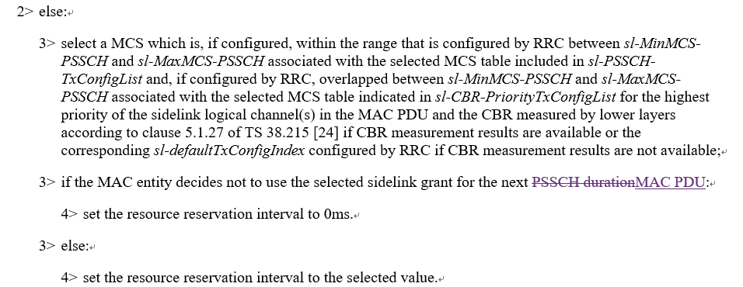

Question 1: Do you agree to reflect the above change in 38.321?
Company | Yes/No | Comment
LG |  | In the last meeting this issue was already discussed. As a result, there was no consensus and captured “Will revisit the issue next meeting (if needed)”  Based on the results, Rapporteur thinks this CR seems to be discussed in this meeting
Ericsson |  | We don’t have strong views, the changes are ok, but meanwhile the spec is not broken without the change.
OPPO | Yes | It’s clearer to change “next PSCCH duration” into “next MAC PDU” since “next PUCCH duration” causes confusion of “retransmission” and “next MAC PDU transmission”.
Huawei, HiSilicon | Yes but | There is no term “next MAC PDU” used in MAC spec for a new transmission. We agree with the intention but the wording needs to be improved. Can think to use e.g. “for the next PSSCH in a new transmission”.
vivo |  | No strong view, can follow the majority.

Summary 1:
Answer | Number of supporting companies

Recommendation 1:

R2-2108220 (VIVO, ZTE)
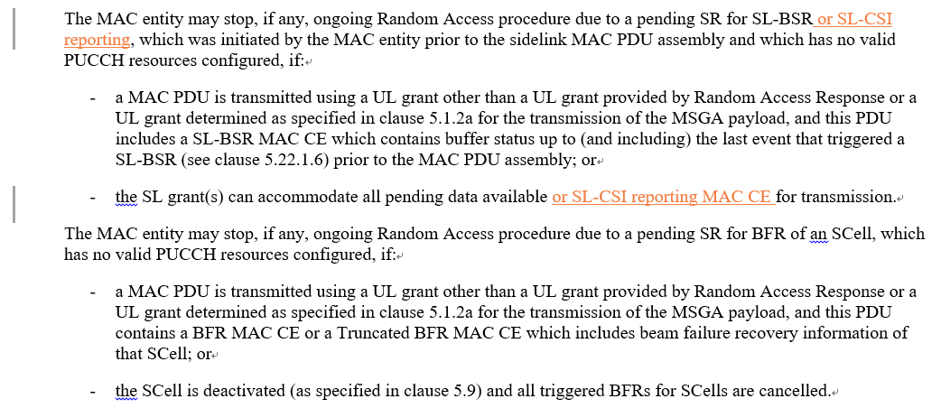

Question 2: Do you agree to reflect the above change in 38.321?
Company | Yes/No | Comment
LG | Yes
Ericsson | Yes
OPPO | See comments | We are fine with the CR after changing “or” into “and”.
Huawei, HiSilicon | Neutral | We don’t think it is critical to have this change and the spec is complete for this behaviour/not broken in this regard. Can follow the majority.  Stopping SR for SL-CSI reporting is described in clause 5.22.1.5: "The pending SR triggered according to the SL-CSI reporting for a destination shall be cancelled and each respective sr-ProhibitTimer shall be stopped when the SL grant(s) can accommodate the Sidelink CSI Reporting MAC CE when the SL-CSI reporting that has been triggered but not cancelled or when the triggered SL-CSI reporting is cancelled due to latency non-fulfilment as specified in 5.22.1.7. All pending SR(s) triggered by either Sidelink BSR or Sidelink CSI report shall be cancelled, when RRC configures Sidelink resource allocation mode 2." If there is no SR needed for SL-CSI reporting, the RACH for this SR won’t be triggered.
vivo | Yes | The RACH triggering condition for SR is the same for all cases i.e. the maximum transmission is reached for the SR. The SR of SL CSI reporting can trigger RACH as all other cases and this is missed in the spec, we think it should be added.  For OPPO’s comment, as the SR configuration for SL-CSI reporting is dedicated, should we just keep ‘or’?

Summary 2:
Answer | Number of supporting companies
Yes
No

Recommendation 2:

R2-2107185 (OPPO, Apple)
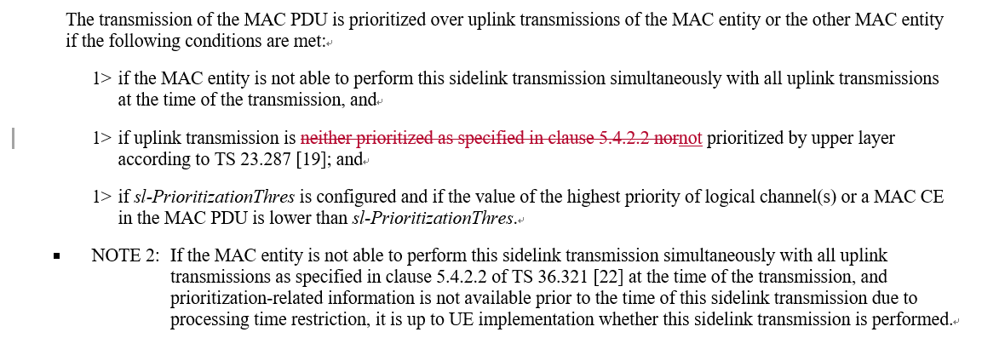

Question 3: Do you agree to reflect the above change in 38.321?
Company | Yes/No | Comment
LG | No | The same issue was already discussed in the last meeting (R2-2104833) and the results was noted.  Rapporteur are thinking that this CR seems not to be needed. Although the sentence is not needed in MAC specification, there is no technical impact. Moreover, current sentence is helpful to understand conditions of SL prioritized transmission.
Ericsson | No | Agree with LG
OPPO | proponent | There seems some misunderstanding by email rapp: the original CR (4833) include 2 changes, where change-1 was addressed by last meeting and removed in the updated version here, and the resubmission is for change-2 only which has not been touched by last meeting.  We can’t agree with Rapp that “there is no technical impact” and “current sentence is helpful to understand conditions of SL prioritized transmission”.  By following the logic of the current wording of SL/UL prioritization in MAC spec, to judge “The transmission of the MAC PDU is prioritized over uplink transmissions of the MAC entity or the other MAC entity”, one has to rely on clause 5.4.2.2 to judge “uplink transmission is not prioritized”, while in clause 5.4.2.2 there is a condition for “uplink transmission is prioritized over sidelink transmission” that “the NR sidelink communication is prioritized as described in clause 5.22.1.3.1a”, which means 5.4.2.2 and 5.22.1.3.1a are circularly referred to each other, and that makes a confusion on the definition of “The transmission of the MAC PDU is prioritized over uplink transmissions of the MAC entity or the other MAC entity”. So logically the circular reference in spec causes problem to implementation.  We would like to understand the point by MAC rapp that how this circular reference “helpful to understand conditions of SL prioritized transmission”.
Huawei, HiSilicon | Maybe not now | We agree with the intention to remove the circular reference between clause 5.4.2.2 and clause 5.22.1.3.1a regarding prioritization. However this CR cannot solve the problem, at least there is another reference to 5.4.2.2 a bit above (page 95, “or prioritized as specified in clause 5.4.2.2”. So we propose to think about a bit more on this, e.g. to use one way reference only, i.e., refer to clause 5.22.1.3.1a in clause 5.4.2.2 and describe prioritization behaviour in clause 5.22.1.3.1a without any reference.
vivo | No | We don’t have strong view on this as it is not really critical as no technical impact.  Huawei’s suggestion is also OK to us. We can follow majority view.

Summary 3:
Answer | Number of supporting companies
Yes
No

Recommendation 3:

R2-2107186 (OPPO, Apple)
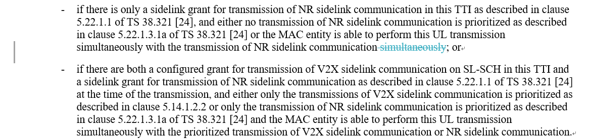

Question 4: Do you agree to reflect the above change in 36.321?
Company | Yes/No | Comment
LG | No | The same issue was already discussed in the last meeting (R2-2104834) and the results was noted.  Rapporteur thinks that this CR seems not to be needed. Although the sentence is not needed in MAC specification, there is no technical impact. Moreover, current sentence is helpful to understand conditions of SL prioritized transmission.
Ericsson | Yes | The change seems to be ok.
OPPO | proponent | We wonder what is the point to leave the typo (two “simultaneously” in the same sentence) as it is.
Huawei, HiSilicon | Yes | Can remove the typo.
vivo | Yes

Summary 4:
Answer | Number of supporting companies
Yes
No

Recommendation 4:

R2-2107187 (OPPO)
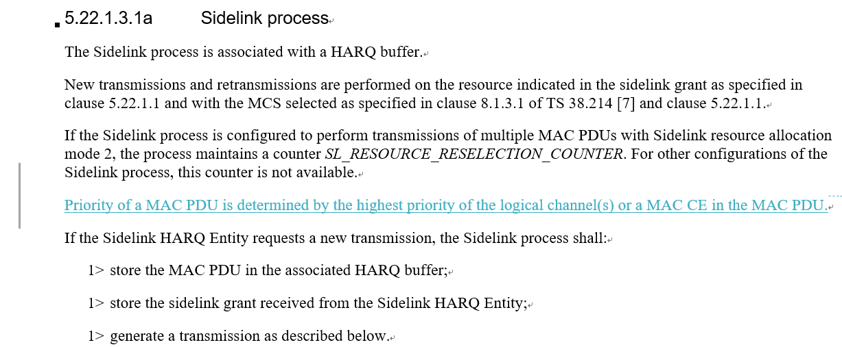

Question 5: Do you agree to reflect the above change in 38.321?
Company | Yes/No | Comment
LG | No | Rapporteur thinks this CR seems not to be needed. Even if the pointed description is missing, there is no technical impact.
Ericsson | Yes | We agree with the intention of the CR. It is better to have a clear definition of the term.
OPPO | proponent | In section 5.4.4, it mentioned that “the priority of the MAC PDU determined as specified in clause 5.22.1.3.1a for the SL-SCH resource”, but yet in section 5.22.1.3.1a, there is no definition of the term “priority of the MAC PDU”. Therefore, the definition for the term “priority of the MAC PDU” should be added in 5.22.1.3.1a.  We wonder how to understand the point by MAC rapp that “there is no technical impact” even if a referred definition is not provided.
Huawei, HiSilicon | Yes | Agree it would be good to have this description, which would be also good for the possible description on the prioritization behaviour.
vivo | See comments | Instead of introducing a new definition for priority of MAC PDU, we can change the section 5.4.4 as follows  3> if a SL-SCH resource overlaps with the PUCCH resource for the SR transmission occasion for the pending SR triggered as specified in clause 5.22.1.5, and the MAC entity is not able to perform this SR transmission simultaneously with the transmission of the SL-SCH resource, and the priority of the triggered SR determined as specified in clause 5.22.1.5 is higher than the highest priority of the logical channel(s) or a MAC CE in the MAC PDU as specified in clause 5.22.1.3.1a for the SL-SCH resource:

Summary 5:
Answer | Number of supporting companies
Yes
No

Recommendation 5:

R2-2108707 (ASUSTeK)
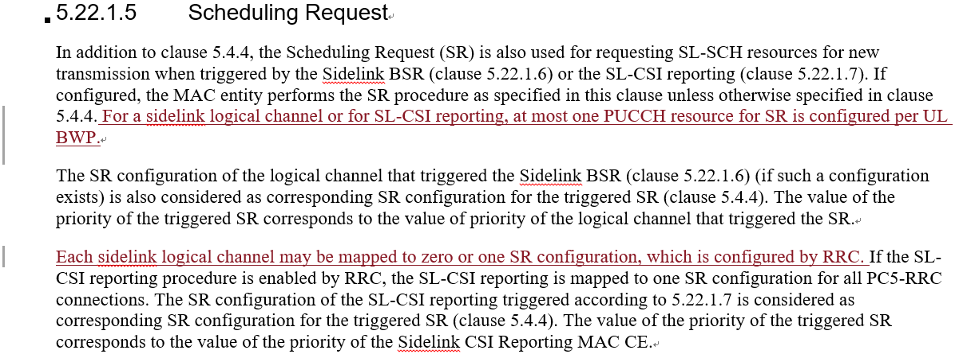

Question 6: Do you agree to reflect the above change in 38.321?
Company | Yes/No | Comment
LG |  | Rapporteur thinks that this CR seems not to be needed. Even if this description is missing, current text is enough to work.
Ericsson | Yes | Agree with the changes, to adopt the same rules/behaviours as in Uu
OPPO |  | We are fine to go for the majority’s view.
Huawei, HiSilicon | Neutral | Can follow the majority.
vivo | See comments | For the first change, no need because it already mentioned:  Each sidelink logical channel may be mapped to zero or one SR configuration, which is configured by RRC. If the SL-CSI reporting procedure is enabled by RRC, the SL-CSI reporting is mapped to one SR configuration for all PC5-RRC connections. The SR configuration of the SL-CSI reporting triggered according to 5.22.1.7 is considered as corresponding SR configuration for the triggered SR (clause 5.4.4). The value of the priority of the triggered SR corresponds to the value of the priority of the Sidelink CSI Reporting MAC CE.  All pending SR(s) triggered according to the Sidelink BSR procedure (clause 5.22.1.6) prior to the MAC  For the second change, no strong view.

Summary 6:
Answer | Number of supporting companies
Yes
No

Recommendation 6:

R2-2107189 (OPPO)
Proposal 1 RAN2 confirm the WA that “UE assumes that next retransmission(s) of the MAC PDU is required when FB is disabled, for CG, if sl-CG-MaxTransNumList is configured with a value not larger than the number of CG resources, when sl-CG-MaxTransNum is not reached”.
Proposal 2 When FB is disabled, for CG, if sl-CG-MaxTransNumList is configured with a value larger than the number of CG resources, when sl-CG-MaxTransNum is reached, UE assumes that next retransmission(s) of the MAC PDU is not required.
Proposal 3 When FB is disabled, for CG, if sl-CG-MaxTransNumList is configured with a value larger than the number of CG resources, when sl-CG-MaxTransNum is not reached, UE assumes that next retransmission(s) of the MAC PDU is required.

Question 7: Do you have any views on the proposals?
Company | Comment
Ericsson | P1 is ok,  P2 is not ok, since in this case, sl-CG-MaxTransNum will never be reached.  P3 is ok, meaning that the retransmission using further DG grants will be fully up to gNB scheduling.
OPPO | For Proposal 1, according to the discussion in RAN1#105, RAN1 concluded as no LS back, so the WA can be confirmed by RAN2.  For P2 and P3, we actually suggest to disc together with the proposal by vivo below together, since the key Q is to conclude on the UE behaviour of reporting A/N in different cases.  For Proposal 2 and Proposal 3, from OPPO perspective, considering it may not start transmission from the first CG resource, in this case “sl-CG-MaxTransNumList is configured with a value larger than the number of CG resources” may end up with the same result as the case where “sl-CG-MaxTransNumList is configured with a value NOT larger than the number of CG resources”. Therefore, we propose the same UE behaviour these two cases.
Huawei, HiSilicon | We are fine with P1 to confirm the WA.
vivo | According to the agreement in RAN2 #113e  - RAN2 confirms sl-CG-MaxTransNumList covers {only CG resources}.  Therefore, if the UE follows the behaviour in WA in this case, then it will always assume that next retransmission(s) of the MAC PDU is required (which is obviously not reasonable), because the sl-MaxTransNum will always NOT be reached..

Recommendation 7:

R2-2108221 (VIVO)
Proposal 1: Besides the WA, RAN2 to clarify that the UE will decide whether the next retransmission(s) of the MAC PDU is required based on implementation when SL HARQ FB is disabled and when sl-MaxTransNum is not reached, in case that sl-CG-MaxTransNumList is configured with a value larger than the number of CG resources.

Question 8: Do you have any views on the proposals?
Company | Comment
Ericsson | P1 is not ok, we more prefer P3 in OPPO contribution R2-2107189
OPPO | For P2 and P3, we actually suggest to disc together with the proposal by vivo below together, since the key Q is to conclude on the UE behaviour of reporting A/N in different cases.  Otherwise, see our reply to Q7 above.
Huawei, HiSilicon | P1 is fine. We think the network will not configure sl-CG-MaxTransNumList with a value larger than the number of CG resources. If it would happen, it is up to UE implementation to handle.
vivo | See Q7, seems it can only be left to UE implementation.

Recommendation 8:

Conclusion and recommendation
In conclusion, Rapporteur proposes the following recommendations as the outcome of this email discussion:

