3GPP TSG-RAN WG2 Meeting #115-e R2-2108994
Online, August, 2021

Agenda item: 6.2.3
Source: LG Electronics Inc. (Rapporteur)
Title: [AT115-e][709][V2X/SL] MAC discussion on remaining issues (LG)
Document for: Discussion and decision

Introduction
This document is to trigger the following email discussion:
- [AT115-e][709][V2X/SL] MAC discussion on remaining issues (LG)
Scope: Discuss all remaining CRs in R2-2107302, R2-2108220, R2-2107185, R2-2107185, R2-2107186, R2-2107187, R2-2108707, R2-2107189 and R2-2108221.
Intended outcome: Discussion summary in R2-2108994 and agreeable MAC CR in R2-2108996 if needed. Will be approved by email.
Deadline: 8/24 13:00pm UTC

Discussion

R2-2107302 (Sharp, ZTE Corporation, Sanechips, OPPO)
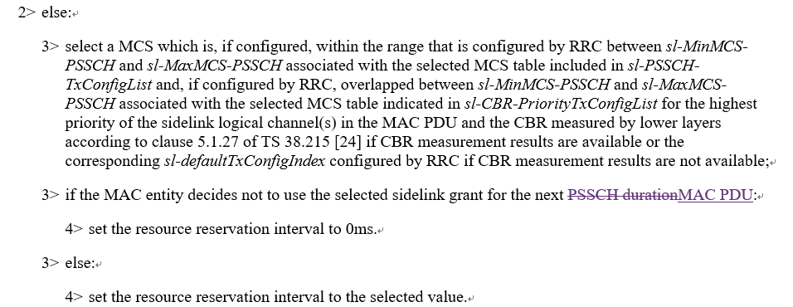

Question 1: Do you agree to reflect the above change in 38.321?
Company | Yes/No | Comment
LG |  | In the last meeting this issue was already discussed. As a result, there was no consensus and captured “Will revisit the issue next meeting (if needed)”  Based on the results, Rapporteur thinks this CR seems to be discussed in this meeting
Ericsson |  | We don’t have strong views, the changes are ok, but meanwhile the spec is not broken without the change.
OPPO | Yes | It’s clearer to change “next PSCCH duration” into “next MAC PDU” since “next PUCCH duration” causes confusion of “retransmission” and “next MAC PDU transmission”.
Huawei, HiSilicon | Yes but | There is no term “next MAC PDU” used in MAC spec for a new transmission. We agree with the intention but the wording needs to be improved. Can think to use e.g. “for the next PSSCH in a new transmission”.
vivo |  | No strong view, can follow the majority.
ASUSTeK | No strong view
MediaTek | Yes but | We support the intention. We also share same view with Huawei that the wording can be improved.
Lenovo | Yes | We thinks change to “next MAC PDU” is reasonable and less confusion
Apple | Yes with comment | Agree with the intention but wE think the “next MAC PDU” is not clear enough, either. We suggest to change to “if the MAC entity decides to not continue to use the select grant after the current resource reservation period”.
Qualcomm | No | We don’t find anythig broken in the current specification. Hence we see no need for this change at this point in the release,
Sharp | Yes | As described in the reason for change section, if the sidelink grant was selected for transmission of multiple MAC PDUs, and the next PSSCH duration is a retransmission of current PDU, the selected grant would not be available for transmission if the resource interval set to 0ms.
ZTE | Yes

Summary 1:
Answer | Number of supporting companies

Recommendation 1:

R2-2108220 (VIVO, ZTE)
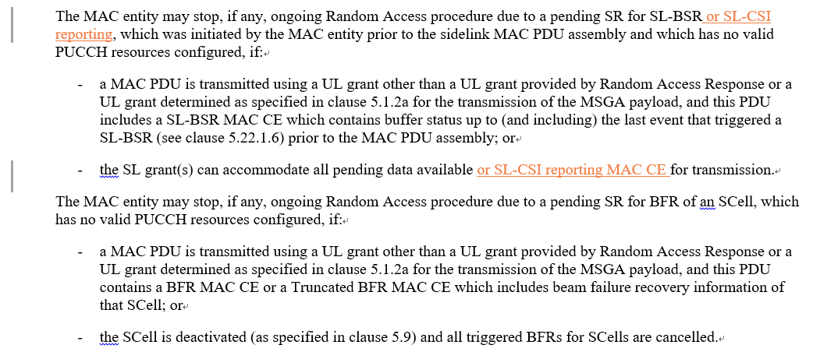

Question 2: Do you agree to reflect the above change in 38.321?
Company | Yes/No | Comment
LG | Yes
Ericsson | Yes
OPPO | See comments | We are fine with the CR after changing “or” into “and”.
Huawei, HiSilicon | Neutral | We don’t think it is critical to have this change and the spec is complete for this behaviour/not broken in this regard. Can follow the majority.  Stopping SR for SL-CSI reporting is described in clause 5.22.1.5: "The pending SR triggered according to the SL-CSI reporting for a destination shall be cancelled and each respective sr-ProhibitTimer shall be stopped when the SL grant(s) can accommodate the Sidelink CSI Reporting MAC CE when the SL-CSI reporting that has been triggered but not cancelled or when the triggered SL-CSI reporting is cancelled due to latency non-fulfilment as specified in 5.22.1.7. All pending SR(s) triggered by either Sidelink BSR or Sidelink CSI report shall be cancelled, when RRC configures Sidelink resource allocation mode 2." If there is no SR needed for SL-CSI reporting, the RACH for this SR won’t be triggered.
vivo | Yes | The RACH triggering condition for SR is the same for all cases i.e. the maximum transmission is reached for the SR. The SR of SL CSI reporting can trigger RACH as all other cases and this is missed in the spec, we think it should be added.  For OPPO’s comment, as the SR configuration for SL-CSI reporting is dedicated, should we just keep ‘or’?
ASUSTeK | Yes
MediaTek | Yes
Lenovo | Yes with comments | We are fine with the CR with the change to “and/or” in both places
Apple | Yes | We are fine with the CR with the change to “and/or” in both places
Qualcomm | No | As the RAN2 #111e agreement cited in the CR indicates no specification change is required, we do not see a strong need for this change.
Sharp | Yes
ZTE | Yes

Summary 2:
Answer | Number of supporting companies
Yes
No

Recommendation 2:

R2-2107185 (OPPO, Apple)
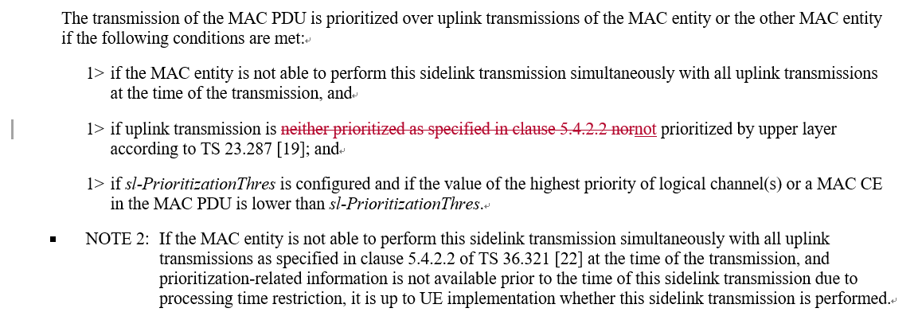

Question 3: Do you agree to reflect the above change in 38.321?
Company | Yes/No | Comment
LG | No | The same issue was already discussed in the last meeting (R2-2104833) and the results was noted.  Rapporteur are thinking that this CR seems not to be needed. Although the sentence is not needed in MAC specification, there is no technical impact. Moreover, current sentence is helpful to understand conditions of SL prioritized transmission.
Ericsson | No | Agree with LG
OPPO | proponent | There seems some misunderstanding by email rapp: the original CR (4833) include 2 changes, where change-1 was addressed by last meeting and removed in the updated version here, and the resubmission is for change-2 only which has not been touched by last meeting.  We can’t agree with Rapp that “there is no technical impact” and “current sentence is helpful to understand conditions of SL prioritized transmission”.  By following the logic of the current wording of SL/UL prioritization in MAC spec, to judge “The transmission of the MAC PDU is prioritized over uplink transmissions of the MAC entity or the other MAC entity”, one has to rely on clause 5.4.2.2 to judge “uplink transmission is not prioritized”, while in clause 5.4.2.2 there is a condition for “uplink transmission is prioritized over sidelink transmission” that “the NR sidelink communication is prioritized as described in clause 5.22.1.3.1a”, which means 5.4.2.2 and 5.22.1.3.1a are circularly referred to each other, and that makes a confusion on the definition of “The transmission of the MAC PDU is prioritized over uplink transmissions of the MAC entity or the other MAC entity”. So logically the circular reference in spec causes problem to implementation.  We would like to understand the point by MAC rapp that how this circular reference “helpful to understand conditions of SL prioritized transmission”.
Huawei, HiSilicon | Maybe not now | We agree with the intention to remove the circular reference between clause 5.4.2.2 and clause 5.22.1.3.1a regarding prioritization. However this CR cannot solve the problem, at least there is another reference to 5.4.2.2 a bit above (page 95, “or prioritized as specified in clause 5.4.2.2”. So we propose to think about a bit more on this, e.g. to use one way reference only, i.e., refer to clause 5.22.1.3.1a in clause 5.4.2.2 and describe prioritization behaviour in clause 5.22.1.3.1a without any reference.
vivo | No | We don’t have strong view on this as it is not really critical as no technical impact.  Huawei’s suggestion is also OK to us. We can follow majority view.
MediaTek | Yes | We think any confusing circular reference in the MAC spec should be removed.
Lenovo | Yes from editorial point of view, No from technique point of view | We think this is more like a duplicated condition, but not circular condition, since the condition “prioritized as specified in clause 5.4.2.2” is already considered in previously paragraph “1> if there is a MAC PDU to be transmitted for this duration in uplink, except a MAC PDU obtained from the Msg3 buffer, the MSGA buffer, or prioritized as specified in clause 5.4.2.2, and the sidelink transmission is prioritized over uplink transmission:”. From technique point of view, we think nothing is broken. From description point of view, we think it is redundant.
Apple | Yes | Same view as OPPO
Qualcomm | No | We agree with the above comments indicating this change is not required.
Sharp | Yes | We share same view as MTk.
ZTE |  | No strong concern. We can follow majority view.

Summary 3:
Answer | Number of supporting companies
Yes
No

Recommendation 3:

R2-2107186 (OPPO, Apple)
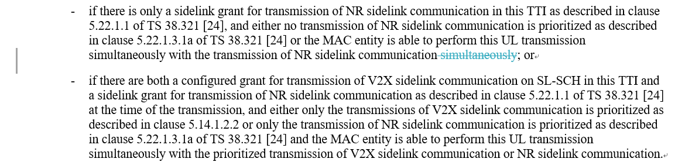

Question 4: Do you agree to reflect the above change in 36.321?
Company | Yes/No | Comment
LG | No | The same issue was already discussed in the last meeting (R2-2104834) and the results was noted.  Rapporteur thinks that this CR seems not to be needed. Although the sentence is not needed in MAC specification, there is no technical impact. Moreover, current sentence is helpful to understand conditions of SL prioritized transmission.
Ericsson | Yes | The change seems to be ok.
OPPO | proponent | We wonder what is the point to leave the typo (two “simultaneously” in the same sentence) as it is.
Huawei, HiSilicon | Yes | Can remove the typo.
vivo | Yes
ASUSTeK | Yes
MediaTek | Yes
Lenovo | Yes
Apple | Yes
Qualcomm | Yes
Sharp | Yes
ZTE | Yes

Summary 4:
Answer | Number of supporting companies
Yes
No

Recommendation 4:

R2-2107187 (OPPO)
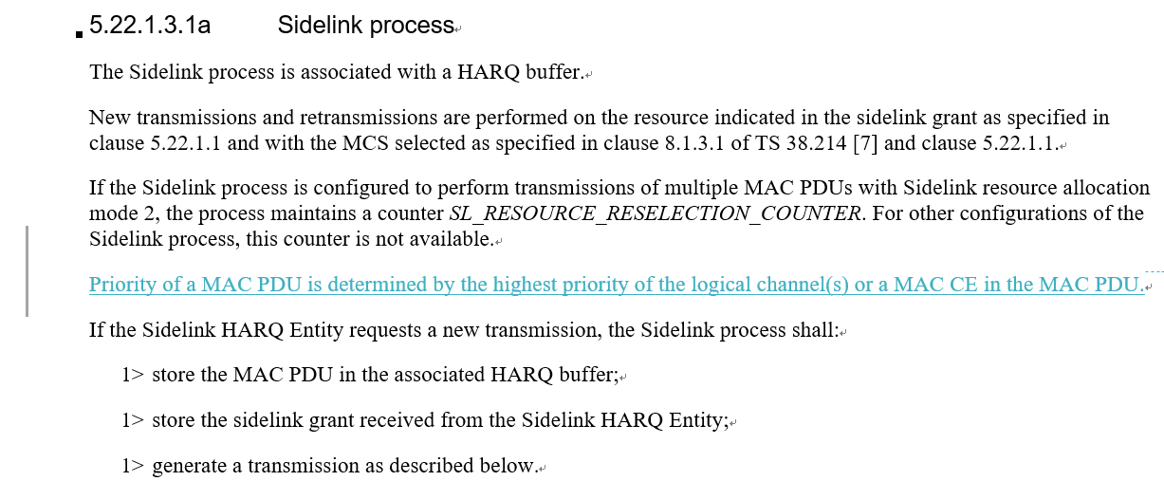

Question 5: Do you agree to reflect the above change in 38.321?
Company | Yes/No | Comment
LG | No | Rapporteur thinks this CR seems not to be needed. Even if the pointed description is missing, there is no technical impact.
Ericsson | Yes | We agree with the intention of the CR. It is better to have a clear definition of the term.
OPPO | proponent | In section 5.4.4, it mentioned that “the priority of the MAC PDU determined as specified in clause 5.22.1.3.1a for the SL-SCH resource”, but yet in section 5.22.1.3.1a, there is no definition of the term “priority of the MAC PDU”. Therefore, the definition for the term “priority of the MAC PDU” should be added in 5.22.1.3.1a.  We wonder how to understand the point by MAC rapp that “there is no technical impact” even if a referred definition is not provided.
Huawei, HiSilicon | Yes | Agree it would be good to have this description, which would be also good for the possible description on the prioritization behaviour.
vivo | See comments | Instead of introducing a new definition for priority of MAC PDU, we can change the section 5.4.4 as follows  3> if a SL-SCH resource overlaps with the PUCCH resource for the SR transmission occasion for the pending SR triggered as specified in clause 5.22.1.5, and the MAC entity is not able to perform this SR transmission simultaneously with the transmission of the SL-SCH resource, and the priority of the triggered SR determined as specified in clause 5.22.1.5 is higher than the highest priority of the logical channel(s) or a MAC CE in the MAC PDU as specified in clause 5.22.1.3.1a for the SL-SCH resource:
MediaTek | Yes | We support this CR. We think it is necessary to use a clear sentence to define how the priority of a MAC PDU is determined.
Lenovo | See comments | We agree with the intention of the CR. But since there is only one place to have this term “priority of the MAC PDU”, maybe we could directly replace this term with “the highest priority of the logical channel(s) or a MAC CE in the MAC PDU”
Apple | Yes | There is no harm to explain the correct understanding of how the priority of MAC PDU is determined. It is not clear to readers of the spec, even though this is obvious among the RAN2 experts.
Qualcomm | No strong view | This change may provide clarity
Sharp | No strong view | We are fine with majority view.
ZTE | See comments | Agree Lenovo’s view.

Summary 5:
Answer | Number of supporting companies
Yes
No

Recommendation 5:

R2-2108707 (ASUSTeK)
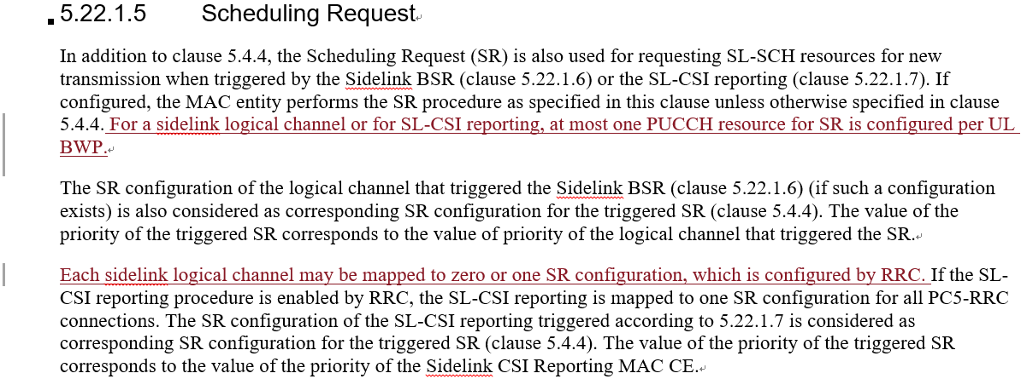

Question 6: Do you agree to reflect the above change in 38.321?
Company | Yes/No | Comment
LG |  | Rapporteur thinks that this CR seems not to be needed. Even if this description is missing, current text is enough to work.
Ericsson | Yes | Agree with the changes, to adopt the same rules/behaviours as in Uu
OPPO |  | We are fine to go for the majority’s view.
Huawei, HiSilicon | Neutral | Can follow the majority.
vivo | See comments | For the first change, no need because it already mentioned:  Each sidelink logical channel may be mapped to zero or one SR configuration, which is configured by RRC. If the SL-CSI reporting procedure is enabled by RRC, the SL-CSI reporting is mapped to one SR configuration for all PC5-RRC connections. The SR configuration of the SL-CSI reporting triggered according to 5.22.1.7 is considered as corresponding SR configuration for the triggered SR (clause 5.4.4). The value of the priority of the triggered SR corresponds to the value of the priority of the Sidelink CSI Reporting MAC CE.  All pending SR(s) triggered according to the Sidelink BSR procedure (clause 5.22.1.6) prior to the MAC  For the second change, no strong view.
ASUSTeK | Yes | @vivo, thanks for the comments, we agree with the highlight sentences in spec, that SL-CSI reporting maps to one SR configuration for all PC5-RRC connection. However, the first change is to clarify a different topic that such SR configuration is mapped up to one PUCCH resource since current RRC allows one SR configuration could map to one or multiple PUCCH resource. And, the first change is merely to clarify this and mainly based on same rules/behaviours in Uu (session 5.4.4)  5.4.4 Scheduling Request  The Scheduling Request (SR) is used for requesting UL-SCH resources for new transmission.  The MAC entity may be configured with zero, one, or more SR configurations. An SR configuration consists of a set of PUCCH resources for SR across different BWPs and cells. For a logical channel or for SCell beam failure recovery (see clause 5.17) and for consistent LBT failure recovery (see clause 5.21), at most one PUCCH resource for SR is configured per BWP.  […] Each logical channel, SCell beam failure recovery, and consistent LBT failure recovery, may be mapped to zero or one SR configuration, which is configured by RRC.
MediaTek | Yes | We are fine to follow Uu design.
Lenovo |  | Fine with majority view
Apple | Yes
Qualcomm | No strong view | Leaning towards adopting the Uu design
Sharp | No strong view | We are fine with majority view.
ZTE | No strong view | We can follow majority view.

Summary 6:
Answer | Number of supporting companies
Yes
No

Recommendation 6:

R2-2107189 (OPPO)
Proposal 1 RAN2 confirm the WA that “UE assumes that next retransmission(s) of the MAC PDU is required when FB is disabled, for CG, if sl-CG-MaxTransNumList is configured with a value not larger than the number of CG resources, when sl-CG-MaxTransNum is not reached”.
Proposal 2 When FB is disabled, for CG, if sl-CG-MaxTransNumList is configured with a value larger than the number of CG resources, when sl-CG-MaxTransNum is reached, UE assumes that next retransmission(s) of the MAC PDU is not required.
Proposal 3 When FB is disabled, for CG, if sl-CG-MaxTransNumList is configured with a value larger than the number of CG resources, when sl-CG-MaxTransNum is not reached, UE assumes that next retransmission(s) of the MAC PDU is required.

Question 7: Do you have any views on the proposals?
Company | Comment
Ericsson | P1 is ok,  P2 is not ok, since in this case, sl-CG-MaxTransNum will never be reached.  P3 is ok, meaning that the retransmission using further DG grants will be fully up to gNB scheduling.
OPPO | For Proposal 1, according to the discussion in RAN1#105, RAN1 concluded as no LS back, so the WA can be confirmed by RAN2.  For P2 and P3, we actually suggest to disc together with the proposal by vivo below together, since the key Q is to conclude on the UE behaviour of reporting A/N in different cases.  For Proposal 2 and Proposal 3, from OPPO perspective, considering it may not start transmission from the first CG resource, in this case “sl-CG-MaxTransNumList is configured with a value larger than the number of CG resources” may end up with the same result as the case where “sl-CG-MaxTransNumList is configured with a value NOT larger than the number of CG resources”. Therefore, we propose the same UE behaviour these two cases.
Huawei, HiSilicon | We are fine with P1 to confirm the WA.
vivo | According to the agreement in RAN2 #113e  - RAN2 confirms sl-CG-MaxTransNumList covers {only CG resources}.  Therefore, if the UE follows the behaviour in WA in this case, then it will always assume that next retransmission(s) of the MAC PDU is required (which is obviously not reasonable), because the sl-MaxTransNum will always NOT be reached..
MediaTek | Fine with P1. For P2 and P3, we have one question for clarification. We wonder that by following the agreement “RAN2 confirms sl-CG-MaxTransNumList covers {only CG resources}”, UE will not get closer to sl-CG-MaxTransNumList when transmitting DG. Then, how the UE know how many DGs should be transmitted after CG? Is the intention that the UE allowed to send DGs for the TB until sl-MaxTransNum is reached?
Lenovo | We agree to have unified UE behaviour for both cases: “sl-CG-MaxTransNumList is configured with a value larger than the number of CG resources”, “sl-CG-MaxTransNumList is configured with a value NOT larger than the number of CG resources”, so we think P1 and P3 are fine
Apple | For P1, we assume this is a case that no DG allocation is expected (e.g. for low priority PDU or PDU with low reliability requirements), so we need to change this to, “UE assumes that next retransmission(s) of the MAC PDU is required when FB is disabled, for CG, if sl-CG-MaxTransNumList is configured with a value not larger than the number of CG resources, when sl-CG-MaxTransNum is not reached and there are still unused CG resource”.  For P2 and P3, it depends on how we interpretate the “sl-MaxTransNum larger than the number of CG resources” . If this is just used as an indication of DG is allowed for a certain SL priority, then P3 is OK, but P2 is not OK. If this is an indication of the total number of allowed CG+DG transmissions, then P2 is OK.
Qualcomm | We are OK to confirm the working assumption, as in P1. Regarding P2 and P3, we do not see the need at this time.
Sharp | We are fine to confirm the WA.
ZTE | For P1, we agree to confirm the WA.  For P2,P3, we think this can be left to UE and gNB implementation.

Recommendation 7:

R2-2108221 (VIVO)
Proposal 1: Besides the WA, RAN2 to clarify that the UE will decide whether the next retransmission(s) of the MAC PDU is required based on implementation when SL HARQ FB is disabled and when sl-MaxTransNum is not reached, in case that sl-CG-MaxTransNumList is configured with a value larger than the number of CG resources.

Question 8: Do you have any views on the proposals?
Company | Comment
Ericsson | P1 is not ok, we more prefer P3 in OPPO contribution R2-2107189
OPPO | For P2 and P3, we actually suggest to disc together with the proposal by vivo below together, since the key Q is to conclude on the UE behaviour of reporting A/N in different cases.  Otherwise, see our reply to Q7 above.
Huawei, HiSilicon | P1 is fine. We think the network will not configure sl-CG-MaxTransNumList with a value larger than the number of CG resources. If it would happen, it is up to UE implementation to handle.
vivo | See Q7, seems it can only be left to UE implementation.
MediaTek | Left to UE implementation is acceptable to us. If we go this way, we should capture the understanding in the spec.
Lenovo | See our comments in Q7 above
Apple | See our comments in Q7 above
Qualcomm | We are fine with Proposal 1
Sharp | We are fine with the proposal.
ZTE | Agree VIVO’s proposal, this can be left to implementation.

Recommendation 8:

Conclusion and recommendation
In conclusion, Rapporteur proposes the following recommendations as the outcome of this email discussion:

