3GPP TSG-RAN WG2 Meeting #115-e R2-2108994
Online, August, 2021

Agenda item: 6.2.3
Source: LG Electronics Inc. (Rapporteur)
Title: [AT115-e][709][V2X/SL] MAC discussion on remaining issues (LG)
Document for: Discussion and decision

Introduction
This document is to trigger the following email discussion:
- [AT115-e][709][V2X/SL] MAC discussion on remaining issues (LG)
Scope: Discuss all remaining CRs in R2-2107302, R2-2108220, R2-2107185, R2-2107185, R2-2107186, R2-2107187, R2-2108707, R2-2107189 and R2-2108221.
Intended outcome: Discussion summary in R2-2108994 and agreeable MAC CR in R2-2108996 if needed. Will be approved by email.
Deadline: 8/24 13:00pm UTC

Discussion

R2-2107302 (Sharp, ZTE Corporation, Sanechips, OPPO)
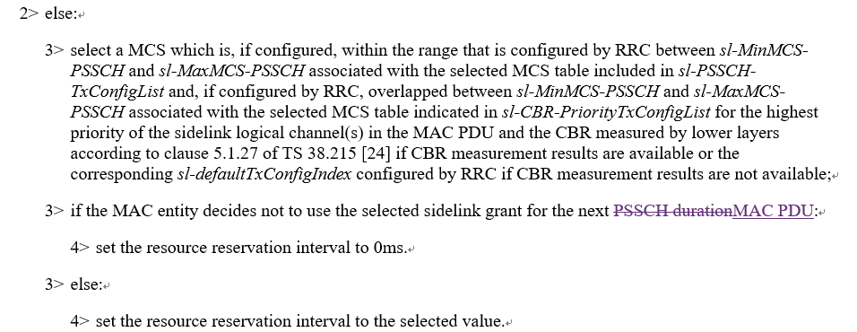

Question 1: Do you agree to reflect the above change in 38.321?
Company | Yes/No | Comment
LG |  | In the last meeting this issue was already discussed. As a result, there was no consensus and captured “Will revisit the issue next meeting (if needed)”  Based on the results, Rapporteur thinks this CR seems to be discussed in this meeting

Summary 1:
Answer | Number of supporting companies

Recommendation 1:

R2-2108220 (VIVO, ZTE)
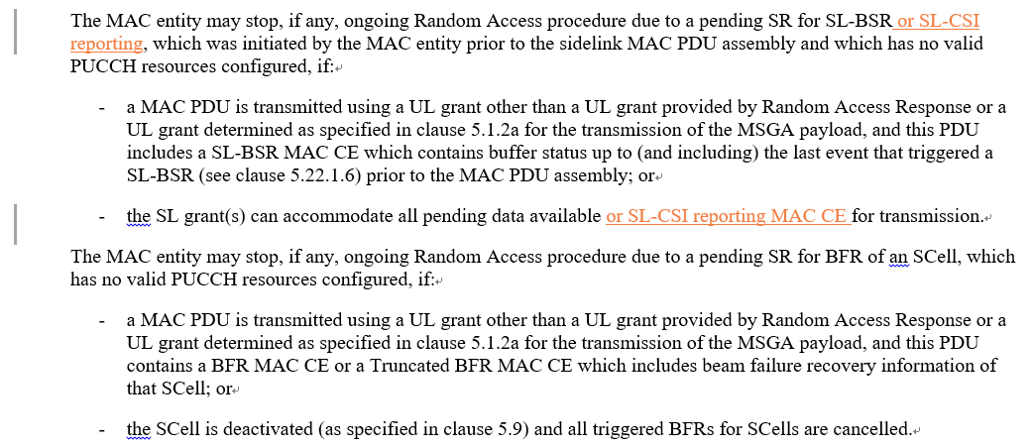

Question 2: Do you agree to reflect the above change in 38.321?
Company | Yes/No | Comment
LG | Yes

Summary 2:
Answer | Number of supporting companies
Yes
No

Recommendation 2:

R2-2107185 (OPPO, Apple)
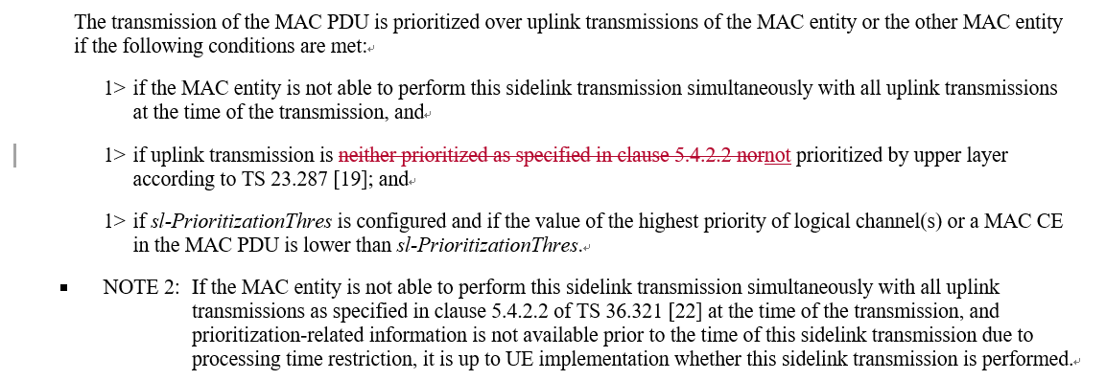

Question 3: Do you agree to reflect the above change in 38.321?
Company | Yes/No | Comment
LG | No | The same issue was already discussed in the last meeting (R2-2104833) and the results was noted.  Rapporteur are thinking that this CR seems not to be needed. Although the sentence is not needed in MAC specification, there is no technical impact. Moreover, current sentence is helpful to understand conditions of SL prioritized transmission.

Summary 3:
Answer | Number of supporting companies
Yes
No

Recommendation 3:

R2-2107186 (OPPO, Apple)
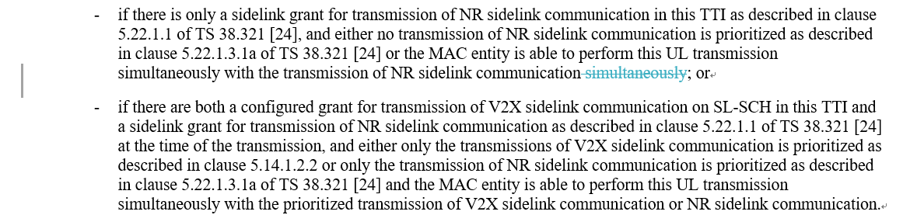

Question 4: Do you agree to reflect the above change in 36.321?
Company | Yes/No | Comment
LG | No | The same issue was already discussed in the last meeting (R2-2104834) and the results was noted.  Rapporteur thinks that this CR seems not to be needed. Although the sentence is not needed in MAC specification, there is no technical impact. Moreover, current sentence is helpful to understand conditions of SL prioritized transmission.

Summary 4:
Answer | Number of supporting companies
Yes
No

Recommendation 4:

R2-2107187 (OPPO)
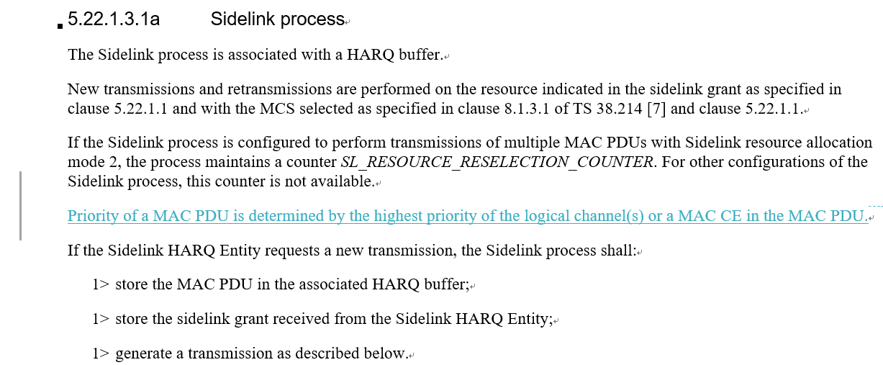

Question 5: Do you agree to reflect the above change in 38.321?
Company | Yes/No | Comment
LG | No | Rapporteur thinks this CR seems not to be needed. Even if the pointed description is missing, there is no technical impact.

Summary 5:
Answer | Number of supporting companies
Yes
No

Recommendation 5:

R2-2108707 (ASUSTeK)
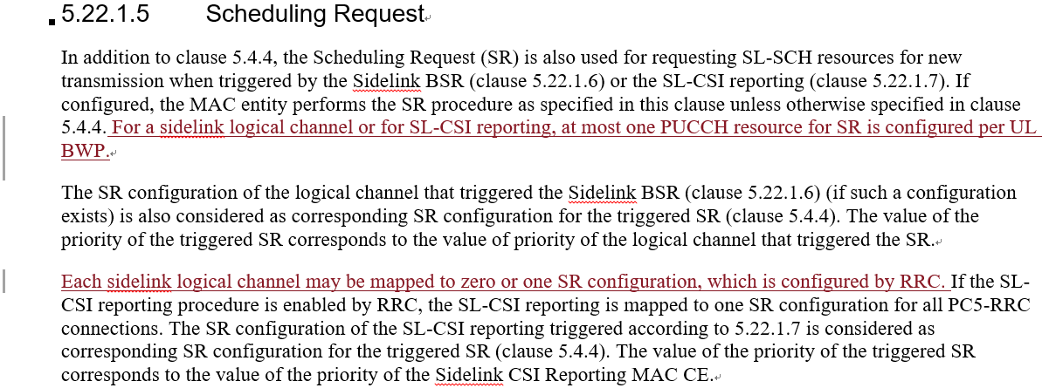

Question 6: Do you agree to reflect the above change in 38.321?
Company | Yes/No | Comment
LG |  | Rapporteur thinks that this CR seems not to be needed. Even if this description is missing, current text is enough to work.

Summary 6:
Answer | Number of supporting companies
Yes
No

Recommendation 6:

R2-2107189 (OPPO)
Proposal 1 RAN2 confirm the WA that “UE assumes that next retransmission(s) of the MAC PDU is required when FB is disabled, for CG, if sl-CG-MaxTransNumList is configured with a value not larger than the number of CG resources, when sl-CG-MaxTransNum is not reached”.
Proposal 2 When FB is disabled, for CG, if sl-CG-MaxTransNumList is configured with a value larger than the number of CG resources, when sl-CG-MaxTransNum is reached, UE assumes that next retransmission(s) of the MAC PDU is not required.
Proposal 3 When FB is disabled, for CG, if sl-CG-MaxTransNumList is configured with a value larger than the number of CG resources, when sl-CG-MaxTransNum is not reached, UE assumes that next retransmission(s) of the MAC PDU is required.

Question 7: Do you have any views on the proposals?
Company | Comment

Recommendation 7:

R2-2108221 (VIVO)
Proposal 1: Besides the WA, RAN2 to clarify that the UE will decide whether the next retransmission(s) of the MAC PDU is required based on implementation when SL HARQ FB is disabled and when sl-MaxTransNum is not reached, in case that sl-CG-MaxTransNumList is configured with a value larger than the number of CG resources.

Question 8: Do you have any views on the proposals?
Company | Comment

Recommendation 8:

Conclusion and recommendation
In conclusion, Rapporteur proposes the following recommendations as the outcome of this email discussion:

