3GPP TSG-RAN WG2 #113bis-e R2-210xxxx

Electronic meeting, 12th April – 20th April 2021

Agenda Item: 5.4.1.2

Source: Ericsson

Title: Summary of [AT113bis-e][007][NR15] Inter-Node

Document for: Discussion, Decision

# 1 Introduction

This document is to handle the following email discussion:

* [AT113bis-e][007][NR15] Inter-Node (Ericsson)

Scope: Treat R2-2102768 (start after on-line), R2-2103027 (start after on-line), R2-2102769, R2-2103028, R2-2103029, R2-2103028, R2-2103641, R2-2103642, R2-2103801, R2-2103802

Phase 1, determine agreeable parts, Phase 2, for agreeable parts Work on CRs.

Intended outcome: Report and Agreed-in-principle CRs.

Deadline: Schedule A

Regarding the deadlines, I would like to set the following 2 deadlines:

1) First deadline on **Wednesday April 14 1000 UTC** to settle scope what is agreeable.

2) Second deadline on **Monday April 19 1800 UTC** to agree the CRs (where applicable) and final check.

# 2 Contact information

|  |  |
| --- | --- |
| Company (Name) | Email |
|  |  |
|  |  |
|  |  |

# 3 Discussion

## 3.1 MN and SN configurations restrictions

### 3.1.1 Additional aspects on MN SN config restrictions

[R2-2102768](http://www.3gpp.org/ftp/tsg_ran/WG2_RL2/TSGR2_113bis-e/Docs/R2-2102768.zip) Additional aspects on MN SN config restrictions Nokia, Nokia Shanghai Bell discussion Rel-15

A figure summarizing the proposals is shown here for quick understanding.

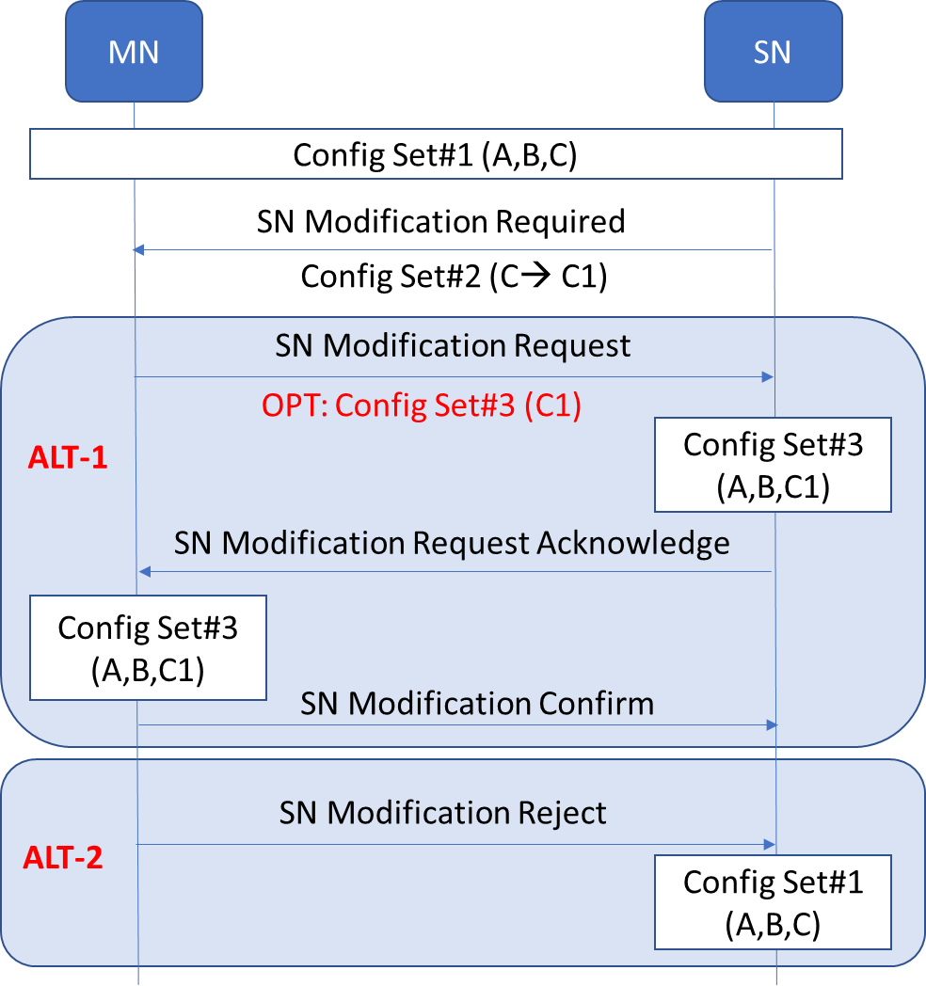

**Figure 4-1: Illustrating the discussions with the message sequence**

Scenario: MN initiated SN modification in an ongoing SN initiated SN modification procedure. In this scenario the MN needs to send SN Modification Request for other purpose (e.g. transfer new gap config).

*Example*: A part of configurations in configRestrictInfo (Config set #1) in the last MN-initiated procedure is overridden by configuration in configRestrictModReq (Config set #2) in the SN-initiated procedure. Combination of Config set #1 and Config set #2 is Config set #3 (i.e. Config set #2 overrides some of Config set #1)

*Proposal 1*: For the given scenario considered along with the example, MN shall assume the **Config set #3** as the latest configuration for the SN (and not **Config set #1)**.

*Proposal 2*: The MN may (i.e. is allowed but not required to) include *configRestrictInfo* in a SgNB Modification Request procedure during an ongoing SN triggered Modification procedure.

*Proposal 3*: In the given scenario, the MN shall echo the same values in *configRestrictInfo* given by **Config set #3***.*

*Proposal 4*: If the given scenario, the receipt of SN Modification Request without the *configRestrictInfo* implies the SN also assumes **Config set #3** as the latest configuration for the SN.

*Proposal 5*: In the given scenario, if the MN sends the SN Modification Reject the SN considers **Config set #1** as the latest configuration for the SN.

**Question 1**: Do companies agree with the proposals in [R2-2102768](http://www.3gpp.org/ftp/tsg_ran/WG2_RL2/TSGR2_113bis-e/Docs/R2-2102768.zip)?

|  |  |  |
| --- | --- | --- |
| Company | Proposal x:  Agree (y/n) | Comments |
|  |  |  |
|  |  |  |
|  |  |  |

### 3.1.2 Further clarify MN and SN configuration restrictions

[R2-2103027](http://www.3gpp.org/ftp/tsg_ran/WG2_RL2/TSGR2_113bis-e/Docs/R2-2103027.zip) Further clarify MN and SN configuration restrictions ZTE Corporation, Sanechips discussion Rel-15 NR_newRAT-Core

[R2-2103028](http://www.3gpp.org/ftp/tsg_ran/WG2_RL2/TSGR2_113bis-e/Docs/R2-2103028.zip) CR on MN and SN configuration restriction coordination ZTE Corporation, Sanechips CR Rel-15 37.340 15.12.0 0255 - F NR_newRAT-Core

[R2-2103029](http://www.3gpp.org/ftp/tsg_ran/WG2_RL2/TSGR2_113bis-e/Docs/R2-2103029.zip) CR on MN and SN configuration restriction coordination ZTE Corporation, Sanechips CR Rel-16 37.340 16.5.0 0256 - F NR_newRAT-Core

One remaining issue is whether MN can include “ConfigRestrictInfo”, if MN sends SN Modification Request in response to SN Modification Required message. See below figure:



*Proposal 1*: In case SN triggers configuration negotiation (by sending ConfigRestrictModReqSCG in SN-initiated procedure), MN should:

* Refuse the SN-initiated modification procedure if MN cannot accept the requested value;
* Confirm the SN-initiated modification procedure, and MN is expected to include ConfigRestrictInfo (e.g. with update value) if MN sends SN Modification Request including CG-ConfigInfo (this does not mean MN must trigger SN Modification Request in response to SN Modification Required message).

**Question 2**: Do you agree with the proposal in [R2-2103027](http://www.3gpp.org/ftp/tsg_ran/WG2_RL2/TSGR2_113bis-e/Docs/R2-2103027.zip)?

|  |  |  |
| --- | --- | --- |
| Company | Proposal x:  Agree (y/n) | Comments |
|  |  |  |
|  |  |  |
|  |  |  |

**Question 3**: If the answer to Q2 is yes, do you agree to introduce the changes in stage 2 as proposed in the CRs [R2-2103028](http://www.3gpp.org/ftp/tsg_ran/WG2_RL2/TSGR2_113bis-e/Docs/R2-2103028.zip) and [R2-2103029](http://www.3gpp.org/ftp/tsg_ran/WG2_RL2/TSGR2_113bis-e/Docs/R2-2103029.zip)?

|  |  |  |
| --- | --- | --- |
| Company | Agree (y/n) | Comments |
|  |  |  |
|  |  |  |
|  |  |  |

## 3.2 Clarification on sCellFrequencies

[R2-2102769](http://www.3gpp.org/ftp/tsg_ran/WG2_RL2/TSGR2_113bis-e/Docs/R2-2102769.zip) Clarification on sCellFrequencies Nokia, Nokia Shanghai Bell discussion Rel-15

Observation 1: It seems that if only the PSCell remains, the *scellFrequenciesSN-NR* shall be signalled as empty but there is no way to current signal it.

Observation 2: If the *scellFrequenciesSN-NR* is omitted (ASN.1 optional field) the procedural text in 11.2.3 will be broken as delta signalling applies for this field and MN will wrongly assume that the SN still has the SCell(s).

Observation 3: Same problem exists also for NE-DC, i.e. for the field *scellFrequenciesSN-EUTRA.*

|  |  |  |  |  |
| --- | --- | --- | --- | --- |
| **Solution option** | **MN impact** | **SN impact** | **ASN.1 NBC** | **Impact** |
| **Solution 1** | YES | YES | Partly | Medium (affects other scenarios but simpler?) |
| **Solution 2** | YES | YES | Strictly | Low |
| **Solution 3** | YES | NO | No | Lowest |
| **Solution 4** | YES | YES | Strictly | High  (affects other scenarios?) |
| **Solution 5** | YES | YES | No | Medium (take new fields into account) |

Table 1: List of all potential solutions with impact analysis

The solutions proposed are described as follows:

*Solution 1*: Add a field (starting Rel-15) indicating that all the SCells are released (one field for NE-DC and other for rest of the MR-DC options).

*Solution 2*: Change the cardinality of the fields to start from 0 rather than 1 (in this case ASN.1 encoding will not change)

*Solution 3*: Use some other field (e.g. *fr-InfoListSCG)* and maybe clarify in the field description that this could be used instead.

*Solution 4*: Remove the fields *scellFrequenciesSN-NR* and *scellFrequenciesSN-EUTRA* from delta configuration.

*Solution 5*: Dummify *scellFrequenciesSN-NR* and *scellFrequenciesSN-EUTRA* and add the fields with the correct cardinality i.e. starting from 0.

**Question 4**: According to the analysis provided in [R2-2102769](http://www.3gpp.org/ftp/tsg_ran/WG2_RL2/TSGR2_113bis-e/Docs/R2-2102769.zip), do companies acknowledge the issue regarding the SCell frequencies fields?

|  |  |  |
| --- | --- | --- |
| Company | Agree (y/n) | Comments |
|  |  |  |
|  |  |  |
|  |  |  |

**Question 5**: If the answer to Q4 is yes, which solution to you prefer to pursue in order to solve the issue regarding the SCell frequencies fields?

|  |  |  |
| --- | --- | --- |
| Company | Solution | Comments |
|  |  |  |
|  |  |  |
|  |  |  |

## 3.3 Clarification on full and delta configuration signalling for inter-MN handover without SN change

[R2-2103228](http://www.3gpp.org/ftp/tsg_ran/WG2_RL2/TSGR2_113bis-e/Docs/R2-2103228.zip) Clarification on full and delta configuration signalling for inter-MN handover without SN change Nokia, Nokia Shanghai Bell discussion Rel-15 NR_newRAT-Core

*Observation 1*: The presence or absence of IE *sourceConfigSCG* and *scg-RB-Config* can be used by target MN to indicate full configuration or delta configuration in target SN in the case of inter-MN Handover with SN change, but not applicable in the case of inter-MN Handover without SN change.

*Proposal 1*: RAN2 to clarify full/delta configuration indicator(s) in *SgNB Addition Request* in the scenario of inter-MN handover without SN change, with below two candidate options.

* ***Option 1:*** *SN UE X2AP ID as full or delta configuration flag*
* Inter-MN HO without SN change (delta config is allowed in SN)
  + SN UE X2AP ID present
  + *sourceConfigSCG* not present
  + *scg-RB-Config* not present
* Inter-MN HO without SN change (SN must apply full config)
  + SN UE X2AP ID not present
  + *sourceConfigSCG* not present
  + *scg-RB-Config* not present

* ***Option 2:*** *IE sourceConfigSCG and scg-RB-Config as full or delta configuration flag*
* Inter-MN HO without SN change (delta config is allowed in SN)
  + SN UE X2AP ID present
  + *sourceConfigSCG* present
  + *scg-RB-Config* present
* Inter-MN HO without SN change (SN must apply full config)
  + SN UE X2AP ID present
  + *sourceConfigSCG* not present
  + *scg-RB-Config* not present

*Proposal 2*: If Option1 is agreed, RAN2 to discuss the update of stage2 description. If Option2 is agreed, RAN2 to discuss the field description update of IE *sourceConfigSCG* and *scg-RB-Config.*

**Question 6**: According to the analysis provided in [R2-2103228](http://www.3gpp.org/ftp/tsg_ran/WG2_RL2/TSGR2_113bis-e/Docs/R2-2103228.zip), do companies acknowledge the issue regarding on how to indicate full configuration or delta configuration in target SN in the case of inter-MN Handover without SN change?

|  |  |  |
| --- | --- | --- |
| Company | Proposal x:  Agree (y/n) | Comments |
|  |  |  |
|  |  |  |
|  |  |  |

**Question 7**: If the answer to Q6 is yes, which option to you prefer to pursue in order to solve the issue on how to indicate full configuration or delta configuration in target SN in the case of inter-MN Handover without SN change?

|  |  |  |
| --- | --- | --- |
| Company | Option | Comments |
|  |  |  |
|  |  |  |
|  |  |  |

## 3.4 Clean-up of INM procedure text

[R2-2103641](http://www.3gpp.org/ftp/tsg_ran/WG2_RL2/TSGR2_113bis-e/Docs/R2-2103641.zip) Clean-up of INM procedure text Ericsson CR Rel-15 38.331 15.13.0 2515 - F NR_newRAT-Core

[R2-2103642](http://www.3gpp.org/ftp/tsg_ran/WG2_RL2/TSGR2_113bis-e/Docs/R2-2103642.zip) Clean-up of INM procedure text Ericsson CR Rel-16 38.331 16.4.1 2516 - A NR_newRAT-Core, TEI16

*Reason for change:*

1. Existing text on fields in CG-Config and CG-ConfigInfo is organized in three parts

* Fields that convey the UE configuration
* Fields that are always included
* Fields that use a delta signalling variant

But the text is not well organized and well-structured

1. The text that covers fields in CG-Config and CG-Configinfo that conveys the UE configuration is incomplete, i.e. CG-Config and CG-ConfigInfo are described differently.
2. The list of fields that are subject to the delta signalling variant contains fields sent by both MN and SN, but existing text inticates that the list covers only fields sent by the MN.
3. Text on that the fields newUE-Identity and t304 included in ReconfigurationWithSync are not used for delta configuration purpose need to be more clear.

**Question 8**: Do company agree with the changes proposed in CRs [R2-2103641](http://www.3gpp.org/ftp/tsg_ran/WG2_RL2/TSGR2_113bis-e/Docs/R2-2103641.zip) and [R2-2103642](http://www.3gpp.org/ftp/tsg_ran/WG2_RL2/TSGR2_113bis-e/Docs/R2-2103642.zip)?

|  |  |  |
| --- | --- | --- |
| Company | Agree (y/n) | Comments |
|  |  |  |
|  |  |  |
|  |  |  |

## 3.5 Clarification of mcg-RB-config field description

[R2-2103801](http://www.3gpp.org/ftp/tsg_ran/WG2_RL2/TSGR2_113bis-e/Docs/R2-2103801.zip) Clarification of mcg-RB-config field description Ericsson CR Rel-15 38.331 15.13.0 2532 - F NR_newRAT-Core

[R2-2103802](http://www.3gpp.org/ftp/tsg_ran/WG2_RL2/TSGR2_113bis-e/Docs/R2-2103802.zip) Clarification of mcg-RB-config field description Ericsson CR Rel-16 38.331 16.4.1 2533 - A NR_newRAT-Core

*Reason for change:*

During MCG full configuration, MN can use release and add of the SN to ensure the SN provides the full SCG configuration. This was confirmed with RAN3 with LS ([R2-1912033](http://www.3gpp.org/ftp/tsg_ran/WG2_RL2/TSGR2_107bis/Docs/%0dR2-1912033.zip)):

*“RAN3 has discussed the scenarios when MN determines to configure the UE with fullConfig IE, SN may not be aware and can only provide delta configuration to the UE. One solution proposed in RAN3 is by indicating over X2 and Xn signalling so that the SN is able to know full configuration is required for SN modification. RAN3 would ask RAN2 to help confirm such scenarios and whether it is possible to include in an inter-node message once confirmed.”*

RAN2 responded in LS ([R2-1914228](http://www.3gpp.org/ftp/tsg_ran/WG2_RL2/TSGR2_107bis/Docs/%0dR2-1914228.zip)):

*“RAN2 would like to thank RAN3 for their LS. RAN2 discussed cases where full configuration of the SN is required and it was observed that the MN can use the release and add procedure in such cases. RAN2 do not see any need to change RAN2 specifications and it is up to RAN3 whether and how to trigger the release and add procedure.”*

Thus it was agreed no explicit indicator in INM from MN to SN is needed. Still, there is a need to clarify in the field description of mcg-RB-config, that it is also absent in case MN uses full configuration, i.e. same as is currently mentioned already for scg-RB-config. This since also for SN addition, MN may or may not provide mcg-RB-config, and thus SN may not be aware whether MN uses full config or not. So in effect it means that if mcg-RB-config is absent, SN must provide the full configuration of SN terminated DRBs.

At the same time, the field description of scg-RB-config is updated to cover also other MR-DC options than (NG)EN-DC, by changing “master eNB” to “MN”.

**Question 9**: Do company agree with the changes proposed in CRs [R2-2103801](http://www.3gpp.org/ftp/tsg_ran/WG2_RL2/TSGR2_113bis-e/Docs/R2-2103801.zip) and [R2-2103802](http://www.3gpp.org/ftp/tsg_ran/WG2_RL2/TSGR2_113bis-e/Docs/R2-2103802.zip)?

|  |  |  |
| --- | --- | --- |
| Company | Agree (y/n) | Comments |
|  |  |  |
|  |  |  |
|  |  |  |

# Conclusion

Based on the discussion in the previous sections we propose the following:

# References