3GPP TSG-RAN WG2 Meeting #112-e R2-200xxxx
Online, November 2 - 13, 2020

Agenda Item: 5.3.3
Source: Apple
Title: Report of [AT112-e][004][NR15] PDCP (Apple)
Document for: Discussion and Decision

1 Introduction
This is to report the result of the following email discussion in RAN2#112-e Meeting [1].
- [AT112-e][004][NR15] PDCP (Apple)
Treat R2-2009481, R2-2010559. R2-2010560, R2-2010667, R2-2010668
Intended outcome: Intermediate: Determine agreeable parts. Final: For agreeable parts, agreed CRs.
Deadline: Intermediate deadline(s) by Rapporteur, Final: Discussion stop at Wed Nov 11, 1200 UTC

2 Contact Information
Company | Contact: Name (E-mail)
Apple | Fangli XU (fangli_xu@apple.com)
MediaTek | Ming-Yuan Cheng (ming-yuan.cheng@mediatek.com)
OPPO | Qianxi Lu (qianxi.lu@oppo.com)
Samsung | Donggun Kim (s_dg.kim@samsung.com)
Nokia | Benoist Sébire (benoist.sebire@nokia.com)
LG | SeungJune Yi (seungjune.yi@lge.com)
Ericsson | Henrik Enbuske (henrik.enbuske@ericsson.com)
CATT | Hao Xu(xuhao@catt.cn)
DOCOMO | Kouhei Harada (kouhei.harada.hf@nttdocomo.com)
Qualcomm | Mouaffac Ambriss (mambriss@qti.qualcomm.com)  Ruiming Zheng (rzheng@qti.qualcomm.com)
Huawei | Rui Wang (wangrui46@huawei.com)
ZTE | Dong Fei (dong.fei@zte,com.cn)
Intel | Yujian Zhang (yujian.zhang@intel.com)

3 Discussion

3.1 NW configuration on PDCP recovery
R2-2009481 NW configuration on PDCP recovery Apple discussion Rel-15 NR_newRAT-Core

According to R2-2009481, the problematic scenario and NW implementation for the clarification is:
For the uplink split DRB, network may select the primary leg based on the radio quality in uplink direction, and decides to keep or delete the SCG link based on the radio link quality in downlink direction.
Based on such network implementation, the following procedure in Figure-1 may happen:
- NW configures the UE in MR-DC and uplink split DRB with primary path = SCG leg;
- NW detects the UE’s SCG uplink is in poor radio quality, and keeps the SCG link but triggers the primary path switch of the split DRB from SCG to MCG via the normal RRCReconfiguration;
Upon the primary leg switching, UE will transmit the new PDCP PDUs to NW via the new primary path (MCG). But for the PDCP PDUs (e.g. the PDCP PDU with SN=3) which have been transmitted via the SCG link but not acknowledged, the RLC retransmission continues on the SCG link.
- Upon the RLC retransmission number reaching the max number, UE detects the RLC failure and trigger the SCG failure recovery, and NW may trigger the RRCReconfiguration to delete the SCG and reconfigure the split DRB to MCG DRB.
Upon the bearer type change, UE will trigger the PDCP recovery procedure, and retransmit the PDCP PDU which did not transmit successfully via the SCG link (e.g. the PDCP PDU with the SN=3) to the NW via the MCG.
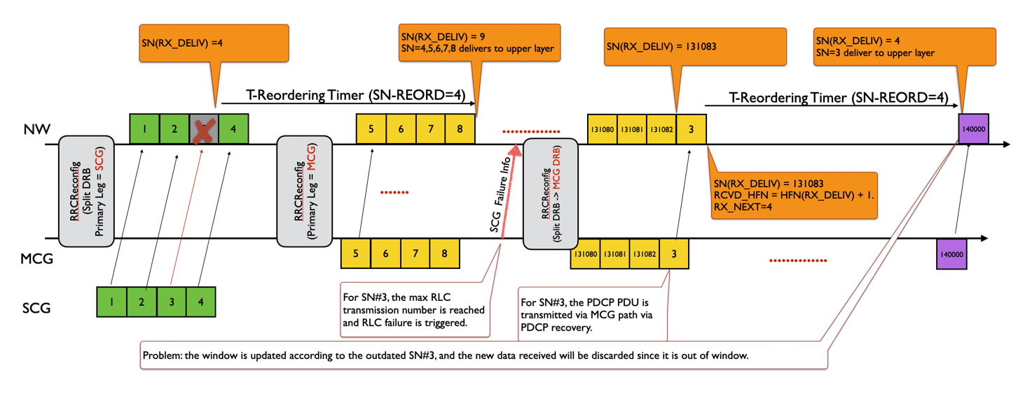
Figure-1. The problem triggered by the late PDCP recovery
As described in Figure-1, since the SCG failure recovery is triggered long time later after the primary leg switching (it’s dependent on the configured RLC retransmission number), there may be huge numbers of PDCP PDUs delivered to NW via MCG link successfully during this period, and the late PDCP recovery may trigger the outdated PDCP PDU (e.g. SN=3) to NW and lead to the mess in the NW PDCP receiving side, and UE throughout decrease.
Observation 1: The late PDCP recovery triggered by the RRCReconfiguration for bearer type change as shown in Figure-1 leads to mess in NW PDCP receiving side.
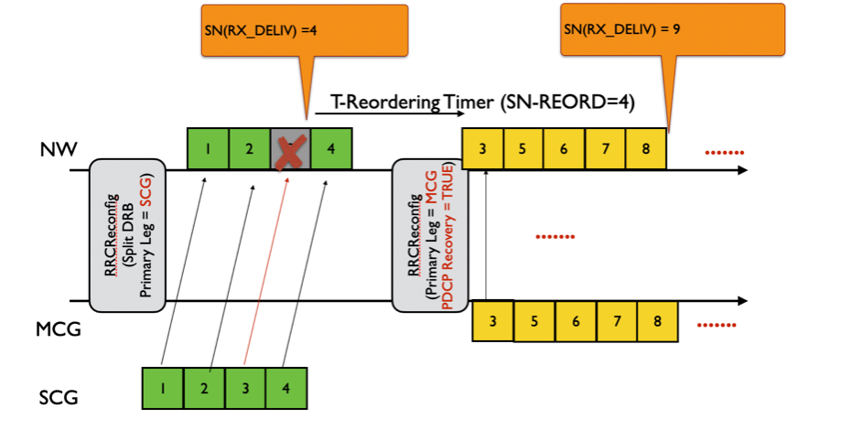
Figure-2. PDCP recovery triggered upon the primary path switching
If the PDCP recovery can be triggered upon the primary leg switching or NW can explicitly indicate UE to perform the PDCP recovery via the normal reconfiguration for any case, the unacknowledged PDCP PDUs can be transmitted to NW earlier and such problem can be avoided as showed in Figure-2.
Observation 2: If PDCP recovery is triggered when NW reconfigures the primary path, the problem indicated in Figure-1 can be avoided.

Q1: Do you agree the observation 1 and 2 ( i.e. the PDCP recovery upon the primary path swiching can resolve the problem of the UE throughput decrease) ?
Company | Yes/No | Comments
MediaTek | Yes
OPPO | Yes
Samsung | No | If the network detects the radio link problem for SCG link, then it would be better to indicate bearer type change from split DRB to MCG DRB instead of path switching. It would be up to network implementation.  Note that the concerned path switching will work not only based on the primary path but also based on the threshold. Even if the network configure the primary path with MCG, UE can transmit UL data via SCG with large volume of data greater than the threshold.  Also, note that PDCP data recovery is just PDCP-level retransmission, which have no impact on the SCG RLC entity. In the same situation, even if the network triggers a PDCP data recovery upon the primary path switching, UE will end up detecting the RLC failure as mention above, “Upon the RLC retransmission number reaching the max number, UE detects the RLC failure and trigger the SCG failure recovery, and NW may trigger the RRCReconfiguration to delete the SCG and reconfigure the split DRB to MCG DRB.” And the network may trigger a PDCP data recovery again since some UL data might be transmitted via SCG link. It seems not a smart network implementation.  In this reason, we don’t have sympathy with the scenario.
Nokia | Yes
LG | No | It is bad implementation that the PDCP transmitter transmits PDCP SDUs more than half of the PDCP SN space. If that happens, HFN de-synchronization problem occurs. Thus, the PDCP specification already provides guideline in the NOTE shown below.  NOTE 1: Associating more than half of the PDCP SN space of contiguous PDCP SDUs with PDCP SNs, when e.g., the PDCP SDUs are discarded or transmitted without acknowledgement, may cause HFN desynchronization problem. How to prevent HFN desynchronization problem is left up to UE implementation.
Apple | Yes | We found the problem in the field which brought negative impact on the UE throughout.  @Samsung, we agree that using the bearer type change instead of primary path switching can avoid the problem, but can we request NW to disable the primary path switching implementation? If the different NW implementation is allowed, we should try to address this issue.  @LG, I understand that the NOTE1 is the guidance for the new data tansmission, not for the retransmission. In this case, if UE doesnot allocate the SN for new data transmission due to the old data transmission via the old SCG link, UE throughput will also be decreased even though NW provides the scheduling.
Ericsson | Yes | The observations are correct, but that does not mean the network cannot do anything about it with the current release.
CATT | Yes
DOCOMO | Yes | We have some sympathy for the concern. But our understanding is that the RLC retransmission excess (i.e., upon the RLC retransmission number reaching the max number) occurs mainly when RLC state mismatch happens. If the RLC retransmission excess occurs due to bad condition of SCG link, the NW can perform bearer type change without waiting for RLC retransmission excess.
Qualcomm | Yes | We observe the issue. The network implementation may be different then the issue still may be happened.
Huawei | Yes | We see the situation may occur.
ZTE | Yes | This can happen
Intel | Yes

The understanding on the current RRC spec is:
According to current RRC spec description as below, there is no restriction to configure recoverPDCP = TRUE which triggers UE to perform the PDCP recovery. Therefore, current RRC spec can support NW to trigger the PDCP recovery any time.
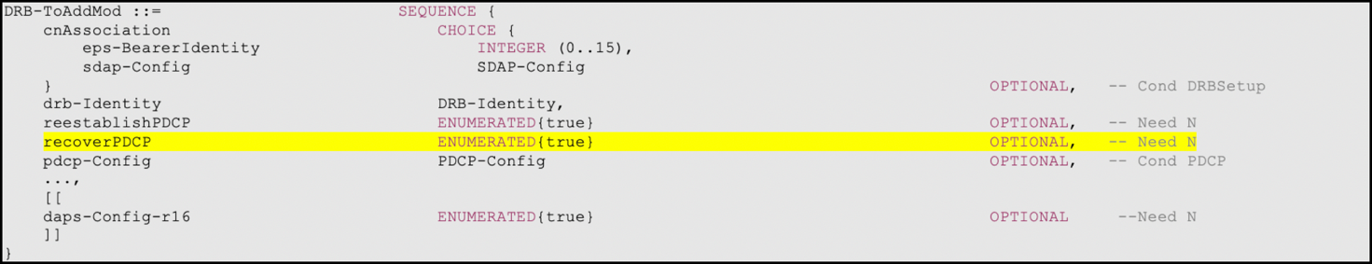
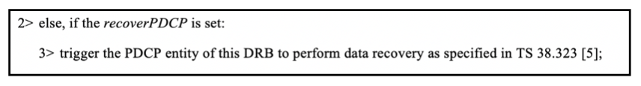
Observation 3: There is no ASN.1 impact if NW is allowed to trigger the PDCP recovery via normal reconfiguration which is for the primary path switching mode.

Q2: Do you agree the observation 3 ( i.e. NW can indicate UE to perform the PDCP recovery when reconfiguring the primary path) ?
Company | Yes/No | Comments
MediaTek | Yes
OPPO | Yes
Samsung | Yes
Nokia | Yes
LG | Yes
Apple | Yes
Ericsson | Yes
CATT | Yes
DOCOMO | Yes
Qualcomm | Yes
Huawei | Yes | From RRC specification perspective, there is no restriction on the use case of the PDCP recovery indication.
ZTE | Yes
Intel | Yes

And the corresponding spec clarification is:
Proposal: NW can explicitly configure UE to perform the PDCP recovery procedure via the normal RRCReconfiguration, not restricted by the following three cases:
- Handover without security change;
- bearer type change;
- reconfiguration after re-establishment.

Q3: Do you agree the proposal and the clarification ?
Company | Yes/No | Comments
MediaTek | Yes, but | Based on current spec, there is no such limitation at all.
OPPO | Same view as MTK
Samsung | Yes, but | In NR, we think that the general principle is not to list such use cases unless there is a critical reason.
Nokia | Yes | In our understanding, there is no such restriction in place and the network should already be able of triggering a recovery procedure whenever it wishes.
LG | Yes, but | Specification change is not needed.
Apple | Yes | To avoid the different understandings, we prefer to capture it somewhere, in spec or in chairman notes.
Ericsson | Yes | There is no such limitation in signaling so the network can handle this already. We think the specifications capture the UE behavior quite clearly.
CATT | Yes
DOCOMO |  | Agree with LG
Qualcomm | Yes | We agree the problem and spirit of the solution.
Huawei | Yes | Agree with the comments from others, there is no limitation in RAN2 specifications.
ZTE | Yes
Intel | Yes

Q4: Do you agree to capture the clarification in the spec ?
Company | Yes/No | Comments
MediaTek | No | Clarification is OK, but seems no need to capture related change.
OPPO | No | Same view as MTK
Samsung | No
Nokia | No | As said above, we do not think the specification currently restricts the ehavior and it would be good to firt understand why this is being brought up. After all, observation 3 indicates there is no ASN.1 impact and the CR does not remove anything from the current specification.
LG | No | Specification change is not needed.
Apple | Yes | If not captured in spec, we prefer to capture in chariman notes.
Ericsson | No | There is no need for a clarification as the network can be implemented to avoid the problem.
CATT | See comment | Not in 38.331. We prefer to capture the proposal in stage 2 specification.
DOCOMO | No | If the current specification has such limitation, we think this is not correction but optimization, and if to resolve this problem is needed, other option can also be considered.
Qualcomm | Yes | It is helpful to capture the clarification to use PDCP recovery in this scenario in the spec or a note.
Huawei | No | We do not see the need to clarify RRC specification.
ZTE | No | Clarification can be confirmed in the minutes, not in RRC spec
Intel | Yes | Although there is no explicit restriction in current specifications, Table A-2 (L2 handling) in TS 37.340 lists the use cases when PDCP recovery procedure is used. There might be misunderstanding that PDCP recovery can be only used in those cases. To avoid any inter-operability problem, it is good to capture the clarification in the specification.

The corresponding text proposal is:

Q5: Do you agree the text proposal ?
Company | Yes/No | Comments
MediaTek | No | Same as Q3 and Q4
OPPO | No
Samsung | No
Nokia | No | Since we think the specification is already clear, if there is a disagreement, confirming the intended ehavior in the meeting minutes should be enough.
LG | No | Specification change is not needed.
Apple | Yes | If not captured in spec, we prefer to capture in chariman notes.
Ericsson | No
CATT | No | We prefer stage 2 CR.
DOCOMO | No
Qualcomm | No | It is probably better to capture the scenario explicitly.
Huawei | No | Same as Q3 and Q4.
ZTE | No
Intel | Yes with changes | We prefer a different wording “The network may configure recoverPDCP at any time independent of other procedures”.

Conclusion:
TBD

3.2 PDCP status report
R2-2010559 PDCP status report Qualcomm Incorporated CR Rel-15 38.323 15.7.0 0058 - F NR_newRAT-Core
R2-2010560 PDCP status report Qualcomm Incorporated CR Rel-16 38.323 16.2.0 0059 - A NR_newRAT-Core

According to R2-2010559 and R2-2010560, the reason for the change is:
Receiving PDCP entity triggers PDCP status report when upper layer requests PDCP re-establishment/recovery. RRC Connection Resume is one of the reasons for PDCP re-establishment. For suspended PDCP entities, RX_NEXT, RX_DELIV are set to initial values. Hence the resulting PDCP status report serves no purpose.
When upper layers request a PDCP entity suspend, the receiving PDCP entity shall:
- if t-Reordering is running:
- stop and reset t-Reordering;
- deliver all stored PDCP SDUs to the upper layers in ascending order of associated COUNT values after performing header decompression;
- set RX_NEXT and RX_DELIV to the initial value.

And corresponding spec change is:

5.4.1 Transmit operation
For AM DRBs configured by upper layers to send a PDCP status report in the uplink (statusReportRequired in TS 38.331 [3]), the receiving PDCP entity shall trigger a PDCP status report when:
- upper layer requests a PDCP entity re-establishment;
- upper layer requests a PDCP data recovery.
If a PDCP status report is triggered, the receiving PDCP entity shall:
- compile a PDCP status report as indicated below by:
- setting the FMC field to RX_DELIV;
- if RX_DELIV < RX_NEXT:
- allocating a Bitmap field of length in bits equal to the number of COUNTs from and not including the first missing PDCP SDU up to and including the last out-of-sequence PDCP SDUs, rounded up to the next multiple of 8, or up to and including a PDCP SDU for which the resulting PDCP Control PDU size is equal to 9000 bytes, whichever comes first;
- setting in the bitmap field as ‘0’ for all PDCP SDUs that have not been received, and optionally PDCP SDUs for which decompression have failed;
- setting in the bitmap field as ‘1’ for all PDCP SDUs that have been received;
- submit the PDCP status report to lower layers as the first PDCP PDU for transmission via the transmitting PDCP entity as specified in clause 5.2.1.
Note: If the PDCP re-establishment is triggered due to the PDCP entity being resumed after PDCP entity suspend, the receiving PDCP entity may omit the PDCP status report.

Q6: Do you agree the intention and the spec change in Rel-15/Rel-16 CR R2-2010559 and R2-2010560?
Company | Yes/No | Comments
MediaTek | Yes
OPPO | Yes | With a NOTE and the word “may”, we assume it is backwards compatible.
Samsung | No | In RAN2#105, RAN2 already had the same discussion and concluded not to pursue this optimization as shown below. In this late stage, we don’t see the need of change since no critical issue would be foreseen.  R2-1901240 Correction on the PDCP SR Huawei, HiSilicon CR Rel-15 38.323 15.4.0 0026 - F NR_newRAT-Core  - Nokia think the network would not consider such PDCP SR.  - Samsung think this is an optimization and not needed. Ericsson agrees.  - R2 assumes that additional SR at RRC resume is not a problem for the network.  - Not pursued
Nokia | No | Why would the network request a status report that serves no purpose?
LG | No | There is no critical issue even if PDCP status report is transmitted in such case. Thus, we don’t want to change the legacy UE behavior.  However, we are open to discuss this issue in Rel-17.
Apple | No | We agree the status report is not necessary, but can live with it.
Ericsson | No | We don’t think this optimization is necessary.
CATT | No | We agree with the proposed intention, but think this is not one key issue and can be left to the implementation.
DOCOMO | Slightly No | We think this is not correction but optimization. But we can follow majority view.
Qualcomm | Yes | Proponent  As you can see it’s a note that doesn’t introduce any interoperability issue, in addition it’s left to the UE implementation, so we don’t understand why there are some companies opposing it.  Please reconsider your decision as it seems some companies are opposing just to oppose
Huawei | No | Even if it is a note, there is still a change on UE behaviour, then we think it would be too late for the optimization.
ZTE | No | The same view with NOKIA
Intel | Yes | We think it is a useful enhancement. Although gNB can configure/de-configure statusReportRequired, additional RRC signaling is required to just disable PDCP status report for RRC resume case.

Conclusion:
TBD

3.3 Corrections on PDCP functionalities
R2-2010667 Corrections on PDCP functionalities Huawei, HiSilicon CR Rel-15 38.323 15.7.0 0060 - F NR_newRAT-Core
R2-2010668 Corrections on PDCP functionalities Huawei, HiSilicon CR Rel-16 38.323 16.2.0 0061 - A NR_newRAT-Core

According to R2-2010667 and R2-2010668, the reason for the change is:
In the PDCP function list in 4.4, the function of PDCP status reporting is missing:

4.4 Functions
The PDCP layer supports the following functions:
- transfer of data (user plane or control plane);
- maintenance of PDCP SNs;
- header compression and decompression using the ROHC protocol;
- ciphering and deciphering;
- integrity protection and integrity verification;
- timer based SDU discard;
- for split bearers, routing;
- duplication;
- reordering and in-order delivery;
- out-of-order delivery;
- duplicate discarding.

And corresponding spec change is:

4.4 Functions
The PDCP layer supports the following functions:
- transfer of data (user plane or control plane);
- maintenance of PDCP SNs;
- header compression and decompression using the ROHC protocol;
- ciphering and deciphering;
- integrity protection and integrity verification;
- timer based SDU discard;
- for split bearers, routing;
- duplication;
- reordering and in-order delivery;
- out-of-order delivery;
- duplicate discarding.
- status reporting.

Q7: Do you agree the intention and the spec change in Rel-15/Rel-16 CR R2-2010667 and R2-2010668?
Company | Yes/No | Comments
MediaTek | Yes
OPPO | Yes
Samsung | No | If we have this CR, then we may need to handle similar CRs for LTE PDCP, LTE RLC, NR PDCP, and NR RLC specifications in the future. We cannot capture all the detailed functionalities and thus don’t support this CR.
Nokia | No | Hard to justify as a separate CR.
LG | No | It is enough to list only major functions.
Apple | No | We share Samsung’s view.
Ericsson | No | We consider "status reporting" to be part of "maintenance of PDCP SNs."
CATT | No | Not sure “status reporting” is a “function”. Note RLC status reporting is not a “function” in 38.322.
DOCOMO | No | Agree with Samsung.
Qualcomm | No
Huawei | Yes (proponent) | We see “status reporting” worth being listed as a PDCP function.
ZTE | No | Agree with Samsung
Intel | Yes

Conclusion:
TBD

4 Conclusion
TBD

5 References
[1] RAN2 112-e Chairman Notes 2020-11-02 0800 UTC.docx

