3GPP TSG-RAN WG2 Meeting #111 electronic R2-200XXXX
Online, August 17 – 28, 2020
Agenda item: 6.5.3
Source: Samsung
Title: Report of Offline 033: IIOT MAC Corrections II
Document for: Discussion & Decision

Introduction
This document provides a summary report of the following offline discussion:
- [AT111-e][033][IIOT] MAC Corrections II (Samsung)
Scope: HARQ PID for SPS: Treat R2-2006712/7527 (related to RRC discussion), and R2-2007136. UE autonoumous retransmission: Treat R2-2007147, 7530, 6863, 7389, 8055
Determine agreeable parts in a first phase, Agree CRs in a second phase
Deadline: Aug 27 0900 UTC, Intermediate deadlines by Rapporteur if needed.
This discussion covers the following tdocs:

HARQ PID for SPS
R2-2006712 Correction on the calculation of HARQ Process ID for SPS Huawei, HiSilicon CR Rel-16 38.321 16.1.0 0774 - F NR_IIOT-Core
R2-2007527 CR on 38.321 for SPS resources and HARQ process ID calculation ZTE Corporation, Sanechips CR Rel-16 38.321 16.1.0 0828 - F NR_IIOT-Core
R2-2007136 Clarification on HARQ process ID determination for SPS OPPO, Samsung CR Rel-16 38.321 16.1.0 0804 - F NR_newRAT-Core, NR_IIOT-Core

UE autonomous retransmissions
R2-2007147 UE autonomous retransmission considering the processing time vivo,Samsung, Lenovo CR Rel-16 38.321 16.1.0 0805 - F NR_IIOT-Core
R2-2007530 Considieration on the lack of time to process the autonomous transmission ZTE Corporation, Sanechips discussion Rel-16 NR_IIOT-Core

RACH collisions
R2-2006863 CR to PUSCH duration comparision with MSGA transmission Fujitsu CR Rel-16 38.321 16.1.0 0791 - F NR_IIOT-Core
R2-2007389 Correction on resource overlapping with grants addressed to T-C-RNTI Huawei, HiSilicon CR Rel-16 38.321 16.1.0 0821 - F NR_IIOT-Core

Other
R2-2008055 Miscellaneous corrections for IIOT MAC Samsung CR Rel-16 38.321 16.1.0 0876 - F NR_IIOT-Core

Phase-1 Discussion

2.1 Issues covered by other discussions (No Phase-1 discussion here)

2.1.1 Note on HARQ Process ID Determination for SPS
R2-2007136 Clarification on HARQ process ID determination for SPS OPPO, Samsung CR Rel-16 38.321 16.1.0 0804 - F NR_newRAT-Core, NR_IIOT-Core
This contribution discusses the same issue with R2-2007135, submitted to Rel-15 UP correction:
R2-2007135 Clarification on HARQ process ID determination for SPS OPPO, Samsung CR Rel-15 38.321 15.9.0 0803 - F NR_newRAT-Core
Note 1. R2-2007136 will be discussed after [AT111-e][002][NR15] NR MAC corrections (Samsung) is concluded.

2.1.2 Clarification on Uplink Grant Addressed to Temporary C-RNTI
R2-2007389 Correction on resource overlapping with grants addressed to T-C-RNTI Huawei, HiSilicon CR Rel-16 38.321 16.1.0 0821 - F NR_IIOT-Core
This contribution discusses the same issue with R2-2007861, submitted to Rel-15 UP correction:
R2-2007861 Clarification on collision between uplink grant for MSG3 retransmission and DG Huawei, HiSilicon CR Rel-15 38.321 15.9.0 0843 - A NR_newRAT-Core
Note 2. R2-2007389 will be discussed after [AT111-e][002][NR15] NR MAC corrections (Samsung) is concluded.

2.1.3 Unit of SPS Periodicity and Formula
R2-2006712 Correction on the calculation of HARQ Process ID for SPS Huawei, HiSilicon CR Rel-16 38.321 16.1.0 0774 - F NR_IIOT-Core
R2-2007527 CR on 38.321 for SPS resources and HARQ process ID calculation ZTE Corporation, Sanechips CR Rel-16 38.321 16.1.0 0828 - F NR_IIOT-Core
R2-2008055 Miscellaneous corrections for IIOT MAC Samsung CR Rel-16 38.321 16.1.0 0876 - F NR_IIOT-Core
An issue on SPS periodicity in three contributions above is related to RRC Correction. Those contributions will be treated in the offline discussion [AT111-e][031][IIOT] RRC Corrections (Ericsson). Depending on the RRC discussion, corresponding MAC CR will be updated.
Note 3. Issue on Unit of SPS periodicity in R2-2006712, R2-2007527, and R2-2008055 will be discussed in [AT111-e][031][IIOT] RRC Corrections (Ericsson).

2.2 Discussion

2.2.1 AutonomousTx with lack of preparation time
In RAN2#110-e meeting, RAN2 discussed how to capture an RAN2#109-e agreement “When the CG is de-prioritized, it is up to the UE implementation to determine the processing time restriction determining whether the very next CG resource with same HARQ process can be used, or the/a following one, for an autonomous transmission.” Despite the large support, it was not agreed due to lack of time. R2-2007147 (vivo, Samsung, Lenovo) proposed to add a NOTE to capture the agreement.
NOTE: It is up to the UE implementation to determine the closest available next configured grant configured with autonomousTx for the transmission of the MAC PDU of the same HARQ process of the previously de-prioritized uplink grant.
Otherwise, the UE may not have sufficient preparation time for the PUSCH transmission when the UE is required to perform the autonomous retransmission.
On the other hand, R2-2007530 (ZTE) pointed out that an uplink grant which does not have sufficient processing time cannot be a prioritized uplink grant, because a condition “for each uplink grant whose associated PUSCH can be transmitted by lower layers” prohibits prioritizing very next CG. Thus, they think further clarification is not necessary.
< Companies’ view >
1) NOTE is necessary.
2) NOTE is not necessary.
Company | 1) or 2) | Comments
Fujitsu | 1 | We can accept to capture the NOTE as RAN2 agreed in the last meeting: “A NOTE for RAN2#109-e agreement on next CG selection for autonomous retransmission will be added”.
Lenovo | 1 | Regarding R2-2007530 (ZTE), the issue is not that an uplink grant having not sufficient processing time cannot be a prioritized grant. The problem is rather that the current spec mandates the UE for triggering an autonomous Retransmission to check whether the previous configured uplink grant for this HARQ process was deprioritized. As shown in the figure, for cases when the very next uplink CG following a deprioritized CG cannot be used for transmission due to processing timing constraints, the immediately preceding uplink grant (when checking the condition for autonomous transmission at the next but one CG) may be a prioritized grant though, leading to a situation that autonomous retransmission is not allowed according to current specified behaviour.  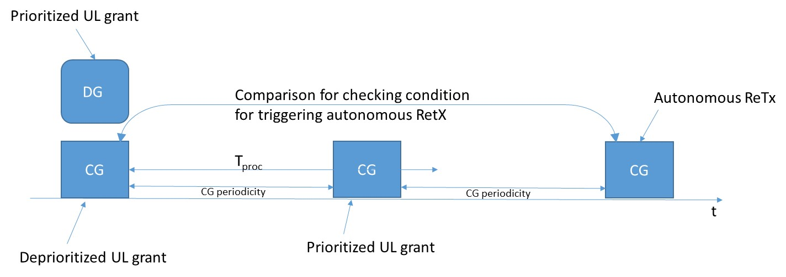
Nokia  (Wallace, Email: Ping-Heng.Kuo@nokia.com) | 1, But … | We think the note is needed, but the wording can be improved. With the current proposed text, it sounds like the UE has to choose the nearest available CG resource, but whether the word “available” means a resource beyond the processing constraint is debatable.  We suggest change the wording as following to make it simpler:  NOTE: It is up to the UE implementation to select a determine the closest available next configured grant configured with autonomousTx for the transmission of the MAC PDU of the same HARQ process of the previously de-prioritized uplink grant.
ZTE (Fei Dong;  dong.fei@zte.com.cn) | 2 | Thanks for explain from Intel. We totally understand the intention of capturing this note. And the reason why we assert that the note may have a redundant specification with the current description is what if depriotized Configured grant can not be prioritized for transmission , the transmission cannot be processed at all. I would like to correct your figure based on the current text procedure as below:  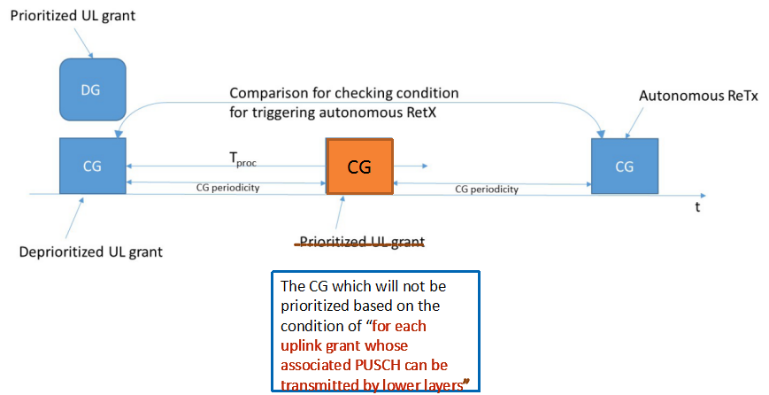  Lenovo (jlohr@lenovo.com): Just to clarify: the point is that the immediately preceding CG (orange color) is not a deprioritized grant. Therefore the condition for triggering an autonomous transmission, (which is checked at the CG following the orange one) can never be true  3> if the previous configured uplink grant, in the BWP, for this HARQ process was de-prioritized; and  Hence UE would not be allowed to trigger autonomous transmission according to current spec.  From above figure, we can see that the very near CG for autonomous transmission cannot be processed by MAC layer, it is naturally this CG cannot be transmitted by lower layer, and it won’t be indicated as “prioritized UL grant” at all. Thus that’s is our understanding the current spec have already captured the note in the text procedure.  In addition, from the note, it will give UE so much loosen behavior for determining the “very closed configured grant”. UE can assume every CG with the same HARQ process ID as the “very closed configured grant”.  From the current text procedure, it will restrict UE to use the real “closest available configured grant” in a more accurate way.  Compare between two methods, we think the current text procedure is our intention of auto-transmission with the configured grant.
Ericsson | 2 | Companies should first confirm if the latest MAC spec mandates or does not mandate UE to transmit autonomously always in the next CG occasion. In our understanding, it is not mandated.  As explained in R2-2007530, due to the following condition,  for each uplink grant whose associated PUSCH can be transmitted by lower layers,  such a grant cannot be declared as prioritized. In clause 5.4.2.1, the transmission on this grant is only initiated when it is declared as prioritized. By this reasoning, UE is not mandated to transmit autonomously always in the next CG occasion (which cannot be transmitted by lower layers).  Not sure I understand the arguments above from Lenovo. The CG in the middle of the above figure cannot be prioritized, as its PUSCH cannot be transmitted by lower layers (due to processing time constraint) and so no declaration that the grant is prioritized.  Lenovo: Please see comments made above to ZTE.  More importantly, in Ericsson’s view, a reasonable gNB does not configure a CG configuration intended for eMBB data and with a very short interval (close to T_proc,2) between the two transmissions with the same HARQ process. This basically leaves no re-transmission opportunity, not only for the data, but also for the MAC CEs that might be multiplexed on the grants. Keep in mind that network also needs time to process and send a retransmission grant if needed.
LG  (Seong Kim; sj117.kim@lge.com) | 2 | Even without the NOTE, the UE would select the closest CG.
vivo | 1 | The current specification is mandating the UE to use the immediate next CG for autonomous retransmission even though the UE is not able to use it due to the processing delay. The ZTE’s proposal does not resolve the issue in the current specification, as the immediate CG can also be considered as the prioritized grant as explained by Lenovo.
CATT  (pierrebertrand@catt.cn) | 1 | We don’t think the newly added condition "whose associated PUSCH can be transmitted by lower layers" covers the processing time discussed here since such processing time involves both MAC and PHY layers, not “lower layers” only. So interpreting such condition as covering this issue is not straightforward at all for us. Hence we would prefer capturing something explicitly.
OPPO  （fuzhe@oppo.com） | 1 | If I remembered correctly, it is already agreed in RAN2 to capture a Note.
MediaTek  (pradeep[dot]jose[at]mediatek[dot]com) | 1 | Agree with others that the newly added condition does not cover processing time, as RAN1 have not defined processing time for CG anywhere. The NOTE is needed to capture our agreements.
Huawei, Hisilicon (Zhenzhen, caozhenzhen@huawei.com) | 2 | No strong view, but it seems proponents of the NOTE also want to further polish the wording, which we think would be time consuming, not only in this meeting but also in future.  We think companies have already sufficiently aligned on the intended UE behaviour.

2.2.2 “PUSCH duration of a MSGA payload”
In the current MAC specification, “PUSCH duration of a MSGA payload” modified by 2-step RACH CR (#0714r5) and “transmission of MSGA payload” introduced by IIOT CR (#0712r3) have the same meaning but are used in different places. Since it is compared with PUSCCH resource of an SR transmission or PUSCH duration of an uplink grant, “PUSCH duration of a MSGA payload” is a correct expression to avoid a confusion. R2-2006863 (Fujitsu) and R2-2008055 (Samsung) propose to use a single consistent expression “PUSCH duration of a MSGA payload” for all cases.
In 5.4.1 (R2-2008055):
1> if the MAC entity is configured with lch-basedPrioritization, and the PUSCH duration of the configured uplink grant does not overlap with the PUSCH duration of an uplink grant received in a Random Access Response for this Serving Cell or with the PUSCH duration of a MSGA payload; or
In 5.4.4 (R2-2006863, R2-2008055):
3> if the MAC entity is configured with lch-basedPrioritization, and the PUCCH resource for the SR transmission occasion does not overlap with an uplink grant received in a Random Access Response nor with the PUSCH duration of a MSGA payload, and the PUCCH resource for the SR transmission occasion for the pending SR triggered as specfied in clause 5.4.5 overlaps with any other UL-SCH resource(s), and the priority of the logical channel that triggered SR is higher than the priority of the uplink grant(s) for any UL-SCH resource(s) where the uplink grant was not already de-prioritized, and the priority of the uplink grant is determined as specified in clause 5.4.1; or
< Companies’ view >
Company | Agree/  Not agree | Comments
Fujitsu | Agree | This was a bit discussed in [AT109bis-e][028][IIOT], and the suggestion from the rapporteur was to wait for MAC discussed in 2sRA. Now, the MAC text in 2sRA uses the terminology “PUSCH duration of a MSGA payload”, so that the current IIoT text should be corrected accordingly as proposed above.
Lenovo | Agree | Agree with Fujitsu
Nokia  (Wallace, Email: Ping-Heng.Kuo@nokia.com) |  | No strong view, the current text should be quite clear already.
ZTE |  | Agree with Nokia
Ericsson | Agree
LG  (Seong Kim; sj117.kim@lge.com) | Agree
vivo | Agree
CATT | Agree
OPPO |  | Agree with Nokia
MediaTek | Agree
Huawei, Hisilicon | Agree | No strong view. Can go with majorities.

2.2.3 Addition of “Considered as” for Cancelled Uplink Grant
When an uplink grant becomes a prioritized uplink grant or de-prioritized uplink grant, the grant is “considered” as either prioritized or de-prioritized. For cancelled uplink grant, the expression is not consistent. Thus, R2-2008055 (Samsung) proposed to add “considered as”.
If the corresponding PUSCH transmission of a configured uplink grant is cancelled by CI-RNTI, as specified in clause 11.2A of TS 38.213 [6], this uplink grant is considered as a de-prioritized uplink grant.
< Companies’ view >
Company | Agree/  Not agree | Comments
Fujitsu | Agree | It looks good to see alignment with other parts.
Lenovo | Agree
Nokia  (Wallace, Email: Ping-Heng.Kuo@nokia.com) | Agree | More consistent
ZTE | Agree
Ericsson | Agree
LG  (Seong Kim; sj117.kim@lge.com) | Agree
vivo | Agree
CATT | Agree
OPPO | Agree
MediaTek | Agree
Huawei, Hisilicon | Agree

2.2.4 Clarification of harq-ProcID-Offset2
harq-ProcID-Offset2 can be configured only for operation in licensed spectrum. However, it is not specified in MAC specification whereas it clearly mention that harq-ProcID-Offset can be configured for operation with shared spectrum channel access. It may give misunderstanding that harq-ProcID-Offset2 can be configured irrespective of spectrum. R2-2008055 (Samsung) proposed to clarify as follows:
RRC configures the following parameters when the configured grant Type 1 is configured:
- cs-RNTI: CS-RNTI for retransmission;
- periodicity: periodicity of the configured grant Type 1;
- timeDomainOffset: Offset of a resource with respect to SFN = timeReferenceSFN in time domain;
- timeDomainAllocation: Allocation of configured uplink grant in time domain which contains startSymbolAndLength (i.e. SLIV in TS 38.214 [7]) or startSymbol (i.e. S in TS 38.214 [7]);
- nrofHARQ-Processes: the number of HARQ processes for configured grant;
- harq-ProcID-Offset: offset of HARQ process for configured grant for operation with shared spectrum channel access;
- harq-ProcID-Offset2: offset of HARQ process for configured grant for operation in licensed spectrum;
- timeReferenceSFN: SFN used for determination of the offset of a resource in time domain. The UE uses the closest SFN with the indicated number preceding the reception of the configured grant configuration.
RRC configures the following parameters when the configured grant Type 2 is configured:
- cs-RNTI: CS-RNTI for activation, deactivation, and retransmission;
- periodicity: periodicity of the configured grant Type 2;
- nrofHARQ-Processes: the number of HARQ processes for configured grant;
- harq-ProcID-Offset: offset of HARQ process for configured grant for operation with shared spectrum channel access;
- harq-ProcID-Offset2: offset of HARQ process for configured grant for operation in licensed spectrum.
< Companies’ view >
Company | Agree/  Not agree | Comments
Fujitsu | Agree, but… | The text can be further improved: “for operation in licensed spectrum channel access”.
Lenovo |  | No strong opinion. However this clarification is in our view not really necessary
Nokia  (Wallace, Email: Ping-Heng.Kuo@nokia.com) | Not agree | Don’t think this is necessary. Typically we do not explicitly indicate whether a parameter is used in licensed band – by default it can be used in licensed band.
ZTE |  | No strong opinion
Ericsson | Not agree | This is covered by the RRC field description  harq-ProcID-Offset2  Indicates the offset used in deriving the HARQ process IDs, see TS 38.321 [3], clause 5.4.1. This field is not configured for operation with shared spectrum channel access.  harq-ProcID-Offset  For operation with shared spectrum channel access, this configures the range of HARQ process IDs which can be used for this configured grant where the UE can select a HARQ process ID within [harq-procID-offset, .., (harq-procID-offset + nrofHARQ-Processes – 1)]  On a separate note, by a simple cross-checking, one can realize that these two RRC fields functional-wise are the same. They both give the lower end of the HARQ process pools configured for a configured grant configuration, while the higher end is procID-Offset + numberOfHARQ-Processes. If the spec readability is a concern here, a merge of these two fields seems to be the best way-forward.
LG  (Seong Kim; sj117.kim@lge.com) | Agree
vivo | Agree
CATT | Not agree | We agree with Ericsson that it is already clear from RRC spec, so this change is not essential.
OPPO | Not agree | As mentioned by Ericsson, the configuration restrictions for harq-ProcID-Offset2 is already captured in RRC field description.
MediaTek | Agree | We prefer consistency in the specifications and therefore support this clarification.
Huawei, Hisilicon | Not agree | The spec is sufficiently clear. The change is not essential.

Conclusion

