3GPP TSG-RAN WG2 Meeting #110e R2-200xxxx
E-meeting, June 1-12, 2020
CR-Form-v11.4
CHANGE REQUEST
 | 38.300 | CR | 0220 | rev | 001 | Current version: | 16.1.0
For HELP on using this form: comprehensive instructions can be found at
http://www.3gpp.org/Change-Requests.

Proposed change affects: | UICC apps |  | ME |  | Radio Access Network | X | Core Network | X

Title: | CR to 38.300 on Integrated Access and Backhaul for NR
Source to WG: | Qualcomm (Rapporteur)
Source to TSG: | R2
Work item code: | NR_IAB-Core |  |  |  |  |  | Date: |  |  | 2020-06-20
Category: | C |  |  |  |  |  | Release: |  |  | Rel-16
 | Use one of the following categories:  F (correction)  A (mirror corresponding to a change in an earlier release)  B (addition of feature),  C (functional modification of feature)  D (editorial modification)  Detailed explanations of the above categories can  be found in 3GPP TR 21.900. |  |  |  |  |  |  |  | Use one of the following releases:  Rel-8 (Release 8)  Rel-9 (Release 9)  Rel-10 (Release 10)  Rel-11 (Release 11)  Rel-12 (Release 12)  Rel-13 (Release 13)  Rel-14 (Release 14)  Rel-15 (Release 15)  Rel-16 (Release 16)
Reason for change: |  | Add further features and corrections to NR_IAB – see CR’s revision history
Summary of change: |  | …
Consequences if not approved: |  | Rel-16 will not support IAB
Clauses affected: |  | 3.2, 4.7, 6.2, 6.11, 7.4, 9.2, 10.4
 |  | Y | N
Other specs |  |  | X | Other core specifications |  |  |  | TS/TR ... CR ...
affected: |  |  | X | Test specifications |  |  |  | TS/TR ... CR ...
(show related CRs) |  |  | X | O&M Specifications |  |  |  | TS/TR ... CR ...
Other comments:

This CR's revision history: | Rev0:  - Update of terminology: Replacement of IAB-node MT with IAB-MT, IAB-node DU with IAB-DU. Replacement of IAB-donor gNB with IAB-donor. Hyphenation of IAB-donor-DU and IAB-donor-CU.  - 6.11.2: Support for multiple egress RLC channel configurations for the support of local rerouting.  - Multiple editorial changes  Rev1:  - 4.7.3.1 BH transport: Add difference of BAP procedures for upstream vs. Downstream.  - 4.7.3.3 UL Scheduling Latency: Add motivation for Pre-emptive BSR.  - 7.4 Access Control: IAB-MT does not follow UAC.  - 9.2.1.1 Cell selection: Includes that IAB-MT follows IAB-support indicator for cell selection and ignores cell barring indicators.  - 9.2.3.1 Handover: Includes that IAB-MT follows same procedure as UEs; BAP enties are not reset; handover is part of topology adaptation procedure defined in 38401.  - 9.2.3.3 Re-establishment procedure: Includes that IAB-MT follows same procedure as UEs; BAP enties are not reset; reestablishment is part of BH recovery procedure defined in 38401.  - 10.4 Include Pre-emptive BSR to description of regular BSR  - Multiple editorial changes

First Modified Subclause

3.2 Definitions
For the purposes of the present document, the terms and definitions given in TR 21.905 [1], in TS 36.300 [2] and the following apply. A term defined in the present document takes precedence over the definition of the same term, if any, in TR 21.905 [1] and TS 36.300 [2].
CAG Cell: a cell broadcasting at least one Closed Access Group identity.
CAG Member Cell: for a UE, a cell broadcasting the identity of the selected PLMN, registered PLMN or equivalent PLMN, and for that PLMN, a CAG identifier belonging to the Allowed CAG list of the UE for that PLMN.
CAG-only cell: a cell that is only available for normal service for CAG UEs.
Cell-Defining SSB: an SSB with an RMSI associated.
Child node: IAB- DU’s and IAB-donor-DU’s next hop neighbour node; the child node is also an IAB-node.
Conditional Handover (CHO): a handover procedure that is executed only when the configured execution condition(s) are met.
CORESET#0: the control resource set for at least SIB1 scheduling, can be configured either via MIB or via dedicated RRC signalling.
DAPS Handover: a handover procedure that maintains the source gNB connection after reception of RRC message for handover and until releasing the source cell after successful random access to the target gNB.
Downstream: Direction toward child node or UE in IAB-topology.
gNB: node providing NR user plane and control plane protocol terminations towards the UE, and connected via the NG interface to the 5GC.
IAB-donor: gNB that provides network access to UEs via a network of backhaul and access links.
IAB-donor-CU: as defined in TS 38.401 [4].
IAB-donor-DU: as defined in TS 38.401 [4].
IAB-DU: gNB-DU functionality supported by the IAB-node to terminate the NR access interface to UEs and next-hop IAB-nodes, and to terminate the F1 protocol to the gNB-CU functionality, as defined in TS 38.401 [4], on the IAB-donor.
IAB-MT: IAB-node function that terminates the Uu interface to the parent node using the procedures and behaviours specified for UEs unless stated otherwise. IAB-MT function used in 38-series of 3GPP Specifications corresponds to IAB-UE function defined in TS 23.501 [3].
IAB-node: RAN node that supports NR access links to UEs and NR backhaul links to parent nodes and child nodes. The IAB-node does not support backhauling via LTE.
Intra-system Handover: Handover that does not involve a CN change (EPC or 5GC).
Inter-system Handover: Handover that involves a CN change (EPC or 5GC).
MSG1: preamble transmission of the random access procedure for 4-step random access (RA) type.
MSG3: first scheduled transmission of the random access procedure.
MSGA: preamble and payload transmissions of the random access procedure for 2-step RA type.
MSGB: response to MSGA in the 2-step random access procedure. MSGB may consist of response(s) for contention resolution, fallback indication(s), and backoff indication.
Multi-hop backhauling: Using a chain of NR backhaul links between an IAB-node and an IAB-donor.
ng-eNB: node providing E-UTRA user plane and control plane protocol terminations towards the UE, and connected via the NG interface to the 5GC.
NG-C: control plane interface between NG-RAN and 5GC.
NG-U: user plane interface between NG-RAN and 5GC.
NG-RAN node: either a gNB or an ng-eNB.
NR backhaul link: NR link used for backhauling between an IAB-node and an IAB-donor, and between IAB-nodes in case of a multi-hop backhauling.
NR sidelink communication: AS functionality enabling at least V2X communication as defined in TS 23.287 [40], between two or more nearby UEs, using NR technology but not traversing any network node.
Numerology: corresponds to one subcarrier spacing in the frequency domain. By scaling a reference subcarrier spacing by an integer N, different numerologies can be defined.
Parent node: IAB- MT’s next hop neighbour node; the parent node can be IAB-node or IAB-donor-DU
SNPN Access Mode: mode of operation whereby a UE only accesses SNPNs.
SNPN-only cell: a cell that is only available for normal service for SNPN subscribers.
Upstream: Direction toward parent node in IAB-topology.
V2X sidelink communication: AS functionality enabling V2X communication as defined in TS 23.285 [41], between nearby UEs, using E-UTRA technology but not traversing any network node.
Xn: network interface between NG-RAN nodes.
Next Modified Subclause

4.7 Integrated Access and Backhaul

4.7.1 Architecture
Integrated access and backhaul (IAB) enables wireless relaying in NG-RAN. The relaying node, referred to as IAB-node, supports access and backhauling via NR. The terminating node of NR backhauling on network side is referred to as the IAB-donor, which represents a gNB with additional functionality to support IAB. Backhauling can occur via a single or via multiple hops. The IAB architecture is shown in Figure 4.7.1-1.
The IAB-node supports gNB-DU functionality, as defined in TS 38.401 [4], to terminate the NR access interface to UEs and next-hop IAB-nodes, and to terminate the F1 protocol to the gNB-CU functionality, as defined in TS 38.401 [4], on the IAB-donor. The gNB-DU functionality on the IAB-node is also referred to as IAB-DU.
In addition to the gNB-DU functionality, the IAB-node also supports a subset of the UE functionality referred to as IAB-MT, which includes, e.g., physical layer, layer-2, RRC and NAS functionality to connect to the gNB-DU of another IAB-node or the IAB-donor, to connect to the gNB-CU on the IAB-donor, and to the core network.
The IAB-node can access the network using either SA- mode or EN-DC. In EN-DC, the IAB-node also connects via E-UTRA to a MeNB, and the IAB-donor terminates X2-C as SgNB (TS 37.340 [21]).
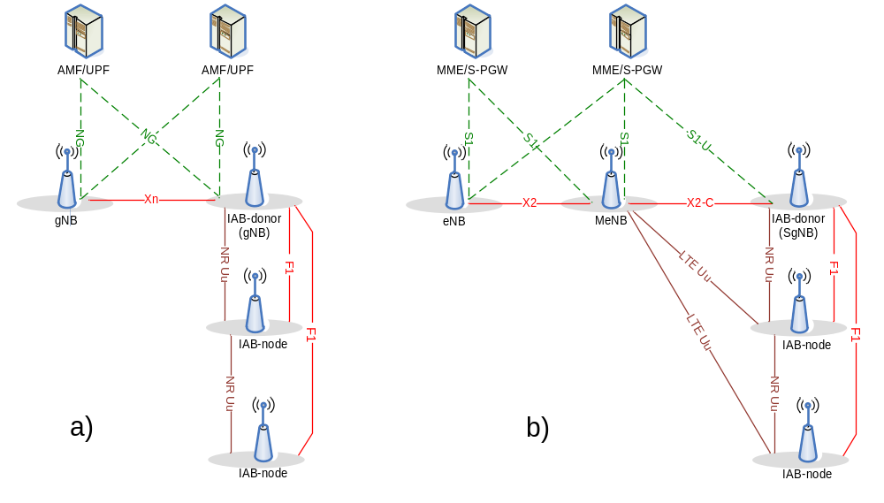
Figure 4.7.1-1: IAB architecture; a) IAB-node using SA mode with NGC; b) IAB-node using EN-DC
All IAB-nodes that are connected to an IAB-donor via one or multiple hops form a directed acyclic graph (DAG) topology with the IAB-donor at its root (Fig. 4.7.1-2). In this DAG topology, the neighbour node on the IAB-DU’s interface is referred to as child node and the neighbour node on the IAB-MT’s interface is referred to as parent node. The direction toward the child node is further referred to as downstream while the direction toward the parent node is referred to as upstream. The IAB-donor performs centralized resource, topology and route management for the IAB topology.
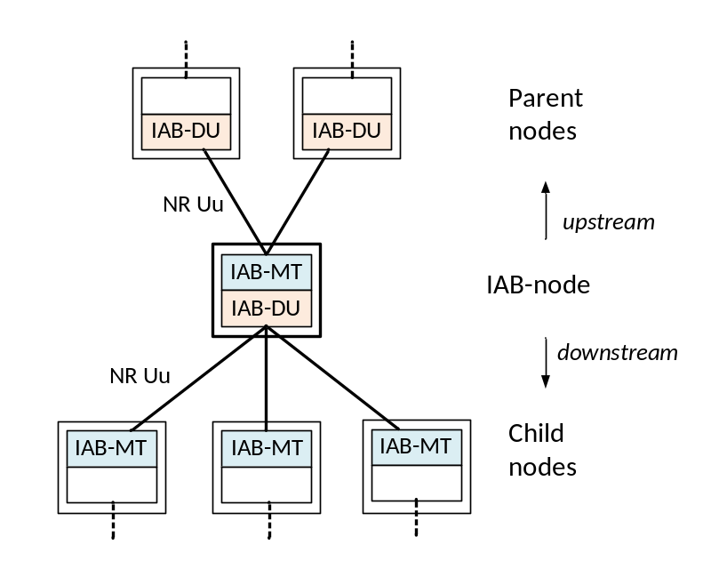
Figure 4.7.1-2: Parent- and child-node relationship for IAB-node

4.7.2 Protocol Stacks
Fig. 4.7.2-1 shows the protocol stack for F1-U and Fig. 4.7.2-2 shows the protocol stack for F1-C between IAB-DU and IAB-donor-CU. In these figures, F1-U and F1-C are carried over two backhaul hops.
F1-U and F1-C use an IP transport layer between IAB-DU and IAB-donor-CU as defined in TS 38.470 [32]. F1-U and F1-C need to be security-protected as described in TS 33.501 [5] (the security layer is not shown in the Figures 4.7.2-1/2).
On the wireless backhaul, the IP layer is carried over the backhaul adaptation protocol (BAP) sublayer, which enables routing over multiple hops. The IP layer can also be used for non-F1 traffic, such as OAM traffic [4].
On each backhaul link, the BAP PDUs are carried by BH RLC channels. Multiple BH RLC channels can be configured on each BH link to allow traffic prioritization and QoS enforcement. The BH-RLC-channel mapping for BAP PDUs is performed by the BAP entities on each IAB-node and the IAB-donor-DU.
Protocol stacks for an IAB-donor with split gNB architecture are specified in TS 38.401 [4].
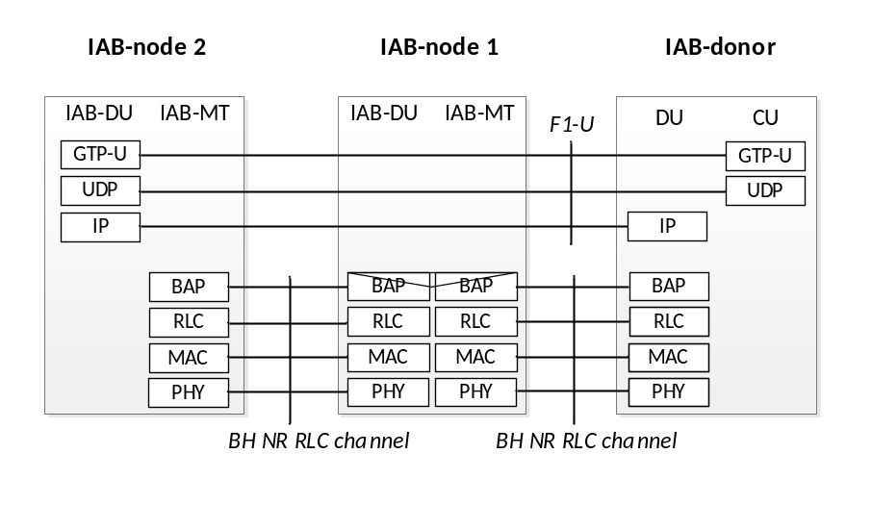
Fig. 4.7.2-1: Protocol stack for the support of F1-U protocol
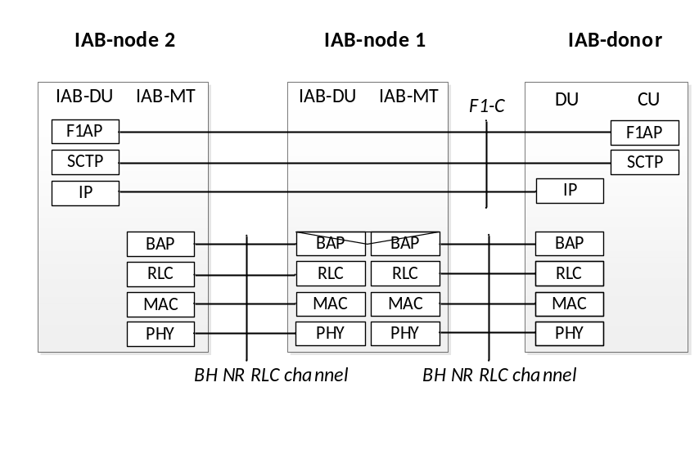
Fig. 4.7.2-2: Protocol stack for the support of F1-C protocol
The IAB-MT further establishes SRBs (carrying RRC and NAS) and potentially also DRBs (e.g. carrying OAM traffic) with the IAB-donor. These SRBs and DRBs are transported between the IAB-MT and its parent node over Uu access channel(s). The protocol stacks for the SRB is shown in Fig. 4.7.2-3.
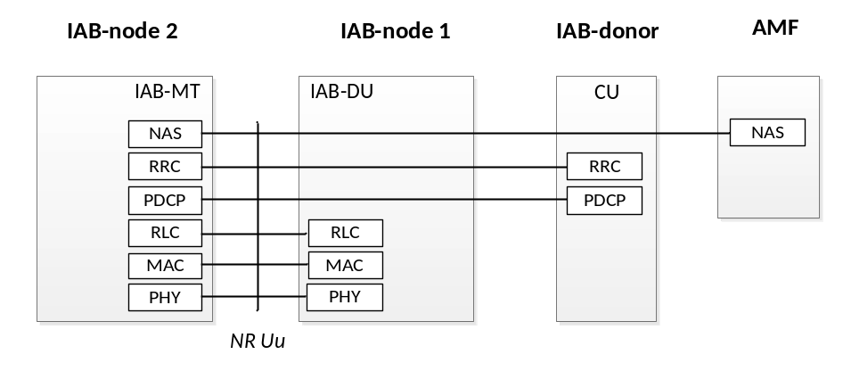
Figure 4.7.2-3: Protocol stack for the support of IAB-MT’s RRC and NAS connections

4.7.3 User-plane Aspects

4.7.3.1 Backhaul transport
The IAB-DU’s IP traffic is routed over the wireless backhaul via the BAP sublayer. The BAP sublayer is specified in TS 38.340 [31]. In downstream direction, upper layer packets are encapsulated by the BAP sublayer at the IAB-donor-DU and de-encapsulated at the destination IAB-node. In upstream direction, upper layer packets are encapsulated at the IAB-node and de-encapsulated at the IAB-donor-DU. IAB-specific transport between IAB-donor-CU and IAB-donor-DU is specified in TS 38.401 [4].
On the BAP sublayer, packets are routed based on the BAP routing ID, which is carried in the BAP header. The BAP header is added to the packet when it arrives from upper layers, and it is stripped off when it has reached its destination node. The selection of the packet’s BAP routing ID is configured by the IAB-donor-CU. The BAP routing ID consists of BAP address and BAP path ID, where the BAP address indicates the destination node of the packet on the BAP sublayer, and the BAP path ID indicates the routing path the packet should follow to this destination. For the purpose of routing, each IAB-node and IAB-donor-DU is further configured with a designated BAP address.
In downstream direction, on each hop of the packet’s path, the IAB-node inspects the packet’s BAP address in the routing header to determine if the packet has reached its destination, i.e., matches the IAB-node’s BAP address. In case the packet has not reached the destination, the IAB-node determines the next hop backhaul link, referred to as egress link, based on the BAP routing ID carried in the packet header and a routing configuration it received from the IAB-donor-CU.
In upstream direction, all packets are forwarded to the IAB-donor. Therefore, on each hop of the packet’s path, the IAB-node determines the next hop backhaul link based on the BAP routing ID.
For each packet, the IAB-node further determines the BH RLC channel on the designated egress link. For packets arriving from upper layers the designated BH RLC channel is configured by the IAB-donor-CU, and it is based on upper layer traffic specifiers. Since each BH RLC channel is configured with QoS information or priority level, BH-RLC-channel selection facilitates traffic-specific prioritization and QoS enforcement on the BH. For F1-U traffic, it is possible to map each GTP-U tunnel to a dedicated BH RLC channel or to aggregate multiple GTP-U tunnels into one common BH RLC channel. For other than F1-U traffic, it is possible to map UE-associated F1AP messages, non-UE-associated F1AP messages and non-F1 traffic onto the same or separate BH RLC channels.
When packets are routed from one BH link to another, the BH RLC channel on the egress BH link is determined based on the mapping configuration between ingress BH RLC channels and egress BH RLC channels provided by the IAB-donor-CU.

4.7.3.2 Flow and Congestion Control
Flow and congestion control can be supported in both upstream and downstream directions in order to avoid congestion-related packet drops on IAB-nodes and IAB-donor-DU:
- In upstream direction, UL scheduling on MAC layer can support flow control on each hop;
- In downstream direction, the NR user plane protocol (TS 38.425 [33]) supports flow and congestion control between the IAB-node and the IAB-donor-CU for UE bearers that terminate at this IAB-node. Further, flow control is supported on BAP sublayer, where the IAB-node can send feedback information on the available buffer size for an ingress BH RLC channel or BAP routing ID to its parent node. The feedback can be sent proactively, e.g., when the buffer load exceeds a certain threshold, or based on polling by the parent node.

4.7.3.3 Uplink Scheduling Latency
In upstream direction, the signalling latency for UL scheduling accumulates with the number of backhaul hops (Figure 4.7.3.3-1).
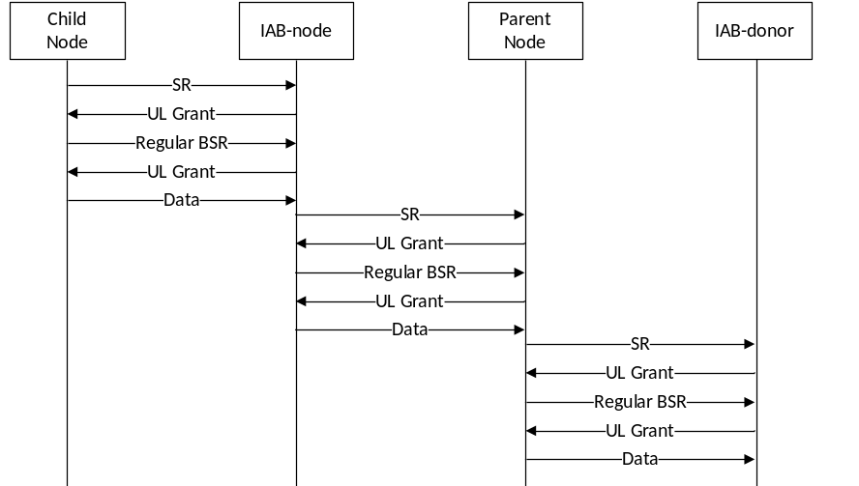
Figure 4.7.3.3-1: Signalling for UL scheduling in multi-hop backhaul with regular BSR

The IAB-node can reduce this UL scheduling latency through pre-emptive signalling of BSR to its parent node. The IAB-node can send the Pre-emptive BSR based on UL grants it has provided to child nodes and/or UEs, or based on BSRs it has received from child nodes or UEs (Figure 4.7.3-3). The Pre-emptive BSR conveys the data expected rather than the data buffered.
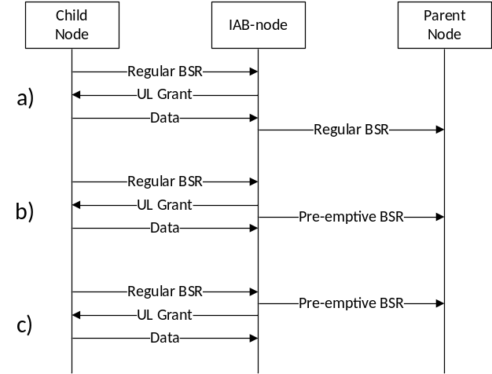
Figure 4.7.3.3-2: Scheduling of BSR in IAB:
a) regular BSR based on buffered data,
b) Pre-emptive BSR based on UL grant,
c) Pre-emptive BSR based on reception of regular BSR

4.7.4 Signalling procedures

4.7.4.1 IAB-node Integration
The IAB-node integration procedure is captured in TS 38.401 [4].

4.7.4.2 IAB-node Migration
The IAB-node can migrate to a different parent node underneath the same IAB-donor-CU. The IAB-node continues providing access and backhaul service when migrating to a different parent node.
The IAB-node migration procedure is captured in TS 38.401 [4].

4.7.4.3 Topological Redundancy
The IAB-node may have redundant routes to the IAB-donor-CU.
For IAB-nodes operating in SA-mode, NR DC is used to enable route redundancy in the BH by allowing the IAB-MT to have concurrent BH links with two parent nodes. The parent nodes have to be connected to the same IAB-donor-CU, which controls the establishment and release of redundant routes via these two parent nodes. The parent nodes’ gNB-DU functionality together with the IAB-donor-CU obtains the role of the IAB-MT’s master node or secondary node. The NR DC framework (e.g. MCG/SCG-related procedures) is used to configure the dual radio links with the parent nodes (TS 37.340 [21]).
The procedure for establishment of topological redundancy for IAB-nodes operating in SA-mode is captured in TS 38.401 [4].
IAB-nodes operating in EN-DC can exchange F1-C traffic with the IAB-donor via the MeNB. The F1-C message are carried over LTE RRC using SRB2 between IAB-node and MeNB and via X2AP between MeNB and IAB-donor.
The procedure for establishment of redundant transport of F1-C for IAB-nodes using EN-DC is captured in TS 38.401 [4].

4.7.4.4 Backhaul RLF Recovery
When the IAB-node using SA-mode declares RLF on the backhaul link, it can migrate to another parent node. The BH RLF recovery procedure to a parent node underneath the same IAB-donor-CU is captured in TS 38.401 [4]. BH RLF declaration for IAB is handled in Section 9.2.7.

Next Modified Subclause

6.1 Overview
The layer 2 of NR is split into the following sublayers: Medium Access Control (MAC), Radio Link Control (RLC), Packet Data Convergence Protocol (PDCP) and Service Data Adaptation Protocol (SDAP). The two figures below depict the Layer 2 architecture for downlink and uplink, where:
- The physical layer offers to the MAC sublayer transport channels;
- The MAC sublayer offers to the RLC sublayer logical channels;
- The RLC sublayer offers to the PDCP sublayer RLC channels;
- The PDCP sublayer offers to the SDAP sublayer radio bearers;
- The SDAP sublayer offers to 5GC QoS flows;
- Comp. refers to header compression and segm. to segmentation;
- Control channels (BCCH, PCCH are not depicted for clarity).
NOTE: The gNB may not be able to guarantee that a L2 buffer overflow will never occur. If such overflow occurs, the UE may discard packets in the L2 buffer.
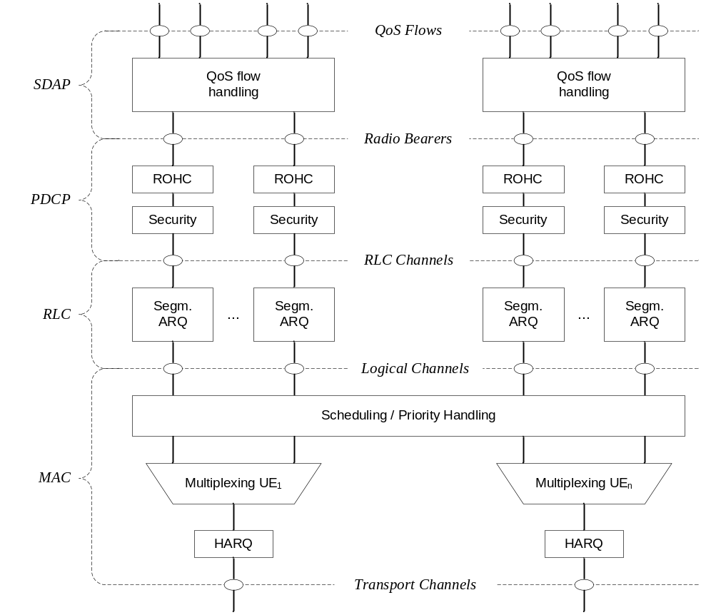
Figure 6.1-1: Downlink Layer 2 Structure
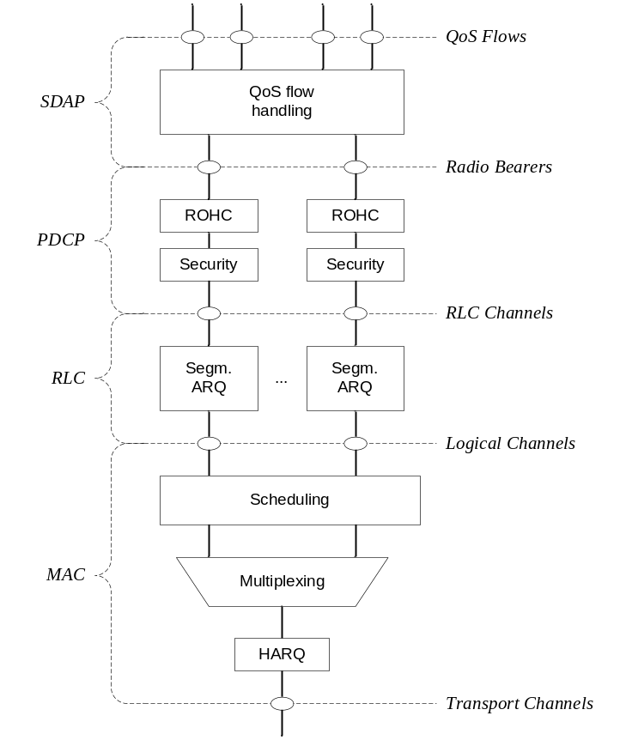
Figure 6.1-2: Uplink Layer 2 Structure
Radio bearers are categorized into two groups: data radio bearers (DRB) for user plane data and signalling radio bearers (SRB) for control plane data.
For IAB, the Layer 2 of NR also includes: Backhaul Adaptation Protocol (BAP).
- The BAP sublayer supports routing across the IAB topology and traffic mapping to BH RLC channels for enforcement of traffic prioritization and QoS.
Figures 6.1-3 below depicts the Layer-2 architecture for downlink on the IAB-donor. Figure 6.1-4 and 6.1-5 depict the Layer-2 architecture for downlink and uplink on the IAB-node, where the BAP sublayer offers routing functionality and mapping to backhaul RLC channels.
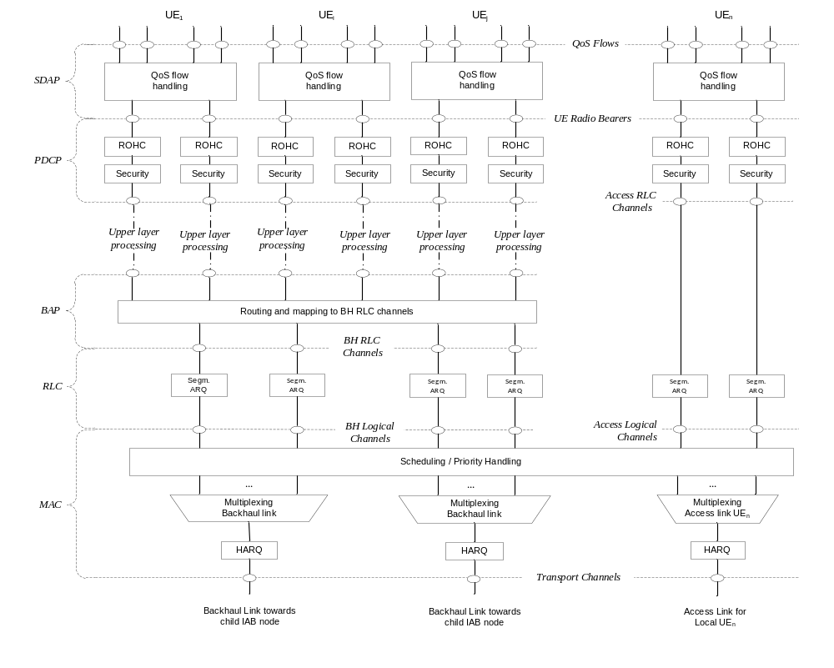
Figure 6-1.3: DL L2-structure for user plane at IAB-donor
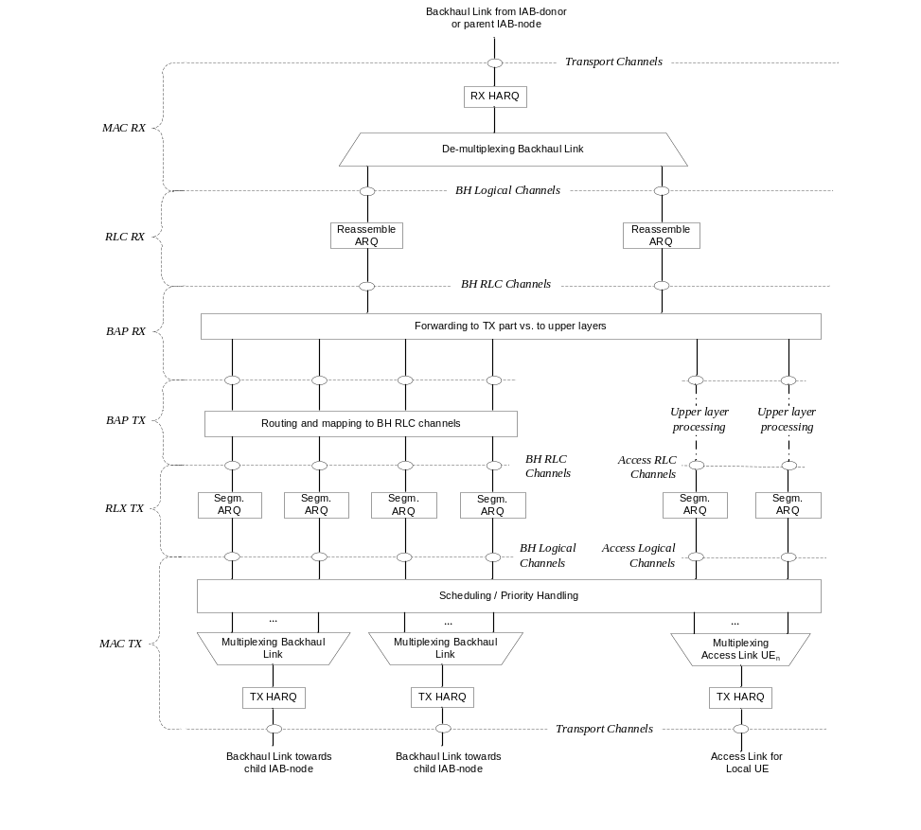
Figure 6.1-4: DL L2-structure at IAB-node
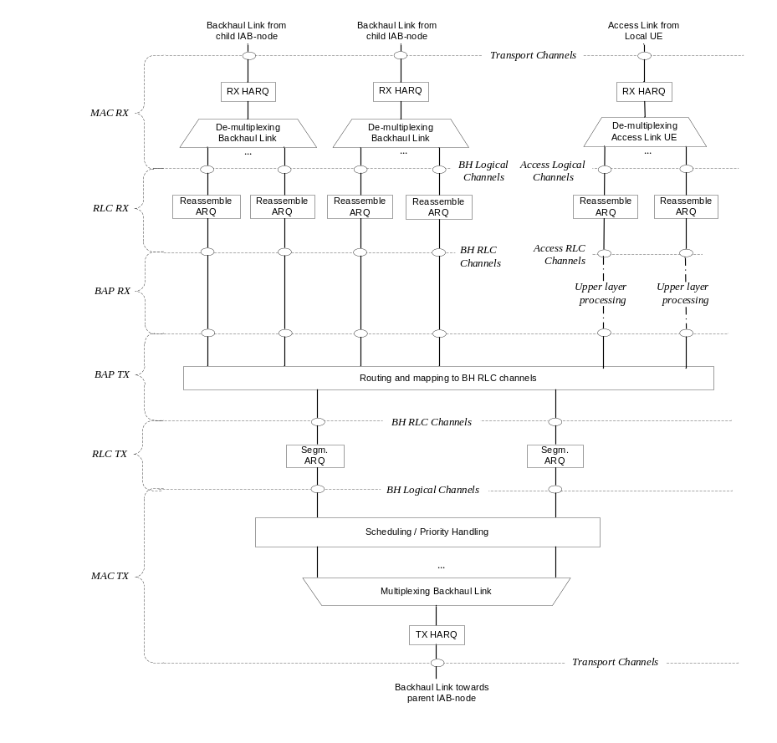
Figure 6.1-5: UL L2-structure at IAB-node
Next Modified Subclause

6.11 Backhaul Adaptation Protocol Sublayer

6.11.1 Services and Functions
The main service and functions of the BAP sublayer include:
- Transfer of data;
- Routing of packets to next hop;
- Determination of BAP destination and BAP path for packets from upper layers;
- Determination of egress BH RLC channels for packets routed to next hop;
- Differentiating traffic to be delivered to upper layers from traffic to be delivered to egress link;
- Flow control feedback signalling;
- BH RLF indication.

6.11.2 Traffic Mapping from Upper Layers to Layer-2
In upstream direction, the IAB-donor-CU configures the IAB-node with mappings between upstream F1 and non-F1 traffic originated at the IAB-node, and the appropriate BAP routing ID, next-hop BAP address and BH RLC channel. A specific mapping is configured:
- for each F1-U GTP-U tunnel;
- for non-UE associated F1AP messages;
- for UE-associated F1AP messages;
- for non-F1 traffic.
Multiple mappings can contain the same BH RLC channel and/or next-hop BAP address and/or BAP routing ID. In case the IAB-MT is NR dual-connected, the mapping may include a BH RLC channel for each of the egress links, and the determination of the egress link is based on routing as described in Section 6.11.3.
These configurations are received via F1AP. During IAB-node integration, before F1AP is established, a default BH RLC channel and a default BAP routing ID are configured via RRC, which are used for all upper layer traffic.
In downstream direction, traffic mapping occurs internal to the IAB-donor. Transport for IAB-donors that use split-gNB architecture is handled in TS 38.401 [4].

6.11.3 Routing and BH-RLC-channel mapping on BAP sublayer
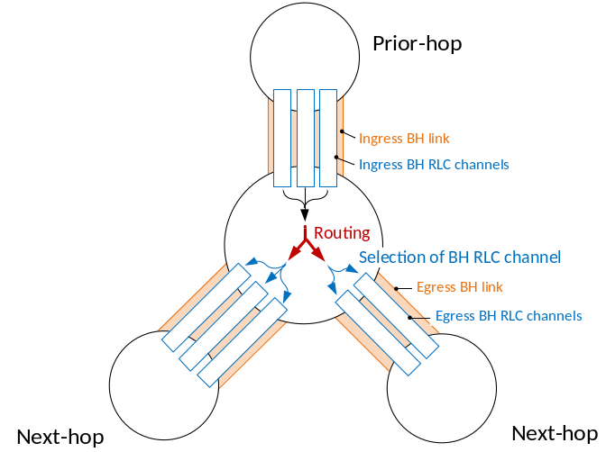
Figure 6.11.3-1: Routing and BH RLC channel selection on BAP sublayer
Routing on BAP sublayer uses the BAP routing ID, which is configured by the IAB-donor. The BAP routing ID consists of BAP address and BAP path ID. The BAP address is used for the following purposes:
1. Determination if a packet has reached the destination node, i.e. IAB-node or IAB-donor-DU, on BAP sublayer. This is the case if the BAP address in the packet’s BAP header matches the BAP address configured via RRC on the IAB-node, or via F1AP on the IAB-donor-DU.
2. Determination of the next-hop node for packets that have not reached their destination. This applies to packets arriving from a prior hop on BAP sublayer or that have been received from IP layer.
For packets arriving from a prior hop or from upper layers, the determination of the next-hop node is based on a routing configuration provided by the IAB-donor-CU via F1AP signalling. This configuration contains the mapping between the BAP routing ID carried in the packet’s BAP header and the next-hop node’s BAP address.
Table 6.11.3-1: Routing configuration
BAP routing ID | Next-hop BAP address
Derived from BAP packet’s BAP header | Egress link to forward packet

The IAB-node resolves the next-hop BAP address to a physical backhaul link. For this purpose, the IAB-donor-CU provides the IAB-node with its child-node’s BAP address via F1AP and its parent-node’s BAP address via RRC.
The IAB-node can receive multiple routing configurations with the same destination BAP address but different BAP path IDs. These routing configurations may resolve to the same or different egress BH links. In case the BH link has RLF, the IAB-node may select another BH link based on routing entries with the same destination BAP address, i.e., by disregarding the BAP path ID. In this manner, a packet can be delivered via an alternative path in case the indicated path is not available.
When routing a packet from an ingress to an egress BH link, the IAB-node derives the egress BH RLC channel on the egress BH link through an F1AP-configured mapping from the BH RLC channel used on the ingress BH link. The BH RLC channel IDs used for ingress and egress BH RLC channels are generated by the IAB-donor-CU. Since the BH RLC channel ID only has link-local scope, the mapping configurations also include the BAP addresses of prior and next hop:
Table 6.11.3-2: BH RLC channel mapping configuration
Next-hop BAP address | Prior-hop BAP address | Ingress RLC channel ID | Egress RLC channel ID
Derived from routing configuration | Derived from packet’s ingress link | Derived from packet’s ingress BH RLC channel | BH RLC channel on egress link to forward packet

The IAB-node resolves the BH RLC channel IDs from logical channel IDs based on the configuration by the IAB-donor-CU. For BH RLC channels in downstream direction, the BH RLC channel ID is included in the F1AP configuration of the BH RLC channel. For BH RLC channels in upstream direction, the BH RLC channel ID is included in the RRC configuration of the corresponding logical channel.
Next Modified Subclause

7.4 Access Control
NG-RAN supports overload and access control functionality such as RACH back off, RRC Connection Reject, RRC Connection Release and UE based access barring mechanisms.
One unified access control framework as specified in TS 22.261 [19] applies to all UE states (RRC_IDLE, RRC_INACTIVE and RRC_CONNECTED) for NR. NG-RAN broadcasts barring control information associated with Access Categories and Access Identities (in case of network sharing, the barring control information can be set individually for each PLMN). The UE determines whether an access attempt is authorized based on the barring information broadcast for the selected PLMN, and the selected Access Category and Access Identity(ies) for the access attempt:
- For NAS triggered requests, NAS determines the Access Category and Access Identity(ies);
- For AS triggered requests, RRC determines the Access Category while NAS determines the Access Identity(ies).
The gNB handles access attempts with establishment causes "emergency", "mps-PriorityAccess" and "mcs-PriorityAccess" (i.e. Emergency calls, MPS, MCS subscribers) with high priority and responds with RRC Reject to these access attempts only in extreme network load conditions that may threaten the gNB stability.
Unified access control does not apply to IAB-MTs.
Next Modified Subclause

9.2.1 Mobility in RRC_IDLE

9.2.1.1 Cell Selection
The principles of PLMN selection in NR are based on the 3GPP PLMN selection principles. Cell selection is required on transition from RM-DEREGISTERED to RM-REGISTERED, from CM-IDLE to CM-CONNECTED and from CM-CONNECTED to CM-IDLE and is based on the following principles:
- The UE NAS layer identifies a selected PLMN and equivalent PLMNs;
- Cell selection is always based on CD-SSBs located on the synchronization raster (see clause 5.2.4):
- The UE searches the NR frequency bands and for each carrier frequency identifies the strongest cell as per the CD-SSB. It then reads cell system information broadcast to identify its PLMN(s):
- The UE may search each carrier in turn ("initial cell selection") or make use of stored information to shorten the search ("stored information cell selection").
- The UE seeks to identify a suitable cell; if it is not able to identify a suitable cell it seeks to identify an acceptable cell. When a suitable cell is found or if only an acceptable cell is found it camps on that cell and commence the cell reselection procedure:
- A suitable cell is one for which the measured cell attributes satisfy the cell selection criteria; the cell PLMN is the selected PLMN, registered or an equivalent PLMN; the cell is not barred or reserved and the cell is not part of a tracking area which is in the list of "forbidden tracking areas for roaming";
- An acceptable cell is one for which the measured cell attributes satisfy the cell selection criteria and the cell is not barred.
- The IAB-MT applies the cell selection procedure as described for the UE with the following differences:
- The IAB-MT ignores cell-barring or cell-reservation indications contained in cell system information broadcast;
- The IAB-MT only selects a cell if the cell system information broadcast indicates IAB support for the selected PLMN.
Transition to RRC_IDLE:
On transition from RRC_CONNECTED or RRC_INACTIVE to RRC_IDLE, a UE should camp on a cell as result of cell selection according to the frequency be assigned by RRC in the state transition message if any.
Recovery from out of coverage:
The UE should attempt to find a suitable cell in the manner described for stored information or initial cell selection above. If no suitable cell is found on any frequency or RAT, the UE should attempt to find an acceptable cell.
In multi-beam operations, the cell quality is derived amongst the beams corresponding to the same cell (see clause 9.2.4).
Next Modified Subclause

9.2.3 Mobility in RRC_CONNECTED

9.2.3.1 Overview
Network controlled mobility applies to UEs in RRC_CONNECTED and is categorized into two types of mobility: cell level mobility and beam level mobility.
Cell Level Mobility requires explicit RRC signalling to be triggered, i.e. handover. For inter-gNB handover, the signalling procedures consist of at least the following elemental components illustrated in Figure 9.2.3.1-1:
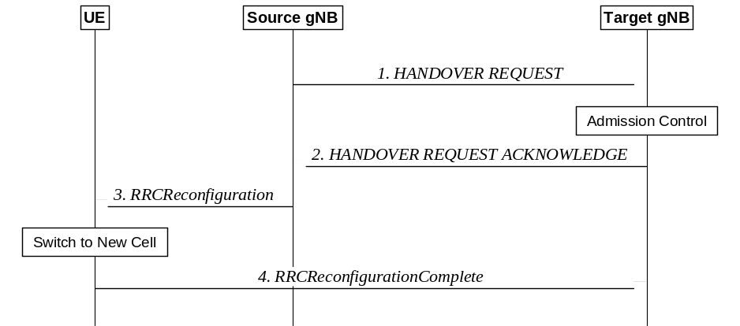
Figure 9.2.3.1-1: Inter-gNB handover procedures
1. The source gNB initiates handover and issues a HANDOVER REQUEST over the Xn interface.
2. The target gNB performs admission control and provides the new RRC configuration as part of the HANDOVER REQUEST ACKNOWLEDGE.
3. The source gNB provides the RRC configuration to the UE by forwarding the RRCReconfiguration message received in the HANDOVER REQUEST ACKNOWLEDGE. The RRCReconfiguration message includes at least cell ID and all information required to access the target cell so that the UE can access the target cell without reading system information. For some cases, the information required for contention-based and contention-free random access can be included in the RRCReconfiguration message. The access information to the target cell may include beam specific information, if any.
4. The UE moves the RRC connection to the target gNB and replies with the RRCReconfigurationComplete.
NOTE 1: User Data can also be sent in step 4 if the grant allows.
In case of DAPS handover, the UE continues the downlink user data reception from the source gNB until releasing the source cell and continues the uplink user data transmission to the source gNB until successful random access procedure to the target gNB.
The handover mechanism triggered by RRC requires the UE at least to reset the MAC entity and re-establish RLC, except for DAPS handover, where upon reception of the handover command, the UE:
The handover mechanism triggered by RRC requires the UE at least to reset the MAC entity and re-establish RLC, except for DAPS handover, where upon reception of the handover command, the UE:
- Creates a MAC entity for target;
- Establishes an RLC entity and an associated DTCH logical channel for target for each DRB configured with DAPS;
- For the DRB configured with DAPS, reconfigures the PDCP entity with separate security and ROHC functions for source and target and associates them with the RLC entities configured by source and target respectively;
- Retains the rest of the source configurations until release of the source.
NOTE 2: The handling on RLC and PDCP for DRBs without DAPS is same as in normal handover.
RRC managed handovers with and without PDCP entity re-establishment are both supported. For DRBs using RLC AM mode, PDCP can either be re-established together with a security key change or initiate a data recovery procedure without a key change. For DRBs using RLC UM mode and for SRBs, PDCP can either be re-established together with a security key change or remain as it is without a key change.
Data forwarding, in-sequence delivery and duplication avoidance at handover can be guaranteed when the target gNB uses the same DRB configuration as the source gNB.
Timer based handover failure procedure is supported in NR. RRC connection re-establishment procedure is used for recovering from handover failure except in certain CHO or DAPS scenarios:
- When DAPS HO fails, the UE reports DAPS HO failure via the source without triggering RRC connection re-establishment if the source link has not been released.
- When initial CHO execution attempt fails or HO fails, the UE performs cell selection, and if the selected cell is a CHO candidate and if network configured the UE to try CHO after HO/CHO failure, then the UE attempts CHO execution once, otherwise re-establishment is performed.
DAPS handover for FR2 to FR2 case is not supported in this release of the specification.
The handover of the IAB-MT in SA mode follows the same procedure as described for the UE. After the backhaul has been established, the handover of the IAB-MT is part of the intra-CU topology adaptation procedure defined in TS 38.401 [4]. During this procedure, the BAP entities on the IAB-node are not released. Modifications to the configuration of BAP sublayer and higher protocol layers above the BAP sublayer are described in TS 38.401 [4].
Beam Level Mobility does not require explicit RRC signalling to be triggered. The gNB provides via RRC signalling the UE with measurement configuration containing configurations of SSB/CSI resources and resource sets, reports and trigger states for triggering channel and interference measurements and reports. Beam Level Mobility is then dealt with at lower layers by means of physical layer and MAC layer control signalling, and RRC is not required to know which beam is being used at a given point in time.
SSB-based Beam Level Mobility is based on the SSB associated to the initial DL BWP and can only be configured for the initial DL BWPs and for DL BWPs containing the SSB associated to the initial DL BWP. For other DL BWPs, Beam Level Mobility can only be performed based on CSI-RS.
Next Modified Subclause

9.2.3.3 Re-establishment procedure
A UE in RRC_CONNECTED may initiate the re-establishment procedure to continue the RRC connection when a failure condition occurs (e.g. radio link failure, reconfiguration failure, integrity check failure…).
The following figure describes the re-establishment procedure started by the UE:
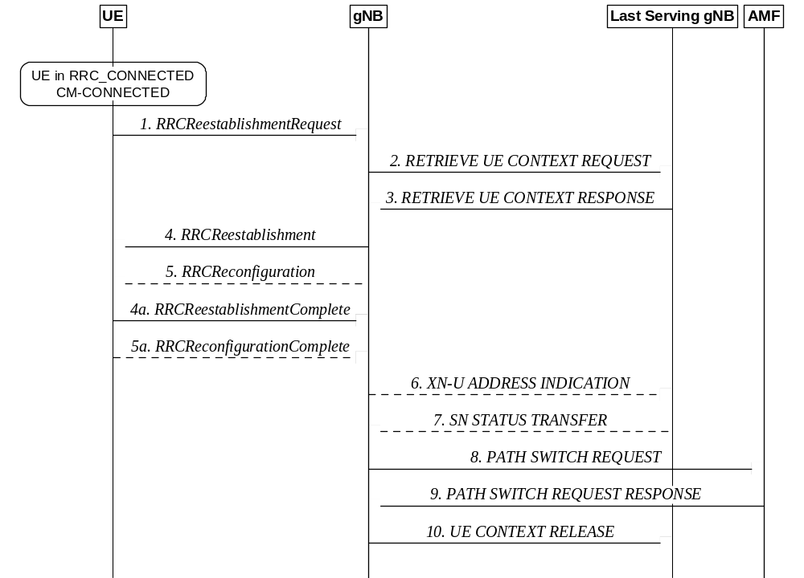
Figure 9.2.3.3-1: Re-establishment procedure
1. The UE re-establishes the connection, providing the UE Identity (PCI+C-RNTI) to the gNB where the trigger for the re-establishment occurred.
2. If the UE Context is not locally available, the gNB, requests the last serving gNB to provide UE Context data.
3. The last serving gNB provides UE context data.
4/4a. The gNB continues the re-establishment of the RRC connection. The message is sent on SRB1.
5/5a. The gNB may perform the reconfiguration to re-establish SRB2 and DRBs when the re-establishment procedure is ongoing.
6/7. If loss of user data buffered in the last serving gNB shall be prevented, the gNB provides forwarding addresses, and the last serving gNB provides the SN status to the gNB.
8/9. The gNB performs path switch.
10. The gNB triggers the release of the UE resources at the last serving gNB.
The IAB-MT in SA mode follows the same re-establishment procedure as described for the UE. After the backhaul has been established, the re-establishment procedure of the IAB-MT is part of the intra-CU backhaul RLF recovery procedure for IAB-nodes defined in TS 38.401 [4]. During this procedure, the BAP entities on the IAB-node are not released. Modifications to the configuration of BAP sublayer and higher protocol layers above the BAP sublayer are described in TS 38.401 [4].

Next Modified Subclause

9.2.7 Radio Link Failure
In RRC_CONNECTED, the UE performs Radio Link Monitoring (RLM) in the active BWP based on reference signals (SSB/CSI-RS) and signal quality thresholds configured by the network. SSB-based RLM is based on the SSB associated to the initial DL BWP and can only be configured for the initial DL BWP and for DL BWPs containing the SSB associated to the initial DL BWP. For other DL BWPs, RLM can only be performed based on CSI-RS. In case of DAPS handover, the UE continues the RLM at the source cell until the successful completion of the random access procedure to the target cell.
The UE declares Radio Link Failure (RLF) when one of the following criteria are met:
- Expiry of a radio problem timer started after indication of radio problems from the physical layer (if radio problems are recovered before the timer is expired, the UE stops the timer); or
- Expiry of a timer started upon triggering a measurement report for a measurement identity for which the timer has been configured while another radio problem timer is running; or
- Random access procedure failure; or
- RLC failure; or
- Detection of consistent uplink LBT failures for operation with shared spectrum channel access as described in 5.6.1; or
- For IAB-MT, the reception of BH RLF indication received from its parent node.
In case of regular handover, after RLF is declared, the UE:
- stays in RRC_CONNECTED;
- selects a suitable cell and then initiates the RRC re-establishment procedure;
- enters RRC_IDLE if a suitable cell was not found within a certain time after RLF was declared.
In case of DAPS handover, if RLF is declared in source cell, the UE:
- stays in RRC_CONNECTED;
- stops any data transmission or reception via the source link and releases the source link, but maintains the source RRC configuration;
In case of DAPS handover, when handover failure is declared at the target cell after source cell RLF was declared, the UE:
- stays in RRC_CONNECTED;
- selects a suitable cell and then initiates the RRC re-establishment procedure;
- enters RRC_IDLE if a suitable cell was not found within a certain time after handover failure was declared.
In case of CHO, after RLF is declared in source cell, the UE:
- stays in RRC_CONNECTED;
- selects a suitable cell and if the selected cell is a CHO candidate and if network configured the UE to try CHO after RLF then the UE attempts CHO execution once, otherwise the re-establishment procedure is performed;
- enters RRC_IDLE if a suitable cell was not found within a certain time after RLF was declared.
When RLF occurs at the IAB BH link, the same mechanisms and procedures are applied as for the access link. This includes BH RLF detection and RLF recovery using RRC reestablishment procedure.
In case the RRC reestablishment procedure fails, the IAB-node may transmit an BH RLF indication to its child nodes. The BH RLF indication is transmitted on the BAP sublayer.
Next Modified Subclause

10.4 Measurements to Support Scheduler Operation
Measurement reports are required to enable the scheduler to operate in both uplink and downlink. These include transport volume and measurements of a UEs radio environment.
Uplink buffer status reports (BSR) are needed to provide support for QoS-aware packet scheduling. In NR, uplink buffer status reports refer to the data that is buffered in for a group of logical channels (LCG) in the UE. Eight LCGs and two formats are used for reporting in uplink:
- A short format to report only one BSR (of one LCG);
- A flexible long format to report several BSRs (up to all eight LCGs).
Uplink buffer status reports are transmitted using MAC signalling. When a BSR is triggered (e.g. when new data arrives in the transmission buffers of the UE), a Scheduling Request (SR) can be transmitted by the UE (e.g. when no resources are available to transmit the BSR).
For IAB, the Pre-emptive BSR can be used on the backhaul links instead of the regular BSR. The Pre-emptive BSR is sent based on expected data rather than buffered data, as described in Section 4.7.3.3. The Pre-emptive BSR is only available in the flexible long format.
Power headroom reports (PHR) are needed to provide support for power-aware packet scheduling. In NR, three types of reporting are supported: a first one for PUSCH transmission, a second one for PUSCH and PUCCH transmission in an LTE Cell Group in EN-DC (see TS 37.340 [21]) and a third one for SRS transmission on SCells configured with SRS only. In case of CA, when no transmission takes place on an activated SCell, a reference power is used to provide a virtual report. Power headroom reports are transmitted using MAC signalling.

End of Modifications

