3GPP TSG-RAN WG2 Meeting #110 R2-200xxxx

Electronic, 1 June – 12 June 2020

Agenda item: 5.4.1.1
Source: Apple
Title: Offline-007: DC Configuration
Document for: Discussion & Decision

Introduction
This is a summary of the following offline discussion on DC configuration:
- [AT110e][007][NR15] DC Configuration (Apple)
Scope: Treat R2-2005531, R2-2005532, R2-2005533, R2-2005534, R2-2005634, R2-2005635, R2-2004488, R2-2004489 (proponents are responsible to explain and drive)
Part 1: Decision whether to make corrections or not, identify agreeable corrections. Deadline: June 4, 0700 UTC.
Part 2: For agreeable parts, continuation to agree CRs. Deadline: June 10, 0700 UTC
This document covers the following contributions submitted to RAN2#110-e meeting:
PSCell Addition NR-DC - SMTC
R2-2005531 SMTC Configuration for PSCell Addition for NR-DC Apple, ZTE Corporation, Sanechips, Qualcomm Incorporated CR Rel-15 38.331 15.9.0 1675 - F NR_newRAT-Core
R2-2005532 SMTC Configuration for PSCell Addition for NR-DC Apple, ZTE Corporation, Sanechips, Qualcomm Incorporated CR Rel-16 38.331 16.0.0 1676 - A NR_newRAT-Core
R2-2005533 SMTC Configuration for PSCell Addition for NR-DC Apple, ZTE Corporation, Sanechips, Qualcomm Incorporated CR Rel-15 38.306 15.9.0 0340 - F NR_newRAT-Core
R2-2005534 SMTC Configuration for PSCell Addition for NR-DC Apple, ZTE Corporation, Sanechips, Qualcomm Incorporated CR Rel-16 38.306 16.0.0 0341 - A NR_newRAT-Core
4 Treated by email [007]

SCG establishment – MAC default
R2-2005634 MAC Default Configuration for SCG Qualcomm Incorporated CR Rel-16 38.331 16.0.0 1685 - A NR_newRAT-Core
R2-2005635 MAC Default Configuration for SCG Qualcomm Incorporated CR Rel-15 38.331 15.9.0 1686 - F NR_newRAT-Core
2 Treated by email [007]
Radio bearer config NR-DC NE-DC
R2-2004488 Clarification for radioBearerConfig and radioBearerConfig2 vivo discussion
R2-2004489 Clarification for radioBearerConfig and radioBearerConfig2 vivo CR Rel-15 38.331 15.9.0 1608 - F NR_newRAT-Core
2 Treated by email [007]
Companies are invited to provide their views for each issue.

Discussion: Part 1

2.1 Issue #1. SMTC Configuration for PSCell Addition for NR-DC (R2-2005531 to R2-2005534)

Regarding which issues that need resolution, it is suggested to use the reason for change from R2-2005531 to R2-2005534 as the input:

For EN-DC, the SMTC configuration for NR PSCell addition is provided in LTE RRCConnectionReconfiguration message.
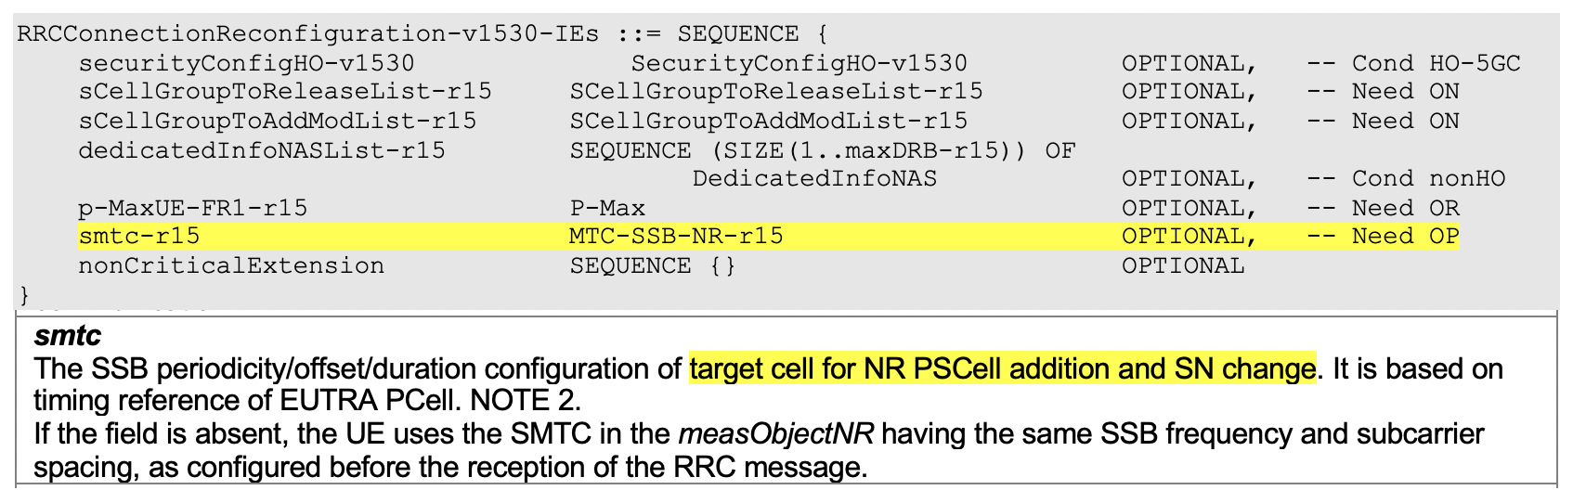

For NR PSCell change in MR-DC, the SMTC configuration is provided in secondaryCellGroup -> SpCellConfig -> reconfigurationWithSync.
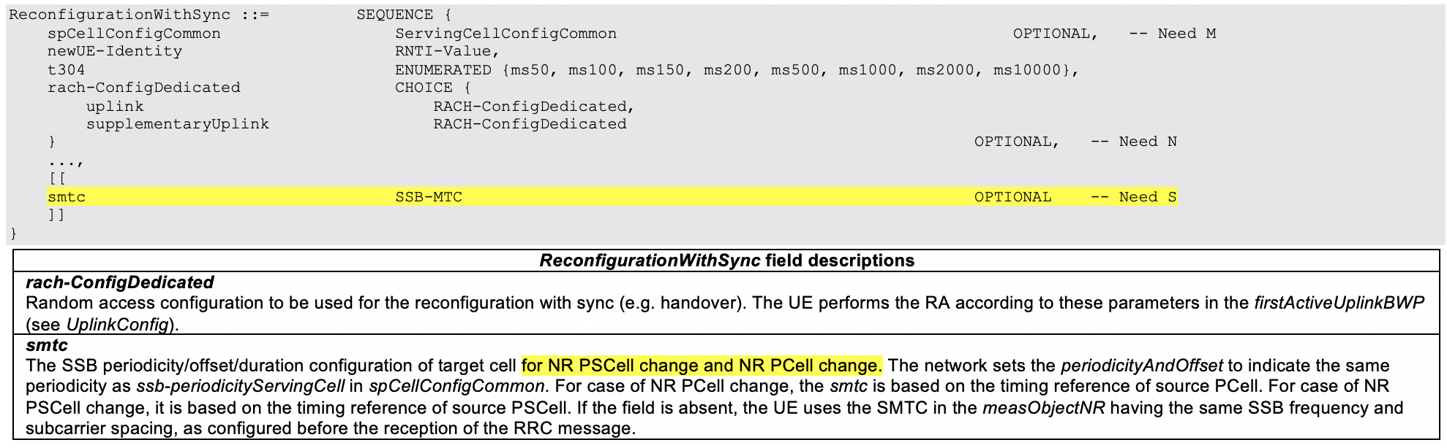

But for NR-DC, the SMTC configuration for NR PSCell addition and SN change is missing.

Q1.1) Do companies agree with the reason for change in R2-2005531 to R2-2005534?
Company | Agree/Disagree | Comments (if any)
Ericsson | Disagree | Our understanding is that the smtc is received by the UE via the reconfigurationWithSync field. Having a look at the ASN.1 we have:  CellGroupConfig ::= SEQUENCE {  cellGroupId CellGroupId,  rlc-BearerToAddModList SEQUENCE (SIZE(1..maxLC-ID)) OF RLC-BearerConfig OPTIONAL, -- Need N  rlc-BearerToReleaseList SEQUENCE (SIZE(1..maxLC-ID)) OF LogicalChannelIdentity OPTIONAL, -- Need N  mac-CellGroupConfig MAC-CellGroupConfig OPTIONAL, -- Need M  physicalCellGroupConfig PhysicalCellGroupConfig OPTIONAL, -- Need M  spCellConfig SpCellConfig OPTIONAL, -- Need M  sCellToAddModList SEQUENCE (SIZE (1..maxNrofSCells)) OF SCellConfig OPTIONAL, -- Need N  sCellToReleaseList SEQUENCE (SIZE (1..maxNrofSCells)) OF SCellIndex OPTIONAL, -- Need N  ...,  [[  reportUplinkTxDirectCurrent ENUMERATED {true} OPTIONAL -- Cond BWP-Reconfig  ]],  (fields omitted)  SpCellConfig ::= SEQUENCE {  servCellIndex ServCellIndex OPTIONAL, -- Cond SCG  reconfigurationWithSync ReconfigurationWithSync OPTIONAL, -- Cond ReconfWithSync  rlf-TimersAndConstants SetupRelease { RLF-TimersAndConstants } OPTIONAL, -- Need M  rlmInSyncOutOfSyncThreshold ENUMERATED {n1} OPTIONAL, -- Need S  spCellConfigDedicated ServingCellConfig OPTIONAL, -- Need M  ...  }  ReconfigurationWithSync ::= SEQUENCE {  spCellConfigCommon ServingCellConfigCommon OPTIONAL, -- Need M  newUE-Identity RNTI-Value,  t304 ENUMERATED {ms50, ms100, ms150, ms200, ms500, ms1000, ms2000, ms10000},  rach-ConfigDedicated CHOICE {  uplink RACH-ConfigDedicated,  supplementaryUplink RACH-ConfigDedicated  } OPTIONAL, -- Need N  ...,  [[  smtc SSB-MTC OPTIONAL -- Need S  ]]  The field condition linked to the reconfigurationWithSync it states that the field is mandatory present upon SpCell change and PSCell addition.  Therefore, we believe that the problem pointed out in the CRs does not exist.
  ReconfWithSync | The field is mandatory present in the RRCReconfiguration message:  - in each configured CellGroupConfig for which the SpCell changes,  - in the masterCellGroup at change of AS security key derived from K_{gNB},  - in the secondaryCellGroup at:  - PSCell addition,  - SCG resume with NR-DC or (NG)EN-DC,  - update of required SI for PSCell,;  - change of AS security key derived from S-K_{gNB} while the UE is configured with at least one radio bearer with keyToUse set to secondary and that is not released by this RRCReconfiguration message,  Otherwiseit is optionally present, need M. The field is absent in the masterCellGroup in RRCResume and RRCSetupmessages.
Qualcomm | Agree | We have noticed the field condition cited by Ericsson, and agree it is possible to indicate SMTC for NR-DC PSCell addition in target cell’s ReconfigurationWithSync. However, we think the field description of smtc within ReconfigurationWithSync missed the cases of NR-DC PSCell addition and SN change:  As highlighted above, it only described that cases of NR PSCell change and NR PCell change, i.e. the cases of NR PSCell addition and SN change are missing. Note that its corresponding timing reference is also missed, which may cause ambiguity.  Thus, we think the issue of the CR is valid because there is something broken in the current spec. If Ericsson don’t prefer to change ASN.1, we think we can try another way we list in Q2 (keeping ASN.1 and adding missed descriptions on NR PSCell addition and SN change in field description of smtc)
  ReconfigurationWithSync field descriptions
  smtc
  The SSB periodicity/offset/duration configuration of target cell for NR PSCell change and NR PCell change. The network sets the periodicityAndOffset to indicate the same periodicity as ssb-periodicityServingCell in spCellConfigCommon. For case of NR PCell change, the smtc is based on the timing reference of source PCell. For case of NR PSCell change, it is based on the timing reference of source PSCell. If the field is absent, the UE uses the SMTC in the measObjectNR having the same SSB frequency and subcarrier spacing, as configured before the reception of the RRC message.
Apple | Agree | (proponent)  The condition for reconfigurationWithSync includes the PSCell addition case, but the condition for smtc configuration in the reconfigurationWithSync doesnot include the PSCell addition case. That’s why we bring the CR set to correct it.  For PSCell addition case, the smtc should be based on the timing reference of MCG PCell.  > If the smtc is provided in reconfigurationWithSync of NR SCG configuration for PSCell addition by SN, SN is required to provide the smtc configuration based on MN PCell timing. I am not sure whether SN has the knowledge of UE’s PCell timing.  > If the smtc is provided in RRCReconfiguration by MN, MN knows the timing and there is no problem to provide the smtc.  In addition, for EN-DC PSCell addition, the smtc is provided by MN and in RRCReconfiguration. We assume SN may have problem to have the MN timing and could not provide the smtc based on MN timing. Therefore, we propose to follow the same way as EN-DC PSCell addition to provide the smtc configuration.

In R2-2005531 to R2-2005534, it is proposed to add the SMTC configuration in NR RRCReconfiguration message for NR PSCell addition and SN change.

If it is not approved, for PSCell addtion and SN change in NR-DC, the UE cannot know the timing information of the target PSCell for the initial cell search if UE is not configured with the measObjectNR (incl. SMTC configuration) having the same SSB frequency and subcarrier spacing before.

Q1.2) If the answer to Q1.1 is “Yes”, do you agree with the changes made in R2-2005531 to R2-2005534?
Company | Agree/Disagree | Comments
Ericsson | Disagree | See comment to Q1.1. We believe the problem pointed out by the CRs does not exist.
Qualcomm | Agree;  And we are also fine with another solution | We co-sourced this CR. So, we agree the change.  In Ericsson have concern on its ASN.1 change. We provide another way:  - Alt-2: add missed descriptions on NR PSCell addition and SN change in field description of smtc:  Note that people may argue that reconfiguratioWithSync is generated by target PSCell, which may not have timing difference with source Cell. However, SFTD measurements have been introduced in CG-ConfigInfo message, so we understand source can forward SFTD to target upon NR PSCell addition. Thus, no further spec change is required.  We are fine with either way
  ReconfigurationWithSync field descriptions
  smtc
  The SSB periodicity/offset/duration configuration of target cell for NR PSCell addition, SN change, NR PSCell change and NR PCell change. The network sets the periodicityAndOffset to indicate the same periodicity as ssb-periodicityServingCell in spCellConfigCommon. For case of NR PCell change, the smtc is based on the timing reference of source PCell. For case of NR PSCell change, it is based on the timing reference of source PSCell. For the cases of NR PSCell addition to NRDC and SN change, the smtc is based on the timing reference of source NR PCell. If the field is absent, the UE uses the SMTC in the measObjectNR having the same SSB frequency and subcarrier spacing, as configured before the reception of the RRC message.
Apple | Agree | For the alt-2 provided by QC, we are fine with it if NW can provide the smtc based on MN PCell timing.

2.2 Issue #2. MAC Default Configuration for SCG (R2-2005634, R2-20056345)
The MAC-CellGroupConfig IE is an optional Need M, therefore network may or may not include it when configuring or adding a cell group.
Per the spec, when configuring or adding the MCG (with FullConfig or during establishment or during IRAT HO to NR) the UE shall apply the default configuration.
Q2.1) Do you agree that the spec has ensured when MCG is being established/configured, if MAC configuration is not provided UE applies the default MAC configuration as per the 9.2.2 table?
Company | Agree/Disagree | Comments
Ericsson | Agree but | However, the reason of having it during the RRC establishment is because the UE did not get yet the RRCReconfiguration and thus it needs to use the MAC default configuration.  In general, it will look a bit strange if the network does not include the mac-CellGroupConfig when sending the first RRCReconfiguration.
Apple | Agree

Q2.2) Do you agree that per the spec, when network adds an SCG, if MAC-CellGroupConfig IE was not included (or partially included) in the reconfiguration message, the expected UE behavior is not defined?
Company | Agree/Disagree | Comments
Ericsson | Maybe | As we stated in our previous comment, the situation on when adding the SCG is a bit different from when the UE initiates the RRC establishment. In general, we believe that there is no reason for the network to not add the mac-CellGroupConfig when sending the first RRCReconfiguration.  However, if the other companies believe that this is good to have, we are fine to go with majority view.
Apple | Agree | From spec point of view, NW is allowed to not provide mac-CellGroupConfig wen adding the SCG. So it’s better to make the UE behaviour clear.

Q2.3) as solution to address the concern in Q2.2, do you agree to let the UE applies the default MAC configuration upon SCG establishment if MAC-CellGroupConfig IE was not included (or partially included) in the reconfiguration message?
Company | Agree/Disagree | Comments
Ericsson | Maybe | In general, we believe that there is no reason for the network to not add the mac-CellGroupConfig when sending the first RRCReconfiguration.  However, if the other companies believe that this is good to have, we are fine to go with majority view.
Apple | Agree

Q2.4) if you don’t agree with the solution provided in Q2.3, please provide an alternate solution.
Company | Agree/Disagree | Comments

2.3 Issue #3. Clarification for radioBearerConfig and radioBearerConfig2 (R2-2004488, R2-2004489)
In TS 38.331, the current field descriptions of radioBearerConfig and radioBearerConfig2 in RRCReconfiguration are insufficient to clearly express the corresponding usage.
radioBearerConfig issue:
radioBearerConfig
Configuration of Radio Bearers (DRBs, SRBs) including SDAP/PDCP. In EN-DC this field may only be present if the RRCReconfiguration is transmitted over SRB3.
nr-SecondaryCellGroupConfig
Includes the NR RRCReconfiguration message as specified in TS 38.331 [82]. In this version of the specification, the NR RRC message only includes fields iab-F1AP-TransferOverSRB-r16, secondaryCellGroup, conditionalReconfiguration and/ or measConfig. If nr-SecondaryCellGroupConfig is configured, the network always includes this field upon MN handover to initiate an NR SCG reconfiguration with sync and key change.
Q3.1) Do companies agree that radioBearerConfig can also be used for NR-DC and NE-DC case?
Company | Agree/Disagree | Comments
Ericsson | Agree | We did not fully get the issue pointed out in these CRs. First, the clarification that the field radioBearerConfig is only absent is a very strange formulation and we would like to avoid it. The reason why we have the restriction for EN-DC is because the NR radioBearConfig, when SRB3 is not configured, is delivered within the E-UTRA RRCConnectionReconfiguration message (i.e., the SN sends the radioBearConfig via INM to the MN).  Further, to our understanding, radioBearerConfig and radioBearerConfig2 can be used inter-changeably in NR-DC and therefore, we do not see the need to have such restriction.  For these reasons, unless there is a real need/issue for having this change, we prefer to not pursue these CRs.
Apple | Agree

Q3.2) Do companies agree the CR in R2-2004489, to clarify the field description of radioBearerConfig, that in NR-DC it is only absent if the RRCReconfiguration is received within mrdc-SecondaryCellGroup, like EN-DC case.
Company | Agree/Disagree | Comments
Ericsson | Disagree | We did not fully get the issue pointed out in these CRs. First, the clarification that the field radioBearerConfig is only absent is a very strange formulation and we would like to avoid it. The reason why we have the restriction for EN-DC is because the NR radioBearConfig, when SRB3 is not configured, is delivered within the E-UTRA RRCConnectionReconfiguration message (i.e., the SN sends the radioBearConfig via INM to the MN).  Further, to our understanding, radioBearerConfig and radioBearerConfig2 can be used inter-changeably in NR-DC and therefore, we do not see the need to have such restriction.  For these reasons, unless there is a real need/issue for having this change, we prefer to not pursue these CRs.
Apple | Disagree | We do not think the change has UE impact.
radioBearerConfig and radioBearerConfig2 issue:
Since that both radioBearerConfig and radioBearerConfig2 can be used in NR-DC and NE-DC, it is not clear how to use them.
Clarify which of the following usages applies to radioBearerConfig and radioBearerConfig2 in NE-DC and NR-DC:
- Option1: The usage of RadioBearerConfig and radioBearerConfig2 in NE-DC and NR-DC are the same;
- Option2: RadioBearerConfig is used to configure MN terminated radio bearers via SRB1 and to configure SN terminated radio bearers via SRB3, while RadioBearerConfig2 is only used to configure SN terminated radio bearer via SRB1.
radioBearerConfig2
Configuration of Radio Bearers (DRBs, SRBs) including SDAP/PDCP. This field can only be used if the UE supports NR-DC or NE-DC.
radioBearerConfig
Configuration of Radio Bearers (DRBs, SRBs) including SDAP/PDCP. In EN-DC this field may only be present if the RRCReconfiguration is transmitted over SRB3.
Q3.3) Do companies think which of the above usages applies to radioBearerConfig and radioBearerConfig2 in NE-DC and NR-DC.
Company | Option1/Option2 or other | Comments
Ericsson | Option 1 (no specification change) | To our understanding, radioBearerConfig and radioBearerConfig2 can be used inter-changeably in NR-DC and therefore, we do not see the need to have such restriction.  For these reasons, unless there is a real need/issue for having this change, we prefer to not pursue these CRs and not have any specification change.

Conclusion: Part 1
Based on the above, RAN2 is request to agree the following proposals:
TBD

Reference

