3GPP TSG-RAN WG2 Meeting #110-e R2-200xxxx

Elbonia, 1-12 June 2020
CR-Form-v12.0
CHANGE REQUEST
 | 38.331 | CR | 1706 | rev | 1 | Current version: | 15.9.0
For HELP on using this form: comprehensive instructions can be found at
http://www.3gpp.org/Change-Requests.

Proposed change affects: | UICC apps |  | ME | X | Radio Access Network | X | Core Network

Title: | SMTC Configuration for PSCell Addition for NR-DC (Option 2)
Source to WG: | Apple
Source to TSG: | R2
Work item code: | NR_newRAT-Core |  |  |  |  |  | Date: |  |  | 2020-05-20
Category: | F |  |  |  |  |  | Release: |  |  | Rel-15
 | Use one of the following categories:  F (correction)  A (mirror corresponding to a change in an earlier release)  B (addition of feature),  C (functional modification of feature)  D (editorial modification)  Detailed explanations of the above categories can  be found in 3GPP TR 21.900. |  |  |  |  |  |  |  | Use one of the following releases:  Rel-8 (Release 8)  Rel-9 (Release 9)  Rel-10 (Release 10)  Rel-11 (Release 11)  Rel-12 (Release 12)  Rel-13 (Release 13)  Rel-14 (Release 14)  Rel-15 (Release 15)  Rel-16 (Release 16)
Reason for change: |  | For EN-DC, the SMTC configuration for NR PSCell addition is provided in LTE RRCConnectionReconfiguration message.  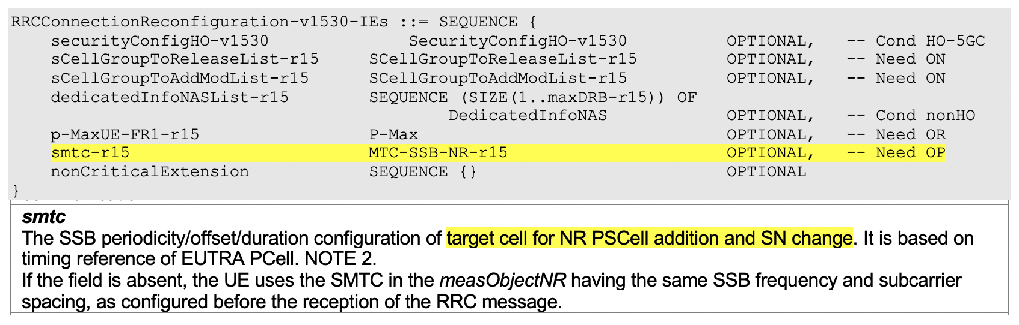  For NR PSCell change in MR-DC, the SMTC configuration is provided in secondaryCellGroup -> SpCellConfig -> reconfigurationWithSync.  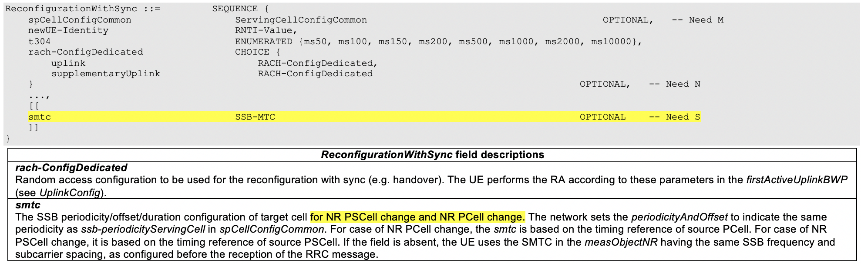  But for NR-DC, the SMTC configuration for NR PSCell addition is missing.
Summary of change: |  | Clarify that SN can provide the smtc configuration for PSCell addition based on MN PCell timing.  Impact analysis  Impacted 5G architecture options: NR-DC  Impacted functionality: PSCell Addition  Inter-operability:  - If the UE is implemented according to the CR and the network is not, the UE cannot know the timing information of the target PSCell for the initial cell search if UE is not configured with the measObjectNR (incl. SMTC configuration) having the same SSB frequency and subcarrier spacing before.  - If the network is implemented according to the CR and the UE is not, the UE cannot know the timing information of the target PSCell for the initial cell search if UE is not configured with the measObjectNR (incl. SMTC configuration) having the same SSB frequency and subcarrier spacing before.
Consequences if not approved: |  | For PSCell addtion in NR-DC, the UE cannot know the timing information of the target PSCell for the initial cell search if UE is not configured with the measObjectNR (incl. SMTC configuration) having the same SSB frequency and subcarrier spacing before.
Clauses affected: |  | 6.3.2
 |  | Y | N
Other specs |  |  | X | Other core specifications |  |  |  | TS/TR ... CR ...
affected: |  |  | X | Test specifications |  |  |  | TS/TR ... CR ...
(show related CRs) |  |  | X | O&M Specifications |  |  |  | TS/TR ... CR ...
Other comments:
This CR's revision history:

--------------------------------- [Change Start] ----------------------------

6.3.2 Radio resource control information elements

– CellGroupConfig
The CellGroupConfig IE is used to configure a master cell group (MCG) or secondary cell group (SCG). A cell group comprises of one MAC entity, a set of logical channels with associated RLC entities and of a primary cell (SpCell) and one or more secondary cells (SCells).
CellGroupConfig information element
-- ASN1START
-- TAG-CELLGROUPCONFIG-START

-- Configuration of one Cell-Group:
CellGroupConfig ::= SEQUENCE {
cellGroupId CellGroupId,

rlc-BearerToAddModList SEQUENCE (SIZE(1..maxLC-ID)) OF RLC-BearerConfig OPTIONAL, -- Need N
rlc-BearerToReleaseList SEQUENCE (SIZE(1..maxLC-ID)) OF LogicalChannelIdentity OPTIONAL, -- Need N

mac-CellGroupConfig MAC-CellGroupConfig OPTIONAL, -- Need M

physicalCellGroupConfig PhysicalCellGroupConfig OPTIONAL, -- Need M

spCellConfig SpCellConfig OPTIONAL, -- Need M
sCellToAddModList SEQUENCE (SIZE (1..maxNrofSCells)) OF SCellConfig OPTIONAL, -- Need N
sCellToReleaseList SEQUENCE (SIZE (1..maxNrofSCells)) OF SCellIndex OPTIONAL, -- Need N
...,
[[
reportUplinkTxDirectCurrent ENUMERATED {true} OPTIONAL -- Cond BWP-Reconfig
]]
}

-- Serving cell specific MAC and PHY parameters for a SpCell:
SpCellConfig ::= SEQUENCE {
servCellIndex ServCellIndex OPTIONAL, -- Cond SCG
reconfigurationWithSync ReconfigurationWithSync OPTIONAL, -- Cond ReconfWithSync
rlf-TimersAndConstants SetupRelease { RLF-TimersAndConstants } OPTIONAL, -- Need M
rlmInSyncOutOfSyncThreshold ENUMERATED {n1} OPTIONAL, -- Need S
spCellConfigDedicated ServingCellConfig OPTIONAL, -- Need M
...
}

ReconfigurationWithSync ::= SEQUENCE {
spCellConfigCommon ServingCellConfigCommon OPTIONAL, -- Need M
newUE-Identity RNTI-Value,
t304 ENUMERATED {ms50, ms100, ms150, ms200, ms500, ms1000, ms2000, ms10000},
rach-ConfigDedicated CHOICE {
uplink RACH-ConfigDedicated,
supplementaryUplink RACH-ConfigDedicated
} OPTIONAL, -- Need N
...,
[[
smtc SSB-MTC OPTIONAL -- Need S
]]
}

SCellConfig ::= SEQUENCE {
sCellIndex SCellIndex,
sCellConfigCommon ServingCellConfigCommon OPTIONAL, -- Cond SCellAdd
sCellConfigDedicated ServingCellConfig OPTIONAL, -- Cond SCellAddMod
...,
[[
smtc SSB-MTC OPTIONAL -- Need S
]]
}

-- TAG-CELLGROUPCONFIG-STOP
-- ASN1STOP

CellGroupConfig field descriptions
mac-CellGroupConfig
MAC parameters applicable for the entire cell group.
rlc-BearerToAddModList
Configuration of the MAC Logical Channel, the corresponding RLC entities and association with radio bearers.
reportUplinkTxDirectCurrent
Enables reporting of uplink and supplementary uplink Direct Current location information upon BWP configuration and reconfiguration. This field is only present when the BWP configuration is modified or any serving cell is added or removed. This field is absent in the IE CellGroupConfig when provided as part of RRCSetup message. If UE is configured with SUL carrier, UE reports both UL and SUL Direct Current locations.
rlmInSyncOutOfSyncThreshold
BLER threshold pair index for IS/OOS indication generation, see TS 38.133 [14], table 8.1.1-1. n1 corresponds to the value 1. When the field is absent, the UE applies the value 0. Whenever this is reconfigured, UE resets N310 and N311, and stops T310, if running. Network does not include this field.
sCellToAddModList
List of seconary serving cells (SCells) to be added or modified.
sCellToReleaseList
List of secondary serving cells (SCells) to be released.
spCellConfig
Parameters for the SpCell of this cell group (PCell of MCG or PSCell of SCG).

ReconfigurationWithSync field descriptions
rach-ConfigDedicated
Random access configuration to be used for the reconfiguration with sync (e.g. handover). The UE performs the RA according to these parameters in the firstActiveUplinkBWP (see UplinkConfig).
smtc
The SSB periodicity/offset/duration configuration of target cell for NR PSCell change, NR PCell change, and NR PSCell addition. The network sets the periodicityAndOffset to indicate the same periodicity as ssb-periodicityServingCell in spCellConfigCommon. For case of NR PCell change and NR PSCell addition, the smtc is based on the timing reference of (source) PCell. For case of NR PSCell change, it is based on the timing reference of source PSCell. If the field is absent, the UE uses the SMTC in the measObjectNR having the same SSB frequency and subcarrier spacing, as configured before the reception of the RRC message.

SCellConfig field descriptions
smtc
The SSB periodicity/offset/duration configuration of target cell for NR SCell addition. The network sets the periodicityAndOffset to indicate the same periodicity as ssb-periodicityServingCell in sCellConfigCommon. The smtc is based on the timing of the SpCell of associated cell group. In case of inter-RAT handover to NR, the timing reference is the NR PCell. In case of intra-NR PCell change (standalone NR) or NR PSCell change (EN-DC), the timing reference is the target SpCell. If the field is absent, the UE uses the SMTC in the measObjectNR having the same SSB frequency and subcarrier spacing, as configured before the reception of the RRC message.

SpCellConfig field descriptions
reconfigurationWithSync
Parameters for the synchronous reconfiguration to the target SpCell.
rlf-TimersAndConstants
Timers and constants for detecting and triggering cell-level radio link failure. For the SCG, rlf-TimersAndConstants can only be set to setup and is always included at SCG addition.
servCellIndex
Serving cell ID of a PSCell. The PCell of the Master Cell Group uses ID = 0.

Conditional Presence | Explanation
BWP-Reconfig | The field is optionally present, Need N, if the BWPs are reconfigured or if serving cells are added or removed. Otherwise it is absent.
ReconfWithSync | The field is mandatory present in case of SpCell change, PSCell addition, update of required SI for PSCell and AS security key change; otherwise it is optionally present, need M. The field is absent in RRCResume and RRCSetup messages.
SCellAdd | The field is mandatory present upon SCell addition; otherwise it is absent, Need M.
SCellAddMod | The field is mandatory present upon SCell addition; otherwise it is optionally present, need M.
SCG | The field is mandatory present in an SpCellConfig for the PSCell. It is absent otherwise.

--------------------------------- [Change End] -----------------------------

