**3GPP TSG-RAN WG2 Meeting #109bis R2-200xxxx**

**Online, April 2020**

**Agenda Item: 6.11.3**

**Source: MediaTek Inc. (Rapporteur)**

**Title: Outcome of [AT109bis-e][504][PowSav] CP/UE assistance Open and ASN.1 Issues**

**Document for: Discussion and decision**

1 Introduction

As all issues raised in the documents submitted to section 6.11.3 were concluded in [1], this document focusses solely on the remaining open class 3 RIL issues that were raised in [2], [3]. Please note: class 2 RIL issues will be discussed as part of the ASN.1 review thread according to the proposed conclusion in [2]

2 Class 3 RIL issues

|  |  |  |  |  |  |
| --- | --- | --- | --- | --- | --- |
| ID | Section | Description (detailed in [3]) | Proposed Change | Comments | Proposed Conclusion |
| Z110 | 5.7.4.3 Actions related to transmission of UEAssistanceInformation message | The fields inside drx-Preference and minSchedulingOffsetPreference are optional. | Add “optionally” before the setting of preferredDRX-LongCycle, preferredDRX-InactivityTimer, preferredDRX-ShortCycle, preferredDRX-ShortCycleTimer, preferredK0-SCS-15kHz, preferredK0-SCS-30kHz, preferredK0-SCS-60kHz, preferredK0-SCS-120kHz, preferredK2-SCS-15kHz, preferredK2-SCS-30kHz, preferredK2-SCS-60kHz, preferredK2-SCS-120kHz. | [Rapporteur] – The text will be updated to reflect the delta signalling agreements. This issue will be addressed as part of that change.  [Chenli] I agree with Rapporteur. We will update this part based on the agreements on the delta signalling.  [CATT] Agree with Rapporteur.  [OPPO] Agree with Rapporteur.  [ZTE]Agree with Rapporteur.  [ERI] Agree with Rapporteur, but does this also mean that we will clarify that omission means “no preference”, except on feature level? |  |
| N024 | – SIB2 | This is unnecessarily complicated: The intention seems to indicate whether “and” or “or” is used with the conditions when both evaluation criteria are present, and then the condition becomes “A OR notB” or “A AND notB”. This could be simply replaced by simple enumeration of “and” and “or” without a loss of generality. Reading the description in 38.304, it seems that the field is not even clearly used there: The text checks usage of “and” and if that doesn’t match, uses “or”. Therefore, this whole field is about whether to use “and” in the first place – otherwise UE uses either of the conditions. Therefore, the field could simply be ENUMERATED{true} for the usage of “and”, with “or” being used if the field is not configured. | Use the following: combineRelaxedMeasConditions-r16 ENUMERATED {true} OPTIONAL, -- Cond MultRelaxCriteria with the field description as relaxedMeasCondition When both lowMobilityEvaluation and cellEdgeEvaluation are present in SIB2, this parameter configures whether UE combines the two conditions when determining whether to relax measurements (see TS 38.304 [20], clause 5.2.4.X.0). | [Rapporteur] – Nokia’s solution is clear and elegant. Suggest to accept this change. An equivalent update to 38.304 will be needed as a result  [Chenli] I am OK with either changing it as suggested by Nokia or leaving as it is. The reason is:  In futher, we may define other criteria for this part (as proposed by some companies during study item phase). In this way, there may be more use case for this and/or issue. Keeping the current signalling structure will be helpful for the possible forward compatibility extension.  If Nokia’s solution is agreeable, I will update the 38.304 specification accordingly.  [CATT] We would be OK with Nokia’s proposed change.  [OPPO] Maybe we just need to update 38.304 to allign with the current field description.  [ZTE] Agree with the proposed change from Nokia and we think the proposed change is more forward compatible compared to the existing one if new relaxation condition is defined in the future.  [ERI] Agree with rapporteur, i.e. simplify as Nokia suggest, and update 38.304. |  |
| N023 | – CellGroupConfig | These field descriptions are very hard to read: The whole “inside/outside active time” is not easily understood (nor explained elsewhere in RRC), so suggest to simpälify the field descriptions. | Suggest to use the following simpler field descriptions: outsideActiveTimeToAddModList List of SCell groups to be added or modified for the use of the “Dormancy outside active time” as specified in TS 38.213 [13]. withinActiveTimeToAddModList List of SCell groups to be added or modified for the use of the “Dormancy within active time” as specified in TS 38.213 [13]. | [Rapporteur] – Not related to power saving, rather this belongs to DCCA discussions. Has been flagged to Hakan.  [Chenli] I suppose this belongs to power saving WI and DC/CA WI, as it is related to dormancy outside active time (which is introduced in DCP in power saving).  We are OK with Nokia’s suggestion to just refer to physical specification.  [CATT] Agree with Rapporteur.  [OPPO] Agree with Rapporteur.  [ZTE] Agree with the proposed change from Nokia to make the field description clearer.  [ERI] Agree with rapporteur, thanks for flagging Håkan. | No action |
| S403 | – PhysicalCellGroupConfig | “when the drx-onDurationTimer does not start” is ambiguous because usually it does not start. It is meant to be “should have started but does not start” | Indicates the UE to transmit periodic L1-RSRP report(s) when if the drx-onDurationTimer does not start because of DCI format 2-6 (see TS 38.321 [3], clause 5.7). If the field is absent, the UE does not transmit periodic L1-RSRP report(s) when the drx-onDurationTimer does not start. | [Rapporteur] – The reference to the MAC specification already clarifies ‘when the drx-onDurationTimer does not start’. We typically don’t duplicate conditions in different specifications.  [Chenli] We share the same view as Rapporteur. In MAC spec, the meaning of all parameters are captured clearly:  *ps-TransmitPeriodicL1-RSRP* (optional): the configuration to transmit periodic L1-RSRP report(s) during the time duration indicated by *drx-onDurationTimer* in case DCP is configured but associated *drx-onDurationTimer* is not started.  [CATT] Agree with rapporteur  [OPPO] – Agree with the proposed change since it is more clear.  [ZTE] Agree with the proposed change since it is more clear.  [ERI] Agree with rapporteur to not try to duplicate. |  |
| S404 | – PhysicalCellGroupConfig | Same issue as S403. “when the drx-onDurationTimer does not start” is ambiguous because usually it does not start. It is meant to be “should have started but does not start” | Indicates the UE to transmit periodic CSI report(s) when if the drx-onDurationTimer does not start because of DCI format 2-6 (see TS 38.321 [3], clause 5.7). If the field is absent, the UE does not transmit periodic CSI report(s) when the drx-onDurationTimer does not start. | [Rapporteur] – Same as S403  [Chenl] Same as above.  [CATT] Same as above.  [OPPO] – Same as S403  [ZTE] Agree with the proposed change since it is more clear.  [ERI] Same answer as for S403 |  |
| S406 | – UEAssistanceInformation | The Power saving information should be grouped alike for every UE assistance reporting feature | Create an IE as shown below PowerSavingAssistance-r16 ::= SEQUENCE {     drx-Preference-r16                  DRX-Preference-r16                  OPTIONAL,     maxBW-Preference-r16                MaxBW-Preference-r16                OPTIONAL,     maxCC-Preference-r16                MaxCC-Preference-r16                OPTIONAL,     maxMIMO-LayerPreference-r16         MaxMIMO-LayerPreference-r16         OPTIONAL,     minSchedulingOffsetPreference-r16   MinSchedulingOffsetPreference-r16   OPTIONAL,     releasePreference-r16               ENUMERATED {idle, inactive, idleOrInactive}         OPTIONAL,     nonCriticalExtension                SEQUENCE {}                         OPTIONAL } | [Rapporteur] – While this issue was marked as class 2, we have already discussed this in the first session and agreed that ‘No further grouping is considered.’  [Chenli] Agree with Rapporteur this has been discussed and concluded.  [CATT] Agree with Rapporteur.  [OPPO] – Agree with Rapporteur. We should follow the agreement in the first session.  [ZTE] Agree with Rapporteur.  [ERI] Agree with Rapporteur. | Rejected |
| Q003 | – SIB2 | The entire structure, use of need codes and presence conditions are confusing. It is our understanding that: In case of low mobility based relaxation, s-SearchDeltaP-r16 is mandatory present and t-SearchDeltaP-r16 is optional. In case of not-at-cell-edge based relaxation, at least one of s-SearchThresholdP-r16 and s-SearchThresholdQ-r16 shall be configured. We should capture too many logics here when they are sufficiently clear from 38.304, e.g. the relaxed measurement requires either low mobility based or not-at-cell-edge based condition to be configured. | Make the following changes - s-SearchDeltaP-r16 > mandatory present. - t-SearchDeltaP-r16 > need R - lowMobilityEvalutation-r16 > need R (remove the condition) - cellEdgeEvalutation-r16 > Need R (remove the condition) | [Rapporteur] – While the issue was marked as class 2, some of the aspects (s-SearchThreshold) were discussed in the PS WI. No strong view on the suggested need code changes. Unclear why s-SearchDeltaP is considered as mandatory while t-SearchDeltaP is considered optional.  [Chenli] I am a littler confuse about the comment, maybe the comment misunderstood the condition OptMandatory. Based on the latest agreement:  *When cellEdgeEvalutation is configured, SSearchThresholdP should be mandatory while SSearchThresholdQ is optional.*  I think we should only make the following change:  s-SearchThresholdP > mandatory  For the condition OptMandatory, I prefer to keep it, since we have the agreement:  *The network broadcasts corresponding parameters of relaxation triggering criteria to enable RRM measurement relaxation feature*We didn’t have such clarification in other specifications/parts.  [CATT] Regarding these fields, the current RRC spec is correctly implemented following RAN2#109-e recommendations:  **RRC rapporteur should be able to use this as a baseline and companies can provide further views over email:**  Proposal 17: The parameter SSearchDeltaP is optional and default value can be 6dB.  Proposal 12: The parameter TSearchDeltaP is optional, and the default value can be 1 minute or 60s.  If we keep the above proposals as a baseline, then the need code should remain unchanged and if the above parameters are absent, the default values will be used. Then the need code should be S. If we don’t want to follow the above proposals (i.e. there is no default value for the above parameters) and think if the parameter is absent, the parameter is deleted, then the need code is R. However, based on the current CR 38.304, there is no case where t-SearchDeltaP nd s-SearchDeltaP are not used within low-mobility criterion. Hence, there are only two options: 1) keep the current ASN.1 or 2) make both s-SearchDeltaP-r16 and t-SearchDeltaP-r16 mandatory.  [OPPO]  We also wonder why to consider s-SearchDeltaP-r16 as mandatory.  In the ASN.1 review, a class 2 issue related to the change of conditions for lowMobilityEvalutation-r16 and cellEdgeEvalutation-r16 is raised in RIL401 and the status is PropAgree. We would prefer to follow the proposed change based on RIL401.  [ZTE] (1) Agree that the s-SearchDeltaP-r16 should be OPTIONAL Need S since we have a default value defined in the field description part. (2)Agree with the proposed change in S401 about the presence condition of lowMobilityEvalutation and cellEdgeEvalutation.  [ERI]  Preference to keep s-SearchDeltaP-r16 optional with default value. That is the same as mandatory, but a litte bit more efficient.  PS: it was agreed: *When cellEdgeEvalutation is configured, SSearchThresholdP should be mandatory while SSearchThresholdQ is optional.* This means a default value for the RSRQ threshold is needed.  t-SearchDeltaP-r16 0: is put under low mobility trigger, but I do not think it is limited or specific for low mobility trigger, i.e. it should be one level up. |  |

3 Release assistance

The UE release assistance is intended to save power by shortening the time in connected mode, when the UE expects that it does not need to send or receive data in the near future. The UE may have higher layer information (app inactivated, screen off, etc) that can be used to quickly release the connection, instead of waiting for the NW to release the connection based on inactivity:

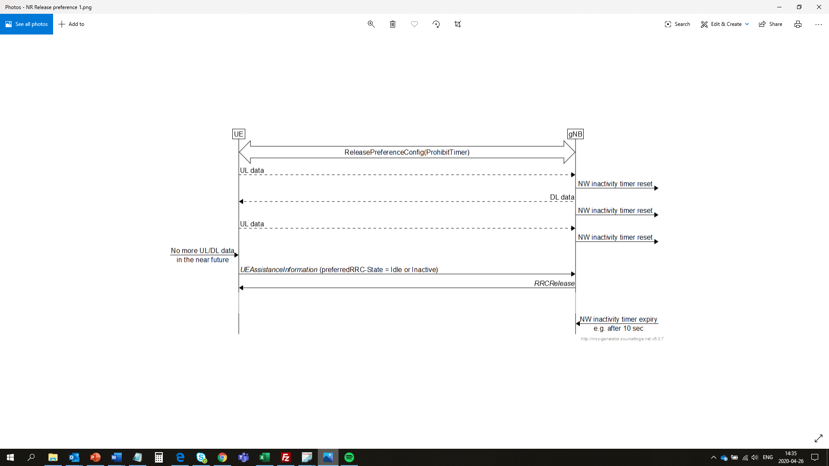

2.1 Reason for change

RAN2 has agreed that the UE can signal “connected” after the UE has signalled a preference to be released to “idle” or “inactive”. The “connected” cancels a previous release request. Some companies think there is a problem with “connected” signalling [4]:

1. When release assistance signalling is supported by the NW, and the UE indicates that it would like to be released, then typically the UE would be released immediately, unless there is a reason not to do that (e.g. there is DL data pending in the gNB that the UE was not aware of). But typically the UE would be released immediately, i.e. the purpose is to shorten the connected time. When the UE typically is released immediately then obvious “connected” signalling does not work, because before the UE can sent “connected”, the UE would be released already.
2. There can be cases when the UE is not released upon request, e.g. when there is DL data in the gNB. In such case the gNB does not release the UE, but sends the DL data, and the NW inactivity timer is reset. In case the UE is not immediately released by the UE, there is no need for the UE to send a cancellation, i.e. this creates uncessary signalling, which is a NW concern. Furthermore the UE may limit/delay itself in sending a second release request when there is no more data later, because the “connected” signalling will (re-)start the prohibit timer:

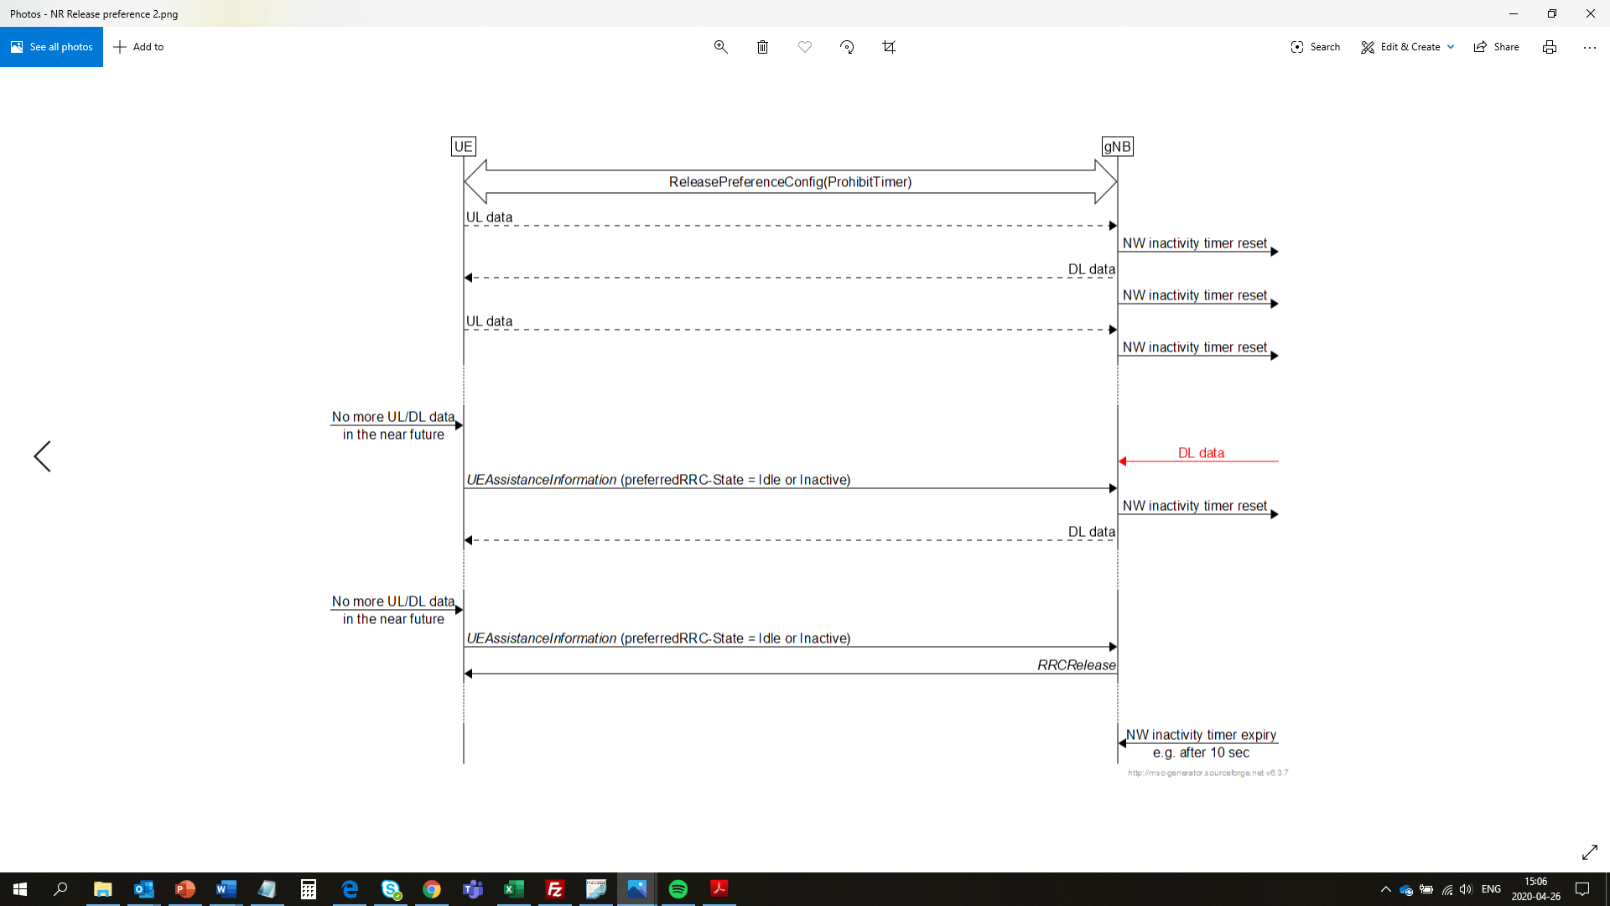

1. When the UE sends a release request, the UE starts the prohibit timer. When the prohibit timer is running the UE is not allowed to send a “connected” i.e. the UE cannot cancel. This means that the UE has to wait for expirty of the prohibit timer (unless a prohibit timer with value 0 is configured) until it can send a cancellation. During that time the NW may already have released the UE.
2. It has not been discussed, agreed nor specified what is the trigger for the UE to send a “connected” preference, i.e. when to cancel. For the release prefenrece, it has been agreed and it is specified that the UE can send a release preference when it does not expect more data to send or receive in the near future. It should be discussed what “connected” means, i.e. the UE expects more data to send or receive in the near future, or the UE has more UL data (this is already covered by BSR?) and/or expects more data date, or if the cancellation should be a generic “no preference” when a preference is omitted for other UAI preference signalling. Furthermore it should be specified whether the NW should wait for another release request from the UE after cancellation, or for how long the cancellation is valid.

Question 2.1: Do companies agree that issue 1, 2, 3, and 4 are valid? In case companies do not think that issues 1, 2, 3 are valid, companies are invited to clarify why:

1. The UE cannot cancel a previous release request, because it is typically released immediately
2. The UE sending a cancellation after prohibit timer expiry creates unnessary signalling
3. The UE waiting for the prohibit timer to expiry to send a cancellation may be released by the NW
4. It is unclear what cancellation means and how the NW should act on it

|  |  |  |
| --- | --- | --- |
| **Company** | **Valid cases** | **Comments** |
| Ericsson | 1, 2, 3, 4 | The main problem we see is the additional and unnecessary signalling due to cancellation. |
|  |  |  |
|  |  |  |
|  |  |  |
|  |  |  |
|  |  |  |
|  |  |  |
|  |  |  |
|  |  |  |
|  |  |  |

2.2 Possible way forward

In case companies agree that there is a reason for change, companies are invited to comment proposals that can resolve the issue:

**Option 1**: “connected” is removed from preferredRRC-State-r16 ENUMERATED {idle, inactive, connected, out of connected}

**Option 2**: “connected” signalling is under NW configuration

**Option 3**: “connected” signalling is only signalled when prohibit timer value is zero

|  |  |  |
| --- | --- | --- |
| **Company** | **Supported options** | **Comments** |
| Ericsson | 1, 2, or 3 | We think that option 3 makes the most sense, because without the prohibit timer the UE is free to send the cancellation.  An infinite prohibit timer avoids “connected” signalling, but it does not address the concerns with other prohibit timer value settings. In case an infinite timer is configured, and there is DL data in the gNB when the UE requests a release, then the UE would have to wait for NW inactivity timer to expire to be released. This is a limitation of an infinite prohibit timer, i.e. the UE does not get a second chance. |
|  |  |  |
|  |  |  |
|  |  |  |
|  |  |  |
|  |  |  |
|  |  |  |
|  |  |  |
|  |  |  |
|  |  |  |

4 Conclusion

Lorem ipsum

5 References

1. R2-2003127 - Summary of [Post109e#43][PowSav] UE Assistance and RRC open issues
2. R2-2003310 - RIL list TS 38.331 Rel-16 ASN.1 review file, phase 1
3. R2-2003309 - TS 38.331 Rel-16 ASN.1 review file, phase 1
4. [R2-2003289](https://www.3gpp.org/ftp/tsg_ran/WG2_RL2//TSGR2_109bis-e/Docs/R2-2003289.zip) - UE assistance for connection release, DISC, Ericsson, ZTE, Deutsche Telekom, RAN2#109bis-e