3GPP TSG-RAN WG2 Meeting #109bis-e R2-200xxxx
Electronic, April 20 – 30, 2020

Source: Qualcomm Incorporated
Title: Summary of email discussion [AT109bis-e][014][NR15] UE Cap Miscellaneous II
Document for: Decision
Agenda Item: 6.19

Introduction
This document summarizes the following email discussion.
(The list of companies below is incorrect. It should be “Ericsson, Huawei”.)
- [AT109bis-e][015][NR15] UE Cap Miscellaneous II (Qualcomm, ZTE, Mediatek, Huawei)
Scope: Treat R2-2003306, R2-2003307, R2-2003280, R2-2003281, R2-2003459, R2-2003460, R2-2003461, R2-2003462
Part 1: Determine which issues that need resolution, find agreeable proposals. Deadline: April 23 0700 UTC
Part 2: For the parts that are agreeable, discussion will continue to agree on CRs.

Discussion: Part 1 (by April 23 0700 UTC)
It is proposed to try to come to a set of agreeable proposals out of the documents listed above.

Undefined band combinations in UECapabilityInformation (R2-2003306)
This document requests RAN2 to confirm that band combinations advertised by UE in NR and E-UTRA UECapabilityInformation are supported by the UE and defined in RAN4 specifications (36.101, 38.101). The document also requests RAN2 to discuss if anything need to be captured in specifications on that regard.
Company name | Agree / Disagree | Comments
Qualcomm Incorporated | Agree, but. | We do not consider it is necessary to capture anything in our specifications. Band combinations defined by RAN4 is moving target and there are always cases where the legacy network in the field would see unknown band combinations reported by the UE.
Nokia | Disagree | Yes, we did not understand the real point of this contribution.
Intel | Same view as Qualcomm. | We agree with the intention, but do not see any need to capture in RAN2 spec.
CATT | Agree with QC. | Not sure if any changes are needed.
OPPO |  | The key point of this contribution is not very clear.  In general, we have not identify the reason for specification change yet.
Huawei | Agree with QC | We understand the band combinations advertised by UE are undoubtedly supported by the UE, and it would be the case that network may see unknown band combinations reported by the UE indicated by Qualcomm. So we don’t think we need to capture anything in the spec.
NTT DOCOMO | Same view as QC | Even though such a UE is found in the real network, it is not compliant with the 3GPP spec. So, we have nothing do here in the standard.

Bands in supportedBandListNR (R2-2003307)
This document requests RAN2 to confirm the UE that indicate support for certain band in supportedBandCombinationList (in RF-Parameters or RF-ParametersMRDC) also indicates this band in supportedBandListNR.
Company name | Agree / Disagree | Comments
Qualcomm Incorporated | Agree
Nokia | Agree | That was obvious and no CR was needed ;-)
Intel | Agree
CATT | Agree | Agree with Nokia.
OPPO | Agree
Huawei | Agree, but | Agree with Nokia that CR is not needed.
NTT DOCOMO | Agree, but | Also incline to Nokia’s view. The same issue also exists in LTE, if it is a valid concern.

Missing "Optional features without UE radio access capability parameters" (R2-2003280, R2-2003281)
These CRs try to clarify that CMAS and ETWS are optional feature without corresponding UE capability parameters.
Company name | Support / Not support | Comments
Qualcomm Incorporated | Support
Nokia | Not Support | Regulatory features are mandated by regulators/operators. It is just not needed to implement *both* CMAS and ETWS with the same region. We think the UE vendors understand this. Also, from NW perspective, everything is optional and what gets implemented depends on operators request. So, it does not make sense to mark it as optional now since anyway PWS is practically mandated by regulators in all regions.
Intel | Neutral | We are ok to go with majority view about adding this to the spec.
CATT | Support | We tend to support this change as it makes the cap clearer. From UE or network perspective we do not see much complexity.
OPPO | Support | Yes as Nokia mentioned, it could be mandatory in some country or region, but could be optional in other area like in China. So then from specification point view, it should be optional.
Huawei | Support | We agree that CMAS and ETWS are optional feature without capability signalling as in LTE, it is OK to clarify it in the spec.
NTT DOCOMO | Support | O.K as it is the same as in LTE. On the other hand, if we try to enhance the text from LTE, to reflect the practical status as commented by Nokia, we could add a note something like:  NOTE: Support of PWS is subject to the regulatory requirements in each region/country.

Correction on default Power class for FR2 (R2-2003459, R2-2003460)
These CRs try to specify that the UE not signalling the power class for FR2 means the UE supports the default power class as defined by RAN4, i.e. implement the same behaviour as FR1 today.
Company name | Support / Not support | Comments
Qualcomm Incorporated | Not support | This is not backward compatible to legacy network. Default UE capability in absence of signalled parameter should be avoided as much as possible.
Nokia | Not support | RAN4 has specified for FR2 in TS38.101-2 that the Power class 3 is default power class (also for FR2). So, the clarification is not required. Agree also that default UE capability in absence of signalled parameter should be avoided as much as possible for BC reasons.
Intel | Not support | Same view as Qualcomm.
CATT | No strong opinion
OPPO | Not support | NBC change (in this case, the main problem is it would be hard for legacy network to understand the absence case) should be avoided.
Huawei | Our CR | We would like to provide the history more: default UE power class for FR1 was introduced in 38.101-1 f40 and RAN2 correct it accordingly in 38.306-f50. Then default UE power class for FR2 was introduced in 38.101-2 f50, but it was not corrected in RAN2 spec.  Thus, the default UE power class for FR2 has been introduced from version f50 but we forgot to correct it in RAN2 spec. So we understand in our CR, we just want to align the RAN2 spec with RAN4 conclusion, instead of changing the functionality.
NTT DOCOMO | Not support | Same view as QC, Nokia, Intel, OPPO. We sent the guidance LS to RAN1/4 that default/implicit capability should be avoided, didn’t we?

Correction to the serving cell number for ENDC power class (R2-2003461, R2-2003462)
These CR try make the power class (the one signalled per band combination) to be applicable to three UL CA case.
Company name | Support / Not support | Comments
Nokia | Not support | This CR seems to implement a draft LS that was never agreed to be sent to RAN2 and how can we make an agreement in RAN2 to correct something that was only Noted in RAN4? We should just wait for RAN4 discussions to conclude, no?
Intel | Not support | Same view as Nokia.
CATT | No strong view | We agree with the intention of this CR. But on the other hand there seems to be limited risk with the current text. So we think majority’s view can be followed on this one.
OPPO | Not support | We can wait for formal LS from RAN4.
Huawei | Our CR | Based on RAN4 spec, e.g. Table 6.2B.1.3-1 in 38.101-3, DC_3C_n41A for three CCs has already been supported. So EN-DC power class UE capability needs to be applied to band combinations with three FR1 uplink serving cells. So we understand it is straightforward powerClass needs to be extended.  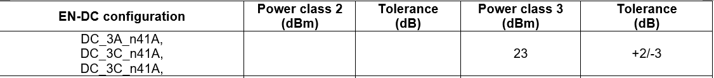  If companies really have concerns on RAN4 conclusion, we are ok to ask RAN4.  [Huawei2] Please allow me to clarify a bit more. The RAN4 R4-2002050 referred in our CR is only a draft LS and was not agreed in last RAN4 meeting. Actually we only say “Based on the RAN4 R4-2002050” in the coversheet but does not say it is agreed. The intention of this CR is just the content in R4-2002050, that RAN4 already specified the FR1 EN-DC combinations with 3CC uplink serving cells. No RAN4 LS comes to RAN2 since it seems reflected in RAN4 spec obviously. As showed below (from 38.101-3), the EN-DC combinations with 3 UL CCs are added and the NOTE4 should also be applied to these EN-DC combinations with 3 UL CCs. To align with RAN4 spec, we think this CR is needed.  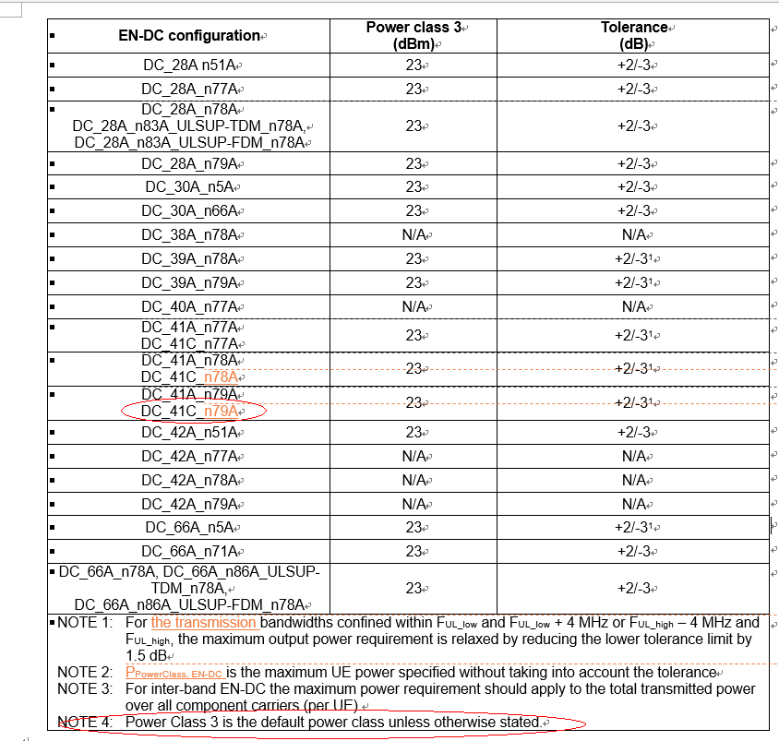
NTT DOCOMO | Not support | Same as Nokia/Intel. The cover sheet gives a fake news that R4-2002050 (LS) was agreed by RAN4, which is not true.

Proposal 1: xxxx

Discussion: Part 2
xxxxxxxxxx

Conclusion
xxxxxxxxxx

Reference
[1]

