3GPP TSG-RAN WG2 Meeting #109bis electronic R2-2004115
20th – 24th April, 2020

Agenda item: 5.2.2
Source: Huawei
Title: Summary of offline [002][NR15] 37340 corrections
Document for: Discussion and Decision

1. Introduction
This is a summary of offline discussion for the following documents:
SPS and CG in DC
R2-2003539 Correction on MAC description in TS 37.340 Huawei, HiSilicon CR Rel-15 37.340 15.8.0 0196 - F NR_newRAT-Core
R2-2003540 Correction on MAC description in TS 37.340 Huawei, HiSilicon CR Rel-16 37.340 16.1.0 0197 - A NR_newRAT-Core

SCG configuration
R2-2003689 Clarification on the SCG configuration handing in RRC_INACTIVE Huawei, HiSilicon CR Rel-15 37.340 15.8.0 0199 - F NR_newRAT-Core

- [AT109bis-e][002][NR15] 37340 corrections (Huawei)
Scope: Treat R2-2003539, R2-2003540, R2-2003689
Part 1: Decision whether to make corrections or not, identify agreeable corrections. Deadline: April 23, 0700 UTC.
Part 2: if agreeable, expected continuation to agree CRs.

2. Discussion

2.1 Correction on MAC description in TS 37.340 in R2-2003539
The reason for change is:
In TS 37.340, there is a description for MAC sublayer: “In MR-DC, semi-persistent scheduling (SPS) resources can be configured on both PCell and PSCell.”
There are two issues related to this description:
- In LTE, the terminology of SPS is for both DL and UL, but for NR, SPS is only for DL and for UL the terminology of configured grant (CG) is used.
- In LTE and NR, SPS and configured grant can be configured on SpCell as well as other serving cells on MCG/SCG, i.e. SCells. There is no other restriction for MR-DC in terms of configuration of SPS and configured grants.
Therefore, it is proposed to clarify that in MR-DC, semi-persistent scheduling (SPS) resources and configured grant (CG) resources can be configured on serving cells in both MCG and SCG.
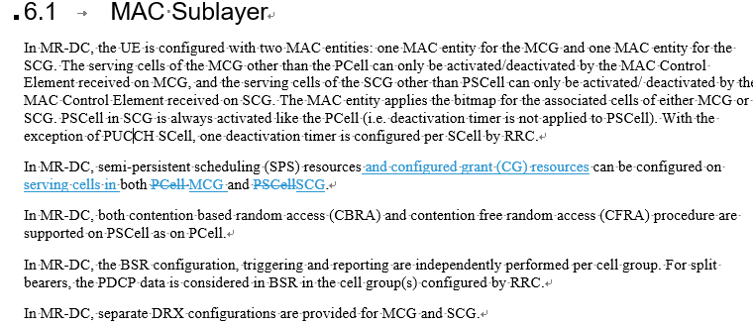
Q1) Do companies agree with the changes in the CR R2-2003539?
Company | Yes/No | Comments (if any)
Ericsson | No | The current specification is not incorrect. We do not think this change is necessary and consider it a text enhancement.
Samsung | Yes, but | Even though the current text is not incorrect, the proposed change enhance the quality. We can consider this in the rapporteur CR
MediaTek | Yes, but | The change is fine but is kind of minor. Thus we have same suggestion as Samsung that it could be in rapporteur CR.
TI | Yes, but | It is better to stick with the proper terminology for the sake of clarity. Ok with the suggestion from Samsung to have it in the Rapporteur CR
Huawei, Hisilicon | Yes | We are also fine to capture it in the rapporteur CR.
vivo | Yes | The proposed changes are better description than the current specification.
Apple | Yes, but | Same view as other companies. It can be in the rapporteur CR.
Intel | May be | Stage 2 does not have to go into all the details. The current specification is not incorrect. If there is support, it can be included in a rapporteur CR (if there is one).
OPPO |  | We actually wondering why stage 2 DC spec needs to capture the CG or SPS operation? I believe this has been captured in 38.300, maybe we can remove this whole sentence about CG and SPS thus there is no confusion.
Summary:
There are 9 companies who have provided their views, and 6 replied yes (or yes but), 1 replied No, 1 replied may be, and 1 asked some questions. It is a majority view to agree the changes and merge to the rapporteur.

2.2 Clarification on the SCG configuration handing in RRC_INACTIVE in R2-2003689
The reason for change is:
According to TS 37.340 Rel-15, the UE releases the SCG configuration when moving to RRC inactive:

In MR-DC with 5GC, the UE stores the PDCP/SDAP configuration when moving to RRC Inactive but it releases the SCG configuration.
According to TS 37.340 Rel-16, even when the UE does not support resuming with MR-DC, the UE stores the SCG configuration when moving to RRC inactive
:
In MR-DC with 5GC, the UE stores the PDCP/SDAP configuration and the SCG configuration when moving to RRC Inactive. During connection resumption, if the UE supports resuming with MR-DC, the UE can be configured to release, restore, or reconfigure the SCG configuration. Otherwise, it releases the SCG configuration.
According to this, a Rel-15 UE in a Rel-15 network will not behave like a Rel-16 UE in a Rel-15 network.

Therefore, it is proposed to clarify that in Rel-15 the UE stores the SCG configuration when moving to RRC Inactive and releases it during connection resumption (like in Rel-16 when the UE does not support resuming with MR-DC).
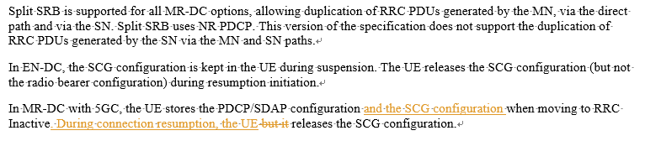
Q2) Do companies agree with the changes in the CR R2-2003689?
Company | Yes/No | Comments (if any)
Ericsson | No | The current specification is not incorrect. We do not think this change is necessary and consider it a text enhancement.
Samsung | Yes, but | Similar to Q1, we agree it is not essential but OK with including it in Rapporteur CR
MediaTek | Yes, but | The change is fine but is kind of minor. Thus we have same suggestion as Samsung that it could be in rapporteur CR.
TI | Yes, but | As in Q1, it is better to stick with the proper terminology for the sake of clarity. Ok with the suggestion from Samsung to have it in the Rapporteur CR
Huawei, Hisilicon | Yes | We are also fine to capture it in the rapporteur CR.
vivo | Yes | Similar to Q1, this is an enhancement of the current specification description
Apple | No | We donot think UE is required to store the SCG configuration when entering the INACTIVE state in Rel-15.
Intel | No | We don’t see any real difference in terms of external behaviour and it is not necessary to update this UE internal handling in stage 2.
OPPO | No | The added sentence seems confusion, why UE needs to store the SCG configuration given that it will releases the SCG configuration when performing resumption?
Summary:
There are 9 companies who have provided their views, and 5 replied yes (or yes but), 4 replied No.

3. Conclusion of Part 1 discussion
Summary of Correction on MAC description in TS 37.340 in R2-2003539:
There are 9 companies who have provided their views, and 6 replied yes (or yes but), 1 replied No, 1 replied may be, and 1 asked some questions. It is a majority view to agree the changes and merge to the rapporteur.

Summary of Clarification on the SCG configuration handing in RRC_INACTIVE in R2-2003689:
There are 9 companies who have provided their views, and 5 replied yes (or yes but), 4 replied No.

