3GPP TSG RAN WG1 #112bis-e R1-23xxxxx
e-Meeting, April 17th – April 26th, 2023

Agenda item: 9.17.16
Source: Moderator (NTT DOCOMO, INC.)
Title: [draft] Summary #1 on UE features for TEIs
Document for: Discussion and Decision

Introduction
This document summarizes contributions submitted to AI 9.17.16 regarding other UE features and captures the following email discussion.
[112bis-e-R18-UE_features-05] Email discussion on UE features for TEIs by April 26 – Shinya (DOCOMO)
- Check points: April 21, April 26

According to the initial UE features list from endorsed TEI proponents [1, 2], there are following feature groups for TEI18.
- FGs for SR periodicity
  - 55-1 additionalSR-Periodicities-r18
- FGs for 1-symbol PRS
  - 55-2 1-symbol PRS

FGs for SR periodicity
In [1], FGs for SR periodicity are captured as below.
Features | Index | Feature group | Components | Prerequisite feature groups | Need for the gNB to know if the feature is supported | Applicable to the capability signalling exchange between UEs (Sidelink WI only)”. | Consequence if the feature is not supported by the UE | Type  (the ‘type’ definition from UE features should be based on the granularity of 1) Per UE or 2) Per Band or 3) Per BC or 4) Per FS or 5) Per FSPC) | Need of FDD/TDD differentiation | Need of FR1/FR2 differentiation | Capability interpretation for mixture of FDD/TDD and/or FR1/FR2 | Note | Mandatory/Optional
55. TEI18 | 55-1 | additionalSR-Periodicities-r18 | Indicates whether the UE supports the following SR periodicities in the periodicityAndOffset parameter as specified in TS 38.331 [9]:  -5sl for 30 kHz SCS  -5sl and 10sl for 120 kHz SCS | N/A | Yes | N/A | If the network implements the TS 38.331 CR on new SR periodicities and the UE does not according to the capability indication, the network will not assign the new SR periodicities.  Legacy behaviour applies. | Per UE | No | No | N/A |  | Optional

Following inputs are provided in contributions for the RAN1#112bis-e meeting.
[1] | Ericsson | We note that there is no prerequisite feature group for the SR periodicities, hence the periodic SR feature is in legacy de facto supported “Per UE”. Hence, it is natural if this extension of that feature is also supported “Per UE”.
[3] | Nokia, NSB | - FG on support of extra slot periodicities to the periodicityAndOffset in SchedulingRequestResourceConfig for 120 kHz  - Candidate values {5, 10}  - FG on support of extra slot periodicity to the periodicityAndOffset in SchedulingRequestResourceConfig for 30 kHz  - Candidate value {5}

Discussion
Question 2-1:
- Companies are encouraged to provide views on whether/how to introduce FG 55-1, e.g., separate FG for 30kHz SCS and 120kHz SCS or report type as per UE with FR1/FR2 differentiation.
Company | Comment
ZTE | Support the proposal in [1] above. In legacy, different SR periodicities are supported for different SCSs, while there is no FR1/FR2 differentiation. Similarly, we think a single UE feature with per UE reporting without FR1/FR2 differentiation is sufficient.
Ericsson | Agree with ZTE but have not a strong view.
MediaTek | We think at least FR1/FR2 differentiation is needed to facilitate IODT process. FR2 may not be supported by some products and should not be mandated if UE wants to indicate the support for this new UE feature.
Nokia, NSB | If the capability is per UE without any differentiation then it implies UE will need to support the capability for both FRs as long as it supports at least one frequency band in each FR, even if there is no deployment requiring both. This creates an unnecessary barrier for feature availability in the field. One possibility is to have it as a single capability with component values as {120 kHz SCS, 30 kHz SCS, both}, in which case the corresponding periodicities are supported if the SCS is indicated as supported. In any case, UE should be allowed to be configured with legacy periodicities as well, which implies the legacy capability should be a pre-requisite to this one, as this is about additional periodicities.
Huawei, HiSilicon | “Need of FR1/FR2 differentiation” should be yes in order to facilitate UE report differently for different FR.
QC | We don’t support the above proposal. The type for a UE feature should be at least per band (if not with finer granularity type), given the potential UE testing differentiation among licensed, unlicensed, and NTN band.
Moderator | Summary of companies’ view  - Reporting type  - Per UE without FR1/FR2 differentiation: ZTE. E///  - With component values as {120 kHz SCS, 30 kHz SCS, both}: Nokia/NSB  - Per UE with FR1/FR2 differentiation: MTK, HW/HiSi  - Per band: QC  - Prerequisite FG  - Add FG4-1 (Basic UL control channel): Nokia/NSB?  - Moderator’s note: It seems not necessary to add FG4-1 since this FG is Mandatory without capability signalling  Given more companies see the necessity for the reporting type finer than Per UE without FR1/FR2 differentiation, following proposal is made  Proposal 2-1:  - Introduce FG 55-1 with one of the following reporting type  - Opt1: per UE with FR1/FR2 differentiation  - Opt2: per band
MTK | We agree with QC and hence prefer Opt2 with “per band”.
Ericsson | After some more internal discussion, it is a bit strange to have the capability per band for an additional SR periodicity for a given SRS. What if the band doesn’t support that SCS? It’s better to have two UE capabilities, one for 30 kHz SCS and another for 120 kHz SCS or as Nokia suggests a single capability with component values as {120 kHz SCS, 30 kHz SCS, both}.
Moderator | Summary of companies’ view  - Reporting type  - Per UE without FR1/FR2 differentiation: ZTE  - With component values as {120 kHz SCS, 30 kHz SCS, both}: Nokia/NSB, E///  - Per UE with FR1/FR2 differentiation: HW/HiSi  - Per band: QC, MTK  Since companies’ views are still divergent, companies are encouraged to provide view which options you have strong concern  Proposal 2-1-1:  - Introduce FG 55-1 with one of the following reporting type  - Opt1-1: per UE without FR1/FR2 differentiation with component values as {120 kHz SCS, 30 kHz SCS, both}  - Opt1-2: per UE with FR1/FR2 differentiation  - Opt2: per band  55. TEI18 55-1 additionalSR-Periodicities-r18 Indicates whether the UE supports the following SR periodicities in the periodicityAndOffset parameter as specified in TS 38.331 [9]: [-5sl for 30 kHz SCS] [-5sl and 10sl for 120 kHz SCS] N/A Yes N/A If the network implements the TS 38.331 CR on new SR periodicities and the UE does not according to the capability indication, the network will not assign the new SR periodicities. Legacy behaviour applies. [Per UE] [No] [No] [N/A] Optional with capability signaling
Huawei, HiSilicon | For reporting type, we prefer per UE with FR1/F2 differentiation as it achieves a tradeoff between flexibility and report overhead. We do not see the ambiguity issue mentioned by Ericsson because UEs that do not support the SCS should not report the corresponding SR periodicity. Per UE with component value is also acceptable if majority of the companies favor this.

FGs for 1-symbol PRS
In [2], FGs for 1-symbol PRS are captured as below.
Features | Index | Feature group | Components | Prerequisite feature groups | Need for the gNB to know if the feature is supported | Applicable to the capability signalling exchange between UEs (Sidelink WI only)”. | Consequence if the feature is not supported by the UE | Type  (the ‘type’ definition from UE features should be based on the granularity of 1) Per UE or 2) Per Band or 3) Per BC or 4) Per FS or 5) Per FSPC) | Need of FDD/TDD differentiation | Need of FR1/FR2 differentiation | Capability interpretation for mixture of FDD/TDD and/or FR1/FR2 | Note | Mandatory/Optional
55. TEI18 | 55-2 | 1-symbol PRS | 1. Support of 1-symbol PRS | 13-1 | No | n/a | 1-symbol PRS is not supported | per UE | n/a | n/a | n/a | Need for location server to know if the feature is supported | Optional with capability signaling

Following inputs are provided in contributions for the RAN1#112bis-e meeting.
[2] | ZTE | According to the above agreement, it is straightforward to introduce a new FG to let UE report this Rel-18 UE capability. The prerequisite should be the basic NR positioning FG, i.e. 13-1. Hence, this new FG will be common for all positioning methods and for both RRC_INACTIVE and RRC_CONNECTED states.
[3] | Nokia, NSB | - Support 1-symbol PRS with legacy comb sizes

Discussion
Question 3-1:
- Companies are encouraged to provide views on whether/how to introduce FG 55-2, e.g., report type as per UE without FDD/TDD and FR1/FR2 differentiation
Company | Comment
Intel | We are fine with the proposed version for FG 55-2 with a small modification – As suggested by Nokia, it’d be good to mention that this is supported for legacy comb sizes. Thus, we suggest to modify the description as:  Support of 1-symbol PRS with comb sizes from {2, 4, 6, 12}
ZTE | Support and confirm the yellow part.
mtk | 1, No need to support 1-symbol DL-PRS for all comb sizes. Remember that for positioning SRS, 1 symbol is supported for comb-2. Then we prefer to support 1 symbol DL-PRS for comb size = 2  2, 1 symbol with larger comb size has the potential problem of performance. The IFFT size is limited to reduce the SNR boosting capability. The 1 symbol DL-PRS also has limited observation range if comb size increases.
MediaTek2 | We prefer to have FR1/FR2 differentiation to facilitate IODT process.  One question: why gNB does not need to know whether this feature is supported.
Ericsson | Support, we also agree with Intel to include the comb sizes for clarity.  To MTK: the gNB is not aware that a particular UE is receiving PRS. This capability is for the location server.
Nokia, NSB | OK to have FR1/FR2 differentiation as commented by Mediatek.
ZTE2 | @mtk 1-symbol PRS with all existing comb sizes is the agreement.  @MediaTek2 We are fine to report this FG to gNB as well since PRS configuration also impacts TS 38.331 which is used for the feature of Propagation delay compensation for IIOT_URLLC. We are fine with FR1/FR2 differentiation.
Huawei, HiSilicon | OK to take per-UE reporting.
QC | We don’t support the above proposal. The type for a UE feature should be at least per band (if not with finer granularity type), given the potential UE testing differentiation among licensed, unlicensed, and NTN band.
Moderator | Summary of companies’ view  - Need for the gNB to know if the feature is supported  - No: ZTE  - Yes: [ZTE]  - Component:  - 1. Support of 1-symbol PRS with comb sizes from {2, 4, 6, 12}: Intel, E///  - 1. Support of 1-symbol PRS with comb size = 2: MTK  - Reporting type  - per UE without FDD/TDD and FR1/FR2 differentiation: ZTE  - per UE with FR1/FR2 differentiation: MTK, Nokia/NSB, [ZTE]  - per band: QC  Proposal 3-1:  - Introduce FG 55-2 with one of the followings  - Component 1: Support of 1-symbol PRS with comb sizes from {2, 4, 6, 12}  - Need for the gNB to know if the feature is supported: Yes  - Reporting type  - Opt1: per UE with FR1/FR2 differentiation  - Opt2: per band
MTK | - On Type, we agree with QC and hence prefer Opt2 with “per band”.  - On Need for the gNB to know, thank Ericsson for explanation. We don’t have strong view on this and is OK with “No.”
ZTE | - If UE vendors have strong concern, we are fine with ‘per band’ granularity.  - Regarding whether need gNB to know, we notice PRS can also be used for IIOT URLLC feature at gNB side. As shown in the Rel-17 FG 25-19a, PRS can be used for delay estimation. This feature is reported to gNB. If 1-symbol PRS is supported by the UE, it is better to let gNB know in our view. Then, gNB can configure 1-symbol PRS according to 38.331.  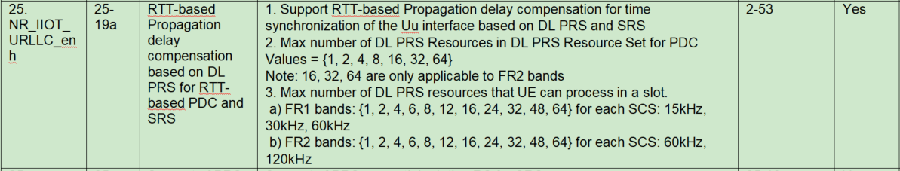  The existing 38.331:  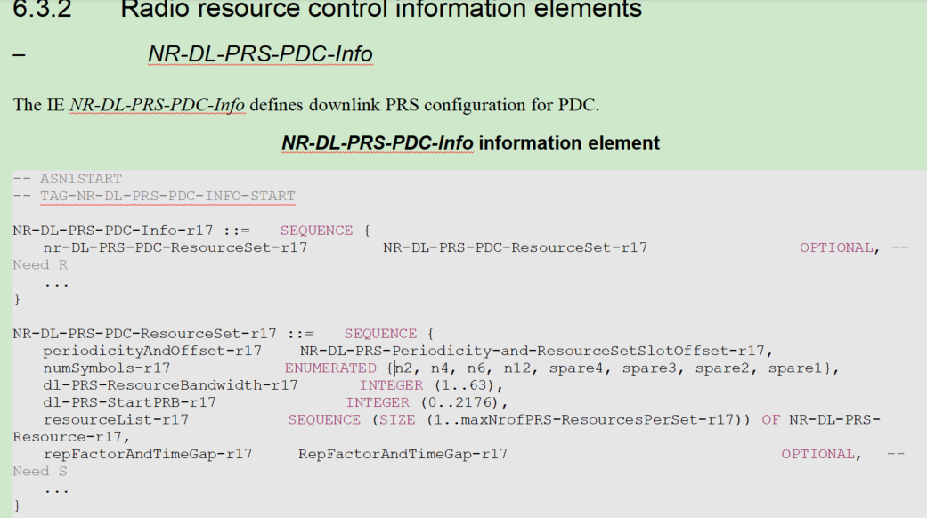
Qualcomm | - A UE reports per-band PRS processing capabilities. This includes the number of PRS resources the UE can process per slot:  - Max number of DL PRS resources that UE can process in a slot under it  - FR1 bands: {1, 2, 4, 6, 8, 12, 16, 24, 32, 48, 64} for each SCS: 15kHz, 30kHz, 60kHz  - FR2 bands: {1, 2, 4, 6, 8, 12, 16, 24, 32, 48, 64} for each SCS: 60kHz, 120kHz  - With the new feature of single-symbol PRS, the network may try to squeeze in a slot more resources compared to what was possible before.  - Compared to comb-N/N-symbols (PRS patterns up to rel-17), comb-N/1-symbol can fit N times more resources in a slot using the same overhead.  - Similarly, a UE might also be able to process more single-symbol PRS resources in a slot compared to the legacy PRS patterns.  - So, this FG would make sense to be kept per band and add actually also the following 2 components so that the UE doesn’t underreport its processing capabilities in a band:  - “Max number of single-symbol DL PRS resources it can process in a slot inside a MG” and “Max number of single-symbol DL PRS resources it can process in a slot outside a MG” with the legacy values:  FR1 bands: {1, 2, 4, 6, 8, 12, 16, 24, 32, 48, 64} for each SCS: 15kHz, 30kHz, 60kHz  FR2 bands: {1, 2, 4, 6, 8, 12, 16, 24, 32, 48, 64} for each SCS: 60kHz, 120kHz  Such components are naturally reported per-band, following the legacy PRS processing capabilities.  Now, in the case companies are not convinced that the new components would be needed, we think that the per-band reporting is still useful: If a UE considers supporting the single-symbol PRS in a band, it may also consider bumping up, either way, the number of single-symbol PRS resources it can process in a slot in that given band only, but it may not be able to do so across all the bands. So, having a per-band single-symbol PRS capability would allow the UE to match better its PRS processing capabilities in that corresponding band.
Moderator | Summary of companies’ view  - Need for the gNB to know if the feature is supported  - No: MTK  - Yes: ZTE  - Component:  - 1. Support of 1-symbol PRS with comb sizes from {2, 4, 6, 12}: Intel, E///  - 1. Support of 1-symbol PRS with comb size = 2: MTK  - 2. Max number of single-symbol DL PRS resources it can process in a slot inside a MG: QC  - FR1 bands: {1, 2, 4, 6, 8, 12, 16, 24, 32, 48, 64} for each SCS: 15kHz, 30kHz, 60kHz  - FR2 bands: {1, 2, 4, 6, 8, 12, 16, 24, 32, 48, 64} for each SCS: 60kHz, 120kHz  - 3. Max number of single-symbol DL PRS resources it can process in a slot outside a MG: QC  - FR1 bands: {1, 2, 4, 6, 8, 12, 16, 24, 32, 48, 64} for each SCS: 15kHz, 30kHz, 60kHz  - FR2 bands: {1, 2, 4, 6, 8, 12, 16, 24, 32, 48, 64} for each SCS: 60kHz, 120kHz  - Reporting type  - per UE without FDD/TDD and FR1/FR2 differentiation: ZTE  - per UE with FR1/FR2 differentiation: MTK, Nokia/NSB, [ZTE]  - per band: QC, MTK, [ZTE]  Based on the comments, proposals is updated as follows  Proposal 3-1-1:  - Introduce FG 55-2 as follows  55. TEI18 55-2 1-symbol PRS 1. Support of 1-symbol PRS with comb sizes from {2, 4, 6, 12} [2. Max number of single-symbol DL PRS resources it can process in a slot inside a MG FR1 bands: {1, 2, 4, 6, 8, 12, 16, 24, 32, 48, 64} for each SCS: 15kHz, 30kHz, 60kHz FR2 bands: {1, 2, 4, 6, 8, 12, 16, 24, 32, 48, 64} for each SCS: 60kHz, 120kHz] [3. Max number of single-symbol DL PRS resources it can process in a slot outside a MG FR1 bands: {1, 2, 4, 6, 8, 12, 16, 24, 32, 48, 64} for each SCS: 15kHz, 30kHz, 60kHz FR2 bands: {1, 2, 4, 6, 8, 12, 16, 24, 32, 48, 64} for each SCS: 60kHz, 120kHz] 13-1 [Yes/No] n/a 1-symbol PRS is not supported per band n/a n/a n/a Need for location server to know if the feature is supported Optional with capability signaling
Huawei, HiSilicon | For the new component 2 and component 3, we do not mind adding a separate set of values in the capability reporting, however, we do not think inside MG and outside MG should be in the same FG. They should be different FGs, and RRC_INACTIVE state should also be added.  For the whether gNB needs to know, if the reason is PDC, we should have another FG, reported to gNB seperately.  For per UE/per band, OK to take per band as well.  So overall we should have the following proposal  55. TEI18 55-2a 1-symbol PRS for MG-based measurement in RRC_CONNECTED state 1. Support of 1-symbol PRS with comb sizes from {2, 4, 6, 12} [2. Max number of single-symbol DL PRS resources it can process in a slot inside a MG FR1 bands: {1, 2, 4, 6, 8, 12, 16, 24, 32, 48, 64} for each SCS: 15kHz, 30kHz, 60kHz FR2 bands: {1, 2, 4, 6, 8, 12, 16, 24, 32, 48, 64} for each SCS: 60kHz, 120kHz] 13-1 No n/a 1-symbol PRS is not supported per band n/a n/a n/a Need for location server to know if the feature is supported Optional with capability signaling  55. TEI18 55-2b 1-symbol PRS for outside MG in RRC_CONNECTED state 1. Support of 1-symbol PRS with comb sizes from {2, 4, 6, 12} [2. Max number of single-symbol DL PRS resources it can process in a slot outside a MG FR1 bands: {1, 2, 4, 6, 8, 12, 16, 24, 32, 48, 64} for each SCS: 15kHz, 30kHz, 60kHz FR2 bands: {1, 2, 4, 6, 8, 12, 16, 24, 32, 48, 64} for each SCS: 60kHz, 120kHz] 27-3-3 No n/a 1-symbol PRS is not supported per band n/a n/a n/a Need for location server to know if the feature is supported Optional with capability signaling  55. TEI18 55-2c 1-symbol PRS in RRC_INACTIVE state 1. Support of 1-symbol PRS with comb sizes from {2, 4, 6, 12} [2. Max number of single-symbol DL PRS resources it can process in a slot outside a MG FR1 bands: {1, 2, 4, 6, 8, 12, 16, 24, 32, 48, 64} for each SCS: 15kHz, 30kHz, 60kHz FR2 bands: {1, 2, 4, 6, 8, 12, 16, 24, 32, 48, 64} for each SCS: 60kHz, 120kHz] 27-6 No n/a 1-symbol PRS is not supported per band n/a n/a n/a Need for location server to know if the feature is supported Optional with capability signaling  55. TEI18 55-2d 1-symbol PRS for PDC 1. Support of 1-symbol PRS with comb sizes from {2, 4, 6, 12} [2. Max number of single-symbol DL PRS resources it can process in a slot outside a MG FR1 bands: {1, 2, 4, 6, 8, 12, 16, 24, 32, 48, 64} for each SCS: 15kHz, 30kHz, 60kHz FR2 bands: {1, 2, 4, 6, 8, 12, 16, 24, 32, 48, 64} for each SCS: 60kHz, 120kHz] 25-19a Yes n/a 1-symbol PRS is not supported per band n/a n/a n/a Optional with capability signaling

Conclusions
To be updated

References
[1] R1-2302920 UE feature for agreed TEI-18 on SR periodicity Ericsson
[2] R1-2303283 UE feature on support of 1-symbol PRS ZTE
[3] R1-2302899 Initial views on UE features for TEI-18 Nokia, Nokia Shanghai Bell

