3GPP TSG RAN WG1 Meeting #112 bis-e [R1-2303887](https://www.3gpp.org/ftp/TSG_RAN/WG1_RL1/TSGR1_112b-e/Docs/R1-2303887.zip)

**e-meeting, April 17 - 26th, 2023**

**Source: Moderator (CATT)**

**Title: FL Summary for Rel-17 Maintenance on NR Positioning Enhancements**

**Agenda item: 7.2**

**Document for: Discussion and Decision**

# Introduction

This document provides a summary of the issues related to Rel-17 Maintenance on NR Positioning Enhancements under AI 7.2.

[112bis-e-R17-Pos-01] Email discussion on Rel-17 positioning maintenance by April 20 – Ren (CATT)

Guideline from RAN1 Chairman:

* *First two days of RAN1#112bis-e will be used to determine which issues to handle during the rest of the meeting.*
* *Companies are recommended to provide their initial views by 11:59pm (UTC) on Day1 of RAN1#112bis-e.*

# Drop of SRS transmission

**Background**

TS 38.214 Clause 6.2.1.4 defines:

*If the transmission of SRS for positioning outside the initial BWP in RRC_INACTIVE mode along with the switching time, indicated in higher layer parameter switchingTimeSRS-TX-OtherTX, in unpaired spectrum, subject to UE capability, collides in time domain with other DL signals or channels or UL signals or channels, the SRS for positioning transmission is dropped in the symbol(s) where the collision occurs.*

**Submitted Proposal/draft CR**

**(Nokia, R1-2302938/R1-2302939) Proposal 1**: Endorse the CR in R1-2302938 for the following change:

If the transmission of SRS for positioning outside the initial BWP in RRC_INACTIVE mode along with the switching time, indicated in higher layer parameter *switchingTimeSRS-TX-OtherTX*, in unpaired spectrum, subject to UE capability, collides in time domain with other DL signals or channels or UL signals or channels, the SRS for positioning transmission is dropped in the symbol(s) where the collision occurs and in the symbol(s) necessary for the UE to switch to receive the other DL signals or channels or transmit UL signals or channels. If the transmission of SRS for positioning outside the initial BWP in RRC_INACTIVE mode along with the switching time, indicated in higher layer parameter *switchingTimeSRS-TX-OtherTX*, in paired spectrum or SUL band, subject to UE capability, collides in time domain with UL signals or channels on the same carrier, the SRS for positioning transmission is dropped in the symbol(s) where the collision occurs and in the symbol(s) necessary for the UE to switch to transmit the UL signals or channels.. The SRS resource for positioning outside the initial BWP in RRC_INACTIVE mode is configured in the same band and CC as the initial UL BWP.

FL Comments

TS 38.214 Clause 6.2.1.4 has defined that the rule for dropping SRS for positioning transmission when SRS transmission collides in time domain with other DL signals/channels or UL signals/channels occurs. It says if the transmission of SRS for positioning outside the initial BWP in RRC_INACTIVE mode along with the switching time collides with other DL/UL signals/channels, SRS transmission is dropped. Nokia observed in [1] that observes that “The current specification is unclear how the UE can switch back to the initial UL BWP for transmission/reception of colliding signals/channels”. To address this issue, Nokia suggested the changes mentioned above. In FL’s view, on one hand, clarification could be helpful since the specification does not explicitly define whether to drop the SRS transmissions when UE switches to receive/transmit the other DL/UL signals or channels. On the other hand, it is expected that all UL transmissions (including SRS for positioning) to be interrupted during RF switching times by default. Interested companies are invited to share their views on the proposed changes.

**Q&A 2-1: What is your view on the changes proposed in R1-2302938/R1-2302939 [1,2]?**

|  |  |  |  |
| --- | --- | --- | --- |
| **Company** | **Yes** | **No** | **Additional comments** |
| Vivo |  | No | Based on the first sentence in the paragraph, the collides have considered the SRS transmission symbol and switching time. So, in this case, there is no switching time that can be along with since SRS has been dropped when collide in time domain with other DL signals or channels or UL signals or channels,?  If the transmission of SRS for positioning outside the initial BWP in RRC_INACTIVE mode along with the switching time, collides in time domain with other DL signals or channels or UL signals or channels… |
| Huawei, HiSilicon |  |  | Agree with FL comments  It says if the transmission of SRS for positioning outside the initial BWP in RRC_INACTIVE mode along with the switching time collides with other DL/UL signals/channels, SRS transmission is dropped.  The spec is clear that both time of switching to SRS transmission and switching back to initial UL BWP should be considered, when deciding whether/which part of the SRS is dropped or not. |
| CATT |  |  | It seems the clarification could be helpful but not essential. |
| Nokia/NSB | Yes |  | Sorry but there seems to be a fundamental misunderstanding about the text. The text currently says that if the SRS + switching time collides with another DL/UL signal or channel that the SRS is dropped in the collision. Our understanding of the behavior RAN1 intended to specify is SRS + switching time collides with DL/UL signal + switching time = SRS dropped. **However, you can’t have a collision between this 2nd switching time and SRS in the current wording of the spec.** The current spec says if something collides with a DL/UL signal or channel then some UE behavior occurs. In the problem scenario we point out there are symbols where there is no direct collision with the DL/UL signal or channel.  To vivo, Huawei, CATT: Can you explain how the current wording says SRS + switching time collides with DL/UL signal + switching time = SRS dropped? There simply isn’t a collision in the switching time for the DL/UL signal based on the current spec wording. We are open to alternative wording on the change but there is something broken in the current spec. |
| Qualcomm |  |  | We agree with vivo, Huawei, CATT. I am trying to understand what Nokia is suggesting as a problem above and still I don’t fully grasp it.  In Nokia’s question:  “Can you explain how the current wording says SRS + switching time collides with DL/UL signal + switching time = SRS dropped?”  Can Nokia explain whether in their question the 2nd switching time, i.e. in the “DL/UL signal + **switching time**”, means the time the UE needs to switch back from the SRS in order to receive the other DL/UL signal? If yes, we think that it is clear already from the specification. If either the switching time to tune towards the SRS, or tune back from the SRS collides, then SRS is dropped. |
| Intel |  | No | Same view as vivo and others that “along with the switching time” includes any switching back from SRS transmission. |
| Nokia/NSB_2 |  |  | To QC, yes in our question we mean the time for the UE to switch back from the SRS to receive/transmit the other DL/UL signal.  The current text is in the following format: If X collides in time domain with Y then UE does Z.  The collision scenario we are discussing is the switching time (to go back to transmit/receive UL/DL signal) colliding with the SRS. However, this does not trigger the condition “If X collides with Y” based on the current wording. That is because in the current spec it says that something must collide in time domain with the DL/UL signal or channel. The switching time in order to get back to transmit that DL/UL signal or channel clearly can’t collide in the time domain with the DL/UL signal or channel. We can also see this in Figure 2 from our Tdoc R1-2302939:    I think we all agree on the intended UE behavior but unfortunately that is not aligned with what the spec says at the current time. |
| Huawei, HiSilicon2 |  |  | Reply to Nokia:  The current spec is interpreted as  If the sum duration of switching time (to) + SRS transmission + switching time (back) collides with other DL/UL transmission, then SRS is dropped, which is also used for other cases, e.g. SRS carrier switching. |
| FL |  |  | Based on the feedback received *by 11:59pm (UTC) on Day1*, it appears that the proponent is the only one who believes that the proposed clarification is necessary, while the other five companies are unconvinced of its importance. In Chairman’s guideline, “*First two days of RAN1#112bis-e will be used to determine which issues to handle during the rest of the meeting*”. My undersatdning is that whether we will handle the issue in this meeting depends on whether the proponent can persuade the majority companies the need of the proposed changes before the end of the two days period. |
| Nokia/NSB_3 |  |  | Reply to Huawei:  Thanks for the discussion. Actually I fully agree with what you wrote above. However the switching time (back) does not collide with the other DL/UL transmission. The switching time back collides with the SRS. This is our point. Huawei and others seem to interpret the existing spec to say: switching time (to) + SRS transmission + switching time (back) collides with switching time (to) + DL/UL transmission + switching time (back). However, that is not what it says as you write above and this is what we intend to fix. |
| Huawei, HiSilicon |  |  | To Nokia:  The switching time back can be counted from the last SRS symbol in the SRS transmission.  For example, if UE is about to transmit SRS on symbol 7 & 8, and the switching time is 4 symbols (140us), then the total time span for the purpose of SRS transmission including switching time should be from symbol 3 – symbol 12. If on symbol 3 to symbol 12, UE is expected to transmit or receive anything, then the SRS transmission should not happen in the first place.  The Rel-16 spec on SRS carrier switching is written as below, which can be used as the baseline assumption when determining the collision of SRS transmission including any switching time.  For a carrier of a serving cell with slot formats comprised of DL and UL symbols, not configured for PUSCH/PUCCH transmission, the UE shall not transmit SRS whenever SRS transmission (including any interruption due to uplink or downlink RF retuning time [11, TS 38.133] as defined by higher layer parameters *switchingTimeUL* and *switchingTimeDL* of *SRS-SwitchingTimeNR)* on the carrier of the serving cell and PUSCH/PUCCH transmission carrying HARQ-ACK/positive SR/RI/CRI/SSBRI and/or PRACH happen to overlap in the same symbol and that can result in uplink transmissions beyond the UE's indicated uplink carrier aggregation capability included in [13, TS 38.306]. |

# PRS reduced samples

**Background**

The following agreement was made in RAN1#108e:

|  |
| --- |
| **Agreement**  The M-sample indication is applicable for all concurrent NR positioning methods and for all positioning frequency layers. |

The above agreement was correctly captured in TS 38.214. In [3], ZTE pointed out in the capability of PRS reduced sample in RRC_connected state is actually *per band*, which may result in the situation where M-sample indication is not applicable for all positioning frequency layers.

**Submitted draft CR in R1-2303274 [3]**

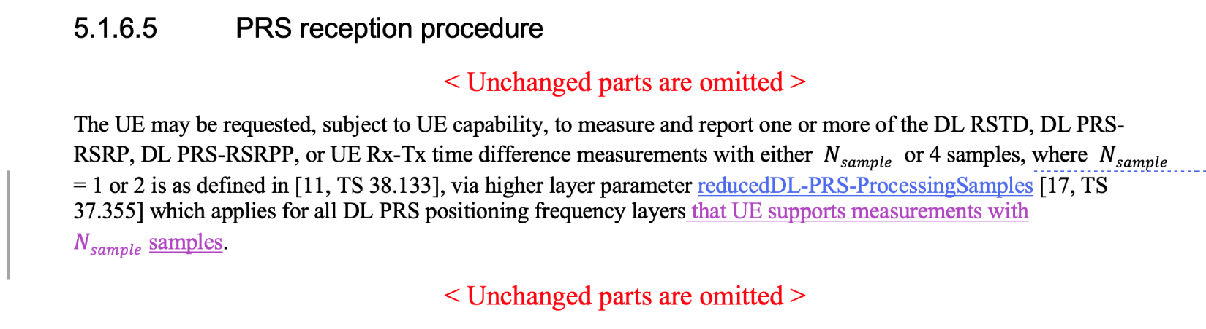

FL Comments

In FL’s view, clarification seems needed. Interested companies are invited to share their views on the proposed changes.

**Q&A 3-1: What is your view on the changes proposed in R1-2303274[3]?**

|  |  |  |  |
| --- | --- | --- | --- |
| **Company** | **Yes** | **No** | **Additional comments** |
| vivo | Yes |  |  |
| Huawei, HiSilicon |  |  | The parameter change is OK for editor alignment CR.  The second change is different from the discussion in RAN1#108-e, where “all positioning frequency” was agreed without any condition. If one PFL is on a band UE supports reduced samples, and another PFL is on a band that UE does not support reduced samples, network should not request reduced samples. The reason is that for this case the measurement latency is not reduced significantly.  **Agreement**  The M-sample indication is applicable for all concurrent NR positioning methods and for all positioning frequency layers |
| ZTE | Yes |  | The clarification is needed.  It seems Huawei and us have different understanding. In Huawei’s view, once the UE does not support Reduced sample in one band, the UE should not be configured with reduced sample in all bands. In such case, why the UE capability is per band granularity? |
| CATT | Yes |  | It seems there is a controversy between RAN1’s agreement on the applicability of M-sample indication and the per-band capability. |
| Nokia/NSB |  |  | Our understanding is that the current spec relies on the network not to request M-sample processing if the UE doesn’t support it for all PFLs it is configured with. This seems inline with RAN1’s prior agreement.  ZTE’s proposal seems to be more in line with the intented functionality from the UE capability discussion but we are not sure that at this stage we need to make this type of change as the spec is not broken but maybe not fully optimized. |
| Qualcomm |  | No | Even though we understand ZTE’s view, we prefer to keep the spec as is now, and not introduce this additional functionality |
| Intel |  | No | Similar virew as QC; we understand the motivation, but does not seem to be an essential correction. |
| ZTE2 |  |  | Now, we have two interpretations for the current specifications:   * Alt.1: once UE does not support reduced samples in one band, UE should not be configured with the reduced samples in all bands.   + Huawei (per band UE capability seems meaningless, per UE should be better) * Alt.2: the configured reduced sample should only be applicable for the band(s) that UE support the feature   + ZTE   @Intel and QC, which one is your understanding ? without the clarification, the feature is not even workable. |
| FL |  |  | Based on the feedback received *by 11:59pm (UTC) on Day1*, there are three companies believe that the proposed clarification is necessary, while the other four ompanies are unconvinced of its importance. Based on the meeting guideline, “*First two days of RAN1#112bis-e will be used to determine which issues to handle during the rest of the meeting*”. My undersatdning is whether we will handle the issue in this meeting depends on whether the proponent can persuade the majority companies the need of the proposed changes before the end of the two days period. |
| Huawei, HiSilicon2 |  |  | To ZTE:  Our intention was clearly misinterpreted by ZTE. You should not have twisted the counter-argument, which is based on standing agreements, to make your proposal seemingly more reasonable.  “Per UE” request does not mean that “per band” capability reporting is meanleass or that “per UE” capability is better.  Capability exchange happens even before assistance data transfer, which is why UE should provide its capability before any positioning procedure.  If in some cases, network deploys PRS in multiple bands, on some of which UE supports reduced samples and on some of which UE does not support reduced samples, and UE may even support PRS processing on bands network does not support at all. The current procedure simply tells network if it expects a low latency service with reduced samples, then just provide the assistance data on the bands that UE supports reduced samples.  On other hands, if some positioning frequency layers (bands) require 4 samples, while some require only 1 sample, the overall latency will be dominated by the 4-sample positioning frequency layers, and the overall latency saving is not very useful. Similar discussion happens in RAN1#108-e on the discussion whether the reduced samples can be requested per positioning method, and it was clarified, with that the overall latency cannot be reduced, and that two LPP sessions for two separate LCS requests should be used. |
| ZTE3 |  |  | To Huawei, thanks for the further clarification. I think the thing is clearer if companies have the same understanding. In such case, I suggest make the following as a conclusion to avoid any ambiguity.  **Proposed conclusion:**  A UE can be provided with higher layer parameter *reducedDL-PRS-ProcessingSamples* only if the UE supports measurements with $N_{sample}$ samples in all bands of configured PFLs.  To FL, our draft CR includes two parts, where one is to align the parameter name, it should be fine. |

# Measurement Gap Activation Request

**Background**

In [4], ZTE proposes the clarification in TS 38.214 *that UE is only expected to request one of the preconfigured measurement gap if the UE is configured by the network to request* based on the following changes were made to TS 38.321 in RAN2#121 [5]:

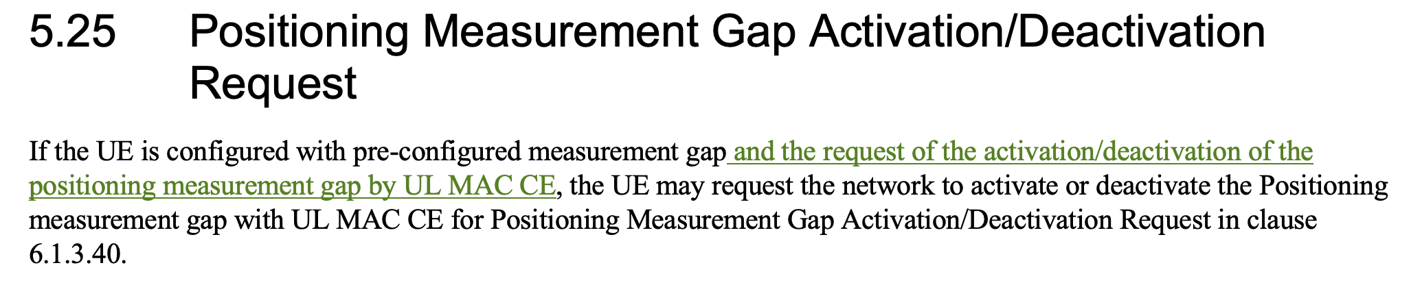

**Submitted Proposal/draft CR [4]**

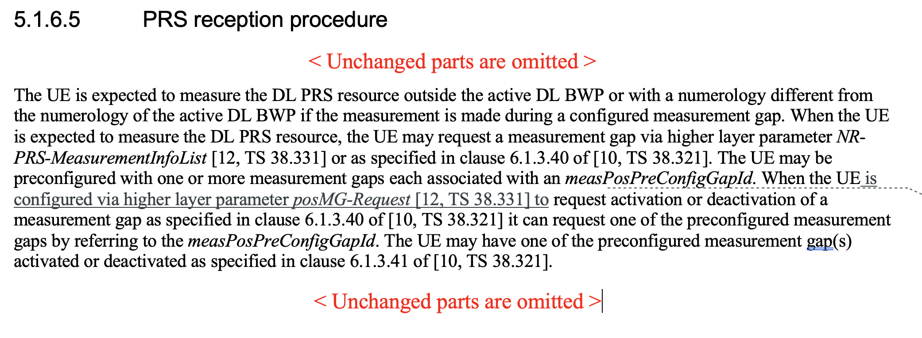

**Q&A 4-1: What is your view on the changes proposed in R1-2303275[4]?**

|  |  |  |  |
| --- | --- | --- | --- |
| **Company** | **Yes** | **No** | **Additional comments** |
| vivo |  | No | Not essential |
| Huawei, HiSilicon |  | No | We do not think current RAN1 spec is wrong.  The behavior “when the UE requests … according to TS 38.321” is sufficient from phy perspective, as MAC layer receives introduction from RRC layer where the parameter posMG-Request is specified as the condition in the RRC procedure.  This parameter has been discussed in RAN1, but we removed it assuming it is up to RAN2 to decide, and no RAN1 spec impact should be considered further. |
| ZTE | Yes |  | The change is based on the new agreement just in last RAN2 meeting. We believe the change is essential. Without the change, the UE could request the activation/deactivation even it is not configured with the higher layer signaling. That is not true. If gNB doesn’t support such MACCE request, UE should not request the activation based on RAN2’s understanding. |
| CATT |  |  | We share the similar view with vivo/Huawei that the change may not be essential. |
| Nokia/NSB |  | No | Not essential. |
| Qualcomm |  | No | This change doesn’t seem essential |
| Intel |  | No | Not an essential change. |
| ZTE2 |  |  | Without the change, UE can directly request the activation/deactivation, that is not aligned with RAN2’s agreement. That is critical. |
| FL |  |  | Based on the feedback received *by 11:59pm (UTC) on Day1*, only the proponent believes that the proposed clarification is necessary, while the other companies are unconvinced of its importance. Based on the meeting guideline, “*First two days of RAN1#112bis-e will be used to determine which issues to handle during the rest of the meeting*”. My undersatdning is whether we will handle the issue in this meeting depends on whether the proponent can persuade the majority companies the need of the proposed changes before the end of the two days period. |
| Huawei, HiSilicon2 |  |  | To ZTE:  The following statement is not correct:  Without the change, UE can directly request the activation/deactivation  UE phy is controlled by MAC, and MAC is controlled by even upper layers. When UE wants to transmit any UL MAC CE, it should pass the MAC procedure, which is futher instructed by RRC. You should not rely only on physical spec to determine whether UE should do anything in MAC, especially in TS 38.214, the sentence is under “when”-clause.  Does ZTE think that UE physical layer can send PRACH or SR whenever it wants? |
| ZTE3 |  |  | To Huawei, PRACH is different from the issue here. For contention based PRACH, UE can directly send PRACH after it gets broadcast information. For the issue here, we are discussing whether UE can trigger activation by it self regardless of its PHY or MAC. The answer is no, it is only allowed when the UE gets the clear RRC signaling.  In addition, we refer to many RRC signaling/parameters in TS 38.214 once the physical procedure is described. However, for this one, we are reluctant to include it, and then people need to check higher layer procedure to get full picture. Yes, the system may not be broken, but it is not what we usually do. |

# References

1. [R1-2302938](https://www.3gpp.org/ftp/TSG_RAN/WG1_RL1/TSGR1_112b-e/Docs/R1-2302938.zip) Correction on SRS transmission outside initial UL BWP Nokia, Nokia Shanghai Bell
2. [R1-2302939](https://www.3gpp.org/ftp/TSG_RAN/WG1_RL1/TSGR1_112b-e/Docs/R1-2302939.zip) Discussion on SRS for positioning outside of initial BWP Nokia, Nokia Shanghai Bell
3. [R1-2303274](https://www.3gpp.org/ftp/TSG_RAN/WG1_RL1/TSGR1_112b-e/Docs/R1-2303274.zip) Draft CR for PRS reduced sample in 38.214 ZTE
4. [R1-2303275](https://www.3gpp.org/ftp/TSG_RAN/WG1_RL1/TSGR1_112b-e/Docs/R1-2303275.zip) Draft CR for Positioning Measurement Gap Activation Request in 38.214 ZTE
5. R2-2302231 Correction to PosMG Activation/Deactivation Request Huawei, HiSilicon, Ericsson, Intel