3GPP TSG RAN WG1 Meeting #112 bis-e [R1-2303887](https://www.3gpp.org/ftp/TSG_RAN/WG1_RL1/TSGR1_112b-e/Docs/R1-2303887.zip)

**e-meeting, April 17 - 26th, 2023**

**Source: Moderator (CATT)**

**Title: FL Summary for Rel-17 Maintenance on NR Positioning Enhancements**

**Agenda item: 7.2**

**Document for: Discussion and Decision**

# Introduction

This document provides a summary of the issues related to Rel-17 Maintenance on NR Positioning Enhancements under AI 7.2.

[112bis-e-R17-Pos-01] Email discussion on Rel-17 positioning maintenance by April 20 – Ren (CATT)

# Drop of SRS transmission

**Background**

TS 38.214 Clause 6.2.1.4 defines:

*If the transmission of SRS for positioning outside the initial BWP in RRC_INACTIVE mode along with the switching time, indicated in higher layer parameter switchingTimeSRS-TX-OtherTX, in unpaired spectrum, subject to UE capability, collides in time domain with other DL signals or channels or UL signals or channels, the SRS for positioning transmission is dropped in the symbol(s) where the collision occurs.*

**Submitted Proposal/draft CR**

**(Nokia, R1-2302938/R1-2302939) Proposal 1**: Endorse the CR in R1-2302938 for the following change:

If the transmission of SRS for positioning outside the initial BWP in RRC_INACTIVE mode along with the switching time, indicated in higher layer parameter *switchingTimeSRS-TX-OtherTX*, in unpaired spectrum, subject to UE capability, collides in time domain with other DL signals or channels or UL signals or channels, the SRS for positioning transmission is dropped in the symbol(s) where the collision occurs and in the symbol(s) necessary for the UE to switch to receive the other DL signals or channels or transmit UL signals or channels. If the transmission of SRS for positioning outside the initial BWP in RRC_INACTIVE mode along with the switching time, indicated in higher layer parameter *switchingTimeSRS-TX-OtherTX*, in paired spectrum or SUL band, subject to UE capability, collides in time domain with UL signals or channels on the same carrier, the SRS for positioning transmission is dropped in the symbol(s) where the collision occurs and in the symbol(s) necessary for the UE to switch to transmit the UL signals or channels.. The SRS resource for positioning outside the initial BWP in RRC_INACTIVE mode is configured in the same band and CC as the initial UL BWP.

FL Comments

TS 38.214 Clause 6.2.1.4 has defined that the rule for dropping SRS for positioning transmission when SRS transmission collides in time domain with other DL signals/channels or UL signals/channels occurs. It says if the transmission of SRS for positioning outside the initial BWP in RRC_INACTIVE mode along with the switching time collides with other DL/UL signals/channels, SRS transmission is dropped. Nokia observed in [1] that observes that “The current specification is unclear how the UE can switch back to the initial UL BWP for transmission/reception of colliding signals/channels”. To address this issue, Nokia suggested the changes mentioned above. In FL’s view, on one hand, clarification could be helpful since the specification does not explicitly define whether to drop the SRS transmissions when UE switches to receive/transmit the other DL/UL signals or channels. On the other hand, it is expected that all UL transmissions (including SRS for positioning) to be interrupted during RF switching times by default. Interested companies are invited to share their views on the proposed changes.

**Q&A 2-1: What is your view on the changes proposed in R1-2302938/R1-2302939 [1,2]?**

|  |  |  |  |
| --- | --- | --- | --- |
| **Company** | **Yes** | **No** | **Additional comments** |
|  |  |  |  |
|  |  |  |  |

# PRS reduced samples

**Background**

The following agreement was made in RAN1#108e:

|  |
| --- |
| **Agreement**  The M-sample indication is applicable for all concurrent NR positioning methods and for all positioning frequency layers. |

The above agreement was correctly captured in TS 38.214. In [3], ZTE pointed out in the capability of PRS reduced sample in RRC_connected state is actually *per band*, which may result in the situation where M-sample indication is not applicable for all positioning frequency layers.

**Submitted draft CR in R1-2303274 [3]**

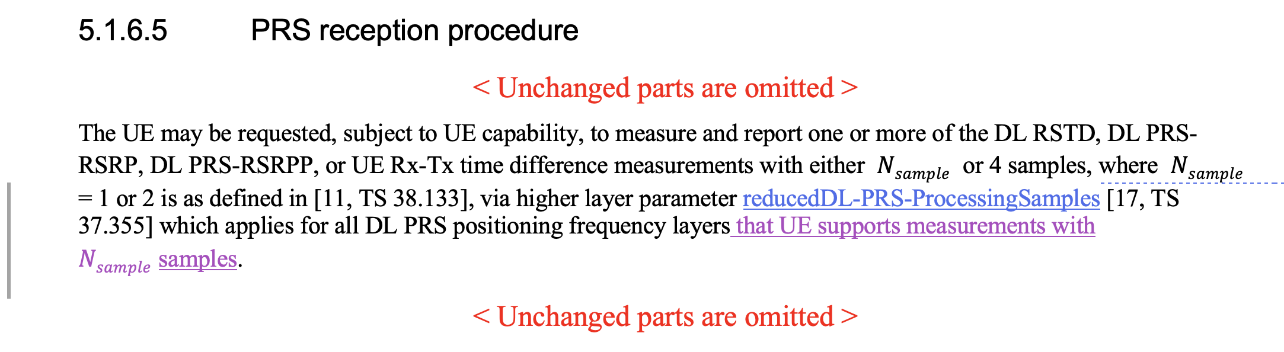

FL Comments

In FL’s view, clarification seems needed. Interested companies are invited to share their views on the proposed changes.

**Q&A 3-1: What is your view on the changes proposed in R1-2303274[3]?**

|  |  |  |  |
| --- | --- | --- | --- |
| **Company** | **Yes** | **No** | **Additional comments** |
|  |  |  |  |
|  |  |  |  |

# Measurement Gap Activation Request

**Background**

In [4], ZTE proposes the clarification in TS 38.214 *that UE is only expected to request one of the preconfigured measurement gap if the UE is configured by the network to request* based on the following changes were made to TS 38.321 in RAN2#121 [5]:

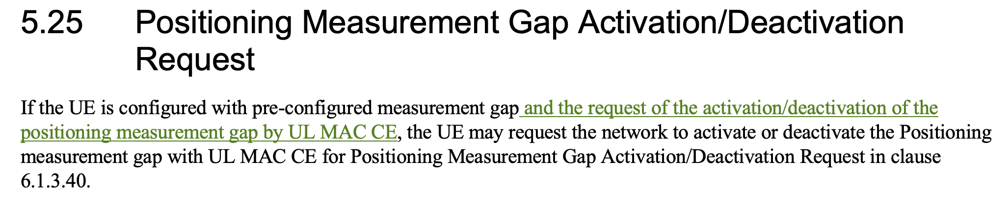

**Submitted Proposal/draft CR [4]**

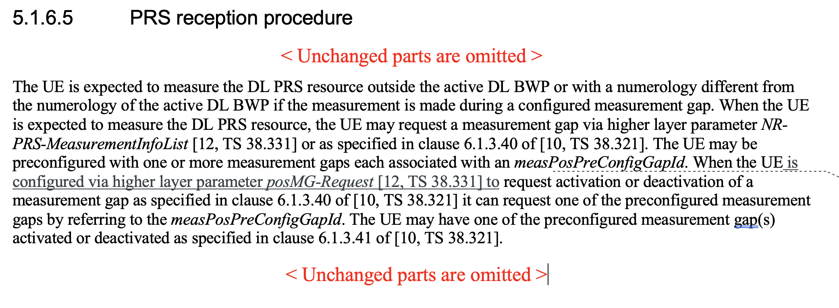

**Q&A 4-1: What is your view on the changes proposed in R1-2303275[4]?**

|  |  |  |  |
| --- | --- | --- | --- |
| **Company** | **Yes** | **No** | **Additional comments** |
|  |  |  |  |
|  |  |  |  |

# References

1. [R1-2302938](https://www.3gpp.org/ftp/TSG_RAN/WG1_RL1/TSGR1_112b-e/Docs/R1-2302938.zip) Correction on SRS transmission outside initial UL BWP Nokia, Nokia Shanghai Bell
2. [R1-2302939](https://www.3gpp.org/ftp/TSG_RAN/WG1_RL1/TSGR1_112b-e/Docs/R1-2302939.zip) Discussion on SRS for positioning outside of initial BWP Nokia, Nokia Shanghai Bell
3. [R1-2303274](https://www.3gpp.org/ftp/TSG_RAN/WG1_RL1/TSGR1_112b-e/Docs/R1-2303274.zip) Draft CR for PRS reduced sample in 38.214 ZTE
4. [R1-2303275](https://www.3gpp.org/ftp/TSG_RAN/WG1_RL1/TSGR1_112b-e/Docs/R1-2303275.zip) Draft CR for Positioning Measurement Gap Activation Request in 38.214 ZTE
5. R2-2302231 Correction to PosMG Activation/Deactivation Request Huawei, HiSilicon, Ericsson, Intel