3GPP TSG RAN WG1 Meeting #112bis-e R1-23xxxxx
Online, April 17th – April 24th, 2023
Agenda Item: 7.2
Source: Moderator (Qualcomm Incorporated)
Title: Summary #1 of [112bis-e-R17-IAB-01]
Document for: Discussion and decision

Introduction
This contribution provides a summary for maintenance of enhancements to integrated access and backhaul under agenda item 7.2 according to the following email thread:
Discussion coordination updates will be published in the following thread:
[112bis-e-R17-IAB-01] Email discussion on Rel-17 IAB maintenance by April 21 – Luca (Qualcomm)

Active discussion items for which companies’ input is sought are yellow background highlighted.
Inactive discussion topics are grey background highlighted.
Agreements or conclusions are green background highlighted.
New text from the moderator in each round of discussion after the initial revision is highlighted in light blue.

Summary
There are 4 topics identified based on the contributions and draft CRs [1] – [5] submitted for eIAB under agenda item 7.2.

Discussion

Topic #1. Correction on the description of slot index in TS38.213
Related input from contributions:
ZTE, Sanechips  [1] | 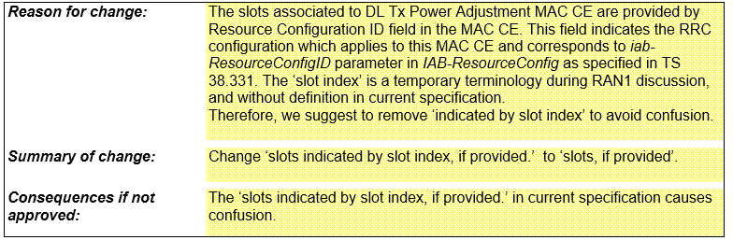  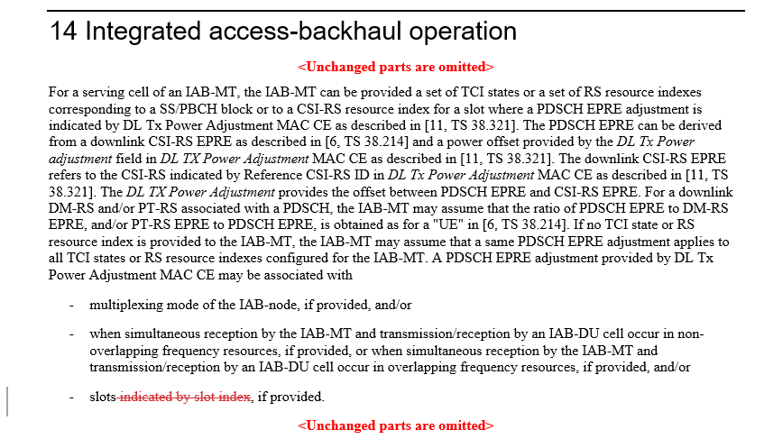

The FL deems the correction has merit and hence it is proposed to endorse it.

FL Proposal 1:
Endorse correction in R1-2303399.

Company | Comments
ZTE, Sanechips | Support
Ericsson | Support
Huawei, HiSilicon | We don’t think there is anything wrong with the current specification.  In TS 38.331, iab-ResourceConfigID is associated to a configuration with slot index list. So essentially, the slots are indicated by slot index. Note that slot index is used in TS 38.331 hence current specification is fine.  slotList  Indicates the list of slot indexes to which the information indicated in the specific MAC CE applies to, as specified in TS 38.321 [3]. The values of the entries in the slotList are strictly less than the value of the periodicitySlotList.
Samsung | Share a view with Huawei. In our understanding, nothing wrong because slots is indicated by slot index from slotList.
ZTE, Sanechips-2 | We think the change makes the spec more clear, when the 38.213 spec. says ‘indicated by’, it is normally followed by a field/parameter name in a DCI format or a higher siganlling(e.g., MAC CE).  If companies think ‘slot index’ is fine here, we can live with it if ‘slot index’ is changed to ‘slot indexes’ or ‘a list of slot indexes’.
Nokia | Ok to support.

Topic #2. Correction on availability indication in eIAB
Related input from contributions:
Ericsson  [2] | 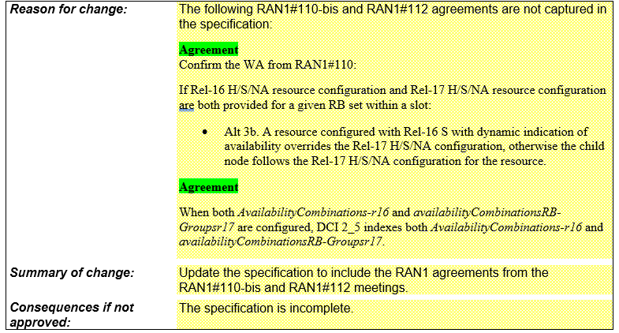  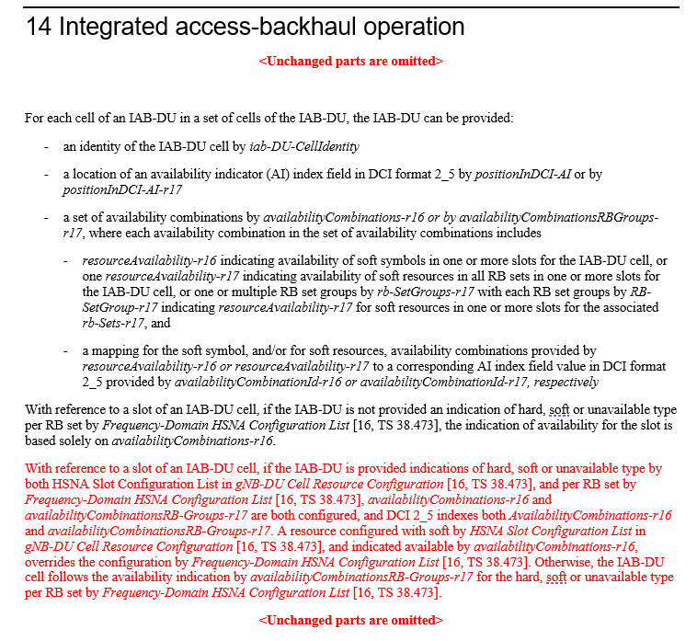

The FL thinks the aforementioned RAN1#110bis-e agreement is captured in TS 38.213 according to the approved CR in R1-2210757, in accordance to the following RAN1#110bis-e agreement:

RAN1#110bis-e Agreement
Confirm the WA from RAN1#110:
If Rel-16 H/S/NA resource configuration and Rel-17 H/S/NA resource configuration are both provided for a given RB set within a slot:
Alt 3b. A resource configured with Rel-16 S with dynamic indication of availability overrides the Rel-17 H/S/NA configuration, otherwise the child node follows the Rel-17 H/S/NA configuration for the resource.
Correction on coexistence of Rel-17 and Rel-16 HSNA configuration for TS38.213 is agreed. Final CR in R1-2210757.

The FL agrees the aforementioned RAN1#112 agreement is not captured in the specifications. A more concise correction is proposed to reflect this agreement.

FL Proposal 2:
Endorse the following correction for TS 38.213:

14 Integrated access-backhaul operation
<Unchanged parts are omitted>

An AI index field value in a DCI format 2_5 indicates to an IAB-DU a soft symbol and/or a soft RB set in an RB set group availability in each slot for a number of slots starting from the earliest slot of the IAB-DU which overlaps in time with the slot of the IAB-MT where the IAB-MT detects the DCI format 2_5. The number of slots is equal to or larger than a PDCCH monitoring periodicity for DCI format 2_5 as provided by SearchSpace. The AI index field includes $max\left\{\left\lceil \log_{2}\left(maxAIindex+1\right)\right\rceil ,1\right\}$ bits where maxAIindex is the maximum of the values provided by corresponding availabilityCombinationId. An availability for a soft symbol or a soft RB set in an RB set group in a slot is identified by a corresponding value resourceAvailability as provided in Table 14-3.
<Unchanged parts are omitted>

Company | Comments
ZTE, Sanechips | OK
Ericsson | Prefer Ericsson’s proposal since we think it is more accurate. The proposed change by the FL does not correspond to the agreement from RAN1 #112 which is about two AI index fields in one DCI format 2_5. Instead, it is more aligned with the RAN1 #109 agreement that one AI index field can be used to point to one availabilityCombinations table or both availabilityCombinations tables.
Huawei, HiSilicon | Support the FL’s proposal.
Samsung | OK
Nokia | Support the proposal.

Topic #3. Correction on reference SCS for availability indication in eIAB
Related input from contributions:
Ericsson  [3], [4] | 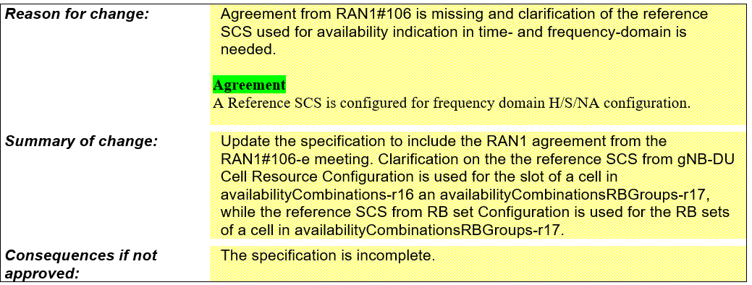  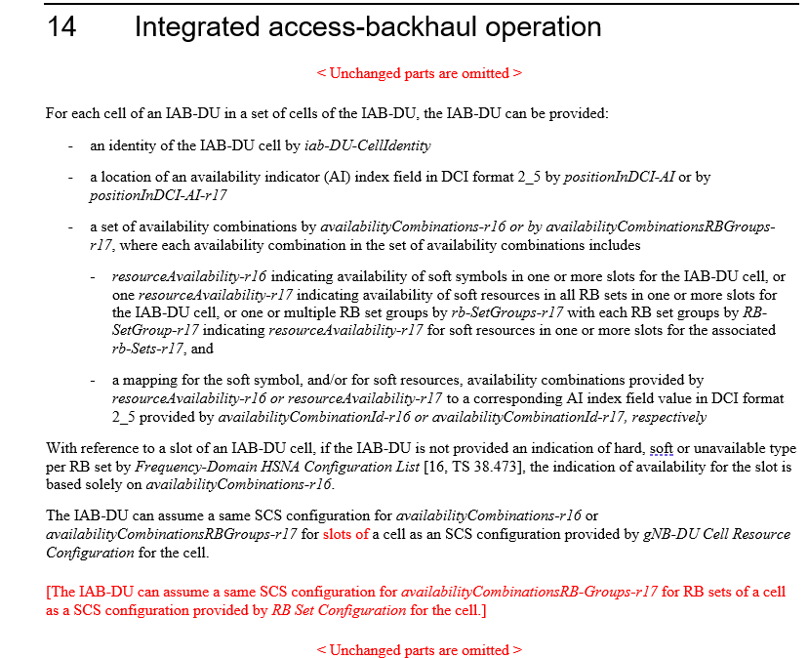  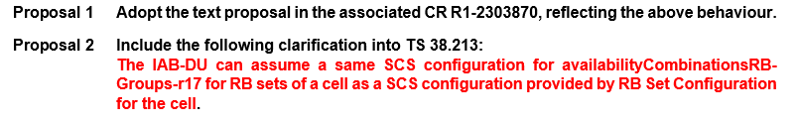

The FL agrees that a clarification is helpful.

FL Proposal 3:
Endorse the following correction:

14 Integrated access-backhaul operation
< Unchanged parts are omitted >
The IAB-DU can assume a same SCS configuration for availabilityCombinations-r16 or availabilityCombinationsRBGroups-r17 for slots of a cell as an SCS configuration provided by gNB-DU Cell Resource Configuration for the cell.
The IAB-DU can assume a same SCS configuration for availabilityCombinationsRB-Groups-r17 for RB sets of a cell as a SCS configuration provided by RB Set Configuration for the cell.
< Unchanged parts are omitted >

Company | Comments
ZTE, Sanechips | The first change is essential, i.e, adding ‘slots of’ to clarify that this is only for time domain.  For the second change, we can live with it although we think this is not necessary.
Ericsson | Support
Huawei, HiSilicon | Support
Samsung | Support
Nokia | Support the proposal.

Topic #4. Correction on RRC parameters in eIAB
Related input from contributions:
Ericsson  [5] | 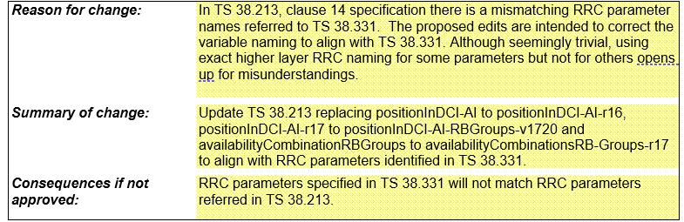  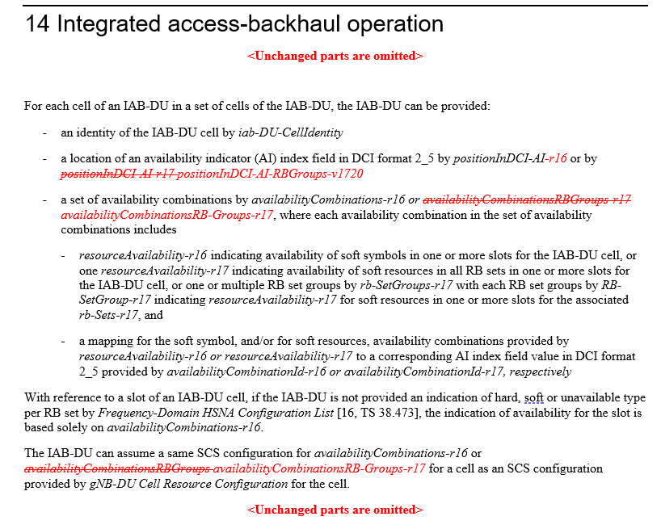

The FL deems the correction has merit and hence it is proposed to endorse it.

FL Proposal 4:
Endorse correction in R1-2303871.

Company | Comments
ZTE, Sanechips | Support
Ericsson | Support
Huawei, HiSilicon | Support
Samsung | Support
Nokia | Support the proposal.

References
[1] R1-2303399 Correction on the description of slot index in TS38.213, ZTE, Sanechips
[2] R1-2303868 Correction on availability indication in eIAB, Ericsson
[3] R1-2303869 Discussion on reference SCS for availability indication in eIAB, Ericsson
[4] R1-2303870 Correction on reference SCS for availability indication in eIAB, Ericsson
[5] R1-2303871 Correction on RRC parameters in eIAB, Ericsson

