**3GPP TSG RAN WG1 #112bis-e R1-23XXXXX**

**e-Meeting, April 17th – April 26th, 2023**

**Source: Moderator (Huawei)**

**Title: FL summary on UE SRS IL imbalance issue#1**

**Agenda item: 5**

**Document for: Discussion and Decision**

# Introduction

In RAN4#106-e meeting, LS R4-2303519 [1] was sent to RAN1 with following action:

|  |
| --- |
| **ACTION:**  RAN4 respectfully ask RAN1 to consider above issue with, but not limited to the three resolutions listed in the Annex for their future study.  **ANNEX:**  1. Enable UE report on the actual IL imbalance for each diversity branch used for SRS so network can use this information for AS-SRS based channel estimation accuracy improvement where the granularity of such report can be per SRS resource and either static or dynamic.  2. Utilize PCMAX, f, c via PHR type 3, where power imbalances across antenna ports are derived by comparing the maximum configured power of main branch to those of diversity branches, where such report is per transmission occasion per SRS (only a report of a single SRS resource is transmitted per transmission occasion).  3. Define UE measurements of downlink channels which are reported in order to assist the network in determining the difference between the UE insertion losses for two given antenna ports, where the network also does its own measurements of SRS channels.  4. RAN4 does not preclude other options.  The above alternatives are considered from Release 18 onwards and for 8Rx capable UE’s, and possible applicability UE’s supporting 2RX or 4RX is FFS. |

This document contains summary of the company’s contributions and FL proposals. Any additional inputs from any company can also be provided in this document.

# Discussion

SRS antenna switching is the key feature to acquire DL CSI for reciprocity-based TDD. However, due to the Tx switching at UE side, the insertion loss (IL) of diversity branch(es) can differ from that of main branch as identified by RAN4. Aforementioned IL imbalance is called SRS IL imbalance, which can be led by RF switch and trace loss difference as shown in Figure 1 [1].

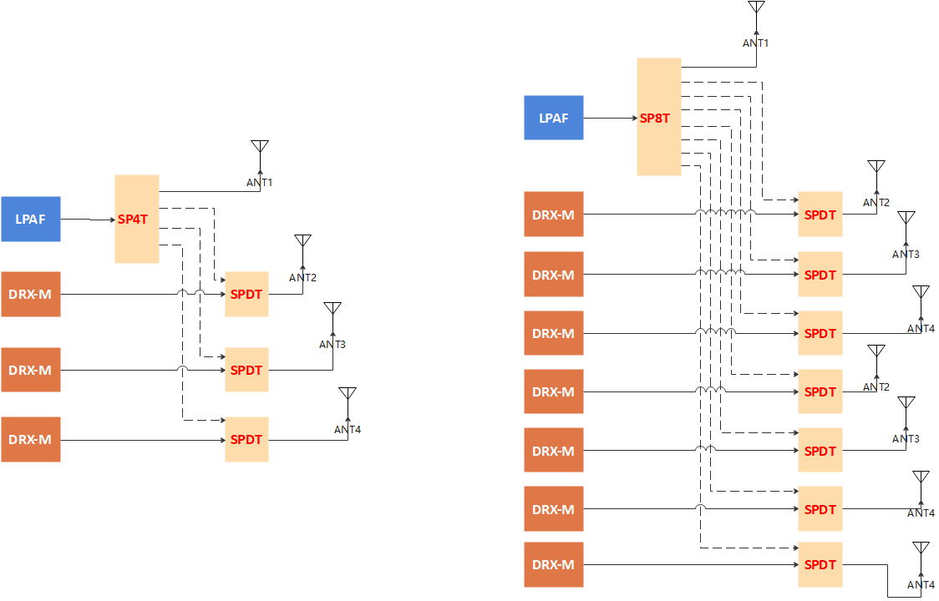

**Figure 1. Exemplary RF architecture of ‘t1r4’ (left) and ‘t1r8’ (right) UE**

Facing SRS IL imbalance, RAN4 has defined a relaxation ∆TRxSRS for 4Rx as a non-ideal factor in PCMAX_L, f, c, the definition of which is attached below. The ongoing RAN4 discussion is considering an even larger ∆TRxSRS for 8Rx.

|  |
| --- |
| PCMAX_L,f,c = MIN {PEMAX,c– ∆TC,c, (PPowerClass – ΔPPowerClass) – MAX(MAX(MPRc+∆MPRc, A-MPRc)+ ΔTIB,c + ∆TC,c +∆TRxSRS, P-MPRc) }  ∆TRxSRS is applied during SRS transmission occasions with *usage* in *SRS-ResourceSet* set as ‘antennaSwitching’ when  a) UE transmits SRS on the second SRS resource in every configured SRS resource set when the *SRS-TxSwitch* capability is indicated as 't1r2' or 't1r1-t1r2'  b) UE transmits SRS on the second, third and fourth SRS resources of the total 4 SRS resources from all configured SRS resource set(s) consisting of one SRS port when the *SRS-TxSwitch* capability is indicated as 't1r4' or, 't1r4-t2r4' or 't1r1-t1r2-t1r4' or, 't1r1-t1r2-t2r2-t1r4-t2r4'  c) UE transmits SRS from the second SRS port pair on the second SRS resource in every configured SRS resource set consisting of two SRS ports when the *SRS-TxSwitch* capabilityis indicated as' t2r4' or ' t1r4-t2r4', or 't1r1-t1r2-t2r2-t2r4' or 't1r1-t1r2-t2r2-t1r4-t2r4', or  d) UE transmits SRS to a DL-only carrier  The value of ∆TRxSRS is 4.5dB for bands whose FUL_high is higher than the FUL_low of n79 and 3 dB for bands whose FUL_high is lower than the FUL_low of n79 when the device is capable of power class 3 or power class 5 or power class 1.5 in the band, or when the device is capable of power class 2 in the band and ΔPPowerClass = 3 dB, or when UE indicating *txDiversity-r16*~~.~~.  The value of ∆TRxSRS is 7.5dB for bands whose FUL_high is higher than the FUL_low of n79 and 6 dB for bands whose FUL_high is lower than the FUL_low of n79 during SRS transmission occasions with configured SRS resources consisting of one SRS port when the device is capable of power class 2 in the band and ΔPPowerClass = 0 dB and not indicating *txDiversity-r16*.  For other SRS transmissions ∆TRxSRS is zero; |

Compared with defining relaxation only, reporting the SRS IL imbalance directly/indirectly can help the gNB to compensate the IL imbalance and improve the channel estimation accuracy, which facilitates DL precoder/rank/MCS calculation and harvests obvious performance benefit [2-3]. Furthermore, most of the companies providing contribution also share the same view that directly/indirectly reporting the SRS IL imbalance should be supported [4-8].

Based on RAN4’s request and above assessment, FL proposal 1 is suggested as below:

### **FL Proposal 1**

**Support directly/indirectly reporting the SRS IL imbalance to gNB for 8Rx UE.**

* **FFS: Static, semi-persistent or dynamic reporting**
* **FFS: Reporting method**
* **FFS: For 2Rx, 4Rx UE**

Please companies provide your views towards above proposal.

|  |  |
| --- | --- |
| **Company** | **Comment** |
| vivo | We do not support the proposal. As we analyzed in our contribution, there could be many reasons IL imbalance stays even if the UE reports. And, considering impact on performance, there could be some degradation for 1T8R UE, but for 4Rx and 2Rx UEs performance degradation is not observed. |
| NTT DOCOMO | We support the FL proposal. This will be quite useful to measure DL CSI based on SRS.  Besides we’d like to understand vivo’s intention above. For the comment “As we analyzed in our contribution, there could be many reasons IL imbalance stays even if the UE reports”, could you clarify how the comment motivates no enhancement on reporting? Yes, we agree that even if specifications enhances reporting feature, the power degradation still exists. But such a reporting enables NW to observe what power degradation UE encounters, which is the actual target of reporting in our view. Could vivo clarify the intention? |

In terms of the resolutions given by RAN4, companies’ position is summarized below. The corresponding reporting granularity supported by each resolution is also listed based on FL’s understanding.

|  |  |  |
| --- | --- | --- |
|  | **Support/fine** | **Concern** |
| **Resolution 1**  **(static, semi-persistent or dynamic)** | Nokia (Study and specify the UE behavior in terms of Tx power setting), Intel (No RAN1 specification impact), Qualcomm | Vivo (No Enhancement), ZTE, Huawei/HiSilicon |
| **Resolution 2**  **(dynamic)** | ZTE | Vivo (No Enhancement), Nokia, Huawei/HiSilicon |
| **Resolution 3**  **(semi-persistent or dynamic)** | Huawei/HiSilicon | Vivo (No Enhancement), Nokia, ZTE |

Please companies provide your views towards above resolutions. Also feel free to suggest other effective resolutions. Decision on whether/which resolution to choose can be delayed after we’ve reached a consensus on FL proposal 1.

|  |  |
| --- | --- |
| **Company** | **Comment** |
| NTT DOCOMO | Our preference is Resolution 1.  For Resolution 2, if we understand correctly, it tries to derive ∆TRxSRS by comparing PCMAX reported by multiple PHRs. To achieve the purpose of SRS IL identification, we believe some restrictions across the PHRs need to be considered, which will require quite some specification impacts in our view (potentially in RAN1/RAN2/RAN4). If such a detail is left untouched, the functionality itself will not be very useful.  For Resolution 3, how would the UE understand that the difference of measurement solely comes from IL? Isn’t there a possibility that it actually comes from the difference of e.g., propagation channel? We wonder how it is practical. |

# Conclusion

TBD

# References

|  |  |  |  |
| --- | --- | --- | --- |
| [1] | R1-2302267 | LS on the UE SRS IL imbalance issue | Huawei, HiSilicon |
| [2] | R4-2300696 | 8RX UE RF requirements | Qualcomm |
| [3] | R4-2301763 | On FR1 8Rx UE RF requirements | Huawei, HiSilicon |
| [4] | R1-2303270 | Discussion on RAN4 LS on the UE SRS IL imbalance issue | Nokia |
| [5] | R1-2303457 | SRS IL Reply LS | Intel |
| [6] | R1-2303563 | Draft reply to RAN 4 LS on the UE SRS IL imbalance issue | Qualcomm |
| [7] | R1-2303657 | Discussion on RAN4 LS on the UE SRS IL imbalance issue | ZTE |
| [8] | R1-2303860 | Discussion on the UE SRS IL imbalance issue | Huawei, HiSilicon |