3GPP TSG RAN WG1 #110bis-e R1-22xxxxx

e-Meeting, October 10th – 19th, 2022
Agenda Item: 8.10
Source: Moderator (Qualcomm Incorporated)
Title: Summary #1 of [110bis-e-R17-eIAB-01]
Document for: Discussion and decision

Introduction
This contribution provides a summary to support the following email discussion for agenda item 8.10, with the objective to determine which topics should be discussed in RAN1#110bis-e.
[110bis-e-R17-eIAB-01] Email discussion to determine maintenance issues to be handled in RAN1#110bis-e by October 12 – Luca (Qualcomm)

Summary
There are 11 topics identified based on the contributions and draft CRs [1] – [16] submitted for agenda item 8.10.
The preliminary FL assessment is the following:
- Topics #1, #2, #3, #4, #5 should be discussed with the highest priority to ensure alignment in understanding amongst companies.
- Topics #6, #7, #8, #9, #10 seem relatively straightforward spec corrections / enhancements for which consensus should be relatively easy to obtain, also considering related discussion and feedback in RAN1#110.
- Topic #11 seems an enhancement that, based on past discussion, the majority of companies did not see as required (the referenced scenarios can be handled based on the current specs and implementation), hence it should deprioritized.

Any input on prioritization for the discussion? Specifically, which topics should be prioritized / deprioritized in your view?
Company | Comments
Ericsson | We agree with the FLs assessment except for the following:  Topic 3 that we think is an enhancement and should not be discussed in the maintenance phase.  Topic 11 should be discussed. If RAN1 does not discuss the topic, that will be an implicit agreement to Alt. 2 meaning RAN4 will consider how the problems should be addressed. We think it is better is RAN1 makes that agreement, should RAN1 want to, explicitly.
ZTE,Sanechips | For Topic #3, we share similar view with Ericsson  For Topic #5, we think current spec works well, no need to revert the RAN1#107e agreement, i.e., such discussion should be deprioritized.  For other topics, we support FL assessment.
Huawei, HiSilicon | For Topic#2, we don’t see the need to discuss this further. There is already LS between RAN1 and RAN3 regarding this agreement and there was clearly different views on whether or not this has been capture into the spec already. Even if something needs to be captured, it should be RAN3 spec instead of RAN1.  For Topic#3, we don’t think it is trivial or a further enhancement on top of Rel-17. As a matter of fact, it is quite important enabler for simultaneous Tx/Rx for IAB, which is the main feature for Rel-17 IAB. The restriction in current specification is mainly due to the fact that TDM is the focus for Rel-16 IAB. For Rel-17 IAB, it does not make sense to keep the restriction anymore.

Identified discussion topics

Topic #1. Coexistence of TD and FD DU resource configurations
Related decisions from prior meetings:
RAN1-106bise Working Assumption:
If both the Rel-16 time domain H/S/NA configuration and Rel-17 frequency domain H/S/NA configuration are provided for a given RB set within a slot, one of the following is selected:
Alt. 1: An IAB node applies the frequency domain H/S/NA only if the IAB node is currently operating in a non-TDM multiplexing mode in the slot, otherwise the Rel-16 time domain H/S/NA configuration is applied.

RAN1-107e Agreement:
Whether or not an IAB node can operate under a given non-TDM multiplexing mode (i.e. multiplexing info in 38.473) is left to IAB implementation in Rel-17

RAN1-109e Conclusion
If both Rel-16 H/S/NA and Rel-17 H/S/NA are configured for a given resource and the child node is operating in TDM multiplexing mode, consider the following alternatives until RAN1#110:
- Alt. 1: the child node follows the Rel-16 H/S/NA configuration for the resource
- Alt. 2: the child node follows the Rel-17 H/S/NA configuration for the resource
- Alt. 3: A resource configured with Rel-16 H or Rel-16 S with dynamic indication of availability overrides the Rel-17 H/S/NA configuration, otherwise the child node follows the Rel-17 H/S/NA configuration for the resource
- Alt. 4 the child node follows the Rel-16 or Rel-17 H/S/NA based on implicit indication (e.g. Case 6 timing indication) between parent and child node.

RAN1-110 Working Assumption
If Rel-16 H/S/NA resource configuration and Rel-17 H/S/NA resource configuration are both provided for a given RB set within a slot:
Alt 3b. A resource configured with Rel-16 H or Rel-16 S with dynamic indication of availability overrides the Rel-17 H/S/NA configuration, otherwise the child node follows the Rel-17 H/S/NA configuration for the resource.

Related input from contributions:
Huawei, Hisilicon  [1], [7] | Proposal 1: If Rel-16 H/S/NA resource configuration and Rel-17 H/S/NA resource configuration are both provided for a given RB set within a slot:  - A symbol configured with Rel-16 S with dynamic indication indicating available overrides the Rel-17 H/S/NA configuration  - For a symbol configured with Rel-16 S with dynamic indication indicating “no indication of availability”, the child node follows the Rel-17 H/S/NA configuration for the symbol  - For a symbol configured with Rel-16 S without receiving dynamic indication of availability, the child node follows the Rel-17 H/S/NA configuration for the symbol  - For a symbol configured with Rel-16 H/NA, the child node follows the Rel-17 H/S/NA configuration for the symbol  Proposal 2: If both Rel-16 H/S/NA and Rel-17 H/S/NA resource configuration are both provided for a given RB set within a slot, and both Rel-16 and Rel-17 dynamic indication of resource availability are received by child node:  - A symbol configured with Rel-16 S with Rel-16 dynamic indication indicating available overrides the Rel-17 H/S/NA configuration  - For a symbol configured with Rel-16 S with Rel-16 dynamic indication indicating “no indication of availability”, the child node follows the Rel-17 H/S/NA configuration and Rel-17 dynamic indication to determine resource availability for the RB set in the symbol  Proposal 3: If only Rel-16 H/S/NA resource configuration is provided for a given a slot:  - If Rel-16 dynamic indication of availability is not configured by RRC or not provided by DCI, the child node ignores the Rel-17 dynamic availability indication, if any.  - If both Rel-16 and Rel-17 dynamic indication of availability are configured and received, the child node ignores the Rel-17 dynamic availability indication.  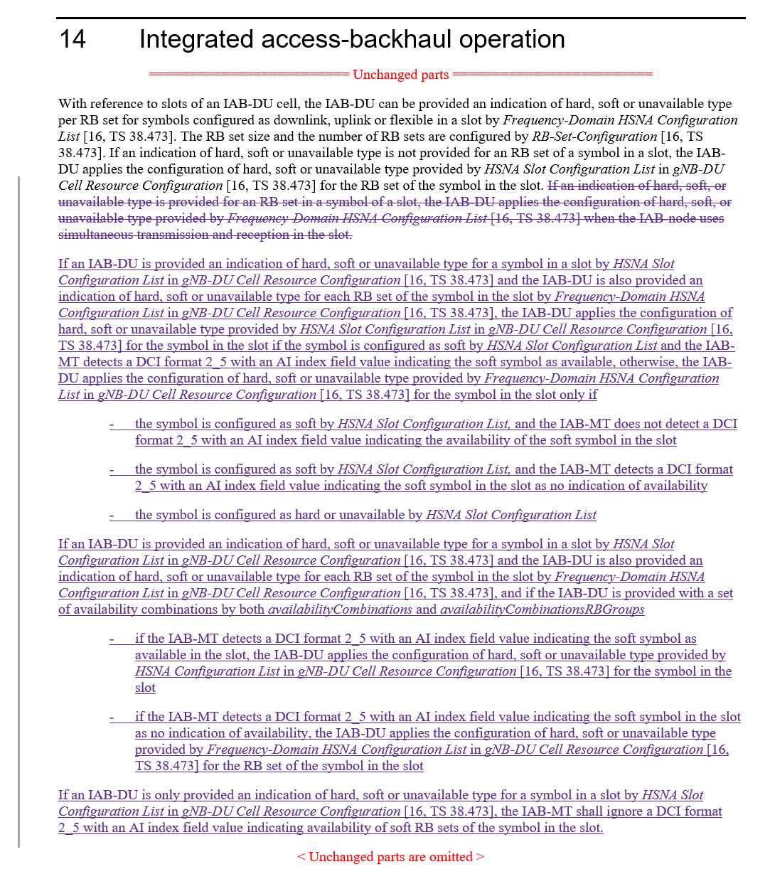
Lenovo  [6] | Observation 1: Compared to Al1. 2, Alt. 3b facilitates a fallback mode and provides higher resource efficiency if the IAB node is not capable of performing FDM at a particular moment.  Observation 2: Separate application of T-HSNA and F-HSNA is a special case of joint application. If joint application is agreed, the IAB-CU still has the possibility of separate (non-overlapping) configurations. Alt. 3b allows higher flexibility for resource configuration by the IAB-CU without loss of generality for TDM-only or FDM-only configurations if desired in a specific implementation.  Observation 3: Since the IAB-CU cannot be informed of whether an IAB node’s channel conditions at a specific time allows simultaneous MT-DU operations, the safe choice for the IAB-CU with Alt. 2 could be to avoid Rel-17 H/S/NA configuration, which could make the new specification useless in practice.  Proposal: Confirm the working assumption from RAN1#110, agenda item 8.10.
Qualcomm  [9] | 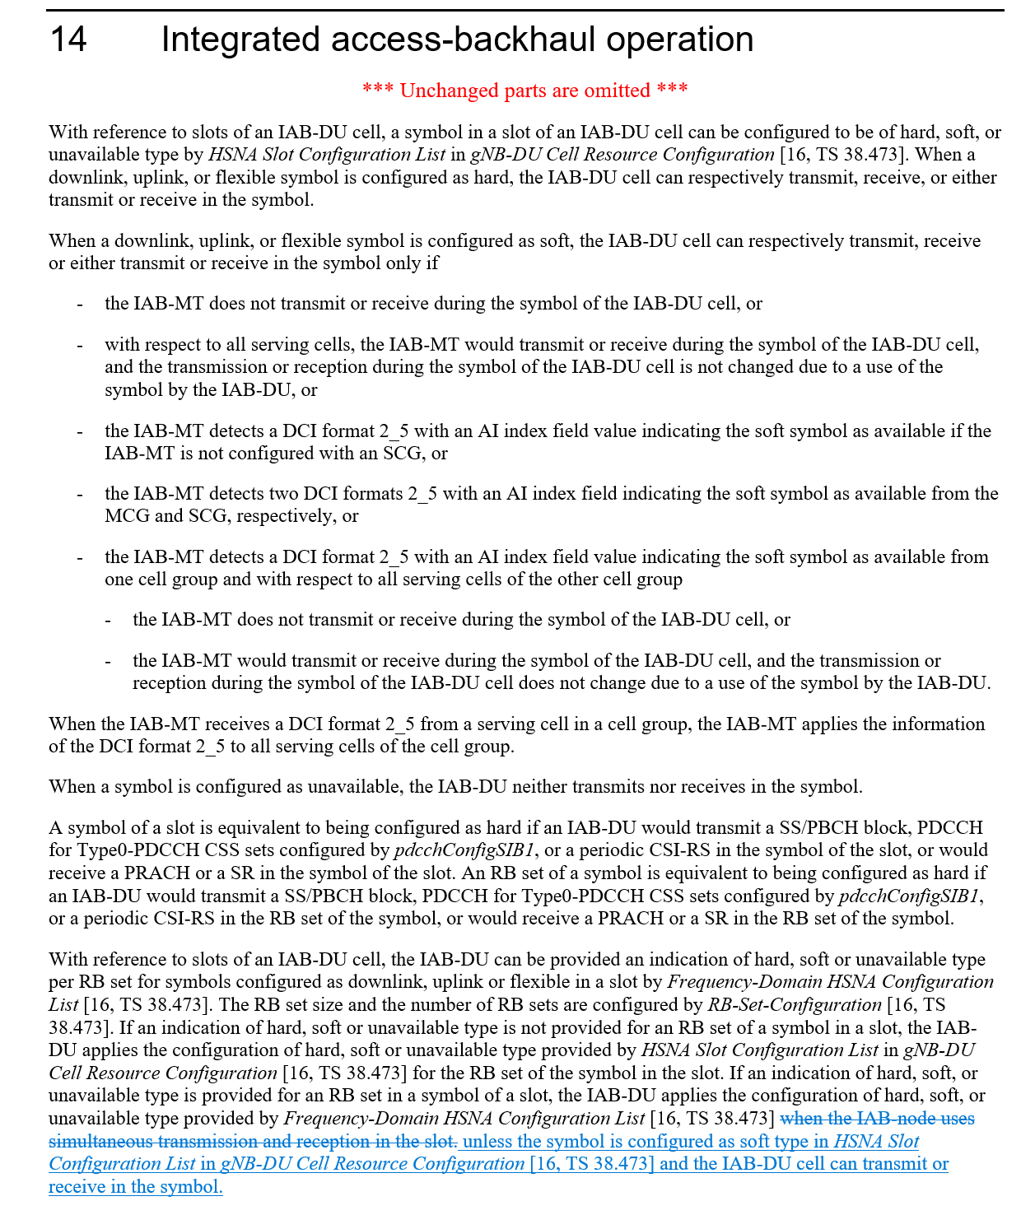
Nokia, Nokia Shanghai Bell  [10] | 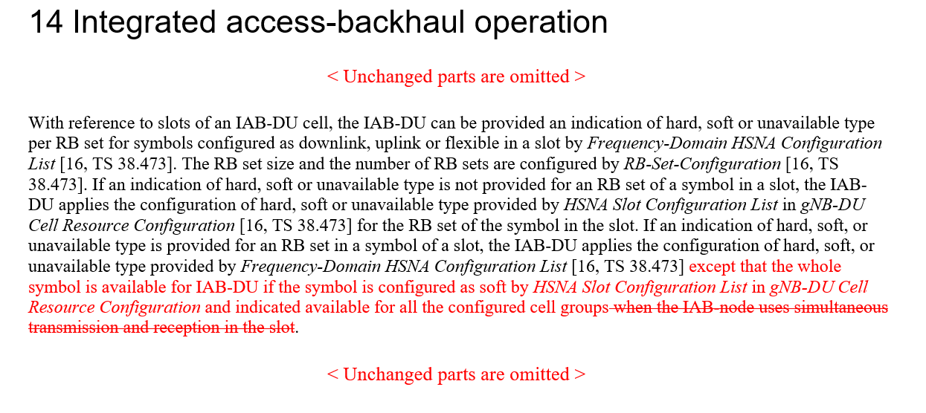
Ericsson  [16] | Proposal 1 If both Rel-16 time-domain H/S/NA configuration and Rel-17 frequency domain H/S/NA configuration are provided for a given RB set within a slot, the AvailabilityCombinationsPerCell-r17 is used to provide dynamic availability indication for both Rel-16 and Rel-17 Soft resource.

In general it seems the WA from RAN1#110 can be confirmed, however some details on related aspects and on the actual specification text still require some discussion.

Topic #2. Corrections on RB set size for Rel-17 IAB FDM multiplexing
Related input from contributions:
Nokia, Nokia Shanghai Bell  [5] | 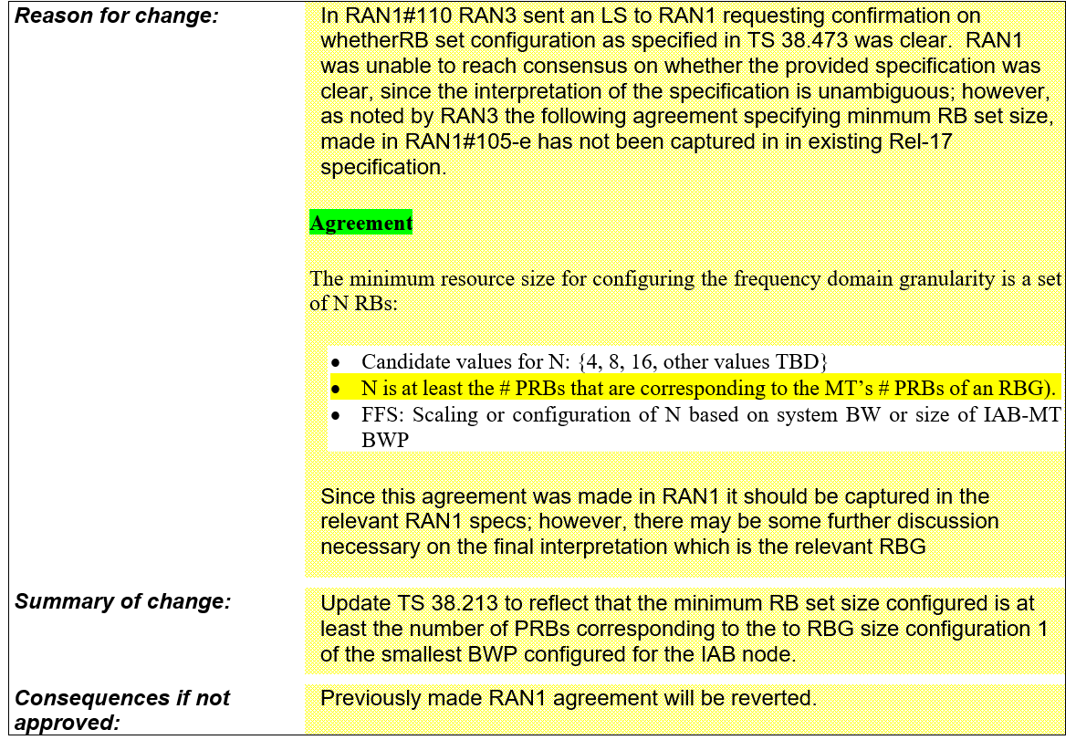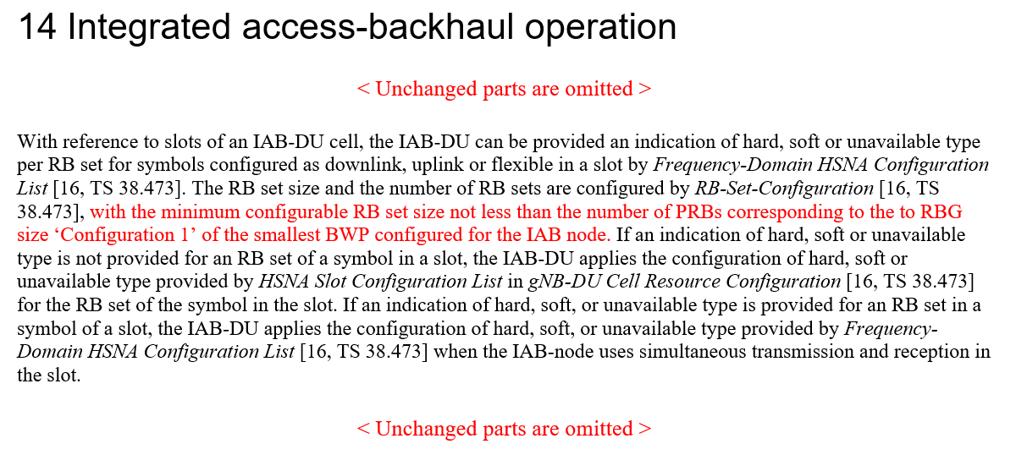

Topic #3. TDD configuration enhancements for IAB-MT

Related input from contributions:
Huawei, Hisilicon  [1], [8] | Proposal 5: If an IAB-MT is additionally provided TDD-UL-DL-ConfigDedicated-IAB-MT, the parameter tdd-UL-DL-ConfigurationDedicated-IAB-MT overrides all symbols per slot over the number of slots as provided by tdd-UL-DL-ConfigurationCommon.  Proposal 6: To increase the resources for simultaneous operation, the specification should allow the collision between tdd-UL-DL-ConfigurationDedicated-IAB-MT and cell-specific signals/channels. In the slots with the collision, the IAB node should ignore tdd-UL-DL-ConfigurationDedicated-IAB-MT. The list of cell-specific signals/channels includes:  - SS/PBCH block  - CORESET for Type0-PDCCH CSS set  - PRACH  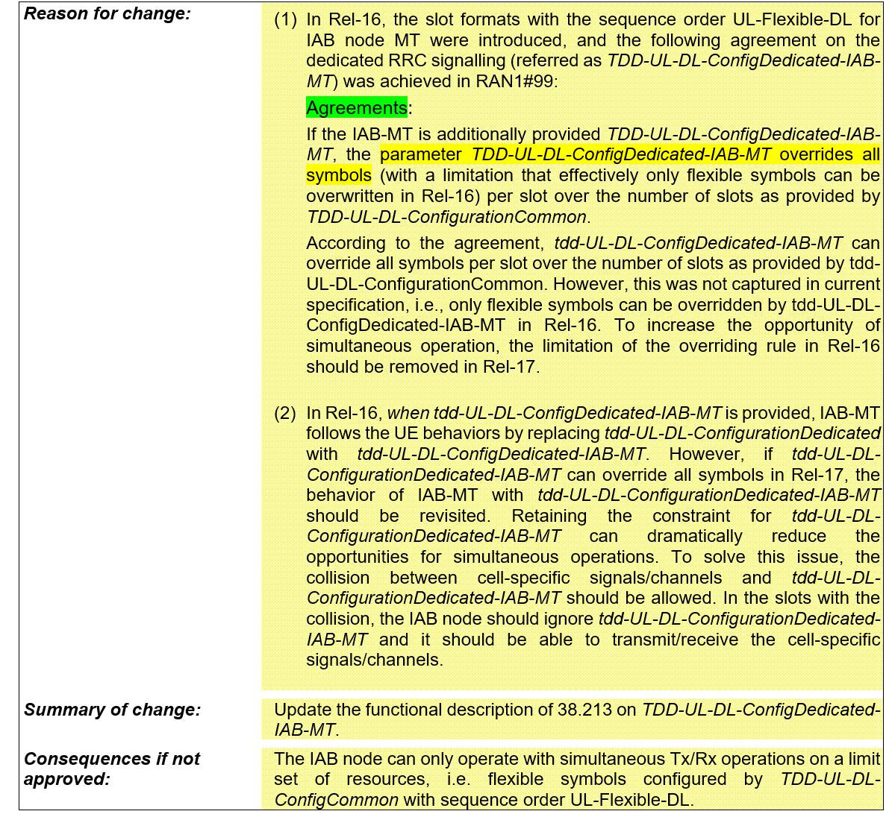  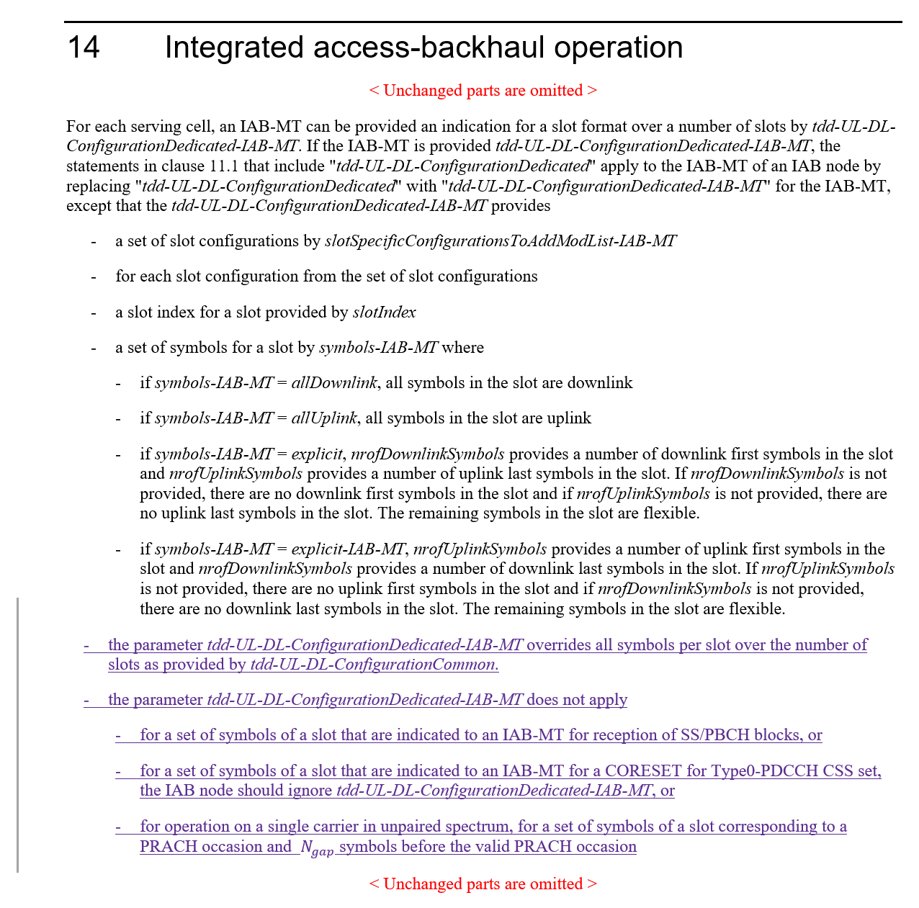

Topic #4. Correction on the formula of Case-7 UL Tx timing for eIAB in TS 38.213
Related input from contributions:
ZTE, Sanechips  [2] | 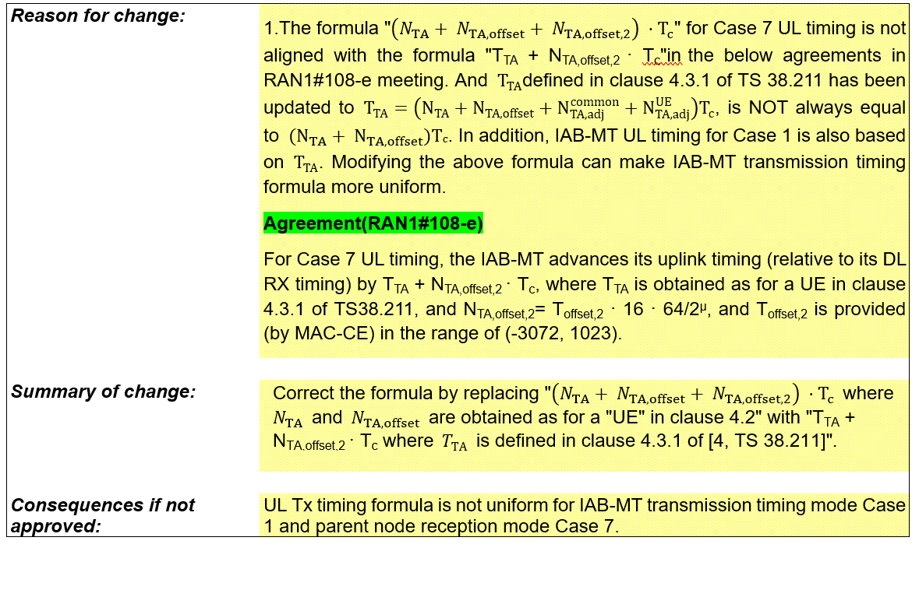

Topic #5. Additional specification for DL Tx power adjustment
Related input from contributions:
Ericsson  [11], [12] | Proposal 1 The following RAN1#107-e agreement is amended as: The indicated desired/provided DL Tx power adjustment is in terms of a relative offset to the non-offset PDSCH Tx power, as derived from a CSI-RS TX power that is RRC configured.  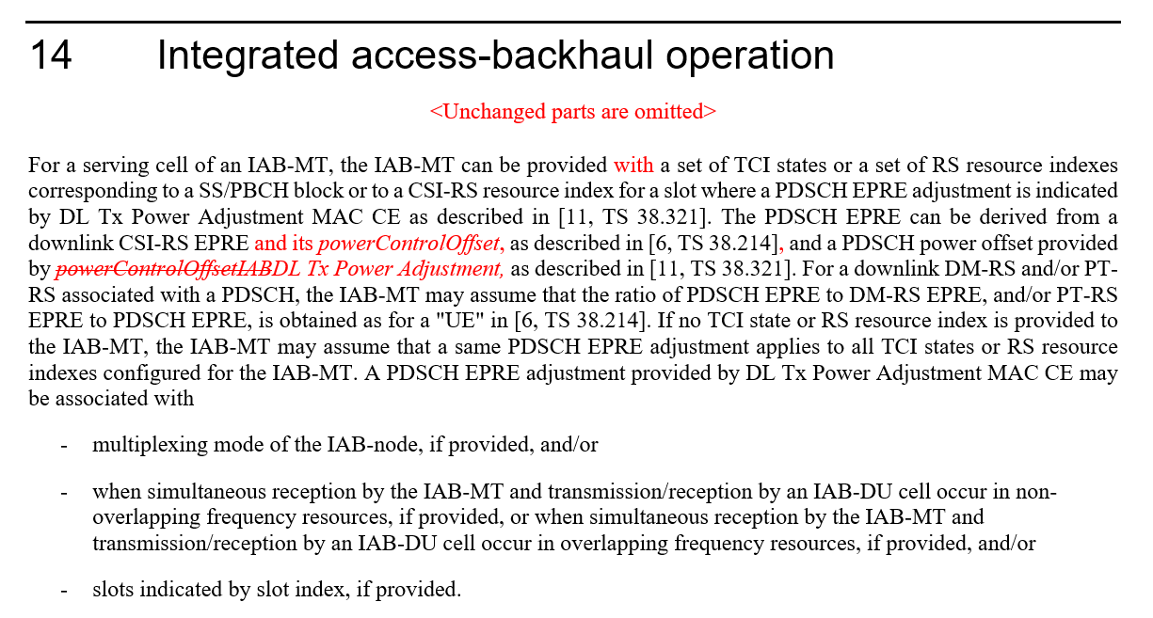

This topic was briefly addressed in RAN1#110 but there was no time to conclude due to higher priority discussions, hence it is recommended to discuss and clarify in this meeting.

Topic #6. Corrections on misaligment for MAC CE or RRC parameters for eIAB TS 38.213
Related input from contributions:
ZTE, Sanechips  [4] | 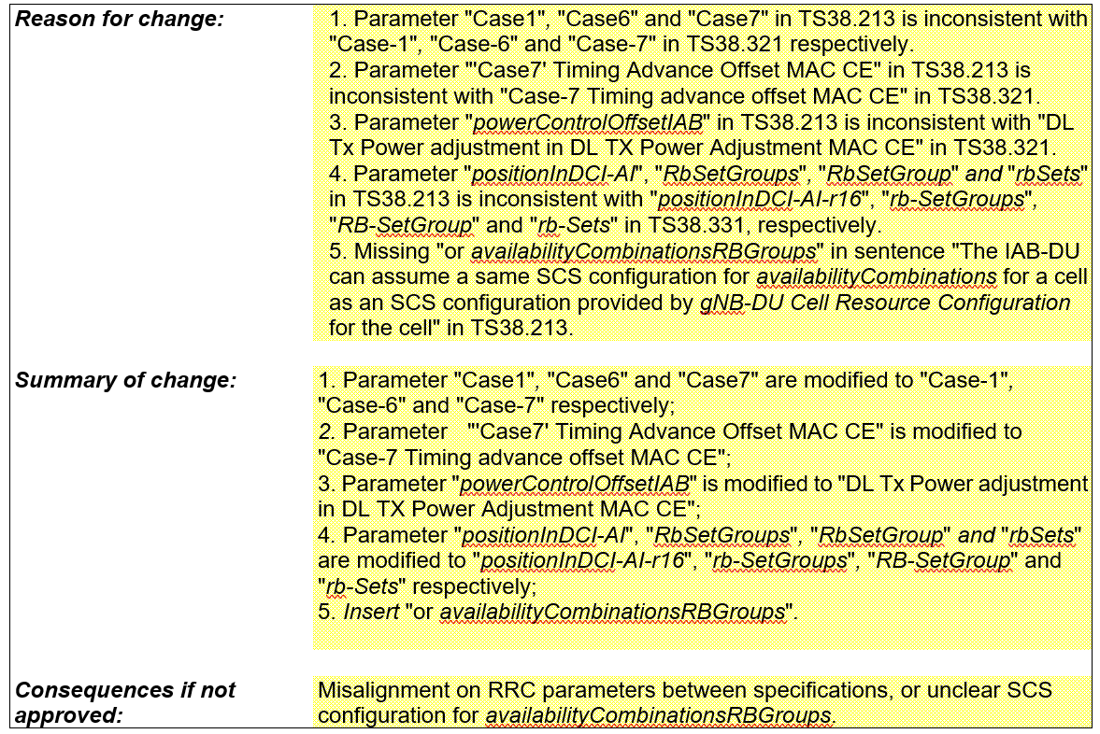

Topic #7. Correction on the position related to the description that the RB set is equivalent to hard for eIAB in TS 38.213
Related input from contributions:
ZTE, Sanechips  [3] | 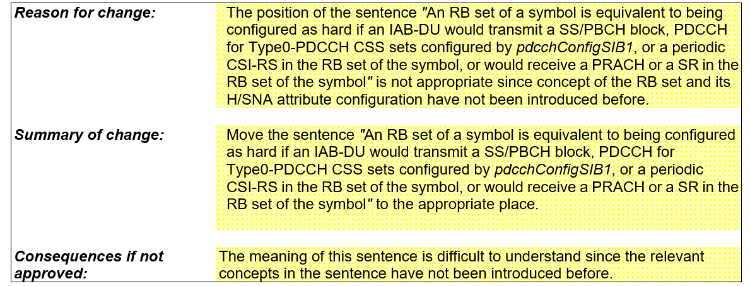

Topic #8. Draft CR on guard symbols MAC CEs
Related input from contributions:
Ericsson  [21] | 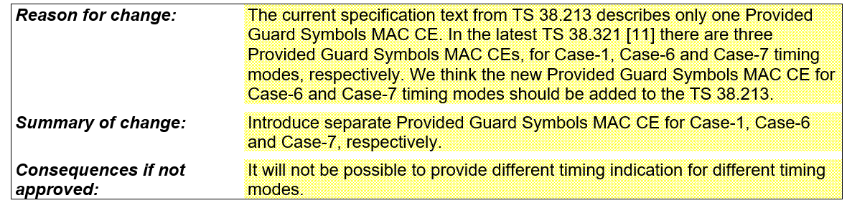  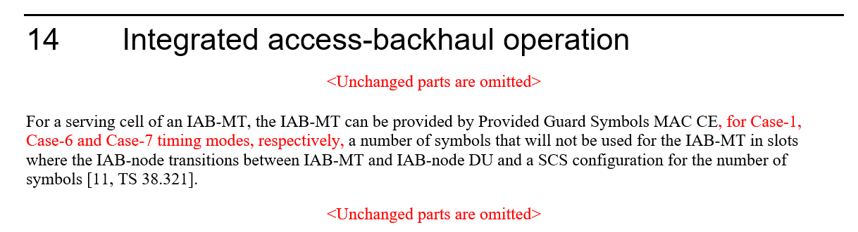

Topic #9. Draft CR on timing case indication
Related input from contributions:
Ericsson  [14] | 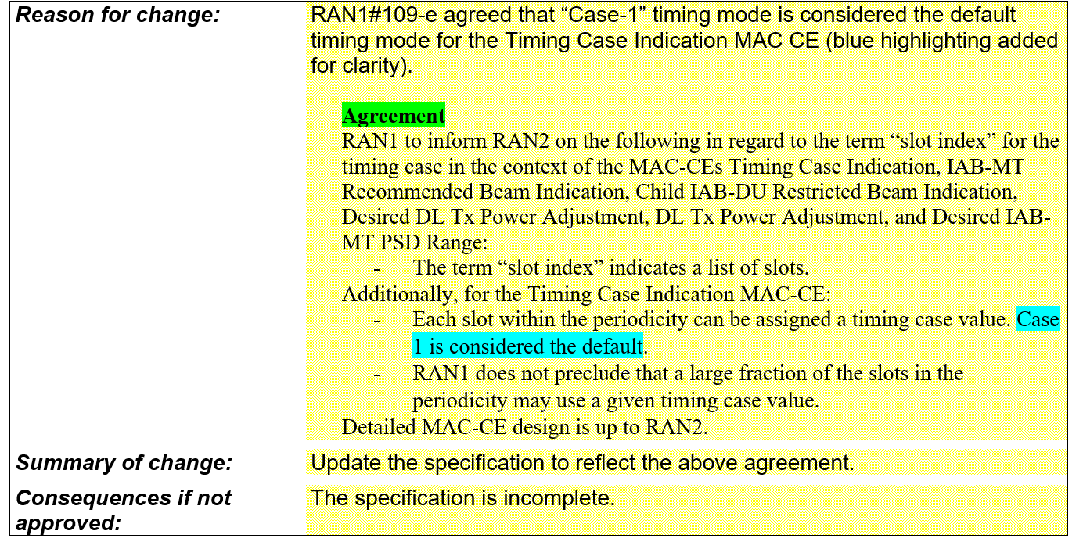  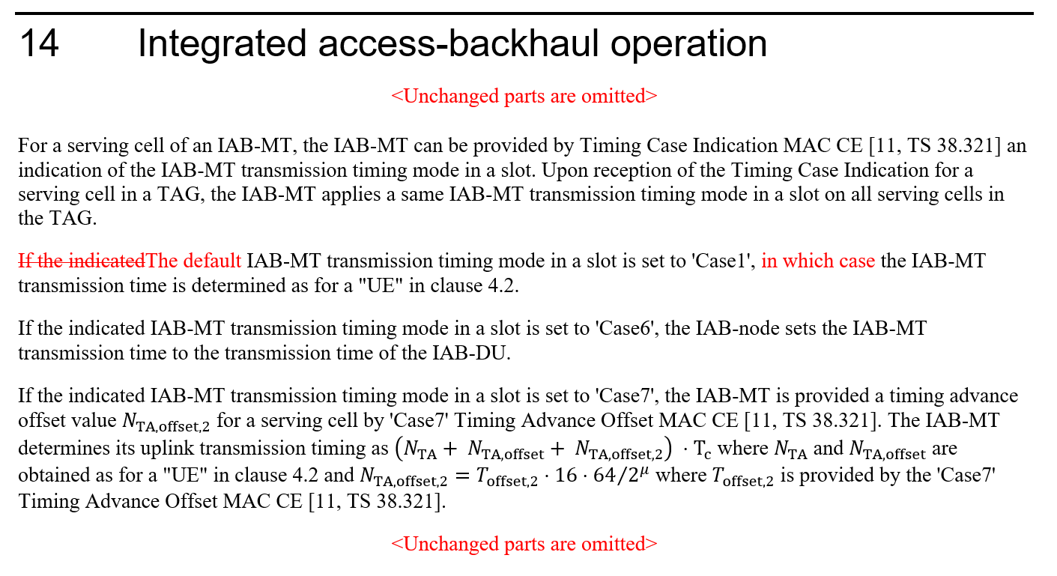

Topic #10. Draft CR on Hard/Soft/Not Available resource definition
Related input from contributions:
Ericsson  [15] | 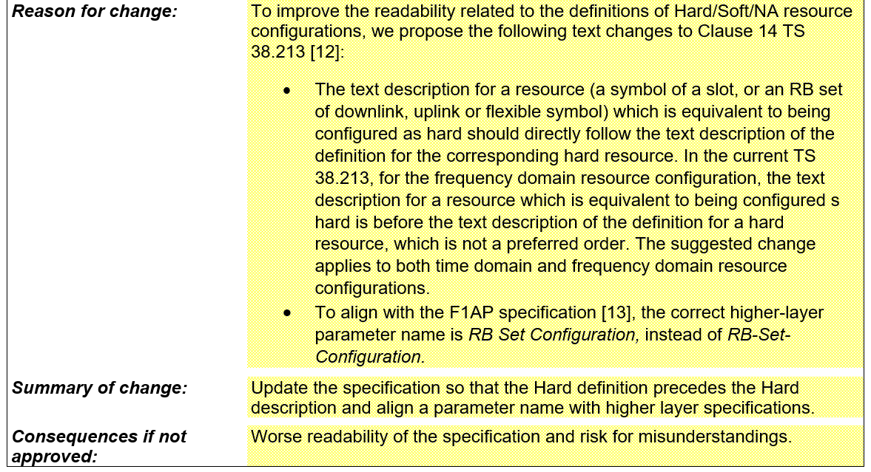  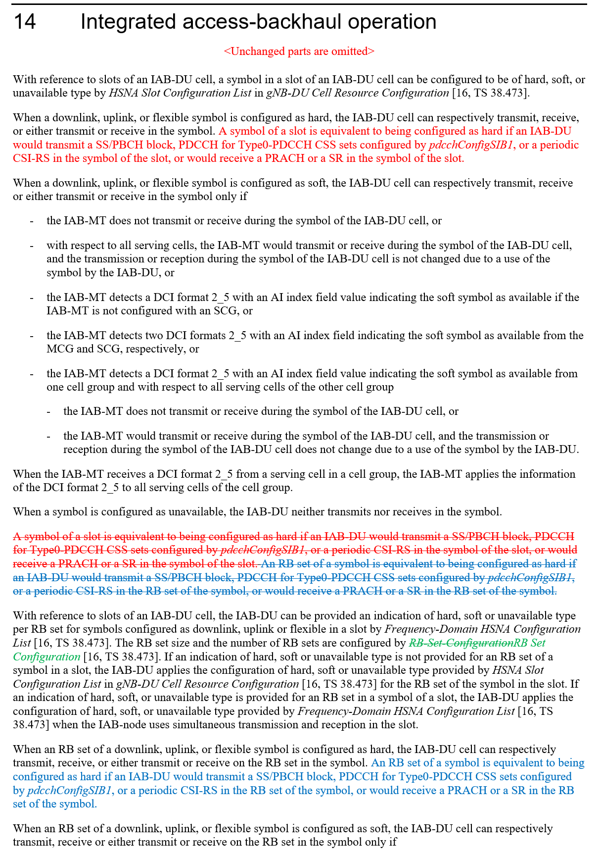

Topic #11. Handling of interference between adjacent RB sets in FDM operation

Related input from contributions:
Huawei, Hisilicon  [1] | Observation 1: Guard band can provide better frequency domain isolation and may be needed to enable the FDM operation between MT and DU.  Observation 2: Placing the guard band on DU resource by implementation to achieve the FDM violates the definition of DU hard resources.  Proposal 4: The guard band including its size and location should be made aware of by IAB node’s parent node and donor node to facilitate efficient FDM operation.
Ericsson  [16] | Observation 1 Allowing the DU unconditional use of Hard resources, irrespective of interference on Soft or Not Available resources, assumes static channel conditions and will require a different solution for Rel-18 mIAB.  Proposal 2 To address the adjacent channel leakage between RB sets in FDM operation, RAN1 to decide to adopt  a. Alt 1: RAN1 based solution, restricting Hard resource utilization, or  b. Alt 2: RAN4 based solution, imposing adjacent leakage requirements into NA and Soft-NIA resources.

References
[1] R1-2208471 Remaining issues on resource multiplexing for IAB, Huawei, HiSilicon
[2] R1-2208786 Correction on the formula of Case-7 UL Tx timing for eIAB in TS 38.213, ZTE, Sanechips
[3] R1-2208787 Correction on the position related to the description that the RB set is equivalent to hard for eIAB in TS 38.213, ZTE, Sanechips
[4] R1-2208788 Corrections on misalignment for MAC CE or RRC parameters for eIAB TS 38.213, ZTE, Sanechips
[5] R1-2209084 Correction on RB set size for Rel-17 IAB FDM multiplexing, Nokia, Nokia Shanghai Bell
[6] R1-2209118 Resource multiplexing in enhanced IAB systems, Lenovo
[7] R1-2209834 Correction on coexistance between Rel-16 and Rel-17 H/S/NA configuration, Huawei, HiSilicon
[8] R1-2209835 Correction on TDD configuration for IAB-MT, Huawei, HiSilicon
[9] R1-2209949 Draft CR on FD and TD DU resource configuration coexistence, Qualcomm
[10] R1-2210170 Clarification on Rel-16 and Rel-17 H/S/NA Configuration, Nokia, Nokia Shanghai Bell
[11] R1-2210225 Draft CR on DL Tx power control, Ericsson
[12] R1-2210226 Discussion on DL Tx power control, Ericsson
[13] R1-2210227 Draft CR on guard symbols MAC CEs, Ericsson
[14] R1-2210228 Draft CR on timing case indication, Ericsson
[15] R1-2210229 Draft CR on Hard/Soft/Not Available resource definition, Ericsson
[16] R1-2210230 Maintenance on enhanced IAB, Ericsson

