3GPP TSG RAN WG1 #110bis-e R1-22xxxxx
e-Meeting, October 10th – 19th, 2022

Agenda Item: 7.1
Source: Moderator (Apple Inc.)
Title: Summary of [110bis-e-NR-R15-06] Discussion on alignment of understanding for BM across multiple cells with different SCS
Document for: Discussion/Decision

Introduction
This document provides summary on the following email discussion;
[110bis-e-NR-R15-06] Discussion on alignment of understanding for BM across multiple cells with different SCS by Oct 14 – Haitong (Apple)
To collect companies’ views on the issue, this document is structured as the following
- Section 2 is used to provide background
- Section 3 is used to collect companies’ views.
- Section 4 is used to summarize the outcome of the email discussion
Please provide your second-round comments in Section 3.2 by 13th Oct 23:59 UTC (2nd^{t} check point).

Background

RAN1 Status
In Rel-15, UE FG2-24, i.e., beamManagementSSB-CSI-RS was introduced for the support of L1-RSRP measurement, in which two components, maxNumberSSB-CSI-RS-ResourceOneTx and maxNumberCSI-RS-ResourceTwoTx are defined “within a slot and across all serving cells”. For NR CA operation with different SCS, the reference slot for the calculation of maxNumberSSB-CSI-RS-ResourceOneTx and maxNumberCSI-RS-ResourceTwoTx is ambiguous.
In RAN1#101-e, RAN1 agreed to clarify the resource counting for L1-RSRP measurement, i.e., maxNumberSSB-CSI-RS-ResourceOneTx and maxNumberCSI-RS-ResourceTwoTx in feature group beamManagementSSB-CSI-RS when measurement is performed across multiple cells with different SCS, the following conclusion was reached and captured in the Chairman note [1]

Conclusion
For UE features maxNumberSSB-CSI-RS-ResourceOneTx and maxNumberCSI-RS-ResourceTwoTx in feature group beamManagementSSB-CSI-RS,
- the total number of resources within a slot and across serving cells in FR1 is determined by x within 1 slot of subcarrier spacing of 15kHz
- the total number of resources within a slot and across serving cells in FR2 is determined by y within 1 slot of the smallest subcarrier spacing configured for PDSCH in FR2
- the total number of resources within a slot and across FR1 and FR2 serving cells is determined by max (x, z*y) within 1 slot of subcarrier spacing of 15 kHz,
  - where x is the reported value in FR1 and y is the reported value in FR2 and z is the ratio of the smallest subcarrier spacing configured in FR2 and 15kHz.

RAN2 Status
In the latest RAN2 #119e meeting, CR R2-2207331was proposed to capture the above conclusion in TS38.306. However, RAN2 cannot reach consensus and requires RAN1 input [2].

R2-2207331 Correction on beamManagementSSB-CSI-RS Qualcomm Incorporated CR Rel-16 38.306 16.9.0 0765 - F TEI16
R2-2207332 Correction on beamManagementSSB-CSI-RS Qualcomm Incorporated CR Rel-17 38.306 17.1.0 0766 - A TEI16
- [012] Rap Ph1 outcome: P4: RAN2 to discuss whether to send LS to RAN1 to clarify the original intention of the capability beamManagementSSB-CSI-RS, and to discuss what is current interpretation based on existing text.
⇒ [012] Both postponed
⇒ [012] Definition correction on beamManagementSSB-CSI-RS CR R2-2207331 is postponed since RAN2 would requires RAN1 input. Interested companies can submit their contributions to RAN1.

Summary of company contributions
In RAN1#110b-e meeting, Apple and MTK submitted contributions for the above-mentioned issue.
In Apple contributions, R1-2209555 and R1-2209556 [3,4], Apple proposed for RAN1 to send LS to RAN2 to inform RAN2 about the conclusion RAN1 agreed in RAN1#101-e meeting with the draft LS provided in R1-2209556.
In MediaTek contribution, R1-2209515 [5], MediaTek proposed to revert the conclusion RAN1 agreed in RAN1#101-e meeting, and raised two issues about the interpretation of the conclusion
- (FR1) How the x resources for one 15kHz slot are distributed among the multiple slots for 30kHz or higher SCS?
- (FR2) When UE reports the capability beamManagementSSB-CSI-RS, “the smallest subcarrier spacing configured for PDSCH in FR2” is still unknown. How could UE report a capability based on an unknown configuration?

Email Discussion

First Round (Completed)
We have the following three questions to collect companies’ view

First round Question #1 (Completed)
Question #1: In general, do you agree that conclusions agreed and captured in Chairman note shall be respected. Specifically, the conclusion reached and captured in Chairman note in RAN1#101-e meeting regarding the interpretation of maxNumberSSB-CSI-RS-ResourceOneTx and maxNumberCSI-RS-ResourceTwoTx shall be respected, subject to further maintenance driven by company contribution
- If you do not agree, please further explain your view on how to treat the conclusions reached so far in RAN1 on various topics.

Company | Yes/No | View
Samsung | Yes | Is the above about the Chairman’s note in RAN1#101-e? If so, yes. We think without such conclusion, it is not clear how the gNB interprets the reported capability.
Ericsson | Yes | We assume that the question refers to the conclusion captured in the Chair notes from RAN1#101-e, and not RAN1#110b-e.
Mod |  | Apologize for the typo. Yes, it is the conclusion in RAN1#101-e. I made the modification with track change on.
QC | Yes | The conclusion shall be respected and is critical to align implementations
MTK | Yes, but … | We agree under the condition that the conclusion is well-defined, as would be discussed in Question 2. After the clarification of Question 2, companies can discuss which revisions can be adopted in legacy release, and which should be adopted in next release (at least for the part which is newly formed in this or future meetings).
vivo | Yes | However, the conclusion is indeed not clear
LG | Yes
Intel | Yes
Nokia, NSB | Yes | Obviously the earlier agreements and conclusions stand unless there is strong reason to revert them and a consensus to do so.
Huawei | Yes

First round Question #2 (Completed)
Question #2: For the following two issues MediaTek raised about the interpretation of the conclusion, do you agree with the proposed understanding
- (FR1) How the x resources for one 15kHz slot are distributed among the multiple slots for 30kHz or higher SCS?
  - Proposed understanding: There is no restriction on the distribution of the x resources within one 15kHz slot.
- (FR2) When UE reports the capability beamManagementSSB-CSI-RS, “the smallest subcarrier spacing configured for PDSCH in FR2” is still unknown. How could UE report a capability based on an unknown configuration?
  - Proposed understanding: UE is required to report the capability so that UE can support all the possible SCS(s) that NW can configure. The SCS(s) that NW can configure subjects to other UE capability reporting related to the UE supported SCS.
- If you disagree, please provide your understanding

Company | Yes/No | View
Samsung | Yes
Ericsson | Yes
QC | Yes
MTK |  | -- FR1: Generally agree; would like to hear more companies’ view  -- FR2: We think the “configured” word in the sentence is kind of erroneous. Hence, maybe keeping only “the smallest subcarrier spacing configured for PDSCH in FR2” make more sense, which would then be a fixed number, say 60kHz.
vivo |  | -- FR1: with the proposed understanding, value of x could be same or smaller for 30KHz or higher SCS, correct?  -- FR2: “UE is required to report the capability so that UE can support all the possible SCS(s) that NW can configure” does it mean the all possible SCS(s) spec supports? Since UE doesn’t know network configuration when UE reports capability
LG | Yes
Intel | Yes
Nokia, NSB | Yes
Huawei | Yes

First round Question #3 (Completed)
Question #3: If you replied Yes to Question #1, i.e., you think RAN1 conclusion shall be respected, do you agree the proposal that RAN1 sends LS to RAN2 to inform RAN2 about the conclusion RAN1 agreed in RAN1#101-e meeting.
- Please also provide your comments, if there is any, regarding the draft LS provided in R1-2209556

Company | Yes/No | View
Samsung | Yes.
Ericsson | Yes
QC | Yes
MTK |  | We think RAN1 should achieve a common understanding on the conclusion before sending an LS. The LS contents can be discussed when Question 2 is settled down.  Besides, in current specification, the number of CSI-RS resources is reported per FR, and it is not reasonable to squeeze z*y resources in a 15kHz slot for an FR1 CG.  Hence, the following contents in the original conclusion need further discussion and we think it may have NBC issue to current spec:  - The total number of resources within a slot and across FR1 and FR2 serving cells is determined by max (x, z*y) within 1 slot of subcarrier spacing of 15 kHz
vivo | Yes | However RAN1 need to have common understanding of the conclusion
LG |  | No strong view but we are not quite convinced the necessity of sending LS to RAN2. From working procedure perspective, it is not typical to send old RAN1 agreement to other WG without any request/question from the WG. RAN2 can always refer to RAN1 agreement/conclusion by themselves, if needed (e.g. via tdoc proposal from individual company capturing RAN1 agreement).
Intel | Yes
Nokia, NSB | Yes | We can of course send the RAN1 understanding captured in RAN1#101 to RAN2. If we can agree to some additional clarification to the earlier understanding in RAN1#110bis, then of course we can send that in addition.
Huawei | Yes and NO | We don’t see anything new beyond RAN1 conclusion as RAN2 can read our 2-year old conclusion directly. How to implement RAN1 conclusion can be left to RAN2, so that RAN2 has slightly more flexibility.  However, if RAN1 can reach some new conclusion or understanding, we shall send LS of new understanding to RAN2 to speed up the process.

Second Round

First round summary
Below is the summary of the first-round discussion

- For question #1
  - All participating companies agree that conclusions agreed and captured in Chairman note shall be respected.
- For question #2
  - MTK proposed to modify the conclusion and raised the concern that some part of the conclusion may need further discussion
  - Vivo indicated that further clarification may be needed
- For question #3
  - MTK and LG have concern on sending LS to RAN2 to inform RAN2 about the conclusion

For the second round, two issues can be discussed
- Further modification/clarification, if needed, of the conclusion
- Further discussion on LS to inform RAN2 about the conclusion
  - As pointed out, the conclusion was discussed in the last RAN2 meeting without any progress, RAN2 would require RAN1 input.

Second round Question #1
Question #1: Do you agree to continue discussing the potential modification/clarification of the conclusion in this email thread
- If yes, please list, clearly, the potential modification/clarification that is needed

Company | Yes/No | View
Apple | No | We are reluctant to continue the discussion.  It is understandable that given the number of topics going on simultaneously in each meeting, companies may not be able to actively participate in the discussion. We can work together to align the understanding.  However, there should be respect for the companies who actively participated in the discussion and respect for the conclusion reached in the past. At least, those companies who have not followed this topic in the past should have at least spent some time to check the previous well-documented email discussion on the reflector before simply stating that they do not understand. In our views, all the issues raised have been discussed and debated in the past. The conclusion was reached after a lengthy and difficult discussion more than two years ago, we believe it was a big compromise and the conclusion was reached with all the companies in that discussion equally happy and equally unhappy.  The conclusion itself is very clear. Companies can always choose not to understand the conclusion in the hope of covering the fact that they missed the discussion in the past. However, not understanding the conclusion shall not be used as excuse to disagree with a conclusion nor to modify a conclusion. For us, we may not like many NR designs, or even disagree. However, we must understand the specification/conclusion unless it is truly ambiguous to show the respect of the time of other companies.  Normally, we are open to any discussion for any clarification. Unfortunately, for this topic, we do not think there is any need for further discussion before companies can admit that the conclusion is clear and accept the conclusion in respect of other companies, with the ensurance that any further clarification is possible following normal CR procedure.
Samsung |  | After reviewing the lengthy discussion in RAN1#101-e, we sympathize with Apple’s frustration.  We still think the conclusion is sufficient to have at least a workable interpretation for the reported capability. Regarding the comment from MTK, the UE can still re-adjust the capability report based on the smallest subcarrier spacing configured for PDSCH.  However, we are open to the following modification.  Conclusion  For UE features maxNumberSSB-CSI-RS-ResourceOneTx and maxNumberCSI-RS-ResourceTwoTx in feature group beamManagementSSB-CSI-RS,  - the total number of resources within a slot and across serving cells in FR1 is determined by x within 1 slot of subcarrier spacing of 15kHz  - the total number of resources within a slot and across serving cells in FR2 is determined by y within 1 slot of the smallest subcarrier spacing configured for PDSCH in FR2 of 60kHz  - the total number of resources within a slot and across FR1 and FR2 serving cells is determined by max (x, z4*y) within 1 slot of subcarrier spacing of 15 kHz,  where x is the reported value in FR1 and y is the reported value in FR2. and z is the ratio of the smallest subcarrier spacing configured in FR2 and 15kHz.
Samsung |  | Corrected a few typos in our response above.
MTK | Yes | We sympathize with Apple’s frustration because we were there to try to clarify spec, but can only live with a conclusion after going through many hardships.  We went back to check the email reflector during RAN1 #101e and there seems to be 105 emails for this topic ([101-e-NR-7.1CRs-03]). Pardon that I was not in charge of R15 CR during that time, and I have to go through the emails from scratch. The following (in brown) are some review for previous email discussion. Sorry to bore you guys if you have already checked the contents.  It seems for FR2, companies were debating to use 60kHz or 120kHz as reference SCS for a long time and can not achieve consensus. Then, Ericsson proposed one possible conclusion (which becomes the final conclusion we have today) as below:  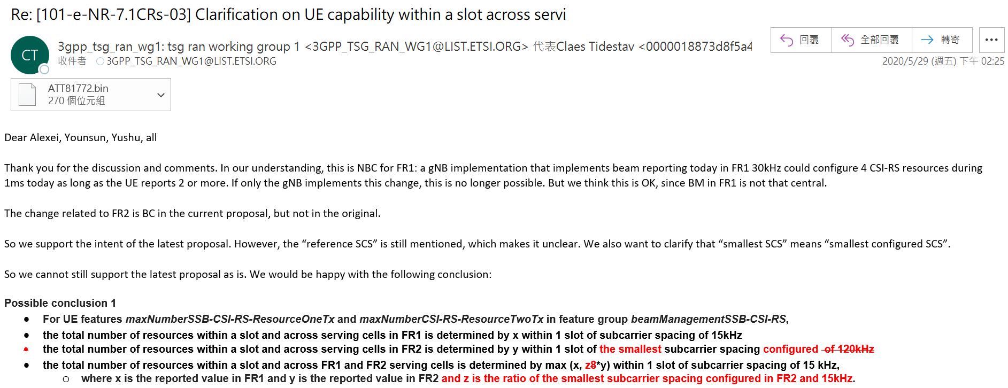  At that time, some company asked about the configuration question, and moderator answers  - I think configured means UE has to prepared for the worst case - all CCs are 120kHz.  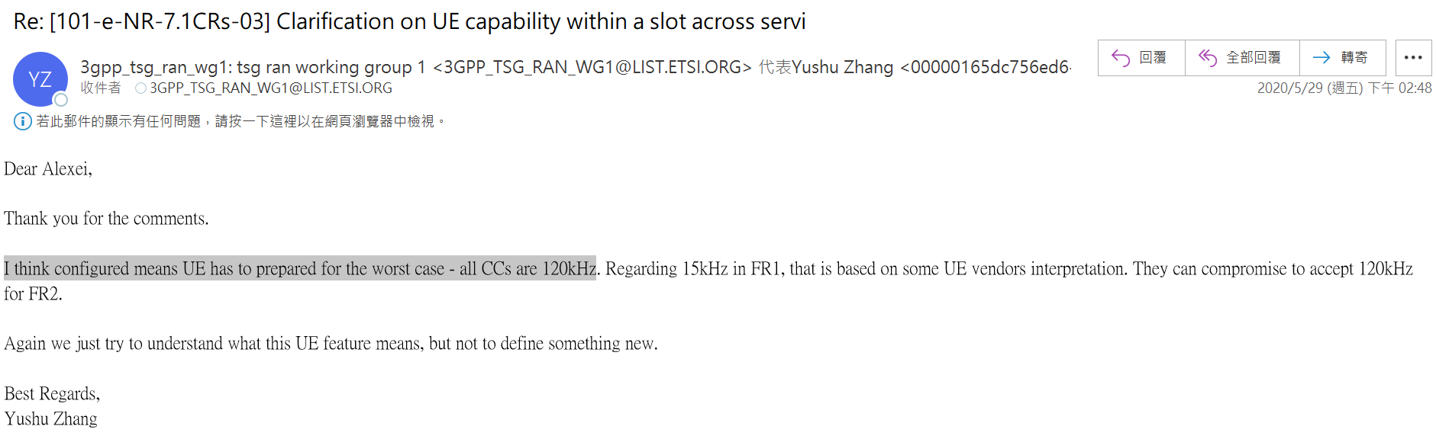  Later Ericsson updates their view that they prefer to just use 120kHz:  - We would actually prefer to change "the smallest subcarrier spacing configured for PDSCH in FR2" to "120kHz" and "z" to "8".  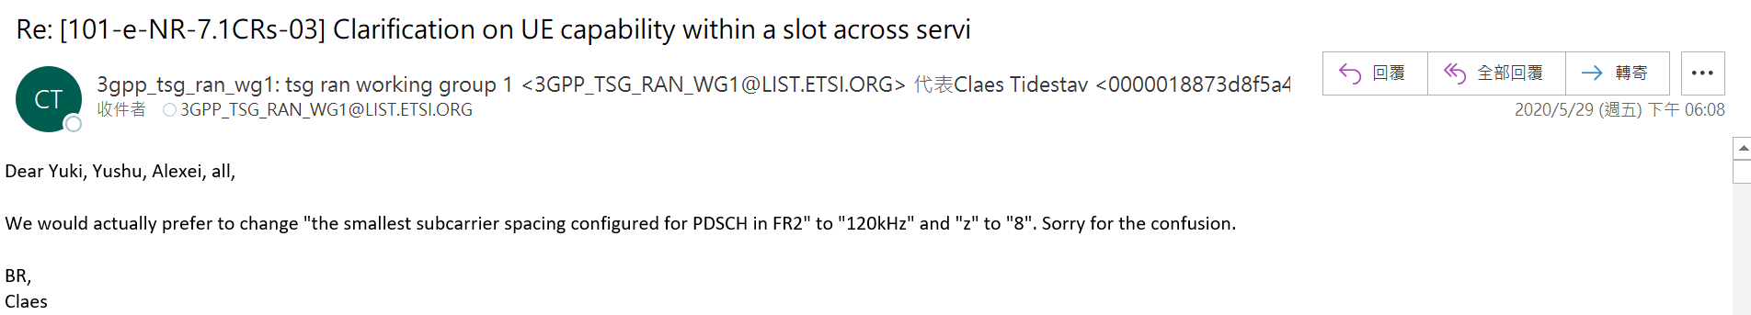  Then, some company raised concern about using 120kHz, and moderator suggests to go back to the original proposal:  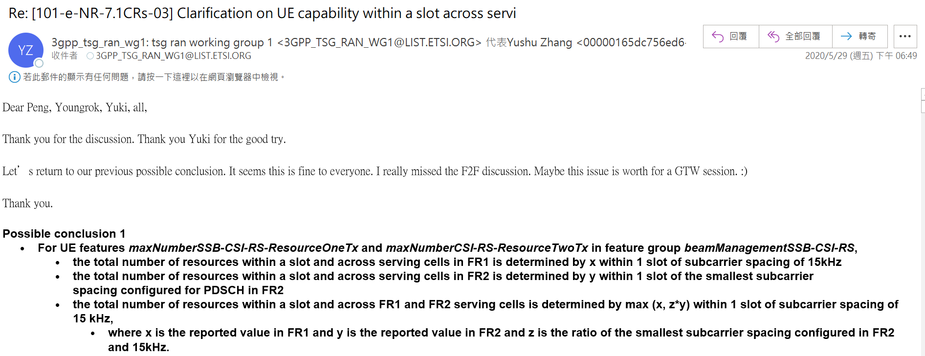  Then, Intel again raises question about the interpretation of “configured”:  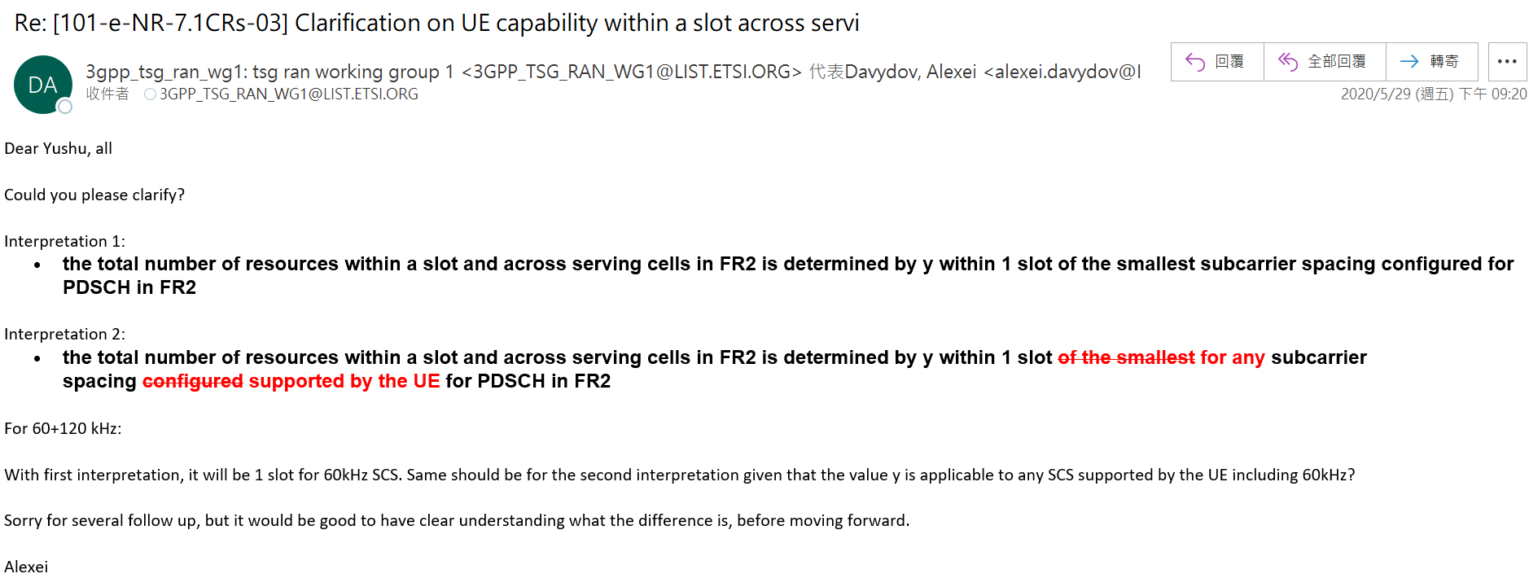  Then, due to the approaching deadline, Intel says they can live with the conclusion with two concerns:  - different interpretations of the same capability parameter depending on the FR  - non-static capability that dependent on RRC configuration  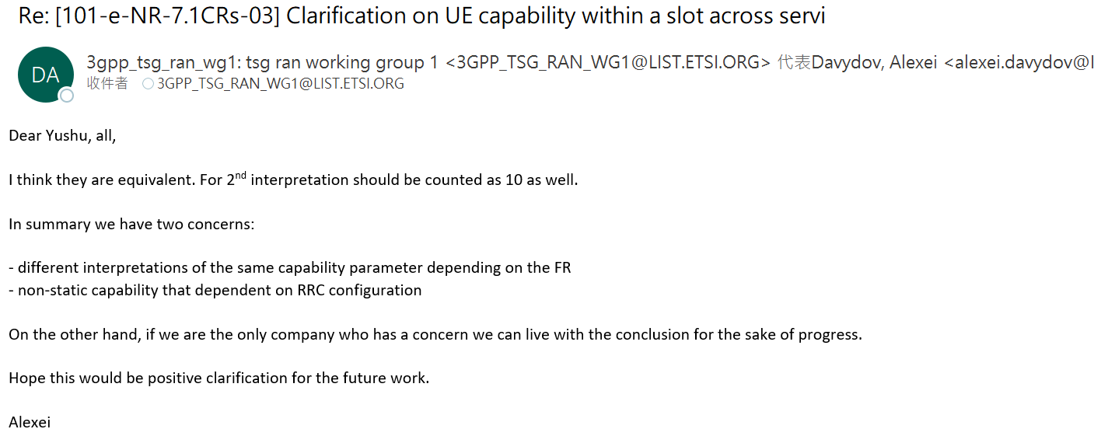  And that seems the end of story for RAN1 #101e.  One additional information during the RAN1 #101e discussion, moderator used to give the following explanation for the 3rd bullet:  - The UE supports a total number of resources equal to the maximum of the FR1 and FR2 value, but no more than the FR1 value across all FR1 serving cells and no more than the FR2 value across all FR2 serving cells.  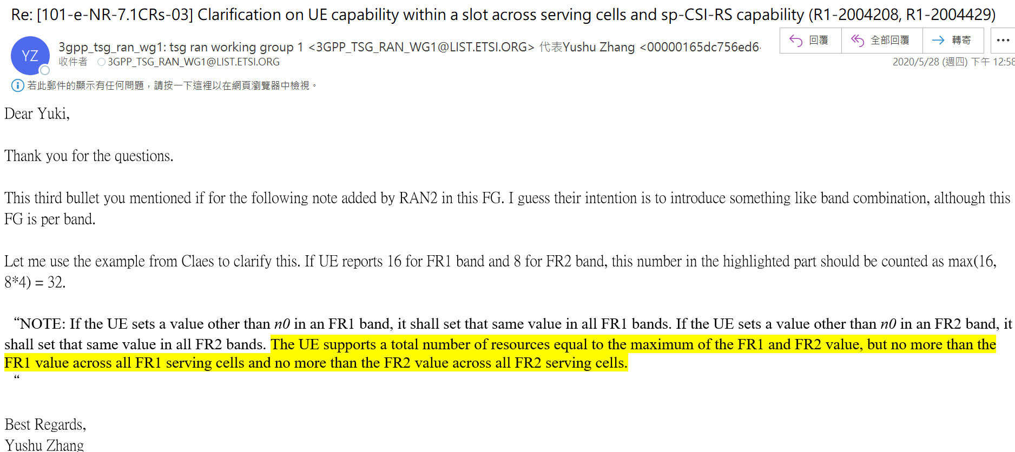  Ok, back to the current timeline. Our bottom line is the above-mentioned explanation for 3rd bullet by moderator in RAN1 #101e should also be captured in the RAN1 LS to avoid confusion:  - The UE supports a total number of resources equal to the maximum of the FR1 and FR2 value, but no more than the FR1 value across all FR1 serving cells and no more than the FR2 value across all FR2 serving cells.  As for the original conclusion, we prefer Samsung’s version, but we can live with the original version if majority of companies think so. At the same time, my RAN2 colleague reminds me that it may trigger another discussion in RAN2 because a non-static configuration that depends on RRC configuration is rare in RAN2 and companies in RAN2 may want to clarify it. However, that is RAN2 work then.
ZTE | No | We tend to agree with Apple and Samsung.
Huawei | NO | We have the same understanding as Apple that the conclusion itself is very clear, regardless whether it is good or bad.  - From RAN1 procedure wise, it is a critical conclusion requiring a lot of compromise. We also had concern as following during the email discussion for the conclusion, as our preference is to define a reference SCS for FR2 as well. But it turned out to be very difficult. For the sake of progress, we have agreed with the majority’s conclusion. We have warned the group that the conclusion might have potential risk, but we respect RAN1 efforts and compromise. After two years, any potential new changes will cause more serious and unforeseen NBC issues.  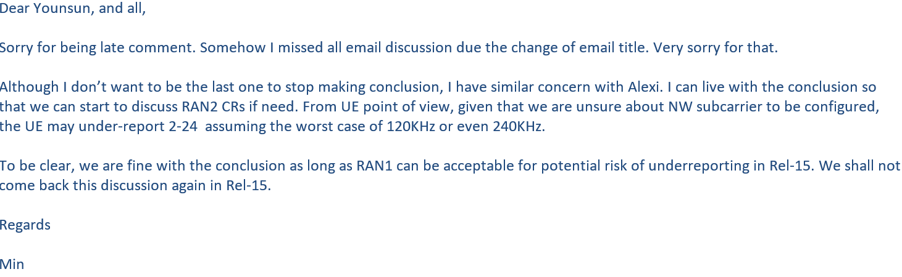  - From solution wise, we don’t see any new solutions here, even from proposed changes from Samsung or MTK. We tried everything before two years ago, as far as I understand.  For forward compatibility, given that Rel16 and Rel17 have future enhancement over BM, which might have more or less correlation with Rel-15 FG (then this conclusion), we don’t want to change Rel-15 baseline as it will cause additional workload/risk for Rel-16/17.
Mod |  | Re: MTK  Thank you for the detailed explanation.  Regarding the following statement from MediaTek  Our bottom line is the above-mentioned explanation for 3rd bullet by moderator in RAN1 #101e should also be captured in the RAN1 LS to avoid confusion:  - The UE supports a total number of resources equal to the maximum of the FR1 and FR2 value, but no more than the FR1 value across all FR1 serving cells and no more than the FR2 value across all FR2 serving cells.  In current TS38.306, this is already captured as the following  NOTE: If the UE sets a value other than n0 in an FR1 band, it shall set that same value in all FR1 bands. If the UE sets a value other than n0 in an FR2 band, it shall set that same value in all FR2 bands. The UE supports a total number of resources equal to the maximum of the FR1 and FR2 value, but no more than the FR1 value across all FR1 serving cells and no more than the FR2 value across all FR2 serving cells.  With this already in TS38.306, would that address the concern/bottom line from MTK?
MTK |  | Thanks moderator for pointing the corresponding spec sentence out. With this sentence, we would be fine with the moderator proposal.

Second round Question #2
Question #2: Do you agree that RAN1 should send LS to RAN2 to inform RAN2 about the conclusion RAN1 agreed regarding the interpretation of maxNumberSSB-CSI-RS-ResourceOneTx and maxNumberCSI-RS-ResourceTwoTx.
- If you agree, under what condition
  - Option 1: Send LS with the conclusion as is
  - Option 2: Send LS after further modification/clarification of the conclusion

Company | Yes/No | View
Apple | Yes | Option 1  If companies are willing to even spend some time to check the previous discussion on RAN1 email reflector, the current conclusion was agreed after lengthy and very difficult discussion among active companies more than 2 years ago. It is formulated without ambiguous understanding. It is a difficult compromise reached among companies more than 2 years ago, like many of the NR agreement/conclusion. It is not the conclusion we, as Apple, anticipated or liked, but it was a compromise that 3GPP offered more than 2 years ago.  As we explained, first, we shall respect those hard time companies went through in the past for reaching the agreed conclusion, by allowing the LS to be sent to RAN2. Otherwise, we do not see any point or value to continue discussion at all.  With respect, any further clarification/modification is possible even though it is more than 2 years late. Otherwise, we have no interest to continue the effort.
Samsung |  | Prefer Option 1 but open for Option 2 too.
ZTE |  | We do not have strong preference. Either way, RAN2 can further review RAN1’s conclusion. If have to, we prefer Option-1.
Huawei | Yes and NO | We don’t see anything new beyond RAN1 conclusion as RAN2 can read our 2-year old conclusion directly. How to implement RAN1 conclusion can be left to RAN2, so that RAN2 has slightly more flexibility.  However, if RAN1 can reach some NEW conclusion or understanding, we shall send LS of new understanding to RAN2 to speed up the process.
vivo |  | Sending the RAN1#101 conclusion in LS as it is doesn’t make sense, RAN2 can always refer to RAN1 agreements
MTK |  | We can be fine to send an LS to RAN2 and adopt Option 1.  At the same time, it may be helpful to also point out which part of the conclusion is missing or not correctly captured in current RAN2 spec in the LS, so RAN2 can know what is the action for them.

Outcome of the Email discussion
To be updated

Reference
- RAN1 Chairman’s Notes, 3GPP TSG RAN WG1 Meeting #101-e e-Meeting, May 25th – June 5th, 2020
- R2-2207331, Correction on beamManagementSSB-CSI-RS, 3GPP TSG-RAN WG2 Meeting #119 e-Meeting, 17-26 August 2022
- R1-2209555, On alignment of understanding for BM across multiple cells with different SCS, October 10th – 19th, 2022
- R1-2209556, Draft LS on beamManagementSSB-CSI-RS, 3GPP TSG RAN WG1 #110bis-e e-Meeting, October 10th – 19th, 2022
- R1-2209515, On maximum supported CSI-RS Resource in beamManagementSSB-CSI-RS, October 10th – 19th, 2022

