**3GPP TSG RAN WG1 #110bis-e R1-22xxxxx**

**e-Meeting, October 10th – 19th, 2022**

Agenda Item: 7.1

Source: Moderator (Ericsson)

Title: [110bis-e-NR-R15-02] Discussion on clarification of CSI reporting

Document for: Discussion/Decision

# Introduction

This document provides summary on the following email discussion;

|  |
| --- |
| [110bis-e-NR-R15-02] Discussion on clarification of CSI reporting by Oct 17 – Mattias (Ericsson) |

This document is created to collect company views on two documents submitted related to the issue:

R1-2208730 Clarification of CSI reporting (Rel-15) Ericsson

R1-2209933 Discussion on even and odd CSI subband index definition Qualcomm Incorporated

RAN1 needs to clarify the intention of the spec during RAN1#110bis-e. Please provide your comments in Section 3 as soon as possible so we can conclude on the issue by **Monday** **17th Oct 23:59 UTC** .

# Background

At least one network vendor observed (from testing of different UE devices) ambiguity in the interpretation and thus implementation of CSI subband indexing when the RRC signalling *csi-ReportingBand* is different from all “111111…”.

A first interpretation counts only the active subbands configured by the gNB, a second counts all the subbands in the BWP with nature order. These two interpretations cause ambiguity in determining even and odd subbands, leading to two different UCI packing orders. Note that the mapping order for CSI part 2 when using subband CQI and PMI follows as (TS 38.212 section 6.3.1.1.2):

1. Subband diff CQI for 2nd TB for all even subbands
2. PMI of all even subbands
3. Subband diff CQI for 2nd TB for all odd subbands
4. PMI of all odd subbands

With mismatched gNB-UE side interpretation respectively, the CSI report contains nonsense unless *csi-ReportingBand* contains all “1”.

* **Interpretation 1**: The CSI subband index count from the first active subband indicated by in the RRC signalling csi-ReportingBand, i.e., the first “1” from the right in the csi-ReportingBand is regarded as subband 0, the second “1” is regarded as subband 1, etc
  + See some examples in the figure below (assuming a total of 8 subbands) together with what values the UE report.

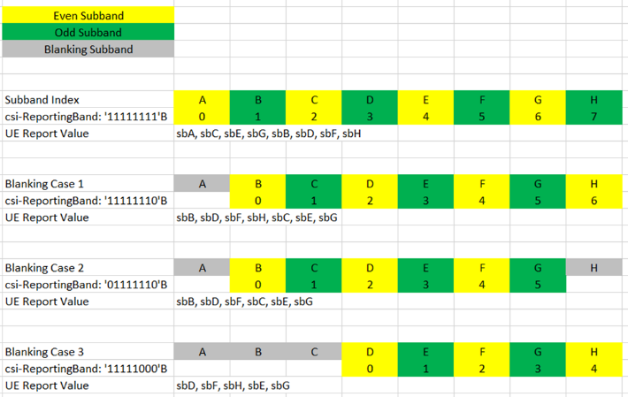

* **Interpretation 2:** The CSI subband index count from the first subband in the BWP, regardless of the RRC signalling csi-ReportingBand. Note that the mapping of subbands is different compared to Interpretation 1 and consequently the UE will report the subbands in a different order.
  + 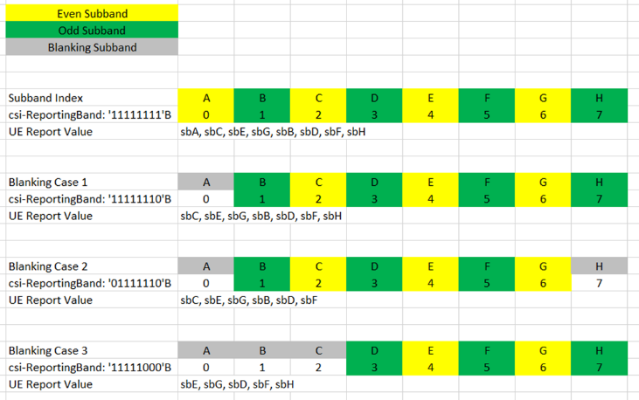

# Proposed Resolution

Since there are UE in the field already with implementation of both interpretation 1 and 2, the feature is broken. Hence, gNB may have to always configure subbands patterns without ambiguity (e.g., all “1”s in csi-ReportingBand) since the gNB does not know the UE implementation.

For Rel.17 UE and onwards on the other hand, the feature can be corrected by clarifying the specification to either interpretation 1 or 2.

Hence, the moderator’s proposal is to introduce a Rel.17 CR that clarifies the specification for either 1 and 2. In addition, the gNB need to know whether the UE is supporting the interpretation according to the clarification or not (basically whether it is a Rel.17 UE following the CR).

**Moderator proposal: Introduce a Rel.17 CR that clarifies the specifications to either Interpretation 1 or 2 together with a UE capability for this clarification.**

|  |  |
| --- | --- |
| Company | View |
| Qualcomm | Our 1st preference is to clarify the Rel-15 spec with interpretation 2. If there exists UE implementing other than interpretation 2, we support moderator proposal.  Besides, maybe a new RRC parameter *csi-ReportingBand-r17* is needed also for the clarified spec while leaving the original *csi-ReportingBand* used for legacy UE. |
| ZTE | If our understanding is correct, we should only specify one of interpretation 1 and 2 in Rel-17 (although Rel-15/16 seems better). Then, we still need to introduce a UE capability for what? Since it is just for Rel-17 UE, in our views, the Rel-17 UE should be implemented according to the endorsed CR.  **Moderator**: But how does the network know that the UE is a Rel.17 UE? I don’t think using the *accessStratumRelease* is a good solution, it will create dependencies and may be even more complicated in the future. |
| OPPO | We are fine with the proposal.  For the new RRC parameter *csi-ReportingBand-r17*, is the understanding correct that when it is configured, the UE behavior will follow the new CR, while Rel-15/16 implementation when *csi-ReportingBand* is configured? If that is the intention, we propose to use *csi-ReportingBand* for both Rel-17 UE and legacy UE. |
| Nokia, NSB | We support the proposal in general. We’d be interested in taking the clarification/correction already than Rel-17, but assuming that a new capability is required, Rel-17 maybe the earliest possible alternative. |
| Samsung | After checking, we also recognized the issue on interpretation between 1 and 2 for subband index for CSI.  From our view, clarifying and having a common understanding on one of two interpretations for all releases (Rel-15/16/17) is the best way. However, the problem is, Rel-15/16 UEs are already in the field and some of their interpretations are not aligned.  In order to solve a problem considering Rel-15/16 UEs and networks already in the field, instead of use Rel-15/16 spec with some holes, we believe that introducing a restriction on *csi-ReportingBand* bitmap can be a better way. Our view is that, with a certain restriction, both contiguous and non-contiguous subband configurations are possible by aligning even/odd subbands for both interpretations. We are open to how to capture this restriction whether to capture in RAN1, 2, or else.  For Rel-17, in order to utilize *csi-ReportingBand* bitmap without any restriction, we need to agree one of two interpretations and further study on how gNB distinguishes between Rel-15/16 UEs and Rel-17 UEs.  For this, we don't think Rel-17 UE capability which indicates an interpretation an UE assumes can solve this issue perfectly, since when the UE capability is adopted, gNB should implement both interpretations and manage UEs with different interpretations separately and which would introduce another complexity.  We can discuss further how to support this feature in Rel-17.  **Proposal**: Strive to have a common understanding on one of two interpretations for all releases (Rel-15/16/17).  - For Rel-15/16, clarify spec with restriction on *csi-ReportingBand* only to have common understanding between interpretation 1 and 2.  - For Rel-17, one of two interpretation is supported and clarify in Spec.  Moderator: Note that a UE capability will not be used to indicate either 1 or 2, but to indicate whether UE support the Rel.17 CR of either option 1 or 2, for example the CR can be written so that if UE support *csi-ReportingBand-r17* then option [1 or 2] shall be assumed. |
|  |  |
|  |  |

**Question: Which interpretation (1 or 2) is should be the Rel.17 clarification in specification?**

|  |  |
| --- | --- |
| Company | View |
| Qualcomm | We believe interpretation 2 is the correct understanding. As stated in our contribution R1-2209933, there are two reasons:   1. **Interpretation 2 reflects the original intention of UCI packing principle, in the sense of, keeping the subbands as close to each other as possible when UCI omission occurs**    1. For instance, with subband configuration 1110001000111, when CSI omission occurs, the orphan subband in the middle will be dropped if following interpretation 1, but will be kept if following interpretation 2. So interpretation 2 will make it much easier for the gNB to perform CQI/PMI interpolation. 2. **Interpretation 2 is described in current 331 and 214 spec.**   When CSI reporting on PUSCH comprises two parts, the UE may omit a portion of the Part 2 CSI. Omission of Part 2 CSI is according to the priority order shown in Table 5.2.3-1, where  is the number of CSI reports configured to be carried on the PUSCH. Priority 0 is the highest priority and priority  is the lowest priority and the CSI report *n* corresponds to the CSI report with the *n*th smallest Prii,CSI(*y,k,c,s*) value among the  CSI reports as defined in Clause 5.2.5. The subbands for a given CSI report *n* indicated by the higher layer parameter *csi-ReportingBand* are numbered continuously in increasing order with the lowest subband of *csi-ReportingBand* as subband 0. When omitting Part 2 CSI information for a particular priority level, the UE shall omit all of the information at that priority level.  ***csi-ReportingBand***  Indicates a contiguous or non-contiguous subset of subbands in the bandwidth part which CSI shall be reported for. Each bit in the bit-string represents one subband. The right-most bit in the bit string represents the lowest subband in the BWP. The choice determines the number of subbands (subbands3 for 3 subbands, subbands4 for 4 subbands, and so on) (see TS 38.214 [19], clause 5.2.1.4). This field is absent if there are less than 24 PRBs (no sub band) and present otherwise, the number of sub bands can be from 3 (24 PRBs, sub band size 8) to 18 (72 PRBs, sub band size 4). |
| ZTE | Technically speaking, we also think that Interpretation-1 looks much more reasonable, considering that we may have almost equal number of odd and even active subbands. It seems that only suband(s) with the corresponding bit set to '1' in csi-ReportingBand may be numbered continuously (some further clarification is needed?). Otherwise, if going with Interpretation-2, in a worst case, all active subbands for reporting (i.e., odd bands by csi-ReportingBand:'01010101'B) may be omitted. It seems to betray the motivation of this omission rule. |
| OPPO | We think Interpretation-1 is the better way and can be applied for Rel-17. Interpretation-1 would avoid the case mentioned by ZTE, where all the subbands would be omitted/maintained. With Interpretation 1 at least half of the subbands can always be reported. Also, we think Interpretation-1 is easier to be implemented for UE, where only the active bands need to be processed. |
| Apple | After checking the issue, what we found is that this issue was clarified as interpretation 1 in RAN1#94b in 10/2018. The sentence "*The subbands for given CSI report n indicated by the higher layer parameter csi-ReportingBand are numbered continuously in the increasing order with the lowest subband of csi-ReportingBand as subband 0*” was endorsed as CR and show up in TS38.214 in RAN1#94b in 10/2018.   * The reason why this sentence was introduced was to clarify the different interpretation as raised by Huawei in "R1-1810099”.   + The proposal from Huawei is to clarify, exactly, that the understanding is only for the indicated subband, which is clear from their contribution. * The proposal from Huawei was also agreed in the same meeting, with FL summary in R1-1812015 and the Chairman note |
| Nokia, NSB | Our understanding is that Interpretation-1 is the original intent of the specification, and Apple’s reference to Huawei R1-1810099 further underlines the point and makes it very difficult for RAN1 to 4 years later revert course and say that interpretation-2 is the correct interpretation. |
| LG | Our understanding is also Interpretation-1. |
| Samsung | We think a common understanding of either interpretation 1 or 2 for gNB and UEs should be needed in Rel-17. |
|  |  |

# Outcome of the Email discussion

To be updated