**3GPP TSG RAN WG1 #110bis-e R1-22xxxxx**

**e-Meeting, October 10th – 19th, 2022**

Agenda Item: 7.1

Source: Moderator (Ericsson)

Title: [110bis-e-NR-R15-02] Discussion on clarification of CSI reporting

Document for: Discussion/Decision

# Introduction

This document provides summary on the following email discussion;

|  |
| --- |
| [110bis-e-NR-R15-02] Discussion on clarification of CSI reporting by Oct 17 – Mattias (Ericsson) |

This document is created to collect company views on two documents submitted related to the issue:

R1-2208730 Clarification of CSI reporting (Rel-15) Ericsson

R1-2209933 Discussion on even and odd CSI subband index definition Qualcomm Incorporated

RAN1 needs to clarify the intention of the spec during RAN1#110bis-e. Please provide your comments in Section 3 as soon as possible so we can conclude on the issue by **Monday** **17th Oct 23:59 UTC** .

# Background

At least one network vendor observed (from testing of different UE devices) ambiguity in the interpretation and thus implementation of CSI subband indexing when the RRC signalling *csi-ReportingBand* is different from all “111111…”.

A first interpretation counts only the active subbands configured by the gNB, a second counts all the subbands in the BWP with nature order. These two interpretations cause ambiguity in determining even and odd subbands, leading to two different UCI packing orders. Note that the mapping order for CSI part 2 when using subband CQI and PMI follows as (TS 38.212 section 6.3.1.1.2):

1. Subband diff CQI for 2nd TB for all even subbands
2. PMI of all even subbands
3. Subband diff CQI for 2nd TB for all odd subbands
4. PMI of all odd subbands

With mismatched gNB-UE side interpretation respectively, the CSI report contains nonsense unless *csi-ReportingBand* contains all “1”.

* **Interpretation 1**: The CSI subband index count from the first active subband indicated by in the RRC signalling csi-ReportingBand, i.e., the first “1” from the right in the csi-ReportingBand is regarded as subband 0, the second “1” is regarded as subband 1, etc
  + See some examples in the figure below (assuming a total of 8 subbands) together with what values the UE report.

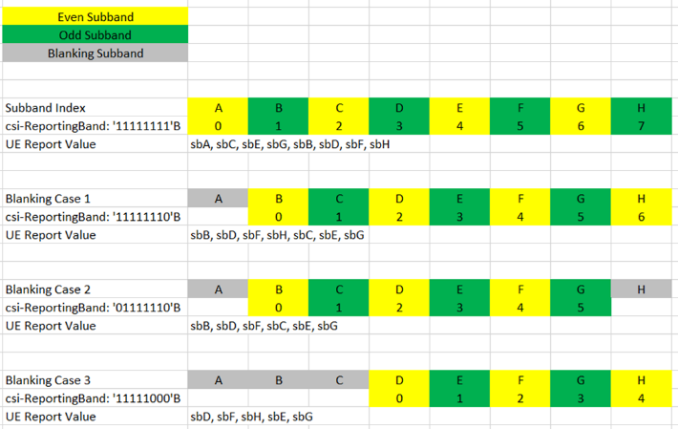

* **Interpretation 2:** The CSI subband index count from the first subband in the BWP, regardless of the RRC signalling csi-ReportingBand. Note that the mapping of subbands is different compared to Interpretation 1 and consequently the UE will report the subbands in a different order.
  + 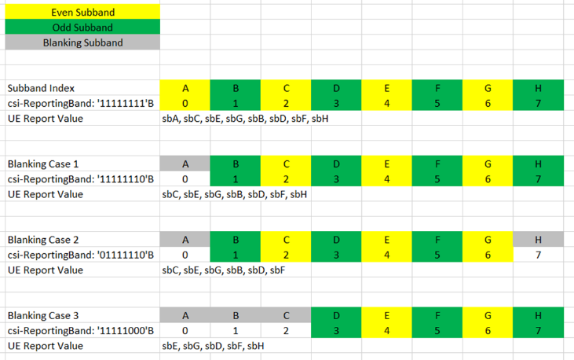

# Proposed Resolution

Since there are UE in the field already with implementation of both interpretation 1 and 2, the feature is broken. Hence, gNB may have to always configure subbands patterns without ambiguity (e.g., all “1”s in csi-ReportingBand) since the gNB does not know the UE implementation.

For Rel.17 UE and onwards on the other hand, the feature can be corrected by clarifying the specification to either interpretation 1 or 2.

Hence, the moderator’s proposal is to introduce a Rel.17 CR that clarifies the specification for either 1 and 2. In addition, the gNB need to know whether the UE is supporting the interpretation according to the clarification or not (basically whether it is a Rel.17 UE following the CR).

**Moderator proposal: Introduce a Rel.17 CR that clarifies the specifications to either Interpretation 1 or 2 together with a UE capability for this clarification.**

|  |  |
| --- | --- |
| Company | View |
|  |  |
|  |  |
|  |  |
|  |  |
|  |  |
|  |  |
|  |  |

**Question: Which interpretation (1 or 2) is should be the Rel.17 clarification in specification?**

|  |  |
| --- | --- |
| Company | View |
|  |  |
|  |  |
|  |  |
|  |  |
|  |  |
|  |  |
|  |  |
|  |  |

# Outcome of the Email discussion

To be updated