**3GPP TSG-RAN WG1 Meeting #110 R1-220xxxx**

**Toulouse, France, August 22 – 26, 2022**

**Agenda item:** 7.1

**Source:** Moderator (Samsung)

**Title:** Summary of Collision handling for overlapping PUCCHs with repetitions

**Document for:** Discussion and Decision

# Introduction

This contribution provides the summary for discussion of Collision handling for overlapping PUCCHs with repetitions in RAN1#110.

**Collision handling for overlapping PUCCHs with repetitions (to be moderated by Sa – Samsung)**

R1-2205785 Discussion on the collision of overlapped PUCCHs with repetition Huawei, HiSilicon

R1-2205786 Correction on the collision of overlapped PUCCHs with repetition Huawei, HiSilicon

R1-2206305 Clarification on collision handling for overlapping PUCCHs with repetitions OPPO

R1-2206350 Collision handling of more than two overlapping PUCCHs with repetition CATT

R1-2206781 Discussion on more than two overlapping PUCCHs with repetitions Samsung

R1-2206782 Draft CR for Intra-UE multiplexing/prioritization of the same priority Samsung

R1-2207170 Issue on PUCCH overlapping with PUCCH with repetitions Qualcomm Incorporated

Additional relevant tdoc R1-2206532 in 7.2.5.

Section 3 provides the background information. Section 4 provides the offline proposals. Section 5 captures the detailed discussions.

# Contact Points

Respondents to the email discussion are kindly asked to fill in the following table.

|  |  |  |
| --- | --- | --- |
| Company | Name | Email |
| Moderator (Samsung) | Sa Zhang | sa.zhang@samsung.com |
| CATT | Yanping Xing | xingyanping@catt.cn |
| Huawei/Hisi | Yuan Li | liyuan3@huawei.com |
|  |  |  |
|  |  |  |
|  |  |  |
|  |  |  |
|  |  |  |
|  |  |  |
|  |  |  |

# Background

In RAN1#109-e, more than two overlapping PUCCHs with repetitions was discussed [1] and the following conclusions were made [2].

|  |
| --- |
| Conclusion:  For resolving overlapping PUCCHs with and/or without repetitions in a slot in Rel-16, a UE first performs clause 9.2.6 (TS 38.213) to resolve overlapping PUCCHs where at least one PUCCH is with repetitions, and then UE performs clause 9.2.5 (TS 38.213) to resolve overlapping PUCCHs without repetitions.   * Note: The above is performed per slot.   Conclusion:  For resolving overlapping PUCCHs with repetitions in clause 9.2.6 of TS 38.213 in Rel-16, PUCCHs with repetitions and PUCCHs overlapping with a PUCCH with repetitions are considered. PUCCHs without repetitions that do not overlap with a PUCCH with repetitions are not considered.   * Note 1: The above is for clarifying the determination of the overlapping PUCCHs resolved in clause 9.2.6 of TS 38.213 and does not impact the determination of “a set of overlapping PUCCHs” when performing clause 9.2.6 of TS 38.213 discussed in [109-e-NR-CRs-03]. * Note 2: The above has no spec impact. This is also assumed in discussion to solve issue in [109-e-NR-CRs-03].   Conclusion:  For resolving the overlapping PUCCHs with repetitions in Rel-16, the procedure of 9.2.6 of TR38.213 only performs prioritization, multiplexing is not performed in 9.2.6 of TR38.213.   * Note: the above has no spec impact.   Conclusion  For resolving overlapping PUCCHs of a same priority in Rel-16, a UE performs the following steps   * Step1, the UE resolves overlapping PUCCHs with repetitions as described in TS 38.213 clause 9.2.6, if any.   + Step 1-1: the UE determines the PUCCHs involved in TS 38.213 clause 9.2.6.     - o    PUCCHs with repetitions and PUCCHs overlapping with a PUCCH with repetitions are involved.     - o    PUCCHs without repetitions that do not overlap with a PUCCH with repetitions are not involved.   + Step 1-2: the UE resolves overlapping PUCCHs determined in Step 1-1 by performing TS 38.213 clause 9.2.6.     - o    Only prioritization is performed. * Step2, the UE resolves overlapping PUCCHs without repetitions as described in TS 38.213 clause 9.2.5, if any.   + Step 2-1: the UE determines the PUCCHs involved in TS 38.213 clause 9.2.5.     - PUCCHs without repetitions that do not overlap with a PUCCH with repetitions are involved.     - Resulting PUCCHs without repetitions of resolving overlapping PUCCHs determined in Step 1-2 are involved.   + Step 2-2: the UE resolves overlapping PUCCHs determined in Step 2-1 by performing TS 38.213 clause 9.2.5.   Note: The above conclusion on the generic framework with high-level steps has no spec impact. The details of certain steps, e.g. step 1-2, may have spec impact subject to outcome of the ongoing and future discussion on the issues identified in email thread [109-e-NR-CRs-03]. |

In addition, the following agreement is made regarding the framework of intra UE multiplexing [2]

|  |
| --- |
| Agreement  For resolving overlapping PUCCHs and/or PUSCHs of a same priority in Rel-16, a UE performs the following steps   * Step1, the UE resolves overlapping PUCCHs with repetitions as described in TS 38.213 clause 9.2.6, if any. * Step2, the UE resolves overlapping PUCCHs without repetitions as described in TS 38.213 clause 9.2.5, if any. * Step3, the UE resolves overlapping PUSCH(s) and PUCCH(s) with repetitions as described in TS 38.213 clause 9, if any. * Step4, the UE resolves overlapping PUSCH(s) and PUCCH(s) without repetitions as described in TS 38.213 clause 9, if any.   FFS: Whether/How to capture Step 1 and Step 2 in the spec. |

In the last meeting, the following aspects regarding overlapping PUCCHs were clarified.

1. The order of resolving overlapping PUCCHs with and without repetitions.

* The UE first resolves overlapping PUCCHs with repetitions as described in TS 38.213 clause 9.2.6.

1. The PUCCHs involved in resolving overlapping PUCCHs with repetitions.

* PUCCHs with repetitions and PUCCHs overlapping with a PUCCH with repetitions are involved.
* PUCCHs without repetitions that do not overlap with a PUCCH with repetitions are not involved.

1. The PUCCHs involved in resolving overlapping PUCCHs without repetitions.

* PUCCHs without repetitions that do not overlap with a PUCCH with repetitions are involved.
* Resulting PUCCHs without repetitions of resolving overlapping PUCCHs determined in clause 9.2.6 are involved.

1. Only prioritization is performed when resolving overlapping PUCCHs with repetitions as described in TS 38.213 clause 9.2.6.

For resolving overlapping PUCCHs with repetitions, if there are two overlapping PUCCHs in a group of overlapping PUCCHs, companies agree that the definition of “first PUCCH” or “second PUCCH” is clear. In this case, UE performs prioritization according the rules defined in clause 9.2.6. However, if there are more than two overlapping PUCCHs in a group of overlapping PUCCHs, UE behaviour is not clear. The remaining issue is how to perform prioritization for a group of overlapping PUCCHs with repetitions when there are more than two PUCCHs in the group.

# Offline proposals

TBD

# Discussion

For the remaining issue of resolving overlapping for a group of more than two overlapping PUCCHs with repetitions, several candidate solutions are proposed by companies and are summarized below.

**Option 1**

Step 1-2-1: UE determines a set of overlapping PUCCHs according to the following two steps:

Step i, a reference PUCCH is selected from all PUCCHs with repetition that overlap with at least one PUCCH in the current slot with the order of earliest symbol followed by longest duration.

Step ii, the “a set of overlapping PUCCHs” is determined as the reference PUCCH and all PUCCHs (with/without repetitions) that are overlapping with this reference PUCCH.

Step 1-2-2: the PUCCH with the highest priority/earliest slot of “a set of overlapping PUCCHs” is transmitted, while the PUCCH with any lower priority/later slot is dropped.

* Proponents: Huawei [3], [4]

**Option 2**

Step 1-2-1: UE determines a set of overlapping PUCCHs according to existing pseudo-code in clause 9.2.5

Step 1-2-2: UE resolves the collision of all PUCCHs within the set of overlapping PUCCHs at a time, according to UCI type priority in clause 9.2.6, transmits PUCCH with UCI type with highest priority and drops all PUCCHs with UCI type with lower priority.

Step 1-2-3: UE repeats step 1-2-1 and step 1-2-2 until all the PUCCHs involved in Step 1-2 are processed.

* Proponents: Qualcomm [5], Intel [6]

**Option 3)**

Step 1-2-1: UE determines a set of overlapping PUCCHs according to existing pseudo-code in clause 9.2.5 with the restriction of selecting up to 2 PUCCH resources

Step 1-2-2: UE resolves the collision of all PUCCHs within the set of overlapping PUCCHs at a time, according to UCI type priority in clause 9.2.6, transmits PUCCH with UCI type with higher priority and drops the PUCCH with UCI type with lower priority.

Step 1-2-3: UE repeats step 1-2-1 and step 1-2-2 until all the PUCCHs involved in Step 1-2 are processed.

* Proponents: Samsung [7]

**Option 4**

Step 1-2-1: UE determines a set of overlapping PUCCHs according to the following

* Determine a first PUCCH with repetition based on UCI priority followed by starting slot/sub-slot as defined in TS 38.213 clause 9.2.6 and “a set of overlapping PUCCHs” including the first PUCCH and all the PUCCHs overlapping with the first PUCCH;

Step 1-2-2: Perform pair-wise prioritization between the first PUCCH and a second PUCCH until there is no overlapping between the first PUCCH and another PUCCH, where the second PUCCH is selected based on UCI priority followed by starting slot/sub-slot as defined in TS 38.213 clause 9.2.6 within “a set of overlapping PUCCHs”.

* Proponents: CATT [8]

**Option 5**

Step 1-2-1: UE determines a set of overlapping PUCCHs according to the following

* Determine a first PUCCH based on UCI priority followed by starting slot/sub-slot as defined in TS 38.213 clause 9.2.6 and “a set of overlapping PUCCHs” including the first PUCCH and all the PUCCHs overlapping with the first PUCCH

Step 1-2-2: Keep the first PUCCH and drop all the other PUCCHs within “a set of overlapping PUCCHs”.

* Proponents: CATT [8]

**Option 6**

Step 1-2-1: UE determines a set of overlapping PUCCHs according to the descending order of UCI priority or the ascending order starting symbol/duration:

* set Q to the PUCCHs involved in TS 38.213 clause 9.2.6, which includes PUCCHs with repetitions and PUCCHs overlapping with a PUCCH with repetitions. Set R to the PUCCHs with repetitions in set Q.
* UE selects the PUCCH with rep with the highest UCI priority or earliest starting symbol in set R as the “first PUCCH”. And then forms the “set of overlapping PUCCHs” and performs prioritization according to observation 1/2, that is, UE selects the PUCCH(s) overlapping with the selected “first PUCCH” as the “second PUCCH(s)”

Step 1-2-2: UE transmits PUCCH with highest UCI priority within the “set of overlapping PUCCH”, drop other PUCCHs within the “set of overlapping PUCCHs” and then excludes the dropped PUCCHs within the “set of overlapping PUCCHs” from Q. UE excludes the selected “first PUCCH” from R.

Step 1-2-3: UE repeats step 1-2-1 and step 1-2-2 until there is no PUCCH overlapping with a PUCCH with repetitions in Q.

* Proponents: OPPO [9]

**Option 7**

UE does not expect to be configured or scheduled more than one PUCCH with repetitions in a slot.

* Proponents: OPPO [9]

## First round

## Framework for resolving PUCCHs with repetitions

The following case was discussed in RAN1#109e for illustration the steps of resolving overlapping PUCCHs in a slot. Set Z includes the PUCCHs involved in Step 1-2, in this example, there are two groups of overlapping PUCCHs in Step 1-2 and a UE can resolve the overlapping PUCCHs for each group in a time order.

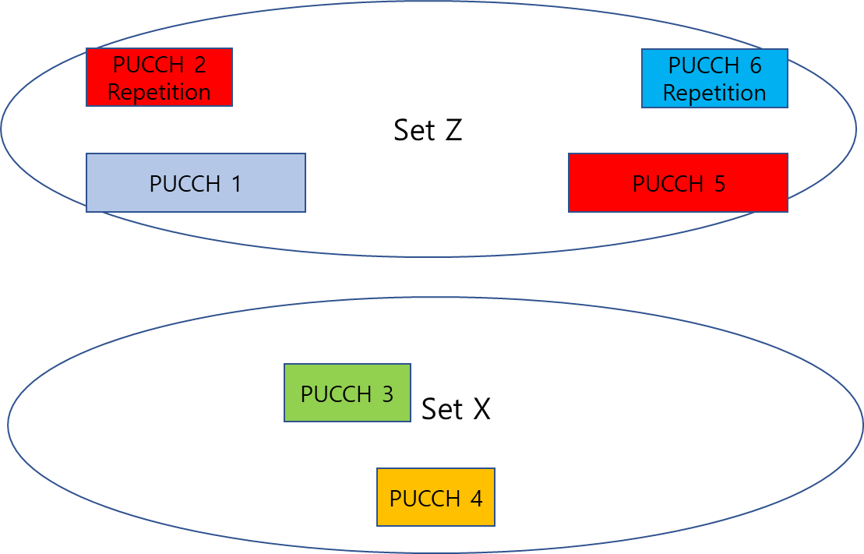

**Figure 1 [1]**

A more complicated case is a group consisting of more than two overlapping PUCCHs and the discussion from the submitted contributions focus on a group of three overlapping PUCCHs. The discussion will first focus on a group of three overlapping PUCCHs to compare the pros and cons of candidate options.

For Option 1 ~ 6, the majority view of the framework is well aligned although Option 1, 4 and 5 do not consider the case of multiple groups of overlapping PUCCHs, in this case, it would be straightforward to repeat the first two steps until there is no collision.

The framework of Step 1-2 is summarized below,

**Step 1-2-1: the UE determines a set of overlapping PUCCHs**

**Step 1-2-2: the UE transmits the PUCCH with UCI type with highest priority and drops the other PUCCHs in the set of overlapping PUCCHs**

**Step 1-2-3: the UE repeats step 1-2-1 and step 1-2-2 until there is no collision**

For Step 1-2-1, the solutions are quite diverse and the details can be further discussed in section 5.1.2.

For Step 1-2-2, the majority view is to reuse the rules defined in clause 9.2.6. One issue for Step 1-2-2 is how to handle the case when there are two non-overlapping PUCCHs with UCI type with highest priority. Consider the example in Figure 2 [8], for Option 1, 2 and 6, UE behaviour seems not clear. There can be two candidate behaviours. UE can transmit one of the SR or UE can transmit both SRs.

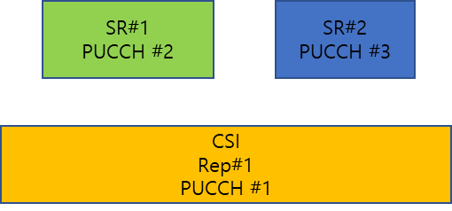

**Figure 2: Case 1**

For Step 1-2-3, there are two alternatives on the interpretation of ‘no collision’.

* Alt1: There are no overlapping PUCCHs.
* Alt 2: There is no PUCCH overlapping with a PUCCH with repetitions, i.e., there can be overlapping PUCCHs without repetitions.

#### **Q1:**

**Do you agree with the following three steps for resolving overlapping PUCCHs with repetitions in a slot? If the answer is NO, please clarify the reason.**

**Step 1-2-1: the UE determines** **a set of overlapping PUCCHs.**

* **FFS details.**

**Step 1-2-2: the UE transmits the PUCCH with UCI type with the highest priority and drops the other PUCCHs in the set of overlapping PUCCHs**

* **FFS: The rules defined in clause 9.2.6 are reused for determining the PUCCH with UCI type with the highest priority.**
* **FFS: A PUCCH with UCI of lower priority overlaps with two non-overlapping PUCCHs with UCI of higher priority.**

**Step 1-2-3: the UE repeats step 1-2-1 and step 1-2-2 until there is no collision for the result PUCCHs. Down select between**

* **Alt1: There are no overlapping PUCCHs.**
* **Alt2: There is no PUCCH overlapping with a PUCCH with repetitions.**

|  |  |
| --- | --- |
| Company | View |
| CATT | As summarized in Option 4 above, our proposal is to perform pair-wise prioritization between a first PUCCH and second PUCCH(s).  For example, for the following case, the first PUCCH is PUCCH 2 with repetition and the second PUCCHs are PUCCH 1 and PUCCH 3. Based on UCI priority, UE first perform prioritization between PUCCH 1 and PUCCH 2 and PUCCH 2 is dropped. Since neither PUCCH 1 nor PUCCH 3 is with repetition, no further prioritization is needed. Therefore, in this example, UE does not only transmit the PUCCH with the highest priority (i.e. PUCCH 1) but also transmits another PUCCH, i.e. PUCCH 3.    The wording of Step 1-2-2 precludes this option so we would like to propose the following modification to the proposal.  **Step 1-2-1: the UE determines a set of overlapping PUCCHs.**   * **FFS details.**   **Step 1-2-2: the UE ~~transmits the PUCCH with UCI type with the highest priority and drops the other~~ performs prioritization among PUCCHs in the set of overlapping PUCCHs**   * **FFS details~~: The rules defined in clause 9.2.6 are reused for determining the PUCCH with UCI type with the highest priority.~~** * **~~FFS: A PUCCH with UCI of lower priority overlaps with two non-overlapping PUCCHs with UCI of higher priority.~~**   **Step 1-2-3: the UE repeats step 1-2-1 and step 1-2-2 until there is no collision for the result PUCCHs. Down select between**   * **Alt1: There are no overlapping PUCCHs.** * **Alt2: There is no PUCCH overlapping with a PUCCH with repetitions.** |
| OPPO | Generally fine with the three steps with the following modified wording:  **Step 1-2-2: the UE transmits the PUCCH with UCI type with the highest priority followed by earliest starting slot and drops the other PUCCHs in the set of overlapping PUCCHs.** |
| Huawei/Hisi | OK in principle, except that the starting slot should also be included in Step 1-2-2 (similar with OPPO).  **the UE transmits the PUCCH with UCI type with the highest priority or the PUCCH starting at an earlier slot if all PUCCHs in the set of overlapping PUCCHs are of the same priority, and drops the other PUCCHs in the set of overlapping PUCCHs** |
|  |  |
|  |  |
|  |  |
|  |  |
|  |  |
|  |  |
|  |  |
|  |  |
|  |  |
|  |  |

For the prioritization rules in step 1-2-2, it is encouraged to reuse the rules defined in clause 9.2.6, it can minimize spec impact as well as implementation complexity. If companies would like to define a new rule for optimization, the motivation needs to be justified first.

#### **Q2:**

**Do you agree to reuse the rules defined in clause 9.2.6 for step 1-2-2? If the answer is NO, please clarify the reason.**

|  |  |
| --- | --- |
| Company | View |
| CATT | We think the problem is that the rules defined in clause 9.2.6 are not clear. Otherwise, we will not have the discussions now.  From our perspective, the principle to perform prioritization based on UCI priority followed by starting slot should be reused. |
| OPPO | If the rules defined in 9.2.6 refers perform prioritization according to UCI priority followed by starting slot, the answer is Yes. |
| Huawei/Hisi | Yes |
|  |  |
|  |  |
|  |  |
|  |  |
|  |  |
|  |  |
|  |  |
|  |  |
|  |  |
|  |  |

For the case in Figure 2, pair-wise prioritization can be considered as in Option 3 and Option 4. Option 3 requires selecting up to 2 PUCCH resources when determining the set of overlapping PUCCHs while Option 4 performs pair-wise prioritization after determining the set of overlapping PUCCHs. For pair-wise prioritization, the rules of selecting the pair needs to be defined. UE behaviour can also be defined for Option 1, 2 and 6, for example, UE can either transmit one of the SR according to a predefined rule or transmits both SRs. Transmitting one PUCCH will lead to some UCI dropping. Transmitting two non-overlapping PUCCHs will have additional spec impact if the pseudo-code of clause 9.2.5 is reused.

|  |
| --- |
| else  if  determine a single resource for multiplexing UCI associated with resources  as described in clauses 9.2.5.0, 9.2.5.1 and 9.2.5.2  set the index of the single resource to    % start from the beginning after reordering unmerged resources at next step    % function that re-orders resources in current set  Set  to the cardinality of |

#### **Q3**

**What is your preference on handling the case where a PUCCH with UCI of lower priority overlaps with two non-overlapping PUCCHs with UCI of higher priority?**

* **Alt 1: Select up to 2 PUCCHs when determining the set of overlapping PUCCHs.**
* **Alt 2: Perform pair-wise prioritization according to a predefined rule for selecting the pair.**
* **Alt 3: Transmit one of the PUCCH with highest priority according to a predefined rule**
* **Alt 4: Transmit the two non-overlapping PUCCHs with highest priority.**
* **Alt 5: Others.**

|  |  |
| --- | --- |
| Company | View |
| CATT | We think it depends on the options and cases.  From performance perspective, it is better to keep both non-overlapping PUCCHs with higher UCI priority. |
| OPPO | To our understanding, the case can only happen when the PUCCH with UCI of lower priority contains CSI, and the two non-overlapping PUCCHs with UCI of higher priority contains SR. If it is the only case, we prefer up to UE implementation to choose transmit one or two SR. |
| Huawei/Hisi | Alt.1 and Alt.2 are subject to the same behavior? A simple way is to select up to 2 resources and perform pairwise comparison, i.e., Alt.1/2 (but at least one of the two PUCCHs should be with repetition, since otherwise it will become the case of 9.2.5).  Or, we can also consider Alt.3, e.g., the earlier PUCCH with highest priority is transmitted, while the later one is dropped. |
|  |  |
|  |  |
|  |  |
|  |  |
|  |  |
|  |  |
|  |  |
|  |  |
|  |  |
|  |  |

For the resulting PUCCHs after performing step 1-2, Alt1 is well aligned the conclusion made in RAN1#109e, there is no overlapping for the resulting PUCCHs, the overlapping is resolved, however, for Alt2, there can be overlapping for the resulting PUCCHs, Alt2 seems not aligned with the conclusion.

|  |
| --- |
| Conclusion  For resolving overlapping PUCCHs of a same priority in Rel-16, a UE performs the following steps   * Step1, the UE resolves overlapping PUCCHs with repetitions as described in TS 38.213 clause 9.2.6, if any.   + Step 1-1: the UE determines the PUCCHs involved in TS 38.213 clause 9.2.6.     - o    PUCCHs with repetitions and PUCCHs overlapping with a PUCCH with repetitions are involved.     - o    PUCCHs without repetitions that do not overlap with a PUCCH with repetitions are not involved.   + Step 1-2: the UE resolves overlapping PUCCHs determined in Step 1-1 by performing TS 38.213 clause 9.2.6.     - o    Only prioritization is performed.   … |

#### **Q4**

**What is your preference on the alternatives for step 1-2-3?**

|  |  |  |
| --- | --- | --- |
| Alt1 | Support or can accept |  |
| Cannot accept |  |
| Alt2 | Support or can accept | **CATT, OPPO, Huawei/Hisi** |
| Cannot accept |  |

|  |  |
| --- | --- |
| Company | View |
| CATT | We are discussing handling of PUCCH with repetition and overlapping PUCCH(s). We do not understand why in Step 1-2, there cannot be overlapping PUCCHs even if they are not with repetition.  For example, our understanding of current specification is that both PUCCH 2 and PUCCH 3 can be transmitted. But if we go with Alt 1, PUCCH 3 has to be dropped as well, which is not reasonable. |
| Huawei/Hisi | The current 9.2.6 handles the case where at least one overlapped PUCCH is with repetition; if all PUCCHs in the “a set of overlapping PUCCHs” are without repetition, it will become a 9.2.5 case. Prioritizing between two PUCCHs without repetition is a new behavior beyond R15. |
|  |  |
|  |  |
|  |  |
|  |  |
|  |  |
|  |  |
|  |  |
|  |  |
|  |  |
|  |  |
|  |  |

## Determining a set of overlapping PUCCHs

The key issue is how to determine a set of overlapping PUCCHs, based on the input for submitted contributions, the solutions are quite diverse.

Option 1, 2 and 3 reuse the pseudo-code in clause 9.2.5 with or without certain restrictions. Option 1 requires that the reference PUCCH is with repetitions and Option 3 requires that the maximum number of overlapping PUCCHs in a set being 2. Option 2 simply reuses the pseudo-code in clause 9.2.5.

The intention of Option 1 is to use the ‘the first PUCCH’ defined in clause 9.2.6 as the reference.

The intention of Option 3 is to reuse the rules for resolving two overlapping PUCCHs defined in clause 9.2.6 since all the companies agree that the UE behaviour is clear in case of two overlapping PUCCHs.

From moderator’s understanding, reusing the pseudo-code seems have less spec impact.

For the candidate options, Option 2 and 3 seems clear, however, some aspects of Option 1, 4, 5 and 6 are not clear to the moderator.

For Option 1, the following aspects are not clear to the moderator.

1. It does not consider the case of multiple groups of overlapping PUCCHs with repetitions
2. The spec impact needs further clarification if multiple groups of PUCCHs are considered, it seems a new pseudo-code is needed.
3. For the example in Figure 3, it seems HARQ-ACK is dropped according the 2nd sub-bullet highlight below, is it the correct understanding? Dropping HARQ-ACK seems not acceptable.
4. it needs to clarify how to handle the case of same earliest symbol and duration.

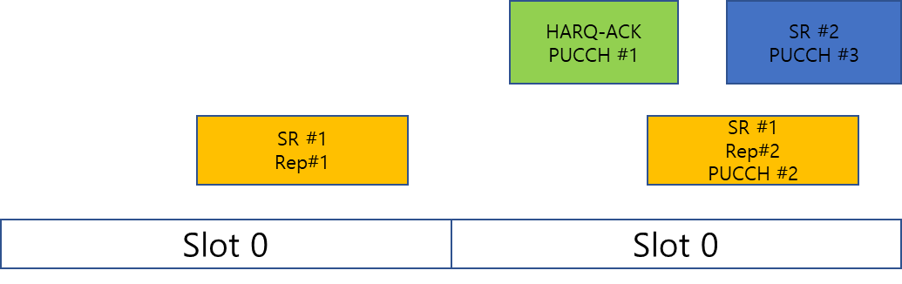

**Figure 3 Case 2**

|  |
| --- |
| 9.2.6 PUCCH repetition procedure < Unchanged parts are omitted >  A UE does not multiplex different UCI types in a PUCCH transmission with repetitions over $N_{\text{PUCCH}}^{\text{repeat}}>1$ slots. If a UE would transmit a first PUCCH over more than one slot and at least a second PUCCH over one or more slots, and the transmissions of the first PUCCH and the second PUCCH would overlap in a number of slots then, for each slot of the number of slots and with UCI type priority of HARQ-ACK > SR > CSI with higher priority > CSI with lower priority  - the UE does not expect the first PUCCH and any of the second PUCCHs to start at a same slot and include a UCI type with same priority  - if the first PUCCH and any of the second PUCCHs include a UCI type with same priority, the UE transmits the PUCCH starting at an earliest slot and does not transmit the PUCCH starting at any later slot  - if the first PUCCH and any of the second PUCCHs do not include a UCI type with same priority, the UE transmits the PUCCH that includes the UCI type with highest priority and does not transmit the PUCCH that include the UCI type with any lower priority  - the UE performs the above rules by selecting the first PUCCH with the order of earliest symbol followed by longest duration from the PUCCHs with repetition that overlap with at least one PUCCH, and the at least a second PUCCH includes all PUCCHs overlapping with the first PUCCH  < Unchanged parts are omitted > |

For Option 4 and 5, the following aspects are not clear to the moderator.

1. UCI priority for the first PUCCH. Does it follow the definition of clause 9.2.6? In addition, it needs to clarify the case of two PUCCHs with the same UCI and same starting slot/sub-slot for both the first and second PUCCH.
2. UE needs to repeat the procedure for multiple groups of PUCCHs, is it the correct understanding?
3. The spec impact needs further clarification. It seems a new pseudo-code needs to be introduced.

For Option 6, the following aspects are not clear to the moderator.

1. First PUCCH determination. Is there two sub-options for determining the first PUCCH?
2. UCI priority for the first PUCCH. Does it follow the definition of clause 9.2.6? In addition, it needs to clarify the case of two PUCCHs with the same UCI.
3. First PUCCH determination based on the earliest starting symbol. How to handle the case of same earliest starting symbol?
4. The spec impact needs further clarification. It seems a new pseudo-code needs to be introduced.

The proponents of Option 1, 4, 5 and 6 are encouraged to provide more details. Regarding the spec impact, providing a TP for each option would be appreciated.

#### **Q5**

**Do you have any comments/suggestions for resolving the unclear aspects above? Do you see any additional issues/ unclear aspects for the candidate options?**

|  |  |
| --- | --- |
| Company | View |
| CATT | Regarding the questions for Option 4 and 5, please find our replies below.   1. UCI priority for the first PUCCH. Does it follow the definition of clause 9.2.6? In addition, it needs to clarify the case of two PUCCHs with the same UCI and same starting slot/sub-slot for both the first and second PUCCH.   [CATT] Yes, the UCI priority follows the definition in clause 9.2.6, i.e. HARQ-ACK>SR>CSI with higher priority>CSI with lower priority.  If the PUCCHs have the same UCI priority and same starting slot/sub-slot, UE can select any of the PUCCHs as discussed in our contribution.   1. UE needs to repeat the procedure for multiple groups of PUCCHs, is it the correct understanding?   [CATT] Yes, same as all the other options.   1. The spec impact needs further clarification. It seems a new pseudo-code needs to be introduced.   [CATT] We can further discuss how to capture in spec. From our perspective, we think the solution can be captured with or without pseudo code. |
| OPPO | Regarding the questions for option 6, pls find our response below:   1. First PUCCH determination. Is there two sub-options for determining the first PUCCH?   [OPPO]: Yes, there are two sub-options   1. UCI priority for the first PUCCH. Does it follow the definition of clause 9.2.6? In addition, it needs to clarify the case of two PUCCHs with the same UCI.   [OPPO]: The UCI priority for the first PUCCH follow the definition of 9.2.6, that is, first UCI priority followed by the starting slot. Then there is no ambiguity for the case of two PUCCHs with same UCI.   1. First PUCCH determination based on the earliest starting symbol. How to handle the case of same earliest starting symbol?   [OPPO]: Starting symbol followed by duration, in fact it is the same with the ordering rule for Q defined in 9.2.5.   1. The spec impact needs further clarification. It seems a new pseudo-code needs to be introduced.   [OPPO]: The spec impact can be further discussed. |
| Huawei/Hisi | As a clarification:   1. For the example in Figure 3, it seems HARQ-ACK is dropped according the 2nd sub-bullet highlight below, is it the correct understanding? Dropping HARQ-ACK seems not acceptable. 2. it needs to clarify how to handle the case of same earliest symbol and duration.     The current spec clause 9.2.6 in below says “if the first PUCCH and any of the second PUCCHs do not include a UCI type with same priority”, the UE will transmit the higher priority PUCCH and drop the lower priority PUCCH. So for the figure above, the UE will transmit HARQ-ACK PUCCH#1 and drop SR#1 w/ repetition.  As pointed out by Moderator, there seems to be contradictory description between the two bullets under more than 2 overlapping PUCCHs case, so I try to make a further change to make them consistent.   |  | | --- | | - if the first PUCCH and ~~any~~ each of the second PUCCHs include a UCI type with same priority, the UE transmits the PUCCH starting at an earlier slot and does not transmit the PUCCH starting at a later slot  - if the first PUCCH and any of the second PUCCHs do not include a UCI type with same priority, the UE transmits the PUCCH that includes the UCI type with higher priority and does not transmit the PUCCH that include the UCI type with lower priority | |
|  |  |
|  |  |
|  |  |
|  |  |
|  |  |
|  |  |
|  |  |
|  |  |
|  |  |
|  |  |

Next, we compare the performance of candidate options, for simplicity, a group of three overlapping PUCCHs are considered. Considering some aspects are not clear for the candidate options is there are two PUCCHs with repetitions in a group, we first focus on only one PUCCH with repetitions.



**Copied Figure 2: Case 1**

|  |  |  |  |
| --- | --- | --- | --- |
|  | Reference PUCCH | Overlapping PUCCHs in the set | Result |
| Option 1 | PUCCH#1 | PUCCH#2, PUCCH#3 | Not clear, based on Q3 |
| Option 2 | PUCCH#1 | PUCCH#2, PUCCH#3 | Not clear, based on Q3 |
| Option 3 | PUCCH#1 | PUCCH#2 | PUCCH#2, PUCCH#3 |
| Option 4 | PUCCH#1 | Not clear for pair-wise | PUCCH#2, PUCCH#3 |
| Option 5 | Not clear | PUCCH#1 | PUCCH#2, PUCCH#3 |
| Option 6 | PUCCH#1 | PUCCH#2, PUCCH#3 | Not clear, based on Q3 |



**Figure 3 Case 2**

|  |  |  |  |
| --- | --- | --- | --- |
|  | Reference PUCCH | Overlapping PUCCHs in the set | Result |
| Option 1 | PUCCH#2 | PUCCH#1, PUCCH#3 | PUCCH#2 |
| Option 2 | PUCCH#1 | PUCCH#2, PUCCH#3 | PUCCH#1, PUCCH#3 |
| Option 3 | PUCCH#1 | PUCCH#2 | PUCCH#1, PUCCH#3 |
| Option 4 | PUCCH#2 | PUCCH#1, PUCCH#3 | PUCCH#1, PUCCH#3 |
| Option 5 | PUCCH#1 | PUCCH#2 | PUCCH#1, PUCCH#3 |
| Option 6 | PUCCH#2 | PUCCH#1, PUCCH#3 | PUCCH#1 |

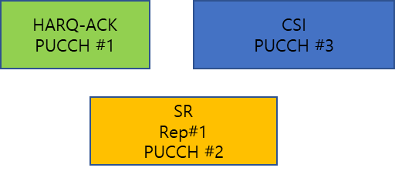

**Figure 4 Case 3**

|  |  |  |  |
| --- | --- | --- | --- |
|  | Reference PUCCH | Overlapping PUCCHs in the set | Result |
| Option 1 | PUCCH#2 | PUCCH#1, PUCCH#3 | PUCCH#1 |
| Option 2 | PUCCH#1 | PUCCH#2 | PUCCH#1, PUCCH#3 |
| Option 3 | PUCCH#1 | PUCCH#2 | PUCCH#1, PUCCH#3 |
| Option 4 | PUCCH#2 | PUCCH#1>PUCCH#3 | PUCCH#1, PUCCH#3 |
| Option 5 | PUCCH#1 | PUCCH#2 | PUCCH#1, PUCCH#3 |
| Option 6 | PUCCH#2 | PUCCH#1, PUCCH#3 | PUCCH#1 |

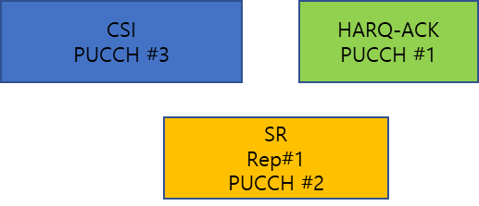

**Figure 5 Case 4**

|  |  |  |  |
| --- | --- | --- | --- |
|  | Reference PUCCH | Overlapping PUCCHs in the set | Result |
| Option 1 | PUCCH#2 | PUCCH#1, PUCCH#3 | PUCCH#1 |
| Option 2 | PUCCH#3 | PUCCH#2 | PUCCH#1 |
| Option 3 | PUCCH#3 | PUCCH#2 | PUCCH#1 |
| Option 4 | PUCCH#2 | PUCCH#1, PUCCH#3 | PUCCH#1, PUCCH#3 |
| Option 5 | PUCCH#1 | PUCCH#2 | PUCCH#1, PUCCH#3 |
| Option 6 | PUCCH#2 | PUCCH#1, PUCCH#3 | PUCCH#1 |

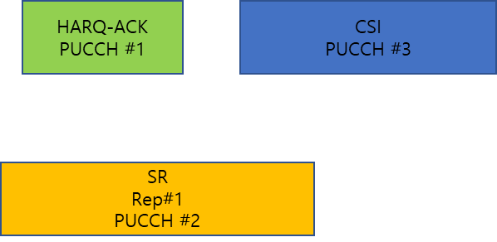

**Figure 6 Case 5**

|  |  |  |  |
| --- | --- | --- | --- |
|  | Reference PUCCH | Overlapping PUCCHs in the set | Result |
| Option 1 | PUCCH#2 | PUCCH#1, PUCCH#3 | PUCCH#1 |
| Option 2 | PUCCH#2 | PUCCH#1, PUCCH#3 | PUCCH#1 |
| Option 3 | PUCCH#2 | PUCCH#1 | PUCCH#1, PUCCH#3 |
| Option 4 | PUCCH#2 | PUCCH#1, PUCCH#3 | PUCCH#1, PUCCH#3 |
| Option 5 | PUCCH#1 | PUCCH#2 | PUCCH#1, PUCCH#3 |
| Option 6 | PUCCH#2 | PUCCH#1, PUCCH#3 | PUCCH#1 |



**Figure 7 Case 6**

|  |  |  |  |
| --- | --- | --- | --- |
|  | Reference PUCCH | Overlapping PUCCHs in the set | Result |
| Option 1 | PUCCH#2 | PUCCH#1, PUCCH#3 | PUCCH#1 |
| Option 2 | Up to UE | Up to UE | PUCCH#1 |
| Option 3 | Up to UE | Up to UE | PUCCH#1 |
| Option 4 | PUCCH#2 | PUCCH#1, PUCCH#3 | PUCCH#1, PUCCH#3 |
| Option 5 | PUCCH#1 | PUCCH#2, PUCCH#3 | PUCCH#1 |
| Option 6 | PUCCH#2 | PUCCH#1, PUCCH#3 | PUCCH#1 |

Option 4 seems to have the best performance with respect to UCI dropping for the above cases. Option 1 and 6 seem to have worse performance compared with the other options for the above cases.

#### **Q6**

**Do you agree with the above analysis? If not, please clarify.**

|  |  |
| --- | --- |
| Company | View |
| CATT | Case 1  For Option 4, the overlapping PUCCHs in the set include PUCCH#2 and PUCCH#3. For pair-wise prioritization, given that the UCI priority and starting slot is the same for PUCCH#2 and PUCCH#3, UE can arbitrarily decide the order as discussed in our contribution. The result would be PUCCH#2 and PUCCH#3 regardless.  For Option 5, the reference PUCCH can be either PUCCH#2 or PUCCH#3 as for Option 4. Regardless, the result would be PUCCH#2 and PUCCH#3.  For other cases, the understanding of Option 4 and Option 5 is correct.  For the above cases, our observation is that the performance is Option 4 > Option 5 > Option 3 > other options |
| Huawei/Hisi | It is better to clarify the details of each Option before making comparison. |
|  |  |
|  |  |
|  |  |
|  |  |
|  |  |
|  |  |
|  |  |
|  |  |
|  |  |
|  |  |
|  |  |

## Preference of candidate options for resolving PUCCHs with repetitions

In addition to Option 1~6, Option 7 is proposed by Oppo [9]. From moderator’s understanding, Option 7 (not allowing more than one PUCCH with repetitions in a slot) is too restrictive for scheduling considering there can be up to 8 SR configurations with different LCH priorities. In addition, there can be a HARQ-ACK PUCCH and multiple CSI PUCCHs in a slot.

Companies are encouraged to provide your preference for the candidate options. Spec impact should be taken as high priority for the CR phase.

#### **Q7**

**What is your preference of the candidate options?**

|  |  |  |
| --- | --- | --- |
| Option 1 | Support or can accept | **OPPO** Huawei/Hisi |
| Cannot accept |  |
| Option 2 | Support or can accept |  |
| Cannot accept |  |
| Option 3 | Support or can accept |  |
| Cannot accept |  |
| Option 4 | Support or can accept | **CATT** Huawei/Hisi |
| Cannot accept |  |
| Option 5 | Support or can accept | **CATT** |
| Cannot accept |  |
| Option 6 | Support or can accept | **OPPO** |
| Cannot accept |  |
| Option 7 | Support or can accept | **OPPO** |
| Cannot accept |  |

|  |  |
| --- | --- |
| Company | View |
| OPPO | We have a clarification question for option 2/3:  In RAN1 #109e meeting, we made the following conclusion:  Conclusion:  For resolving overlapping PUCCHs with and/or without repetitions in a slot in Rel-16, a UE first performs clause 9.2.6 (TS 38.213) to resolve overlapping PUCCHs where at least one PUCCH is with repetitions, and then UE performs clause 9.2.5 (TS 38.213) to resolve overlapping PUCCHs without repetitions.   * Note: The above is performed per slot.   To our understanding, option 2/3 violate the above conclusion in the following case: first UE selects PUCCH 1 and PUCCH 2 as “a set of overlapping PUCCHs”, then UE drop PUCCH 2. After that, UE will select PUCCH 3 and PUCCH 4 as “a set of overlapping PUCCHs” but PUCCH 3 and PUCCH4 are all without repetitions. Please correct me if I fall into a wrong understanding😊 |
| Huawei/Hisi | Our major concern for other options is, from the description, whether/how they can guarantee the selected “a set of overlapping PUCCHs” includes at least one PUCCH with repetition. If all the PUCCHs in “a set of overlapping PUCCHs” is w/o repetition, then how to handle the case needs to be clarified. |
|  |  |
|  |  |
|  |  |
|  |  |
|  |  |
|  |  |
|  |  |
|  |  |
|  |  |
|  |  |
|  |  |

## CR for capturing the previous agreement

The following agreement is made regarding the framework of intra UE multiplexing in RAN1#109e [2].

|  |
| --- |
| Agreement  For resolving overlapping PUCCHs and/or PUSCHs of a same priority in Rel-16, a UE performs the following steps   * Step1, the UE resolves overlapping PUCCHs with repetitions as described in TS 38.213 clause 9.2.6, if any. * Step2, the UE resolves overlapping PUCCHs without repetitions as described in TS 38.213 clause 9.2.5, if any. * Step3, the UE resolves overlapping PUSCH(s) and PUCCH(s) with repetitions as described in TS 38.213 clause 9, if any. * Step4, the UE resolves overlapping PUSCH(s) and PUCCH(s) without repetitions as described in TS 38.213 clause 9, if any.   FFS: Whether/How to capture Step 1 and Step 2 in the spec. |

Samsung [10] proposed a draft CR to capture the agreement, companies are encouraged to check the draft CR. Although some companies had some concern of capturing Step 1 and Step 2 in the last meeting, from moderator’s understanding, capturing the whole procedure does not contradict with the current spec, in addition, it can help improve the readability.

|  |
| --- |
| **9 UE procedure for reporting control information**  *** Unchanged text is omitted ***  When a UE determines overlapping for PUCCH transmissions with SL HARQ-ACK reports and PUCCH of larger and/or smaller priority index, the UE resolves the overlapping for PUCCH transmissions with SL HARQ-ACK reports and PUCCH of each priority index as described in clause 9.2.5 and 9.2.6 before resolving the overlapping for PUCCH transmissions without SL HARQ-ACK or the overlapping for PUCCH transmissions and PUSCH transmissions.  When a UE determines overlapping for PUCCH and/or PUSCH transmissions of the same priority index other than PUCCH transmissions with SL HARQ-ACK reports before considering limitations for UE transmission as described in clause 11.1 and clause 11.1.1, including repetitions if any,  - first, the UE resolves the overlapping for PUCCHs with repetitions as described in clause 9.2.6, if any  - second, the UE resolves the overlapping for PUCCHs without repetitions as described in clauses 9.2.5  - third, the UE resolves the overlapping for PUSCHs and PUCCHs with repetitions as described in clause 9.2.6.  - fourth, the UE resolves the overlapping for PUSCHs and PUCCHs without repetitions as is subsequently described in this clause  *** Unchanged text is omitted *** |

#### **Q8**

**Do you agree with the draft CR provided in R1-2206782?**

|  |  |
| --- | --- |
| Company | View |
| CATT | As we commented in the last meeting, the spec is clear that Step 1 is before Step 2 and Step1 and Step 2 are before Step 3 and Step 4. So it seems sufficient to clarify in spec that Step 3 is before Step 4. But we would not object to the text proposal if majority see the need. |
| Huawei/Hisi | Generally OK to make a clarification in spec. But need to avoid redundant description with the current text.   |  | | --- | | If a UE has overlapping resources for PUCCH transmissions in a slot and at least one of the PUCCH transmissions is with repetitions over multiple slots, the UE first follows the procedures described in Subclause 9.2.6 for resolving the overlapping among the resources for the PUCCH transmissions. | |
|  |  |
|  |  |
|  |  |
|  |  |
|  |  |
|  |  |
|  |  |
|  |  |
|  |  |
|  |  |
|  |  |

# Reference

1. R1-2205342, Summary of [109-e-NR-CRs-03] Collision of more than two overlapped PUCCHs with repetition Moderator (Samsung), RAN1#109-e, May, 2022.
2. RAN1 Chairman’s Notes, 3GPP TSG RAN WG1 Meeting #109-e, May, 2022.
3. R1-2205785, Discussion on the collision of overlapped PUCCHs with repetition Huawei, HiSilicon
4. R1-2205786, Correction on the collision of overlapped PUCCHs with repetition Huawei, HiSilicon
5. R1-2207170, Issue on PUCCH overlapping with PUCCH with repetitions Qualcomm Incorporated
6. R1-2206532, PUCCH collision handling for more than two overlapped PUCCHs with repetition Intel Corporation
7. R1-2206781, Discussion on more than two overlapping PUCCHs with repetitions Samsung
8. R1-2206350, Collision handling of more than two overlapping PUCCHs with repetition CATT
9. R1-2206305, Clarification on collision handling for overlapping PUCCHs with repetitions OPPO
10. R1-2206782, Draft CR for Intra-UE multiplexing/prioritization of the same priority Samsung