**For each proposal, we discuss at most five minutes**

**UE-UE channel model**

In RAN1#109-e meeting, there was a discussion on UE-UE channel model, but no agreement was achieved.

|  |
| --- |
| Updated proposal 4-4-3b  For UE-UE channel model, select option 1:   * Option 1: Reuse the gNB-UE 5GCM in TR 38.901 with necessary modifications for both FR1 and FR2, similar as the UE-UE channel model for flexible duplex evaluation in TR38.802 for FR2.   + For Indoor hotspot, reuse the gNB-UE 5GCM Indoor-office in TR38.901, and for Dense urban and Urban macro, reuse the gNB-UE 5GCM Umi-Street canyon in TR38.901 with necessary modification, e.g.,     - Replacing the gNB’s antenna height with UE’s antenna height, updating ASD and ZSD.     - FFS: Other details and necessary modifications. * Option 2: Reuse the UE-UE channel model for flexible duplex evaluation in TR 38.802 for both FR1 and FR2 with necessary modifications. |

[FL comments] For Option 1, at least the following issues need to be further discussed:

* The applicability range of the pathloss model for UMi-Street canyon in Table 7.4.1-1 in TR 38.901 is extended from 10m<=d_2D<=5km to [X] m<=d_2D<=5km.
  + X depends on the minimum UE-UE distance we assumed
* Based on Option 1, there could be different options for Dense Urban and Urban Macro, e.g., see the table below. We need to make down-selection.

For Option 2, we do not need to discuss these, just reuse TR38.802.

|  |  |  |
| --- | --- | --- |
|  | **Dense urban, Urban macro** | **Indoor hotspot** |
| Large-scale channel parameters | Option 1-1:   * UE-to-UE: UMi-Street canyon in TR 38.901 (hBS =1.5m ~ 22.5m), penetration loss between UEs follows Table A.2.1-13 in TR38.802   Option 1-2:   * UE-to-UE: InH-Office in TR 38.901 (hBS =1.5m ~ 22.5m) for indoor to indoor, and UMi-Street canyon in TR 38.901(hBS =1.5m ~ 22.5m) for other cases. Penetration loss between UEs follows Table A.2.1-13 in TR38.802   + FFS: details of indoor to indoor, e.g., UEs in the same building | Option 1:   * UE-to-UE: InH-Office in TR 38.901 (hBS =1.5m) |
| Fast fading parameters | Option 1-1:   * UE-to-UE: UMi-Street canyon in TR 38.901; ASD and ZSD statistics updated to be the same as ASA and ZSA.   Option 1-2:   * UE-to-UE: InH-Office in TR 38.901 for indoor to indoor, and UMi-Street canyon in TR 38.901 for other cases. ASD and ZSD statistics updated to be the same as ASA and ZSA.   + FFS: details of indoor to indoor, e.g., UEs in the same building | Option 1:   * UE-to-UE: InH-Office in TR 38.901 (hBS =1.5m), ASD and ZSD statistics updated to be the same as ASA and ZSA |

#### ***Updated proposal 2-7-3-r1 (Open):***

For UE-UE channel model, reuse the UE-UE channel model for flexible duplex evaluation in TR 38.802 for both FR1 and FR2, and adopt the following tables.

UE-UE channel model

|  |  |  |
| --- | --- | --- |
|  | **Dense urban, Urban macro** | **Indoor hotspot** |
| Large-scale channel parameters | FR1:   * UE-to-UE: A.2.1.2 in TR36.843(*), penetration loss between UEs follows Table A.2.1-13 in TR38.802   FR2-1:   * UE-to-UE: UMi-Street canyon in TR 38.901 (hBS =1.5m ~ 22.5m), penetration loss between UEs follows Table A.2.1-12 in TR38.802 | FR1:   * UE-to-UE: A.2.1.2 in TR36.843 (*)   FR2-1:   * UE-to-UE: InH-Office in TR 38.901 (hBS =1.5m) |
| Fast fading parameters | FR1:   * UE-to-UE: A.2.1.2 in TR36.843 (ITU InH) for indoor to indoor, and 3D UMi for other cases. ASD and ZSD statistics updated to be the same as ASA and ZSA.   FR2-1:   * UE-to-UE: UMi-Street canyon in TR 38.901; ASD and ZSD statistics updated to be the same as ASA and ZSA. | FR1:   * UE-to-UE: A.2.1.2 in TR36.843 (ITU InH), ASD statistics updated to be the same as ASA.   FR2-1:   * UE-to-UE: InH-Office in TR 38.901 (hBS =1.5m), ASD and ZSD statistics updated to be the same as ASA and ZSA |

#### ***Updated proposal 2-2-8-r1(Open):***

For SLS of SBFD operation, introduce an evaluation metric for the additional energy consumption of SBFD at the BS side, which can be defined as follows:

$$E_{AEC}=\left(\frac{(E_{DPD}^{'}+E_{PA}^{'}+ E_{SIC}^{'}+{E^{'}}_{Rx-AFE})-(E_{DPD}+E_{PA}+E_{Rx-AFE}) }{(E_{DPD}+E_{PA}+E_{Rx-AFE}) }\right)×100$$

* $E_{AEC }:$ Percentage of the additional energy consumption for SBFD.
* $E_{DPD}^{'} :$ Total energy consumption from all DPDs used in SBFD (including energy consumption from all feedback chains).
* $E_{PA}^{'} :$ Total energy consumption from all PAs used in SBFD.
* $E_{SIC}^{'} :$ Total energy consumption from SIC used in SBFD (including any additional associated components).
* $E_{DPD} :$ Total energy consumption from all DPDs used in legacy TDD that was compared with SBFD (including energy consumption from all feedback chains).
* $E_{PA} :$ Total energy consumption from all PAs used in legacy TDD that was compared with SBFD.
* ${E^{'}}_{Rx-AFE}$**:** Total energy consumption from all the analog front ends of the receive chains used in SBFD
* $E_{Rx-AFE}$**:** Total energy consumption from all the analog front ends of the receive chains used in legacy TDD that was compared with SBFD.

#### ***Updated proposal 1-1-1-r1(Open):***

For SLS of NR duplex evolution, Rural scenario is not considered in Rel-18.

#### ***Initial proposal 1-1-2(Open):***

For NR duplex evolution evaluation, FR2-2 is not considered in Rel-18.

#### ***Initial proposal 1-1-3(Open):***

For SBFD evaluation from RAN1 perspective, the evaluation assumptions that are specific for Deployment Case 2 and Case 3-1 can be discussed with low priority (i.e., it can be discussed after the evaluation assumptions for Deployment case 1/4/3-2 are determined).

#### ***Initial proposal X (new):***

RAN1 strives to agree on system level simulation parameters for SBFD deployment case 4 by RAN1#111 with specific focus on different power levels and load levels between adjacent carriers.

#### ***Initial proposal Y (new):***

RAN1 needs to perform link-level evaluation of self-IC performance/feasibility

* To facilitate link-level evaluation of self-IC performance/feasibility in RAN1, it is important to model the gNB transmit and receive chains with sufficient accuracy including non-linearities
* The results of the link-level performance evaluations, e.g., X dB suppression, can be used as input for system level simulation so that realistic dB suppression numbers are used in SBFD SLS evaluations

#### ***Initial proposal 2-6-1 (Open):***

For evaluation of SBFD operation, separate-Tx/Rx antenna array can be modelled by two panel groups.

* Legacy parameters $\left(M,N,P,M_{g},N_{g}\right)$, $\left(d_{H},d_{V}\right)$ and $\left(d_{g,H},d_{g,V}\right)$ are used for description of each panel group:
  + M: Number of vertical antenna elements within a panel, on one polarization
  + N: Number of horizontal antenna elements within a panel, on one polarization
  + P: Number of polarizations
  + $M_{g}$: Number of panels in a column within a panel group.
  + $N_{g}$: Number of panels in a row within a panel group.
  + $d_{g,H}$: Antenna panel spacing in horizontal direction within a panel group.
  + $d_{g,V}$: Antenna panel spacing in vertical direction within a panel group.
* Companies report the separation of the two panel groups. Introduce new parameters $\left(d_{a,H},d_{a,V}\right)$ as illustrated in the following figure.
  + $d_{a,H}$: Panel group spacing in the horizontal direction. Typically, $d_{a,H}$ = 0.
  + $d_{a,V}$: Panel group spacing in the vertical direction.



#### ***Initial proposal 2-6-2 (Open):***

For evaluation and comparison between SBFD and legacy TDD, the two options for the SBFD antenna configuration agreed in RAN1#109 are further clarified as below:

* **SBFD antenna configuration option-1** (same as Opt 1 in RAN1#109 agreement): The total number of antenna elements of the antenna array for SBFD is the same as the total number of antenna elements of the antenna array for legacy TDD. The total number of TxRUs of the antenna array for SBFD is the same as the total number of TxRUs of the antenna array for legacy TDD.
* **SBFD antenna configuration option-2** (same as Opt 2 in RAN1#109 agreement): The total number of antenna elements of the antenna array for SBFD is two times of the total number of antenna elements of the antenna array for legacy TDD. The total number of TxRUs of the antenna array for SBFD is the same as the total number of TxRUs of the antenna array for legacy TDD.
* **SBFD antenna configuration option-3** (new): The total number of antenna elements of the antenna array for SBFD is the same as the total number of antenna elements of the antenna array for legacy TDD. The total number of TxRUs of the antenna array for SBFD is half of the total number of TxRUs of the antenna array for legacy TDD.

These options are further clarified with examples in the following:

* For legacy TDD with shared-Tx/Rx antenna array, assume the antenna configuration is $\left(M,N,P,M_{g},N_{g};M_{p},N_{p}\right)$. The total number of TxRUs is $K={PM}_{p}N_{p}M_{g}N_{g}$, and the total number of antenna elements is $L=PMNM_{g}N_{g}$.

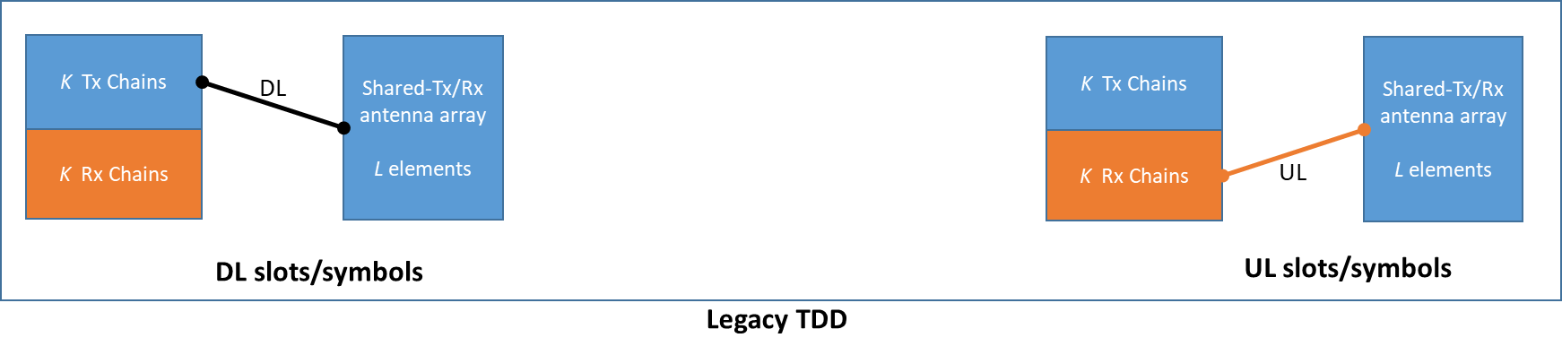

* For SBFD antenna configuration option-1, the separate-Tx/Rx antenna array has two panel groups, and the antenna configuration for each panel group is $\left(M,N,P,M_{g}/2,N_{g}\right)$. The total number of TXRUs is $K={PM}_{p}N_{p}M_{g}N_{g}$ (same as legacy TDD), and the total number of antenna elements is $L=PMNM_{g}N_{g}$ (same as legacy TDD). One method on the usage of TXRUs and antenna elements in DL/UL/SBFD slots/symbols is illustrated as below. Other methods are not precluded and can be reported by companies.
  + Method 1:
    - In DL slots, L⁄2 antenna elements on panel group#1 are connected to K⁄2 Tx chains in TxRU group#1, and L⁄2 antenna elements on panel group#2 are connected to K⁄2 Tx chains in TxRU group#2.
    - In UL slots, L⁄2 antenna elements on panel group#1 are connected to K⁄2 Rx chains in TxRU group#1, and L⁄2 antenna elements on panel group#2 are connected to K⁄2 Rx chains in TxRU group#2.
    - In SBFD slots, L⁄2 antenna elements on panel group#1 are connected to K⁄2 Tx chains in TxRU group#1, and L⁄2 antenna elements on panel group#2 are connected to K⁄2 Rx chains in TxRU group#2.

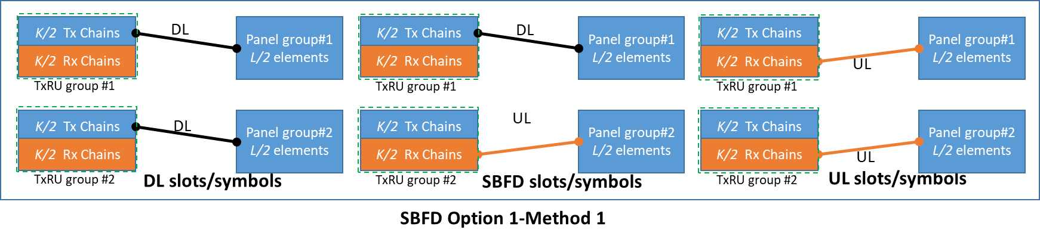

* For SBFD antenna configuration option-2, the separate-Tx/Rx antenna array has two panel groups, and the antenna configuration for each panel group is $\left(M,N,P,M_{g},N_{g}\right)$. The total number of TXRUs is $K={PM}_{p}N_{p}M_{g}N_{g}$ (same as legacy TDD), and the total number of antenna elements is $2L=2PMNM_{g}N_{g}$ (two times of that for legacy TDD). Two methods on the usage of TXRUs and antenna elements in DL/UL/SBFD slots/symbols are illustrated as below. Other methods are not precluded and can be reported by companies.
  + Method 2-1:
    - In DL slots, L antenna elements on panel group#1 are connected to K Tx chains.
    - In UL slots, L antenna elements on panel group#2 are connected to K Rx chains.
    - In SBFD slots, L antenna elements on panel group#1 are connected to K Tx chains, and L antenna elements on panel group#2 are connected to K Rx chains.

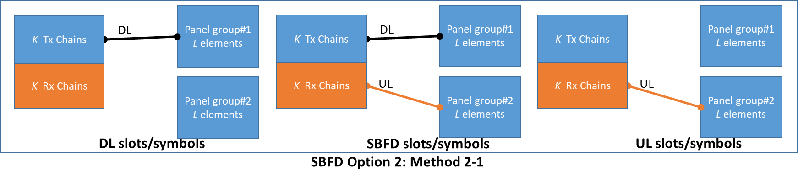

* + Method 2-2:
    - In DL slots, L antenna elements on panel group#1 are connected to K Tx chains.
    - In UL slots, L antenna elements on panel group#1 are connected to K Rx chains.
    - In SBFD slots, L antenna elements on panel group#1 are connected to K Tx chains, and L antenna elements on panel group#2 are connected to K Rx chains.

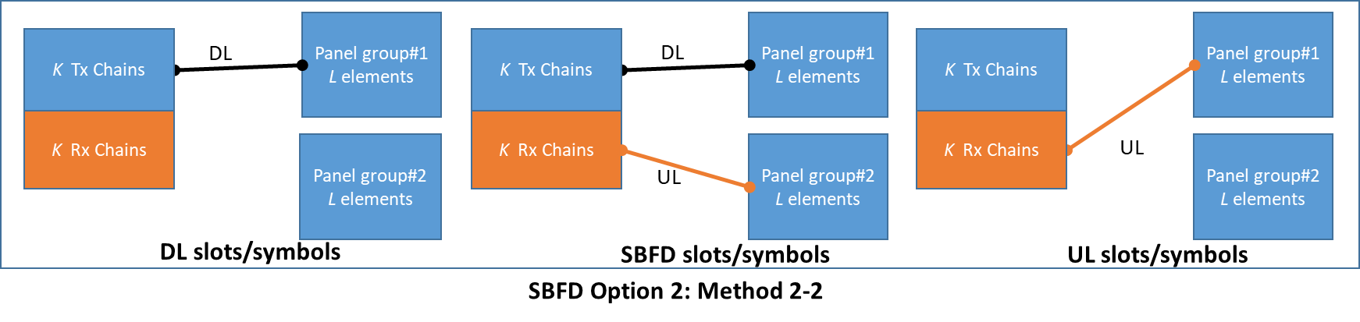

* For SBFD antenna configuration option-3, the separate-Tx/Rx antenna array has two panel groups, and the antenna configuration for each panel group is $\left(M,N,P,M_{g}/2,N_{g}\right)$. The total number of TXRUs is $K/2={PM}_{p}N_{p}M_{g}N_{g}/2$ (half of that for legacy TDD), and the total number of antenna elements is $L=PMNM_{g}N_{g}$ (same as legacy TDD). The method on the usage of TXRUs and antenna elements in DL/UL/SBFD slots/symbols are illustrated as below. Other methods are not precluded and can be reported by companies.
  + Method 3-1:
    - In DL slots, L⁄2 antenna elements on panel group#1 are connected to K⁄2 Tx chains.
    - In UL slots, L⁄2 antenna elements on panel group#2 are connected to K⁄2 Rx chains.
    - In SBFD slots, L⁄2 antenna elements on panel group#1 are connected to K⁄2 Tx chains, and L⁄2 antenna elements on panel group#2 are connected to K⁄2 Rx chains.

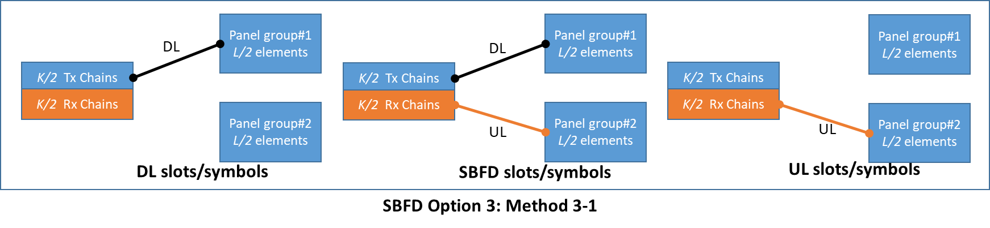

* + Method 3-2:
    - In DL slots, L⁄2 antenna elements on panel group#1 are connected to K⁄2 Tx chains in TxRU group#1.
    - In UL slots, L⁄2 antenna elements on panel group#1 are connected to K⁄2 Rx chains in TxRU group#1.
    - In SBFD slots, L⁄2 antenna elements on panel group#1 are connected to K⁄2 Tx chains in TxRU group#1, and L⁄2 antenna elements on panel group#2 are connected to K⁄2 Rx chains in TxRU group#1.

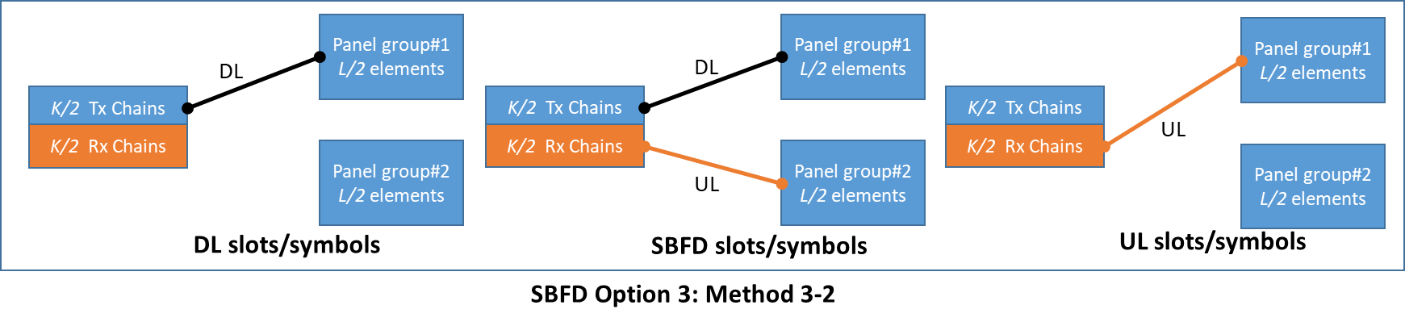

#### ***Updated proposal 2-6-5-r1 (Open):***

For evaluation of SBFD operation, it is up to companies to report the BS antenna configurations used in their simulations. The BS antenna configurations in the following table can be considered for calibration purpose.

|  |  |  |  |
| --- | --- | --- | --- |
| **Scenarios** | **FR** | **Legacy TDD** | **SBFD** |
| **BS antenna configuration for Indoor office** | FR1 | $\left(M,N,P,M_{g},N_{g};M_{p},N_{p}\right)$ = (4,4,2,1,1; 4,4) $\left(d_{H},d_{V}\right)$ = (0.5, 0.5)λ, +45°/-45° polarization | * SBFD antenna configuration option-1 (Method 1)   + Two panel groups   + For each panel group: $\left(M,N,P,M_{g},N_{g}\right)$ = (2,4,2,1,1).   + Number of TxRUs: same as legacy TDD   + = (0.5, 0.5)λ, +45°/-45° polarization, (da,H,da,V) = (0, 4)λ |
| FR2-1 | $\left(M,N,P,M_{g},N_{g};M_{p},N_{p}\right)$ =(16,8,2,1,1; 1,1) $\left(d_{H},d_{V}\right)$ = (0.5, 0.5)λ, +45°/-45° polarization | * SBFD antenna configuration option-1 (Method 1)   + Two panel groups   + For each panel group: $\left(M,N,P,M_{g},N_{g}\right)$ = (8,8,2,1,1).   + Number of TxRUs: same as legacy TDD   + = (0.5, 0.5)λ, +45°/-45° polarization, (da,H,da,V) = (0, 30)λ |
| **BS antenna configuration for Urban Macro/ Dense Urban Macro layer/ Dense Urban Micro layer** | FR1 | $\left(M,N,P,M_{g},N_{g};M_{p},N_{p}\right)$ =  (8,8,2,1,1;2,8) $\left(d_{H},d_{V}\right)$ = (0.5, 0.8)λ, +45°/-45° polarization | * SBFD antenna configuration option-1 (Method 1)   + Two panel groups   + For each panel group: $\left(M,N,P,M_{g},N_{g}\right)$ = (4,8,2,1,1).   + Number of TxRUs: same as legacy TDD   + = (0.5, 0.8)λ, +45°/-45° polarization, (da,H,da,V) = (0, 4)λ |
| FR2-1 | $\left(M,N,P,M_{g},N_{g};M_{p},N_{p}\right)$ =  (4,16,2,2,2; 1,1) $\left(d_{H},d_{V}\right)$ = (0.5, 0.5)λ, +45°/-45° polarization | * SBFD antenna configuration option-1 (Method 1)   + Two panel groups   + For each panel group: $\left(M,N,P,M_{g},N_{g}\right)$ = (4,8,2,2,2).   + Number of TxRUs: same as legacy TDD   + = (0.5, 0.5)λ, +45°/-45° polarization, (da,H,da,V) = (0, 30)λ |

#### ***Initial proposal 2-3-4 (Open):***

For evaluation of adjacent-channel coexistence between two networks for Urban Macro and Dense Urban Macro layer scenarios in RAN1, consider grid shifts between two networks of 0% and 100%.

* the topologies shown below can be used for the 0% and 100% grid shift for RAN1 evaluation.



#### ***Updated proposal 2-3-7-r1 (Open):***

For SBFD Deployment Case 1 to 4, a cell layout of hexagonal grid with 7 macro sites and 3 sectors per site with wrap around is considered as baseline for Urban Macro and Dense Urban Macro layer.

* hexagonal grid with 19 macro sites and 3 sectors per site with wrap around can be optionally considered.

#### ***Initial proposal 2-3-8 (Open):***

For NR duplex evolution evaluation, consider the minimum UE-to-UE distance as 3m for macro/micro cell and 1~3m for indoor.

#### ***Initial proposal 2-4-1 (Open):***

For performance evaluation and comparison between baseline legacy TDD operation and SBFD operation under SBFD Deployment Case 1, make the following update for Alt 3:

* Alt 3 (strive for the same UL/DL resource ratio between Legacy TDD and SBFD):
  + Legacy TDD: Static TDD UL/DL configuration with {DDSUU}, where S=[12D:2G:0U]
  + SBFD: Frame structure#2 (XXXXU), where X denotes a SBFD slot. In time domain, SBFD UL subband spans all the symbols in a SBFD slot. In frequency domain, SBFD UL subband is about 25% of the channel bandwidth.

#### ***Updated proposal 2-4-2-r1 (Open):***

For SBFD evaluation, the guard band size (i.e. NG) should be reported by companies.

* For SLS calibration purpose, SBFD Subband configuration#1 with {DUD} pattern is assumed.
  + Alt 1/2/4 (SBFD UL subband is about 20% of the channel bandwidth):
    - For FR1 with 100MHz channel bandwidth and 30kHz SCS (273 PRB): < ND, NU,NG > = <104, 55, 5>
    - For FR2 with 100MHz channel bandwidth and 120kHz SCS (65 PRB) < ND, NU,NG > = <26, 13, 0>
  + Alt 3 (SBFD UL subband is about 25% of the channel bandwidth):
    - For FR1 with 100MHz channel bandwidth and 30kHz SCS (273 PRB): < ND, NU,NG > = <97, 69, 5>
    - For FR2 with 100MHz channel bandwidth and 120kHz SCS (65 PRB) < ND, NU,NG > = <24, 17, 0>

#### ***Updated proposal 1-1-4-r2-Modified:***

For evaluation of SBFD Deployment Case 3-2, consider the following scenarios for FR1:

* (Optional) 2-layer Scenario A (Dense Urban with 2-layer)
  + Layer 1: Dense Urban Macro layer
  + Layer 2: Dense Urban Micro layer
  + uses legacy static TDD operation, Dense Urban Micro layer uses SBFD operation. All the Micro gNBs use the same SBFD subband configuration.
* (Optional) 2-layer Scenario B
  + Layer 1: Urban Macro
  + Layer 2: Indoor office or Indoor factory (companies to report which one is used)
    - Regarding the Indoor office layer, reuse the Indoor office (InH) scenario and relevant channel model in TR38.901.
    - Regarding the Indoor factory layer, reuse the Indoor factory (InF) scenario and relevant channel model in TR38.901.
* Layer 1 uses legacy static TDD operation, Layer 2 uses SBFD operation. All the gNBs in Layer 2 use the same SBFD subband configuration.

#### ***Updated proposal 1-2-1-r1-Modified:***

For evaluation of dynamic/flexible TDD for the single operator case, consider the following scenarios:

* FR1
  + 1-layer scenario: Indoor office with dynamic TDD UL/DL assignment
  + (Optional) 1-layer scenario: Urban Macro with dynamic TDD UL/DL assignment
  + (Optional) 2-layer Scenario A
    - Layer 1: Dense Urban Macro layer
    - Layer 2: Dense Urban Micro layer
    - uses legacy static TDD operation, Dense Urban Micro layer uses SBFD operation. All the Micro gNBs use the same SBFD subband configuration.
  + (Optional) 2-layer Scenario B
    - Layer 1: Urban Macro
    - Layer 2: Indoor office or Indoor factory (companies to report which one is used)
      * Regarding the Indoor office layer, reuse the Indoor office (InH) scenario and relevant channel model in TR38.901.
      * Regarding the Indoor factory layer, reuse the Indoor factory (InF) scenario and relevant channel model in TR38.901.
  + Regarding 2-layer Scenario A and 2-layer Scenario B, the two layers are deployed in the same carrier
    - Layer 1 uses legacy static TDD operation with DL dominant static TDD UL/DL configuration
    - Layer 2 uses one of the following options (companies to report which option is used)
      * Option 1: All gNBs in layer 2 use legacy static TDD operation with the same UL dominant static TDD UL/DL configuration
      * Option 2: All gNBs in layer 2 use dynamic TDD UL/DL assignment
* FR2-1
  + 1-layer scenario: Indoor office with dynamic TDD UL/DL assignment
  + 1-layer scenario: Dense Urban Macro layer with dynamic TDD UL/DL assignment
* For above scenarios, the following is assumed:
  + DL dominant static TDD UL/DL configuration: assume {DDDSU}, where S=[12D:2G:0U]
  + UL dominant static TDD UL/DL configuration: assume {DSUUU}, where S=[12D:2G:0U]
  + dynamic TDD UL/DL assignment: assume {FFFFF}, companies to report the guard symbols assumed in their simulation

#### ***Initial proposal Z (new):***

For RAN1 LLS evaluations, it is sufficient to model a “net effect” of the various components in the gNB transmit and receive chains, rather than each individual component separately

* + gNB Tx: at least CFR, DPD, PA
  + gNB Rx: at least LNA, AGC

Accurate modeling of the net effect, at least on the gNB Tx side, requires modeling of memory effects, e.g., through use a generalized memory polynomial, which captures the frequency variation of the self-interference

In order for RAN1 to progress on link level evaluation of self-IC performance, input is needed from RAN4 on the net-effect models

#### ***Initial proposal K (new):***

Send an LS to RAN4 requesting feedback on the following:

* + For the gNB transmitter:
    - Realistic model capturing the net effect of components in the Tx chain, e.g., at least CFR, DPD, and PA, ensuring that the gNB at least meets a target ACLR performance, e.g. -45 dBc. RAN4 to discuss appropriate modeling of memory effects in the net-effect model.
  + For the gNB receiver
    - Simple, but realistic, model capturing the net effect of components in the Rx chain, e.g., least LNA, AGC
    - Simple model for the phase stability of the LO for down conversion of the UL received signal