**3GPP TSG-RAN WG1 Meeting #110 R1-2205883**

**Toulouse, France, August 22 – 26, 2022**

**Agenda Item: 9.1.3.2**

**Source: Huawei, HiSilicon, LG Uplus**

**Title: SRS enhancement for TDD CJT and UL 8Tx operation in Rel-18**

**Document for: Discussion and Decision**

# Introduction

The WID of NR MIMO enhancements for Rel-18 related to the SRS enhancement is [1]:

|  |
| --- |
| 1. Study, and if justified, specify enhancements of CSI acquisition for Coherent-JT targeting FR1 and up to 4 TRPs, assuming ideal backhaul and synchronization as well as the same number of antenna ports across TRPs, as follows:    * SRS enhancement to manage inter-TRP cross-SRS interference targeting TDD CJT via SRS capacity enhancement and/or interference randomization, with the constraints that 1) without consuming additional resources for SRS; 2) reuse existing SRS comb structure; 3) without new SRS root sequences 2. Study, and if justified, specify UL DMRS, SRS, SRI, and TPMI (including codebook) enhancements to enable 8 Tx UL operation to support 4 and more layers per UE in UL targeting CPE/FWA/vehicle/Industrial devices    * Note: Potential restrictions on the scope of this objective (including coherence assumption, full/non-full power modes) will be identified as part of the study. |

In last meeting, some agreements on simulation assumptions have been achieved, and several potential enhancement options were listed for further discussion.

|  |
| --- |
| For SRS enhancement in CJT:  Agreement  Study the following for SRS enhancement to manage inter-TRP cross-SRS interference targeting TDD CJT via SRS interference randomization and/or capacity enhancement   * Randomized frequency-domain resource mapping for SRS transmission   + E.g., further enhancements to frequency hopping, comb hopping * Randomized code-domain resource mapping for SRS transmission   + E.g., cyclic shift hopping/randomization, sequence hopping/randomization, per-hop sequence from a long SRS sequence * Randomized transmission of SRS   + E.g., pseudo-random muting of SRS transmission for periodic and semi-persistent SRS * Per-TRP power control and/or power control of one SRS towards to multiple TRPs * SRS TD OCC * Increasing the maximum number of cyclic shifts   + E.g., multiplying mask sequence to the legacy SRS sequence to effectively increase the maximum cyclic shifts * Precoded SRS for DL CSI acquisition * Enhanced signaling for flexible SRS transmission   + E.g., dynamic update of SRS parameters * Partial frequency sounding extensions   + E.g., larger partial frequency sounding factor, starting RB location hopping enhancements, partial frequency hopping on other bandwidths corresponding to *b* , besides the last bandwidth  * Enhanced configuration of SRS transmission to enable more efficient SRS parameter assignment   + E.g., configuration of $v$ (sequence index within a group) per SRS resource   + E.g., configuration of cyclic shift per SRS port per SRS resource. * Resource mapping for SRS transmission based on network-provided parameters or system parameters   + E.g., SRS resource mapping based on network-provided parameters (e.g., configurable indexes) or system parameters (e.g., slot index)   Note: PAPR performance and maintaining DFT waveform property should be considered when deciding the enhancement for Rel-18.  Agreement  Consider the scenario where there exists SRSs sent by a UE and utilized by multiple TRPs for channel estimation, and the pathlosses between the UE and the TRPs differ by at least x dB in Rel-18 SRS study   * x can be {3,6,10}, and other values can be used.   For 8Tx UL enhancement:  Agreement  For SRS enhancements to enable 8 Tx UL operation to support 4 and more layers per UE in UL targeting CPE/FWA/vehicle/Industrial devices, study aspects include, for SRS for CB/NCB/AS,   * Design parameters, including the maximum number of SRS resource sets, number of SRS resource sets, number of SRS resources, number of ports per resource, number of OFDM symbols, the allowed configurations for comb / comb shifts / cyclic shifts, number of simultaneous ports / resources / resource sets per OFDM symbol * For the next decision point, study   + Whether to support 8 ports in one or multiple resources   + Whether to support 8 ports in one or multiple OFDM symbols   + The maximum number of SRS resource sets. * Note: For SRS for NCB, number of ports per SRS resource is still 1 (same as R15)   Agreement   * Study the potential enhancements for SRS of 8T8R with usage *antennaSwitching*.   Agreement  Study the potential enhancements for SRS for 8 Tx operation   * SRS resource(s) with 8 ports are configured for codebook-based PUSCH * Up to 8 single-port SRS resources are configured for non-codebook-based PUSCH |

In this contribution, we mainly focus on the SRS enhancement targeting TDD CJT and 8Tx UL transmission.

# SRS interference management for CJT

## General view on interference management

In CJT operation, to achieve attractive performance gain compared with NCJT, the precoders at the coordinated TRPs should enable their transmitted signals to have aligned phases at the UE side and be constructively superimposed, which poses higher requirements on the accuracy of CSI.

However, for TDD system, limited by protocol constraints and implementation challenges, the SRS may suffer from more severe interference under possible CJT SRS measurement hypothesis. The SRS measurement hypothesis mainly contains following aspects:

***Only one SRS resource set for DL CSI per UE is allocated by the serving cell.***

The CJT scenario calls for more SRS resources due to the following reasons:

* CJT has higher requirements on CSI precision. Sufficient SRS density in both frequency and time domain are required to guarantee the CSI precision. Low density in frequency domain will lead to poor SRS channel estimation accuracy, while low density in time domain will bring channel aging problem. Some simulations have shown the performance loss due to channel aging problem in [3].
* CJT is mainly used to improve the user experience at the cell edge. Considering the coverage requirement, SRS repetition may be used, the resource consumption of which is multiplied.

Due to the higher resource requirement, the SRS resource under CJT scenario is more limited. As a result, it is assumed that the serving TRP only allocates one SRS resource set for DL CSI to a served UE. As shown in Figure 1, it is assumed that TRP1 is the serving TRP of UE1 and TRP2 is the serving TRP of UE2 as well as the coordinated TRP of UE1. The SRS1 is allocated by TRP1 and the SRS2 is allocated by TRP2. There exists certain probability that the SRS1 and SRS2 occupy the same physical resource (in terms of time, frequency and cyclic shift).

***SRS power control is performed by the serving cell.***

It is also assumed that the PL RS of serving TRP is used for the SRS power control. Using the PL RS of the coordinated TRP to improve the SRS power may be an inefficient way. For example, as shown in Figure 1, PL RS from TRP2 can be used for the power control of SRS1. Since SRS3 is transmitted by UE3 that served by TRP3 and coordinated by TRP1, increasing the transmission power of SRS1 will cause stronger interference to SRS3. Furthermore, as UE1 is cell-edge UE, the power may already reach Pcmax and there is no room for further power promotion.

Based on the proposed SRS measurement hypothesis, there exists certain probability that the SRS resources allocated to UE1 and UE2 served by different TRPs occupy the same physical resource. Considering the distance difference between UE1 and UE2, from the view of TRP2, SRS2 may cause pretty large interference to SRS1.

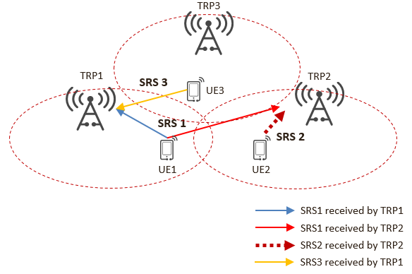

**Figure 1. Illustration of SRS interference issue for CJT scenario**

The simulation modelling of LLS is conducted based on the above analysis. As shown in Figure 2, it is assumed that TRP1 is the serving TRP of target UE and TRP2 is the coordinated TRP of target UE as well as the serving TRP of interference UE. Both SRS1 and SRS2 can be received by TRP1 and TRP2. The SRS1 and SRS2 may occupy the same physical resource (in terms of time and frequency).

In order to portray the SRS interference in CJT scenario more accurately, parameter $∆_{1}$ and $∆_{2}$ shown in Figure 2 need to be adopted cautiously. During last meeting, $∆_{1}={PL}_{2} \left(dB\right)-{PL}_{1} \left(dB\right)$ depicting the pathloss difference from CJT UE to serving TRP and coordinated TRP(s) is agreed to be chosen from {-3, -6, -10}dB, which can also be utilized to describe the SRS receiving power difference between serving TRP and coordinated TRP(s). In terms of the $∆_{2}=P_{target}∙{PL}_{2} \left(dB\right)-P_{interference}∙{PL}_{4} \left(dB\right)$, it describes the receiving power difference at coordinated TRP(s) between the SRS sent by target UE and interference UE (i.e., SIR of SRS1 at TRP2), where $P_{target}$ and $P_{interference}$ are the SRS transmission power of target UE and interference UE. The elaboration of the relationship between $∆_{1}$ and $∆_{2}$ is shown in the Appendix A. Based on the analyses, $∆_{2}$ can be chosen from {-3, -6, -9}dB when $∆_{1}$ is set to -3dB; $∆_{2}$ can be chosen from {-6, -9, -12}dB when $∆_{1}$ is set to -6dB and $∆_{2}$ can be chosen from {-10, -13, -16}dB when $∆_{1}$ is set to -10dB.

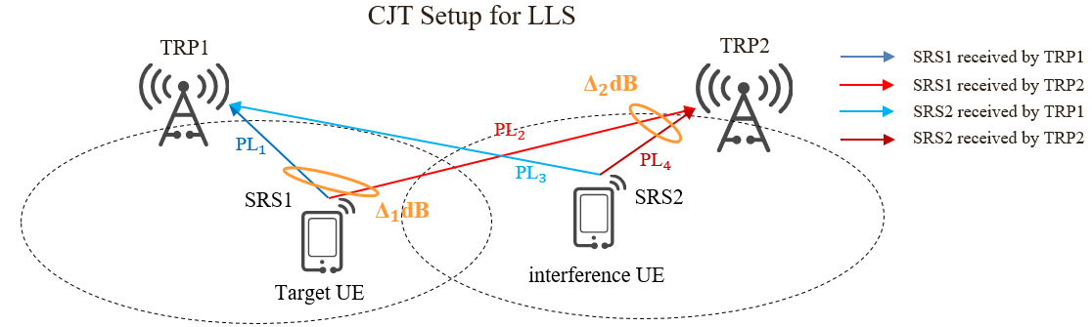

**Figure 2. Illustration of SRS modelling under CJT scenario for LLS**

Without loss of generality, only the performance of target UE(s) is evaluated. Therefore, only the target UE(s) and the interference UE(s) occupying the same physical resource (in terms of time and frequency, different root sequences are assumed) are modeled.

Two typical SRS configurations used in the LLS are comb 2 CS 4 and comb 2 CS 8. For comb 2 CS 4, the SRS of the 4T4R target UE (served by two TRPs in CJT manner) takes up 4CS on a comb, while that of 4T4R interference UE takes up the same comb. For comb 2 CS 8, the SRSs of two 4T4R target UEs take up 8 CS on a comb, while that of two 4T4R interference UEs take up the same comb.

During the simulations, the NMSE and throughput are adopted as two main performance metric. The NMSE is defined as

${NMSE}_{p}=\frac{\sum_{k,s}{{\left|{\hat{H}}_{p,k,s}-H_{p,k,s}\right|}^{2}}}{\sum_{k,s}{{\left|H_{p,k,s}\right|}^{2}}}$,

where ${\hat{H}}_{p,k,s}$ and $H_{p,k,s}$ are the estimated channel coefficient and ideal channel coefficient corresponding to SRS port *p*, TRP receiving antenna *k* and subcarrier *s*.

The NMSE performance of the SRS channel estimation executed at coordinated TRP under comb 2 CS 4 & comb 2 CS 8, are shown in Figure 3. Detailed simulation parameters can be found in the appendix. It can be observed from Figure 3 (a) that for CS 4, the performance gap between large interference case ($∆_{2}=∆_{1}-6dB$) and no interference case (upper bound) under different $∆_{1}$ varies among 1.8~3.8dB, the larger the $∆_{1}$, the larger the performance gap. The performance gap grows to 4.2~6dB for CS 8 as shown in Figure 3 (b).

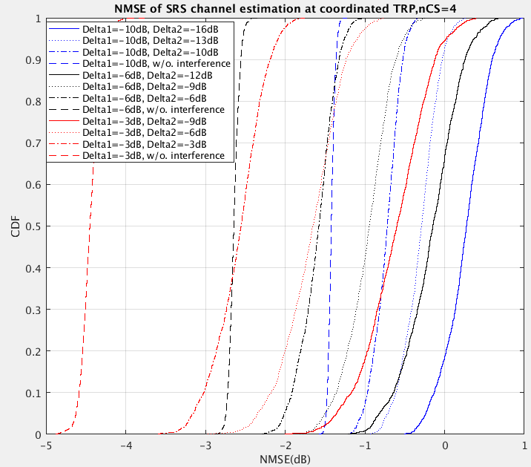 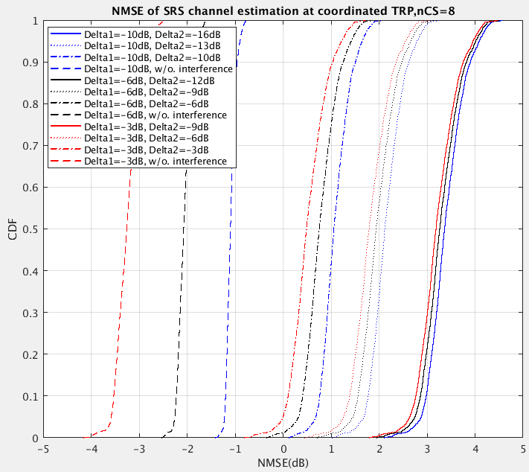

(a) Comb 2 CS 4 (b) Comb 2 CS 8

**Figure 3. NMSE performance of SRS channel estimation in LLS**

The SU & MU throughput performance of CJT under comb 2 CS 4 & comb 2 CS 8 are shown in Figure 4 & 5 and summarized in Table 1, 2 & 3. It can be easily observed from the tables that larger interference always leads to severer performance loss under each $∆_{1}$. Furthermore, due to a larger number of interference experienced, the performance loss under CS 8 is far larger than that under CS 4.

**Table 1. Summary of SU throughput under comb 2 CS 4**

|  |  |  |  |  |
| --- | --- | --- | --- | --- |
| Parameter Adoption | Without interference | $$∆_{2}=∆_{1}$$ (small interference) | $$∆_{2}=∆_{1}-3dB$$ (mid interference) | $$∆_{2}=∆_{1}-6dB$$ (large interference) |
| $$∆_{1}=-3dB$$ | 100% (100%) | 92.96% | 90.14% | 83.57% |
| $$∆_{1}=-6dB$$ | 100% (89.00%) | 96.26% | 92.14% | 83.85% |
| $$∆_{1}=-10dB$$ | 100% (83.65%) | 95.42% | 90.51% | 81.65% |

**Table 2. Summary of MU throughput under comb 2 CS 4**

|  |  |  |  |  |
| --- | --- | --- | --- | --- |
| Parameter Adoption | Without interference | $$∆_{2}=∆_{1}$$ (small interference) | $$∆_{2}=∆_{1}-3dB$$ (mid interference) | $$∆_{2}=∆_{1}-6dB$$ (large interference) |
| $$∆_{1}=-3dB$$ | 100% (100%) | 91.93% | 87.73% | 79.92% |
| $$∆_{1}=-6dB$$ | 100% (94.49%) | 91.56% | 87.92% | 79.83% |
| $$∆_{1}=-10dB$$ | 100% (90.65%) | 92.48% | 89.00% | 80.39% |

**Table 3. Summary of MU throughput under comb 2 CS 8**

|  |  |  |  |  |
| --- | --- | --- | --- | --- |
| Parameter Adoption | Without interference | $$∆_{2}=∆_{1}$$ (small interference) | $$∆_{2}=∆_{1}-3dB$$ (mid interference) | $$∆_{2}=∆_{1}-6dB$$ (large interference) |
| $$∆_{1}=-3dB$$ | 100% (100%) | 78.10% | 68.27% | 51.69% |
| $$∆_{1}=-6dB$$ | 100% (97.80%) | 72.08% | 61.07% | 44.87% |
| $$∆_{1}=-10dB$$ | 100% (92.73%) | 68.96% | 58.07% | 40.29% |

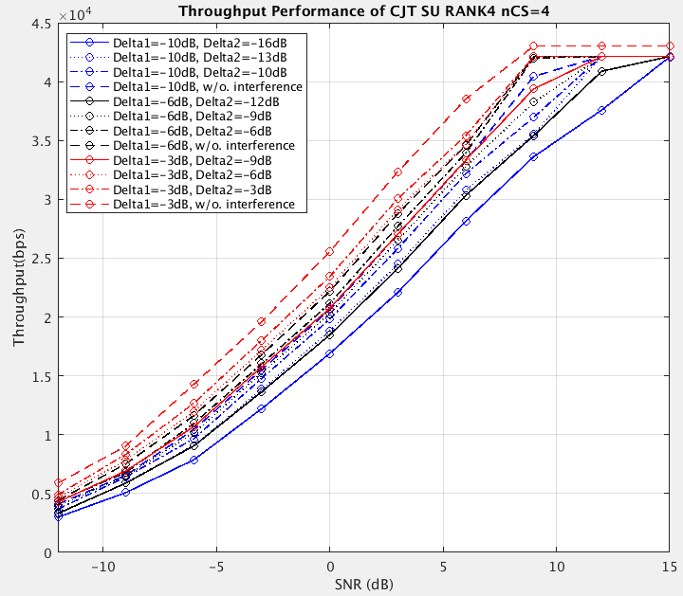 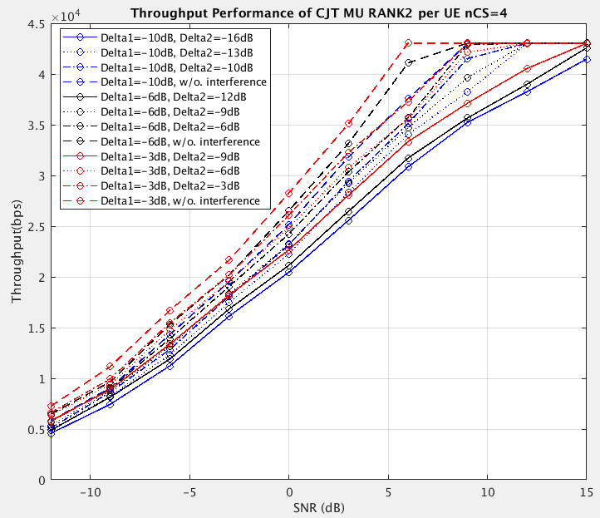

(a) SU-MIMO (b) MU-MIMO

**Figure 4. Throughput of CJT in LLS under comb 2 CS 4**

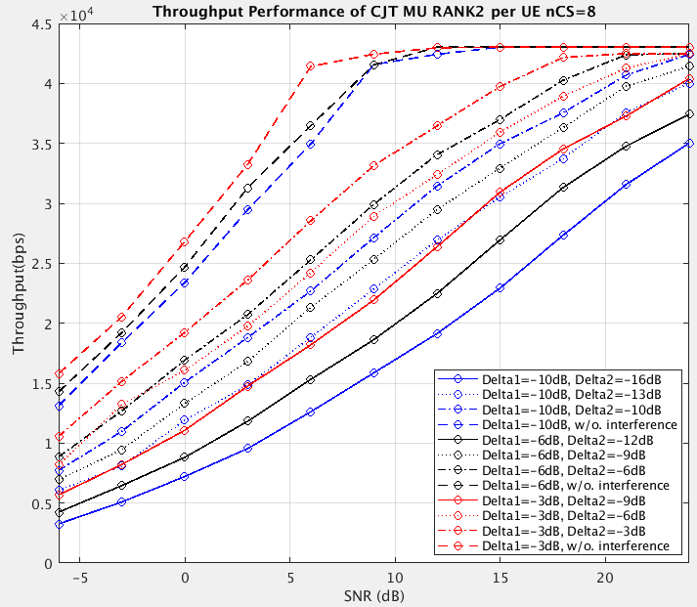

**Figure 5. MU Throughput of CJT in LLS under comb 2 CS 8**

***Observation 1: Large inter-TRP cross-SRS interference can lead to up to 60% performance loss under different SRS configurations.***

Based on the proposed SRS measurement hypothesis, the SLS is also conducted to show the performance gap. During the simulation, the coordinated TRP(s) in a coordination set are selected based on the RSRP gap between the coordinated TRP(s) and the serving TRP. DFT-based real SRS channel estimation is performed.

The NMSE performance of the SRS channel estimation executed by serving TRP and coordinated TRP(s) is shown in Figure 6. It can be obviously observed in Figure 6 that there exists a large gap between the channel estimation performance of serving TRP and coordinated TRP(s). Due to the inaccurate channel information, the performance of CJT will be severely degraded.

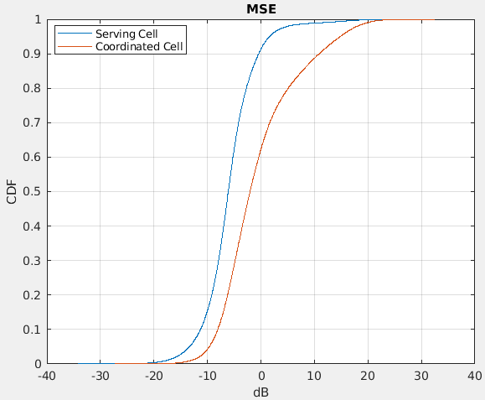

**Figure 6. NMSE performance of SRS channel estimation in SLS**

To further verify the performance loss of CJT caused by SRS interference, the performance of the following three schemes are compared in Figure 7:

1. CJT with SRS interference.
2. CJT with whitened SRS interference: interference are whitened by randomization, where the SRS interference after LS estimation is modeled as noise random variable with the same power.
3. CJT without SRS interference: SRS are ideally free from interference through fully-orthogonal physical resources allocation. This can be considered as an upper bound for CJT performance.

**Figure 7. Throughput of CJT for different schemes in SLS**

Figure 7 shows a large performance gap between scheme A and scheme C (about 50%), which means that significant performance gain can be expected by proper interference management.

***Observation 2: Significant performance gain can be expected under CJT scenario in SLS if the inter-TRP cross- SRS interference can be properly managed.***

Based on the analysis and simulation above, we have the following proposal:

***Proposal 1: Support SRS enhancement to manage inter-TRP cross-SRS interference under CJT scenario in R18.***

## SRS interference randomization

As discussed in [3], one of the most straightforward directions to manage inter-TRP cross-SRS interference is interference randomization. In current NR spec, some methods have already been supported to randomize the SRS interference, i.e., group hopping and sequence hopping. However, these two methods have limited interference randomization effect under CJT scenario.

For the group hopping, there are only 30 sequence groups in total and every UE will select one of the sequence groups per SRS transmission. It is possible that the same group is used in both the serving TRP and a neighbor TRP, which will cause serious interference. The collision probability is analyzed in a typical network as shown in Figure 8, where TRP 0 is considered as the serving TRP of the target UE and the neighboring 6 TRPs are considered as the TRPs whose UE may cause strong SRS interference to the target UE.

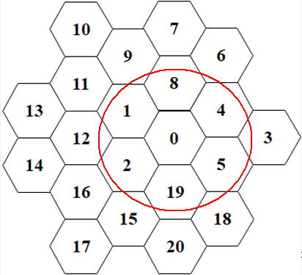

**Figure 8. Illustration of SRS sequence group collision in network @TRP0**

The sequence group collision probability between the serving TRP and neighboring TRPs is given in Table 4. When the same sequence group is used for serving TRP and at least one neighboring TRP in at least one symbol of SRS transmission, it is counted as a collision. It can be observed that the collision probability increases with the increase of the number of neighboring TRPs, which is up to 18.41%. Considering the SRS repetition, the collision probability is further increased, which is up to 55.68% for 4-times repetition.

**Table 4. Collision probability of sequence group for group hopping in current spec**

|  |  |  |  |  |  |  |
| --- | --- | --- | --- | --- | --- | --- |
| Total neighboring TRP number | 1 | 2 | 3 | 4 | 5 | 6 |
| No repetition | 3.33% | 6.56% | 9.67% | 12.68% | 15.59% | 18.41% |
| 2-time repetition | 6.56% | 12.68% | 18.41% | 23.75% | 28.75% | 33.42% |
| 4-time repetition | 12.68% | 23.75% | 33.42% | 41.87% | 49.24% | 55.68% |

Note that, the collision may cause much stronger interference under CJT scenario. As shown in Figure 9, if SRS1 and SRS2 use the same sequence group, SRS2 will cause a very strong interference to SRS1 at TRP2, which will bring disastrous influence to the channel estimation performance of the target UE at TRP2.

For the sequence hopping, different TRPs can always use different sequence groups, every UE randomly selects one sequence from the sequence group per slot per symbol to obtain the interference randomization effect. However, since a sequence group only contains two sequences, the interference cannot be randomized well, especially for the case where repetition factor is large. For example, as shown in Figure 9, sequence group #A and sequence group #B are used for UE1 from TRP1 and UE2 from TRP2 respectively. The same level of interference happens in Symbol#1 and Symbol#4 for both UEs. Such mechanism cannot provide much performance gain under CJT scenario with relatively large interference.

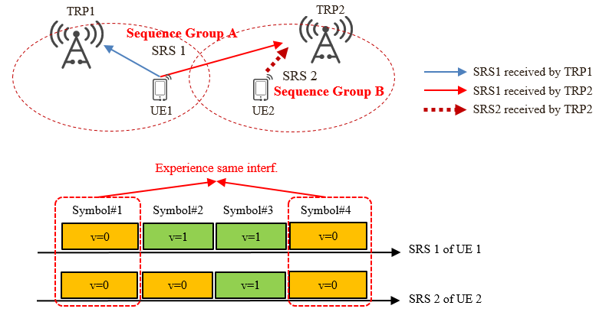

Figure 9. Illustration of SRS sequence hopping during SRS transmission

From the above analysis, it can be seen that neither the group hopping nor the sequence hopping is sufficient to randomize the interference under CJT scenario.

***Observation 3: Sequence hopping and group hopping is not sufficient to randomize the interference.***

During last meeting, the following candidate schemes of SRS interference randomization are agreed to be further studied:

* Randomized frequency-domain resource mapping for SRS transmission, e.g., further enhancements to frequency hopping, comb hopping
* Randomized code-domain resource mapping for SRS transmission, e.g., cyclic shift hopping/ randomization, sequence hopping/ randomization, per-hop sequence from a long SRS sequence
* Partial frequency sounding extensions, e.g., starting RB location hopping enhancements
* Randomized transmission of SRS, e.g., pseudo-random muting of SRS transmission for periodic and semi-persistent SRS

All these schemes share similar benefit source, that is utilizing the degrees of freedom (DoF) in a certain domain to change the relative relationship between target SRS and interference SRS among different SRS transmissions, and conducting joint filtering to obtain the randomization effect. More specifically, frequency hopping enhancement, comb hopping as well as starting RB location hopping enhancement utilizes the DoF in frequency domain; cyclic shift hopping/randomization, sequence hopping/randomization as well as per-hop sequence from a long SRS sequence utilizes the DoF in code domain and pseudo-random muting of SRS transmission utilizes the DoF in time domain. However, for frequency domain randomization, significant benefit can only be expected when the frequency domain resource utilization rate is relatively low, which is hard to be guaranteed considering the scarcity of SRS resource; while for time domain randomization, performance loss may occur due to the muting of SRS transmissions, which is not preferred. As a result, following sections mainly focus on the code domain randomization.

### CS hopping/randomization

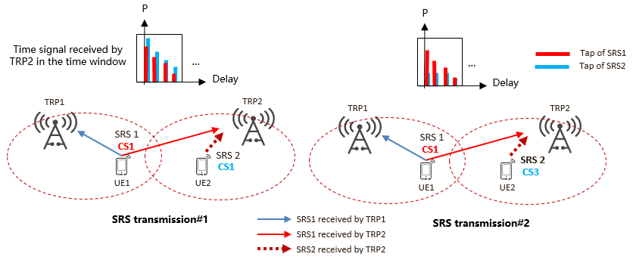CS hopping/randomization is a potential code domain randomization scheme that should be considered. As shown in Figure 10, the CS value used for SRS1 and SRS2 hops/randomizes in different SRS transmissions. By this means, SRS2 will cause different interference levels to SRS1 at the TRP2 side in different SRS transmissions. As discussed above, if proper time domain filtering is performed, the interference can be whitened to a large extent.

**Figure 10. Illustration of CS hopping/randomization**

The NMSE performance of the proposed CS hopping is presented in Figure 11. The simulation uses the comb 2 CS 4 configuration in section 2.1. Since the relative relationship between CS hopping and existing schemes (baseline, group hopping and sequence hopping) is similar under different $∆_{1}$, here $∆_{1}=-3dB$ is chosen as an example. As shown in Figure 11, under arbitrary $∆_{2}$ the difference between the baseline and sequence hopping is marginal, which confirms the analysis in section 2.2 that sequence hopping is insufficient to randomize the interference. Although both the CS hopping and group hopping can bring apparent benefit at 50% point of CDF curve, the noticeable trail of group hopping caused by the sequence group collision as discussed in section 2.2 will cumber the overall performance of group hopping.

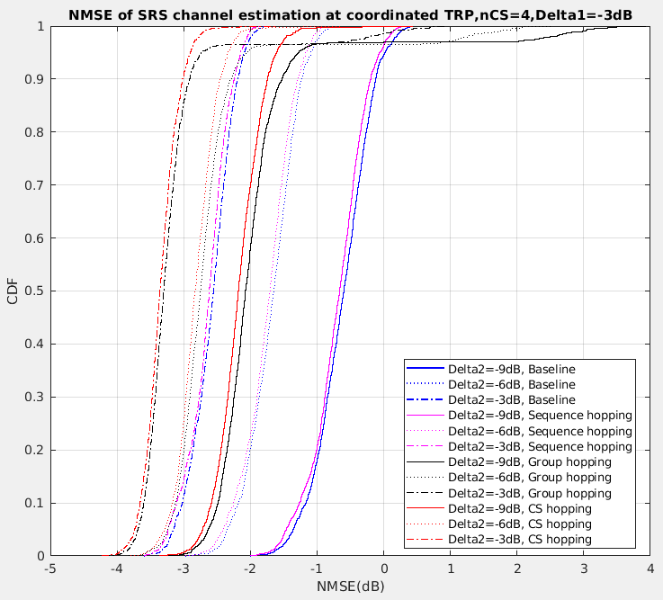

**Figure 11. NMSE performance of CS hopping and existing schemes**

The SU & MU throughput performance under different $∆_{1}$ is shown in Figure 12. It can be observed from Figure 12 that facing strong interference, CS hopping can bring up to 12% throughput benefit for SU compared with group hopping under different combinations of $∆_{1}$. and $∆_{2}$. Considering the higher rank under real deployment, the throughput benefit can be even larger.

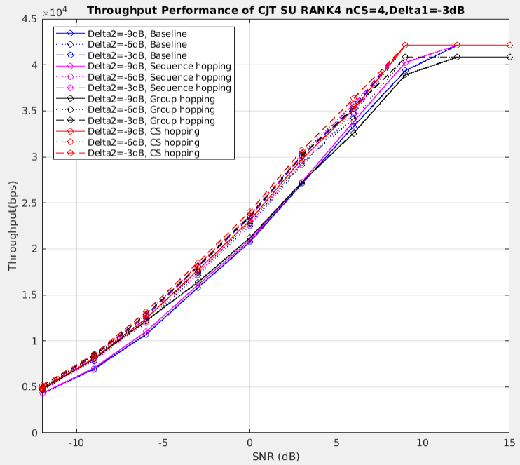 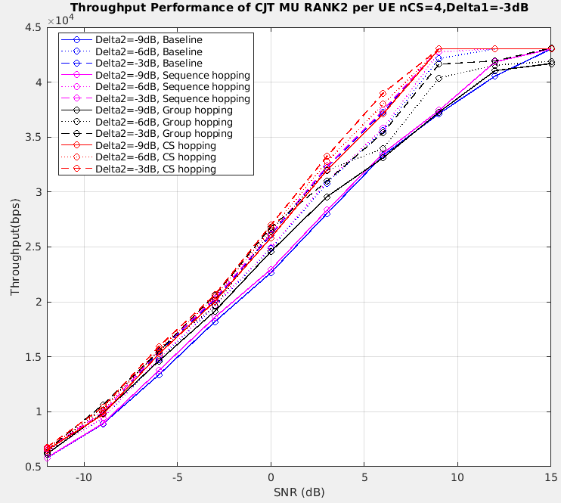

(a) SU-MIMO, $∆_{1}=-3dB$ (b) MU-MIMO, $∆_{1}=-3dB$

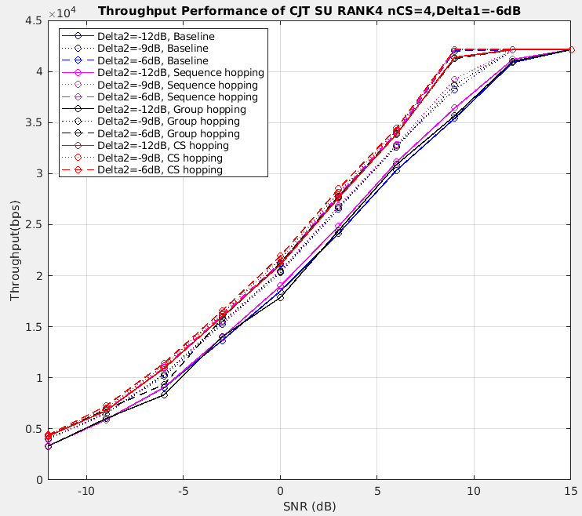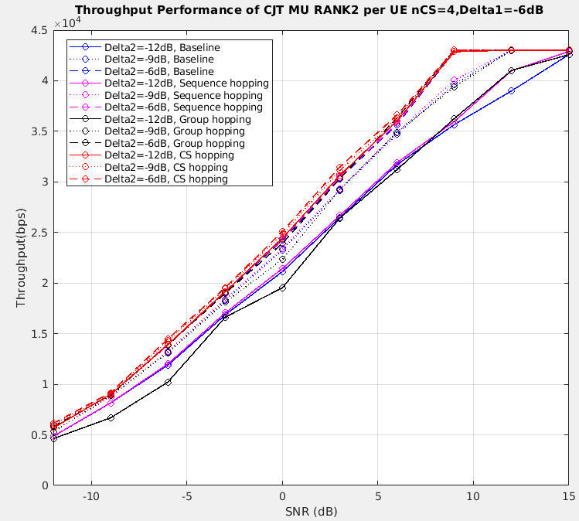

(c) SU-MIMO, $∆_{1}=-6dB$ (d) MU-MIMO, $∆_{1}=-6dB$

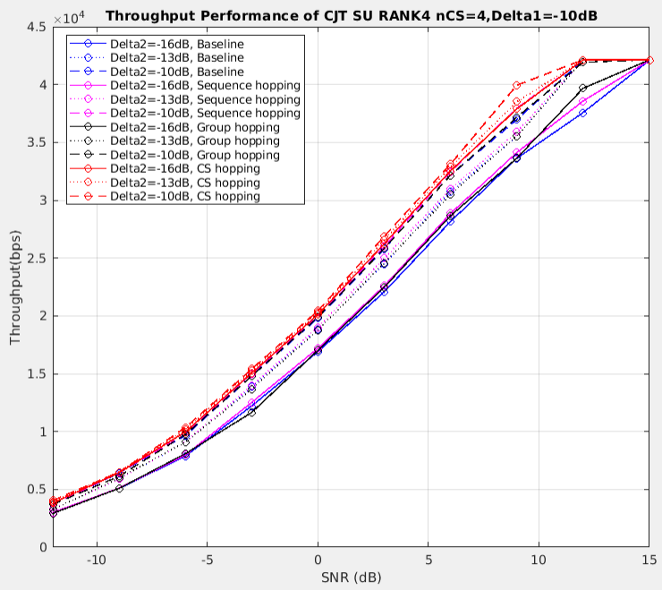 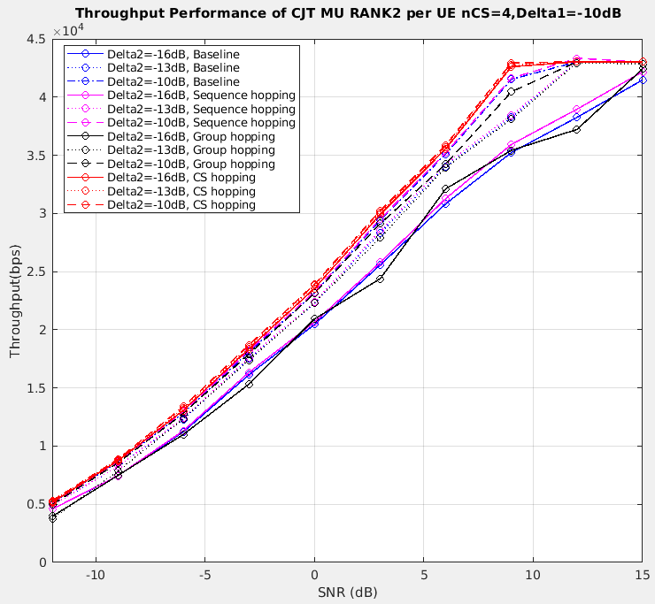

(e) SU-MIMO, $∆_{1}=-10dB$ (f) MU-MIMO, $∆_{1}=-10dB$

**Figure 12. Throughput performance of CS hopping and existing schemes**

***Observation 4: Compared with group hopping, CS hopping can bring up to 12% throughput benefit for SU and 16% throughput benefit for MU.***

Based on the analysis and simulation above, we have the following proposal:

***Proposal 2: CS hopping for interference randomization should be supported in R18.***

### Sequence aggregation

Sequence aggregation is another potential code domain randomization scheme that can be considered. In current spec, when frequency hopping is enabled, the SRS root sequence is generated according to the number of REs per hop as shown in Figure 13. However, when the number of REs per hop is relatively small, the cross-correlation between different root sequences is relatively high, which will lead to severe interference. Based on the phenomenon mentioned above, a straightforward enhancement is to generate the SRS root sequence according to the total number of REs across hops within a frequency hopping period as shown in Figure 13. Accompanied by joint channel estimation, the lower cross-correlation of longer SRS root sequence in Figure 14 can be fully utilized and better performance can be expected.

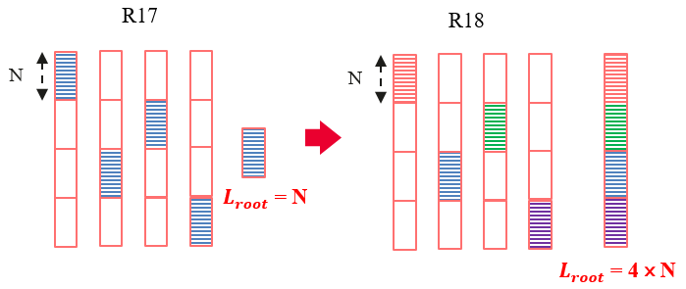

**Figure 13. Illustration of sequence aggregation**

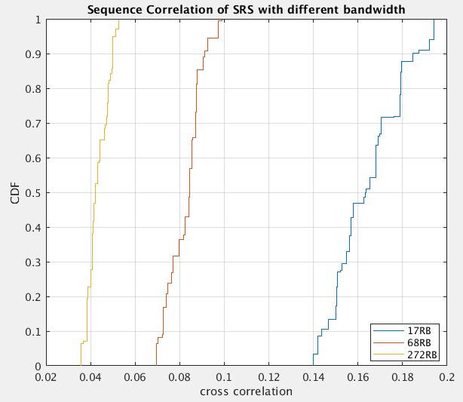

**Figure 14. CDF of cross-correlation between SRS root sequences under different length**

***Observation 5: Longer SRS root sequences have better cross-correlation property.***

Based on the analysis above, we have the following proposal:

***Proposal 3: Sequence aggregation for interference randomization could be supported in R18.***

## SRS capacity enhancement

During last meeting, the following candidate schemes of SRS capacity enhancement are agreed to be further studied:

* SRS TD OCC
* Increasing the maximum number of cyclic shifts, e.g., multiplying mask sequence to the legacy SRS sequence to effectively increase the maximum cyclic shifts
* Precoded SRS for DL CSI acquisition
* Partial frequency sounding extensions, e.g., larger partial frequency sounding factor

All these schemes shares similar benefit source, that is conducting multiplexing in a certain domain to increase the number of concurrent SRS transmissions without introducing additional overhead. With increased capacity, TRPs have the potential to jointly perform orthogonal SRS resource allocation for UEs, by which means the inter-TRP cross-SRS interference can be avoided/alleviated. More specifically, TD OCC conducts time domain complexing; increasing the maximum number of cyclic shifts conducts code domain complexing; precoded SRS conducts spatial domain multiplexing and partial frequency sounding extensions conducts frequency domain multiplexing. However, for TD OCC, the maximum capacity is not really increased and the multiplexing between different repetition factors should be considered; for partial frequency sounding extensions, the SRS density in frequency domain is further reduced and the CSI precision cannot be guaranteed, which is unacceptable under CJT scenario. As a result, following sections mainly focus on precoded SRS and the schemes of increasing the maximum number of cyclic shifts.

### Precoded SRS

In current spec, the number of SRS ports required for DL CSI acquisition is the same as the number of UE receiving antennas. Precoded SRS is an effective solution to reduce the number of required SRS ports to the number of PDSCH layers. Meanwhile, the gNB can still obtain relatively accurate downlink precoding matrix based on the effective channel measured by SRS channel estimation. Under the MU-MIMO scenario, which is the target scenario for CJT, the PDSCH layer number is mainly 1 or 2, so the SRS port number for a 4R UE can be reduced from 4 to 1 or 2.

More specifically, The UE will calculate the $N_{\text{ap}}^{\text{SRS}}×rank$ SRS precoding matrix $W_{SRS}$ based on the DL channel matrix $H_{DL}$, which can be obtained through CSI-RS based channel estimation, and send the *rank*-port precoded SRS to the gNB. The gNB will conduct SRS channel estimation to obtain the effective UL channel as

$$H_{UL}^{eff}=H_{UL}W_{SRS}.$$

Then, based on the reciprocity, the effective DL channel can be expressed as

$H_{DL}^{eff}={H_{UL}^{eff}}^{T}=W_{SRS}^{T}H_{DL}$**.**

The gNB may further calculate the PDSCH precoding matrix based on the effective DL channel,

$W_{PDSCH}=V_{[1:rank]}^{eff}$,

where $V_{[1:rank]}^{eff}$ is the right eigenvectors corresponding to the strongest *rank* eigenvalues of the matrix $H_{DL}^{eff}.$

* For 4T4R antenna switching

The SRS precoding matrix $W_{SRS}$ can be designed as

$W_{SRS}^{T}=U_{[1:rank]}^{H}$, (1)

where $U_{[1:rank]}$ is the left eigenvectors corresponding to the strongest *rank* eigenvalues of the DL channel matrix $H_{DL}=UDV^{H}$. Then the effective DL channel can be expressed as:

$H_{DL}^{eff}=U_{[1:rank]}^{H}H_{DL}=D_{rank}V_{[1:rank]}^{H}$.

* For 2T4R antenna switching

Take *rank* = 2 as an example, for the *i*th antenna pair ($i∈\left\{0,1\right\}$), the SRS precoding matrix $W_{SRS,[i]}$ can be designed as

$W_{SRS,[i]}^{T}=V_{[i]}^{H}H_{DL,[i]}^{H}$, (2)

where the vector $V_{[i]}^{H}$ is the right eigenvectors corresponding to the *i*th strongest eigenvalue of the DL channel matrix $H_{DL}=UDV^{H}$ and $H_{DL,[i]}^{H}$ is the DL subchannel matrix corresponding to the *i*th antenna pair. Then the effective DL channel can be expressed as:

$H_{DL}^{eff}=\left[\begin{matrix}V_{[1]}^{H}H_{DL,[1]}^{H}H_{DL,[1]} \\ V_{[2]}^{H}H_{DL,[2]}^{H}H_{DL,[2]}\end{matrix}\right]$.

The performance of precoded SRS and legacy SRS are evaluated in LLS. The simulation uses the comb 2 CS 8 configuration in section 2.1. It is assumed that SRS resources of four UEs occupy the same comb. For legacy SRS, both the 4-port SRS resource of target UE 1 and that of interference UE 1 take up CS {0, 2, 4, 6} (utilizing different SRS root sequence), while both the 4-port SRS resource of target UE 2 and that of interference UE 2 take up CS {1, 3, 5, 7} (utilizing different SRS root sequence). For precoded SRS, since only *rank*(2)-port SRS resource is required for each UE, four UEs can be jointly allocated orthogonal SRS resources to avoid/alleviate the inter-TRP cross-SRS interference. More specifically, the 2-port SRS resources of four UEs take up CS {0, 4}, {1, 5}, {2, 6} and {3, 7} (utilizing same SRS root sequence) respectively. The wideband precoder based on Equation (1) is used for SRS transmission.

Figure 15 shows the CDF of correlation factor between ideal DL precoding matrix and the DL precoding matrix obtained by SRS. The correlation factor for the *j*th layer of *i*th UE is defined as

$ρ_{i,j}=\frac{\left|{\left(W_{PDSCH}^{(i,j)}\right)}^{H}W_{ideal}^{i,j}\right|}{\left|W_{PDSCH}^{i,j}\right|\left|W_{ideal}^{i,j}\right|}$.

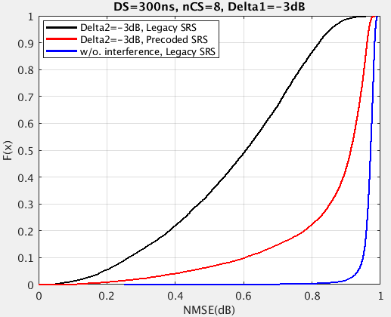

**Figure 15. CDF of correlation factor between ideal DL precoding matrix and the DL precoding matrix obtained by SRS**

It can be observed that owing to the overhead reduction and joint resource allocation, the correlation factor between ideal DL precoding matrix and the DL precoding matrix obtained by precoded SRS is higher than that between ideal DL precoding matrix and the DL precoding matrix obtained by legacy SRS. Although the wideband precoder may cause some performance loss under relatively high DS (300ns), high DL CSI accuracy (the probability of correlation factor being larger than 0.9 exceeds 55%) can still be ensured.

The throughput performance of precoded SRS is provided in Figure 16. About 35% throughput benefit proves the analysis above that both overhead reduction and high-accuracy CSI acquisition can be achieved through precoded SRS.

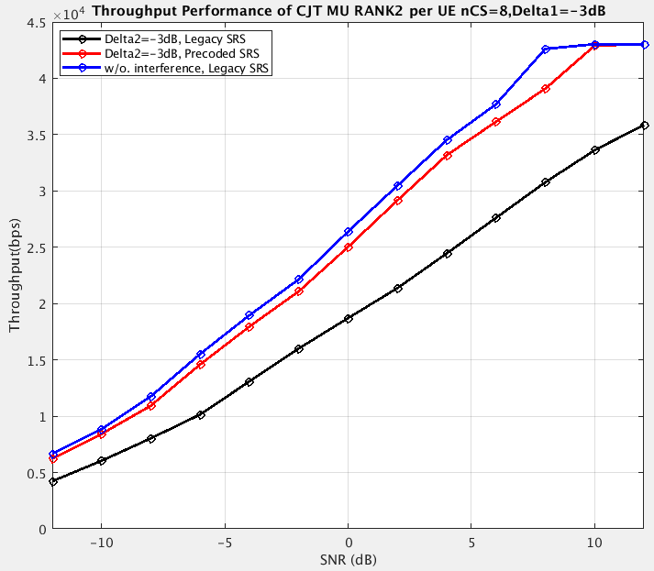

**Figure 16. Throughput performance of precoded SRS and legacy SRS**

***Observation 6: Precoded SRS can bring about 35% throughput benefit.***

Based on the analysis and simulation above, we have the following proposal:

***Proposal 4: Precoded SRS should be supported for capacity enhancement in R18.***

### SRSs with increased maximum number of cyclic shifts

For a given SRS bandwidth consisting of $N$ consecutive subcarriers, the legacy $K_{\text{TC}}$ comb based SRS construction with maximum number of cyclic shifts $n_{SRS}^{cs,max}$ can accommodate a total of $n_{SRS}^{cs,max}K_{\text{TC}}$‘orthogonal’ SRS ports with zero correlation zone (ZCZ) of length $\frac{N}{n_{SRS}^{cs,max}K_{TC}}$. When multiple SRSs are transmitted concurrently with proper timing advance (TA) adjustment over channels whose maximum delay $L_{max}$ is no larger than this ZCZ, the channel impulse response (CIR) of each SRS can be estimated by the TRP using the conventional matched filtering + windowing based method. The length of detection window $D$ can be selected to satisfy $L_{max}≤D≤\frac{N}{n_{SRS}^{cs,max}K_{TC}}$, such that the CIRs of the desired SRS and interfering SRSs can completely fall, respectively, inside and outside the detection window after matched filtering. By this means, intra-cell interference can be perfectly avoided. An illustration of the matched filtering output under this scenario is given in Figure 17 (a).

According to the agreement in last meeting, if the SRS capacity is enhanced by directly increasing the maximum number of cyclic shifts $n_{SRS}^{cs,max}$, e.g., by $Q$ times, the ZCZ length will also be reduced by $Q$ times, which may become shorter than $L_{max}$. Consequently, when multiple SRSs are transmitted concurrently, the orthogonality can no longer be maintained even with perfect TA adjustment, and intra-TRP cross-SRS interference will occur. In this case, the $D$ has to be shortened to be no larger than the length of ZCZ, so as to avoid including the head of the CIR experienced by an interfering SRS taking up the next adjacent cyclic shift. The consequence of the reduced $D$ is two-fold: first, the tail of the CIR experienced by the desired SRS will fall out of the detection window, i.e., a distortion will occur during the channel estimation of desired SRS; second, the tail of the CIR experienced by another interfering SRS taking up the previous adjacent cyclic shift will fall into the detection window and cause interference.

 

(a) (b)

 

(c) (d)

**Figure 17. Illustrations of the matched filtering outputs**

The above discussion can be better understood by the following example. Consider the legacy $K_{\text{TC}}=2$ comb based SRS construction with maximum number of cyclic shifts $n_{SRS}^{cs,max}=8$ over SRS frequency bandwidth of $N$ consecutive subcarriers, a total of $n_{SRS}^{cs,max}K_{\text{TC}}=16$‘orthogonal’ SRS ports are supported with a ZCZ of length $\frac{N}{n_{SRS}^{cs,max}K_{TC}}=\frac{N}{16}$. When multiple SRSs are transmitted over a channel generated based on the agreed CDL-C channel model with 300ns desired delay spread and 30 kHz subcarrier spacing, the corresponding $L_{max}$ is about $8.6523×300×{10}^{-9}×30×{10}^{3}N≈\frac{N}{12.84}$, which is already 24.6% larger than the ZCZ length, i.e., the intra-TRP cross-SRS interference already exists, although such interference is low due to the marginal channel power carried by the last quarter of CIR. An illustration of the matched filtering output for this scenario is given in Figure 17 (b).

Taking above example as baseline, if we further increase the maximum number of cyclic shifts by $Q=2$ times, i.e., to $n_{SRS}^{cs,max}=16$, the corresponding ZCZ length will be reduced to $\frac{N}{n_{SRS}^{cs,max}K_{TC}}=\frac{N}{32}$, and the $L_{max}$ will be 149.2% larger than the ZCZ length, i.e., about 60% of the CIR of the desired SRS will fall out of the detection time window, while the 40% to 80% of the CIR of an interfering SRS taking up the previous adjacent cyclic shift will fall into the detection time window and cause severe interference. An illustration of the matched filtering output under this scenario is given in Figure17 (c).

The NMSE performance of the channel estimation at the serving TRP is shown in Figure 18. For baseline SRS, the target UEs and interference UEs take up the same physical resource (in terms of time and frequency) under comb 2 CS 8 configuration; while for ‘advanced’ SRS, the target UEs and interference UEs take up different physical resource (in terms of time, frequency and cyclic shift) under comb 2 CS 16 configuration. It can be obtained from Figure 18 that by directly doubling the maximum number of cyclic shifts, the benefit of avoiding inter-TRP cross-SRS interference does not outweigh the loss caused by introducing intra-TRP cross-SRS interference, which leads to the channel estimation accuracy degradation and is not preferred.



**Figure 18. NMSE performance of the channel estimation at the serving TRP**

The channel estimation accuracy degradation caused by directly increasing the maximum number of cyclic shifts can be even more significant at the coordinate TRP when the arrival time difference between different SRSs is taken into account. Conventionally, TA mechanism is applied to guarantee the arrival time of concurrently transmitted SRSs being aligned at the serving TRP. This TA mechanism will inevitably cause arrival time difference at a coordinate TRP. For example, under the inter-site distance of 300 meters, assuming that both UE1 (locating at the center of cell 1) and UE2 (locating at the boundary of cell 1 & 2) are CJT users served by TRP1 (serving TRP) and TRP2 (coordinated TRP) , then UE2’s SRS needs to be transmitted earlier than UE1’s SRS by about $\frac{150}{3×{10}^{8}}=5×{10}^{-7}$ second so as to align their arrival time at the serving TRP. On the other hand, since UE1 is farther from the coordinated TRP than UE2 by 150 meters, its propagation time to arrive at the coordinated TRP is longer than that of UE2 by about $\frac{150}{3×{10}^{8}}=5×{10}^{-7}$ second. Combining these two factors, the arrival time difference between UE1 and UE2’s SRSs at the coordinated TRP will accumulate to $1×{10}^{-6}$ second, which corresponds to about $\frac{N}{33}$ samples, i.e., approximately equals to the reduced ZCZ length of $\frac{N}{32}$. When the SRSs transmitted by UE1 and UE2 take up adjacent cyclic shifts, such a large arrival time difference at the coordinated TRP will lead severe CIR collision as shown in Figure 17 (d).

In summary, the feature of directly increasing the maximum number of cyclic shifts is to maintain the ZCZ property but with a reduced ZCZ length. However, the reduced ZCZ length can no longer maintain the mutual orthogonality among the SRSs, i.e., the intra-TRP cross-SRS interference will be introduced. Considering that the introduction of intra-TRP cross-SRS interference is inevitable when the SRS capacity is enhanced, how to efficiently handle the introduced interference becomes a key issue. From the analysis and simulation above, it can be seen that maintaining the ZCZ property compulsorily will not bring any performance benefit, then other potential direction such as breaking the ZCZ property to pursue interference equalization should be considered. One possible approach is to multiply mask sequence to the legacy SRS sequence to effectively increase the maximum cyclic shifts.

***Observation 7: Maintaining the ZCZ property compulsorily will not bring any performance benefit.***

Based on the analysis and simulation above, we have the following proposal:

***Proposal 5: Breaking the ZCZ property to pursue interference equalization should be considered in R18. One possible approach is to multiply mask sequence to the legacy SRS sequence to effectively increase the maximum cyclic shifts.***

For SRS capacity enhancement, the option of directly increasing the maximum number of cyclic shifts leads to a reduced zero correlation zone (ZCZ) length among the generated larger SRS set, which can no longer maintain the mutual orthogonality among the SRSs and so will inevitably introduce severe intra-TRP cross-SRS interference. A potential solution is to give up the ZCZ property among the SRSs and instead try to maintain a low correlation among the SRSs. For example, new SRSs can be constructed by multiplying a mask sequence to the legacy SRSs, and they together can increase the SRS capacity by 2 times with the following properties:

* All the legacy SRSs still maintain their original ZCZ, without reducing the ZCZ length;
* All the new SRSs with mask sequence can maintain a same ZCZ length as that among all the legacy SRSs, due to a common mask sequence used by them;
* A legacy SRS and a new SRS with mask sequence do not maintain any ZCZ property between them. Instead, by proper mask sequence selection, the amplitudes of their periodic cross correlation function can be kept low at all cyclically delay offsets, which implies a low interference between the legacy and new SRSs at the BS.

By this means, all the legacy and new SRSs can maintain a low correlation zone (LCZ) among them, whose length is the same as the ZCZ length among legacy SRSs only. This avoids the severe interference between two SRSs with adjacent cyclic shifts constructed by directly increasing the maximum number of cyclic shifts.

# SRS design for 8Tx UL MIMO

Based on the previous agreement, there are some open issues to be decided in this meeting:

* Whether to support 8 ports in one or multiple OFDM symbols

This issue is mainly for CB based UL MIMO. In current spec, the SRS ports for 2/4 Tx CB based UL MIMO are distributed within one OFDM symbol. There are two potential benefits of supporting 8 SRS ports in multiple OFDM symbols. One is that power boosting can be performed. Distributing 8SRS ports within multiple OFDM symbol can obtain per-port power lifting compared with current one-symbol mapping way, which can be fully utilized by the CPE. The other is that better resource allocation flexibility can be obtained. In current spec, gNB has the flexibility to configure multiple SRS pattern (e.g., 2 or 4 ports per comb) according to different channel conditions. In order to retain similar flexibility, supporting 8 ports in multiple OFDM symbols is necessary.

***Proposal 6: Support 8 SRS ports in multiple OFDM symbols.***

* Whether to support 8 ports in one or multiple resources

This issue is also for CB based UL MIMO. Multiple SRS resources should be supported to save spec effort and obtain higher flexibility. If multiple resource is supported, the 8 SRS ports can be divided into several groups and the configurations in current spec can be fully reused for each group, which will avoid designing patterns for an 8-port SRS resource. Furthermore, different resources for different groups can be configured in FDM/TDM/CDM manner, which provides higher flexibility and suits the channel condition better.

***Proposal 7: Support 8 SRS ports in multiple SRS resources.***

* The maximum number of SRS resource sets.

In our view, the motivation of supporting 8 SRS ports in multiple SRS resource sets is still unclear and further study is needed.

# Conclusions

In this paper, SRS enhancement for CJT and 8Tx UL transmission is discussed. The following observations and proposals are made:

***Observation 1: Large inter-TRP cross-SRS interference can lead to up to 60% performance loss under different SRS configurations.***

***Observation 2: Significant performance gain can be expected under CJT scenario in SLS if the inter-TRP cross- SRS interference can be properly managed.***

***Observation 3: Sequence hopping and group hopping is not sufficient to randomize the interference.***

***Observation 4: Compared with group hopping, CS hopping can bring up to 12% throughput benefit for SU and 16% throughput benefit for MU.***

***Observation 5: Longer SRS root sequences have better cross-correlation property.***

***Observation 6: Precoded SRS can bring about 35% throughput benefit.***

***Observation 7: Maintaining the ZCZ property compulsorily will not bring any performance benefit.***

***Proposal 1: Support SRS enhancement to manage inter-TRP cross-SRS interference under CJT scenario in R18.***

***Proposal 2: CS hopping for interference randomization should be supported in R18.***

***Proposal 3: Sequence aggregation for interference randomization could be supported in R18.***

***Proposal 4: Precoded SRS should be supported for capacity enhancement in R18.***

***Proposal 5: Breaking the ZCZ property to pursue interference equalization should be considered in R18. One possible approach is to multiply mask sequence to the legacy SRS sequence to effectively increase the maximum cyclic shifts.***

***Proposal 6: Support 8 SRS ports in multiple OFDM symbols.***

***Proposal 7: Support 8 SRS ports in multiple SRS resources.***

# Appendix

## Appendix A: Relationship between $∆_{1}$ and $∆_{2}$

Each blue circle in Figure x corresponding to a specific combination of $∆_{1}$ and $∆_{2}$ represents the real interference situation faced by a UE in SLS. In fact, if we roughly ignore the SRS transmitting power difference between target UE and interference UE to generally observe the relationship between $∆_{1}$ and $∆_{2}$, it can be easily obtained that $∆_{2}∝{PL}_{2} \left(dB\right)-{PL}_{4} \left(dB\right)$, which means the main difference between $∆_{1}$ and $∆_{2}$ comes from the difference between ${PL}_{1}$ and ${PL}_{4}$. Since the target UE is a CJT UE while the interference UE can be either a CJT UE or a sTRP UE, the absolute value of ${PL}_{1}$ is likely to be larger than or equal to the absolute value of ${PL}_{4}$, which can be proved by Figure 19 where the vast majority of blue circles are under the line representing $∆_{2}=∆_{1}.$ Based on the above analysis and the distribution of blue circles in Figure 19, the gap between $∆_{1}$ and $∆_{2}$ is chosen from {0, 3, 6}dB.

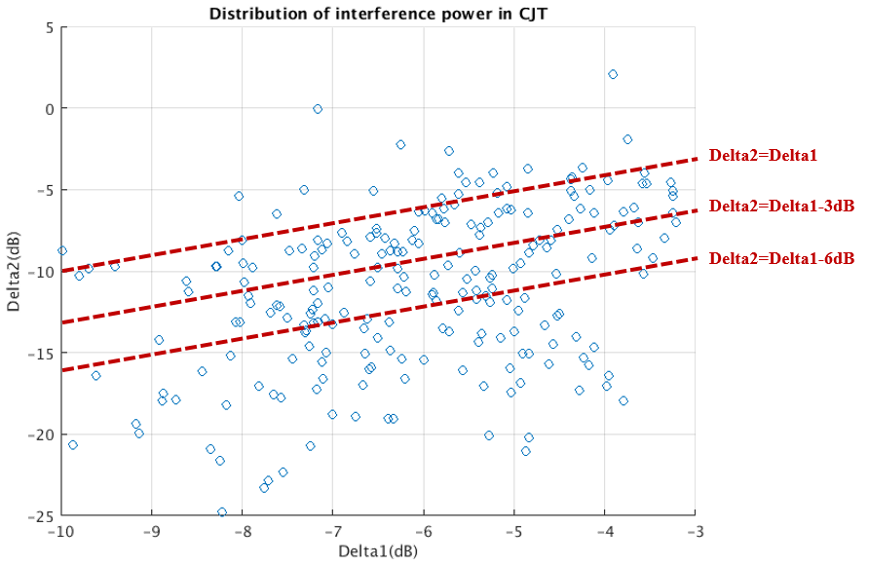

**Figure 19. Relationship between $∆_{1}$ and $∆_{2}$ in SLS**

## Appendix B: Link level simulation parameters for SRS enhancement

**Table 5 Simulation assumptions of LLS for SRS enhancement**

|  |  |
| --- | --- |
| **Parameter** | **Value** |
| Scenario | N_TRP = 2 |
| Carrier frequency and subcarrier spacing | 3.5 GHz with 30 kHz SCS |
| System bandwidth | 20MHz |
| Channel model | CDL-B with 300ns delay spread Same propagation delays between UE and N_TRP TRPs Ideal synchronization and backhaul |
| UE speed | 3km/h |
| Antennas at UE | 2T4R, 4T4R |
| Antennas at gNB | 64 ports: (8,8,2,1,1,4,8), (dH,dV) = (0.5, 0.8)λ |
| Rank and MCS | Fixed Rank 4, adaptive MCS |
| Precoding granularity | 2 for DL, wideband for UL |
| SRS configurations | SRS periodicity = 5ms SRS frequency hopping is disabled  Comb 2 with 4 CS or Comb 2 with 8 CS |
| UL SNR | UL SNR = 0 dB |

## Appendix C: System level simulation parameters for SRS enhancement

**Table 6 Simulation assumptions of SLS for SRS enhancement**

|  |  |
| --- | --- |
| **Parameter** | **Value** |
| Duplex, Waveform | TDD, OFDM |
| Carrier Frequency | 3.5GHz |
| Channel Model | According to the TR 38.901 |
| Scenario | Uma with 300 m ISD |
| BS anatenna configuration | (M, N, P, Mg, Ng; Mp, Np) =  (8,8,2,1,1,4,8), (dH, dV) = (0.5, 0.8) λ |
| UE antenna configuration | (M, N, P, Mg, Ng; Mp, Np) =  (1,2,2,1,1,1,2), (dH, dV) = (0.5, 0.5) λ |
| BS Tx power | 41 dBm |
| BS antenna height | 25 m |
| Numerology | 30kHz SCS |
| Scheduled Bandwidth | 5MHz |
| MIMO scheme | MU-MIMO with Rank 1-2 per UE |
| Traffic model | FTP model 3 with packet size 0.5 Mbytes |
| RU | 70% |
| UE speed | 3 km/h |
| UE receiver | MMSE-IRC |
| UE receiver noise figure | 9dB |
| UE Tx power for SRS | 23dBm |
| Network Layout | 7ⅹ3 cell, 4 UE per cell, outdoor 80%, indoor 20% |
| Precoding granularity | 2 RB |
| N_TRP | Semi-statically chosen based on ΔRSRP = 10 dB |
| Precoding method | Distributed precoding method for CJT |
| SRS period | 5ms |
| SRS configuration | 2 Combs, 4 CSs, 25MHz |

# Reference

1. RP-213598, “New WID: MIMO Evolution for Downlink and Uplink”, 3GPP RAN#94e, Electronic Meeting, 6-17 December, 2021.
2. 3GPP RAN1#109-e, Chairman Notes.
3. R1-2203153, SRS enhancement for TDD CJT and 8 TX operation in Rel-18, Huawei, HiSilicon