# Summary of evaluation results for objective#3

Multiple companies (FUTUREWEI, Huawei/HiSilicon, ZTE, vivo, Lenovo, OPPO, CATT, Xiaomi, Samsung, Fraunhofer IIS/HHI MediaTek , Ericsson, Qualcomm, Nokia) show evaluation results to compare between the 5 options. In this section, evaluation results are summarized. For the details, please review the companies’ tdocs. For discussion in RAN1#110, please go to sect. 3 and 4.

## FUTUREWEI [1]

Figure CDL-C,16QAM, CR=0.5, [90o 6o]

Since the delay spread is 30ns, hence flat channel, opt.1 outperforms legacy DMRS due to its longer OCC length. Opt.3 perform worse that legacy DMRS due to its sparser DMRS density.

## Huawei/HiSilicon [3]

**Table 3. Performance gains achieved by Opt.1 and Opt.3 compared to Scheme A**

|  |  |  |  |  |
| --- | --- | --- | --- | --- |
| Throughout gain v.s. Scheme A | Type 1, DS=30ns | Type 1, DS=300ns | Type 2, DS=30ns | Type 2, DS=300ns |
| Scheme B | 104.3% | 105.7% | 105.5% | 105.2% |
| Scheme C | 104.3% | 106.3% | 105.5% | 106.5% |

***Observation 6: For DL MU-MIMO with 2-symbol DMRS, Opt.1 (based on length-4 FD-OCC) has similar performance under DS=30ns and better performance under DS=300ns compared with Opt.3.***

1. **Non-orthogonal DMRS ports**
2. **Opt.1: Enhance FD-OCC**
3. **Opt.3: Sparser frequency allocation**
4. **Double symbol front-loaded Rel.15 DMRS ports (only used to compare the performance of single-symbol DMRS port enhancements)**
5. **Table 4. Performance gains compared to Scheme D for 1-symbol DMRS**

|  |  |  |
| --- | --- | --- |
| Throughout gain v.s. Scheme D | Type 1 | Type 2 |
| Scheme A | 105.2% | 105.2% |
| Scheme B | 111.1% | 110.7% |
| Scheme C | 111.1% | 112.6% |

***Observation 7: For DL MU-MIMO with 1-symbol DMRS, Opt.1 (based on length-4 FD-OCC) has better performance under DS=300ns compared with Opt.3.***

***Observation 8: Thanks to overhead reduction, 1-symbol Rel.18 DMRS can obtain about 5% ~13% performance gain compared to 2-symbol front-loaded Rel.15 DMRS.***

## ZTE [4]

**Figure 2** LLS simulation results with (a) UE speed 3km/h and delay spread 30ns, (b) UE speed 3km/h and delay spread 300ns, and (c) UE speed 60km/h and delay spread 30ns

***Observation 4:*** *In order to accommodate different MU-MIMO scenarios, TD-OCC performs better BLER performance over FDM and FD-OCC in the scenario of low-speed and high-delay-spread. However, there is severe performance degradation for TD-OCC when compared with FDM and FD-OCC in the scenario of high-speed and low-delay.*

## vivo [6]

**2 UEs co-scheduled in MU-MIMO**

|  |  |
| --- | --- |
| a) 16QAM, DS=30 | b) 16QAM, DS=300 |
| c) 64QAM, DS=30 | d) 64QAM, DS=300 |

1. The BLER performance of R18 DMRS type 1 in MU-MIMO with 2 UEs
2. For DMRS type 1 enhancement, the performance degradation of FD-OCC=4 is acceptable, compared with FD-OCC=2.
3. For DMRS type 1 enhancement, FD-OCC=4 with two channel estimations in each RB has a similar performance to FD-OCC=4 with 2RB as scheduling granularity in the case of large delay spread.

**4 UEs co-scheduled in MU-MIMO**

|  |  |
| --- | --- |
| a) 16QAM, DS=30 | b) 16QAM, DS=300 |

1. The BLER performance of R18 DMRS type 1 in MU-MIMO with 4 UEs
2. For DMRS type 1 enhancement, FD-OCC=4 outperforms FD-OCC=6 and FDM schemes in the case of large delay spread.

## Lenovo [9]

(a) (b)

(c) (d)

(e) (f)

Fig.3 BLER comparison of enhanced DMRS pattern with FD-OCC4, FD-OCC6 and FDM

Fig.4 MSE comparison of FD-OCC4, FD-OCC6 and FDM

***Observation 1：The performances of MSE and BLER are similar for small channel frequency selectivity and the performance gap between enhanced DMRS and R15 DMRS is larger for the channel with large frequency selectivity.***

***Observation 2：At low SNR ranges the performance of MSE and BLER of enhanced FDM-OCC DMRS with OCC length 4 are best; in high SNR range, the performances of enhanced FDM DMRS are best.***

## OPPO [10]

 

Fig.4: DMRS enhancement without additional DMRS for legacy DMRS/FDM/CDM for type 1 DMRS



Fig.5: DMRS enhancement without additional DMRS for legacy DMRS/FDM/CDM for type 2 DMRS

 

Fig.6: DMRS enhancement with additional DMRS for type 1 DMRS

 

Fig.7: DMRS enhancement with additional DMRS for type 2 DMRS

***Observation 2: TDM/TD-OCC cannot provide significant performance gain over FDM/CDM even with large delay spread.***

***Observation 3: FDM outperforms CDM at high SNR with large delay spread.***

## CATT [11]

Figure 5: Comparison of option 1 and option 3 under 30ns delay spread

**Observation 1: When pre-coding assumption of interference of co-scheduled UEs is modelled according to Alt.2 and 2 layers are scheduled for each user, option 1 (enhance FD-OCC) achieves better performance than option 3 (sparser frequency allocation).**

## グラフ 自動的に生成された説明グラフ, 折れ線グラフ 自動的に生成された説明グラフ, 折れ線グラフ 自動的に生成された説明グラフ 自動的に生成された説明Xiaomi [14]

Fig.3 BLER comparison among all candidate DMRS type and R15 DMRS Type considering different UE speed (speed=3km/h and 120km/h)

***Observation 1: There is much performance degradation in high UE velocity for the enhanced DMRS pattern corresponding to option 2 and option 4.***

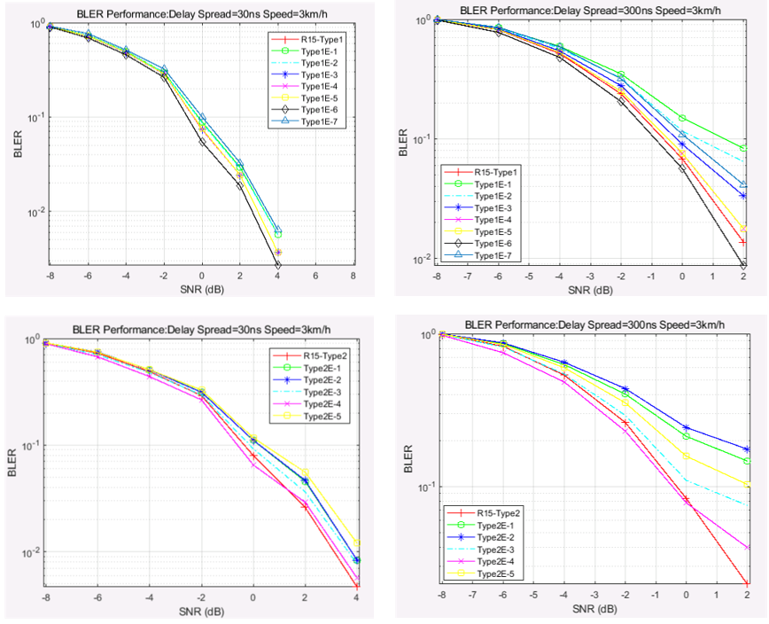

Fig.4 BLER comparison among all candidate DMRS type and R15 DMRS Type considering different channel delay spread. (delay spread=30ns and 300ns)

***Observation 2: There is much channel estimation performance loss in the case of large delay spread for the enhanced DMRS patterns related to option 3.***

***Observation 3: The enhanced DMRS types corresponding to option1*** ***have less performance loss for*** ***both high UE velocity and large channel delay spread.***

## Samsung [15]

Direction 1) Increase the number of CDM groups

Direction 2) Increase the number of DMRS ports within CDM group

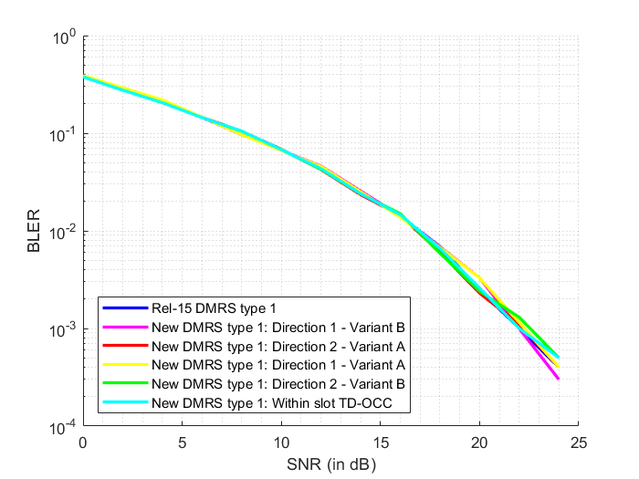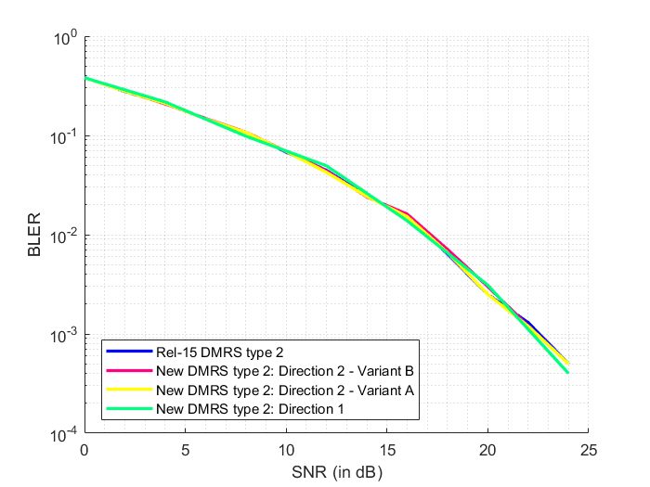

Figure 6. BLER versus SNR curves for DMRS types 1 and 2 considering all Directions in CDL-C channel with 30ns delay-spread and 3kmph UE speed

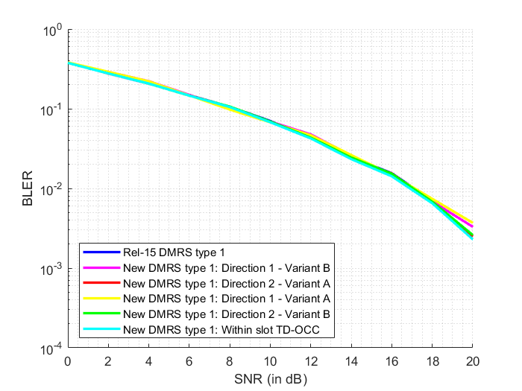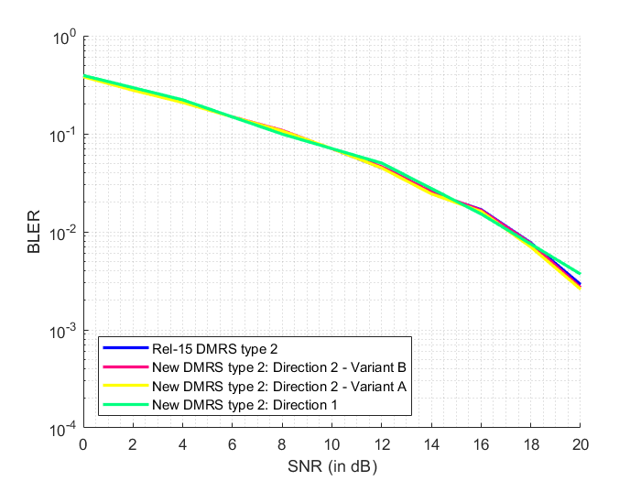

Figure 7. BLER versus SNR curves for DMRS types 1 and 2 considering all Directions in CDL-C channel with 30ns delay-spread and 30kmph UE speed

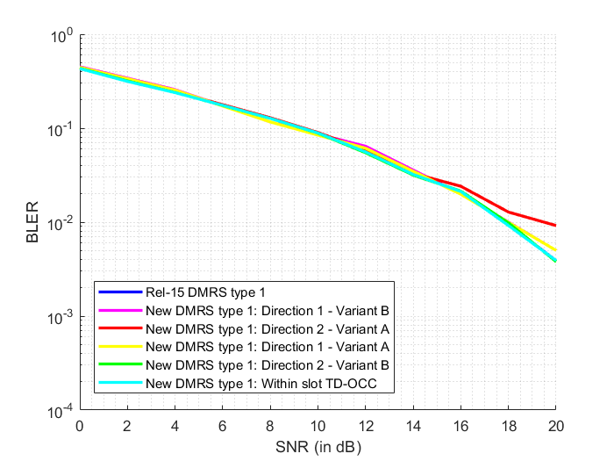 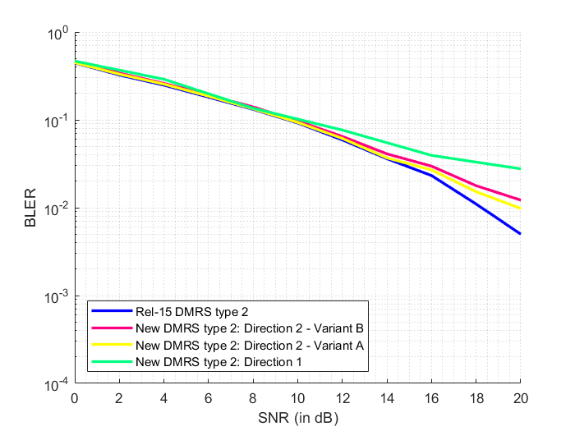

Figure 8. BLER versus SNR curves for DMRS types 1 and 2 considering all Directions in CDL-C channel with 300ns delay-spread and 3kmph UE speed

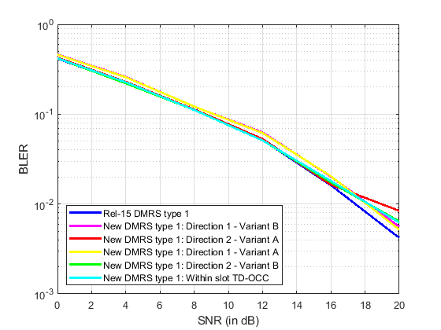

Figure 9. BLER versus SNR curves for DMRS types 1 and 2 considering all Directions in CDL-C channel with 300ns delay-spread and 30kmph UE speed

Figure 10. BLER versus SNR curves for DMRS type 1 considering all Directions in CDL-C channel with 300ns delay-spread and 120kmph UE speed

As we can see above, all the proposals perform similarly at low delay-spreads and low UE speeds (30ns DS, 3kmph). As the speed is increased to 30kmph and even 120kmph, New DMRS type 1 with within-slot TD-OCC starts performing poorly at high SNR. On the other hand, if we keep the UE speed low (3kmph) and delay-spread is increased (300ns) instead, the type 1: Direction 2 – Variant A scheme starts performing poorly, due to FD-OCC length of 6. The considered type 2 proposals also perform poorly due to larger OCC length and higher inter-RE distance between the DMRS REs.

## Fraunhofer IIS/HHI [18]

|  |  |
| --- | --- |
| C:\Users\vns\Documents\MATLAB\5g-nr-simulator\dmrs_MUMIMO_scripts\Fig1.png | C:\Users\vns\Documents\MATLAB\5g-nr-simulator\dmrs_MUMIMO_scripts\Fig2.png |
| **Figure 3:** BLER vs SNR for 4 co-scheduled MU-MIMO users with 4 ports per UE | **Figure 4:** BLER vs SNR for 4 co-scheduled MU-MIMO users with 4 ports per UE |

|  |  |
| --- | --- |
| C:\Users\vns\Documents\MATLAB\5g-nr-simulator\dmrs_MUMIMO_scripts\Fig3.png | C:\Users\vns\Documents\MATLAB\5g-nr-simulator\dmrs_MUMIMO_scripts\Fig4.png |
| **Figure 5:** BLER vs SNR for 2 co-scheduled MU-MIMO users with 2 ports per UE | **Figure 6:** BLER vs SNR for 2 co-scheduled MU-MIMO users with 2 ports per UE |

|  |  |
| --- | --- |
| C:\Users\vns\Documents\MATLAB\5g-nr-simulator\dmrs_MUMIMO_scripts\Fig5.png | C:\Users\vns\Documents\MATLAB\5g-nr-simulator\dmrs_MUMIMO_scripts\Fig6.png |
| **Figure 7:** BLER vs SNR for 4 co-scheduled MU-MIMO users with 1 port per UE | **Figure 8:** BLER vs SNR for 4 co-scheduled MU-MIMO users with 1 port per UE |

|  |
| --- |
| C:\Users\vns\Documents\MATLAB\5g-nr-simulator\dmrs_MUMIMO_scripts\Fig_TP.png |
| **Figure 9:** Mean user throughput versus SNR with adaptive MCS and rank. Maximum of 4 layers per UE, 2 front-load symbols and 0 DMRS additional positions. |

***Observation 6: With FDM, the drop in channel estimation quality reflects in 1.5-2 dB loss in terms of the throughput even with low delay spread and pedestrian UE velocity.***

## MediaTek [19]

|  |  |  |
| --- | --- | --- |
| (CDL-A) | **Delay spread = 30 ns** | **Delay Spread = 300 ns** |
| **MCS2** |  |  |
| **MCS 8** |  |  |

We also analyzied the performance in terms of NMSE. This is depicted in the Table below (CDL-A):

|  |  |
| --- | --- |
|  |  |

Nonetheless, FDM can still show a slightly better performance in terms of channel estimation when the interference power is high. While this is not clear in CDL-A, it is more obvious in CDL-B and CDL-C channels models as seen below.

|  |  |  |
| --- | --- | --- |
|  | Interference power offset = 0 dB | Interference power offset = -9 dB |
| CDL-B |  |  |
| CDL-C |  |  |

|  |  |
| --- | --- |
|  | Interference power offset = 0 dB |
| CDL-B  MCS = 2 |  |
| CDL-C  MCS = 2 |  |

The above figures show a slight advantage for FD-OCC in terms of BLER for MCS 2 and 8. For MCS 15, the interefrence power is too high and it will not be selected in this case, thus we skip it.

For completeness, we also show that for MCS = 15 and CDL-C, both FD-OCC and FDM exibit almost identical performance.

***Observation 6:* FD-OCC has a clear better NMSE performance, and a better BLER performance, compared to FDM based DMRS enhancement.**

***Observation 7:* In edge cases, FDM can show better performance at very high interefrence power.**

## Ericsson [21]

Rank 1 without interference

1. For Option1 alternatives: FD-OCC length 6 shows worse performance than length 4 for CDL-B with 300ns delay spread.
2. Option1 FD-OCC length 4 and Option3 ´comb4´ show similar performance for different delay spreads.

Figure : throughput comparison with one additional DMRS symbols

1. Option5 methods provide better performance than Option1 for CDL-B with 300ns delay spread and UE-speed 3km/h while the same performance as for Option 1 is achieved for CDL-B with 30ns delay spread and UE speed 3km/h or 30km/h .

## Qualcomm [22]

**Fig 2:** **Option 2 (TD-OCC) suffers performance loss at low Doppler (3km/h)**

**Fig 3:** **Option 2 (TD-OCC) suffers performance loss at medium Doppler (30km/h)**

****

**Fig 4:** **Option 2 (TD-OCC) performs worse than option 1/3(FD-OCC/FDM) with FTL residual error**

**Observation 2:** **Option 2 for DMRS enhancement performs worse than option 1/3 in all Doppler range including low, medium, and high Doppler.**

**Observation 3:** **Option 2 for DMRS enhancement performance is sensitive to FTL residual error.**

## Nokia/NSB [25]

Table 1. the summary of the considered options for DMRS patterns.

|  |  |  |  |  |
| --- | --- | --- | --- | --- |
| Patterns | # of CDM groups | FD-OCC level | Re-mapping pattern | Maximum number of ports (double symbol) |
| 1-A | 4 | FD-OCC2 | Type 1 | 16 |
| 1-B | 6 | FD-OCC2 | Type 1 | 24 |
| 1-C | 6 | FD-OCC2 | Type 2 | 24 |
| 2-A | 2 | FD-OCC6 | Type 1 | 24 |
| 2-B | 3 | FD-OCC4 | Type 2 | 24 |
| 3-A | 3 | FD-OCC4 | New, extended Type 1 | 24 |
| 3-B | 2 | FD-OCC6 | New, extended Type 2 | 24 |
| 3-C | 3 | FD-OCC4 | New, extended Type 2 | 24 |
| 3-D | 2 | FD-OCC6 | New, extended Type 2 | 24 |
| 3-E | 1 | FD-OCC12 | New, extended Type 2 | 24 |

Figure 6 MU-MIMO PDSCH throughput performance comparison with rank=2 between legacy types (1-2) and Rel-18 DMRS patterns, w/ OCC.

***Observation 14:*** *For Rank-2 with short delay and MU-MIMO channel, Rel-18 DMRS option G provides the best PDSCH throughput performances at 70%-tile. Patterns applying FD-OCC6 (Patterns 2-A, 3-B/D) show relatively good performance, when compared to Legacy Type-1 option.*

***Observation 15:*** *For MU-MIMO the gain is not visible, only one-third of available DMRS ports are used with two users and rank-2.*

# References

|  |  |  |  |
| --- | --- | --- | --- |
| [1] | [**R1-2205749**](https://www.3gpp.org/ftp/TSG_RAN/WG1_RL1/TSGR1_110/Docs/R1-2205749.zip) | On increasing the number of orthogonal DM-RS ports for MU-MIMO | FUTUREWEI |
| [2] | [**R1-2205819**](https://www.3gpp.org/ftp/TSG_RAN/WG1_RL1/TSGR1_110/Docs/R1-2205819.zip) | Enhanced Capacity DMRS | InterDigital, Inc. |
| [3] | [**R1-2205882**](https://www.3gpp.org/ftp/TSG_RAN/WG1_RL1/TSGR1_110/Docs/R1-2205882.zip) | Enhancements on DMRS in Rel-18 | Huawei, HiSilicon |
| [4] | [**R1-2205921**](https://www.3gpp.org/ftp/TSG_RAN/WG1_RL1/TSGR1_110/Docs/R1-2205921.zip) | DMRS enhancement for UL/DL MU-MIMO and 8 Tx UL SU-MIMO | ZTE |
| [5] | [**R1-2205984**](https://www.3gpp.org/ftp/TSG_RAN/WG1_RL1/TSGR1_110/Docs/R1-2205984.zip) | Discussion on increased number of orthogonal DMRS ports | Spreadtrum Communications |
| [6] | [**R1-2206027**](https://www.3gpp.org/ftp/TSG_RAN/WG1_RL1/TSGR1_110/Docs/R1-2206027.zip) | Discussion on DMRS enhancements | vivo |
| [7] | [**R1-2206106**](https://www.3gpp.org/ftp/TSG_RAN/WG1_RL1/TSGR1_110/Docs/R1-2206106.zip) | Discussions on increased number of orthogonal DMRS ports | New H3C Technologies Co., Ltd. |
| [8] | [**R1-2206190**](https://www.3gpp.org/ftp/TSG_RAN/WG1_RL1/TSGR1_110/Docs/R1-2206190.zip) | On DMRS Enhancement | Google |
| [9] | [**R1-2206212**](https://www.3gpp.org/ftp/TSG_RAN/WG1_RL1/TSGR1_110/Docs/R1-2206212.zip) | Discussion of increased number of orthogonal DMRS ports | Lenovo |
| [10] | [**R1-2206266**](https://www.3gpp.org/ftp/TSG_RAN/WG1_RL1/TSGR1_110/Docs/R1-2206266.zip) | DMRS enhancement for Rel-18 MIMO | OPPO |
| [11] | [**R1-2206378**](https://www.3gpp.org/ftp/TSG_RAN/WG1_RL1/TSGR1_110/Docs/R1-2206378.zip) | On DMRS enhancements | CATT |
| [12] | [**R1-2206460**](https://www.3gpp.org/ftp/TSG_RAN/WG1_RL1/TSGR1_110/Docs/R1-2206460.zip) | Discussion on increased number of orthogonal DMRS ports | NEC |
| [13] | [**R1-2206573**](https://www.3gpp.org/ftp/TSG_RAN/WG1_RL1/TSGR1_110/Docs/R1-2206573.zip) | Discussion on DMRS enhancement | Intel Corporation |
| [14] | [**R1-2206623**](https://www.3gpp.org/ftp/TSG_RAN/WG1_RL1/TSGR1_110/Docs/R1-2206623.zip) | Discussion on DMRS enhancement | Xiaomi |
| [15] | [**R1-2206815**](https://www.3gpp.org/ftp/TSG_RAN/WG1_RL1/TSGR1_110/Docs/R1-2206815.zip) | Views on DMRS enhancements | Samsung |
| [16] | [**R1-2206869**](https://www.3gpp.org/ftp/TSG_RAN/WG1_RL1/TSGR1_110/Docs/R1-2206869.zip) | Increased number of orthogonal DMRS ports | LG Electronics |
| [17] | [**R1-2206897**](https://www.3gpp.org/ftp/TSG_RAN/WG1_RL1/TSGR1_110/Docs/R1-2206897.zip) | Discussion on increased number of orthogonal DMRS ports | CMCC |
| [18] | [**R1-2206966**](https://www.3gpp.org/ftp/TSG_RAN/WG1_RL1/TSGR1_110/Docs/R1-2206966.zip) | Increased number of orthogonal DMRS ports | Fraunhofer IIS, Fraunhofer HHI |
| [19] | [**R1-2206993**](https://www.3gpp.org/ftp/TSG_RAN/WG1_RL1/TSGR1_110/Docs/R1-2206993.zip) | Increased number of orthogonal DMRS ports | MediaTek Inc. |
| [21] | [**R1-2207135**](https://www.3gpp.org/ftp/TSG_RAN/WG1_RL1/TSGR1_110/Docs/R1-2207135.zip) | On DMRS enhancement in Rel-18 | Ericsson |
| [22] | [**R1-2207218**](https://www.3gpp.org/ftp/TSG_RAN/WG1_RL1/TSGR1_110/Docs/R1-2207218.zip) | Design for increased number of orthogonal DMRS ports | Qualcomm Incorporated |
| [23] | [**R1-2207323**](https://www.3gpp.org/ftp/TSG_RAN/WG1_RL1/TSGR1_110/Docs/R1-2207323.zip) | Views on supporting increased number of orthogonal DMRS ports | Apple |
| [24] | [**R1-2207396**](https://www.3gpp.org/ftp/TSG_RAN/WG1_RL1/TSGR1_110/Docs/R1-2207396.zip) | Discussion on DMRS enhancements | NTT DOCOMO, INC. |
| [24] | [**R1-2207453**](https://www.3gpp.org/ftp/TSG_RAN/WG1_RL1/TSGR1_110/Docs/R1-2207453.zip) | Increased number of orthogonal DMRS ports | Sharp |
| [25] | [**R1-2207547**](https://www.3gpp.org/ftp/TSG_RAN/WG1_RL1/TSGR1_110/Docs/R1-2207547.zip) | Rel-18 UL and DL DMRS Enhancements | Nokia, Nokia Shanghai Bell |