**3GPP TSG RAN WG1 Meeting #110 R1-2207715**

**Toulouse, France, August 22nd – 26th, 2022**

**Source: Moderator (NTT DOCOMO)**

**Title: FL summary on DMRS#1**

**Agenda item: 9.1.3.1**

**Document for: Discussion and Decision**

# Introduction

In RAN#94-e meeting, a new Rel-18 WID on MIMO [1] was agreed. From 7 objectives, there are two objectives for DMRS enhancements, as shown below.

|  |
| --- |
| 1. Study, and if justified, specify larger number of orthogonal DMRS ports for downlink and uplink MU-MIMO (without increasing the DM-RS overhead), only for CP-OFDM,  * Striving for a common design between DL and UL DMRS * Up to 24 orthogonal DM-RS ports, where for each applicable DMRS type, the maximum number of orthogonal ports is doubled for both single- and double-symbol DMRS   […]   1. Study, and if justified, specify UL DMRS, SRS, SRI, and TPMI (including codebook) enhancements to enable 8 Tx UL operation to support 4 and more layers per UE in UL targeting CPE/FWA/vehicle/Industrial devices  * Note: Potential restrictions on the scope of this objective (including coherence assumption, full/non-full power modes) will be identified as part of the study. |

For objective#3 (increased DMRS ports), in RAN1#109-e meeting, the following agreement was made. From FL perspective, the highest priority in RAN1#110 is to down select from the agreed 5 options.

|  |
| --- |
| Agreement   * To increase the number of DMRS ports for PDSCH/PUSCH, evaluate and, if needed, specify one or more from the following options:   + Opt.1 (enhance FD-OCC): Introduce larger FD-OCC length than Rel.15 (e.g. 4 or 6).     - Study aspect includes potential performance degradation in large delay spread, potential scheduling restriction, backward compatibility.   + Opt.2 (enhance TD-OCC): Utilize TD-OCC over non-contiguous DMRS symbols (e.g. TD-OCC across front/additional DMRS symbols)     - Study aspect includes potential performance degradation in high UE velocity, potential scheduling restriction (e.g. how to apply freq. hopping), potential DMRS configuration restriction (e.g. restriction of the number of additional DMRS), backward compatibility.   + Opt.3 (Sparser frequency allocation): increase the number of CDM groups (e.g. larger number of comb/FDM).     - Study aspect includes potential performance degradation in large delay spread, backward compatibility.   + Opt.4 (using TDMed DMRS symbol): reusing additional DMRS symbols to increase orthogonal DMRS ports     - Study aspect includes potential performance degradation in high UE velocity, potential DMRS configuration restriction (e.g. restriction of the number of additional DMRS), backward compatibility.   + Opt.5 TD-OCC over non-contiguous DMRS symbols combined with FD-OCC or FDM: reusing additional DMRS symbol(s) to improve channel estimation performance.     - Study aspect includes potential performance degradation in high UE velocity, potential scheduling restriction (e.g. how to apply freq. hopping), potential DMRS configuration restriction (e.g. restriction of the number of additional DMRS), backward compatibility.   + The same option can be applied to both single symbol DMRS and double symbol DMRS. |

This document contains summary of the company’s proposal and FL proposals.

# Summary of evaluation results for objective#3

Multiple companies (FUTUREWEI, Huawei/HiSilicon, ZTE, vivo, Lenovo, OPPO, CATT, Xiaomi, Samsung, Fraunhofer IIS/HHI MediaTek , Ericsson, Qualcomm, Nokia) show evaluation results to compare between the 5 options. In this section, evaluation results are summarized. For the details, please review the companies’ tdocs. For discussion in RAN1#110, please go to sect. 3 and 4.

## FUTUREWEI [1]

Figure 1 CDL-C,16QAM, CR=0.5, [90o 6o]

Since the delay spread is 30ns, hence flat channel, opt.1 outperforms legacy DMRS due to its longer OCC length. Opt.3 perform worse that legacy DMRS due to its sparser DMRS density.

## Huawei/HiSilicon [3]

**Table 3. Performance gains achieved by Opt.1 and Opt.3 compared to Scheme A**

|  |  |  |  |  |
| --- | --- | --- | --- | --- |
| Throughout gain v.s. Scheme A | Type 1, DS=30ns | Type 1, DS=300ns | Type 2, DS=30ns | Type 2, DS=300ns |
| Scheme B | 104.3% | 105.7% | 105.5% | 105.2% |
| Scheme C | 104.3% | 106.3% | 105.5% | 106.5% |

***Observation 6: For DL MU-MIMO with 2-symbol DMRS, Opt.1 (based on length-4 FD-OCC) has similar performance under DS=30ns and better performance under DS=300ns compared with Opt.3.***

1. **Non-orthogonal DMRS ports**
2. **Opt.1: Enhance FD-OCC**
3. **Opt.3: Sparser frequency allocation**
4. **Double symbol front-loaded Rel.15 DMRS ports (only used to compare the performance of single-symbol DMRS port enhancements)**
5. **Table 4. Performance gains compared to Scheme D for 1-symbol DMRS**

|  |  |  |
| --- | --- | --- |
| Throughout gain v.s. Scheme D | Type 1 | Type 2 |
| Scheme A | 105.2% | 105.2% |
| Scheme B | 111.1% | 110.7% |
| Scheme C | 111.1% | 112.6% |

***Observation 7: For DL MU-MIMO with 1-symbol DMRS, Opt.1 (based on length-4 FD-OCC) has better performance under DS=300ns compared with Opt.3.***

***Observation 8: Thanks to overhead reduction, 1-symbol Rel.18 DMRS can obtain about 5% ~13% performance gain compared to 2-symbol front-loaded Rel.15 DMRS.***

## ZTE [4]

**Figure 2** LLS simulation results with (a) UE speed 3km/h and delay spread 30ns, (b) UE speed 3km/h and delay spread 300ns, and (c) UE speed 60km/h and delay spread 30ns

***Observation 4:*** *In order to accommodate different MU-MIMO scenarios, TD-OCC performs better BLER performance over FDM and FD-OCC in the scenario of low-speed and high-delay-spread. However, there is severe performance degradation for TD-OCC when compared with FDM and FD-OCC in the scenario of high-speed and low-delay.*

## vivo [6]

**2 UEs co-scheduled in MU-MIMO**

|  |  |
| --- | --- |
| a) 16QAM, DS=30 | b) 16QAM, DS=300 |
| c) 64QAM, DS=30 | d) 64QAM, DS=300 |

1. The BLER performance of R18 DMRS type 1 in MU-MIMO with 2 UEs
2. For DMRS type 1 enhancement, the performance degradation of FD-OCC=4 is acceptable, compared with FD-OCC=2.
3. For DMRS type 1 enhancement, FD-OCC=4 with two channel estimations in each RB has a similar performance to FD-OCC=4 with 2RB as scheduling granularity in the case of large delay spread.

**4 UEs co-scheduled in MU-MIMO**

|  |  |
| --- | --- |
| a) 16QAM, DS=30 | b) 16QAM, DS=300 |

1. The BLER performance of R18 DMRS type 1 in MU-MIMO with 4 UEs
2. For DMRS type 1 enhancement, FD-OCC=4 outperforms FD-OCC=6 and FDM schemes in the case of large delay spread.

## Lenovo [9]

(a) (b)

(c) (d)

(e) (f)

Fig.3 BLER comparison of enhanced DMRS pattern with FD-OCC4, FD-OCC6 and FDM

Fig.4 MSE comparison of FD-OCC4, FD-OCC6 and FDM

***Observation 1：The performances of MSE and BLER are similar for small channel frequency selectivity and the performance gap between enhanced DMRS and R15 DMRS is larger for the channel with large frequency selectivity.***

***Observation 2：At low SNR ranges the performance of MSE and BLER of enhanced FDM-OCC DMRS with OCC length 4 are best; in high SNR range, the performances of enhanced FDM DMRS are best.***

## OPPO [10]

 

Fig.4: DMRS enhancement without additional DMRS for legacy DMRS/FDM/CDM for type 1 DMRS



Fig.5: DMRS enhancement without additional DMRS for legacy DMRS/FDM/CDM for type 2 DMRS

 

Fig.6: DMRS enhancement with additional DMRS for type 1 DMRS

 

Fig.7: DMRS enhancement with additional DMRS for type 2 DMRS

***Observation 2: TDM/TD-OCC cannot provide significant performance gain over FDM/CDM even with large delay spread.***

***Observation 3: FDM outperforms CDM at high SNR with large delay spread.***

## CATT [11]

Figure 5: Comparison of option 1 and option 3 under 30ns delay spread

**Observation 1: When pre-coding assumption of interference of co-scheduled UEs is modelled according to Alt.2 and 2 layers are scheduled for each user, option 1 (enhance FD-OCC) achieves better performance than option 3 (sparser frequency allocation).**

## グラフ 自動的に生成された説明グラフ, 折れ線グラフ 自動的に生成された説明グラフ, 折れ線グラフ 自動的に生成された説明グラフ 自動的に生成された説明Xiaomi [14]

Fig.3 BLER comparison among all candidate DMRS type and R15 DMRS Type considering different UE speed (speed=3km/h and 120km/h)

***Observation 1: There is much performance degradation in high UE velocity for the enhanced DMRS pattern corresponding to option 2 and option 4.***

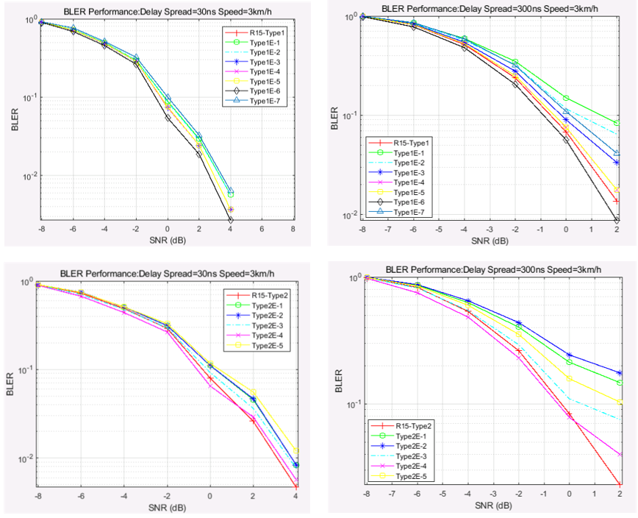

Fig.4 BLER comparison among all candidate DMRS type and R15 DMRS Type considering different channel delay spread. (delay spread=30ns and 300ns)

***Observation 2: There is much channel estimation performance loss in the case of large delay spread for the enhanced DMRS patterns related to option 3.***

***Observation 3: The enhanced DMRS types corresponding to option1*** ***have less performance loss for*** ***both high UE velocity and large channel delay spread.***

## Samsung [15]

Direction 1) Increase the number of CDM groups

Direction 2) Increase the number of DMRS ports within CDM group

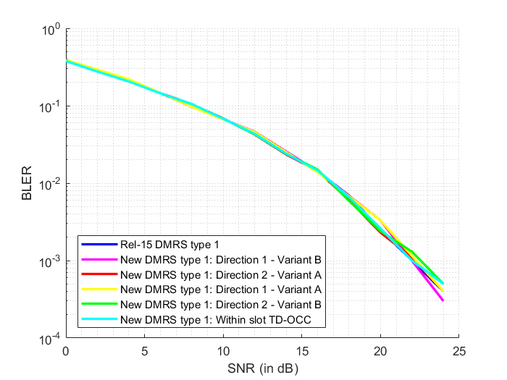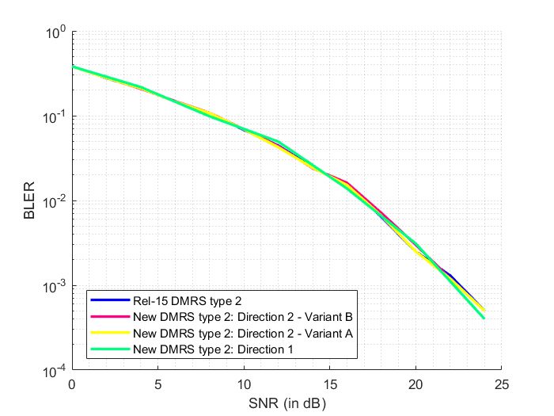

Figure 6. BLER versus SNR curves for DMRS types 1 and 2 considering all Directions in CDL-C channel with 30ns delay-spread and 3kmph UE speed

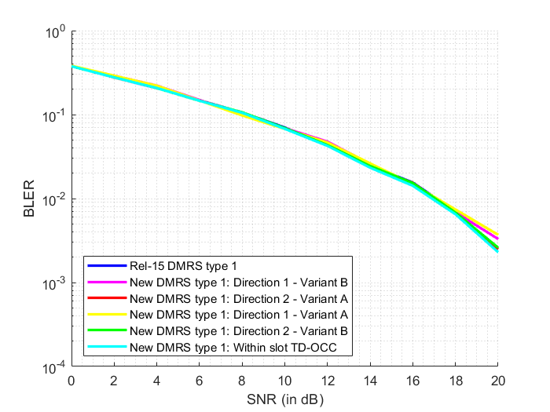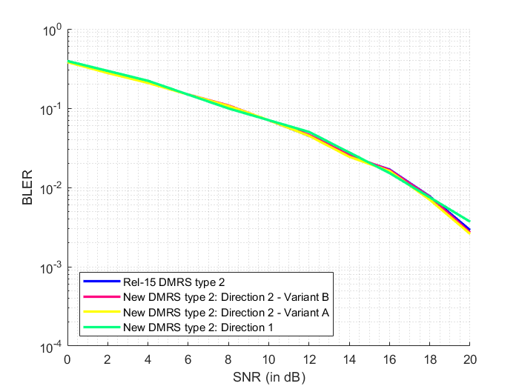

Figure 7. BLER versus SNR curves for DMRS types 1 and 2 considering all Directions in CDL-C channel with 30ns delay-spread and 30kmph UE speed

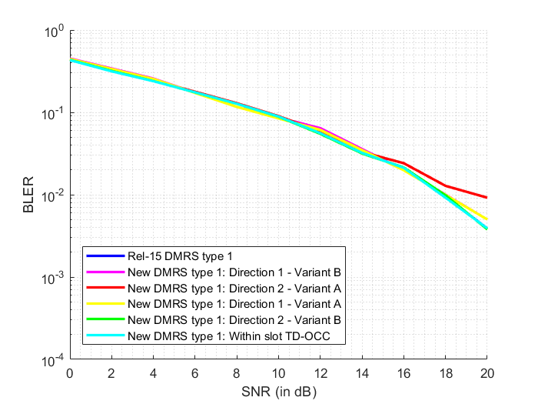 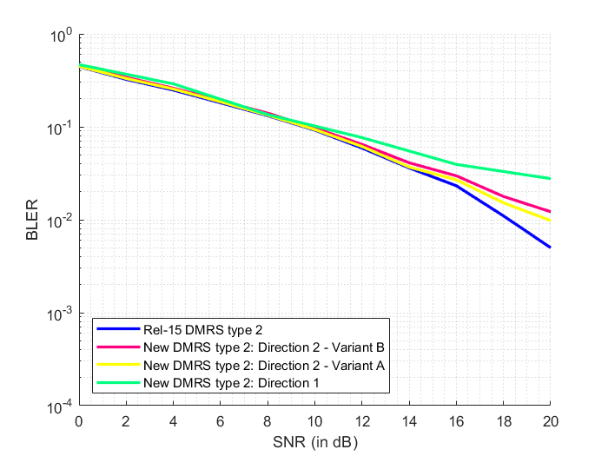

Figure 8. BLER versus SNR curves for DMRS types 1 and 2 considering all Directions in CDL-C channel with 300ns delay-spread and 3kmph UE speed

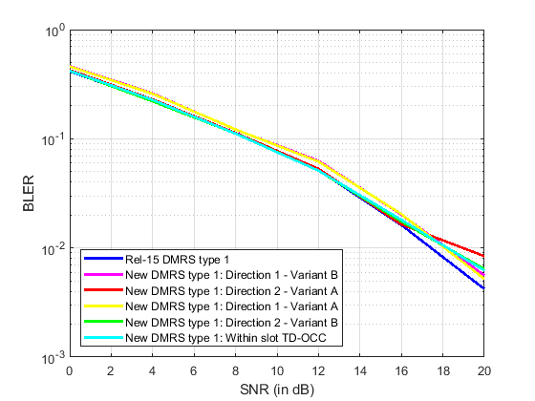

Figure 9. BLER versus SNR curves for DMRS types 1 and 2 considering all Directions in CDL-C channel with 300ns delay-spread and 30kmph UE speed

Figure 10. BLER versus SNR curves for DMRS type 1 considering all Directions in CDL-C channel with 300ns delay-spread and 120kmph UE speed

As we can see above, all the proposals perform similarly at low delay-spreads and low UE speeds (30ns DS, 3kmph). As the speed is increased to 30kmph and even 120kmph, New DMRS type 1 with within-slot TD-OCC starts performing poorly at high SNR. On the other hand, if we keep the UE speed low (3kmph) and delay-spread is increased (300ns) instead, the type 1: Direction 2 – Variant A scheme starts performing poorly, due to FD-OCC length of 6. The considered type 2 proposals also perform poorly due to larger OCC length and higher inter-RE distance between the DMRS REs.

## Fraunhofer IIS/HHI [18]

|  |  |
| --- | --- |
| C:\Users\vns\Documents\MATLAB\5g-nr-simulator\dmrs_MUMIMO_scripts\Fig1.png | C:\Users\vns\Documents\MATLAB\5g-nr-simulator\dmrs_MUMIMO_scripts\Fig2.png |
| **Figure 3:** BLER vs SNR for 4 co-scheduled MU-MIMO users with 4 ports per UE | **Figure 4:** BLER vs SNR for 4 co-scheduled MU-MIMO users with 4 ports per UE |

|  |  |
| --- | --- |
| C:\Users\vns\Documents\MATLAB\5g-nr-simulator\dmrs_MUMIMO_scripts\Fig3.png | C:\Users\vns\Documents\MATLAB\5g-nr-simulator\dmrs_MUMIMO_scripts\Fig4.png |
| **Figure 5:** BLER vs SNR for 2 co-scheduled MU-MIMO users with 2 ports per UE | **Figure 6:** BLER vs SNR for 2 co-scheduled MU-MIMO users with 2 ports per UE |

|  |  |
| --- | --- |
| C:\Users\vns\Documents\MATLAB\5g-nr-simulator\dmrs_MUMIMO_scripts\Fig5.png | C:\Users\vns\Documents\MATLAB\5g-nr-simulator\dmrs_MUMIMO_scripts\Fig6.png |
| **Figure 7:** BLER vs SNR for 4 co-scheduled MU-MIMO users with 1 port per UE | **Figure 8:** BLER vs SNR for 4 co-scheduled MU-MIMO users with 1 port per UE |

|  |
| --- |
| C:\Users\vns\Documents\MATLAB\5g-nr-simulator\dmrs_MUMIMO_scripts\Fig_TP.png |
| **Figure 9:** Mean user throughput versus SNR with adaptive MCS and rank. Maximum of 4 layers per UE, 2 front-load symbols and 0 DMRS additional positions. |

***Observation 6: With FDM, the drop in channel estimation quality reflects in 1.5-2 dB loss in terms of the throughput even with low delay spread and pedestrian UE velocity.***

## MediaTek [19]

|  |  |  |
| --- | --- | --- |
| (CDL-A) | **Delay spread = 30 ns** | **Delay Spread = 300 ns** |
| **MCS2** |  |  |
| **MCS 8** |  |  |

We also analyzied the performance in terms of NMSE. This is depicted in the Table below (CDL-A):

|  |  |
| --- | --- |
|  |  |

Nonetheless, FDM can still show a slightly better performance in terms of channel estimation when the interference power is high. While this is not clear in CDL-A, it is more obvious in CDL-B and CDL-C channels models as seen below.

|  |  |  |
| --- | --- | --- |
|  | Interference power offset = 0 dB | Interference power offset = -9 dB |
| CDL-B |  |  |
| CDL-C |  |  |

|  |  |
| --- | --- |
|  | Interference power offset = 0 dB |
| CDL-B  MCS = 2 |  |
| CDL-C  MCS = 2 |  |

The above figures show a slight advantage for FD-OCC in terms of BLER for MCS 2 and 8. For MCS 15, the interefrence power is too high and it will not be selected in this case, thus we skip it.

For completeness, we also show that for MCS = 15 and CDL-C, both FD-OCC and FDM exibit almost identical performance.

***Observation 6:* FD-OCC has a clear better NMSE performance, and a better BLER performance, compared to FDM based DMRS enhancement.**

***Observation 7:* In edge cases, FDM can show better performance at very high interefrence power.**

## Ericsson [21]

Rank 1 without interference

1. For Option1 alternatives: FD-OCC length 6 shows worse performance than length 4 for CDL-B with 300ns delay spread.
2. Option1 FD-OCC length 4 and Option3 ´comb4´ show similar performance for different delay spreads.

Figure 15: throughput comparison with one additional DMRS symbols

1. Option5 methods provide better performance than Option1 for CDL-B with 300ns delay spread and UE-speed 3km/h while the same performance as for Option 1 is achieved for CDL-B with 30ns delay spread and UE speed 3km/h or 30km/h .

## Qualcomm [22]

**Fig 2:** **Option 2 (TD-OCC) suffers performance loss at low Doppler (3km/h)**

**Fig 3:** **Option 2 (TD-OCC) suffers performance loss at medium Doppler (30km/h)**

****

**Fig 4:** **Option 2 (TD-OCC) performs worse than option 1/3(FD-OCC/FDM) with FTL residual error**

**Observation 2:** **Option 2 for DMRS enhancement performs worse than option 1/3 in all Doppler range including low, medium, and high Doppler.**

**Observation 3:** **Option 2 for DMRS enhancement performance is sensitive to FTL residual error.**

## Nokia/NSB [25]

Table 1. the summary of the considered options for DMRS patterns.

|  |  |  |  |  |
| --- | --- | --- | --- | --- |
| Patterns | # of CDM groups | FD-OCC level | Re-mapping pattern | Maximum number of ports (double symbol) |
| 1-A | 4 | FD-OCC2 | Type 1 | 16 |
| 1-B | 6 | FD-OCC2 | Type 1 | 24 |
| 1-C | 6 | FD-OCC2 | Type 2 | 24 |
| 2-A | 2 | FD-OCC6 | Type 1 | 24 |
| 2-B | 3 | FD-OCC4 | Type 2 | 24 |
| 3-A | 3 | FD-OCC4 | New, extended Type 1 | 24 |
| 3-B | 2 | FD-OCC6 | New, extended Type 2 | 24 |
| 3-C | 3 | FD-OCC4 | New, extended Type 2 | 24 |
| 3-D | 2 | FD-OCC6 | New, extended Type 2 | 24 |
| 3-E | 1 | FD-OCC12 | New, extended Type 2 | 24 |

Figure 6 MU-MIMO PDSCH throughput performance comparison with rank=2 between legacy types (1-2) and Rel-18 DMRS patterns, w/ OCC.

***Observation 14:*** *For Rank-2 with short delay and MU-MIMO channel, Rel-18 DMRS option G provides the best PDSCH throughput performances at 70%-tile. Patterns applying FD-OCC6 (Patterns 2-A, 3-B/D) show relatively good performance, when compared to Legacy Type-1 option.*

***Observation 15:*** *For MU-MIMO the gain is not visible, only one-third of available DMRS ports are used with two users and rank-2.*

## Comments for evaluation results

If you’d like to add observation for the evaluation results, please provide it in the following (if any).

|  |  |
| --- | --- |
| **Company** | **Comment** |
|  |  |
|  |  |
|  |  |
|  |  |

# Objective #3 (increasing DMRS ports)

## Down-selection of 5 options

Based on reviewing companies’ tdocs, Pros. and Cons. of each option are summarized in the following table.

Table 3.1-1: Companies views on the 5 options.

|  |  |  |  |
| --- | --- | --- | --- |
|  | **Pros.** | **Cons.** | **Support/Concern** |
| **Opt.1 (FD-OCC)** | * HW: Good Backward compatibility. * Small spec. impact. * No performance degradation in high UE velocity | * ZTE: Performance degradation in large delay spread. * LGE: Not possible to multiplex with legacy UE in the same CDM group. | **Support/Fine (21):**  Huawei/HiSilicon (length 4), ZTE (length 4), Spreadtrum, vivo (length 4), New H3C Technolog, Google (length 4), Lenovo (length 4), OPPO (length 4), CATT (length 4), NEC, Intel (length 6 for type 1, length 4 for type 2), Xiaomi, , Samsung, CMCC, Fraunhofer IIS/HHI, MediaTek (length 4), Qualcomm (length 4), Apple (2nd pref., length 4), DOCOMO (length 4) Sharp(length 4), Nokia  **Concern:** |
| **Opt.2 (TD-OCC)** | * No performance degradation in large delay spread. * LGE: MU-MIMO targets low mobility UEs. | * HW, DCM: Limitation on applicable scenarios (must be with additional DMRS symbols) * HW, DCM: Performance degradation in high UE velocity * HW: Affecting the capability of the Doppler or frequency shift estimation * Spreadtrum: Further enhancements needed due to frequency hopping * Xiaomi, Samsung, HW: The front-DMRS is specified to support faster demodulation of PDSCH/PUSCH. It causes additional latency for channel estimation. * LGE: Not possible to multiplex with legacy UE in the same CDM group * Nokia: Confliction with WID restriction of “without increasing DM-RS overhead” | **Support/Fine (3):**  InterDigital, ZTE, DOCOMO (in addition to Opt.1)  **Concern:**  Xiaomi, Ericsson |
| **Opt.3 (FDM)** | * No performance degradation in high UE velocity. | * + HW, Sharp: Compatibility between Rel.15 and Rel.18 DMRS ports   + HW, ZTE: Power boosting design   + HW: Low PAPR DMRS sequence design   + HW PXSCH rate matching design   + ZTE: More interference   + Performance degradation in large delay spread.   + Sharp: Channel estimation accuracy is degraded | **Support/Fine (10):**  FUTUREWEI, Spreadtrum New H3C Technolog, Google, Lenovo, OPPO, CATT, Samsung, CMCC, Apple  **Concern:** |
| **Opt.4 (TDM)** | * No performance degradation in large delay spread. * LGE: MU-MIMO targets low mobility UEs. | * HW, DCM: Limitation on applicable scenarios (must be with additional DMRS symbols) * HW, DCM: Performance degradation in high UE velocity * HW: Affecting the capability of the Doppler or frequency shift estimation * Sharp, Samsung, Xiaomi: The front-DMRS is specified to support faster demodulation of PDSCH/PUSCH. It cause additional latency for channel estimation. * HW: Compatibility between Rel.15 and Rel.18 DMRS ports * ZTE: More impact on legacy DMRS estimation * MediaTek: PAPR will be too large (some OFDM symbols may have zero power) * Qualcomm: Not able to maintenance the phase continuity of PUSCH. * Nokia, ZTE, MediaTek: confliction with WID restriction of “without increasing DM-RS overhead” * Nokia: cause UL coverage problem. | **Support/Fine (3):**  InterDigital, New H3C Technolog, LGE  **Concern:**  Xiaomi, Ericsson |
| **Opt.5 (TD-OCC over FD OCC/FDM)** | * Ericsson: Better performance than Opt.1 with large delay spread (300ns). There is no performance loss. | * Limitation on applicable scenarios (must be with additional DMRS symbols) | **Support/Fine (1):**  Ericsson  **Concern:** |

Based on the above observations, several concerns are observed for Opt.2 (TD-OCC) and Opt.4 (TDM). Especially, concerns on Opt.4 are critical (e.g. PAPR is too large, not able to maintain the phase continuity, UL coverage problem). Hence, FL suggestion is to preclude Opt.4 firstly. Then, among other 4 options, Opt.1 and Opt.3 have more applicable scenarios (applicable with/without additional DMRS) than Opt.2/5, and better performance except for the large delay spread. Between Opt.1 and Opt.3, not significant performance difference is observed, and Opt.1 has the largest number of supporters. Hence, FL suggestion is to agree at least on Opt.1. On the other hand, based on the evaluation results, sometimes Opt.2/3/5 has better performance than Opt.1, and later discussion is not precluded to support Opt.2/3/5 additionally. Note that some companies (e.g. Samsung, Qualcomm, etc) believe single solution is enough to complete the WID, on the other hand, other some companies (e.g. ZTE, DOCOMO, etc) think multiple options can be considered. This can be discussed as part of FFS later.

**FL proposal#3.1:**

* **To increase the number of DMRS ports for PDSCH/PUSCH, support at least Opt.1 (introduce larger FD-OCC length than Rel.15 (e.g. 4 or 6)).**
  + **FFS: FD-OCC length for Rel.18 DMRS type 1 and type 2.**
  + **FFS: whether to support additional option(s) from Opt.2/3/5.**
  + **Opt.4 (TDMed DMRS symbol) is precluded.**

Please provide your views. If you prefer other option(s), please check the concerns for other options in the above table.

|  |  |
| --- | --- |
| **Company** | **Comment** |
|  |  |
|  |  |
|  |  |
|  |  |
|  |  |
|  |  |
|  |  |
|  |  |
|  |  |
|  |  |
|  |  |
|  |  |
|  |  |
|  |  |
|  |  |
|  |  |
|  |  |
|  |  |
|  |  |
|  |  |
|  |  |
|  |  |
|  |  |

## Details on Opt.1 (FD-OCC)

If Opt.1 (FD-OCC) is agreed, details of FD-OCC should be discussed.

### 3.2.1 FD-OCC length.

For the FD-OCC length, we can discuss the following options. Based on reviewing tdocs, for DMRS type 2, all companies assume length 4 FD-OCC in their tdocs. For DMRS type 1, Opt.1-2 is the majority view for DMRS type 1. For Opt.1-2, FD-OCC can be applied across different PRBs. How to handle the issue (orphan RE/RB) in Opt.1-2 can be discussed in sect. 3.2.2.

* + **For Rel.18 DMRS type 1:**
    - **Opt.1-1: length 6 is applied to 6 REs of DMRS within a PRB**
    - **Opt.1-2: length 4 is applied to nearby 4 REs of DMRS within a PRB or across consecutive PRBs**
  + **For Rel.18 DMRS type 2:**
    - **length 4 is applied to 4 REs of DMRS within a PRB**



Figure 2-1. Extension of FD-OCC for DMRS type 1 (CDM group 0) [24].



Figure 2-2. Extension of FD-OCC for DMRS type 2 (CDM group 0) [24].

For the details of FD-OCC code, following FD-OCC codes are proposed.

* **Length 4: Walsh matrix** (Fraunhofer, Qualcomm, DOCOMO, etc.):
$$W_{Hadamard}^{4}=\left[\begin{matrix}\begin{matrix}1 & 1 \\ 1 & -1\end{matrix} & \begin{matrix}1 & 1 \\ 1 & -1\end{matrix} \\ \begin{matrix}1 & 1 \\ 1 & -1\end{matrix} & \begin{matrix}-1 & -1 \\ -1 & 1\end{matrix}\end{matrix}\right]$$

* **Length 6: FFT-based sequence** (Fraunhofer, Intel):

$$W_{FFT}^{6}=\left[\begin{matrix}\begin{matrix}1 & 1 \\ 1 & e^{-jπ/3}\end{matrix} & \begin{matrix}1 & 1 \\ e^{-j2π/3} & -1\end{matrix} & \begin{matrix}1 & 1 \\ e^{j2π/3} & e^{jπ/3}\end{matrix} \\ \begin{matrix}1 & e^{-j2π/3} \\ 1 & -1\end{matrix} & \begin{matrix}e^{-j2π/3} & 1 \\ 1 & -1\end{matrix} & \begin{matrix}e^{j4π/3} & e^{j2π/3} \\ 1 & -1\end{matrix} \\ \begin{matrix}1 & e^{-j4π/3} \\ 1 & e^{-j5π/3}\end{matrix} & \begin{matrix}e^{-j8π/3} & 1 \\ e^{-j10π/3} & -1\end{matrix} & \begin{matrix}e^{j8π/3} & e^{j4π/3} \\ e^{j10π/3} & e^{j5π/3}\end{matrix}\end{matrix}\right]$$

Multiple companies show performance comparison between length 4 FD-OCC and length 6 FD-OCC in DMRS type 1. Based on the evaluation results, length 4 FD-OCC has better performance in large delay spread.

**Fig 12: Peak throughput (at 40dB SNIR) comparison between size 4 and size 6 FD-OCC [22]**

Based on reviewing tdocs, majority supports Opt.1-2:

|  |  |
| --- | --- |
| **Options** | **Support** |
| Opt.1-1 (length 6 FD-OCC) | Intel, Fraunhofer |
| Opt.1-2 (length 4 FD-OCC) | Huawei/HiSilicon, ZTE, vivo, Google, Lenovo, OPPO, CATT, MediaTek, Qualcomm, Apple, DOCOMO, Sharp |

Hence, FL proposal is to agree on Opt.1-2.

**FL proposal#3.2.1:**

* **If Opt.1 (enhanced FD-OCC) is supported, for enhanced FD-OCC length for DMRS of PDSCH/PUSCH, support the following FD-OCC length:**
  + **For Rel.18 DMRS type 1:**
    - **Opt.1-2: Length 4 FD-OCC is applied to nearby 4 REs of DMRS within a PRB or across consecutive PRBs**
  + **For Rel.18 DMRS type 2:**
    - **Length 4 FD-OCC is applied to 4 REs of DMRS within a PRB**

|  |  |
| --- | --- |
| **Company** | **Comment** |
|  |  |
|  |  |
|  |  |
|  |  |
|  |  |
|  |  |
|  |  |
|  |  |
|  |  |
|  |  |
|  |  |
|  |  |
|  |  |
|  |  |
|  |  |
|  |  |
|  |  |
|  |  |
|  |  |
|  |  |
|  |  |
|  |  |

### 3.2.2 How to handle orphan RE/RB in length 4 FD-OCC in DMRS type 1

Since length 4 FD-OCC can be applied across different PRBs, there is orphan RE/RB. How to deal with the orphan RE/RB should be discussed. Based on reviewing tdocs, following options are proposed.

* + **Alt.1: Scheduling restriction (i.e. gNB always schedules PDSCH/PUSCH with even number of PRBs): CATT, DOCOMO, MediaTek, etc.**
  + **Alt.2: No scheduling restriction (i.e. gNB can schedules PDSCH/PUSCH with any number of PRBs).**
    - **Length 4 FD-OCC can be decoded per a PRB at a receiver: vivo, Huawei**

Note that in figure of Alt.2-1 below, RE#4 and RE#6 are used twice for FD-OCC decoding on CE window 1 and 2.

Alt.1: Channel estimation across two RBs[6]  Alt.2-1: Two channel estimations based on FD-OCC=4 in one RB [6]

It is pointed out by Huawei that performance loss due to the orphan RE is not significant.

|  |
| --- |
|   **Figure 12. Example of orphan RB/REs of Type1 DMRS [3]**  For example, the scheduling bandwidth is 13 RBs, and the proportion of orphan REs is only 2.56%. Therefore, the overall performance loss caused by orphan REs is not significant. |

Two companies (vivo, Huawei) show the performance loss due to Alt.2 is small.

|  |
| --- |
| In vivo [6]    d) 64QAM, DS=300   1. For DMRS type 1 enhancement, FD-OCC=4 with two channel estimations in each RB has a similar performance to FD-OCC=4 with 2RB as scheduling granularity in the case of large delay spread. |

|  |
| --- |
| In Huawei [3]  **A. OCC decoding is performed three times in 2RBs based on length-4 FD-OCC.**  **B. Each RB performs decoding of the length-4 FD-OCC twice according to the method proposed above.**  **C. Non-orthogonal DMRS ports**  C:\Users\g00435124\AppData\Roaming\eSpace_Desktop\UserData\g00435124\imagefiles\107CD0FD-67DB-46E1-B121-6089E9A6370C.png  **Figure 13. NMSE performance of orphan RB/REs of Type1 DMRS**  ***Observation 10: Through appropriate channel estimation algorithm, orphan RB/REs only introduces negligible performance loss.*** |

**FL proposal#3.2.2:**

* **If Opt.1 (enhanced FD-OCC) is supported, for orphan RE/RB for Rel.18 DMRS type 1 with length 4 FD-OCC, down select from the following:**
  + **Alt.1: Scheduling restriction (i.e. gNB always schedules PDSCH/PUSCH with even number of PRBs).**
  + **Alt.2: No scheduling restriction (i.e. gNB can schedules PDSCH/PUSCH with any number of PRBs).**
    - **Length 4 FD-OCC can be decoded per a PRB at a receiver.**

|  |  |
| --- | --- |
| **Company** | **Comment** |
|  |  |
|  |  |
|  |  |
|  |  |
|  |  |
|  |  |
|  |  |
|  |  |
|  |  |
|  |  |
|  |  |
|  |  |
|  |  |
|  |  |
|  |  |
|  |  |
|  |  |
|  |  |
|  |  |
|  |  |
|  |  |
|  |  |

## Dynamic indication of Rel.15 DMRS ports and Rel.18 DMRS ports

Multiple companies (e.g. Spreadtrum, Lenovo, CATT, NEC, Samsung, Sharip, ZTE, Fraunhofer, DOCOMO, etc.) mentioned it is beneficial to support dynamic indication of Rel.15 DMRS ports and Rel.18 DMRS ports. One use-case is that gNB can dynamically indicate Rel.15 DMRS ports, if not large number of DMRS ports are required for the scheduled PDSCH/PUSCH. Another use-case is that gNB can find good MU-MIMO UE pairing if dynamic switching is supported.

FL suggestion is to discuss the following proposal. Note that Nokia and NEC mentioned that we should strive not to increase the size of DCI for the dynamic indication. This option is included in Alt.2, and whether to increase the size of the existing DCI field is a part of the study in next step.

**FL proposal#3.3:**

* **For increased DMRS ports, support DCI-based dynamic antenna ports indication between Rel.15 DMRS ports and Rel.18 DMRS ports, and down select from the following:**
  + **Alt.1: Introduce new DCI field for dynamic switching between Rel.15 DMRS ports and Rel.18 DMRS ports.**
  + **Alt.2: No new DCI field is introduced. Existing DCI field (e.g. antenna port indication field, or TDRA field) can be used for indication between Rel.15 DMRS ports and Rel.18 DMRS ports.**
    - **FFS: whether to increase the DCI size of the existing DCI field.**

|  |  |
| --- | --- |
| **Company** | **Comment** |
|  |  |
|  |  |
|  |  |
|  |  |
|  |  |
|  |  |
|  |  |
|  |  |
|  |  |
|  |  |
|  |  |
|  |  |
|  |  |
|  |  |
|  |  |
|  |  |
|  |  |
|  |  |
|  |  |
|  |  |
|  |  |
|  |  |

## MU-MIMO between Rel.15 DMRS ports and Rel.18 DMRS ports

Multiple companies (e.g. Spreadtrum, Lenovo, Xiaomi, DOCOMO, CMCC, Nokia, Ericsson, etc.) support MU-MIMO between Rel.15 DMRS ports and Rel.18 DMRS ports. For multiplexing with different CDM groups, it should be no problem to support MU-MIMO between Rel.15 DMRS ports and Rel.18 DMRS ports. For multiplexing within a CDM group, whether/how to multiplex R15 DMRS ports and Rel.18 DMRS ports depends on which option is selected.

**FL proposal#3.4:**

* **Support MU-MIMO between Rel.15 DMRS ports and Rel.18 DMRS ports.**
  + **For MU-MIMO by different CDM groups, no MU-MIMO scheduling restriction of PUSCH/PDSCH (i.e. MU-MIMO between Rel.15 UE and Rel.18 UE is allowed).**
  + **For MU-MIMO within a CDM group, study whether and how to support MU-MIMO between Rel.15 DMRS ports and Rel.18 DMRS ports for PUSCH/PDSCH.**
    - **Note: the study includes MU-MIMO between Rel.15 UE and Rel.18 UE, and between Rel.18 UEs.**

|  |  |
| --- | --- |
| **Company** | **Comment** |
|  |  |
|  |  |
|  |  |
|  |  |
|  |  |
|  |  |
|  |  |
|  |  |
|  |  |
|  |  |
|  |  |
|  |  |
|  |  |
|  |  |
|  |  |
|  |  |
|  |  |
|  |  |
|  |  |
|  |  |
|  |  |
|  |  |

## Other proposals

Following proposals are also proposed.

|  |  |
| --- | --- |
| **Proposals** | **Companies** |
| 1. **PTRS-DMRS association for Rel.18 DMRS ports** | Lenovo |
| 1. **Study how to support dynamic switching between different number of additional DMRS symbols in Rel-18** | Ericsson |
| 1. **If Opt.3 (FDM) is supported, study the following issues**  * **DMRS power boosting** * **DMRS sequence generation** * **Frequency domain subsampling at CDM group level or PRB level** | Lenovo, CATT, LGE, CMCC, Apple |
| 1. **Study on OCC disabling scheme for new DMRS type (Rel.17 feature in above 52.6GHz).** | Samsung |

Please provide your views on the above proposals, or other aspects which are not included in the summary, if any.

|  |  |
| --- | --- |
| **Company** | **Comment** |
|  |  |
|  |  |
|  |  |
|  |  |

# Specifying objective #5 (>4 layers PUSCH DMRS)

Based on reviewing the companies’ tdocs, the following DMRS enhancements for >4 layers PUSCH are proposed to support more than 4 layers PUSCH. Whether to support >4 layers PUSCH is discussed under AI 9.1.4.2, but we can start technical discussion for potential DMRS enhancement, in case AI 9.1.4.2 agrees to support >4 layers PUSCH.

## PTRS-DMRS association

Multiple companies (e.g. Huawei/HiSilicon, CMCC, ZTE, Xiaomi, Sharp, DOCOMO, Samsung, LGE, Ericsson, etc.) mentioned study/specify enhancement of PTRS-DMRS association is needed. On the other hand, OPPO thinks this should be FFS because whether > 4 layer PUSCH is supported in FR2 is not clear. From FL perspective, it is beneficial to clarify what aspects need to be studied for PTRS-DMRS association.

**FL proposal#4.1:**

* **For potential support of more than 4 layers SU-MIMO PUSCH, study the following potential enhancements for PTRS-DMRS association.** 
  + **1) Whether to support more than 2-port UL PTRS.**
  + **2) Whether to increase the DCI size of PTRS-DMRS association field in DCI format 0\_1/0\_2.**

|  |  |
| --- | --- |
| **Company** | **Comment** |
|  |  |
|  |  |
|  |  |
|  |  |
|  |  |
|  |  |
|  |  |
|  |  |
|  |  |
|  |  |
|  |  |
|  |  |
|  |  |
|  |  |
|  |  |
|  |  |
|  |  |
|  |  |
|  |  |
|  |  |
|  |  |
|  |  |

## Rel.15/18 DMRS ports for >4 layers PUSCH

Multiple companies (e.g. Huawei/HiSilicon, ZTE, DOCOMO, Lenovo, Intel, Nokia/NSB, etc.) think it is beneficial to use Rel.18 DMRS ports to support >4 layer PUSCH. Advantage is to avoid using Rel.15 double symbol DMRS, for example, to support 8-port, Rel.15 DMRS requires double symbol DMRS, however, Rel.18 DMRS can support 8-port with single symbol DMRS, if Opt.1 or Opt.3 is supported. On the other hand, Spreadtrum says there is no need to mandate UE with > 4 layers PUSCH to support Rel.18 DMRS ports. hence, Alt.3 is also added.

**FL proposal#4.2:**

* **If AI 9.1.4.2 agree to specify > 4 layers PUSCH, support one option from the following to support >4 layers SU-MIMO for PUSCH.**
  + **Alt.1: utilize Rel.15 DMRS ports only.**
  + **Alt.2: utilize Rel.18 DMRS ports only.**
  + **Alt.3: utilize Rel.15 DMRS ports or Rel.18 DMRS ports, depending on RRC-configuration, DCI-indication, and/or UE capability.**
  + **Note: this does not impact the discussion whether to specify > 4 layers PUSCH in AI 9.1.4.2.**

|  |  |
| --- | --- |
| **Company** | **Comment** |
|  |  |
|  |  |
|  |  |
|  |  |
|  |  |
|  |  |
|  |  |
|  |  |
|  |  |
|  |  |
|  |  |
|  |  |
|  |  |
|  |  |
|  |  |
|  |  |
|  |  |
|  |  |
|  |  |
|  |  |
|  |  |
|  |  |

## Antenna port indication table for >4 layers PUSCH

Multiple companies mentioned enhancement of antenna port indication table for rank 5/6/7/8 is needed to support >4 layers PUSCH. Some companies (e.g. Huawei/HiSilicon, CATT, vivo, OPPO, CMCC, LGE, etc) think the baseline is to reuse the same or a subset of DMRS port indication for rank 5/6/7/8 for PDSCH. On the other hand, Note/CATT pointed out that DMRS port indication mechanism is different between PUSCH and PDSCH:

* For PUSCH, DMRS is indicated from ports combinations with total ports number equals to the number of layers indicated by TPMI/SRI.
* For PDSCH, DMRS is indicated from all ports combinations.

Whether Rel.15 DMRS ports or Rel.18 DMRS ports will be used for >4 layers PUSCH is under discussion in FL proposal#4-2. So, following proposal summarizes possible options. If Rel.18 DMRS ports are supported for > 4 layers PUSCH, we should carefully check the DMRS ports combinations for rank = 5/6/7/8 for PDSCH, whether it enables to use “single symbol DMRS” to support rank = 5/6/7/8, because it is the motivation to support Rel.18 DMRS ports for > 4 layers.

**FL proposal#4.3:**

* **If AI 9.1.4.2 agree to specify > 4 layers PUSCH, support new antenna port indication table** **for rank = 5, …, M for both DMRS type 1/2, and for both single-symbol/double-symbol DMRS.**
  + **For Rel.15 DMRS ports (if supported),**
    - **Alt.1: same DMRS port combinations as that for rank = 5, …, M for PDSCH are reused.**
    - **Alt.2: new DMRS port combinations are used for rank = 5, …, M (FFS: details).**
  + **For Rel.18 DMRS ports (if supported),**
    - **Alt.1: same DMRS port combinations as that for rank = 5, …, M for PDSCH are reused.**
      * **Note: whether the DMRS port combination allows to use single symbol DMRS for rank = 5, …, M should be checked.**
    - **Alt.2: new DMRS port combinations are used for rank = 5, …, M (FFS: details).**
  + **Note: the max number of ranks M for > 4 layers PUSCH will be decided in AI 9.1.4.2.**

|  |  |
| --- | --- |
| **Company** | **Comment** |
|  |  |
|  |  |
|  |  |
|  |  |
|  |  |
|  |  |
|  |  |
|  |  |
|  |  |
|  |  |
|  |  |
|  |  |
|  |  |
|  |  |
|  |  |
|  |  |
|  |  |
|  |  |
|  |  |
|  |  |
|  |  |
|  |  |

## Other proposals

Following proposals are also proposed. Note that discussion of two CW or one CW, and CW to layer mapping is not listed because it is not related to DMRS enhancement. These proposals can be discussed in AI 9.1.4.2.

|  |  |
| --- | --- |
| **Proposals** | **Companies** |
| 1. **Prioritize one device type for efficient study/discussion (e.g. CPE, FWA, etc.)** | Samsung |
|  |  |
|  |  |
|  |  |

Please provide your views on the above proposals, or other aspects which are not included in the summary, if any.

|  |  |
| --- | --- |
| **Company** | **Comment** |
|  |  |
|  |  |
|  |  |
|  |  |
|  |  |
|  |  |

# Other issues

This section contains other issues the companies want to highlight, if any.

|  |  |
| --- | --- |
| Company | Comment |
|  |  |
|  |  |
|  |  |

# Conclusion

Based on the email discussion, following FL proposals are proposed.

To be updated.

# References

|  |  |  |  |
| --- | --- | --- | --- |
| [1] | [**R1-2205749**](https://www.3gpp.org/ftp/TSG_RAN/WG1_RL1/TSGR1_110/Docs/R1-2205749.zip) | On increasing the number of orthogonal DM-RS ports for MU-MIMO | FUTUREWEI |
| [2] | [**R1-2205819**](https://www.3gpp.org/ftp/TSG_RAN/WG1_RL1/TSGR1_110/Docs/R1-2205819.zip) | Enhanced Capacity DMRS | InterDigital, Inc. |
| [3] | [**R1-2205882**](https://www.3gpp.org/ftp/TSG_RAN/WG1_RL1/TSGR1_110/Docs/R1-2205882.zip) | Enhancements on DMRS in Rel-18 | Huawei, HiSilicon |
| [4] | [**R1-2205921**](https://www.3gpp.org/ftp/TSG_RAN/WG1_RL1/TSGR1_110/Docs/R1-2205921.zip) | DMRS enhancement for UL/DL MU-MIMO and 8 Tx UL SU-MIMO | ZTE |
| [5] | [**R1-2205984**](https://www.3gpp.org/ftp/TSG_RAN/WG1_RL1/TSGR1_110/Docs/R1-2205984.zip) | Discussion on increased number of orthogonal DMRS ports | Spreadtrum Communications |
| [6] | [**R1-2206027**](https://www.3gpp.org/ftp/TSG_RAN/WG1_RL1/TSGR1_110/Docs/R1-2206027.zip) | Discussion on DMRS enhancements | vivo |
| [7] | [**R1-2206106**](https://www.3gpp.org/ftp/TSG_RAN/WG1_RL1/TSGR1_110/Docs/R1-2206106.zip) | Discussions on increased number of orthogonal DMRS ports | New H3C Technologies Co., Ltd. |
| [8] | [**R1-2206190**](https://www.3gpp.org/ftp/TSG_RAN/WG1_RL1/TSGR1_110/Docs/R1-2206190.zip) | On DMRS Enhancement | Google |
| [9] | [**R1-2206212**](https://www.3gpp.org/ftp/TSG_RAN/WG1_RL1/TSGR1_110/Docs/R1-2206212.zip) | Discussion of increased number of orthogonal DMRS ports | Lenovo |
| [10] | [**R1-2206266**](https://www.3gpp.org/ftp/TSG_RAN/WG1_RL1/TSGR1_110/Docs/R1-2206266.zip) | DMRS enhancement for Rel-18 MIMO | OPPO |
| [11] | [**R1-2206378**](https://www.3gpp.org/ftp/TSG_RAN/WG1_RL1/TSGR1_110/Docs/R1-2206378.zip) | On DMRS enhancements | CATT |
| [12] | [**R1-2206460**](https://www.3gpp.org/ftp/TSG_RAN/WG1_RL1/TSGR1_110/Docs/R1-2206460.zip) | Discussion on increased number of orthogonal DMRS ports | NEC |
| [13] | [**R1-2206573**](https://www.3gpp.org/ftp/TSG_RAN/WG1_RL1/TSGR1_110/Docs/R1-2206573.zip) | Discussion on DMRS enhancement | Intel Corporation |
| [14] | [**R1-2206623**](https://www.3gpp.org/ftp/TSG_RAN/WG1_RL1/TSGR1_110/Docs/R1-2206623.zip) | Discussion on DMRS enhancement | Xiaomi |
| [15] | [**R1-2206815**](https://www.3gpp.org/ftp/TSG_RAN/WG1_RL1/TSGR1_110/Docs/R1-2206815.zip) | Views on DMRS enhancements | Samsung |
| [16] | [**R1-2206869**](https://www.3gpp.org/ftp/TSG_RAN/WG1_RL1/TSGR1_110/Docs/R1-2206869.zip) | Increased number of orthogonal DMRS ports | LG Electronics |
| [17] | [**R1-2206897**](https://www.3gpp.org/ftp/TSG_RAN/WG1_RL1/TSGR1_110/Docs/R1-2206897.zip) | Discussion on increased number of orthogonal DMRS ports | CMCC |
| [18] | [**R1-2206966**](https://www.3gpp.org/ftp/TSG_RAN/WG1_RL1/TSGR1_110/Docs/R1-2206966.zip) | Increased number of orthogonal DMRS ports | Fraunhofer IIS, Fraunhofer HHI |
| [19] | [**R1-2206993**](https://www.3gpp.org/ftp/TSG_RAN/WG1_RL1/TSGR1_110/Docs/R1-2206993.zip) | Increased number of orthogonal DMRS ports | MediaTek Inc. |
| [21] | [**R1-2207135**](https://www.3gpp.org/ftp/TSG_RAN/WG1_RL1/TSGR1_110/Docs/R1-2207135.zip) | On DMRS enhancement in Rel-18 | Ericsson |
| [22] | [**R1-2207218**](https://www.3gpp.org/ftp/TSG_RAN/WG1_RL1/TSGR1_110/Docs/R1-2207218.zip) | Design for increased number of orthogonal DMRS ports | Qualcomm Incorporated |
| [23] | [**R1-2207323**](https://www.3gpp.org/ftp/TSG_RAN/WG1_RL1/TSGR1_110/Docs/R1-2207323.zip) | Views on supporting increased number of orthogonal DMRS ports | Apple |
| [24] | [**R1-2207396**](https://www.3gpp.org/ftp/TSG_RAN/WG1_RL1/TSGR1_110/Docs/R1-2207396.zip) | Discussion on DMRS enhancements | NTT DOCOMO, INC. |
| [24] | [**R1-2207453**](https://www.3gpp.org/ftp/TSG_RAN/WG1_RL1/TSGR1_110/Docs/R1-2207453.zip) | Increased number of orthogonal DMRS ports | Sharp |
| [25] | [**R1-2207547**](https://www.3gpp.org/ftp/TSG_RAN/WG1_RL1/TSGR1_110/Docs/R1-2207547.zip) | Rel-18 UL and DL DMRS Enhancements | Nokia, Nokia Shanghai Bell |

# **Appendix**

RAN1#109e agreements:

|  |  |  |  |  |  |  |  |  |  |  |  |  |  |  |  |  |  |  |  |  |  |  |  |  |  |  |  |  |  |  |  |  |  |  |  |  |  |  |  |  |  |  |  |  |  |  |  |  |  |  |  |  |  |  |  |  |  |  |  |  |  |  |  |  |  |  |  |  |  |  |  |  |  |  |  |  |  |  |  |  |  |  |  |  |  |  |  |  |  |  |  |  |  |  |  |  |  |  |  |  |  |  |  |  |  |  |  |  |  |  |  |  |  |  |  |  |  |  |  |  |  |  |  |  |  |  |  |  |  |  |  |  |  |  |  |  |  |  |
| --- | --- | --- | --- | --- | --- | --- | --- | --- | --- | --- | --- | --- | --- | --- | --- | --- | --- | --- | --- | --- | --- | --- | --- | --- | --- | --- | --- | --- | --- | --- | --- | --- | --- | --- | --- | --- | --- | --- | --- | --- | --- | --- | --- | --- | --- | --- | --- | --- | --- | --- | --- | --- | --- | --- | --- | --- | --- | --- | --- | --- | --- | --- | --- | --- | --- | --- | --- | --- | --- | --- | --- | --- | --- | --- | --- | --- | --- | --- | --- | --- | --- | --- | --- | --- | --- | --- | --- | --- | --- | --- | --- | --- | --- | --- | --- | --- | --- | --- | --- | --- | --- | --- | --- | --- | --- | --- | --- | --- | --- | --- | --- | --- | --- | --- | --- | --- | --- | --- | --- | --- | --- | --- | --- | --- | --- | --- | --- | --- | --- | --- | --- | --- | --- | --- | --- | --- | --- | --- |
| **EVM**  Agreement   * LLS is used for objective #3 (increasing DMRS ports for MU-MIMO) in Rel.18 MIMO, while SLS can be used optionally.   Agreement   * No EVM discussion is needed for objective #5 (>4 layers PUSCH DMRS) in AI 9.1.3.1 (DMRS) in Rel.18.   Agreement   * LLS for increasing DMRS ports in AI 9.1.3.1 in Rel.18:   + Evaluated channel: PDSCH as baseline (Companies can additionally submit evaluation results of PUSCH).   + Evaluation metric:     - BLER for fixed MCS and rank as baseline     - User throughput for adaptive MCS and rank as optional     - MSE or NMSE of DMRS as optional   + Evaluation baseline (i.e. compared with):     - For evaluation of enhanced single-symbol DMRS, baseline refers to Rel.15 single-symbol DMRS or Rel.15 double-symbol DMRS.     - For evaluation of enhanced double-symbol DMRS, baseline refers to Rel.15 double-symbol DMRS.   Agreement   * Following evaluation assumptions are used for LLS for increasing DMRS ports in AI 9.1.3.1 in Rel.18.  |  |  | | --- | --- | | **Parameter** | **Value** | | Duplex, Waveform | TDD, OFDM  Note: FDD, OFDM is not precluded | | Carrier Frequency | 4 GHz | | Subcarrier spacing | 30kHz | | Channel Model | CDL-B or CDL-C in TR 38.901 with 30ns or 300ns delay spread as baseline for MU-MIMO and SU-MIMO  Note: Other delay spread is not precluded.  Note: Simulation using TDL-A with 30ns or 300ns for MU-MIMO is not precluded. | | Delay spread | Baseline: 30ns, 300ns  Optional: 1000ns | | UE velocity | Baseline: 3km/h, 30km/h  Optional: 60km/h, 120km/h | | Allocation bandwidth | 20MHz  Note: Other bandwidth smaller than 20MHz is not precluded | | MIMO scheme | Baseline: MU-MIMO  Optional: SU-MIMO | | BS antenna configuration | Companies can select and need to report which option(s) are used between  - 32 ports: (M, N, P, Mg, Ng, Mp, Np) = (8,8,2,1,1,2,8), (dH,dV) = (0.5, 0.8)λ  - 16 ports: (M, N, P, Mg, Ng, Mp, Np) = (8,4,2,1,1,2,4), (dH,dV) = (0.5, 0.8)λ  Other configurations are not precluded. | | UE antenna configuration | Companies can select and need to report which option(s) are used between  4RX: (M, N, P, Mg, Ng, Mp, Np) = (1,2,2,1,1,1,2), (dH,dV) = (0.5, 0.5)λ for rank > 2  2RX: (M, N, P, Mg, Ng, Mp, Np) = (1,1,2,1,1,1,1), (dH,dV) = (0.5, 0.5)λ for (rank 1,2)  Other configuration is not precluded. | | MIMO Rank | 1, 2, or 4 per UE (rank fixed or rank adaptation) | | UE number for MU-MIMO | 1, 2, 4, 8, or 12 | | Precoding and precoding granularity | For PDSCH: Companies can select and need to report which option(s) are used between   * [ZF or SVD] based sub-band precoding (with 4PRB precoding granularity) on ideal channel knowledge * CSI codebook based sub-band precoding (with 4PRB precoding granularity) on ideal CSI feedback.   For PUSCH: Companies can select and need to report which option(s) are used between   * [ZF or SVD] based wide-band precoding on ideal channel knowledge * Codebook based wide-band precoding on ideal CSI feedback. | | Feedback delay for precoding | 5ms | | DMRS type | Type 1E and/or Type 2E, which are enhanced DMRS that are based on the legacy RE mappings of DMRS Type 1/2, where the enhanced DMRS support larger DMRS ports.  Note: The terminology of Type 1E and/or Type 2E is for discussion purpose. | | DMRS configurations | Baseline:   * Single symbol DMRS without additional DMRS symbols and 1 additional DMRS symbol * Double symbol DMRS without additional DMRS symbols.   Note: evaluation of other additional DMRS symbol(s) are not precluded. | | DMRS mapping type | Mapping type A (slot based) for PDSCH.  Mapping type A (slot based) for PUSCH. | | Link adaptation | * Fixed modulation, coding and rank for BLER evaluation as baseline. * Adaptation of both MCS and rank for throughput evaluation as optional. | | HARQ | Baseline: Off  Optional: On (HARQ with max. 4 re-transmissions) for throughput evaluation | | Channel estimation | Realistic channel estimation with ideal info of frequency sync, SNR, doppler and delay spread | | Receiver type | MMSE as baseline | | EVM | No radio impairments |   Agreement   * For LLS assumptions for increasing DMRS ports in AI 9.1.3.1 in Rel.18:   + Precoding assumption of PUSCH, “[ZF or SVD]” in RAN1#109e agreement is updated by     - Alt.2-2: SVD   Agreement  For LLS assumptions for increasing DMRS ports in AI 9.1.3.1 in Rel.18:   * Precoding assumption of PDSCH, “[ZF or SVD]” in RAN1#109e agreement is updated by SVD.   Agreement   * For MU-MIMO LLS of PDSCH, for evaluation of SVD/CSI-codebook based sub-band precoding, companies shall report the pre-coding assumption of interference of co-scheduled UEs from the following:   + Alt.1: calculated by pre-coder of channel of each co-scheduled UE.     - For precoding assumption of PDSCH, precoder of target UE and precoder of co-scheduled UE are generated independently.     - Companies can report a set of azimuth and zenith angle offset used for evaluation (For example, azimuth angle offsets from [30o, 60o, 90o] and zenith angle offset from [3o, 6o] can be considered).   + Alt.2: calculated by random pre-coder (i.e. precoder selected randomly from a predefined set of precoders) which is different from the pre-coder of target UE.     - For precoding assumption of PDSCH, only the channel of one target UE, i.e. *Hd*, needs to be modelled. Precoder is generated based on *Hd* to obtain the precoder for this UE only. The interference from co-scheduled UEs can be modelled as, , wherein *Wi* can be randomly selected from a predefined set of precoders  * + - * Companies shall report how to generate the predefined set of precoders for simulation.   + Alt.3: the same pre-coder as scheduled UE.     - PDSCH interference and interfering DMRS ports are emulated using the same pre-coder as for the scheduled UE.     - Power offset of the co-scheduled UE is one value from {0dB, -3dB, -6dB} as fixed evaluation parameter. Other values are not precluded.     - For precoding assumption of PDSCH, only the channel of one target UE, i.e. *Hd*, needs to be modelled. Precoder for the target UE (denoted as *Wd*) is generated based on *Hd* only. Denote the precoding matrix/vector of the ith co-scheduled UEs as *Wi*, and *Wi*=*Wd* (*Wi* for all th co-scheduled UEs are same). Then the interference from co-scheduled UEs can be modelled as .​   For the above Alt.1-3, only PDSCH performance of the target UE is evaluated, while interference of both PDSCH and DMRS of co-scheduled UE(s) is simulated.  Agreement   * For SLS assumption for increasing DMRS ports in AI 9.1.3.1 in Rel.18,   + Scenario: Dense Urban (Macro only) at 4GHz is a baseline. Other scenarios (e.g. Umi, Uma) are not precluded.   + Following evaluation assumptions are used for SLS.  |  |  |  | | --- | --- | --- | | **Parameter** | | **Value** | | Scenario | | Dense Urban (macro only) | | Carrier frequency | | 4GHz | | Duplex, Waveform | | TDD, OFDM  Note: FDD, OFDM is not precluded | | Multiple access | | OFDMA | | Frequency Range | | FR1 only. | | Inter-BS distance | | 200 m | | Channel model | | According to the TR 38.901 | | Antenna setup and port layouts at gNB | | Companies need to report which option(s) are used between   * 32 ports: (M, N, P, Mg, Ng, Mp, Np) = (8,8,2,1,1,2,8), (dH,dV) = (0.5, 0.8)λ * 16 ports: (M, N, P, Mg, Ng, Mp, Np) = (8,4,2,1,1,2,4), (dH,dV) = (0.5, 0.8)λ   Other configurations are not precluded. | | Antenna setup and port layouts at UE | | 4RX: (M, N, P, Mg, Ng, Mp, Np) = (1,2,2,1,1,1,2), (dH,dV) = (0.5, 0.5)λ for rank > 2  2RX: (M, N, P, Mg, Ng, Mp, Np) = (1,1,2,1,1,1,1), (dH,dV) = (0.5, 0.5)λ for (rank 1,2)  Other configurations are not precluded. | | BS Tx power | | 41 dBm for 10MHz, 44dBm for 20MHz, 47dBm for 40MHz | | BS antenna height | | 25 m | | BS noise figure | | 5 dB | | UE noise figure | | 9 dB | | UE antenna height & gain | | Follow TR36.873 | | Modulation | | Up to 256 QAM | | Coding on PDSCH | | LDPC  Max code-block size=8448bit | | Numerology | Slot/non-slot | 14 OFDM symbols per slot | | SCS | 30 kHz | | Simulation bandwidth | | 20 MHz | | Number of RBs | | 52 for 30 kHz SCS | | Frame structure | | Slot Format 0 (all downlink) for all slots | | MIMO scheme | | SU/MU-MIMO with rank adaptation is a baseline  For low RU, SU-MIMO or SU/MU-MIMO with rank adaptation are assumed  For medium/high RU, SU/MU-MIMO with rank adaptation is assumed | | MIMO layers | | For all evaluation, companies to provide the assumption on the maximum MU layers (e.g. 8 or 12) | | CSI feedback | | Feedback assumption at least for baseline scheme  CSI feedback periodicity (full CSI feedback): 5 ms,  Scheduling delay (from CSI feedback to time to apply in scheduling): 4 ms | | Overhead | | Companies shall provide the downlink overhead assumption | | Traffic model | | Baseline: FTP1 with 50% Resource Utilization  Optional: Full buffer | | UE distribution | | [80%] indoor (3km/h),  [20%] outdoor (30km/h) | | UE receiver | | MMSE-IRC as the baseline receiver | | Feedback assumption | | Realistic | | Channel estimation | | Realistic |   **For increasing orthogonal DMRS ports**  Agreement   * Specify to increase the max. number of DMRS ports for PDSCH/PUSCH larger than Rel.15 for CP-OFDM without increasing the DMRS overhead.   + Strive to have common design of DMRS enhancement for PDSCH and PUSCH for a given DMRS Type.   Agreement   * The maximum number of enhanced DMRS ports in Rel.18 is doubled from Rel.15 DMRS ports:   + For DMRS type 1, the max. number of enhanced DMRS ports in Rel.18 for PDSCH/PUSCH is     - Single symbol DMRS: 8 DMRS ports.     - Double symbol DMRS: 16 DMRS ports.   + For DMRS type 2, the max. number of enhanced DMRS ports in Rel.18 for PDSCH/PUSCH is     - Single symbol DMRS: 12 DMRS ports.     - Double symbol DMRS: 24 DMRS ports.   Agreement   * To increase the number of DMRS ports for PDSCH/PUSCH, evaluate and, if needed, specify one or more from the following options:   + Opt.1 (enhance FD-OCC): Introduce larger FD-OCC length than Rel.15 (e.g. 4 or 6).     - Study aspect includes potential performance degradation in large delay spread, potential scheduling restriction, backward compatibility.   + Opt.2 (enhance TD-OCC): Utilize TD-OCC over non-contiguous DMRS symbols (e.g. TD-OCC across front/additional DMRS symbols)     - Study aspect includes potential performance degradation in high UE velocity, potential scheduling restriction (e.g. how to apply freq. hopping), potential DMRS configuration restriction (e.g. restriction of the number of additional DMRS), backward compatibility.   + Opt.3 (Sparser frequency allocation): increase the number of CDM groups (e.g. larger number of comb/FDM).     - Study aspect includes potential performance degradation in large delay spread, backward compatibility.   + Opt.4 (using TDMed DMRS symbol): reusing additional DMRS symbols to increase orthogonal DMRS ports     - Study aspect includes potential performance degradation in high UE velocity, potential DMRS configuration restriction (e.g. restriction of the number of additional DMRS), backward compatibility.   + Opt.5 TD-OCC over non-contiguous DMRS symbols combined with FD-OCC or FDM: reusing additional DMRS symbol(s) to improve channel estimation performance.     - Study aspect includes potential performance degradation in high UE velocity, potential scheduling restriction (e.g. how to apply freq. hopping), potential DMRS configuration restriction (e.g. restriction of the number of additional DMRS), backward compatibility.   + The same option can be applied to both single symbol DMRS and double symbol DMRS.   Agreement   * To increase the max. number of DMRS ports for PDSCH/PUSCH compared to Rel.15 DMRS for CP-OFDM without increasing the DMRS overhead,   + Study whether/how to enable MU-MIMO between Rel.15 DMRS ports and Rel.18 DMRS ports, as well as whether/how to enable MU-MIMO among Rel.18 DMRS ports, in the same or different CDM group.   Agreement   * To increase the max. number of orthogonal DMRS ports for PDSCH/PUSCH larger than Rel.15   + Study whether/how to support DCI-based dynamic antenna ports indication of Rel.18 DMRS ports and/or Rel.15 DMRS ports.   + Study whether/how to reuse the antenna port indication table in 38.212 as much as possible for both PDSCH and PUSCH   + Study the potential need for MU scheduling restrictions in the design of the enhanced antenna port indication table in 38.212 for DL PDSCH.   **For 8 Tx UL SU-MIMO**  Agreement   * Study the following potential DMRS enhancement for potential support of more than 4 layers SU-MIMO PUSCH.   + Extend DMRS port allocation table for rank 5~8     - Note: DL DMRS table can be a reference   + Enhancement for DMRS to PTRS mapping * Study whether to utilize Rel.18 DMRS ports for more than 4 layers SU-MIMO PUSCH. * Note: the above study does not imply more than 4 layers SU-MIMO PUSCH is supported. * Note: other study for potential DMRS enhancement for potential support of more than 4 layers SU-MIMO PUSCH is not precluded. |