# Evaluation for Rel-17 FeTypeII codebook

The performances of the R17-Type II-based CJT codebook and R16-Type II-based CJT codebook are compared and analysed. System-level simulation results with rank adaptation for inter-site CJT with 3 cooperated TRPs are provided in Figure 1, corresponding to 32T4R for 50%/70% RU. The baseline is the sing-TRP transmission with R17 FeTypeII codebook. For R16-Type II-based CJT codebook, DFT basis is adopted in both SD and FD and the number of SD basis is TRP-specific. All the CJT cases utilize the full rank feedback with each rank corresponding to channel of one receiving antenna. And the total overhead is the same for all CJT cases, which is three times of the R17 FeTypeII codebook overhead. The CSI-RS overhead is observed to be 1.5% for non-full buffer with 70% RU. The other simulation assumptions are aligned with those agreed in RAN1#109.

As shown in Figure 1, the R17-FeTypeII-based CJT codebook with joint space-frequency domain statistical eigenvectors achieves better performance than R16-Type II-based CJT codebook with DFT basis for both mean UPT and 5% UPT.

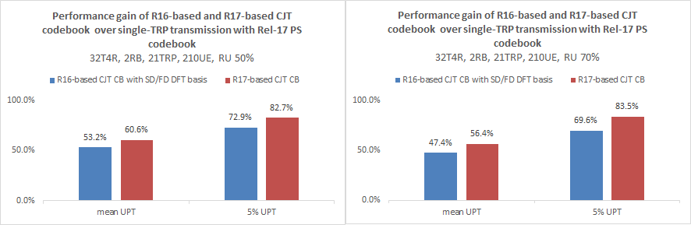

Figure 1. Performance gain of CJT with joint SD-FD basis based PS codebook over single-TRP transmission with Rel-17 PS codebook

***Observation: The R17-FeTypeII-based CJT codebook with joint space-frequency domain statistical eigenvectors achieves 7~9% gain for mean UPT and 10~14% gain for 5%-tile UE UPT, compared with R16-Type II-based CJT codebook with DFT basis.***