3GPP TSG RAN WG1 Meeting #110 R1-22xxxxx
Toulouse, France, August 22 – 26, 2022

Agenda Item: 5
Source: Moderator (Huawei)
Title: Summary 1 of discussion on IAB rely LS for R1-2205705
Document for: Discussion and Decision

- Introduction
RAN3 sent LS in R1-2205705(R3-224031) to RAN1 and asked two questions:
Question 1: Whether the RB set needs to be configurable to the IAB-donor-DU?
Question 2: Whether the current F1AP signalling about RB set size is clear enough. If not, which kind of clarification should be added?
- Company views
Companies submitted contributions to RAN1#110 and discuss the above questions as summarized below
Samsung  [1][5] | Proposal 3: Inform RAN3 that the RB set don’t need to be configurable to the IAB-donor-DU and the current F1AP signalling about RB set size is clear enough in RAN1 perspective.
Qualcomm  [2] | Proposal 3.1  Provide the following responses in the reply LS to RAN3 in response to R1-2205705:  - Yes, the RB set needs to be configurable to the IAB-donor DU.  - Yes, the current F1AP signalling about RB set size is clear enough.
Huawei, HiSilicon  [3][4] | Proposal 1: The RB set configuration is not applicable to IAB-donor-DU.  Proposal 2: The RB set configuration is clear enough and there is no need to add any further clarification.  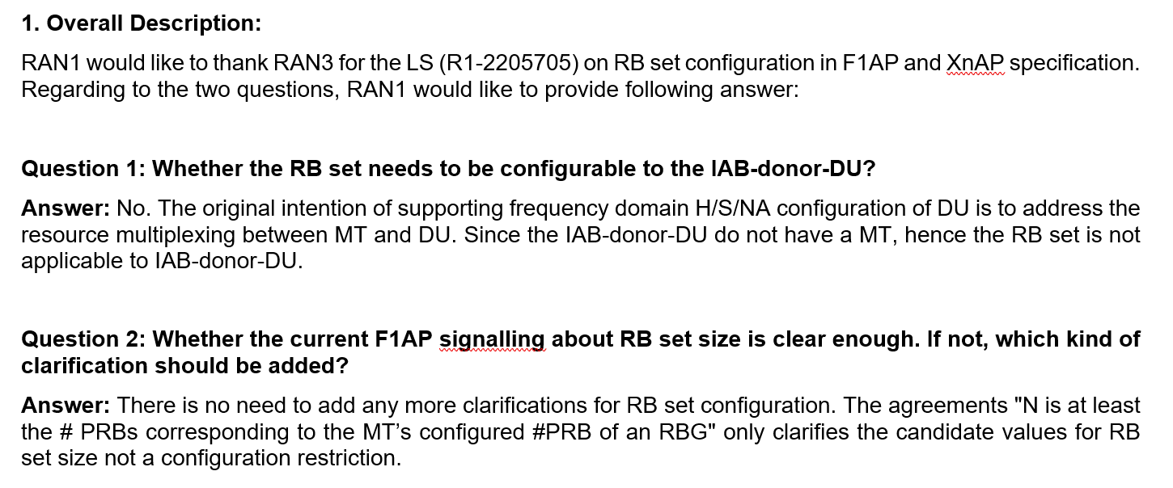
ZTE, Sanechips  [5] | Proposal 1: To clarify to RAN3 that the intention of RB set configuration in RAN1 is to achieve simultaneous operation of an IAB DU and its co-located IAB MT, and RB set configuration can be applied to IAB donor-DU if new use cases are identified by RAN3.  Proposal 2: Confirm with RAN3 that the current F1AP signalling about RB set size is clear enough
Nokia, Nokia Shanghai Bell  [6] | Proposal 2.1: Indicate to RAN3 that the IAB-donor-DU must be configurable with RB set configuration by the donor-CU.  Proposal 2.2: Indicate to RAN3 that the RB set configuration as provided in [X] is sufficiently clear and requires no further modification.
Ericsson  [7][8] | Observation 1 A donor-DU does not share (time- and frequency) resources with a co-located MT, making a donor-DU RB set configuration superfluous.  Observation 2 As a parent node, the donor-DU will be limited by the (child) IAB-DU’s H/S/NA configuration in communication between the donor-DU and (child) IAB-MT which may be provided by an IAB-node to its parent node.  Observation 3 A donor-DU does not need an H/S/NA configuration about which other nodes need to be informed about for the sake of proper resource utilization.  Proposal 1 Clarify to RAN3 that there is no need to configure an RB set configuration to an IAB-donor-DU.  Proposal 2 Clarify to RAN3 that the RB set size in F1AP signalling relates to the MT’s configured #PRBs and this should be included in the F1AP RB set size description.

- Discussion
Companies further provided the following replies in the email reply.
Company | Comments
ZTE, Sanechips | OK
AT&T | Support the proposals from Qualcomm/Nokia. Time domain configuration at the Donor DU is already supported, so frequency domain coordination should be as well.
Intel | Fine with further discussion for 1st question.  In our view, the purpose of H/S/NA configuration for IAB-DU is to divide resources between co-located IAB-MT and IAB-DU in one IAB-node, there is no need for H/S/NA configuration as there is no IAB-MT in the donor node.
Ericsson | For the first question, we are fine with further discussion although we do not see a need for the donor-DU to have this configuration.  Regarding the second question, it is not a matter of majority but a matter of principle that we honor made agreements, and that agreements affecting the specification find their way into the specification. We have an agreement that “N is at least the # PRBs corresponding to the MT’s configured #PRB of an RBG” which is not reflected in the specification. If it is not included in the specification, there is nothing preventing an implementation opposing said agreement and still follow the specification. The referred RAN3 spec is the appropriate place for that and therefore it should be included there. If companies did not want this behavior, they should not have agreed to it in the first place.
Lenovo, Motorola Mobility | Fine with proposals from Qualcomm and Nokia.
NTT DOCOMO | Fine to further discuss.  For the first question, we think RB set may not need to be configurable for donor-DU.  For the second question, we think current signaling is clear enough.
Samsung | Fine to further discuss.
Huawei, HiSi | For the 1st question, as the IAB-donor-DU do not have a co-located MT as well as parent node and the donor DU do not have parent node which can semi-static or dynamically control the usability of the DU’s resources. Hence the RB set configuration is not needed for IAB-donor-DU.  For the second question, we have similar discussion before. The current RAN3 specification is clear and complete, which has provide sufficient configuration flexibly and no more clarification is needed.

- Offline summary
During the offline session, consensus have been reached on questions 1 that the RB set configuration is not applicable to IAB-donor-DU.
Proposed RAN3 reply:
Question 1: Whether the RB set needs to be configurable to the IAB-donor-DU?
Answer: No. From RAN1 point of view, the RB set configuration is not applicable to IAB-donor-DU
On questions 2, according to the offline discussion and email rely, all companies except one agreed that the current F1AP signalling about RB set size is clear enough and no further clarification is needed.
Agreement
The minimum resource size for configuring the frequency domain granularity is a set of N RBs:
- Candidate values for N: {4, 8, 16, other values TBD}
- N is at least the # PRBs that are corresponding to the MT’s # PRBs of an RBG).
- FFS: Scaling or configuration of N based on system BW or size of IAB-MT BWP
Ericsson thinks that the RAN1 agreement (highlighted in yellow) needs to be captured in the specification. However, there is a different understanding that the agreement has already been captured. The argument is that the agreement is made when the candidate values for the RB set size N was discussed. The above agreement says that the RB set size should be chosen from the value of RBG size and the candidate values for N agreed later covers all possible RBG sizes. Hence the agreement has been captured in specification already.
Regarding the understanding of agreement highlighted in yellow, similar discussion happened in RAN1#106 but unfortunately there was no further clarification. However, there was some later discussion on whether the RB set size for IAB-DU should be coupled with the BWP of the IAB-MT but no agreement can be achieved since there seems no good reason to do so. In addition, the following FFS bullet highlighted in the below agreement has not been addressed further. It was also pointed out by Samsung that there could other potential issues if the following sentence “N is at least the # PRBs corresponding to the MT’s configured #PRB of an RBG” is added to the RB set size definition.
Agreement
N is a configured number of PRBs, where the CU configures N
- N = {2, 4, 8, 16, 32, 64}
- FFS: Value(s) of N in case of multiple configured BWPs at the IAB-MT
- This agreement does not revert any existing RAN1 agreement

From moderator point of view, the current RB set size definition in RAN3 works fine and provides sufficient configuration flexibility. Given that adding the clarifications may lead to more confusion and potential issues, the moderator would like to propose the following answer to RAN3
Proposed RAN3 reply:
Question 2: Whether the current F1AP signalling about RB set size is clear enough. If not, which kind of clarification should be added?
Answer: No. From RAN1 point of view, the current F1AP signalling about RB set size is clear enough and no further clarification is needed.

- Online proposal
Proposed RAN3 reply:
Question 1: Whether the RB set needs to be configurable to the IAB-donor-DU?
Answer: No. From RAN1 point of view, the RB set configuration is not applicable to IAB-donor-DU

Question 2: Whether the current F1AP signalling about RB set size is clear enough. If not, which kind of clarification should be added?
Answer: No. From RAN1 point of view, the current F1AP signalling about RB set size is clear enough and no further clarification is needed.

- References
- R1-2206803 Maintenance on Enhancements to NR IAB, Samsung
- R1-2207205 Remaining issues on eIAB, Qualcomm
- R1-2205803 On RB set configuration for IAB, Huawei, HiSilicon
- R1-2205804 Draft reply LS on RB set configuration for IAB, Huawei, HiSilicon
- R1-2206779 Draft Reply LS on RB set configuration for IAB, Samsung
- R1-2207374 On Rel-17 RB set configuration for IAB, Nokia, Nokia Shanghai Bell
- R1-2207671 Discussion on RAN3 LS on RB set configuration for IAB, Ericsson
- R1-2207672 [DRAFT] Reply LS on RB set configuration for IAB, Ericsson

