3GPP TSG RAN WG1 Meeting #110 R1-220xxxx
Toulouse , France, 22nd August – 26th August, 2022
Agenda Item: 8.10
Source: Moderator (Huawei)
Title: Summary #1 of reply LS to R1-2205705
Document for: Discussion and decision

Introduction

RAN3 has captured the RB set configuration in F1AP and XnAP specification.
RAN3 did not reach consensus on whether the RB set Configuration is applicable for the IAB-donor-DU. Consequently, RAN3 would like to ask RAN1 to clarify whether the RB set needs to be configurable to the IAB-donor-DU.

In addition, the RB set size in current F1AP specification [TS38.473] designed by RAN3 is provided in the following table. And RAN1 previously agreed to the following “N is at least the # PRBs corresponding to the MT’s configured #PRB of an RBG” during RAN1#105-e regarding configuring for an IAB-DU the frequency domain granularity in units of RB set for Rel-17 H/S/NA. Companies in RAN3 have different understanding on this agreement and cannot reach consensus on whether to add clarification in the semantics description of the RB Set Size IE regarding to the mentioned agreement.

9.3.1.230 RB Set Configuration
This IE contains the RB Set Configuration. The IE is only applicable if the gNB-DU is an IAB-DU.

IE/Group Name | Presence | Range | IE type and reference | Semantics description
Subcarrier Spacing | M |  | ENUMERATED (kHz15, kHz30, kHz60, kHz120, kHz240, spare3, spare2, spare1, …) | Subcarrier spacing used as reference for the RB set configuration.
RB Set Size | M |  | ENUMERATED (rb2, rb4, rb8, rb16, rb32, rb64) | Number of PRBs in each RB set.
>>>>>>>>>>unrelated parts are skipped<<<<<<<<<<

RAN3 would like to ask RAN1 to confirm whether the current F1AP signalling about RB set size is clear enough. If not, which kind of clarification should be added?

Samsung  [4], [27] | Proposal 3: Inform RAN3 that the RB set don’t need to be configurable to the IAB-donor-DU and the current F1AP signalling about RB set size is clear enough in RAN1 perspective.
Qualcomm  [6] | Proposal 3.1  Provide the following responses in the reply LS to RAN3 in response to R1-2205705:  - Yes, the RB set needs to be configurable to the IAB-donor DU.  - Yes, the current F1AP signalling about RB set size is clear enough.
Huawei, HiSilicon  [25], [26] | Proposal 1: The RB set configuration is not applicable to IAB-donor-DU.  Proposal 2: The RB set configuration is clear enough and there is no need to add any further clarification.  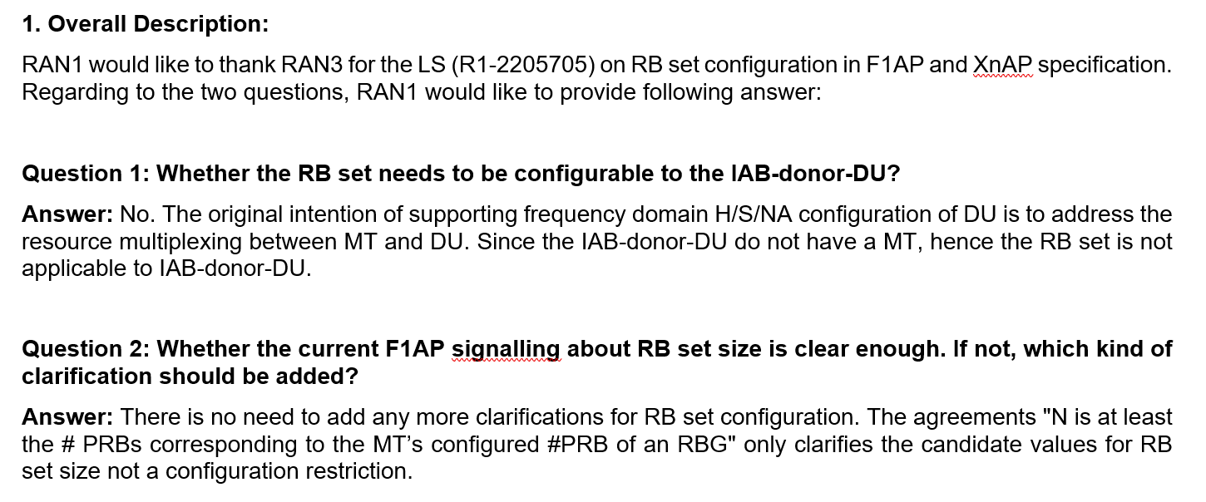
ZTE, Sanechips  [27] | Proposal 1: To clarify to RAN3 that the intention of RB set configuration in RAN1 is to achieve simultaneous operation of an IAB DU and its co-located IAB MT, and RB set configuration can be applied to IAB donor-DU if new use cases are identified by RAN3.  Proposal 2: Confirm with RAN3 that the current F1AP signalling about RB set size is clear enough
Nokia, Nokia Shanghai Bell  [28] | Proposal 2.1: Indicate to RAN3 that the IAB-donor-DU must be configurable with RB set configuration by the donor-CU.  Proposal 2.2: Indicate to RAN3 that the RB set configuration as provided in [X] is sufficiently clear and requires no further modification.
Ericsson  [29], [30] | Observation 1 A donor-DU does not share (time- and frequency) resources with a co-located MT, making a donor-DU RB set configuration superfluous.  Observation 2 As a parent node, the donor-DU will be limited by the (child) IAB-DU’s H/S/NA configuration in communication between the donor-DU and (child) IAB-MT which may be provided by an IAB-node to its parent node.  Observation 3 A donor-DU does not need an H/S/NA configuration about which other nodes need to be informed about for the sake of proper resource utilization.  Proposal 1 Clarify to RAN3 that there is no need to configure an RB set configuration to an IAB-donor-DU.  Proposal 2 Clarify to RAN3 that the RB set size in F1AP signalling relates to the MT’s configured #PRBs and this should be included in the F1AP RB set size description.

Company | Comments
ZTE, Sanechips | OK
AT&T | Support the proposals from Qualcomm/Nokia. Time domain configuration at the Donor DU is already supported, so frequency domain coordination should be as well.
Intel | Fine with further discussion for 1st question.  In our view, the purpose of H/S/NA configuration for IAB-DU is to divide resources between co-located IAB-MT and IAB-DU in one IAB-node, there is no need for H/S/NA configuration as there is no IAB-MT in the donor node.
Ericsson | For the first question, we are fine with further discussion although we do not see a need for the donor-DU to have this configuration.  Regarding the second question, it is not a matter of majority but a matter of principle that we honor made agreements, and that agreements affecting the specification find their way into the specification. We have an agreement that “N is at least the # PRBs corresponding to the MT’s configured #PRB of an RBG” which is not reflected in the specification. If it is not included in the specification, there is nothing preventing an implementation opposing said agreement and still follow the specification. The referred RAN3 spec is the appropriate place for that and therefore it should be included there. If companies did not want this behavior, they should not have agreed to it in the first place.
Lenovo, Motorola Mobility | Fine with proposals from Qualcomm and Nokia.
NTT DOCOMO | Fine to further discuss.  For the first question, we think RB set may not need to be configurable for donor-DU.  For the second question, we think current signaling is clear enough.
Samsung | Fine to further discuss.
Huawei, HiSi | For the 1st question, as the IAB-donor-DU do not have a co-located MT as well as parent node and the donor DU do not have parent node which can semi-static or dynamically control the usability of the DU’s resources. Hence the RB set configuration is not needed for IAB-donor-DU.  For the second question, we have similar discussion before. The current RAN3 specification is clear and complete, which has provide sufficient configuration flexibly and no more clarification is needed.

FL proposal
- Whether the RB set needs to be configurable to the IAB-donor-DU.
No. the RB set configuration is not needed for IAB-donor-DU.

- Whether the current F1AP signalling about RB set size is clear enough. If not, which kind of clarification should be added?

Confirm with RAN3 that the current F1AP signalling about RB set size is clear enough

Summary

Discussion

References
[1] R1-2206206 Discussion on coexistence between Rel-16 and Rel-17 H/S/NA configuration, ZTE, Sanechips
[2] R1-2206508 Resource multiplexing in enhanced IAB systems, Lenovo
[3] R1-2206561 Remaining Issues on Frequency-domain Resource Multiplexing for IAB, Intel Corporation
[4] R1-2206803 Maintenance on Enhancements to NR IAB, Samsung
[5] R1-2206950 Discussions on eIAB CSI, ETRI
[6] R1-2207205 Remaining issues on eIAB, Qualcomm
[7] R1-2207521 Remaining issues on resource multiplexing for IAB, Huawei, HiSilicon
[8] R1-2207675 Discussion on DL Tx power control, Ericsson
[9] R1-2207679 Maintenance on enhanced IAB, Ericsson
[10] R1-2205808 Correction on TDD configuration for IAB-MT, Huawei, HiSilicon
[11] R1-2206202 Corrections on misalignment for MAC CE or RRC parameters for eIAB TS 38.213, ZTE, Sanechips
[12] R1-2206203 Correction on the formula of Case-7 UL Tx timing for eIAB in TS 38.213, ZTE, Sanechips
[13] R1-2206204 Correction on the position related to the description that the RB set is equivalent to hard for eIAB in TS 38.213, ZTE, Sanechips
[14] R1-2206205 Correction on coexistence between Rel-16 and Rel-17 H/S/NA configuration, ZTE, Sanechips
[15] R1-2206951 Draft CR on eIAB CSI, ETRI
[16] R1-2207204 Draft CR on eIAB, Qualcomm
[17] R1-2207373 On Handling for Rel-16 and Rel-17 Resource Configuration Conflicts, Nokia, Nokia Shanghai Bell
[18] R1-2207522 Correction on CQI derivation accounting for provided DL Tx power adjustment for IAB-MT, Huawei, HiSilicon
[19] R1-2207665 Correction on HSNA resource configuration for IAB, Huawei, HiSilicon
[20] R1-2207674 Draft CR on DL Tx power control, Ericsson
[21] R1-2207676 Draft CR on guard symbols MAC CEs, Ericsson
[22] R1-2207677 Draft CR on timing case indication, Ericsson
[23] R1-2207678 Draft CR on Hard/Soft/Not Available resource definition, Ericsson
[24] R1-2207673 Discussion on RAN4 LS on range of power control parameters for eIAB, Ericsson
[25] R1-2205803 On RB set configuration for IAB, Huawei, HiSilicon
[26] R1-2205804 Draft reply LS on RB set configuration for IAB, Huawei, HiSilicon
[27] R1-2206779 Draft Reply LS on RB set configuration for IAB, Samsung
[28] R1-2207374 On Rel-17 RB set configuration for IAB, Nokia, Nokia Shanghai Bell
[29] R1-2207671 Discussion on RAN3 LS on RB set configuration for IAB, Ericsson
[30] R1-2207672 [DRAFT] Reply LS on RB set configuration for IAB, Ericsson
[31] R1-2206761 Maintenance on Enhancements to Integrated Access and Backhaul, vivo
[32] R1-2206762 Corrections on resource availability indication, vivo

