3GPP TSG RAN WG1 Meeting #110 R1-220xxxx
Toulouse , France, 22nd August – 26th August, 2022
Agenda Item: 8.10
Source: Moderator (Qualcomm Incorporated)
Title: Summary #1 of [110-R17-IAB]
Document for: Discussion and decision

Introduction
This contribution provides a summary for agenda item 8.10, maintenance of enhancements to integrated access and backhaul.
Discussion coordination updates will be published in the following thread:
[110-R17-IAB] To be used for sharing updates on online/offline schedule, details on what is to be discussed in online/offline sessions, tdoc number of the moderator summary for online session, etc – Luca (Qualcomm)

Summary
There are 13 topics identified based on the contributions and draft CRs [1] – [23] submitted for agenda item 8.10. Additional related input in the context of received LSs was provided in [24] – [30].
Any input on prioritization for the discussion? Specifically, which topics should be prioritized / deprioritized in your view?
Company | Comments
ZTE, Sanechips | Topic #1, Topic #4, Topic #5 should be prioritized.  Topic #3, Topic #7 should be deprioritized.  The other topics can be discussed after the high priority topics are closed.
Ericsson | Prioritized for online discussion  Topic 1: TD/FD H/S/NA coexistence (incomplete spec.)  Topic 2: DL Tx power adjustment (spec. ambiguity)  Topic 5: RAN3 LS (RAN3 impact)  Topic 6: Guard band for FDM operation (possibly RAN4 impact)

Discussion

Topic #1. Coexistence of TD and FD DU resource configurations
Related decisions from prior meetings:
RAN1-106bise working assumption:
If both the Rel-16 time domain H/S/NA configuration and Rel-17 frequency domain H/S/NA configuration are provided for a given RB set within a slot, one of the following is selected:
Alt. 1: An IAB node applies the frequency domain H/S/NA only if the IAB node is currently operating in a non-TDM multiplexing mode in the slot, otherwise the Rel-16 time domain H/S/NA configuration is applied.

RAN1-107e Agreement:
Whether or not an IAB node can operate under a given non-TDM multiplexing mode (i.e. multiplexing info in 38.473) is left to IAB implementation in Rel-17

RAN1-109e Conclusion
If both Rel-16 H/S/NA and Rel-17 H/S/NA are configured for a given resource and the child node is operating in TDM multiplexing mode, consider the following alternatives until RAN1#110:
- Alt. 1: the child node follows the Rel-16 H/S/NA configuration for the resource
- Alt. 2: the child node follows the Rel-17 H/S/NA configuration for the resource
- Alt. 3: A resource configured with Rel-16 H or Rel-16 S with dynamic indication of availability overrides the Rel-17 H/S/NA configuration, otherwise the child node follows the Rel-17 H/S/NA configuration for the resource
- Alt. 4 the child node follows the Rel-16 or Rel-17 H/S/NA based on implicit indication (e.g. Case 6 timing indication) between parent and child node.

Related input from contributions:
ZTE, Sanechips  [1], [14] | Observation 1: Alternative 3 and 4 will lead to inconsistent understanding of H/S/NA types applied on an IAB-node DU among the IAB-node(s), its parent node(s), and its donor CU.  Observation 2: Alternative 3 and 4 will not play a good role in resource coordination in case of DC and CLI management.  Proposal 1: If both the Rel-16 time domain H/S/NA configuration and Rel-17 frequency domain H/S/NA configuration are provided for a given RB set within a slot, Rel-17 frequency domain H/S/NA configuration is applied.  Proposal 2: Proposal 2: Delete the sentence “when the IAB-node uses simultaneous transmission and reception in the slot” in TS38.213.  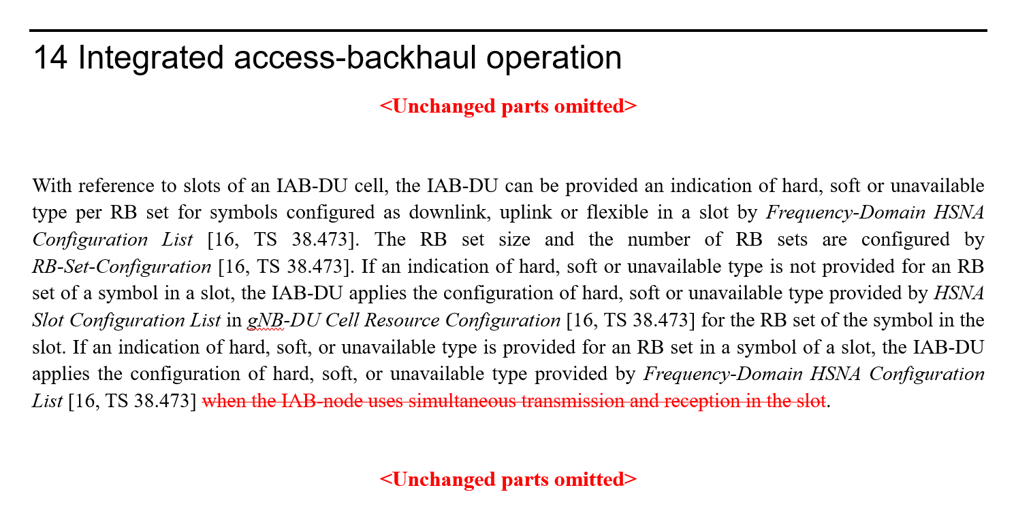
Lenovo  [2] | Observation 1: Joint application of time-domain H/S/NA (T-HSNA) and frequency-domain H/S/NA (F-HSNA) attributes facilitates a fallback mode, avoids the complexity of defining dynamic multiplexing modes at L1/L2, and provides higher resource efficiency if the IAB node is not capable of performing FDM at a particular moment.  Observation 2: Separate application of T-HSNA and F-HSNA is a special case of joint application. If joint application is agreed, the IAB-CU still has the possibility of separate (non-overlapping) configurations. Joint application allows higher flexibility for resource configuration by the IAB-CU without loss of generality for TDM-only or FDM-only configurations if desired in a specific implementation.  Proposal 1: Support joint application of T-HSNA and F-HSNA configurations and specify behaviour for determining H/S/NA resource attributes for time-frequency resources based on a combination of T-HSNA and F-HSNA attributes., e.g., Alt. 3 in RAN1#109-e conclusion.
Intel  [3] | Observation 1: Regarding Alt.2/3/4 when both Rel-16 and Rel-17 H/S/NA are provided,  - Alt.2 provides a clear common understanding between the IAB-node and parent node although may cause some resource usage waste/inefficiency when an IAB-node must apply Rel-17 H/S/NA with TDM multiplexing.  - Alt.3 mixes up Rel-16 and Rel-17 H/S/NA configurations and there is no clear intention of Rel-16 Hard or Soft indicated available always overriding Rel-17 H/S/NA configuration.  - Alt.4 may have some issue since Case#6 or Case#7 timing does not strictly associate with FDM or Rel-17 H/S/NA and cannot be used as implicit indication of Rel-17 H/S/NA application.  Proposal 1: Support Alt.2 (child node follows the Rel-17 H/S/NA configuration) if both Rel-16 H/S/NA and Rel-17 H/S/NA are configured for a given resource.
Samsung  [4] | Proposal 1: If both the Rel-16 time domain H/S/NA configuration and Rel-17 frequency domain H/S/NA configuration are provided for a given RB set within a slot, the child node follows the Rel-17 frequency domain H/S/NA configuration for the resource.
Qualcomm  [6], [16] | Proposal 2.1  Adopt the following TP for TS38.213:  Reason for change: Resolution of ambiguity in presence of both time domain and frequency domain H/S/NA DU resource configuration.  Summary of change: The frequency domain H/S/NA DU resource configuration takes priority over the time domain H/S/NA DU resource configuration.  Consequences if not approved: Specifications would continue to have ambiguity for the IAB-DU behavior, which may result in overall system performance degradation
Huawei, Hisilicon  [7], [19] | Observation 1: Parent node cannot be made aware of the multiplexing mode of IAB node, which may lead to misunderstanding on H/S/NA resource configurations between parent and child.  Observation 2: Alt 4, i.e. the child node follows the Rel-16 or Rel-17 H/S/NA based on implicit indication (e.g. Case 6 timing indication) between parent and child node is not feasible.  Observation 3: Guard band can provide better frequency domain isolation and may be needed to enable the FDM operation between MT and DU.  Observation 4: Placing the guard band on DU resource by implementation to achieve the FDM violates the definition of DU hard resources.  Proposal 1: If Rel-16 H/S/NA resource configuration and Rel-17 H/S/NA resource configuration are both provided for a given RB set within a slot, the IAB node applies the Rel-17 H/S/NA resource configuration in the slot.  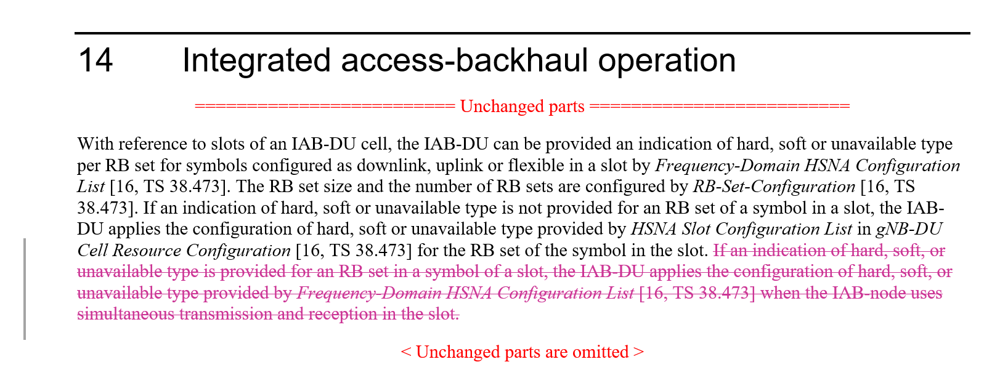
Ericsson  [9] | Observation 1 Both Alt. 2 and Alt. 3 require joint TDM and FDM H/S/NA configurations, increasing complexity and reducing performance.  Proposal 1 If both Rel-16 time-domain H/S/NA configuration and Rel-17 frequency domain H/S/NA configuration are provided for a given RB set within a slot, support implicit indication (e.g., Case 6 timing indication) between the IAB node and the parent node about which H/S/NA configuration to apply.
Nokia, Nokia Shanghai Bell  [17] | 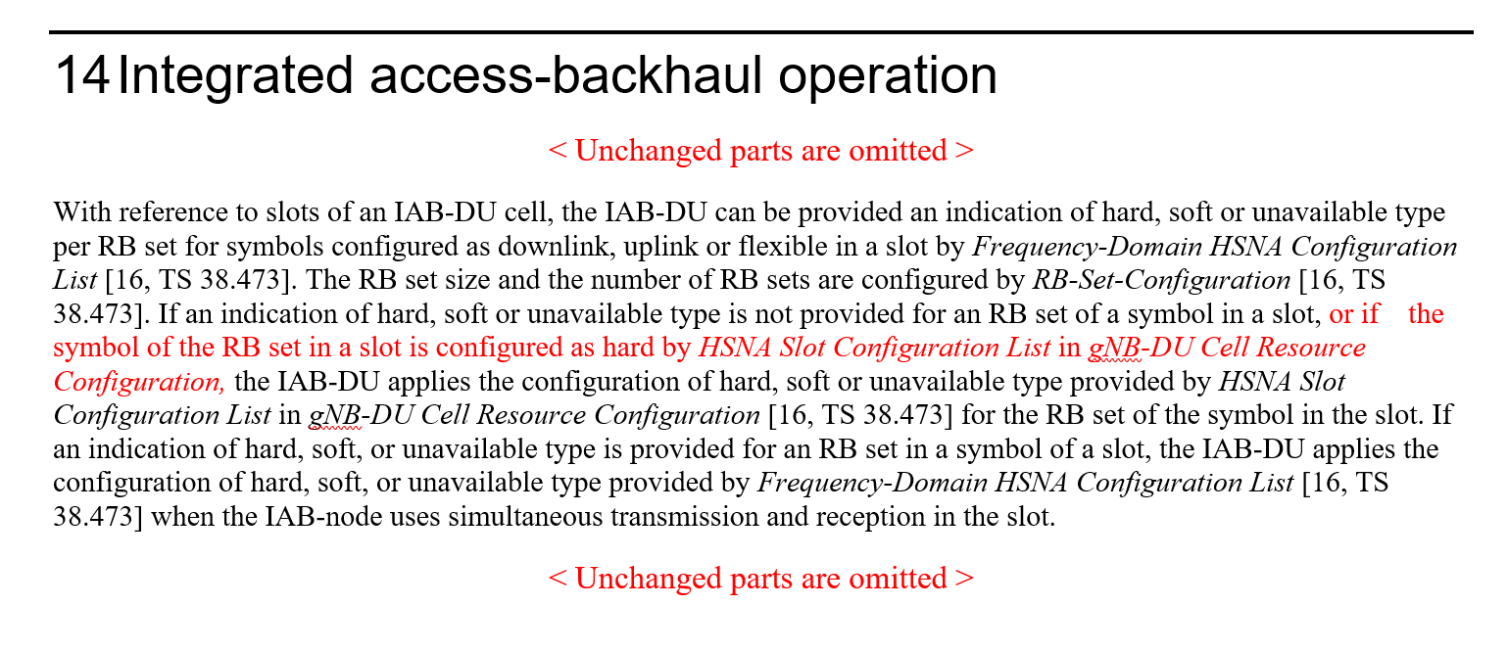
Vivo [31] | Proposal 1: Adopt both Alt.2 and Alt.4 from the RAN1#109e conclusion to address the Rel-16/17 resource type configuration conflict.  Proposal 2: When IAB node requires Case 6 timing indication, IAB node applies the Rel-16 H/S/NA for the time resource indicated with Case 1 timing and configured/indicated as MT UL&DU DL, otherwise IAB node applies Rel-17 H/S/NA, e.g., for the time resource indicated with Case 6 timing and the time resource not configured/indicated as MT UL&DU DL.

This issue has been discussed for a long time over multiple meetings. There is now a majority view in favor of Alt. 2, hence it is proposed to adopt it.

FL Proposal 1.1:
If Rel-16 H/S/NA resource configuration and Rel-17 H/S/NA resource configuration are both provided for a given RB set within a slot, the IAB node applies the Rel-17 H/S/NA resource configuration in the slot.

Company | Comments
ZTE, Sanechips | Support
AT&T | We do not support the proposal (e.g. Alt. 2) since it is inefficient for the scenarios where fallback was identified to be supported in prior RAN1 agreements. We would be OK with either Alt. 3 or Alt. 4 from RAN1#109e.
Intel | Support the proposal
Vivo | We prefer a fair compromise from both side, so both alt.2 and alt.4 can be supported.
Ericsson | Do not support, prefer implicit indication. The alternatives from RAN1#109-e relates to an IAB node operating in TDM mode, i.e., FDM is out of question. By supporting Rel-17 (FDM) H/S/NA, some resources will be rendered unavailable since they are configured FDM and the use of such resources will be blocked since the use of that symbol will be ambiguous. The more FDM resources are configured, the more blocked resources there will be.
Lenovo, Motorola Mobility | We do not support the proposal. We have argued that without a way of applying T-HSNA at the moments that the channel does not allow simultaneous operation (hence F-HSNA not applicable), this feature will be impractical and will be unlikely to be implemented at all. We support Alt. 3 and have argued that against Alt. 4 for its disadvantages: overloading timing case indication and neglecting SDM/multi-panel.
NTT DOCOMO | Support
Samsung | Support
Huawei, HiSi | We support this proposal.

Topic #2. Additional specification for DL Tx power adjustment
Related decisions from prior meetings:
RAN1-109e Conclusion
Consider until RAN1#110 whether additional specification is required when FDM multiplexing mode is applied for the CSI reference resource.

Related input from contributions:
Lenovo  [2] | Proposal 2: No need to introduce additional specification to CSI reference resource.
ETRI  [5], [15] | Observation 1: DL TX power adjustment can only be associated with a subset of frequency resources among those for CSI report.  Observation 2: CSI report of IAB-MT may not be accurate due to the following gap between spec interpretation and the corresponding IAB-MT behaviour on PDSCH EPRE derivation:  - Interpretation: For CSI report with CSI reference resource indicated with the DL TX power adjustment, 1) the IAB-MT shall derive PDSCH EPRE by powerControlOffset and DL TX power adjustment across frequency resources associated with that DL TX power adjustment and 2) shall derive PDSCH EPRE by powerControlOffset across frequency resources NOT associated with that DL TX power adjustment.  - IAB-MT behaviour: For CSI report with frequency resources, which are wider than FDM resources, the IAB-MT may derive PDSCH EPRE by averaging DL TX power adjusted ones and not-adjusted ones.  Proposal 1. Adopt the following TP:  5.2.2.5 CSI reference resource definition  <Omitted text>  If configured to report CQI index, in the CSI reference resource, the UE shall assume the following for the purpose of deriving the CQI index, and if also configured, for deriving PMI and RI:  - The first 2 OFDM symbols are occupied by control signaling.  - The number of PDSCH and DM-RS symbols is equal to 12.  - The same bandwidth part subcarrier spacing configured as for the PDSCH reception  - The bandwidth as configured for the corresponding CQI report.  - The IAB-MT shall only assume the frequency resources as indicated by the DL TX power adjustment MAC CE, if indicated for the slot of the CSI reference resource by DL Tx Power Adjustment MAC CE as described in [10, TS 38.321].  - The reference resource uses the CP length and subcarrier spacing configured for PDSCH reception  - No resource elements used by primary or secondary synchronization signals or PBCH.  - Redundancy Version 0.  - The ratio of PDSCH EPRE to CSI-RS EPRE is as given in Clause 5.2.2.3.1.  - In addition, the IAB-MT shall account for the provided DL TX power adjustment, if indicated for the slot of the CSI reference resource by DL Tx Power Adjustment MAC CE as described in [10, TS 38.321].  <Omitted text>
Ericsson  [8], [20] | Proposal 1 The following RAN1#107-e agreement is amended as: The indicated desired/provided DL Tx power adjustment is in terms of a relative offset to the non-offset PDSCH Tx power, as derived from a CSI-RS TX power that is RRC configured.  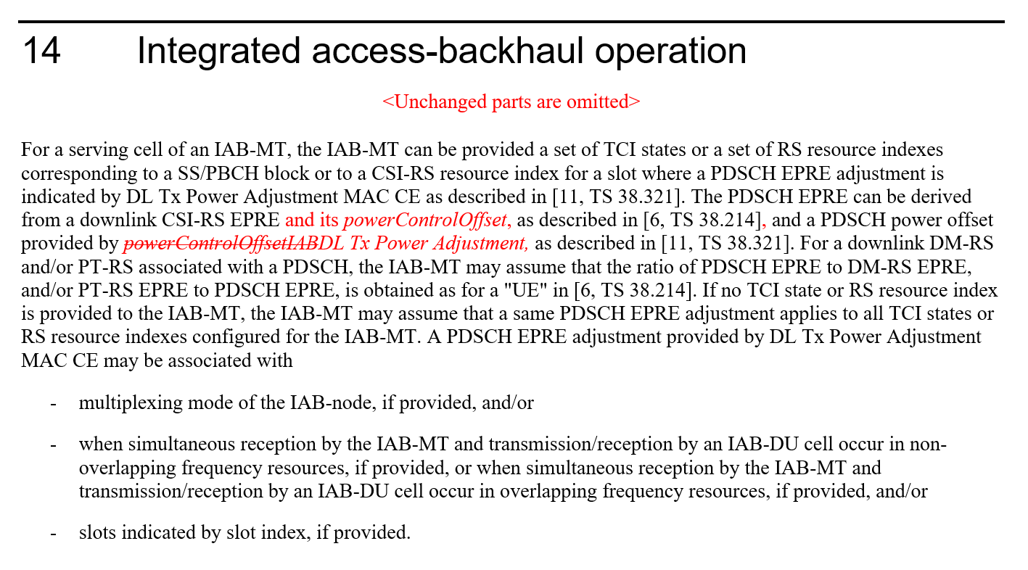
Huawei, HiSilicon  [18] | 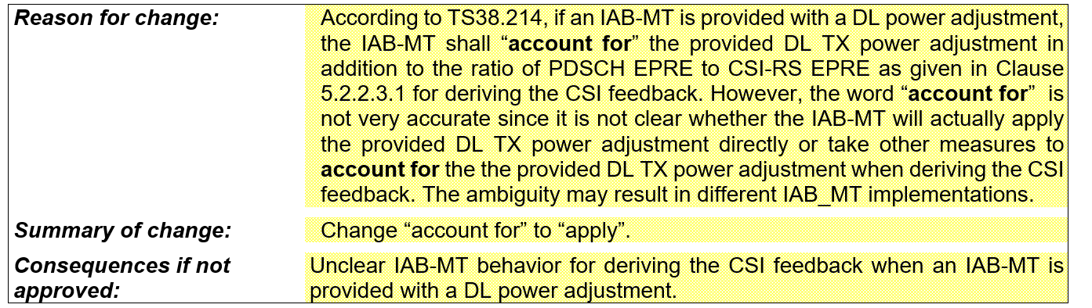

FL observation 2.1:
In regard to the issue raised by ETRI, the FL understanding is that the following clause in TS28.214 already takes care of all conditions related to the applicability of the DL Tx power adjustment, including possibly any potential mismatch between the CSI configured bandwidth and the bandwidth of the frequency domain resources for which the DL Tx power adjustment is applied. Hence no further action seems required.

FL observation 2.2:
In regard to the issue raised by Ericsson, the FL understanding is that there is no ambiguity on which CSI-RS resource to be used as a reference for the PDSCH EPRE computation as long as there is a CSI-RS associated with the PDSCH via the provided TCI state ID or the provided CSI-RS ID.

FL Proposal 2.1:
Endorse aforementioned Huawei CR.

Company | Comments
ZTE, Sanechips | OK
AT&T | OK
Intel | We agree.
Vivo | OK
Ericsson | Regarding FL Obeservation 2.2:  The text is ambiguous in the following different interpretations with respect to the i^{th} CSI-RS resource:  - Adjusted PDSCH EPRE = CSI-RS(i) EPRE + powerControlOffset(i) + DL TX Power Adjustment  - Adjusted PDSCH EPRE = CSI-RS(i) EPRE + DL TX Power Adjustment  For alt a., DL TX Power Adjustment is constant regardless of CSI-RS EPRE since CSI-RS(i) EPRE + powerControlOffset(i) is constant.  For alt b., DL TX Power Adjustment is variable with CSI-RS(i) EPRE.  We think that the above must be discussed in the meeting and clarified in 38.213. If b. is the interpretation of the current spec text, we think that a change to PDSCH is motivated.  Regarding FL proposal 2.1, we don’t think the proposed change makes much of a difference.
ETRI | Regarding FL observation 2.1:  We would like to see which part of 214 clarifies the following comments from FL, “TS28.214 already takes care of all conditions related to the applicability of the DL Tx power adjustment, including possibly any potential mismatch between the CSI configured bandwidth and the bandwidth of the frequency domain resources for which the DL Tx power adjustment is applied”.  Regarding FL proposal 2.1, we also think the proposed change does not make much of a difference.
Lenovo, Motorola Mobility | Fine
NTT DOCOMO | We are fine with the proposals.
Samsung | For observation 2.2 and proposal 2.1, fine with the proposals
Huawei, HiSi | We agree with FL.

Topic #3. Extension of indication of resource availability
Related decisions from prior meetings:
RAN1-109e Conclusion
Consider until RAN1#110 the following solutions to increase the number of IAB-DU cells that can be provided with availability information for soft resources:
- Alt. 1. extension of DCI format 2_5 payload from 128 bits to 134 bits
- Alt. 2. Mapping the bits of an availabilityIndicator to one or multiple cells

Related input from contributions:
Lenovo  [2] | Proposal 3: Support Alt. 1 – extend the number of bits in DCI format 2_5 payload.
Ericsson  [9] | Observation 3 In the current DCI format 2_5, the number of availability indication can be limited to 14 IAB-DU cells of maximum 512 IAB-DU cells.  Proposal 3 Rel-17 enhancement on DCI format 2_5 should at least consider extension of the maximum payload size of DCI format 2_5 to increase the number of IAB-DU cells that can be provided with availability information for Soft resources.

FL Proposal 3.1:
Support extension of DCI format 2_5 payload from 128 bits to 134 bits.

Company | Comments
ZTE, Sanechips | One thing should be clarified first, except the payload size, whether this proposal has further impact on RAN1/2 specs or not ?
AT&T | Support
Ericsson | Support
Lenovo, Motorola Mobility | Support
NTT DOCOMO | Support
Samsung | Similar question with ZTE.
Huawei, HiSi | We have concern on this proposal. We don’t think the scenario that IAB-DU support many cells with different resource type indications is typical and hence we think such enhancement is not necessary.

Topic #4. Range of DL Tx power adjustment
Related input from contributions:
Samsung  [4] | Proposal 2: [-8, 15] is supported for the range of DL Tx power adjustment.
Ericsson  [24] | Observation 1 According to RAN4, DL Tx adjustment to limit Rx PSD variation may benefit reception performance and/or extend the deployment scenarios for IAB-nodes.  Observation 2 The specification already supports signaling of guard symbols for DL Tx power adjustment.  Proposal 1 A single range of DL Tx power adjustment is specified for both wide area and local area IA nodes.  Proposal 2 The range of the DL Tx power adjustment is limited to ±10 dB.

FL Proposal 4.1:
Support [-10, 10] for the range of DL Tx power adjustment.

Company | Comments
ZTE, Sanechips | OK
Ericsson | Support
Lenovo, Motorola Mobility | Fine
NTT DOCOMO | We support.
Samsung | Although it is our preference, we can accept majority view.
Huawei, HiSi | We noticed the LS response from RAN4. We are wondering whether it is reasonable to allow the positive values up to 10dB, as the intention of DL power adjustment feature is to lower the transmit power of parent node to achieve simultaneously reception at child node.

Topic #5. Reply LS to R1-2205705
Related input from contributions:
Samsung  [4], [27] | Proposal 3: Inform RAN3 that the RB set don’t need to be configurable to the IAB-donor-DU and the current F1AP signalling about RB set size is clear enough in RAN1 perspective.
Qualcomm  [6] | Proposal 3.1  Provide the following responses in the reply LS to RAN3 in response to R1-2205705:  - Yes, the RB set needs to be configurable to the IAB-donor DU.  - Yes, the current F1AP signalling about RB set size is clear enough.
Huawei, HiSilicon  [25], [26] | Proposal 1: The RB set configuration is not applicable to IAB-donor-DU.  Proposal 2: The RB set configuration is clear enough and there is no need to add any further clarification.  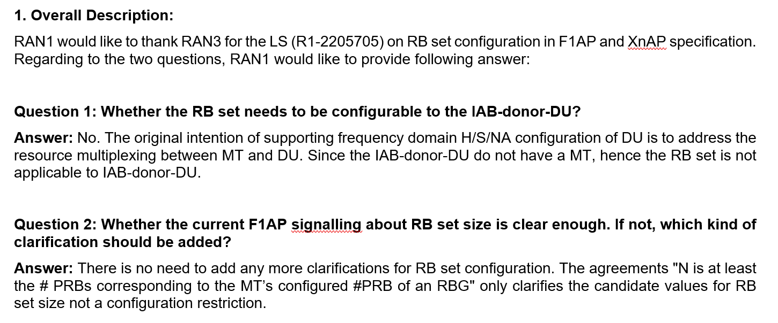
ZTE, Sanechips  [27] | Proposal 1: To clarify to RAN3 that the intention of RB set configuration in RAN1 is to achieve simultaneous operation of an IAB DU and its co-located IAB MT, and RB set configuration can be applied to IAB donor-DU if new use cases are identified by RAN3.  Proposal 2: Confirm with RAN3 that the current F1AP signalling about RB set size is clear enough
Nokia, Nokia Shanghai Bell  [28] | Proposal 2.1: Indicate to RAN3 that the IAB-donor-DU must be configurable with RB set configuration by the donor-CU.  Proposal 2.2: Indicate to RAN3 that the RB set configuration as provided in [X] is sufficiently clear and requires no further modification.
Ericsson  [29], [30] | Observation 1 A donor-DU does not share (time- and frequency) resources with a co-located MT, making a donor-DU RB set configuration superfluous.  Observation 2 As a parent node, the donor-DU will be limited by the (child) IAB-DU’s H/S/NA configuration in communication between the donor-DU and (child) IAB-MT which may be provided by an IAB-node to its parent node.  Observation 3 A donor-DU does not need an H/S/NA configuration about which other nodes need to be informed about for the sake of proper resource utilization.  Proposal 1 Clarify to RAN3 that there is no need to configure an RB set configuration to an IAB-donor-DU.  Proposal 2 Clarify to RAN3 that the RB set size in F1AP signalling relates to the MT’s configured #PRBs and this should be included in the F1AP RB set size description.

FL observation 5.1:
There is a split view on the first question, while the large majority of the companies is aligned on the second question. Further discussion is recommended.
Company | Comments
ZTE, Sanechips | OK
AT&T | Support the proposals from Qualcomm/Nokia. Time domain configuration at the Donor DU is already supported, so frequency domain coordination should be as well.
Intel | Fine with further discussion for 1st question.  In our view, the purpose of H/S/NA configuration for IAB-DU is to divide resources between co-located IAB-MT and IAB-DU in one IAB-node, there is no need for H/S/NA configuration as there is no IAB-MT in the donor node.
Ericsson | For the first question, we are fine with further discussion although we do not see a need for the donor-DU to have this configuration.  Regarding the second question, it is not a matter of majority but a matter of principle that we honor made agreements, and that agreements affecting the specification find their way into the specification. We have an agreement that “N is at least the # PRBs corresponding to the MT’s configured #PRB of an RBG” which is not reflected in the specification. If it is not included in the specification, there is nothing preventing an implementation opposing said agreement and still follow the specification. The referred RAN3 spec is the appropriate place for that and therefore it should be included there. If companies did not want this behavior, they should not have agreed to it in the first place.
Lenovo, Motorola Mobility | Fine with proposals from Qualcomm and Nokia.
NTT DOCOMO | Fine to further discuss.  For the first question, we think RB set may not need to be configurable for donor-DU.  For the second question, we think current signaling is clear enough.
Samsung | Fine to further discuss.
Huawei, HiSi | For the 1st question, as the IAB-donor-DU do not have a co-located MT as well as parent node and the donor DU do not have parent node which can semi-static or dynamically control the usability of the DU’s resources. Hence the RB set configuration is not needed for IAB-donor-DU.  For the second question, we have similar discussion before. The current RAN3 specification is clear and complete, which has provide sufficient configuration flexibly and no more clarification is needed.

Topic #6. Guard band for FDM operation

Related input from contributions:
Huawei, Hisilicon  [7] | Observation 3: Guard band can provide better frequency domain isolation and may be needed to enable the FDM operation between MT and DU.  Observation 4: Placing the guard band on DU resource by implementation to achieve the FDM violates the definition of DU hard resources.  Proposal 2: The guard band including its size and location should be made aware of by IAB node’s parent node and donor node to facilitate efficient FDM operation.
Ericsson  [9] | Observation 2 Allowing the DU unconditional use of Hard resources, irrespective of interference on Soft or Not Available resources, assumes static channel conditions and will require a different solution for Rel-18 mIAB.  Proposal 2 To address the adjacent channel leakage between RB sets in FDM operation, RAN1 to decide to adopt  a. Alt 1: RAN1 based solution, restricting Hard resource utilization, or  b. Alt 2: RAN4 based solution, imposing adjacent leakage requirements into NA and Soft-NIA resources.

FL observation 6.1:
This topic has been discussed in prior meetings and the majority view seemed aligned on managing any guard band requirement via implementation. That is consistent with the handling of the situation in Rel-16 where an IAB-node requiring TDM has a conflict between IAB-MT and IAB-DU handles such conflict by implementation. Moreover it is also possible for the CU to explicitly introduce Soft resources for RB sets at the edge of FDM regions. Furthermore additional signaling enhancements are to be avoided at this stage of this Rel-17 WI.

Company | Comments
ZTE, Sanechips | Support to handle the guard band via implementation.
AT&T | Don’t see a need for additional RAN1 impact, but open to discuss Ericsson’s Alt. 2 proposal to introduce RAN4 requirements.
Intel | Agree with the observation.
Vivo | Agree with the observation
Ericsson | We agree that further signaling should be avoided. Involving the CU to specify the guard band will be inefficient since the there is no signaling providing the CU with information about the required guard band and combined with DL Tx power adjustments will make such CU configuration inefficient. However, worse than that is that the parent-DU will not know that said Soft resource should exclusively be indicated IA to the IAB-DU due to interference. Hence, the proposed CU configuration cannot work. Only the IAB-node itself knows about its interference properties. The problem will be solved in one way or another, either by us or RAN4.
Lenovo, Motorola Mobility | Agree with the FL observation.
NTT DOCOMO | Agree that additional signaling enhancements are to be avoided
Huawei, HiSi | We explained in our contribution why we believe such issue cannot be addressed by implementation in our contribution. When the hard resources configured, DU will utilize it while IAB-MT does not transmit or receive, or IAB-MT would transmit or receive and DU’s transmission or reception is not changed due to a use of the symbol by the IAB-DU. With this definition, when transmission or reception on edge RB of MT is dynamic scheduled by parent, and DU is transmitting or receiving on the edge RB based on semi-static configuration, the interference due to lack of frequency isolation will impact the performance.  Regarding to Ericsson’s Alt 2, we don’t think RAN4 have sufficient time to discuss at current stage. Even such new requirement specified, we prefer a solution for all IABs even without satisfying new requirement should also be able to work with FDM.

Topic #7. TDD configuration enhancements for IAB-MT

Related input from contributions:
Huawei, Hisilicon  [7], [10] | Proposal 3: If an IAB-MT is additionally provided TDD-UL-DL-ConfigDedicated-IAB-MT, the parameter tdd-UL-DL-ConfigurationDedicated-IAB-MT overrides all symbols per slot over the number of slots as provided by tdd-UL-DL-ConfigurationCommon.  Proposal 4: To increase the resources for simultaneous operation, the specification should allow the collision between tdd-UL-DL-ConfigurationDedicated-IAB-MT and cell-specific signals/channels. In the slots with the collision, the IAB node should ignore tdd-UL-DL-ConfigurationDedicated-IAB-MT. The list of cell-specific signals/channels includes:  - SS/PBCH block  - CORESET for Type0-PDCCH CSS set  - PRACH  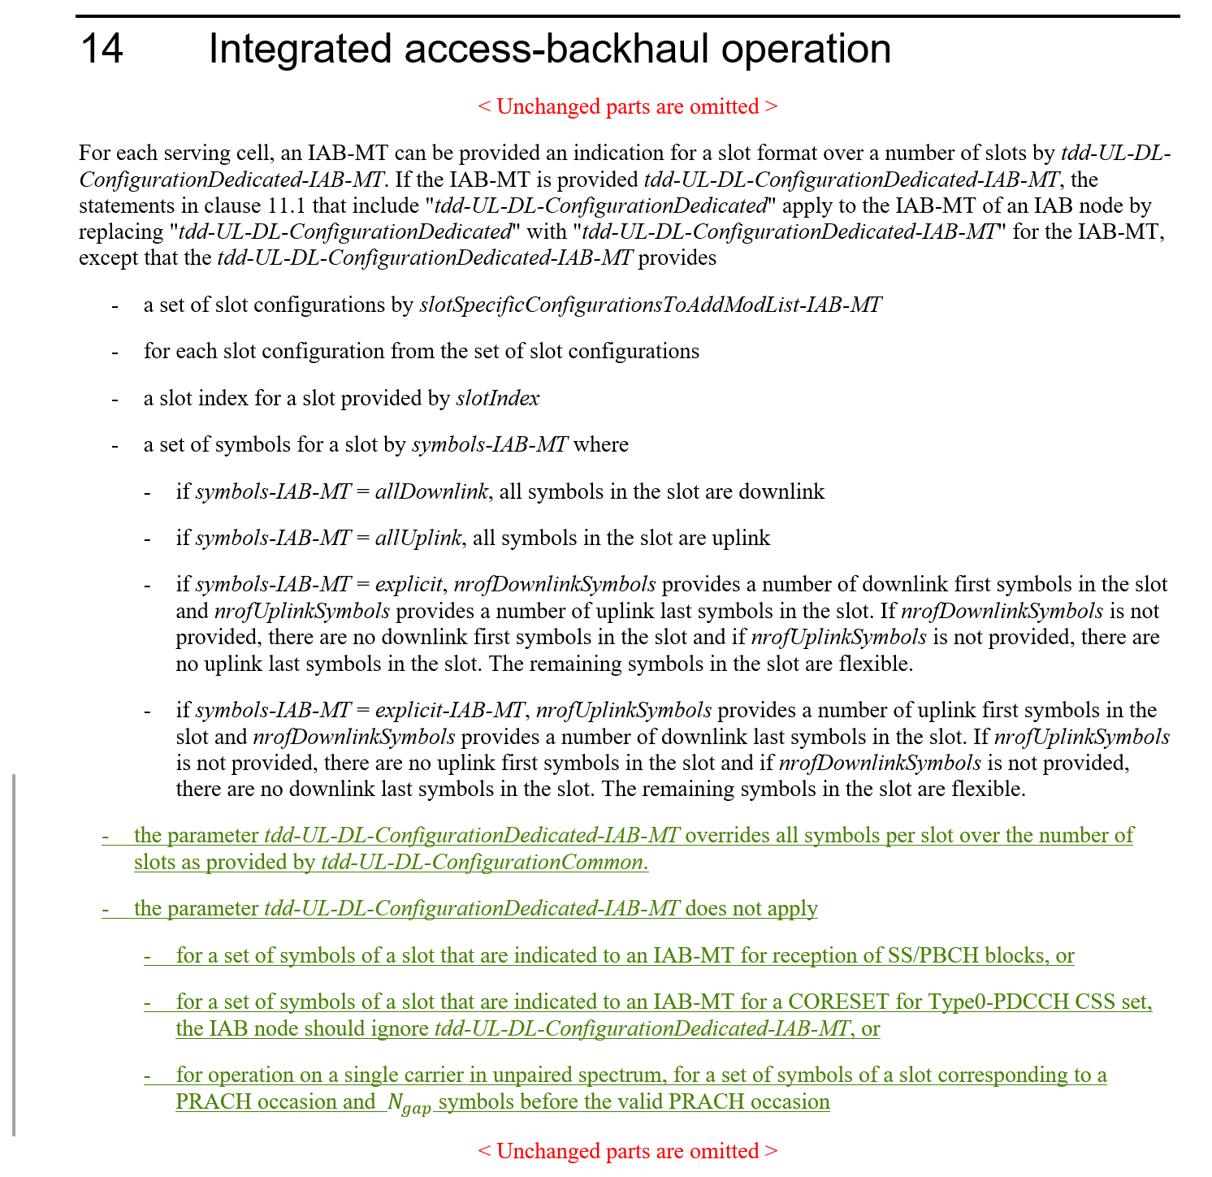

FL observation 7.1:
Discuss whether the following RAN1#99 agreement should be extended to Rel-17:
RAN1#99 Agreements:
If the IAB-MT is additionally provided TDD-UL-DL-ConfigDedicated-IAB-MT, the parameter TDD-UL-DL-ConfigDedicated-IAB-MT overrides all symbols (with a limitation that effectively only flexible symbols can be overwritten in Rel-16) per slot over the number of slots as provided by TDD-UL-DL-ConfigurationCommon.

Company | Comments
ZTE, Sanechips | Discussion on this optimization issue should be deprioritized in maintenance phase.
AT&T | Ok to support the proposals from Huawei
Intel | Fine to the extension to Rel-17.
Ericsson | We don’t see a need to discuss this agreement since the agreement has not been invalidated in Rel-17 and for that reason applies (and should apply) equally in Rel-17.
Lenovo, Motorola Mobility | This is how we understand the matter independent of whether it is further emphasized in the spec. We are fine either way.
NTT DOCOMO | We think it may not be necessary
Huawei, HiSi | We believe the change is necessary. Otherwise although Rel-17 introduced lot of functions/features to support enhanced multiplexing between MT and DU, due to the limitation introduced in Rel-16 on TDD, only few resources could apply enhanced multiplexing operation. And then the improvements of Rel-17 IAB may also be limited.

Topic #8. Corrections on misaligment for MAC CE or RRC parameters for eIAB TS 38.213
Related input from contributions:
ZTE, Sanechips  [11] | 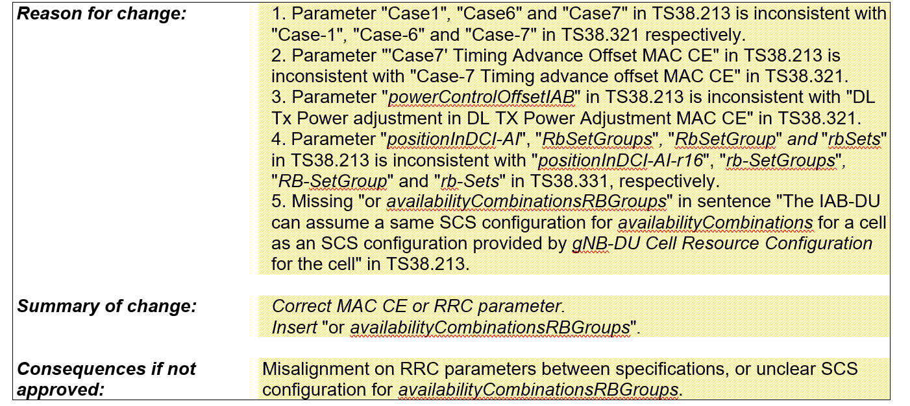

FL Proposal 8.1:
Endorse aforementioned CR.

Company | Comments
ZTE, Sanechips | Support
AT&T | Support
Intel | We agree.
Vivo | Support
Ericsson | Support
Lenovo, Motorola Mobility | Support
NTT DOCOMO | Support
Samsung | Support
Huawei, HiSi | We think the editorial changes can be taken care by the editor.

Topic #9. Correction on the formula of Case-7 UL Tx timing for eIAB in TS 38.213
Related input from contributions:
ZTE, Sanechips  [12] | 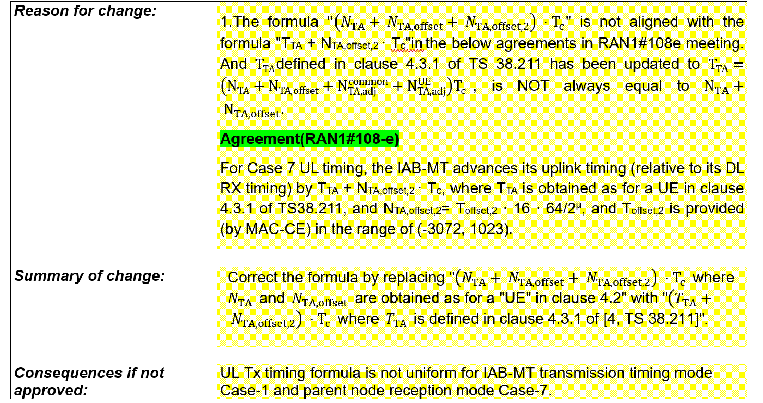

FL Proposal 9.1:
Endorse aforementioned CR.

Company | Comments
ZTE, Sanechips | Support
Intel | We’re not sure the CR is needed. Current version of (N_{TA} +N_{TA,offset} + N_{TA,offset,2})* T_{c} seems better and clear than put T_{TA} there.
Ericsson | We recognize the intention, but the proposed formula should be slightly modified. The correct formulation is given by removing the parenthesis:  The IAB-MT determines its uplink transmission timing as $\left(N_{TA}+ N_{TA,offset}+ N_{TA,offset,2}\right) ⋅T_{c}$ where $N_{TA}$ and $N_{TA,offset}$ are obtained as for a "UE" in clause 4.2  $T_{TA}+ N_{TA,offset,2}⋅T_{c}$ where $T_{\text{TA}}$ is defined in clause 4.3.1 of [4, TS 38.211]
NTT DOCOMO | In our understanding, the point is whether $N_{TA,adj}^{common}$ and $N_{TA,adj}^{UE}$ are needed for IAB. If $N_{TA,adj}^{common}$ and $N_{TA,adj}^{UE}$ are not used for IAB, the equation in current spec. and the equation in the CR become the same.
Samsung | Similar view with NTT DCM.
Huawei, HiSi | We think the change may not be necessary. Current version is crystal clear. While the $T_{TA}$ includes some other terms which is not related to IAB, it will be more ambiguous for IAB spec.

Topic #10. Correction on the position related to the description that the RB set is equivalent to hard for eIAB in TS 38.213
Related input from contributions:
ZTE, Sanechips  [13] | 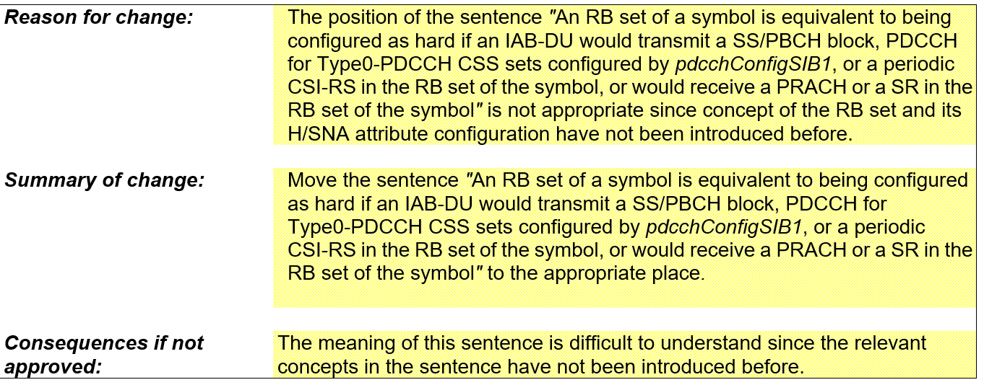

FL Proposal 10.1:
Endorse aforementioned CR.

Company | Comments
ZTE, Sanechips | Support
AT&T | Support
Vivo | Support
Ericsson | This proposal relates to FL Proposal 13.1, and they should be discussed jointly. We prefer FL Proposal 13.1.
NTT DOCOMO | Support
Samsung | Can be discussed together with 13.1
Huawei, HiSi | Ok.

Topic #11. Draft CR on guard symbols MAC CEs
Related input from contributions:
Ericsson  [21] | 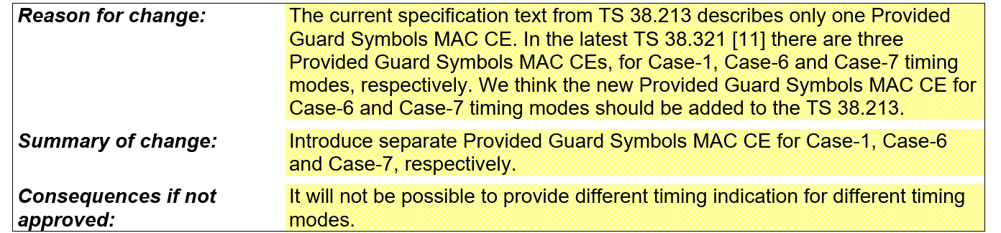  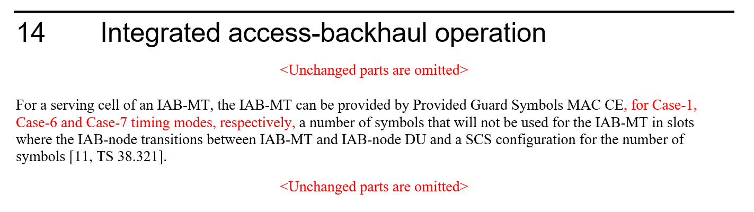

FL Proposal 11.1:
Endorse aforementioned CR.

Company | Comments
ZTE, Sanechips | OK
Intel | We don’t think this CR is needed.  As long as different guard symbol is provided by MAC CE for different mode, IAB should know the guard symbol is applied to the corresponding mode respectively. So the current spec is clear without the CR.
Ericsson | Support
NTT DOCOMO | Fine to support it.
Huawei, HiSi | We are OK for this.

Topic #12. Draft CR on timing case indication
Related input from contributions:
Ericsson  [22] | 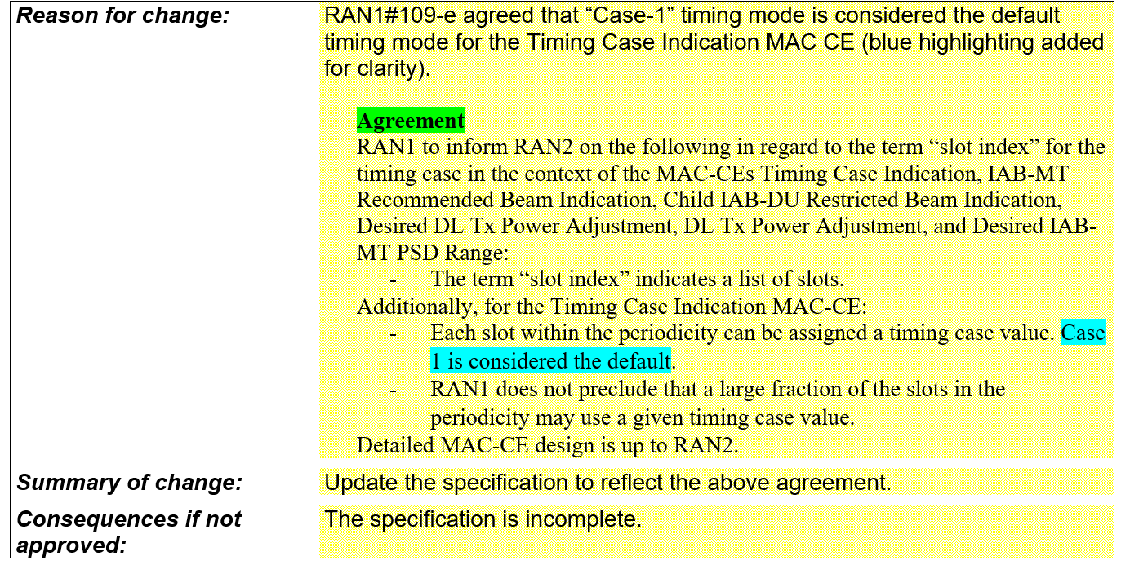  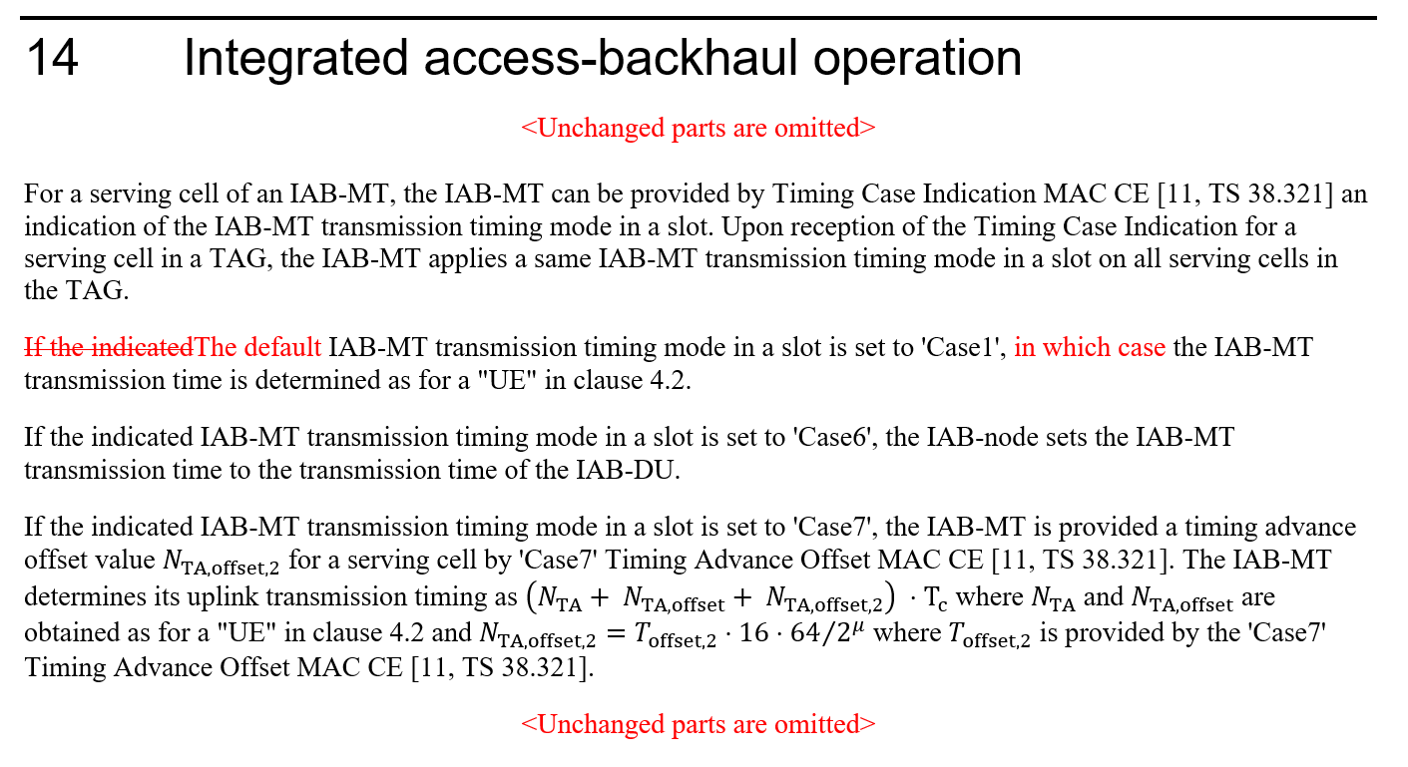

FL Proposal 12.1:
Endorse aforementioned CR.

Company | Comments
ZTE, Sanechips | From our point of view, the default timing mode is only applied on these slots which are within the periodicity but not listed by ‘slot index’. We prefer to change the text as:  If the indicated IAB-MT transmission timing mode in a slot is set to 'Case1' or the IAB-MT transmission timing mode indication in a slot is not provided, the IAB-MT transmission time is determined as for a "UE" in clause 4.2.
Intel | Fine with the CR.
Ericsson | Support
NTT DOCOMO | We prefer the version from ZTE. It is more clear than the aforementioned CR.
Huawei, HiSi | Indeed, there was an agreement that Case 1 timing can be a default one. However, according to the MAC-CE provided by RAN2, Case 1 timing can also be explicitly indicated. We can further discuss how to make this change, in RAN1 or RAN2.

Topic #13. Draft CR on Hard/Soft/Not Available resource definition
Related input from contributions:
Ericsson  [23] | 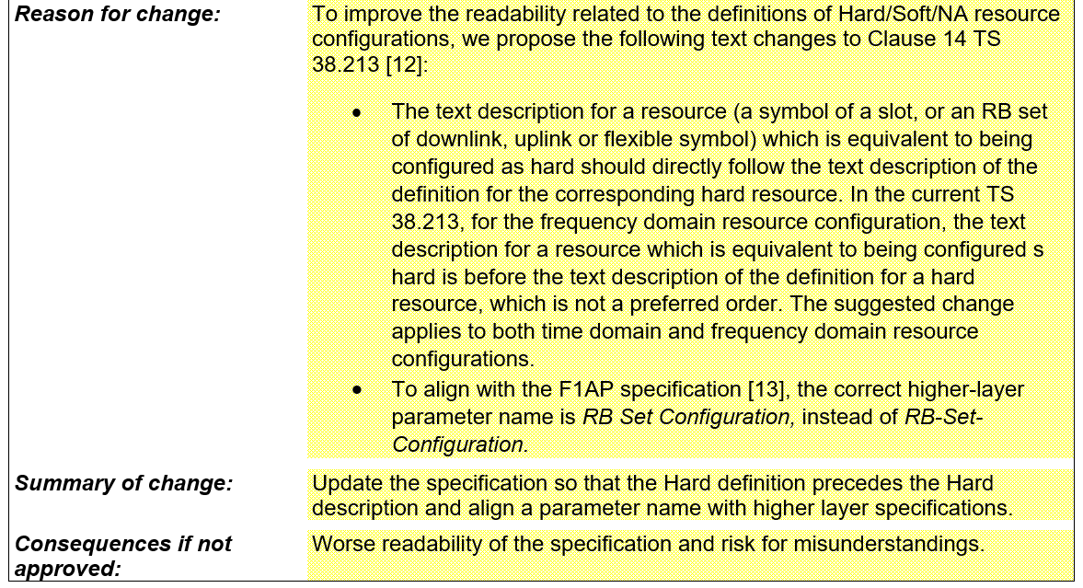  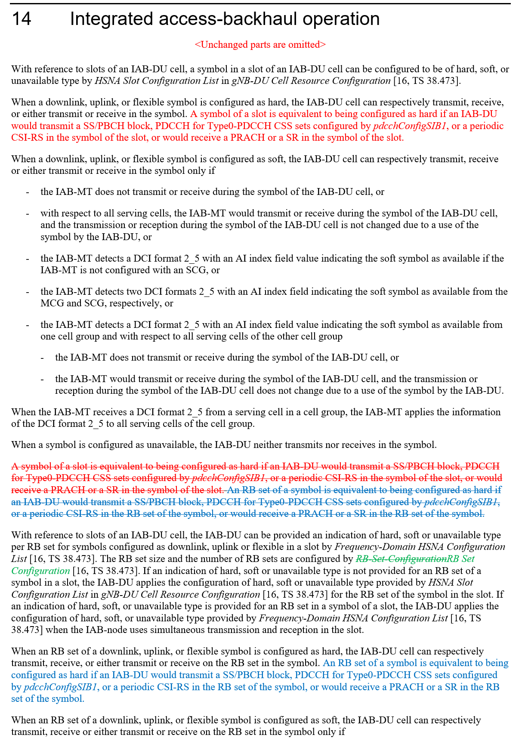

FL Proposal 13.1:
Endorse aforementioned CR.

Company | Comments
ZTE, Sanchips | It addresses the same issue as Topic #10, these two topics can be discussed together.
AT&T | Support
Intel | Fine with the CR.
Vivo | Support
Ericsson | Support
Lenovo, Motorola Mobility | Fine
NTT DOCOMO | Support
Samsung | OK with a suggestion from ZTE.
Huawei, HiSi | OK with the suggestion from ZTE. Can be handled same as other editorial changes.

References
[1] R1-2206206 Discussion on coexistence between Rel-16 and Rel-17 H/S/NA configuration, ZTE, Sanechips
[2] R1-2206508 Resource multiplexing in enhanced IAB systems, Lenovo
[3] R1-2206561 Remaining Issues on Frequency-domain Resource Multiplexing for IAB, Intel Corporation
[4] R1-2206803 Maintenance on Enhancements to NR IAB, Samsung
[5] R1-2206950 Discussions on eIAB CSI, ETRI
[6] R1-2207205 Remaining issues on eIAB, Qualcomm
[7] R1-2207521 Remaining issues on resource multiplexing for IAB, Huawei, HiSilicon
[8] R1-2207675 Discussion on DL Tx power control, Ericsson
[9] R1-2207679 Maintenance on enhanced IAB, Ericsson
[10] R1-2205808 Correction on TDD configuration for IAB-MT, Huawei, HiSilicon
[11] R1-2206202 Corrections on misalignment for MAC CE or RRC parameters for eIAB TS 38.213, ZTE, Sanechips
[12] R1-2206203 Correction on the formula of Case-7 UL Tx timing for eIAB in TS 38.213, ZTE, Sanechips
[13] R1-2206204 Correction on the position related to the description that the RB set is equivalent to hard for eIAB in TS 38.213, ZTE, Sanechips
[14] R1-2206205 Correction on coexistence between Rel-16 and Rel-17 H/S/NA configuration, ZTE, Sanechips
[15] R1-2206951 Draft CR on eIAB CSI, ETRI
[16] R1-2207204 Draft CR on eIAB, Qualcomm
[17] R1-2207373 On Handling for Rel-16 and Rel-17 Resource Configuration Conflicts, Nokia, Nokia Shanghai Bell
[18] R1-2207522 Correction on CQI derivation accounting for provided DL Tx power adjustment for IAB-MT, Huawei, HiSilicon
[19] R1-2207665 Correction on HSNA resource configuration for IAB, Huawei, HiSilicon
[20] R1-2207674 Draft CR on DL Tx power control, Ericsson
[21] R1-2207676 Draft CR on guard symbols MAC CEs, Ericsson
[22] R1-2207677 Draft CR on timing case indication, Ericsson
[23] R1-2207678 Draft CR on Hard/Soft/Not Available resource definition, Ericsson
[24] R1-2207673 Discussion on RAN4 LS on range of power control parameters for eIAB, Ericsson
[25] R1-2205803 On RB set configuration for IAB, Huawei, HiSilicon
[26] R1-2205804 Draft reply LS on RB set configuration for IAB, Huawei, HiSilicon
[27] R1-2206779 Draft Reply LS on RB set configuration for IAB, Samsung
[28] R1-2207374 On Rel-17 RB set configuration for IAB, Nokia, Nokia Shanghai Bell
[29] R1-2207671 Discussion on RAN3 LS on RB set configuration for IAB, Ericsson
[30] R1-2207672 [DRAFT] Reply LS on RB set configuration for IAB, Ericsson
[31] R1-2206761 Maintenance on Enhancements to Integrated Access and Backhaul, vivo
[32] R1-2206762 Corrections on resource availability indication, vivo

