3GPP TSG RAN WG1 Meeting #107-e R1-211xxxx
e-Meeting, November 11th – 19th, 2021

Agenda Item: 7.2.10
Source: Moderator (Huawei)
Title: Discussion on dormancy indication Case-1
Document for: Discussion and Decision

Introduction
This document aims to address the dormancy indication issue raised in [1] per the following.
[107-e-NR-MRDC-CA-01] Email discussion/approval on the issue raised in R1-2111934 using the two alternatives provided as the starting point, until November 17 – Yi Wang (Huawei)
It is suggested to have companies’ initial round of input by the following
- check point: November 15

Discussion
During the preparation phase a majority preference made in Preparation is to take Alt 1 in [1] while there are different preference made via emails considering the following agreements for Case 2 dormancy indication.
Agreement:
HARQ-ACK timeline of the Case 2 SCell dormancy indication DCI is defined by adding X symbols to the SPS release PDCCH HARQ-ACK timeline (i.e., X+N symbols)
- X = 4, 4, 5, 6 for capability #1 for μ =0,1,2,3
- X = 2, 2, 4 for capability #2 for μ =0,1,2

The above agreement applies to Case 2 SCell dormancy indication DCI without data scheduling, such that the PUCCH timeline is modified to be different from non-dormancy case due to potential interruption time. Now for Case 1 SCell dormancy indication, which was designed to be with data scheduling however was also extended to the cases of e.g. SPS release indication without scheduling data in the specification stage, it is unclear whether the same issue (i.e. interruption) may occur and needs to be accounted for, or the current specification may be maintained without changes.
Moderator assumes the issue has been well understood given previous discussion made for Case 2 and in the CR stage, some alternatives can be directly proposed as below. Draft CRs can be provided after some level of consensus for the proposals. The proposals are generated considering the majority preference is to maintain the function in spec therefore there seems to be a need to modify the timeline, while it is possible to take different approaches. Please see relevant proposal(s) and/or discussion point(s).

First round

Discussion Point 1
- In line with the function as in current specifications, which one do you prefer or accept?
  - Alt 1-a: no change to the current specifications (in which case a conclusion is possible)
  - Alt 1-b:
    - modify the HARQ-ACK timeline for Case 1 dormancy indication DCI indicating SPS release, using same values per SCS as that for Case 2 SCell dormancy indication, i.e.
      - HARQ-ACK timeline of the Case 1 SCell dormancy indication DCI is defined by adding X symbols to the SPS release PDCCH HARQ-ACK timeline (i.e., X+N symbols)
        - X = 4, 4, 5, 6 for capability #1 for μ =0,1,2,3
        - X = 2, 2, 4 for capability #2 for μ =0,1,2

Moderator Note: For DCI indicating release of UL grant Type 2 PUSCH or deactivating semi-persistent CSI report(s) on PUSCH, there is no HARQ-ACK on PUCCH so there is no need for change. An example TP to TS 38.213 in accordance to Alt 1-b can be as below. Comments for the example TP are also invited if you support/can accept Alt 1-b.

38.213 TP1
---------------------------------------- 38.213 TP1 start -----------------------------------------

10.3 PDCCH monitoring indication and dormancy/non-dormancy behaviour for SCells
==== Unchanged parts ====
A UE is expected to provide HARQ-ACK information in response to a detection of a DCI format 1_1 indicating SCell dormancy or in response to a detection of a DCI format 1_1 that indicates SPS PDSCH release and includes a SCell dormancy indication field after $N$ symbols from the last symbol of a PDCCH providing the DCI format 1_1. If processingType2Enabled of PDSCH-ServingCellConfig is set to enable for the serving cell with the PDCCH providing the DCI format 1_1, $N=7$ for $μ=0$, $N=7.5$ for $μ=1$, and $N=15$ for $μ=2$; otherwise, $N=14$ for $μ=0$, $N=16$ for $μ=1$, $N=27$ for $μ=2$, and $N=31$ for $μ=3$, where $μ$ is the smallest SCS configuration between the SCS configuration of the PDCCH providing the DCI format 1_1 and the SCS configuration of a PUCCH with the HARQ-ACK information in response to the detection of the DCI format 1_1.
==== Unchanged parts ====
----------------------------------------------- TP1 end ------------------------------------------------

Company | Alternatives | Comments
Qualcomm | None | Although we mentioned the timeline issue in the email discussion for preparation, we do not support either of the two proposals. Both are making new agreements when the original design in the agreement is not broken. Making new agreements for this kind of issue is out of the scope of CR phase.
ZTE | Alt 1-a | As we commented in the preparation phase, the current spec doesn’t have any limitation on the applicable RNTIs of Case1 SCell dormancy indication. Our understanding is that PDCCH not scheduling PDSCH/PUSCH should be allowed to indicate dormancy under Case 1, i.e., via SCell dormancy indication field instead of via reinterpretation of the other DCI fields.  Regarding the timeline issue, we were wondering whether the current spec can already cover this case since the spec says “in response to a detection of a DCI format 1_1 indicating SCell dormancy”, it seems the spec doesn’t restrict to Case 2 only. “DCI format 1_1 indicating SCell dormancy” can also cover Case 1 without scheduling PDSCH. But we can check whether this is RAN1’s common understanding.  A UE is expected to provide HARQ-ACK information in response to a detection of a DCI format 1_1 indicating SCell dormancy after $N$ symbols from the last symbol of a PDCCH providing the DCI format 1_1
MTK | We prefer Alt 2-a. If only comparing Alt 1-a and Alt 1-b, then Alt 1-b is better to us. | As we commented in the email reflector, there used to be a discussion in R1-2009575 (RAN1 reply LS to RAN4) about the timeline feasibility of DCI-based multiple BWP switch for dormancy, where only the timeline of scheduling DCI is discussed.  For non-scheduling DCI (Ex. for SPS release), the HARQ-ACK response should follow K1 value and it may not work for FR2 and Type 2 UE as shown in the two tables below  - due to the reason that the time duration corresponding to maximum K1 value is still smaller than the dormant BWP switch time for 120kHz SCS and Type 2 UE  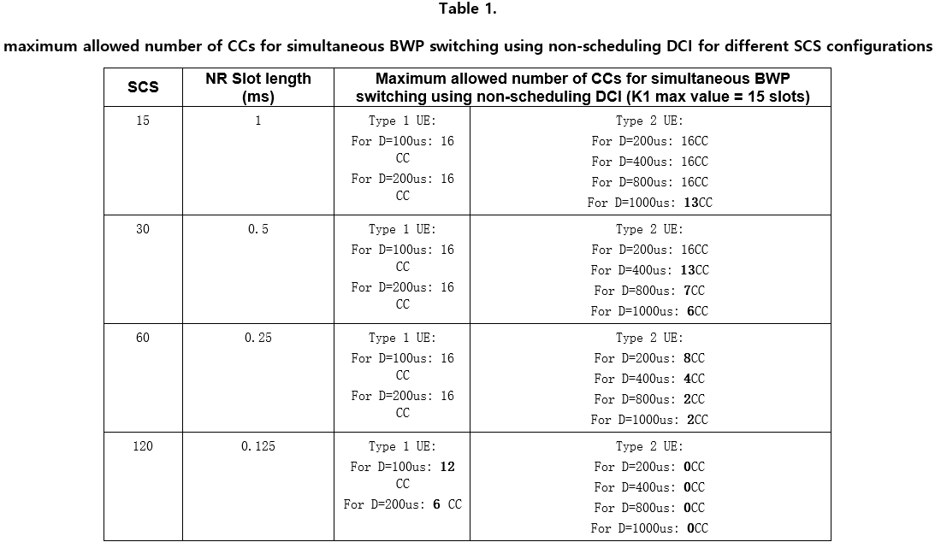  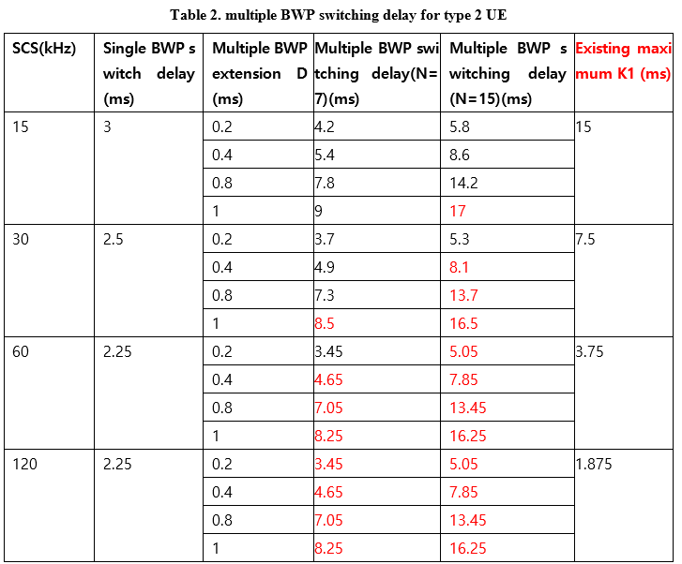
CATT | Alt 1a | No spec changes.
NTT DOCOMO | Alt.1b or Alt.2a | Based on the discussion so far, we see that multiple companies consider the interruption issue needs to be accounted. So, either Alt.1b or Alt.2a would be necessary, and we don’t have a strong view between them.
vivo | Alt 1a | No spec changes.  Conclusion may not be needed either – besides the dormancy indication, there are many other fields (other than the fields used for validation) in the DCI, but we don’t have conclusions for each of these fields.
Ericsson | Alt 1a

Discussion point 2
- If you consider the function can be (partially) removed, which one of the below do you prefer or can be acceptable?
  - Alt 2-a: do not support Case 1 dormancy indication for the DCI for release of semi-persistent PDSCH/PUSCH (including both CS-RNTI and SP-CSI-RNTI), in line with previous RAN1 agreements that Case 1 only refers to cases without scheduling data
    - Note: specification changes seem to be also needed for TS 38.212 in addition to the one submitted for TS 38.213 in [1]. TP examples (TP2, TP3) can be found in Appendix. If you prefer this Alt, comments to the TPs are also invited.
  - Alt 2-b: do not support Case 1 dormancy indication for the DCI scrambled with CS-RNTI
    - Note: this was proposed by one or two companies indicating the same as Case-2 SCell dormancy, by removing the function for DCI indicating SPS/configured grant activation and release. However, a following up question can be whether SP-CSI-RNTI is kept or not, as Case-2 SCell dormancy indication applies to neither. Specification changes seem to be needed for TS 38.212 and TS 38.213. More discussion are needed and no TP available at hand - can be provided later.
  - Alt 2-c: others, please provide details in the ‘Comments’ column of the below table.

Company | Alternatives | Comments
Qualcomm | Alt 2-a | Thanks the moderator for pointing out the difference between Alt 2-a and Alt 2-b. For Alt 2-b, the SPS activation DCI is available for Case 1 dormancy indication DCI as it schedules data. In this case, we support Alt 2-a which is fully aligned with the early agreements.
MTK | Alt 2-a | Same view as QC.
Intel | Alt 2-a | Since we already have multiple means to trigger SCell dormancy switching, it will be fine to go with a simple solution.  If majority company prefers to allow it, Alt 1-b is our second preference.
CATT | Alt 2-a | Alt2-a is consistent with RAN1 agreements
vivo | Alt 2-a | In case to remove this function, Alt 2-a seems to be more clear and complete.
Ericsson | Alt 2-c | We prefer to keep current spec.  Since we are in essential corrections stage, we would like proponents to explain what would be the impact if current specs are retained.

Second round
According to the first round of discussion in section 2.1,
- 4 companies (ZTE, CATT, vivo, Ericsson) indicate preference of Alt 1-a (no change of specs) while 2 of them (CATT, vivo) are also ok to accept Alt 2-a in case alignment with previous RAN1 agreements and timeline issue resolution is needed
- 2 companies (MTK, NTT DOCOMO) indicate Alt 1-b while also Ok/better to have Alt 2-a.

Furthermore, it seems 2 companies are only Ok with Alt 1-a whereas one of them consider the timeline issue is already resolved by “in response to a detection of a DCI format 1_1 indicating SCell dormancy” for Case-1. However, it is the Moderator understanding that, according to the previous discussion, the term of “SCell dormancy indication” in the specification refers to Case-2 only, i.e. without scheduling data, in line with previous agreements and the specification spirit that SPS PDSCH release and DCI format 1_1 indicating SCell dormancy coexist together in multiple places as different things. With that, it is Moderator observation that this company also in principle agrees with the timeline issue that is raised. This could also be the consequence that the timeline issue is not resolved if the current specs are retained.

Therefore, Alt 1-a/2-c is insisted by one company in principle and Alt 2-b does not gain any support in this round of discussion, in the meantime Alt 2-a is Ok with majority. Moderator suggests we take Alt 2-a since it anyway follows previous RAN1 agreements and can resolve the timeline issue in a clear manner. With that, it does not seem to cause any further issue since dormancy can still be indicated with dynamic scheduling DCIs, which should cover most typical cases.

Moderator proposal
  - Alt 2-a-update: do not support Case 1 dormancy indication for the DCI for release of semi-persistent PDSCH/PUSCH (including both CS-RNTI and SP-CSI-RNTI), in line with previous RAN1 agreements that Case 1 only refers to cases without scheduling data
    - Endorse CRs based on TP2 and TP3 respectively
    - Note: specification changes seem to be also needed for TS 38.212 in addition to the one submitted for TS 38.213 in [1]. TP examples (TP2, TP3) can be found in Appendix. If you prefer this Alt, comments to the TPs are also invited.

Moderator note: fixing a typo of “without”. Comments to Moderator updated proposal are invited.

Company | Yes/No | Comments

Conclusion
TBD

References
- R1-2111934, Discussion on Case-1 dormancy operation with data scheduling.

Appendix

TP2 and TP3 for Alt 2-a
---------------------------------------- 38.213 TP2 start -----------------------------------------

10.3 PDCCH monitoring indication and dormancy/non-dormancy behaviour for SCells
==== Unchanged parts ====
If a UE is provided search space sets to monitor PDCCH for detection of DCI format 0_1 and DCI format 1_1 and if one or both of DCI format 0_1 and DCI format 1_1 include a SCell dormancy indication field,
- the SCell dormancy indication field is a bitmap with size equal to a number of groups of configured SCells, provided by dormancyGroupWithinActiveTime,
- each bit of the bitmap corresponds to a group of configured SCells from the number of groups of configured Scells
- if the UE detects a DCI format 0_1 or a DCI format 1_1 that does not include a carrier indicator field, or detects a DCI format 0_1 or DCI format 1_1 that includes a carrier indicator field with value equal to 0, and if a DCI format 0_1 is detected and the DCI format 0_1 does not indicate UL grant Type 2 release or deactivate semi-persistent CSI report(s) on PUSCH, or if a DCI format 1_1 is detected and the DCI format 1_1 does not indicate SPS PDSCH release
- a '0' value for a bit of the bitmap indicates an active DL BWP, provided by dormantBWP-Id, for the UE for each activated SCell in the corresponding group of configured SCells
- a '1' value for a bit of the bitmap indicates
- an active DL BWP, provided by firstWithinActiveTimeBWP-Id, for the UE for each activated SCell in the corresponding group of configured SCells, if a current active DL BWP is the dormant DL BWP
- a current active DL BWP, for the UE for each activated SCell in the corresponding group of configured SCells, if the current active DL BWP is not the dormant DL BWP
- the UE sets the active DL BWP to the indicated active DL BWP
==== Unchanged parts ====
----------------------------------------------- TP2 end ------------------------------------------------
---------------------------------------- 38.212 TP3 start -----------------------------------------

7.3.1.1.2 Format 0_1
==== Unchanged parts ====
The following information is transmitted by means of the DCI format 0_1 with CRC scrambled by C-RNTI or CS-RNTI or SP-CSI-RNTI or MCS-C-RNTI:
==== Unchanged parts ====
- SCell dormancy indication – 0 bit if higher layer parameter dormancyGroupWithinActiveTime is not configured; otherwise 1, 2, 3, 4 or 5 bits bitmap determined according to higher layer parameter dormancyGroupWithinActiveTime, where each bit corresponds to one of the SCell group(s) configured by higher layers parameter dormancyGroupWithinActiveTime, with MSB to LSB of the bitmap corresponding to the first to last configured SCell group. The field is only present when this format is carried by PDCCH on the primary cell within DRX Active Time and the UE is configured with at least two DL BWPs for an SCell. The field is reserved if this format indicates UL grant Type 2 release according to Clause 10.2 of [5, TS 38.213] or deactivates semi-persistent CSI report(s) on PUSCH according to Clause 5.2.1.5.2 of [6, TS 38.214].

==== Unchanged parts ====

7.3.1.2.2 Format 1_1
==== Unchanged parts ====
The following information is transmitted by means of the DCI format 1_1 with CRC scrambled by C-RNTI or CS-RNTI or MCS-C-RNTI:
==== Unchanged parts ====
- SCell dormancy indication – 0 bit if higher layer parameter dormancyGroupWithinActiveTime is not configured; otherwise 1, 2, 3, 4 or 5 bits bitmap determined according to higher layer parameter dormancyGroupWithinActiveTime, where each bit corresponds to one of the SCell group(s) configured by higher layers parameter dormancyGroupWithinActiveTime, with MSB to LSB of the bitmap corresponding to the first to last configured SCell group. The field is only present when this format is carried by PDCCH on the primary cell within DRX Active Time and the UE is configured with at least two DL BWPs for an SCell. The field is reserved if this format indicates SPS PDSCH release according to Clause 10.2 of [5, TS 38.213].
----------------------------------------------- TP3 end ------------------------------------------------

