3GPP TSG RAN WG1 Meeting #106-e [R1-210xxxx]
e-Meeting, August 16th – 27th, 2021

Agenda Item: 8.13.2
Source: Moderator (Huawei)
Title: Summary#1 of efficient SCell activation/de-activation mechanism of NR CA
Document for: Discussion and Decision

Introduction
This summary is about the email discussion of RRC parameters for SCell activation enhancement. Per Chair’s guidance, this email discussion does not make any RAN1 decision for RRC parameters but provides good starting-point for the first version of RRC parameters that will be consolidated in October meeting.
[Post-106-e-Rel17-RRC-14] LTE_NR_DC_enh2 – to be moderated by Frank (Huawei)
- From September 1 until September 10

Schedule
Let’s have multiple check points for this email discussion as below, so that we have
- 1st check point: September 23 UTC 213:59
- 2nd check point: September 67 UTC 23:59
- Wrap-up check: September 89 UTC 213:59

A draft list of RRC parameters can be found in file v000 in the draft folder under 8.13.2. Since there are two alternatives under discussion for MAC-CE to trigger temporary RS(s), the common RRC parameters are mainly targeted.
To facilitate the discussion, for those parameters specific to any alternative, they are also listed to provide a big picture for the discussion but their names are still kept in brackets since no agreement about which alternative to go yet. Additionally, the existing RRC parameters/structure that are reused by new RRC parameters are also listed with green mark.
For the first two check points, the major columns #C, E, G, H, J, K, P are prioritized because they mainly shape the structure of RRC parameters. With stable major columns, columns #L, M, N are much easier to be discussed.

For your convenience, two diagrams for Alt.1 and Alt.2 are also provided below, respectively, to better understand the relationships between RRC parameters listed in the excel file.
Alt.1: For example, received MAC-CE value per cell => the corresponding entry number in a per-cell list => the entry number refers to a configuration of temporary RS per cell
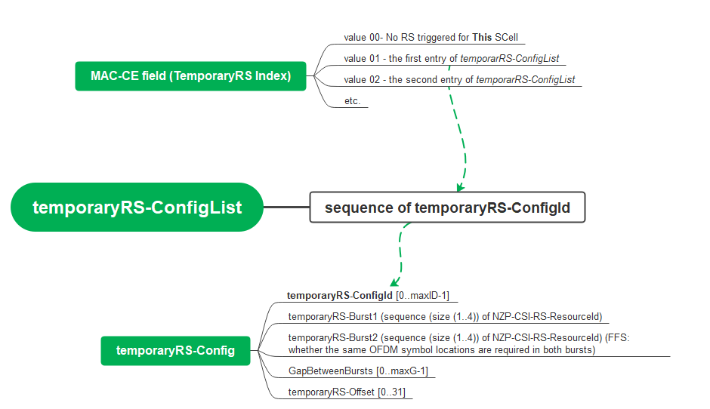

Alt.2: For example, received MAC-CE value for all cells => the corresponding trigger state number in a list => the state number refers to a list of “Configinfo” where each “Configinfo” for one cell => an entry number provided in each “Configinfo” => the entry number refers to a configuration of temporary RS for a cell
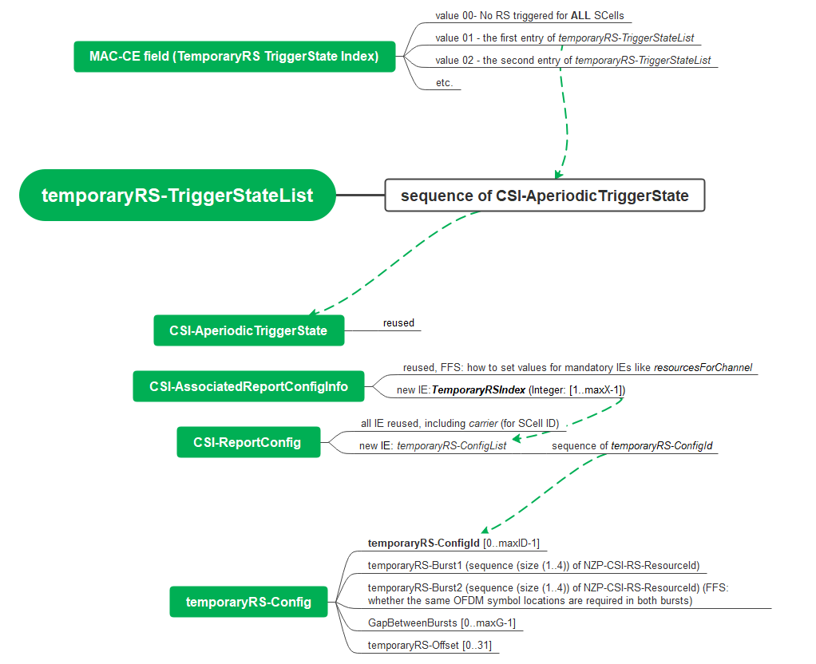

If any suggestions on the schedule, they are welcome here.
Company | View
OPPO | We are generally fine. Just one comment: this discussion of RRC parameter is out of official RAN1 meeting window, so the resulted RRC structure and definition after September 8 are still subject to modification due to future RAN1 decision, rather than serve as restriction to future RAN1 decision.
Qualcomm | I took a liberty to update the timeline of the email discussion above based on the moderator’s update.  - 1st check point: September 23 UTC 213:59  - 2nd check point: September 67 UTC 23:59  - Wrap-up check: September 89 UTC 213:59

Discussions

Common RRC parameters
In this section, rows #2 - #13 are discussed.

Major columns #C, E, G, H, J, K, P
Question: For these columns, any suggested change to rows #2 to #13?
The discussion is based on file v000.
Your comments are welcome! To better incorporate your suggested change into the excel file, it is appreciated if your comments could be provided in the following suggested form. Since the suggested change may be provided in a form of table. Let’s stack companies’ comments in a similar way to email reply. For example,
[The previous comments from other companies]
======= (breaking line)
[OPPO]
//comment#1
[Concerned Parameter name: row#4, temporaryRSBurst1-Resources]
[The configuration for each temporary RS burst in proposed RRC structure is built upon NZP-CSI-RS-ResourceID. However, RAN1 agreed temporary RS comes from TRS, while the RRC configuration for TRS is relating to RRC parameter NZP-CSI-RS-ResourceSet, instead of NZP-CSI-RS-Resource.
------- 38.214 text for TRS configuration:
A UE in RRC connected mode is expected to receive the higher layer UE specific configuration of a NZP-CSI-RS-ResourceSet configured with higher layer parameter trs-Info
-------
In addition, the proposal of “sequence (size(1..4))” seems to allow 1 or 3 samples per burst, which does not align with existing spec for TRS and temp-RS as well. We think this configuration needs more discussion.
]
[Proposed changes to the row with track in color], e.g.

LTE_NR_DC_enh2-Core |  | 38.214 |  |  |  | temporaryRSBurst1-Resources | New |  | Resource configuration for a temporary burst. (periodicityAndOffset and qcl-InfoPeriodicCSI-RS within NZP-CSI-RS-Resource are not configured for temporary RS). | SEQUENCE (SIZE (1..4)) OF NZP-CSI-RS-ResourceId  NZP-CSI-RS-ResourceSetID |  | per cell | UE-specific

//comment#2
[Concerned Parameter name: row#5, temporaryRSBurst2-Resources]
[The proposal allows independent CSI-RS/TRS patterns between two bursts. This does not match our understanding to the context of RAN1 discussion, which tries to break the existing restriction between trs_info and repetition. Meanwhile, to have the same CSI-RS pattern (in both time domain and frequency domain) across all temporary RS samples in all bursts would simplify UE implementation. So we prefer to a configuration that can lock this benefit. To be more specific, the 2nd burst information can be contained in NZP-CSI-RS-ResourceSet of row#4, while the starting symbol of the 2nd burst is a part of gap indication between two bursts. So the row#5 can be removed. ]
[Proposed change with track in color],
LTE_NR_DC_enh2-Core |  | 38.214 |  |  |  | temporaryRSBurst2-Resources | New |  | Resource configuration for the second temporary burst, Optional (periodicityAndOffset and qcl-InfoPeriodicCSI-RS within NZP-CSI-RS-Resource are not configured for temporary RS) ( FFS: whether the same OFDM symbol locations are required in both bursts) | SEQUENCE (SIZE (1..4)) OF NZP-CSI-RS-ResourceId |  | per cell | UE-specific

//comment#3
[Concerned Parameter name: row#8 ~ row#12]
[In our view, these rows are not needed, given the corresponding information is already given by associated NZP-CSI-RS-ResourceSet.]

======= (breaking line)
[Qualcomm]
//comment#1
[Concerned Parameter name: row#1-13]
[Your detailed comments] The primary discussion point for Alt.2 is whether we can fully reuse existing RRC parameters. Currently, the specifications already enable an A-TRS transmission where an A-TRS is composed of 4 CSI-RS resources on two consecutive slots. The necessary change for temporary RS is to enable triggering two A-TRSs where one A-TRS is in a set of two consecutive slots and another A-TRS is in another set of two consecutive slots with a gap in-between based on a single triggering state. We consider this would be possible without changing RRC configuration itself.
[Proposed changes to the row with track in color] for the time being, remove all “Alt.2” from the spreadsheet as a starting point. Note that comment #1 focuses on Alt.2.
LTE_NR_DC_enh2-Core |  | 38.214 |  | [ServingCellConfig or CSI-ReportConfig] |  | temporaryRS-ConfigList | New |  | List of temporary RS configurations. | SEQUENCE (SIZE (1..maxX)) OF temporaryRS-ConfigId, maxX is TBD |  | per cell | UE-specific | 38.331 | Common for both Alt.1 and Alt.2 but with different Parent IE  Alt1: Parent IE may be ServingCellConfig  Alt2: Parent IE may be CSI-ReportConfig
LTE_NR_DC_enh2-Core |  | 38.214 |  | temporaryRS-Config |  | temporaryRS-ConfigId | New |  | Temporary RS configuration ID. | INTEGER (0..maxID-1), FFS: whether maxID=maxX | N/A | per cell | UE-specific | 38.331 | Common for both Alt.1 and Alt. 2
LTE_NR_DC_enh2-Core |  | 38.214 |  | temporaryRS-Config |  | temporaryRSBurst1-Resources | New |  | Resource configuration for a temporary burst. (periodicityAndOffset and qcl-InfoPeriodicCSI-RS within NZP-CSI-RS-Resource are not configured for temporary RS) | SEQUENCE (SIZE (1..4)) OF NZP-CSI-RS-ResourceId | N/A | per cell | UE-specific | 38.331 | Common for both Alt.1 and Alt. 2
LTE_NR_DC_enh2-Core |  | 38.214 |  | temporaryRS-Config |  | temporaryRSBurst2-Resources | New |  | Resource configuration for the second temporary burst, Optional (periodicityAndOffset and qcl-InfoPeriodicCSI-RS within NZP-CSI-RS-Resource are not configured for temporary RS) ( FFS: whether the same OFDM symbol locations are required in both bursts) | SEQUENCE (SIZE (1..4)) OF NZP-CSI-RS-ResourceId | N/A | per cell | UE-specific | 38.331 | Common for both Alt.1 and Alt. 2
LTE_NR_DC_enh2-Core |  | 38.214 |  | temporaryRS-Config |  | gapBetweenTemporaryRSbursts | New |  | The gap length between two temporary RS bursts, if temporaryRSBurst2-Resources (two temporary RS bursts) is indicated. | TBD (unit of slot or symbol) | FFS | per cell | UE-specific | 38.331 | Common for both Alt.1 and Alt. 2
LTE_NR_DC_enh2-Core |  | 38.214 |  | temporaryRS-Config |  | temporaryRS-TriggeringSlotOffset | New |  | Offset X between the reference slot for triggering offset of temporary RS and the slot in which the temporary RS burtst(s) is transmitted. | [0..maxG-1]; TBD maxG, (unit of slot) | FFS | per cell | UE-specific | 38.331 | Common for both Alt.1 and Alt. 2
LTE_NR_DC_enh2-Core |  | 38.214 |  | NZP-CSI-RS-Resource |  | nzp-CSI-RS-ResourceId | existing |  | For Temporary RS resource ID. |  |  |  | UE-specific | 38.331 | Common for both Alt.1 and Alt. 2
LTE_NR_DC_enh2-Core |  | 38.214 |  | NZP-CSI-RS-Resource |  | resourceMapping | existing |  | OFDM symbol location(s) in a slot and subcarrier occupancy in a PRB of the temporary RS resource. |  |  |  | UE-specific | 38.331 | Common for both Alt.1 and Alt. 2
LTE_NR_DC_enh2-Core |  | 38.214 |  | NZP-CSI-RS-Resource |  | powerControlOffset | existing |  | Power offset of PDSCH RE to NZP CSI-RS RE. Value in dB. |  |  |  | UE-specific | 38.331 | Common for both Alt.1 and Alt. 2
LTE_NR_DC_enh2-Core |  | 38.214 |  | NZP-CSI-RS-Resource |  | powerControlOffsetSS | existing |  | Power offset of NZP CSI-RS RE to SSS RE. Value in dB. |  |  |  | UE-specific | 38.331 | Common for both Alt.1 and Alt. 2
LTE_NR_DC_enh2-Core |  | 38.214 |  | NZP-CSI-RS-Resource |  | scramblingID | existing |  | Scrambling ID. |  |  |  | UE-specific | 38.331 | Common for both Alt.1 and Alt. 2
LTE_NR_DC_enh2-Core |  | 38.214 |  | NZP-CSI-RS-Resource |  | qcl-InfoTemporaryRS | New |  | For a target temporary RS, contains a reference to one TCI-State in TCI-States for providing the QCL source and QCL type. | TBD | N/A | per cell | UE-specific | 38.331 | Common for both Alt.1 and Alt. 2

//comment#2
[Concerned Parameter name: row#1-13]
[Your detailed comments] For Alt.1, the key point is that the MAC-CE indicates the temporary RS [configuration index] for each SCell. Even for Alt.1, it seems that the existing RRC parameters/configurations can mostly be re-used. The temporary RS [configuration index] points to a particular configuration that includes necessary parameters to identify temporary RS structure and timing offset for a given SCell. The configuration can be a CSI-ResourceConfig that lists one or multiple NZP-CSI-RS-ResourceSet. As moderator indicates in row #8 of the spreadsheet, CSI-ResourceConfig has its own ID, CSI-ResourceConfigId, which can be re-used as the temporary RS index. Since SCell index is directly indicated by the MAC-CE in Alt.1, involving CSI-ReportConfig is not necessary. As such, overall, the necessary enhancement for Alt.1 is to enable association between a value of “Z-bit block in the bitmap” for a given SCell and the CSI-ResourceConfigId for the same SCell. This can be realized by defining a per serving cell configuration that lists CSI-ResourceConfigId for the SCell, i.e., temporaryRS-ConfigList in row #2 of the spreadsheet. It can be FFS whether the association is based on entry number of the list, or descending order of the ID values in the list, etc.
[Proposed changes to the row with track in color] Remove rows #3 - #13 and modify row #2 as follows.
LTE_NR_DC_enh2-Core |  | 38.214 |  | [ServingCellConfig or CSI-ReportConfig] |  | temporaryRS-ConfigList | New |  | List of CSI-ResourceConfigId temporary RS configurations for Alt.1.  Each CSI-ResourceConfigId is associated to a value of Z-bit block in the bitmap.  [Entry number n in this list is associated to n-th codepoint of the Z-bit block or descending order of the ID values in the list, etc.] | SEQUENCE (SIZE (1..maxX)) OF CSI-ResourceConfigId temporaryRS-ConfigId, maxX is TBD |  | per cell | UE-specific | 38.331 | Common for both Alt.1 and Alt.2 but with different Parent IE  Alt1: Parent IE may be ServingCellConfig  Alt2: Parent IE may be CSI-ReportConfig
LTE_NR_DC_enh2-Core |  | 38.214 |  | temporaryRS-Config |  | temporaryRS-ConfigId | New |  | Temporary RS configuration ID. | INTEGER (0..maxID-1), FFS: whether maxID=maxX | N/A | per cell | UE-specific | 38.331 | Common for both Alt.1 and Alt. 2
LTE_NR_DC_enh2-Core |  | 38.214 |  | temporaryRS-Config |  | temporaryRSBurst1-Resources | New |  | Resource configuration for a temporary burst. (periodicityAndOffset and qcl-InfoPeriodicCSI-RS within NZP-CSI-RS-Resource are not configured for temporary RS) | SEQUENCE (SIZE (1..4)) OF NZP-CSI-RS-ResourceId | N/A | per cell | UE-specific | 38.331 | Common for both Alt.1 and Alt. 2
LTE_NR_DC_enh2-Core |  | 38.214 |  | temporaryRS-Config |  | temporaryRSBurst2-Resources | New |  | Resource configuration for the second temporary burst, Optional (periodicityAndOffset and qcl-InfoPeriodicCSI-RS within NZP-CSI-RS-Resource are not configured for temporary RS) ( FFS: whether the same OFDM symbol locations are required in both bursts) | SEQUENCE (SIZE (1..4)) OF NZP-CSI-RS-ResourceId | N/A | per cell | UE-specific | 38.331 | Common for both Alt.1 and Alt. 2
LTE_NR_DC_enh2-Core |  | 38.214 |  | temporaryRS-Config |  | gapBetweenTemporaryRSbursts | New |  | The gap length between two temporary RS bursts, if temporaryRSBurst2-Resources (two temporary RS bursts) is indicated. | TBD (unit of slot or symbol) | FFS | per cell | UE-specific | 38.331 | Common for both Alt.1 and Alt. 2
LTE_NR_DC_enh2-Core |  | 38.214 |  | temporaryRS-Config |  | temporaryRS-TriggeringSlotOffset | New |  | Offset X between the reference slot for triggering offset of temporary RS and the slot in which the temporary RS burtst(s) is transmitted. | [0..maxG-1]; TBD maxG, (unit of slot) | FFS | per cell | UE-specific | 38.331 | Common for both Alt.1 and Alt. 2
LTE_NR_DC_enh2-Core |  | 38.214 |  | NZP-CSI-RS-Resource |  | nzp-CSI-RS-ResourceId | existing |  | For Temporary RS resource ID. |  |  |  | UE-specific | 38.331 | Common for both Alt.1 and Alt. 2
LTE_NR_DC_enh2-Core |  | 38.214 |  | NZP-CSI-RS-Resource |  | resourceMapping | existing |  | OFDM symbol location(s) in a slot and subcarrier occupancy in a PRB of the temporary RS resource. |  |  |  | UE-specific | 38.331 | Common for both Alt.1 and Alt. 2
LTE_NR_DC_enh2-Core |  | 38.214 |  | NZP-CSI-RS-Resource |  | powerControlOffset | existing |  | Power offset of PDSCH RE to NZP CSI-RS RE. Value in dB. |  |  |  | UE-specific | 38.331 | Common for both Alt.1 and Alt. 2
LTE_NR_DC_enh2-Core |  | 38.214 |  | NZP-CSI-RS-Resource |  | powerControlOffsetSS | existing |  | Power offset of NZP CSI-RS RE to SSS RE. Value in dB. |  |  |  | UE-specific | 38.331 | Common for both Alt.1 and Alt. 2
LTE_NR_DC_enh2-Core |  | 38.214 |  | NZP-CSI-RS-Resource |  | scramblingID | existing |  | Scrambling ID. |  |  |  | UE-specific | 38.331 | Common for both Alt.1 and Alt. 2
LTE_NR_DC_enh2-Core |  | 38.214 |  | NZP-CSI-RS-Resource |  | qcl-InfoTemporaryRS | New |  | For a target temporary RS, contains a reference to one TCI-State in TCI-States for providing the QCL source and QCL type. | TBD | N/A | per cell | UE-specific | 38.331 | Common for both Alt.1 and Alt. 2

=======
Moderator
@OPPO, regarding your comment#1 on row#4, maybe we can start with the following IE for P-TRS/A-TRS and align our understanding on them first.
Under NZP-CSI-RS-ResourceSet:
nzp-CSI-RS-Resources SEQUENCE (SIZE (1..maxNrofNZP-CSI-RS-ResourcesPerSet)) OF NZP-CSI-RS-ResourceId,
In FL understanding, a UE is configured with a sequence of size 4 of NZP-CSI-RS-ResourceId in case of P-TRS/A-TRS with 4 resources in two consecutive slots. The structure of RRC parameters is much flexible to indicate more resources and more slots because it is not dedicated to TRS only but support all kinds of NZP-CSI-RS. As a result, the constraints, such as “four periodic NZP CSI-RS resources in two consecutive slots”, are only reflected in TS 38.214. Such handling could be reused for temporary RS, i.e. the detailed constraints of time domain structure for a burst is captured in TS 38.214 rather than the RRC parameter itself.
In FL draft excel file, the same handling is assumed, i.e. nzp-CSI-RS-Resources is reused as temporaryRSBurst1-Resources. Thank you for suggesting to reuse its parent IE instead, i.e. NZP-CSI-RS-ResourceSet. However, many unnecessary IEs within NZP-CSI-RS-ResourceSet are never used for temporary RS, as copied below. Therefore, the FL draft seems better than your suggested change. Additionally, as shown in the diagram in Section 1, the temporaryRS-Config already serves the purpose of original NZP-CSI-RS-ResourceSet, and considering forward-compatibility, it prevents any negative impact to NZP-CSI-RS-ResourceSet from any future introduction of any IE that is specific to temporary RS. As a result, it seems no need to have additional level of nested structure.
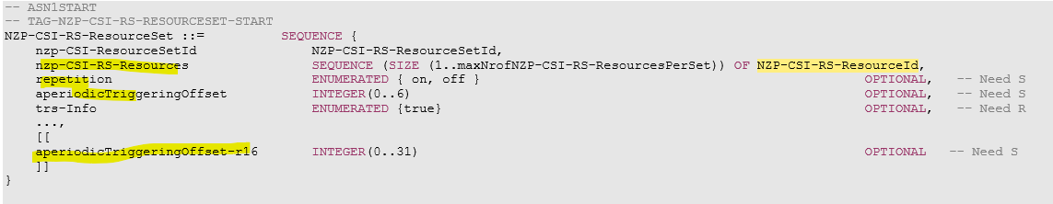
Regarding the spec text in TS 38.214 you quoted, it was quoted by some companies in the discussions two meetings ago, it seems to only mean that P-TRS is always configured to a UE, rather than the structure of resource-set.
Regarding “allow 1 or 3 samples per burst”, as explained about, your proposed change seems not to resolve it yet. Both need specific constraint to be captured in TS 38.214. At this stage, we can add it into column P, as below

LTE_NR_DC_enh2-Core |  | 38.214 |  | temporaryRS-Config |  | temporaryRSBurst1-Resources | New |  | Resource configuration for a temporary burst. (periodicityAndOffset and qcl-InfoPeriodicCSI-RS within NZP-CSI-RS-Resource are not configured for temporary RS) | SEQUENCE (SIZE (1..4)) OF NZP-CSI-RS-ResourceId | N/A | per cell | UE-specific | 38.331 | Common for both Alt.1 and Alt. 2.  A temporaryRSBurst1-Resources is expected to either consist of four NZP CSI-RS resources in two consecutive slots with two NZP CSI-RS resources in each slot, or consists of two periodic NZP CSI-RS resources in one slot
LTE_NR_DC_enh2-Core |  | 38.214 |  | temporaryRS-Config |  | temporaryRSBurst2-Resources | New |  | Resource configuration for the second temporary burst, Optional (periodicityAndOffset and qcl-InfoPeriodicCSI-RS within NZP-CSI-RS-Resource are not configured for temporary RS) ( FFS: whether the same OFDM symbol locations are required in both bursts) | SEQUENCE (SIZE (1..4)) OF NZP-CSI-RS-ResourceId | N/A | per cell | UE-specific | 38.331 | Common for both Alt.1 and Alt. 2.  A temporaryRSBurst2-Resources, if configured, is expected to either consist of four NZP CSI-RS resources in two consecutive slots with two NZP CSI-RS resources in each slot, or consists of two periodic NZP CSI-RS resources in one slot

Regarding your comment#2 on row#5, as replied above, removing row#5 seems not to lock any benefit. I feel we share the same purpose of making the configuration constraints clearer and plain, but are only different in how to present it. Anyway, the constraints have been captured into the column P, which is usually captured in TS 38.214. Please note that a FFS in column J has also resolved your concerns, i.e. “FFS: whether the same OFDM symbol locations are required in both bursts”.

@Qualcomm, regarding your comment#1 on row#1-13, could you elaborate more how to achieve this for Alt. 2 and 1? “The necessary change for temporary RS is to enable triggering two A-TRSs where one A-TRS is in a set of two consecutive slots and another A-TRS is in another set of two consecutive slots with a gap in-between based on a single triggering state. We consider this would be possible without changing RRC configuration itself.” The current NZP-CSI-RS configurations have many levels of structures with many IEs that are never used by temporary RS. It is hard for us to collect all necessary IEs from a sea of unrelated IEs, and also hard to ensure all the unrelated IEs can be optional configured. Therefore, a flow of necessary IEs is helpful for discussions, similar to the diagrams shown in section 1, maybe you could elaborate more a bit what extract IEs would be extracted after a field indicated by MAC-CE, and how to reflect the gap in spec.
Regarding your comment#2 on row#1-13, could you clarify a bit why the following highlight IEs are still needed for temporary RS? Many redundant IEs seems making the spec hard to read and to have future extension. No mention that, it is not sure yet that all mandatory IEs have no harm.
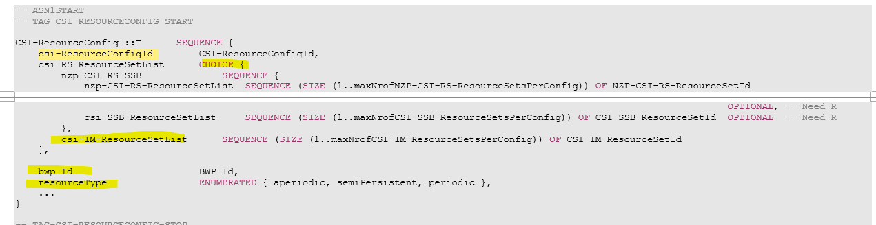
Additionally, regarding your change to column P, as shown in the diagrams in Section 1, it seems always true that there are common RRC parameters between Alt.1 and Alt.2 because the difference is only whether its so called “RS index” is indicated directly by MAC-CE or indirectly by a nested trigger structure. Therefore, it is always useful to identify the common parameters first, rather than having two separate RRC settings for independent discussions. It would be no good to change row#1-13 as being dedicated to Alt.1.
======= (breaking line)
[The other company name]

Columns #L, M, N
Question: For these columns, any suggested change to rows #2 to #13?
The discussion is based on file v000.
Your comments are welcome! Please take the same form for your comments as suggested in section 3.1.1.

======= (breaking line)
[Your company name (in bold)]
//comment#1
[Concerned Parameter name: row#]
[Your detailed comments]
[Proposed changes to the row with track in color], e.g.

RRC parameters specific to Alt.1
Question: Any suggested change specific to Alt.1? Any new row needed?
The discussion is based on file v000.
======= (breaking line)
[Your company name (in bold)]
//comment#1
[Concerned Parameter name: row#]
[Your detailed comments]
[Proposed changes to the row with track in color]

RRC parameters specific to Alt. 2
In this section, rows #14 - #18, starting from parameter temporaryRS-TriggerStateList, are discussed

Major columns #C, E, G, H, J, K, P
Question: Any suggested change specific to Alt.2? Any new row needed?
The discussion is based on file v000.
Your comments are welcome! Please take the same form for your comments as suggested in section 3.1.1.

======= (breaking line)
[Qualcomm]
//comment#1
[Concerned Parameter name: row#15 - #18]
[Your detailed comments] Due to the same reason we commented in 2.1.1 (see comment#1), these rows would not be necessary.
[Proposed changes to the row with track in color] Suggest to delete the rows as follows.
LTE_NR_DC_enh2-Core |  |  |  |  |  | CSI-AperiodicTriggerState | existing |  | A trigger state containing one or multiple CSI-AssociatedReportConfigInfo | SEQUENCE (SIZE(1..maxNrofReportConfigPerAperiodicTrigger)) OF CSI-AssociatedReportConfigInfo | N/A |  | UE-specific | 38.331 | Specific to Alt 2
LTE_NR_DC_enh2-Core |  |  |  | CSI-AssociatedReportConfigInfo |  | [TemporaryRSIndex] | New |  | Entry number in the temporaryRS-ConfigList in the CSI-ReportConfig indicated by reportConfigId in the same CSI-AssociatedReportConfigInfo (value 1 corresponds to the first entry, value 2 to the second entry, and so on). | INTEGER(1..(SIZE (1..maxX))), maxX is TBD | N/A | per cell | UE-specific | 38.331 | Specific to Alt 2; The existing IE structure CSI-AssociatedReportConfigInfo is reused. FFS: how to set values for mandatory IEs like resourcesForChannel
LTE_NR_DC_enh2-Core |  |  |  | CSI-ReportConfig |  | reportConfigId | existing |  |  |  |  |  | UE-specific | 38.331 | Specific to Alt 2
LTE_NR_DC_enh2-Core |  |  |  | CSI-ReportConfig |  | carrier | existing |  |  |  |  |  | UE-specific | 38.331 | Specific to Alt 2

//comment#2
[Concerned Parameter name: row#14]
[Your detailed comments] The question for Alt.2 is for CSI-AperiodicTriggerStateList for temporary RS triggered by the MAC-CE, whether the list is the shared one as for DCI-triggered A-TRS/A-CSI-RS and whether the list size (i.e., maxNrOfCSI-AperiodicTriggers) is kept unchanged. Row #14 can be kept for further discussion of these aspects.
[Proposed changes to the row with track in color] For further discussion, we can keep row #14 with some changes as follows.
LTE_NR_DC_enh2-Core |  |  |  | CSI-MeasConfig |  | [temporaryRS-TriggerStateList]  CSI-AperiodicTriggerStateList | New  Existing |  | A list of trigger states for temporary RS triggered by the MAC-CE.  FFS: whether the list is the shared one as for DCI-triggered A-TRS/A-CSI-RS and whether the list size (i.e., maxNrOfCSI-AperiodicTriggers) is kept unchanged, etc | SEQUENCE (SIZE (1..maxNrOfCSI-AperiodicTriggers)) OF CSI-AperiodicTriggerState | N/A | per cell | UE-specific | 38.331 | Specific to for Alt 2

======= (breaking line)
Moderator
@Qualcomm, Regarding your comment#1, it is under discussion in section 2.1.1. Regarding your comment#2 on row#14, in FL understanding, if CSI-AperiodicTriggerStateList is reused with its original IE name rather than a new name as FL draft, then it equivalently requires a UE to support MAC-CE triggering for all kinds of CSI-RS, which is surely out of scope of the WI. In this sense, a new IE name dedicated to MAC-CE triggering for temporary RS is necessary.
======= (breaking line)
[Your company name (in bold)]
//comment#1
[Concerned Parameter name: row#]
[Your detailed comments]
[Proposed changes to the row with track in color]

Columns #L, M, N
Question: For these columns, any suggested change to rows specific to Alt.2?
The discussion is based on file v000.
Your comments are welcome! Please take the same form for your comments as suggested in section 3.1.1.

======= (breaking line)
[Your company name (in bold)]
//comment#1
[Concerned Parameter name: row#]
[Your detailed comments]
[Proposed changes to the row with track in color]

Other Issues
Issues or comments that cannot fit in any of the previous sections of this document can be provided in this section.
Company | View
OPPO | Within both Alt-1 and Alt-2, what is the plan for MAC-CE information relating to SCell activation? It seems the information relating to SCell activation is arranged either in separate MAC-CE or in same MAC-CE but in the separate MAC-CE field from the field for temporary RS triggering. Is it the right understanding to have this proposal to exclude the configuration where SCell-activation and temp-RS triggering are combined in the same MAC-CE field? Just ask for clarification.

Conclusions
TBD

References
- R1-210xxxx xxxx xxxx

Appendix: Agreements

Agreements:
As working assumption, with respect to efficient SCell activation, reuse existing Rel-15/16 TRS structure for temporary RS
- FFS: how many burst/symbols are required for both AGC settling and Time/Frequency tracking for different cases, e.g. FR1 and FR2, known and unknown SCell
  - A burst of temporary RS is notated as in S5.1.6.1.1 of TS 38.214
    - “2-slot with four CSI-RSs resources (4 samples)” for FR1
    - either “1-slot with two CSI-RSs resources (2 samples)” or “2-slot with four CSI-RSs resources (4 samples)” for FR2
- The working assumption can be confirmed after RAN4 check. (A LS for such request is planned).

Agreements:
For efficient SCell activation, discuss and agree from the following alternatives at RAN1#104-e
- Alt 1: the trigger of temporary RS is integrated into a single triggering signaling with the trigger of SCell activation transmitted on an activated cell.
  - FFS detailed design of this integrated triggering signaling.
  - Potential examples of single triggering signaling for further discussions
  - A PDSCH TB, e.g. containing two respective MAC-CEs for both triggers, one MAC-CE for both triggers
  - A DCI for both triggers
  - A PDSCH TB and its scheduling DL grant, e.g. MAC-CE for activation and DL grant for temporary RS
  - A DL grant and a UL grant received in the same slot/OFDM symbols of PDCCH where the DL grant is scheduling a MAC-CE for SCell activation and the UL grant is triggering the RS.
  - Rel-15/16 SCell activation MAC-CE and a specific configuration of temporary RS being implicitly triggered as well
- Alt2: Triggering of temporary RS separately from SCell activation command is not precluded and both ‘separate’ triggers (examples below) and ‘integrated’ triggers (examples in Alt 1) are considered for SCell activation
  - FFS detailed design of separate triggering signaling.
  - Potential examples of separate triggering signaling for further discussions
  - Rel-15/16 SCell activation MAC-CE and Rel 15/16 DCI triggering
  - Rel-15/16 SCell activation MAC-CE and new DCI triggering for temporary RS
- Note: temporary RS should be triggered by DCI or MAC-CE.
- Note: the final mechanism of trigger signaling targets at applicability to one or more SCell activation.
- FFS handling of SCell activation by existing Rel15/16 CA activation command when temporary RS is configured and triggered/not triggered

Working Assumption
At least for the case of known cell, temporary RS is supported to expedite the activation process during the SCell activation procedure for efficient SCell activation for both FR1 and FR2:
- The temporary RS should provide at least the functionalities of AGC settling and time/frequency tracking during SCell activation procedure.
- FFS potential functionalities of CSI measurement/acquisition and cell search

Agreements:
TRS is selected as temporary RS for Scell activation
• If more functionalities are confirmed to be supported by temporary RS, other RS candidates, e.g. aperiodic CSI-RS, P/SP-CSI RS, SRS and RS based on SSS/PSS, are not precluded.
• The TRS should be triggered by DCI or MAC-CE. FFS which exact triggering command.

Agreements:
UEs measure the triggered temporary RS during Scell activation procedure no earlier than a slot m:
• FFS timeline values m which may need coordination with RAN4.
• FFS if the triggered temporary RS can be associated with a BWP, then the measurement above is independent of the activation state of the BWP.

Agreements:
Companies are encouraged to provide design details of temporary RS next meeting, at least including:
- TRS structure, e.g. whether to fully reuse existing Rel-15/16 TRS structure and configuration restriction (refer to S5.1.6.1.1 of TS 38.214), or any modification
- QCL information, if any
- Triggering command: DCI format/fields or MAC-CE fields
- Triggering timeline/scheduling offset

Working Assumption
For efficient SCell activation with assistance of temporary RS, a SSB of the to-be-activated SCell can be indicated as a QCL source for the temporary RS in case of known SCell
- FFS: QCL type
- FFS: the case of unknown SCell
- FFS: other QCL source, e.g. the SSB/P-TRS of another active cell
Agreement
For efficient activation of SCells, down select at least one option from below:
- Option 1a: MAC CE(s) contained in a single PDSCH to trigger both SCell activation and corresponding temporary RS(s)
  - Details FFS including timeline design for receiving temporary RS
- Option 1b: A single DCI to trigger both SCell activation and corresponding temporary RS(s)
  - Details FFS including potential impact on SCell activation related procedures and, e.g. timeline design for SCell activation and for receiving temporary RS
  - FFS: The same DCI for SCell deactivation
- Option 2: A Rel-15/16 SCell activation MAC-CE to trigger SCell activation and a Rel-15/16 DCI to trigger corresponding temporary RS(s) with enhancement of timeline
  - Details FFS including timeline design for receiving a DCI trigger of temporary RS, and for receiving temporary RS
- Note: Companies are encouraged to provide complete solutions for fast SCell activation.
- Note: the previous agreement on the definitions of Alt 1 and Alt 2 is still effective

Agreement
For efficient activation of SCells
- Option 1a: MAC CE(s) contained in a single PDSCH to trigger both SCell activation and corresponding temporary RS(s)
  - Details FFS including timeline design for receiving temporary RS
Note: Separate from the support of Option 1a, it is up to RAN4 whether or not to consider an activation time enhancement for Option 2 without requiring further RAN1 work
- Option 2: A Rel-15/16 SCell activation MAC-CE to trigger SCell activation and a Rel-15/16 DCI to trigger corresponding Rel-15/16 A-TRS(s)
Send an LS to RAN4. The LS is endorsed in R1-2104110.
Agreement
For efficient activation of Scells, the triggered temporary RS is aperiodic.
Agreement
For efficient activation of a Scell (in known Scell case), at least the number of temporary RS bursts is indicated by a field in new MAC-CE
- The number of temporary RS bursts is RRC configurable.
- FFS: which field in MAC-CE is used and how this field is associated with the number of bursts
- For the purpose of designing temporary RS Scell activation, there is no RAN1 specification impact for the case where the number of indicated temporary RS bursts is smaller than what is expected by the UE
Agreement
To trigger temporary RS for efficient activation of SCells, the contents of the triggering MAC-CE(s) in a single PDSCH provide at least the following information (explicitly or implicitly):
- Whether or not temporary RS is triggered
- FFS detailed Information of temporary RS, e.g.:
  - Resources used for triggered Temporary RS
  - Triggering time offset of triggered Temporary RS
  - QCL source for triggered Temporary RS
- FFS: Detailed signalling structure of the triggering MAC-CE(s) including the down-selection between the following example options and whether the decision should be made in RAN1 or RAN2
  - Opt. 1.1: One new MAC CE for both SCell activation triggering and corresponding temporary RS triggering
  - Opt. 1.2: One R15/16 SCell activation MAC CE for SCell activation triggering and one new MAC CE (in the same PDSCH) for corresponding temporary RS triggering
Agreement
For efficient activation of a Scell (in known Scell case), the triggering offset of temporary RS is indicated by a field in new MAC-CE
- The candidate value(s) of triggering offset(s) is RRC configurable
- FFS: which field in MAC-CE is used and how this field is associated with the value of triggering offset
Agreement
For the reference slot for triggering offset of temporary RS
- Option 2: the last DL slot of the to-be-activated Scell overlapping with slot n+k as defined in 38.213 sub-clause 4.3
- FFS: the earliest slot no earlier than the reference slot for a UE to receive a triggered temporary RS
Agreement
If a UE measures a temporary RS triggered by a MAC-CE during SCell activation procedure, the measurement is performed within the BWP bandwidth of BWP indicated by firstActiveDownlinkBWP-Id

Agreement
For efficient SCell activation, the earliest slot for a UE to receive a triggered temporary RS is the reference slot (i.e., the last DL slot of the to-be-activated Scell overlapping with slot n+k as defined in 38.213 sub-clause 4.3).

Conclusion
For the purpose of designing temporary RS for Scell activation, RAN1 will not discuss for the case where a gNB may assume the to-be-activated SCell with assistance of temporary RS is a known SCell for a UE but it is actually unknown SCell from the UE side during the SCell activation duration.

Agreement
For to-be-activated SCell, if any BWP ID is configured as part of temporary RS(s) configuration, the value of the BWP ID is expected to be equal to firstActiveDownlinkBWP-Id;

Agreement
For efficient SCell activation, the earliest slot for a UE to receive a triggered temporary RS is the reference slot (i.e., the last DL slot of the to-be-activated Scell overlapping with slot n+k as defined in 38.213 sub-clause 4.3).

Conclusion
For the purpose of designing temporary RS for Scell activation, RAN1 will not discuss for the case where a gNB may assume the to-be-activated SCell with assistance of temporary RS is a known SCell for a UE but it is actually unknown SCell from the UE side during the SCell activation duration.

Agreement
For to-be-activated SCell, if any BWP ID is configured as part of temporary RS(s) configuration, the value of the BWP ID is expected to be equal to firstActiveDownlinkBWP-Id;

Agreement
To trigger temporary RS,
- MAC-CE at least provides the following information:
- temporary RSs are to be triggered on X out of Y (Y≥X) to-be-activated SCells, respectively, while no temporary RS is to be triggered on the other to-be-activated SCells.
- The following information can be provided by RRC for temporary RS for each SCell
- The number of RS bursts and the gap length between the RS bursts (Opt 2.3.3)
- Triggering offset of temporary RS (Opt 2.3.4)
    - Triggering offset can be provided, e.g., by reusing existing CSI-RS framework
- QCL information (Opt 2.3.5)
    - Triggering QCL information can be provided, e.g., by reusing existing CSI-RS framework
- A unique temporary RS configuration index
- FFS: the maximum number of temporary RS per cell/per UE
Note: Reusing A-TRS triggering framework is not precluded.
- Information for 0, 1, or more temporary RS can be provided for each configured SCell

Agreement
- For triggering temporary RS, down-select based on the following alternatives, or let RAN2 be aware the status of this discussion
- Alt 1: Bitmap approach in MAC-CE similar to SCell activation
    - Every Z-bit block in the bitmap corresponds to a SCell, Z>=0
    - A Z-bit block indicates the temporary RS [configuration index], and a value zero indicated by the bit block means no RS resource transmitted.
    - The to-be-activated SCell is indicated via the C values in the legacy SCell activation/de-activation MAC CE or in the new MAC-CE
- Alt 2: Reuse A-TRS triggering framework
    - A trigger state is indicated by the MAC-CE explicitly
    - The association between a trigger state and aperiodic temporary RS for one or multiple SCells is configured by RRC according Rel-16 A-TRS triggering framework
      - SCell ID is configured as a part of the temporary RS configuration. Some SCell IDs derived from the trigger state triggered by the new MAC-CE may not refer to to-be-activated SCells that are indicated by the new MAC-CE or the legacy SCell activation/de-activation MAC-CE
    - FFS: The value zero of the MAC-CE indication means no temporary RS is triggered by the MAC-CE for all to-be-activated SCells
- Note: The down-selection targets at a RAN1 consensus on MAC-CE functionality and the list of RRC parameters for this feature. Any MAC-CE signaling design above are reference concept, its final MAC-CE signaling design is up to RAN2.

