3GPP TSG RAN WG1 #106-e R1-210XXXX

e-Meeting, August 16th – 27th, 2021
Agenda item: 7.2.5
Source: Moderator (Qualcomm)
Title: Summary of [106-e-NR-L1enh-URLLC-01]
Document for: Discussion and Decision

Introduction
This document is created to facilitate the email discussion of “[106-e-NR-L1enh-URLLC-01] Issue#3: Correction on SRS resource configuration. This email thread is triggered by the following draft CR.
R1-2107318 Remaining issues on PDCCH enhancements for URLLC Qualcomm Incorporated

Explanation of the problem
In the RAN1 #105_e meeting, an agreement was made to restrict the RRCs parameters associated with the SRS resource set in srs-ResourceSetToAddModListDCI-0-2 with usage equal to “codebook” or “noncodebook” to be the same as the RRC parameters associated with the SRS resource set configured in srs-ResourceSetToAddModList with the same usage. The purpose is to make sure that the SRS resource set configured by srs-ResourceSetToAddModListDCI-0-2 only contain a subset of SRS resources that are configured by the SRS resources set in srs-ResourceSetToAddModList.
However, [1] argues that it is neither necessary nor correct to make all RRC parameters associated with the two SRS resource sets to be the same. For example, [1] suggests to remove the restrictions of same RRC configuration for the following parameters associated with an SRS resource set configuration.
- srs-ResourceSetId
- srs-ResourceIdList
- aperiodicSRS-ResourceTrigger
- aperiodicSRS-ResourceTriggerList
Furthermore, the following CR on TS 38.212 was proposed.

7.3.1.1.3 Format 0_2
< Unchanged parts are omitted >
- SRS resource indicator –$\left\lceil \log_{2}\left(\sum_{k=1}^{min\left\{L_{max}, N_{SRS,0_2}\right\}}{\left(\begin{matrix}N_{SRS,0_2} \\ k\end{matrix}\right)}\right)\right\rceil$or $\left\lceil \log_{2}{N_{SRS, 0_2}}\right\rceil$bits, where $N_{SRS, 0_2}$ is the number of configured SRS resources in the SRS resource set configured by higher layer parameter srs-ResourceSetToAddModListDCI-0-2, and associated with the higher layer parameter usage of value 'codeBook' or 'nonCodeBook', where the SRS resource set is composed of the first $N_{SRS, 0_2}$ SRS resources together with other configurations in the SRS resource set configured by higher layer parameter srs-ResourceSetToAddModList, if any, and associated with the higher layer parameter usage of value 'codeBook' or 'nonCodeBook', respectively, except for the higher layer parameters ‘srs-ResourceSetId’, ‘srs-ResourceIdList’, ‘aperiodicSRS-ResourceTrigger’, and ‘aperiodicSRS-ResourceTriggerList’
- $\left\lceil \log_{2}\left(\sum_{k=1}^{min\left\{L_{max}, N_{SRS,0_2}\right\}}{\left(\begin{matrix}N_{SRS,0_2} \\ k\end{matrix}\right)}\right)\right\rceil$ bits according to Tables 7.3.1.1.2-28/29/30/31 if the higher layer parameter txConfig = nonCodebook, where $N_{SRS, 0_2}$ is the number of configured SRS resources in the SRS resource set configured by higher layer parameter srs-ResourceSetToAddModListDCI-0-2, and associated with the higher layer parameter usage of value 'nonCodeBook', where the SRS resource set is composed of the first $N_{SRS, 0_2}$ SRS resources together with other configurations in the SRS resource set configured by higher layer parameter srs-ResourceSetToAddModList, if any, and associated with the higher layer parameter usage of value 'nonCodeBook', except for the higher layer parameters ‘srs-ResourceSetId’, ‘srs-ResourceIdList’, ‘aperiodicSRS-ResourceTrigger’, and ‘aperiodicSRS-ResourceTriggerList’, and
- if UE supports operation with maxMIMO-LayersDCI-0-2 and the higher layer parameter maxMIMO-LayersDCI-0-2 of PUSCH-ServingCellConfig of the serving cell is configured, L_{max} is given by that parameter
- otherwise, L_{max} is given by the maximum number of layers for PUSCH supported by the UE for the serving cell for non-codebook based operation.
- $\left\lceil \log_{2}{N_{SRS, 0_2}}\right\rceil$bits according to Tables 7.3.1.1.2-32 if the higher layer parameter txConfig = codebook, where $N_{SRS, 0_2}$ is the number of configured SRS resources in the SRS resource set configured by higher layer parameter srs-ResourceSetToAddModListDCI-0-2, and associated with the higher layer parameter usage of value 'codeBook', where the SRS resource set is composed of the first $N_{SRS, 0_2}$ SRS resources together with other configurations in the SRS resource set configured by higher layer parameter srs-ResourceSetToAddModList, if any, and associated with the higher layer parameter usage of value 'codeBook', except for the higher layer parameters ‘srs-ResourceSetId’, ‘srs-ResourceIdList’, ‘aperiodicSRS-ResourceTrigger’, and ‘aperiodicSRS-ResourceTriggerList’.
< Unchanged parts are omitted >

For your reference, the RRC configuration for SRS resource set in Rel-16 is provided below.
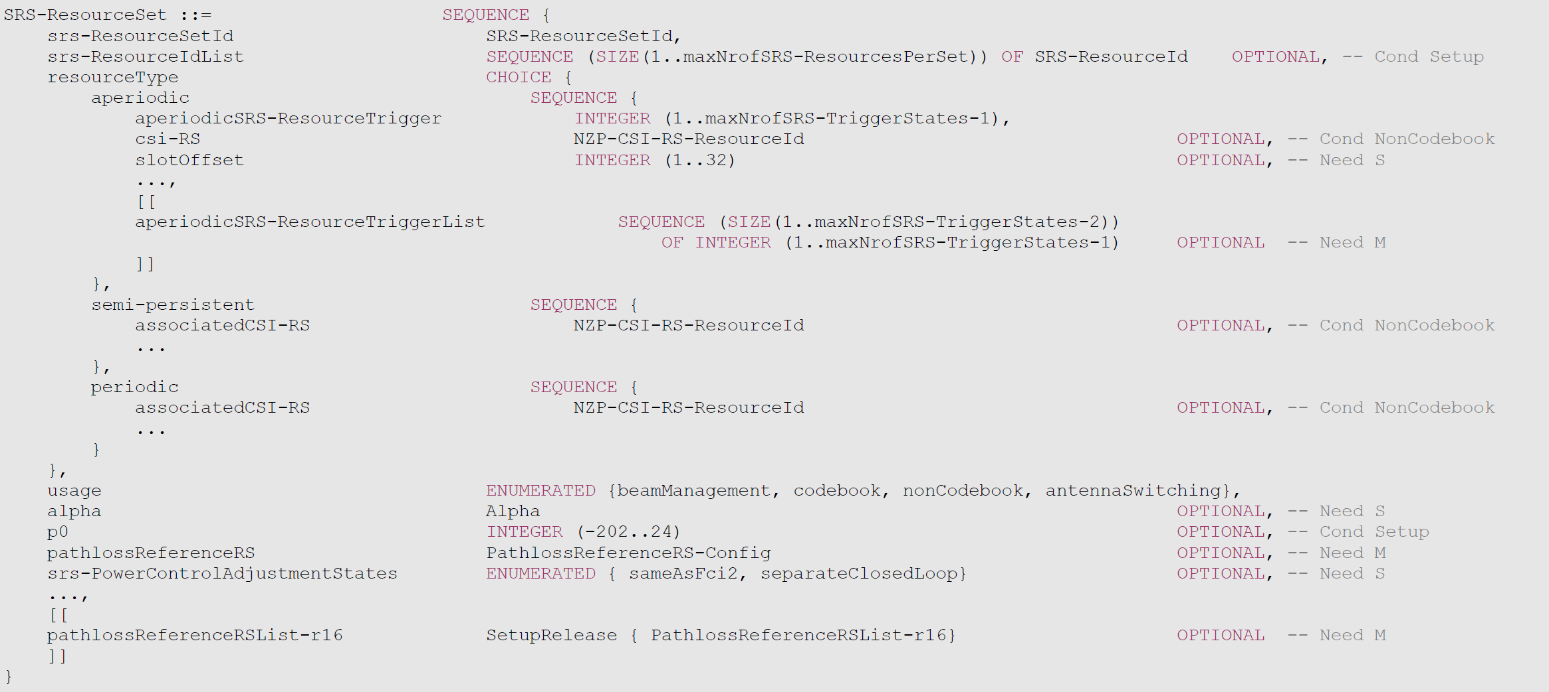

Company views
Companies are encouraged to provide comments on the following questions.
Q1: Do you agree with the intention of the CR described in Section 2 that the RRC parameters associated with the SRS resource set configured in srs-ResourceSetToAddModListDCI-0-2 and srs-ResourceSetToAddModList with the same usage can not all be configured the same? If not, any justifications?

Company | Yes or No | Comment
HW/HiSi | [No] | Tentative no support. In our view it does not seem needed to configure the parameters separately since the SRS resource set of 0_2 is intended to be a sub-set of 0_1. The specification is not broken, and this CR would be an optimization in our view. But we would like to hear the views from others.
Apple | [No] | We have a similar understanding as Huawei.
Nokia, NSB | No | We agree with Huawei/HiSi assessment there, this is regarded as some unnecessary optimization.
Ericsson | No | Our understanding of the CRs made in RAN1#105e is similar to HW/HiSi/Apple/Nokia/NSB. The intention was that SRS resource set of DCI format 0_2 is the subset of that of 0_1, including the configurations. Before the CRs was made, it was stipulated that only a single SRS resource set can be configured for ‘codebook’, which was more restrictive. The same for ‘nonCodebook’.  [1] argues that something is incorrect in current spec. But we fail to see the error case at the moment. If it is true that there is an error, we are open to correct. Maybe QC can explain better.
Vivo | No | We share similar views with Huawei/HiSi.  Bit width of SRS request field in DCI format 0_2 is configured by RRC parameter srs-RequestDCI-0-2 instead of depending on aperiodicSRS-ResourceTrigger or aperiodicSRS-ResourceTriggerList. With a proper configuration, SRS resource sets can be triggered separately for different DCI formats.  Different configurations on aperiodicSRS-ResourceTrigger or aperiodicSRS-ResourceTriggerList are an optimization issue.
Qualcomm | Yes | At least it is incorrect to force the “srs-ResourceSetId” and “srs-ResourceIdList” to be always configured the same between the two SRS resource sets belonging to srs-ResourceSetToAddModListDCI-0-2 and srs-ResourceSetToAddModList.  - For example, “srs-ResourceSetId” must be configured differently for the two SRS resource sets configured in the two SRS resource set lists, since this index will be used by the UE to determine which SRS resource set to use once triggered by DCI format 0_1/1_1/0_2/1_2. If the two SRS resource sets are configured with the same ID, e.g., ID=1, then both srs-ResourceSetToAddModList and srs-ResourceSetToAddModList will include SRS resource set with ID=1. In this case, how should the UE know which SRS resource set is triggered by DCI 0_1/1_1, and which SRS resource set is triggered by DCI 0_2/1_2?  - Similarly, it is not correct to enforce srs-ResourceIdList to be always the same for the two SRS resource sets with same usage. In a typical configuration, the SRS resource set associated with srs-ResourceSetToAddModListDCI-0-2 should contain less SRS resources as the SRS resource set associated with srs-ResourceSetToAddModList in order to achieve a smaller DCI size for DCI 0_2 and 1_2. If we always configure the same list of SRS resources across the two SRS resource sets, how can we achieve the goal of reducing the DCI size for DCI 0_2 and 1_2?  For the trigger-sate ‘aperiodicSRS-ResourceTrigger’, and ‘aperiodicSRS-ResourceTriggerList’, there is no need to configure these to be the same across the two SRS resource sets associated with the two SRS resource set list discussed above, since these are just codepoints used by different DCI formats to trigger A-SRS transmission. But we do agree that this is an optimization for better network configuration flexibility, and the system could work without any change.
Samsung | No | Agree with HW/HiSi.

Q2: If you answer to Q1 is yes, what are the RRC parameters that you think may or must be configured differently?

Company | Yes or No | Comment
Qualcomm |  | As discussed above, we think that “srs-ResourceSetId” and “srs-ResourceIdList” need to be specified as exceptions as in the CR in Section 2, and ‘aperiodicSRS-ResourceTrigger’, and ‘aperiodicSRS-ResourceTriggerList’ are nice to have if we anyways need to change the spec.

Q2: If you answer to Q1 is yes, any additional comments on the CR in Section 2?

Company | Yes or No | Comment

Conclusion
To be added after the discussion.

References
- R1-2107318, Remaining issues on PDCCH enhancements for URLLC, Qualcomm, 3GPP WG1 106-e, Aug 16-27, 2021.

