3GPP TSG RAN WG1 #106-e R1-210XXXX

e-Meeting, August 16th – 27th, 2021
Agenda item: 7.2.5
Source: Moderator (Qualcomm)
Title: Summary of [106-e-NR-L1enh-URLLC-01]
Document for: Discussion and Decision

Introduction
This document is created to facilitate the email discussion of “[106-e-NR-L1enh-URLLC-01] Issue#3: Correction on SRS resource configuration. This email thread is triggered by the following draft CR.
R1-2107318 Remaining issues on PDCCH enhancements for URLLC Qualcomm Incorporated

Explanation of the problem
In the RAN1 #105_e meeting, an agreement was made to restrict the RRCs parameters associated with the SRS resource set in srs-ResourceSetToAddModListDCI-0-2 with usage equal to “codebook” or “noncodebook” to be the same as the RRC parameters associated with the SRS resource set configured in srs-ResourceSetToAddModList with the same usage. The purpose is to make sure that the SRS resource set configured by srs-ResourceSetToAddModListDCI-0-2 only contain a subset of SRS resources that are configured by the SRS resources set in srs-ResourceSetToAddModList.
However, [1] argues that it is neither necessary nor correct to make all RRC parameters associated with the two SRS resource sets to be the same. For example, [1] suggests to remove the restrictions of same RRC configuration for the following parameters associated with an SRS resource set configuration.
- srs-ResourceSetId
- srs-ResourceIdList
- aperiodicSRS-ResourceTrigger
- aperiodicSRS-ResourceTriggerList
Furthermore, the following CR on TS 38.212 was proposed.

7.3.1.1.3 Format 0_2
< Unchanged parts are omitted >
- SRS resource indicator –$\left\lceil \log_{2}\left(\sum_{k=1}^{min\left\{L_{max}, N_{SRS,0_2}\right\}}{\left(\begin{matrix}N_{SRS,0_2} \\ k\end{matrix}\right)}\right)\right\rceil$or $\left\lceil \log_{2}{N_{SRS, 0_2}}\right\rceil$bits, where $N_{SRS, 0_2}$ is the number of configured SRS resources in the SRS resource set configured by higher layer parameter srs-ResourceSetToAddModListDCI-0-2, and associated with the higher layer parameter usage of value 'codeBook' or 'nonCodeBook', where the SRS resource set is composed of the first $N_{SRS, 0_2}$ SRS resources together with other configurations in the SRS resource set configured by higher layer parameter srs-ResourceSetToAddModList, if any, and associated with the higher layer parameter usage of value 'codeBook' or 'nonCodeBook', respectively, except for the higher layer parameters ‘srs-ResourceSetId’, ‘srs-ResourceIdList’, ‘aperiodicSRS-ResourceTrigger’, and ‘aperiodicSRS-ResourceTriggerList’
- $\left\lceil \log_{2}\left(\sum_{k=1}^{min\left\{L_{max}, N_{SRS,0_2}\right\}}{\left(\begin{matrix}N_{SRS,0_2} \\ k\end{matrix}\right)}\right)\right\rceil$ bits according to Tables 7.3.1.1.2-28/29/30/31 if the higher layer parameter txConfig = nonCodebook, where $N_{SRS, 0_2}$ is the number of configured SRS resources in the SRS resource set configured by higher layer parameter srs-ResourceSetToAddModListDCI-0-2, and associated with the higher layer parameter usage of value 'nonCodeBook', where the SRS resource set is composed of the first $N_{SRS, 0_2}$ SRS resources together with other configurations in the SRS resource set configured by higher layer parameter srs-ResourceSetToAddModList, if any, and associated with the higher layer parameter usage of value 'nonCodeBook', except for the higher layer parameters ‘srs-ResourceSetId’, ‘srs-ResourceIdList’, ‘aperiodicSRS-ResourceTrigger’, and ‘aperiodicSRS-ResourceTriggerList’, and
- if UE supports operation with maxMIMO-LayersDCI-0-2 and the higher layer parameter maxMIMO-LayersDCI-0-2 of PUSCH-ServingCellConfig of the serving cell is configured, L_{max} is given by that parameter
- otherwise, L_{max} is given by the maximum number of layers for PUSCH supported by the UE for the serving cell for non-codebook based operation.
- $\left\lceil \log_{2}{N_{SRS, 0_2}}\right\rceil$bits according to Tables 7.3.1.1.2-32 if the higher layer parameter txConfig = codebook, where $N_{SRS, 0_2}$ is the number of configured SRS resources in the SRS resource set configured by higher layer parameter srs-ResourceSetToAddModListDCI-0-2, and associated with the higher layer parameter usage of value 'codeBook', where the SRS resource set is composed of the first $N_{SRS, 0_2}$ SRS resources together with other configurations in the SRS resource set configured by higher layer parameter srs-ResourceSetToAddModList, if any, and associated with the higher layer parameter usage of value 'codeBook', except for the higher layer parameters ‘srs-ResourceSetId’, ‘srs-ResourceIdList’, ‘aperiodicSRS-ResourceTrigger’, and ‘aperiodicSRS-ResourceTriggerList’.
< Unchanged parts are omitted >

For your reference, the RRC configuration for SRS resource set in Rel-16 is provided below.
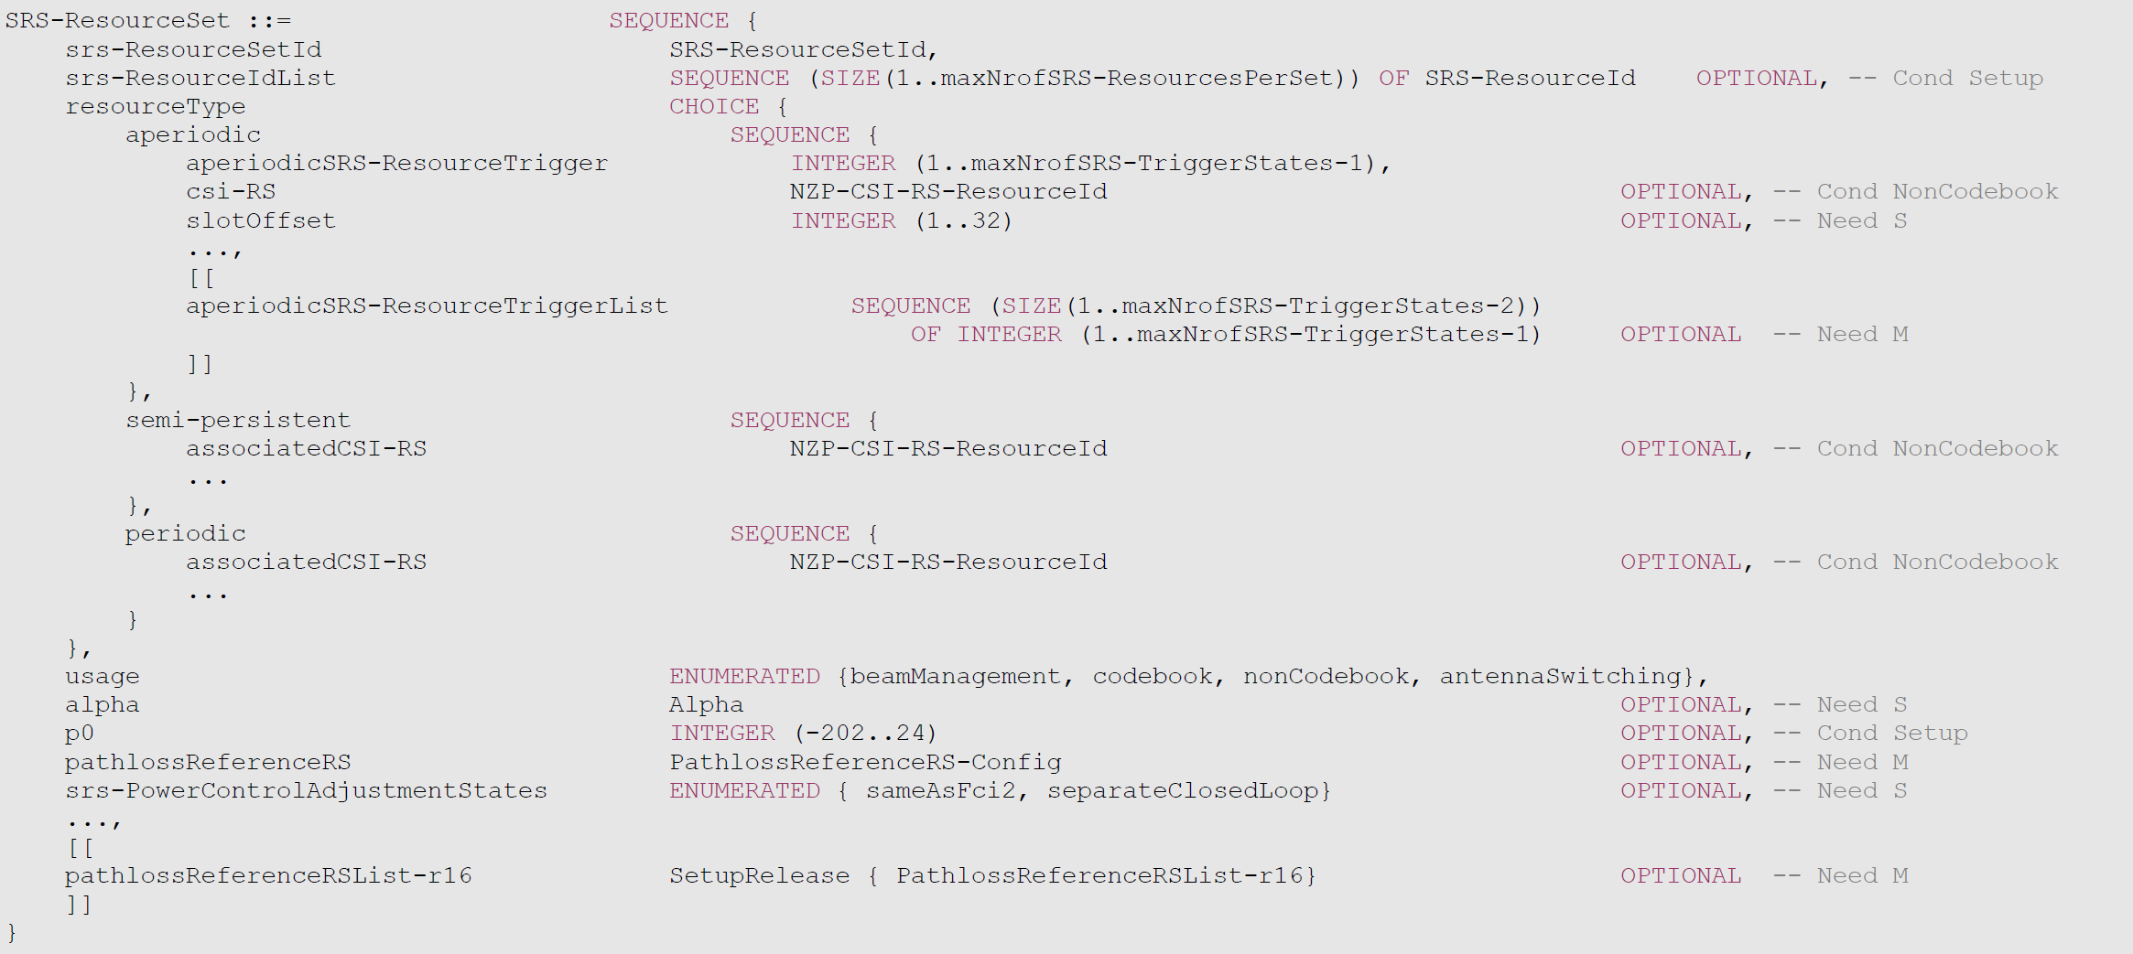

Company views
Companies are encouraged to provide comments on the following questions.
Q1: Do you agree with the intention of the CR described in Section 2 that the RRC parameters associated with the SRS resource set configured in srs-ResourceSetToAddModListDCI-0-2 and srs-ResourceSetToAddModList with the same usage can not all be configured the same? If not, any justifications?

Company | Yes or No | Comment

Q2: If you answer to Q1 is yes, what are the RRC parameters that you think may or must be configured differently?

Company | Yes or No | Comment

Q2: If you answer to Q1 is yes, any additional comments on the CR in Section 2?

Company | Yes or No | Comment

Conclusion
To be added after the discussion.

References
- R1-2107318, Remaining issues on PDCCH enhancements for URLLC, Qualcomm, 3GPP WG1 106-e, Aug 16-27, 2021.

