3GPP TSG-RAN WG1 Meeting ##104bis-e R1-210xxxx
e-Meeting, April 12 - 20, 2021

Agenda Item: 7.2.10
Source: Moderator (Apple)
Title: Feature lead summary #1 on UL Power Control for NN-DC
Document for: Discussion

1 Introduction
This document contains the feature lead summary of issues based on the contributions submitted under AI 7.2.10 related to uplink power control for NR-NR DC topic under Rel-16 LTE_NR_DC_CA_enh WI.
[104b-e-NR-MRDC-CA-01] Email discussion/approval on the following until Apr-16 – Hong (Apple)
- PC1: Discuss the issue raised in R1-2102489, R1-2102709, R1-2102949, R1-2103641, R1-2103641 and R1-2103757 related to RAN4 LS in R1-2102303 and potentially develop and agree on a CR to 38.213 and/or a response LS to RAN4/RAN2
- PC2: Discuss and potentially agree the draft CR in R1-2103754

2. Issue related to RAN4 LS on applicability of p-NR-FR2
RAN4 provides the following information in [8] about the parameter p-NR-FR2, which was used in both semi-static and dynamic power control operations for Rel-16 NR-NR DC on FR2.
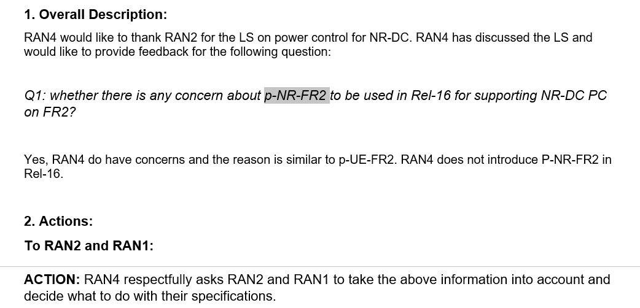

The parameter is used 38.213 subclause 7.6.2 as shown in below text excerpt.
“If a UE is configured with an MCG and a SCG using NR radio access in FR1 and/or in FR2, the UE is configured a maximum power $P_{\text{MCG}}$ for transmissions on the MCG by p-NR-FR1 and/or by p-NR-FR2 and a maximum power $P_{\text{SCG}}$ for transmissions on the SCG by p-NR-FR1 and/or by p-NR-FR2 and with an inter-CG power sharing mode by nrdc-PCmode-FR1 for FR1 and/or by nrdc-PCmode-FR2 for FR2. The UE determines a transmission power on the MCG and a transmission power on the SCG per frequency range.”
Referring to the cited text above, if a UE is configured with MCG and SCG using NR radio access in FR2, the maximum power for FR2 for transmissions in MCG ($P_{\text{MCG}}$) is given p-NR-FR2 corresponding to MCG, and the maximum power for FR2 for transmissions in SCG ($P_{\text{SCG}}$) is given p-NR-FR2 corresponding to SCG.
According RAN4 LS, it appears that UE performance requirements related to procedures that require p-NR-FR2 will not be specified in Rel16 and this has to be reflected in other specs.
In contributions [1,2,3,4,5,6], views regarding how to handle this issue have been presented:
Table 1: Potential options
 | Description | Draft TPs | Companies | Num. of Companies
Opt.1: | Adding note in secition 7.6.2 that ‚the UE does not expect to be configured with p-NR-FR2 in this release of the specification‘ | R1-2103641 | Ericsson [4]  ZTE [1] | 2
Opt.2 | Specify ‘independent power control’ for NR-DC FR2+FR2 (i.e. remove power sharing modes of semi-static-mode1, semi-static-mode2 and dynamic from FR2-FR2 NR-DC) | R1-2102949,  R1-2103757 | Huawei [5],  vivo [3] | 2
Opt.3 | Apply a fixed power ratio, e.g, half and half are assumed between MCG/SCG, if SPS is configured by MCG gNB. |  | Nokia [2] | 1
Opt.4 | Semi-static Power Sharing is not supported in Rel-16; FR2-FR2 DC would only be supported with dynamic power sharing. |  | Nokia [2] | 1

Concerns on Opt.2:
- [5]: This would not be consistent with previous RAN1 decisions on NR-DC power sharing. Also, it is unclear if such independent power sharing would be consistent with RAN4 requirements related to UE power limits for FR2 transmissions and further input from RAN4 is needed to decide such aspects.

It is FL understanding that based on RAN4 LS, both semi-static PS and dynamic PS cannot be supported for FR2 NR-NR DC at least in this release, regardless of Opt.1 and Opt.2. Companies are encouraged to be really flexible on this issue to conclude it as soon as possible. Please not object other solutions and we will simply go with the Option that got the most support based on the answers to Question 2_1 below.
Question 2_1: Which option in the list in Table 1 is preferred to address this issue? Please provide brief justification on the preferred option.
Companies | Preferred Option | Views
ZTE | Opt.1 | All other options seem to introduce new UE behaviors compared with the one in current spec. To avoid duplicated discussion in the future once RAN4 requirements are in place, it is preferred to keep the current RAN1 spec as it is and add a note in the spec to clarify the UE does not expect to be configured with p-NR-FR2 in this release of the specification.
CATT | Opt. 1 | We have concern on options 2, 3, and 4 since they are not consistent with previous agreements in supporting both dynamic and semi-static power sharing and have new UE behavior.
Samsung | Opt. 1 | Agree with views above.
Qualcomm |  | From RAN4’s point of view, FR2 transmit power is characterized by TRP and EIRP in which case the effect of beam-forming is combined with the power allocation. Power-sharing based on the higher-layer parameters related to p-max does not work. This is why they decided not to use p-UE-FR2 and p-NR-FR2.  However, with this, FR2-FR2 NR-DC power-sharing is now undefined in RAN1 spec. Considering the RAN4’s concern, it is not good idea to re-design FR2-FR2 NR-DC power-sharing in RAN1 without taking into account the FR2 specific aspects considered in RAN4. A simple approach is to go with no power-sharing (or independent power-control) between CGs for FR2-FR2 NR-DC. However, RAN1 cannot determine if this is a feasible solution.  Therefore, we suggest to send an LS to RAN4 asking, whether it is feasible to specify in RAN1 that for FR2-FR2 NR-DC, no power-sharing between CGs is necessary and power-control is fully independent per CG in FR2.
OPPO | Option 1 | Share the same view of ZTE/CATT/Samsung.
vivo | Option 2 | We have similar understanding as Qualcomm. Given that RAN4 characterizes the FR2 Tx power by TRP and EIRP, it is obviously that the parameters use p-UE-FR2 and p-NR-FR2 are useless, and the configuration-based FR2 NR-DC power sharing does not work. Thus, option 2 is a much clear approach.  We are also fine to the suggestion from Qualcomm, i.e., sending an LS to RAN4 to ask the feasibility of independent power control for FR2 NR-DC.
MTK | Option 1 | Share the same view with ZTE. Option 1 and Option 2 both can address the issue and align with previous RAN1 agreements, while Option 1 seems to have smaller spec impact.
Intel | Option 2 | Not sure the current defined behavior of semi-static or dynamic power sharing for FR2-FR2 DC can be used in future release. Therefore, we prefer to specify the behavior that is actually applicable.
Nokia, NSB | Option 2, with the assumption that it is possible to confirm that this is implementable from RAN4 perspective. | We share the same view as Qualcomm. In our view option 1 and option 4 are the same => FR2-FR2 DC is not supported in Rel-16, and in our view we should find a way to support this in Rel-16.  If it is generally understood that RAN1-based power sharing is not feasible, then option 2 could be a way forward, but it seems RAN1 cannot do this alone, and an LS to RAN4 requesting to confirm this can be done would be necessary.

Depending on the outcome of discussion, one LS maybe prepared and sent to RAN2/RAN4 as recommended by a few companies already [3] [6].

3. Draft CR in R1-2103754
Companies views on this identified clarification in R1-2103754 [7] can be provided in the table below.
Question 3-1: Can we agree the CR R1-2103754? If not, please clarify why and potential modification.
Companies | Y/N | Comments
ZTE |  | Ok as it seems to be an editorial CR.
CATT | Y | We are OK with the draft CR
Samsung | Y | Editorial
OPPO |  | Support in principle. One more minor issue, according to RAN2 LS (R1-2009669), the suffix should be removed from the RRC parameter (at least for the Rel-16 new RRC parameters).
vivo | Y | The CR looks fine to us.
MTK | Y | We are OK with the draft CR
Intel | Y
Nokia | Y (see Oppo’s comment) | Agree with Oppo’s comment though.

Reference
- RP-2102489 Remaining Issues of Power Sharing for NR-DC ZTE
- R1-2102709 On removal of p-NR-FR2 from NR-NR DC power control Nokia, Nokia Shanghai Bell
- R1-2102949 Maintenance on NR-DC power control vivo
- R1-2103641 Maintenance for Rel-16 MR-DC and CA enhancements Ericsson
- R1-2103757 UL power control for NR-NR dual connectivity Huawei, HiSilicon
- R1-2103754 Correction on the MR-DC Uplink Power Control in 38.213 Huawei, HiSilicon
- R1-2102303, “Further Reply LS on power control for NR-DC”, RAN4 to RAN1,RAN2 LS, RAN1#104b-e, April 2021.

