3GPP TSG-RAN WG1 Meeting ##104bis-e R1-210xxxx
e-Meeting, April 12 - 20, 2021

Agenda Item: 7.2.10
Source: Moderator (Apple)
Title: Feature lead summary #1 on UL Power Control for NN-DC
Document for: Discussion

1 Introduction
This document contains the feature lead summary of issues based on the contributions submitted under AI 7.2.10 related to uplink power control for NR-NR DC topic under Rel-16 LTE_NR_DC_CA_enh WI.
[104b-e-NR-MRDC-CA-01] Email discussion/approval on the following until Apr-16 – Hong (Apple)
- PC1: Discuss the issue raised in R1-2102489, R1-2102709, R1-2102949, R1-2103641, R1-2103641 and R1-2103757 related to RAN4 LS in R1-2102303 and potentially develop and agree on a CR to 38.213 and/or a response LS to RAN4/RAN2
- PC2: Discuss and potentially agree the draft CR in R1-2103754

2. Issue related to RAN4 LS on applicability of p-NR-FR2
RAN4 provides the following information in [8] about the parameter p-NR-FR2, which was used in both semi-static and dynamic power control operations for Rel-16 NR-NR DC on FR2.
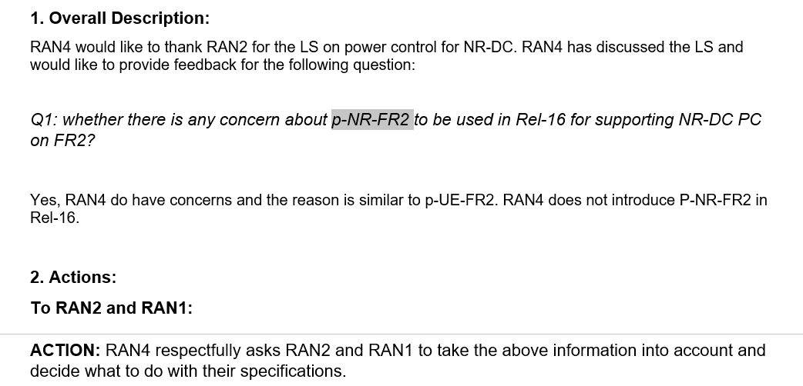

The parameter is used 38.213 subclause 7.6.2 as shown in below text excerpt.
“If a UE is configured with an MCG and a SCG using NR radio access in FR1 and/or in FR2, the UE is configured a maximum power $P_{\text{MCG}}$ for transmissions on the MCG by p-NR-FR1 and/or by p-NR-FR2 and a maximum power $P_{\text{SCG}}$ for transmissions on the SCG by p-NR-FR1 and/or by p-NR-FR2 and with an inter-CG power sharing mode by nrdc-PCmode-FR1 for FR1 and/or by nrdc-PCmode-FR2 for FR2. The UE determines a transmission power on the MCG and a transmission power on the SCG per frequency range.”
Referring to the cited text above, if a UE is configured with MCG and SCG using NR radio access in FR2, the maximum power for FR2 for transmissions in MCG ($P_{\text{MCG}}$) is given p-NR-FR2 corresponding to MCG, and the maximum power for FR2 for transmissions in SCG ($P_{\text{SCG}}$) is given p-NR-FR2 corresponding to SCG.
According RAN4 LS, it appears that UE performance requirements related to procedures that require p-NR-FR2 will not be specified in Rel16 and this has to be reflected in other specs.
In contributions [1,2,3,4,5,6], views regarding how to handle this issue have been presented:
Table 1: Potential options
 | Description | Draft TPs | Companies | Num. of Companies
Opt.1: | Adding note in secition 7.6.2 that ‚the UE does not expect to be configured with p-NR-FR2 in this release of the specification‘ | R1-2103641 | Ericsson [4]  ZTE [1] | 2
Opt.2 | Specify ‘independent power control’ for NR-DC FR2+FR2 (i.e. remove power sharing modes of semi-static-mode1, semi-static-mode2 and dynamic from FR2-FR2 NR-DC) | R1-2102949,  R1-2103757 | Huawei [5],  vivo [3] | 2
Opt.3 | Apply a fixed power ratio, e.g, half and half are assumed between MCG/SCG, if SPS is configured by MCG gNB. |  | Nokia [2] | 1
Opt.4 | Semi-static Power Sharing is not supported in Rel-16; FR2-FR2 DC would only be supported with dynamic power sharing. |  | Nokia [2] | 1

Concerns on Opt.2:
- [5]: This would not be consistent with previous RAN1 decisions on NR-DC power sharing. Also, it is unclear if such independent power sharing would be consistent with RAN4 requirements related to UE power limits for FR2 transmissions and further input from RAN4 is needed to decide such aspects.

It is FL understanding that based on RAN4 LS, both semi-static PS and dynamic PS cannot be supported for FR2 NR-NR DC at least in this release, regardless of Opt.1 and Opt.2. Companies are encouraged to be really flexible on this issue to conclude it as soon as possible. Please not object other solutions and we will simply go with the Option that got the most support based on the answers to Question 2_1 below.
Question 2_1: Which option in the list in Table 1 is preferred to address this issue? Please provide brief justification on the preferred option.
Companies | Preferred Option | Views

Depending on the outcome of discussion, one LS maybe prepared and sent to RAN2/RAN4 as recommended by a few companies already [3] [6].

3. Draft CR in R1-2103754
Companies views on this identified clarification in R1-2103754 [7] can be provided in the table below.
Question 3-1: Can we agree the CR R1-2103754? If not, please clarify why and potential modification.
Companies | Y/N | Comments

Reference
- RP-2102489 Remaining Issues of Power Sharing for NR-DC ZTE
- R1-2102709 On removal of p-NR-FR2 from NR-NR DC power control Nokia, Nokia Shanghai Bell
- R1-2102949 Maintenance on NR-DC power control vivo
- R1-2103641 Maintenance for Rel-16 MR-DC and CA enhancements Ericsson
- R1-2103757 UL power control for NR-NR dual connectivity Huawei, HiSilicon
- R1-2103754 Correction on the MR-DC Uplink Power Control in 38.213 Huawei, HiSilicon
- R1-2102303, “Further Reply LS on power control for NR-DC”, RAN4 to RAN1,RAN2 LS, RAN1#104b-e, April 2021.

