3GPP TSG RAN WG1 #103-e R1-2008140
e-Meeting, October 26th – November 13th, 2020

Agenda item: 7.2.6
Source: Moderator (Samsung)
Title: Summary for Rel.16 NR eMIMO maintenance
Document for: Discussion and Decision

- Introduction
The moderator summary of the maintenance-related issues raised in the submitted contributions for Rel.16 NR_eMIMO maintenance is given below. The listed maintenance issues are under the usual designations:
- LP: low-PAPR RS
- MB: Multi-beam operation
- MT: Multi-TRP
- MU: Type-II enhancement for MU-CSI
- UL: UL full power transmission
An initial assessment on each of the issues is given (but can be revised based on the outcome of the discussion during the preparation week). The assessment will be used as a basis to select four issues (per chairman instruction) for further discussion in the upcoming weeks.
- High priority (H): this includes high-priority item (essential, pending issues, broken spec components) and proposed editorial changes that either enhance the clarity of the specs or correct mistakes
  - H2: The proposal can be endorsed without discussion in the upcoming weeks (i.e. unless pointed out otherwise, the moderator will propose to the chair that the proposal be endorsed by Oct 23rd thereby not counted toward the four-thread quota). It can be merged with any of the assigned threads without any further discussion
- Non-essential (N): this includes all other purposes such as spec optimization and low priority issues

- Maintenance issues
The issues are summarized in the following table:

Table 1 Summary of issues
# | Issue (summary) | Companies | Initial assessment | Company inputs (if any)
LP.x
MB.1 | Specifying TCI state codepoint mapping for DCI format 1_2  FL note: Remaining work from the Reply LS (R1-2007197) | Samsung, Qualcomm, Ericsson | H
MB.2 | Clarifying that multi-CC simultaneous TCI update can be applied to CORESET#0  FL note: Good clarification for aligning TS38.321 and TS38.213 | Vivo | H2
MB.3 | Aligning RRC parameter names with TS38.331 (MediaTek’s TP handles the names of the CC lists and Nokia’s TP handles the names of QCL types)  FL note: Editorial corrections | MediaTek, Nokia/NSB | H2
MB.4 | Text change made in #102-e for default PL RS for DCI format 0_2 was not same as the agreed TP, and it is proposed to adopt the agreed TP due to potential misunderstanding of the current text.  FL note: Current text seems to have the same meaning with the agreed TP. | ZTE | N
MB.5 | Further refinement on the QCL definition  FL note: Proposal is not related to Rel-16 features and seems not critical | Samsung | N
MB.6 | Supporting default spatial relation/PL RS for Rel-16 MTRP features  FL note: Extension of feature, considered as not essential issue | Apple | N
MB.7 | Supporting default PL RS in FR1  FL note: Discussed in the last meeting but not agreed | Qualcomm | N
MB.8 | Support SSB for SCell BFD (TP2 in R1-2007748)  Delete SSB in PCell/PSCell for BFD (TP2 in R1-2008213)  FL note: TP from ZTE reverts previous agreement, and TP from OPPO is related to PCell BFR. | ZTE, OPPO | N
MB.9 | After SCell BFR, define CORESET pool index = 0 for all CORESETs (TP3 in R1-2007748)  FL note: This is a new issue, but it seems this is related to Rel-17 TRP specific BFR. | ZTE | N
MB.10 | Correction on L1-SINR Resource Setting (R1-2007909)  - Editorial correction (add SSB in CMR)  - Support both ZP and NZP IMR  Do not support both ZP and NZP IMR (R1-2008571)  FL note: Whether to support both ZP and NZP IMR has been discussed multiple times. | FutureWei, LGE | N for 2  H2 for editorial correction
MB.11 | Specify that the UE shall apply same QCL-TypeD assumption on channel measurement and interference measurement when QCL-TypeD RS is not configured to the NZP CSI-RS resource for channel measurement. (TP1 in R1-2008213)  FL note: This seems to be a resubmission, and according to the feedback in previous meetings, not to configure QCL for CSI-RS looks to be a general issue. | OPPO | H
MB.12 | Update referenes to nrofReportedRSForSINR as to nrofReportedRS in 38.214. (R1-2008324, R1-2008641)  FL note: Editorial correction. | Huawei/HiSil, Nokia/NSB | H2
MB.13 | PUCCH spatial relation assumption after CBRA-BFR (R1-2008536)  FL note: This was discussed in last meeting, and the proposal seems to be updated based on some discussion in last meeting. | Docomo, Nokia/NSB, IDC | H
MB.14 | Define measurement restriction related UE behavior for L1-SINR measurement (R1-2008674)  FL note: This seems to be related to previous conclusion and aligned with agreed CR for L1-RSRP. | vivo | H
MT.1 | TP to capture the agreement on default TCI state of AP CSI-RS in mTRP  - ZTE (R1-2007750) proposed TP to capture the agreement  - OPPO (R1-2008212) provided TP to capture the agreement of default TCI state of AP CSI RS in mTRP  - Apple (R1-2008436) provided TP to capture that  - Ericsson (R1-2008635) also provided TP for that agreement  - vivo (R1-2008675) proposed TP too  FL note: it is the agreement made in last meeting but no time to discuss the TP in last meeting. | ZTE,OPPO, Apple, Ericsson, vivo | H
MT.2 | Issue 1: The issue of PDCCH and PDSCH collide with different QCL-TypeD  - ZTE (R1-2007750) proposed to clarify UE behavior for the case when PDCCH and PDSCH with different QCL-TypeD collide.  - Apple (R1-2008436) propose that priority rule of PDSCH colliding with PDCCH is applied to per CORESETPoolIndex  - vivo (R1-2008675) proposed to conclude that PDSCH and PDCCH for different TRP shall not overlap  Issue 2: Clarify PDCCH monitoring with respect to a QCL-TypeD in M-DCI mTRP:  - ZTE(R1-2007750)proposed to support two QCL-TypeD for PDCCH reception at a given time in M-DCI.  - Intel [R1-2007938] proposed to extend the PDCCH prioritization based on QCL-TypeD to M-DCI multi-TRP operation.  - Spreadtrum (R1-2008093) proposed to specify the priority rules of monitoring PDCCHs is applied within the CORESETs with the same value of CORESETPoolIndex  - Qaulcomm (R1-2008610) proposed to specify that Rel. 15 procedures on PDCCH for QCL prioritization is done per CORESETPoolIndex  - Nokia (R1-2008723) proposed to specify that For a UE capable of simultaneous reception with different QCL-TypeD, the PDCCH monitoring priority rule based on QCL-TypeD is applied within CORESETs of the same coresetPoolIndex. | ZTE, Intel, Spreadtrum, Apple, vivo, Nokia | H
MT.3 | The issue of default TCI state for PDSCH in S-DCI mTRP  - ZTE (R1-2007750) propose to Clarify the default TCI state for single-DCI mTRP: scheme 1a/2a/2b for the following cases: When one TCI state is indicated and When two TCI states are indicated  - vivo (R1-2008675) proposed to specify the default TCI state for:  - Indicating one TCI state  - TCI field is not present  - Scheme 2a/2b  FL note: this issue has been discussed in previous meeting | ZTE, vivo | N
MT.4 | ZTE ((R1-2007750) proposed to specify the UE behavior in single-DCI mTRP transmission when sequenceOffsetforRV-r16 is not configured.  FL note: This issue can be avoided by implementation. | ZTE | N
MT.5 | The issue of 3 CDMs groups in S-DCI mTRP:  - Apple (R1-2008436) proposed to clarify that 3 CDMs groups should not be used in mTRP  FL note: Current specification suggests that when 2 TCI states are indicated, 3 CDM groups cannot be indicated | Apple | N
MT.6 | The issue of radio link monitoring in mTRP:  - Apple (R1-2008436) proposed to specify the method of UE determining RLM RS in M-DCI mTRP system  FL note: Optimization | Apple | N
MT.7 | The issue of RV value for PDSCH scheme 4:  - CATT (R1-2007818) proposed that table 5.1.2.1-2 in 38.214 is used to specify the RV for PDSCH with aggregation factor or scheme 4. So, R1-2007818 proposed to use a separate table to specify the RV for PDSCH of scheme 4.  FL note: It seems there is no confusion in current spec. | CATT | N
MT.8 | The issue of out-of-order of PDSCH in mTRP:  - CATT (R1-2007818) proposed to update 38.214 to support out-of-order of PDSCH from different TRPs within a slot: description in current 38.214 only supports out-of-order PDSCH across slot  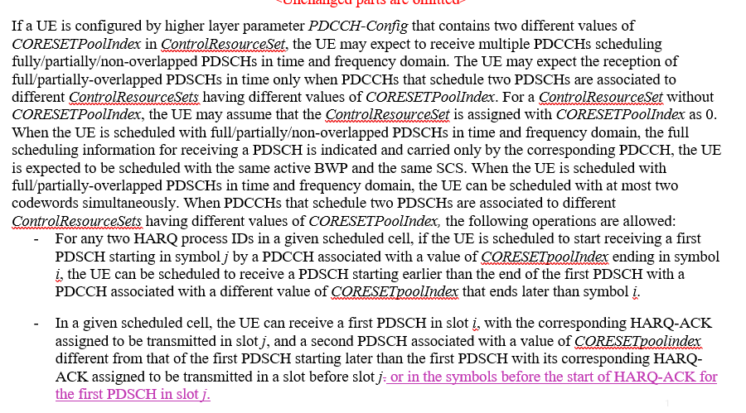  FL note: It seems to be optimization | CATT | N
MT.9 | Spreadtrum (R1-2008093) proposed  - to add the constraint at N_"cells" ^"Cap" in text description when UE does not report pdcch-BlindDetectionCA:  FL note: It captures what is included in one previous agreement. | Spreadtrum | H2
MT.10 | Spreadtrum (R1-2008093) proposed to delete redundant description in Section 9.1.2 of 38.213  FL note: Not essential | Spreadtrum | N
MT.11 | Clarify in 38.214 the default TCI state for PDSCH of cross-carrier scheduling in single-DCI based mTRP  - Samsung (R1-2008141) propose to specify the default TCI state of PDSCH of cross-carrier in single-DCI based mTRP.  - vivo (R1-2008675) also proposed to specify the default TCI state for cross-carrier scheduling case.  FL note: It is a further optimization. | Samsung, vivo | N
MT.12 | Issue of SPS transmission in mTRP:  - Samsung (R1-2008141) proposed to include the SPS of scheme 4 in the description of Type-1 HARQ-ACK codebook determination.  - Samsung (R1-2008141) propose to specify how to receive two overlapped SPS PDSCHs associated with different TRPs in M-DCI mTRP  - LGE proposed the following TP to support SPS of mTRP transmission.  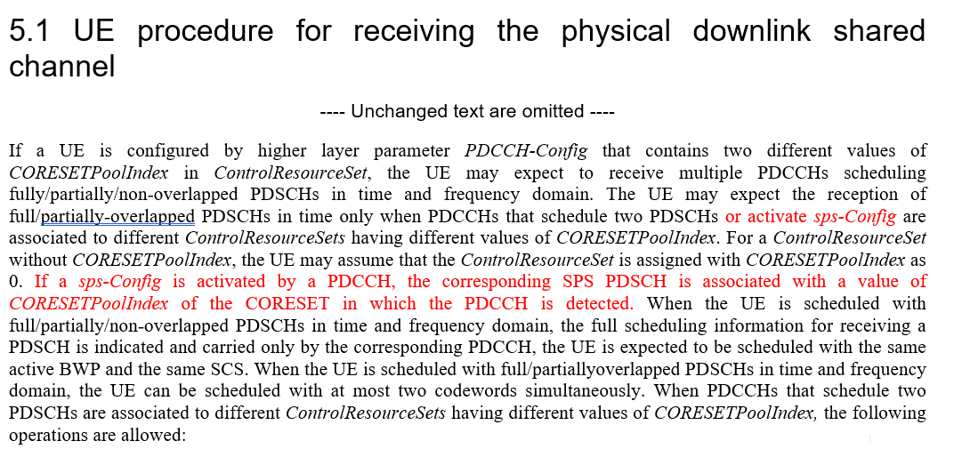  - Qualcomm (R1-2008610) proposed Clarification that the RV sequence used across multiple repetitions in schemes 2b, 3, and 4 is based on setting rvid=0. And Qualcomm also proposed TP to specify that Each SPS PDSCH is associated with a CORESETPoolIndex value, and resolving overlap procedures are done within the same CORESETPoolIndex value  - Ericsson (R1-2008637) provided TP for the change: specifies the RV values to be assumed for DL SPS scheduled with single DCI based multi-TRP PDSCH repetition schemes. To indicate RV values for DL SPS based multi-TRP PDSCH repetition schemes, a similar approach to what is adopted for Rel-15 based DL SPS PDSCH repetition is reused.  FL note: supporting mTRP SPS seems to be optimization | Samsung, LGE, Qualcomm, Ericsson | N
MT.13 | The issue of PUCCH/PUSCH overlapping with two HARQ-ACKs associated with different TRPs  - OPPO (R1-2008211) and vivo (R1-2008675) proposed to specify in 38.213 that this case is not expected by the UE  FL note: it can be resolved by system implementation. | OPPO, vivo | N
MT.14 | The issue of closed-loop power control in mTRP  - OPPO (R1-2008211) proposed to specify a default closed loop index for CORESETPoolIndex = 1 related with out-of-order operation.  - OPPO (R1-2008211) proposed to specify the default pathloss for mTRP case.  FL note: The issue of closed-loop power control related with out-of-order was discussed in last meeting and some companies commented there is no spec impact | OPPO | N
MT.15 | The issue of active BWP in M-DCI mTRP system:  - Lenovo/MOT (R1-2008293) proposed that If a UE detects two DCIs indicating a same active DL BWP change in a same slot, the UE is not required to receive or transmit in the cell during a time duration from the end of the third symbol of a slot where the UE receives the DCI until the beginning of a slot indicated by the smaller slot offset value of the time domain resource assignment fields in the two DCI  FL note: It seems to be further optimization. Comment from companies in previous meeting is this is not an issue. | Lenovo/MOT | N
MT.16 | CR on maximum number and index value of CORESET in M-DCI mTRP:  - Huawei (R1-2008325) proposed the TP on maximum number of CORESETs:  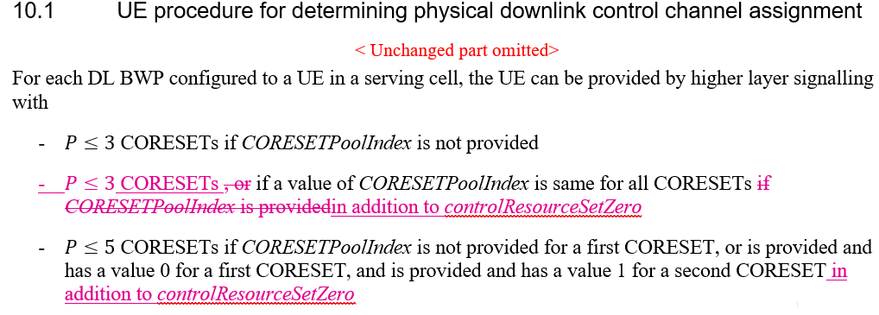  - Huawei (R1-2008326) proposed the TP on index value of CORESETs:  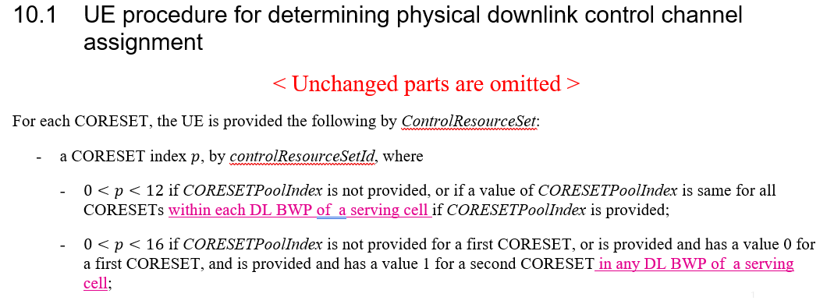  Note: the current spec looks clear | Huawei | N
MT.17 | The issue of sub-slot based HARQ-ACK feedback vs M-DCI mTRP:  - Apple (R1-2008436) propose to clarify whether sub-slot based HARQ-ACK feedback can be used in M-DCI mTRP | Apple | N
MT.18 | The issue of BFR in mTRP:  - Qualcomm (R1-2008610) proposed to specify that for S-DCI mTRP, after BFR, the UE reset all the TCI state point to the qnew.  Note: rel17 is discussing BFR in mTRP now. | Qualcomm | N
MT.19 | The issue of NR-DC and M-DCI based mTRP  - Qualcomm (R1-2008610) proposed to clarify BD/CC limit in the presence of NR-DC in M-DCI based mTRP system  Note: optimization | Qualcomm | N
MT.20 | Quectel (R1-2008569) proposed a TP to delete redundant text:  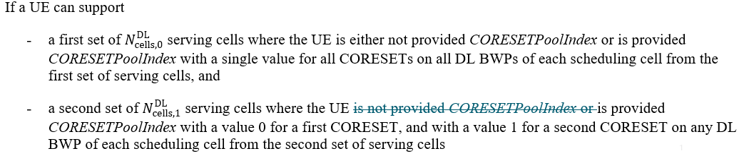  Note: It looks like that the text does not have redundancy. | Quectel | N
UL.1 | Port coherence assumption in UL full power Mode1  FL note: This has been discussed for several meetings | ZTE | N
UL.2 | PTRS port assumption in the case of rank-1 full coherent TPMI and 2 PTRS ports  FL note: This has been discussed in last meeting. | CATT | H(?)
UL.3 | UL full power and single port SRS configuration  FL note: This has been discussed for several meetings. | Spreadtrum | N
UL.4 | To capture TPMI groups in spec. (Samsung proposes to capture in 38.214, LG proposes to capture in 38.306) | Samsung, LG | H

- Discussion and proposal
From the inputs shared by participating companies during the preparation phase, the following observation can be made:
- The following four issues can be designated as H2 (editorial TPs that can be agreed without further email discussion): ...
- The following five issues can be designated as essentially uncontested H: ...
- The following issues can potentially be designated as H (although contested): ...
  - XYZ

In light of the above observations, the moderator makes the following proposals:
- XYZ

Appendix A: ...

References
1 | R1-2007748 | Maintenance of multi-beam operation | ZTE
2 | R1-2007749 | Draft CR on UL full power transmission Mode 1 | ZTE
3 | R1-2007750 | Maintenance of Multi-TRP enhancements | ZTE
4 | R1-2007818 | Discussion on remaining issues of multi-TRP/panel transmission | CATT
5 | R1-2007819 | Correction on PTRS for UL full power transmission | CATT
6 | R1-2007820 | Remaining Issues on multi-beam operation enhancement | CATT
7 | R1-2007909 | Correction on L1-SINR Resource Setting | FUTUREWEI
8 | R1-2007938 | Corrections to multi TRP | Intel Corporation
9 | R1-2008093 | Discussion on remaining issues for multi-TRP operation | Spreadtrum Communications
10 | R1-2008094 | Discussion on remaining issues on full TX power for UL transmission | Spreadtrum Communications
11 | R1-2008139 | On maintenance of Rel.16 multi-beam operation | Samsung
12 | R1-2008140 | Summary for Rel.16 NR eMIMO maintenance | Moderator (Samsung)
13 | R1-2008141 | On Rel.16 multi-TRP/panel transmission | Samsung
14 | R1-2008142 | On UL full power transmission | Samsung
15 | R1-2008211 | Text proposals for enhancements on multi-TRP and panel Transmission | OPPO
16 | R1-2008212 | Correction for default TCI state of AP CSI-RS for M-TRP | OPPO
17 | R1-2008213 | Text Proposals for Multi-beam Operation Enhancement | OPPO
18 | R1-2008293 | Maintenance on multi-TRP operation | Lenovo, Motorola Mobility
19 | R1-2008324 | Correction on L1-SINR reporting | Huawei, HiSilicon
20 | R1-2008325 | Correction on the maximum number of CORESETs for Multi-DCI Transmission | Huawei, HiSilicon
21 | R1-2008326 | Correction on the index value range of CORESET for Multi-DCI Transmission | Huawei, HiSilicon
22 | R1-2008345 | Remaining issues on multi-beam operation | Sony
23 | R1-2008436 | Remaining issues on Rel-16 Multi-TRP enhancement | Apple
24 | R1-2008437 | Remaining issues on Rel-16 Beam Management | Apple
25 | R1-2008514 | Remaining issues on multi-beam operation | MediaTek Inc.
26 | R1-2008536 | Updated proposal of PUCCH spatial relation after CBRA-BFR in Rel.16 | NTT DOCOMO, INC, Nokia, Nokia Shanghai Bell, InterDigital
27 | R1-2008569 | Corrections on Multi-TRP PDCCH | Quectel
28 | R1-2008570 | Draft CR on multi-TRP/panel transmission | LG Electronics
29 | R1-2008571 | Draft CR on beam management | LG Electronics
30 | R1-2008572 | Text proposals on full Tx power UL transmission | LG Electronics
31 | R1-2008610 | Remaining Issues on Multi-TRP Enhancements | Qualcomm Incorporated
32 | R1-2008611 | Remaining issue on multi-beam operation | Qualcomm Incorporated
33 | R1-2008635 | Draft CR on TCI states for Aperiodic CSI-RS | Ericsson
34 | R1-2008637 | Draft CR on DL SPS based PDSCH repetitions | Ericsson
35 | R1-2008638 | Draft CR on TCI state codepoint mapping for DCI format 1_2 | Ericsson
36 | R1-2008640 | Draft CR on QCL terminology alignment | Nokia, Nokia Shanghai Bell
37 | R1-2008641 | draft CR on higher layer parameter enabling L1-SINR operation procedures | Nokia, Nokia Shanghai Bell
38 | R1-2008674 | Remaining issues and corrections on multi beam related issues | vivo
39 | R1-2008675 | Corrections on multi TRP related issues | vivo
40 | R1-2008676 | Miscellaneous corrections on power control | vivo
41 | R1-2008723 | Maintenance of Rel-16 Multi-TRP operation | Nokia, Nokia Shanghai Bell

