**3GPP TSG-RAN WG1 Meeting #101-eR1-200xxxx**

**e-Meeting, May 25th – June 5th, 2020**

**Agenda Item:** 7.2.5.7

**Source:** Moderator (LG Electronics)

**Title:** Summary of [101-e-NR-L1enh-URLLC-IIoTenh-02]

**Document for:** Discussion and decision

# Introduction

According to discussion at the preparation phase, the following email thread is allocated by Chairman for further discussion:

[101-e-NR-L1enh-URLLC-IIoTenh-02] Email discussion on the following issues by 5/29 and corresponding TP (if any) by 6/5 – Duckhyun (LGE)

* 3.4. SPS PDSCH release and SPS PDSCH receptions

To address the identified issues from companies’ contributions related to the above email thread, the suggestions for the issues are provided in Section 2. [In Section 3, a few open issues identified are listed up so companies are encouraged to provide your input/feedback in the next meeting in order to facilitate the discussion]. In section [4], the outcome from [101-e-NR-L1enh-URLLC-IIoTenh-02] are provided including all the agreements and all the endorsed TPs.

# Email discussions

## Issue 3.4: SPS PDSCH release and SPS PDSCH receptions

It seems that the issue is how to handle the scenario where **SPS release DCI and SPS PDSCH for the same configuration are received in the same slot**. This scenario can happen at least if 1 slot periodicity is configured.

In this scenario, we will face the following cases:

* Case 1: In a slot, if SPS release DCI is received before the end of the SPS PDSCH for the same SPS configuration
  + Case 1-1: A UE is not required to receive the SPS PDSCH if HARQ-ACK for the SPS release and the SPS reception would map to different PUCCHs
    - Expected consequence: separate HARQ-ACK bits but NACK for the SPS PDSCH?
  + Case 1-2: A UE is not required to receive the SPS PDSCH if HARQ-ACK for the SPS release and the SPS reception would map to the same PUCCH
    - Expected consequence: only 1 bit for SPS release
* Case 2: In a slot, if SPS release DCI is received after the end of the SPS PDSCH for the same SPS configuration
  + Case 2-1: SPS PDSCH is received if HARQ-ACK for the SPS release and the SPS reception would map to different PUCCHs
    - Expected consequence: Separate HARQ-ACK bits
  + Case 2-2: A UE is not required to receive the SPS PDSCH if HARQ-ACK for the SPS release and the SPS reception would map to the same PUCCH
    - Expected consequence: only 1 bit for SPS release

There were two Questions from the last meeting

**Q1: Which cases are to be disallowed? For any case(s) disallowed, what is the expected UE behavior on HARQ-ACK feedback (especially please provide your feedback if you disagree with the above observation on the expected consequence).**

**Q2: Do you think how to handle the cases above should be differentiated between a UE having processing capability of a single unicast PDSCH reception per slot and a UE having processing capability of more than one unicast PDSCH reception per slot? If so, please provide your reason, and specific solution.**

For the above issues, most companies show their view and preference on Q1.

* Case 1: **ZTE, vivo, Ericsson, Nokia, NEC(1-2 only), Intel(1-2 only), Spreadtrum, LG(1-1 only), QC(1-2 only), Huawei,** 
  + Expected consequence of Case 1-1 (release received first and different PUCCHs)
    - separate HARQ-ACK bits
      * **Nokia, Spreadtrum, LG, Huawei,**
      * **Spreadtrum: NACK for SPS PDSCH**
      * **Nokia**: unless the PUCCH for SPS reception would only contain 1 bit of (NACK) feedback, in which case the PUCCH for SPS reception is not reported
    - only 1 bit for SPS release
      * **Vivo, Ericsson**
  + Expected consequence of Case 1-2: (release received first and same PUCCHs)
    - separate HARQ-ACK bits
    - only 1 bit for SPS release
      * **Vivo, Ericsson, Nokia, Spreadtrum, Huawei**
    - HARQ-ACK bit for SPS release and SPS PDSCH can be bundled as 1bit if the UE detects that the SPS PDSCH corresponding to the SPS release DCI is actually transmitted in the slot, otherwise, UE generates only the 1-bit HARQ-ACK for the SPS release.
      * **ZTE**
* Case 2: **Ericsson, Nokia(2-1 only), Spreadtrum, LG(1-1 only), Huawei,** 
  + Expected consequence of Case 2-1 (release received later and different PUCCHs)
    - separate HARQ-ACK bits
      * **Spreadtrum, Huawei**
    - only 1 bit for SPS release
      * **Ericsson**
  + Expected consequence of Case 2-2: (release received later and same PUCCHs)
    - separate HARQ-ACK bits
    - only 1 bit for SPS release
      * **Ericsson, Spreadtrum, Huawei**

For Q2, following are proposed by [1][2][5][7]

* ZTE[1]: No need to differentiate the lower processing capability of a single unicast PDSCH reception per slot and higher capability of more than one unicast PDSCH reception per slot. The key issue is the SPS release DCI and SPS PDSCH occur in one slot. The capability of processing whether one or more than one unicast PDSCH reception doesn’t affect the capability of DCI reception.
* Vivo[2]: For a UE having processing capability of a single unicast PDSCH reception per slot and a UE having processing capability of more than one unicast PDSCH reception per slot, a UE is not required to receive the SPS PDSCH if HARQ-ACK for the SPS release and the SPS reception would map to different PUCCHs or the same PUCCH. UE generates only 1-bit HARQ-ACK for SPS release.
* CATT[5]:
  + ***For a UE* *not indicating a capability to receive more than one unicast PDSCH per slot,*** 
    - ***only HARQ-ACK corresponding to the SPS PDSCH release is transmitted and the HARQ-ACK corresponding to the SPS PDSCH is omitted.***
  + ***For a UE indicating a capability to receive more than one unicast PDSCH per slot,***
    - ***If the HARQ-ACK bit location for the SPS PDSCH release collides with that for an SPS PDSCH, only HARQ-ACK corresponding to the SPS PDSCH release is transmitted and the HARQ-ACK corresponding to the SPS PDSCH is omitted.***
* Intel[7]: UE behavior can be generalized for both types of UEs. The context of Q1 (and Q2) is when release and PDSCH occasion are for/include the same configuration. Thus, the same case (Case 1-2 only) applies for both cases.
* LG[10]:
  + For a UE not indicating a capability to receive more than one unicast PDSCH per slot
    - Case 2-1 (and 2-2) is not allowed
  + For a UE indicating a capability to receive more than one unicast PDSCH per slot
    - Case 2-1 is allowed (no spec impact)

## FL’s suggestion on the issue 3.4

There were so diverge views on each case. And the reason why to support each case are also different per companies. One common proposal is Case 1 can be supported. (SPS release received earlier than the end of SPS PDSCH). From FL’s perspective, considering UE processing complexity aspect, I would like to take Case 1 as a baseline and discuss details and whether to extend Case 1.

**Proposal 1: At least, it is allowed that SPS release DCI is received before the end of the SPS PDSCH for the same SPS configuration in a slot.**

* **FFS if SPS release DCI is received after the end of the SPS PDSCH for the same SPS configuration**

Companies are encouraged to provide your feedback (or editorial correction) if any on above proposal.

**Comment:**

|  |  |
| --- | --- |
| Company | Comment if any |
| vivo | We are fine with the proposal in general. Maybe we can also move a little forward by adding UE behavior for above case. For example:  **Proposal 1: At least, ~~it is allowed~~ support the case that SPS release DCI is received before the end of the SPS PDSCH for the same SPS configuration in a slot.**   * **1 bit HARQ-ACK is generated for SPS release and a UE is not required to receive the SPS PDSCH.** * **FFS whether and how to support the HARQ-ACK for the SPS release and the SPS reception mapping to different PUCCHs** * **FFS if SPS release DCI is received after the end of the SPS PDSCH for the same SPS configuration** |
|  |  |
|  |  |
|  |  |

According to following specification, PUCCH for SPS PDSCH release is determined by a value of a PDSCH-to-HARQ_feedback timing indicator. Thus, there was no restriction of same PUCCH between release and SPS PDSCH at least for a UE having processing capability of more than one unicast PDSCH reception per slot.

|  |
| --- |
| 9.1.2 Type-1 HARQ-ACK codebook determination  This clause applies if the UE is configured with *pdsch-HARQ-ACK-Codebook = semi-static*.  A UE reports HARQ-ACK information for a corresponding PDSCH reception or SPS PDSCH release only in a HARQ-ACK codebook that the UE transmits in a slot indicated by a value of a PDSCH-to-HARQ_feedback timing indicator field in a corresponding DCI format 1_0 or DCI format 1_1. The UE reports NACK value(s) for HARQ-ACK information bit(s) in a HARQ-ACK codebook that the UE transmits in a slot not indicated by a value of a PDSCH-to-HARQ_feedback timing indicator field in a corresponding DCI format 1_0 or DCI format 1_1. |

**Proposal 2: At least for a UE having processing capability of more than one unicast PDSCH reception per slot, it is allowed to receive SPS PDSCH release in same slot where corresponding SPS PDSCH is configured to be received if HARQ-ACK for the SPS release and the corresponding SPS reception would map to different PUCCHs.**

Companies are encouraged to provide your feedback (or editorial correction) if any on above proposal.

**Comment:**

|  |  |
| --- | --- |
| Company | Comment if any |
| vivo | We would like to clarify the relation between proposal 1 and proposal 2. Proposal 1 seems applied to UEs both capable and incapable of processing more than one unicast PDSCH reception per slot. If the updated proposal including the red sentences is acceptable, then proposal 2 is covered by proposal 1. |
|  |  |
|  |  |
|  |  |

As a next, I also would like to ask some principle to solve the problem in order to step forward.

For the processing capability of a single unicast PDSCH reception per slot, there are two meaning. One is that UE is only capable to decode one PDSCH per single slot. The other is that UE generates most single HARQ-ACK bit per slot (Of course, they can be transmitted in one PUCCH by multiplexing). Based on proposals from companies’ contributions, there is no issue with former one. However, I think a latter part can be related to this issue. Thus, the additional Question is,

**Q3: For a UE having processing capability of a single unicast PDSCH reception per slot, is it possible to generate two HARQ-ACK bits for SPS PDSCH release and SPS PDSCH reception in a slot?**

Companies are encouraged to provide your feedback (or editorial correction) if any on above Question.

**Comment:**

|  |  |
| --- | --- |
| Company | Comment if any |
| vivo | No, from our understanding the HARQ-ACK generation is part of PDSCH processing. So, for a UE having processing capability of a single unicast PDSCH reception per slot, one HARQ-ACK is generated. |
|  |  |
|  |  |
|  |  |

Depending on the upcoming discussion, UE may receive SPS PDSCH release of which HARQ-ACK would map to same or different PUCCH with the corresponding SPS PDSCH reception. Thus, it would be helpful to discuss for each cases in advance.

If HARQ-ACK for the SPS release and the SPS reception would map to the **same PUCCH**, i.e., SPS PDSCH release is indicated with same value of K1 with SPS configuration, they would be mapped to same HARQ-ACK bit position in the PUCCH based on current specification. In this case, we should consider DCI missing case.

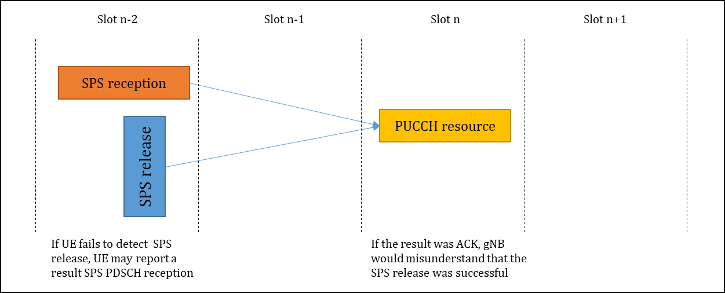

**Figure: An example of DCI missing case when both HARQ-ACKs are mapped to same PUCCH**

In the situation above, there could be ambiguity on HARQ-ACK bit between SPS PDSCH release and SPS reception due to DCI missing case. Based on the contribution, most of companies proposed “UE generates only 1 bit for SPS release” when same PUCCH is used. In this case, gNB is able to ensure no successful transmission on the SPS PDSCH by gNB implementation so that UE always report NACK for the SPS reception bit even if UE fails to detect SPS release DCI.

**Proposal 3:** **If it is supported that HARQ-ACKs corresponding to a SPS release and a SPS reception in a slot map to the same PUCCH (i.e., same HARQ-ACK bit in the PUCCH), UE generates only 1 bit corresponding to the SPS release for the slot.**

Companies are encouraged to provide your feedback (or editorial correction) if any on above proposal.

**Comment:**

|  |  |
| --- | --- |
| Company | Comment if any |
| vivo | Agree. We would like to point out the example may not exist. Since if gNB wants to send SPS release, it should not transmit SPS PDSCH; if gNB wants to transmit the ‘last’ SPS PDSCH in slot n-2, then gNB can send SPS release only in slot n-1. |
|  |  |
|  |  |
|  |  |

If HARQ-ACK for the SPS release and the SPS reception would map to the **different PUCCH**, i.e., SPS PDSCH release is indicated with different value of K1 with SPS configuration, there seems no ambiguity at the gNB perspective. Based on contributions, the majority of companies thinks that UE can generates separated PUCCH in this case.

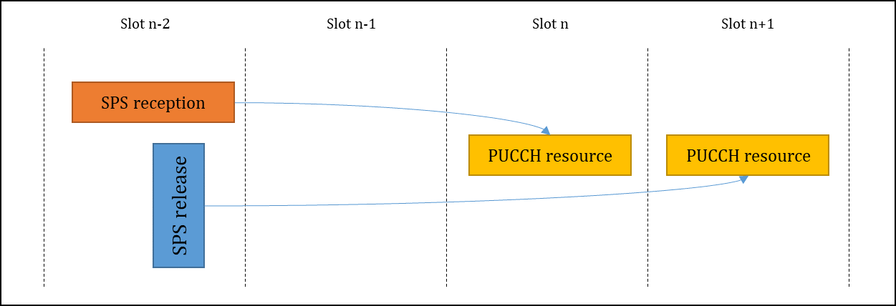

**Figure: An example of DCI missing case when both HARQ-ACKs are mapped to same PUCCH**

For the decoding of SPS reception, there are a lot of view per different conditions. First of all, I would like to suggest to consider baseline above first.

**Proposal 4:**

* **At least for a UE having processing capability of more than one unicast PDSCH reception per slot,** 
  + **If SPS release DCI is received before the end of the SPS PDSCH for the same SPS configuration in a slot and (i.e., Case 1),**
  + **If HARQ-ACK for the SPS release and the SPS reception would map to the different PUCCHs,**
  + **Down-select among following options:**
    - **Opt. 1: the UE is not required to receive the SPS PDSCH if SPS release is detected.**
    - **Opt. 2: the UE is required to receive the SPS PDSCH even if SPS release is detected.**

Companies are encouraged to provide your feedback (or editorial correction) if any on above proposal.

**Comment:**

|  |  |  |
| --- | --- | --- |
| Company | Preferred Options | Comment if any |
| vivo | Option 1 | Irrespective of a UE having processing capability of more than one unicast PDSCH reception per slot or not, it should be the common understanding that if gNB plans to send the SPS release PDCCH in a slot, then the gNB will not schedule the SPS PDSCH in the same slot. So, from gNB perspective, it does not expect to receive the HARQ-ACK feedback for the released SPS PDSCH. From UE perspective, based on the last e-meeting email discussion, as long as the SPS release DCI is received before the end of the SPS PDSCH for the same SPS configuration, HARQ-ACK generation for SPS PDSCH can be interrupted, instead the 1-bit HARQ-ACK can be generated only for SPS release. Therefore, we prefer option 1. In addition, we are fine to support case 1-2 only. |
|  |  |  |
|  |  |  |
|  |  |  |

# Open issues to be discussed

For section 3, it is recommended for companies to take into account the issues carefully and to come back with sufficiently specific options/preference/suggestions to the next meeting so that we can complete RAN1 works on the relevant functionalities with respect to specification.

# Final outcome from [101-e-NR-L1enh-URLLC-IIoTenh-02]

# References

1. R1-2003323, Remaining issues on SPS enhancements, ZTE
2. R1-2003393, Other issues for URLLC, vivo
3. R1-2003445, Remaining Issue of Other Enhancements for NR URLLC/IIoT, Ericsson
4. R1-2003582, Maintenance of Rel-16 URLLC/IIoT SPS enhancements, Nokia, Nokia Shanghai Bell
5. R1-2003625, Remaining issues on IIoT, CATT
6. R1-2003710, Remaining issues on DL SPS enhancement for URLLC, NEC
7. R1-2003741, Corrections for DL SPS and intra-UE prioritization involving CG PUSCH, Intel Corporation
8. R1-2003869, Remaining issues for Others, Samsung
9. R1-2003982, Remaining issues on enhanced DL SPS for IIoT, Spreadtrum Communications
10. R1-2004034, Remaining issues of other aspects for URLLC/IIOT, LG Electronics
11. R1-2004120, DL SPS enhancement, OPPO
12. R1-2004125, Remaining issues on intra-UE prioritization for URLLC, MediaTek Inc.
13. R1-2004184, Discussion on RAN2 LS on Intra-UE Prioritization, Sony
14. R1-2004227, Remaining Issues in eURLLC/IIoT, Apple
15. R1-2004394, Remaining issues for SPS enhancement for Rel-16 URLLC, NTT DOCOMO, INC
16. R1-2004461, Remaining issues on uplink collision handling and SPS for URLLC, Qualcomm Incorporated
17. R1-2004611, Corrections on other aspects for URLLC/IIOT enhancements, Huawei, HiSilicon
18. R1-2003347, Discussion on Intra-UE Prioritization, vivo
19. R1-2003583, Discussion on RAN2 LS on Intra-UE Prioritization, Nokia, Nokia Shanghai Bell
20. R1-2004433, Discussion on Intra-UE prioritization, Qualcomm Incorporated
21. R1-2003345, Draft reply LS on Intra-UE Prioritization, ZTE
22. R1-2003348, Draft reply LS on Intra-UE Prioritization, vivo
23. R1-2003584, [Draft] Reply LS on Intra-UE Prioritization, Nokia
24. R1-2003589, Draft LS reply on Intra-UE Prioritization, CATT
25. R1-2004124, [Draft] Rely LS on Intra UE prioritization, OPPO