**3GPP TSG RAN Meeting #88-e RP-2xxxxx**

**E-meeting, June 29 - July 3, 2020**

**Agenda Item: 9.6.1**

**Source: Huawei**

**Title: Summary for WI on Physical layer enhancements for NR ultra-reliable and low latency case (URLLC)**

**WI code(s): NR_L1enh_URLLC-Core**

**Leading WG: RAN WG1**

**Release: Rel-16**

# Introduction

In Release 15 the basic support for URLLC was introduced with TTI structures for low latency as well as methods for improved reliability. Use cases with tighter requirements, e.g. higher reliability up to 1E-6 and short latency in the order of 0.5 to 1ms, have been identified as important areas for NR. This work item [1] was approved based on the outcome of the study items as shown in TR 38.824 [2] and TR 38.825 [3].

This work item specifies PDCCH enhancements, UCI enhancements, PUSCH enhancements, enhanced inter UE TX prioritization/multiplexing and enhanced UL configured grant transmission.

# Description

The following key functionalities were introduced by this WI.

* **DCI format 0_2 and DCI format 1_2**

DCI format 0_2/1_2 with configurable sizes for most of the DCI fields are introduced, which provides the possibility to improve the reliability by decreasing the DCI size (e.g. ~24 bits) with appropriate RRC configuration of the DCI fields. Details of DCI format 0_2/1_2 can be found in [4].

* **Enhanced PDCCH monitoring capability**

Rel-16 span-based PDCCH monitoring capability is introduced mainly for achieving low latency. A UE can indicate a capability to monitor PDCCH according to one or more of the combinations (X, Y) = (2, 2), (4, 3), and (7, 3) per SCS configuration of $μ=0$ and $μ=1$. A span is a number of consecutive symbols in a slot where the UE is configured to monitor PDCCH. For each reported combination (X, Y), the UE supports the limit $M_{PDCCH}^{max,\left(X,Y\right),μ}$ on the maximum number of monitored PDCCH candidates per PDCCH monitoring span as defined in Table 10.1-2A in [5] and the limit $C_{PDCCH}^{max,\left(X,Y\right),μ}$ on the maximum number of non-overlapped CCEs for channel estimation per PDCCH monitoring span as defined in Table 10.1-3A in [5]. An example of PDCCH monitoring according to combination (4, 3) is as shown in Figure 1.



**Fig. 1**. **An example of PDCCH monitoring using Rel-16 span based PDCCH monitoring capability.**

* **Sub-slot based HARQ-ACK feedback**

Sub-slot based HARQ-ACK feedback is introduced to support more than one PUCCH for HARQ-ACK transmission within a slot, which is mainly beneficial for achieving low latency. An UL slot consists of a number of sub-slots. No more than one PUCCH carrying HARQ-ACKs starts in a sub-slot. A UE can indicate the supported sub-slot configuration among the candidate values of {7-symbol*2, 2-symbol*7 and 7-symbol*2} for normal CP or { 6-symbol*2, 2-symbol*6 and 6-symbol*2} for extended CP.

* **Two HARQ-ACK codebooks constructed simultaneously**

This work item specifies the support of two HARQ-ACK codebooks with different priorities to be simultaneously constructed, which is applied to a UE supporting both eMBB and URLLC and mainly beneficial for improving reliability for URLLC service. Each of the two HARQ-ACK codebooks can be either slot-based HARQ-ACK codebook or sub-slot-based HARQ-ACK codebook. Separate PUCCH configurations are supported for different HARQ-ACK codebooks. The feature supports two priority levels for HARQ-ACK. Rules are defined for the UE to resolve collisions between UL channels/signals with different priorities.

* **PUSCH enhancements**

This work item specifies PUSCH repetition type B and PUSCH repetition type A for PUSCH enhancements. PUSCH repetition type B is mainly beneficial for achieving low latency. PUSCH repetition type A can improve the spectral efficiency.

For PUSCH repetition type B, for a transport block, one dynamic UL grant or one configured grant schedules two or more PUSCH repetitions that can be in one slot, or across a slot boundary in consecutive available slots. Examples of PUSCH repetition type B are given in Figure 2. Inter-slot frequency hopping and inter-repetition frequency hopping are specified for PUSCH repetition type B. Interaction with DL/UL directions is specified as in Clause 6 in [6].

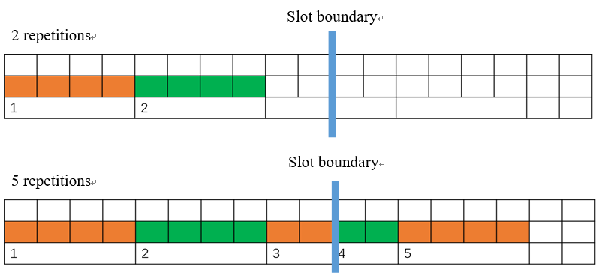

**Fig. 2**. **Examples of PUSCH repetition type B.**

PUSCH repetition type A corresponds to PUSCH transmission with Rel-15 behavior with or without slot aggregation. With slot aggregation, the number of repetitions can be dynamically indicated in Rel-16.

* **Enhanced inter UE Tx prioritization/multiplexing**

This work item specifies UL cancellation scheme and enhanced UL power control scheme for enhanced inter UE Tx prioritization/multiplexing. UL cancellation scheme is mainly beneficial for achieving low latency. Enhanced UL power control is mainly beneficial for improving the system spectral efficiency while ensuring the reliability for URLLC service.

For UL cancellation scheme, DCI format 2_4 is introduced for notifying the PRB(s) and OFDM symbol(s) where UE cancels the corresponding UL transmission from the UE. An indication by DCI format 2_4 for a serving cell is applicable to a PUSCH transmission or an SRS transmission on the serving cell.

For UL power control scheme, open-loop power control parameter set indication is included in DCI format 0_1/0_2 to indicate the P0 value for PUSCH scheduled dynamically as defined in [5].

* **Multiple active configured grant configurations for a BWP**

Up to 12 configured grant configurations can be configured in a BWP of a serving cell, which is mainly beneficial for achieving high reliability. Separate RRC parameters can be configured for different configured grant configurations. Separate activation/release can be used for different configured grant Type 2 configurations. In addition, joint release for two or more configured grant Type 2 configurations for a given BWP of a serving cell is also supported.

# References

1. RP-191584, “Revised WID: Physical Layer Enhancements for NR Ultra-Reliable and Low Latency Communication (URLLC)”, Newport Beach, CA, June 3-6, 2019.
2. TR 38.824 v16.0.0.
3. TR 38.825 v16.0.0.
4. TS 38.212 v16.2.0.
5. TS 38.213 v16.2.0.
6. TS 38.214 v16.2.0.