3GPP TSG RAN WG1 #100bis R1- 200xxxx
e-Meeting, April 20th – 30th, 2020

Agenda item: 6.2.4
Source: Moderator (Qualcomm Incorporated)
Title: Email discussion [100b-e-LTE-TerrBcast-01]
Document for: Discussion and Decision

Summary of issues
This document contains the discussion for the following:
[100b-e-LTE-TerrBcast-01] Email discussion/approval on reference signal aspects for 0.37 kHz numerology (antenna port definition; presence of RS; correction to MBSFN-RS generation) by 4/23; if necessary, followed by endorsing the corresponding TPs by 4/28 - Alberto (Qualcomm)

Issue #1: Antenna port definition
In x1635, it is proposed to modify the text in TS 36.211 on antenna port definition as follows:
<TP-1, TS 36.211, 6.2.1>

- MBSFN reference signals are transmitted on antenna port. The channel over which a symbol on antenna portis conveyed can be inferred from the channel over which another symbol on the same antenna port is conveyed only if the two symbols correspond to subframes of the same MBSFN area. For MBSFN reference signal pattern type 1 of 0.37 kHz subcarrier spacing, the channel over which a symbol on antenna port is conveyed can be inferred from the channel over which another three symbols on the same port is conveyed only if the four symbols correspond to slots of the same MBSFN area. For MBSFN reference signal pattern type 2 of 0.37 kHz subcarrier spacing, the channel over which a symbol on antenna port is conveyed can be inferred from the channel over which another symbol on the same port is conveyed only if the two symbols correspond to slots of the same MBSFN area.

This introduces the following changes:
- Use “slots” instead of subframes.
- Limit the coherency for four symbols / two symbols depending on the RS pattern.

Company name | Comment
Qualcomm | In general, the current specification should be enough, since the spec says “two symbols correspond to subframes of the same MBSFN area”, and, in the end, the 3 subframes of a slot belong to the same MBSFN area. If this needs to be made more clear, we suggest the following revision:  For subcarrier spacing other than 0.37kHz, the channel over which a symbol on antenna portis conveyed can be inferred from the channel over which another symbol on the same antenna port is conveyed only if the two symbols correspond to subframes of the same MBSFN area. For subcarrier spacing of 0.37kHz, the channel over which a symbol on antenna portis conveyed can be inferred from the channel over which another symbol on the same antenna port is conveyed only if the two symbols correspond to slots of the same MBSFN area  What we do not support is the limitation of another three symbols. In theory, if the channel is completely static, the UE should be able to run an infinite filter to keep improving the channel estimation.
ZTE | The intention of this TP is to address Issue#1 and Issue#2 together. Seems like companies have different understandings on whether the above TP could resolve Issue#2. In this case, we could focus on the Issue#1 here. The revision from Qualcomm for Issue#1 looks good to us.
Huawei/HiSilicon | We don’t think the TP here is needed. The antenna port definition is kept in the same description formatting across 211 or different releases.

Issue #2: Presence of RS
In x2626 and x2179, it is recommended to discuss the assumptions the UE can make regarding the presence of reference symbols outside a given PMCH slot. More precisely, the following observations are made:
- In x2626: A UE implementing frequency-only channel interpolation for the PMCH numerology with Δf = 0.37 kHz and RS pattern with D_{t} = 4/2 only achieves a theoretical equalisation interval of 225/450µs.
- In x2179: The following TP is proposed, along with some additional observations on the proposals:

<TP-2, 36.211 6.10.2>

6.10.2 MBSFN reference signals
MBSFN reference signals shall be transmitted in the MBSFN region of MBSFN subframes only when the PMCH is transmitted. MBSFN reference signals are transmitted on antenna port 4.
For a PMCH transmitted with 0.37 kHz subcarrier spacing in slot $n$,
- for MBSFN reference signal pattern type 1, the UE may assume that MBSFN reference signals associated with the same $N_{ID}^{MBSFN}$ are present in the three preceding slots to slot $n$.
- for MBSFN reference signal pattern type 2, the UE may assume that MBSFN reference signals associated with the same $N_{ID}^{MBSFN}$ are present in the preceding slot to slot $n$.
MBSFN reference signals are defined for extended cyclic prefix only.
</TP-2>

Company name | Comment
Qualcomm | Support this change.
Huawei, HiSilicon | Don’t support this change. This issue was discussed in the last meeting. The concerns from the last meeting were not fully addressed nor justified by necessary evaluations.
BBC | We support this TP.  As per our contribution to this meeting in R1-2002626 Observations 3 and 4 state the following:  Observation 3: A UE implementing frequency-only channel interpolation for the PMCH numerology with Δf = 0.37 kHz and RS pattern with D_{t} = 2 only achieves a theoretical equalisation interval of 450µs, instead of 900µs.  Observation 4: A UE implementing frequency-only channel interpolation for the PMCH numerology with Δf = 0.37 kHz and RS pattern with D_{t} = 4 only achieves a theoretical equalisation interval of 225µs. The 300µs CP would therefore not be supported.  We also note that the performance of the physical layer will be limited by the worst performing component. Hence, we do not think it is acceptable to end up with a system where the equalization interval does not even support the full extent of the CP.

Issue #3: Correction to MBSFN-RS generation
In x2179, a potential issue with the MBSFN-RS generation for 0.37kHz SCS is presented. The current equation gives the following pattern for Td=4:
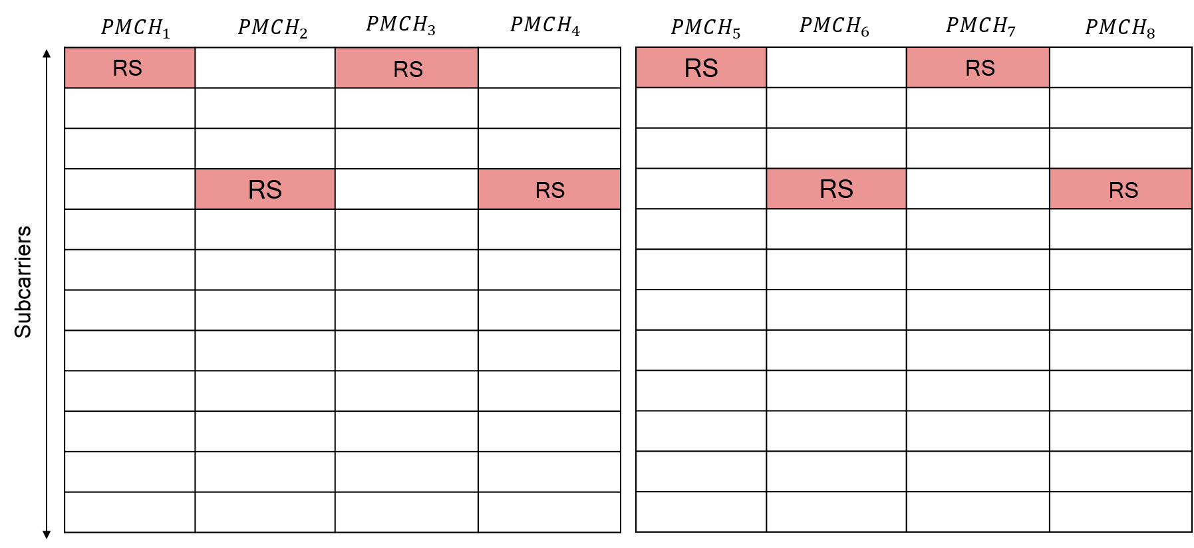
A TP is presented in x2179 as follows:
<TP-3, 6.10.2.2.4>
The reference-signal sequence $r_{l}\left(m'\right)$ in OFDM symbol $l$ shall be mapped to complex-valued modulation symbols $a_{k,l}^{(p)}$ with $p=4$ according to
$$a_{k,l}^{(p)}=r_{l,n_{\text{s}}}\left(m'\right)$$

0≤k<NscRB12NRBDL
where ${\tilde{n}}_{\text{s}}$ is the 3ms absolute slot number, defined as ${\tilde{n}}_{\text{s}}=$ $n_{\text{s}}+13\left\lfloor n_{\text{f}}/4\right\rfloor ,$ $n_{\text{s}}$ is the 3 ms slot number as defined in clause 4.1 and
- for MBSFN reference signal pattern type 1
0≤k<NscRB12NRBDL
l=0
m'=0,1,…,NscRB12NRBmax,DL-1
  - For $N_{RB}^{DL}$ odd

k=12m'-12NscRB12 NRBmax,DL- NscRB12NRBDLNscRB12Δ+3ns mod 4if ns mod 4∈0,112m'-12NscRB12NRBmax,DL- NscRB12NRBDL-1NscRB12Δ+3ns mod 4if ns mod 4∈2,3l=0Δ=NRBmax,DL-NRBDL2m'=0,1,…,NscRB12NRBmax,DL-1
  - For $N_{RB}^{DL}$ even
k= 12m'-12NscRB12NRBmax,DL-NRBDL+3ns mod 4

- for MBSFN reference signal pattern type 2
0≤k<NscRB6NRBDL
$$k=6\left(m^{'}-\left\lfloor \frac{N_{\text{sc}}^{\text{RB}}}{6}Δ\right\rfloor \right)+3\left({\tilde{n}}_{\text{s}}\text{ mod }2\right) \\ l=0 \\ Δ=\frac{N_{\text{RB}}^{\text{max,DL}}-N_{\text{RB}}^{\text{DL}}}{2} \\ m^{'}=0,1,…,\frac{N_{\text{sc}}^{\text{RB}}}{6}N_{\text{RB}}^{\text{max,DL}}-1$$
</TP-3>
Company name | Comment
Qualcomm | Support this change. If other companies find an easier way to write the equations, we would also be OK.
ZTE | Based on our understanding, it seems there is no need to include separate equations for odd and even number of RBs for RS pattern type1. One equation could cover both odd and even number of RBs and cover all potential ${\tilde{n}}_{\text{s}}$ numbers for RS pattern type1.  Thus, we propose the following TP, which looks simpler. Companies could further check whether our equation covers all the cases.  --------------------------------- ZTE’s TP ---------------------------------  The reference-signal sequence $r_{l}\left(m'\right)$ in OFDM symbol $l$ shall be mapped to complex-valued modulation symbols $a_{k,l}^{(p)}$ with $p=4$ according to  $$a_{k,l}^{(p)}=r_{l,n_{\text{s}}}\left(m'\right)$$  when  $$0≤k<\frac{N_{\text{sc}}^{\text{RB}}}{12}N_{\text{RB}}^{\text{DL}}$$  and where ${\tilde{n}}_{\text{s}}$ is the 3ms absolute slot number, defined as ${\tilde{n}}_{\text{s}}=$ $n_{\text{s}}+13\left\lfloor n_{\text{f}}/4\right\rfloor ,$ $n_{\text{s}}$ is the 3 ms slot number as defined in clause 4.1 and  - for MBSFN reference signal pattern type 1  k=12m'-NscRB12Δ+3ns mod 4if ns mod 4∈0,112m'-NscRB12Δ+3ns mod 4if ns mod 4∈2,3  k=12m'-NscRB12Δ+3ns mod 4l=0Δ=NRBmax,DL-NRBDL2m'=0,1,…,NscRB12NRBmax,DL-1  - for MBSFN reference signal pattern type 2  k=6m'-NscRB6ΔNscRB6Δ+3ns mod 2l=0Δ=NRBmax,DL-NRBDL2m'=0,1,…,NscRB6NRBmax,DL-1
Qualcomm 2 | The proposed equation by ZTE has the issue that the tones are not exactly from the center of the sequence, but this may not be a big deal – if companies are OK, we can go with the simpler approach.  While reviewing the equation, we realized that there is an additional bug: the range of k should be $$0≤k<N_{\text{sc}}^{\text{RB}}N_{\text{RB}}^{\text{DL}}$$  Instead of $$0≤k<\frac{N_{\text{sc}}^{\text{RB}}}{12}N_{\text{RB}}^{\text{DL}}$$  Merging these two issues together, we have the following revised TP:  <TP-3 Revision 2, 6.10.2.2.4>  The reference-signal sequence $r_{l}\left(m'\right)$ in OFDM symbol $l$ shall be mapped to complex-valued modulation symbols $a_{k,l}^{(p)}$ with $p=4$ according to  $$a_{k,l}^{(p)}=r_{l,n_{\text{s}}}\left(m'\right)$$  when  0≤k<NscRBNscRB12NRBDL  and where ${\tilde{n}}_{\text{s}}$ is the 3ms absolute slot number, defined as ${\tilde{n}}_{\text{s}}=$ $n_{\text{s}}+13\left\lfloor n_{\text{f}}/4\right\rfloor ,$ $n_{\text{s}}$ is the 3 ms slot number as defined in clause 4.1 and  - for MBSFN reference signal pattern type 1  k=12m'-NscRB12Δ+3ns mod 4if ns mod 4∈0,112m'-NscRB12Δ+3ns mod 4if ns mod 4∈2,3  k=12m'-NscRB12Δ+3ns mod 4l=0Δ=NRBmax,DL-NRBDL2m'=0,1,…,NscRB12NRBmax,DL-1  - for MBSFN reference signal pattern type 2  k=6m'-NscRB6ΔNscRB6Δ+3ns mod 2l=0Δ=NRBmax,DL-NRBDL2m'=0,1,…,NscRB6NRBmax,DL-1  </TP-3 Revision 2>
Huawei, HiSilicon | The revised TP looks ok.

References
R1-2001635 | Corrections to TS 36.211 for the 0.37kHz subcarrier spacing MBSFN | ZTE
R1-2002179 | Support of longer numerologies for rooftop reception | Qualcomm Incorporated
R1-2002626 | UE assumptions of MBSFN-RS for new PMCH numerology for support of rooftop reception | EBU, BBC, IRT

