INVITATION FOR:

ETSI SMG2 UMTS Physical Layer Expert Group, Meeting No. 10
January 18-20. 1999

&

3GPP RAN TSG WG1 & WG4, The 1st Meetings, January 21-22, 1999

Nokia has the pleasure of inviting you to the last meeting of ETSI SMG2 UMTS Physical Layer Expert Group (UMTS-L1) and for the kick-off meetings of 3GPP RAN TSG WG1 and WG4 at:

HOTEL SERENA KORPILAMPI
Korpilammentie, 02970 Espoo
Tel. +358-9 613 8411
Fax +358-9- 6138 4220

January 18-20 1999 and January 21-22, 1999, respectively.

The deadline for meeting registrations is January 11, 1999. Enclosed is the registration form. Please note the separate deadline for hotel reservations.

For the ETSI UMTS-L1 the document submission deadline is January 13th , (12.00 CET), on the UMTS-L1 email reflector or by alternatively bringing 120 copies to the meeting.

Delegates are kindly asked to send their contributions for the 3GPP working groups on the 3GPP reflectors before January 15, 1999, (12.00 CET) or to bring sufficient number of copies to the meeting. The meeting chairmen will provide practical information for the document submission.

The UMTS-L1 meeting will start at 9.00 AM and the final day (Wednesday) is expected to end no later than 4.00 PM. Meeting agenda will be distributed separately by the chairman.

Meeting agendas for WG1 & WG4 meetings will be prepared separately by the chairmen as well. Please note that meetings will take place partly jointly and partly in parallel. The first day will start 9.00 AM and the final day is expected to end around 3.00 PM.

Yours sincerely,

Antti Toskala
Nokia Telecommunications.

TRAVEL INFORMATION

The way to travel from the airport to the hotel is by taxi. It takes about 30-40 minutes and costs about 150 FIM.

The meeting venue is the same hotel where the block booking is made. Staying in a different hotel in Helsinki area instead will mean over half an hour drive each direction.

The bus service from Helsinki City bus terminal, platform 48, is provided with busses Nr. 338 & 339

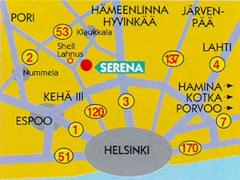

ACCOMMODATION

A block booking has been made to the meeting hotel,

HOTELLI SERENA KORPILAMPI
Korpilammentie, 02970 Espoo
Tel. +358-9 613 8411
Fax +358-9- 6138 4220

Please fax the attached form no later than January 4th to make your reservation. The special room rate is 485 FIM. The room rate for a double room is 640 FIM. The block booking is on the first come, first served basis.

The hotel is next to the Serena waterpark, the biggest indoor waterpark in Europe, and for the hotel residents the admitance fee for the waterpark is 50 FIM.

All delegates are asked to pay their accommodation costs personnally upon departure.

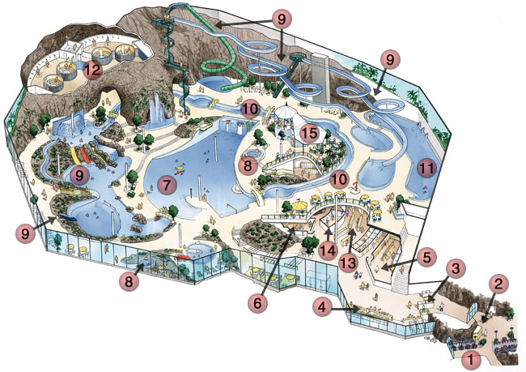

UMTS PHYSICAL LAYER EXPERT GROUP &
RAN TSG WG1/WG4 MEETING REGISTRATION FORM

Please complete and return this form no later than January 11, 1999, to

Ms Maarit Anio
Nokia Telecommunications
Fax: +358 9 511 38 452

REGISTRATION :

NAME
COMPANY
ADDRESS

TELEPHONE
FAX
E-mail

I’m attending:

ETSI UMTS-L1

RAN TSG WG1 RAN TSG WG4 (From WGs, mark only one)

Signature ___________________________

Note: This form is for the meeting registration only, for hotel reservation please contact the hotel directly with the separate reservation form. From the meeting registration no separate confirmation will be made.

HOTEL RESERVATION FORM

For the ETSI SMG UMTS Physical Layer Expert Group & 3GPP RAN TSG WG1/WG4 meeting, 18-20 & 21-22 January 1998, in Espoo, Finland.

Please complete ALL sections in BLOCK CAPITALS and send it no later than 4 January 1998 to:

HOTELLI SERENA KORPILAMPI FAX + 358-9-613 84 220

Special rate Single room

Special rate Double room

I would like to reserve ........... single/double room (s) for the following nights to the special rate.

Dates: Arrival: ................…………. Departure: ….................……..

Name: ___________________________________________________________

Company: ___________________________________________________________

Address: __________________________________________________________
_____________________________________________________________________

Fax*: ___________________________________________________________

Tel*: ___________________________________________________________

(* = including country code)

Please guarantee my room for late arrival.

Credit card to guarantee this reservation:

VISA AMEX EC DINERS OTHER ____________________________

Number:_________________________________exp. date:_____________________

Signature: __________________________________________________

