**3GPP TSG-SA WG6 Meeting #63 S6-244604**

**Hyderabad, India, 14th – 18th October 2024 (revision of S6-244212)**

**Source: NTT DOCOMO**

**Title: Pseudo-CR on addition of addition of AIMLE client discovery procedure in TS23.482.**

**Spec: 3GPP TS 23.482 v0.2.0**

**Agenda item: 9.10**

**Document for: Approval**

**Contact: yuushin.hayashi.ew@nttdocomo.com**

**1. Introduction**

This addition to the note in section 8.8.1 outlines the process of conducting AIMLE client discovery across multiple AIMLE servers.

**2. Reason for Change**

This addition is made to specify the process for requesting discovery from multiple AIMLE servers in case the initial AIMLE client discovery process is unsuccessful, as this was not previously included.

**3. Proposal**

It is proposed to agree the following changes to 3GPP TS 23.482 v0.2.0

* * * First Change * * * *

## 8.8 AIMLE client discovery

### 8.8.1 General

Discovery of AIMLE clients is an important step in the AI/ML process for distributed, federated, split AI/ML, and transfer learning. Due to the nature of such learning, VAL servers need to discover suitable AIMLE clients to fulfil the requirements for the AI/ML application. The VAL server can then use the discovered AIMLE clients to select a set of AIMLE clients to perform AI/ML operations.

The following clauses specify procedures, information flows, and APIs for AIMLE client discovery.

### 8.8.2 Procedure

#### 8.8.2.1 AIMLE client discovery

Pre-conditions:

1. AIMLE clients that support AI/ML operations have registered with the AIMLE server and included their AIMLE client profiles and optionally a list of supported services.

2. The AIMLE server can access a ML repository to obtain AIMLE client profiles and supported services associated with AIMLE clients.

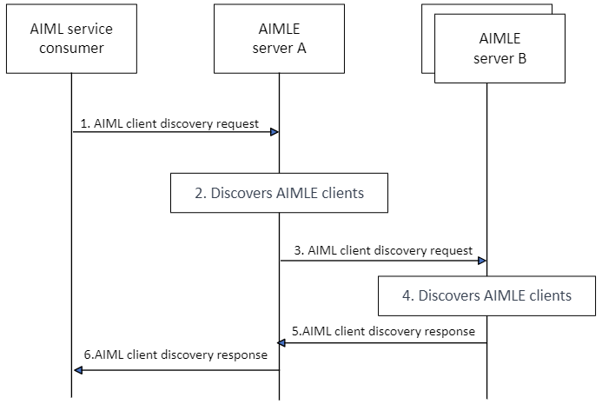

Figure 8.8.2.1-1: AIMLE client discovery

1. A VAL server sends an AIMLE client discovery request to an AIMLE server to discover a list of AIMLE clients that are available to participate in AI/ML operations (e.g., is available and have required data to train an ML model). The AIMLE client discovery request includes information as described in Table 8.8.3.1-1.

2. The AIMLE server performs authentication and authorization checks to determine if the requestor is able to discover AIMLE clients. If the requestor is authorized, the AIMLE server performs the following to discover AIMLE clients fulfilling the provided AIMLE client discovery criteria.

The AIMLE server also obtains candidate UEs from the ML repository.

Editor’s Note: Whether Member UE filtering criteria is included in the request is FFS.

From the list of candidate UEs, the AIMLE server discovers a list of UEs (i.e., AIMLE clients) that fulfils the discovery criteria based on AIMLE client profiles and AIMLE client discovery criteria.

Editor’s Note: Whether AI/ML Policy IDs is included in the request is FFS.

1. If the initial AIMLE client discovery is unsuccessful, the process can be conducted against another AIMLE server (e.g. central AIMLE servers).
2. The AIMLE server performs authentication and authorization checks to determine if the requester is able to discover AIMLE clients. If the requester is authorized, the AIMLE server executes the following steps to discover AIMLE clients that meet the provided AIMLE client discovery criteria.
3. The AIMLE server B sends an AIMLE client discovery response to the AIMLE server A that includes the information of AIMLE client .
4. The AIMLE server A sends an AIMLE client discovery response to the requester that includes the information specified in Table 8.8.3.2-1.

* * * Next Change * * * *

8.8.3.2 AIMLE client discovery response

Table 8.8.3.2-1 shows the response sent by the AIMLE server to the VAL server for the AIMLE client discovery procedure.

**Table 8.8.3.2-1: AIMLE client discovery response**

|  |  |  |
| --- | --- | --- |
| **Information element** | **Status** | **Description** |
| Status | M | The status for the request: success or fail. |
| List of AIMLE client IDs | M | A list of AIMLE client IDs that matches the AIML discovery criteria. |
| List of AIMLE servers that meets the criteria | O | Indicates AIMLE servers to be discovered based on selection policies. |

* * * End of Change * * * *