3GPP TSG-SA5 Meeting #157 S5-246245
Hyderabad, India, 14 - 18 October 2024

Source: Nokia, Ericsson

Title: Rel-19 pCR TR 28.869 Resolve editor's note in Annex F by updating the content and the related figure

Document for: Approval
Agenda Item: 6.19.6

1 Decision/action requested
In this box give a very clear / short /concise statement of what is wanted.

2 References
[1] 3GPP TR 28.869, " Study on cloud aspects for management and orchestration."

3 Rationale
This pCR resolves the editor’s note in Annex F of TR 28.869 [1] by updating the content and Figure F-1 to show the interactions between the 3GPP management system and the orchestration and management entity for the termination of the NF deployment instance. In addition, this pCR replaces the term cloud-native NF with NF deployment as agreed.

4 Detailed proposal
It is proposed that the following changes be made to Annex F of TR 28.869 [1].

Begin Change

Annex <F>: Example scenario using interactions with orchestration and management entity for termination of cloud-native NFs
Figure F-1 depicts an example scenario for interaction with an orchestration and management entity for the termination of a 3GPP NF instance.

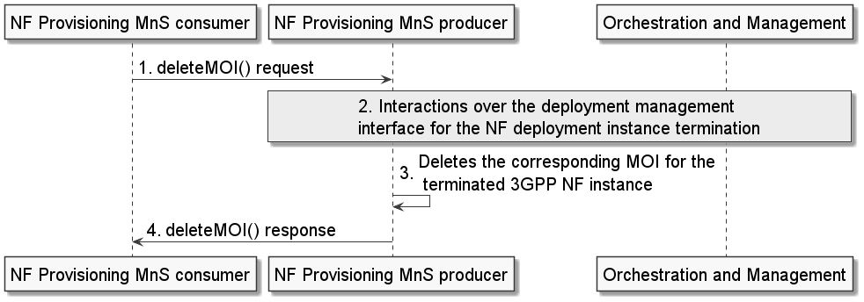
Figure F-1: Example scenario for interaction with the orchestration and management entity for the termination of an NF deployment instance
An authorized NF provisioning MnS Consumer requests the termination of an3GPP NF instance from the NF provisioning MnS producer by sending a deleteMOI request with DN of the 3GPP NF MOI.
The NF provisioning MnS producer invokes interactions with an orchestration and management entity for the termination of the corresponding NF deployment instance(s) for the 3GPP NF instance. Following the completion of the required interactions with the orchestration and management entity, the NF provisioning MnS producer deletes the MOI of the 3GPP NF instance and sends the deleteMOI response to the NF provisioning MnS Consumer with the DN of the deleted MOI of the 3GPP NF instance.
Note: If the orchestration and management entity is ETSI NFV MANO, the interactions over xyz reference point are as specified in clause 7.12 of 28.531 [7].
Editor’s Note: The term “cloud-native NF” is not yet defined.

End Change

