**3GPP TSG-SA5 Meeting #157 *S5-246244d1***

Hyderabad, India, 14 - 18 October 2024

**Source: NTT DOCOMO**

**Title: pCR 28.869 note for data streaming services**

**Document for: Approval**

**Agenda Item: 6.19.6**

# 1 Decision/action requested

***In this box give a very clear / short /concise statement of what is wanted.***

# 2 References

1. 3GPP TR 28.869 v1.0.1 Study on cloud aspects of management and orchestration.

# 3 Rationale

The contribution proposes to add conclusions and recommendations.

# 4 Detailed proposal

It proposes to make the following changes to TR 28.869 [1].

|  |
| --- |
| **1st Change** |

5.2.2.3.1 Solution #1: Management data streaming based on message bus

This potential solution proposes the addition of a new reporting method for management data for network functions running in the cloud. The solution proposes the use of message bus for the reporting of management data from the MnS producer to the MnS consumer as shown in figure 5.2.2.3.1-1.

MnS producer

MnS consumer

Message bus communication

Management data job control (e.g., PM or trace job creation, PM metric subscription, conveying end-point information)

**Figure 5.2.2.3.1-1: Potential solution for management data streaming based on message bus**

The proposed solution enables MnS producer(s) to stream management data to the message bus when ready while also enabling the MnS consumer(s) to consume the data from the message bus whenever they need to. In addition, this potential solution decouples the production of management data from the consumption of management data.

|  |
| --- |
| **2nd Change** |

5.2.3.3.2 Use of xyz reference point based on declarative descriptor

In this solution the 3GPP management system interacts with an orchestration and management entity using the xyz reference point as described in clause 5.2.1.3 for creation of a cloud-native NF instance. The deployment requirements for creating a workload of a NF are conveyed from the 3GPP management system to the orchestration and management system via a declarative descriptor.

Figure 5.2.3.3.2-1 depicts a high-level view of proposed procedure for creation of a cloud-native NF instance based on declarative descriptor.

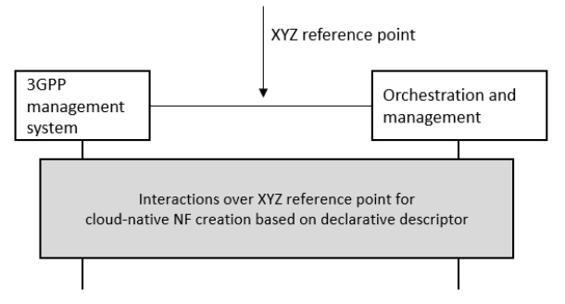

**Figure 5.2.3.3.2-1: Interaction between 3GPP management system and orchestration and management system using xyz reference point based on declarative descriptor**

The declarative descriptor provides a declaration in high-level on what to be achieved by the orchestration and management system rather than how to achieve it.

If the orchestration and management entity is ETSI NFV MANO, the interactions over xyz reference point are as specified in clause 7.10 of 28.531 [7]. For the case of NFV-MANO, the declarative descriptors are VNFD and NSD, as per ETSI NFV specifications (see ETSI GS NFV-IFA 011 [22] and ETSI GS NFV-IFA 014 [24], respectively).

|  |
| --- |
| **End of Changes** |