3GPP TSG-SA5 Meeting #157 S5-246123
Hyderabad, India, 14 - 18 October 2024

Source: Nokia, Ericsson

Title: Rel-19 pCR TR 28.869 Resolve editor's note in Annex D by updating the content and the related figure

Document for: Approval
Agenda Item: 6.19.6

1 Decision/action requested
In this box give a very clear / short /concise statement of what is wanted.

2 References
[1] 3GPP TR 28.869, " Study on cloud aspects for management and orchestration."

3 Rationale
This pCR resolves the editor’s note in Annex D of TR 28.869 [1] by updating the content and Figure D-1 to show the interactions between the 3GPP management system and the orchestration and management entity for the creation of the cloud-native NF. In addition, this pCR replaces the term cloud-native NF with NF deployment as agreed.

4 Detailed proposal
It is proposed that the following changes be made to Annex D of TR 28.869 [1].

Begin Change

Annex <D>: Example scenario using interactions with orchestration and management entity for the creation of NF deployments
Figure D-1 depicts an example scenario for the interaction between the 3GPP management system and the orchestration and management entity for the creation of a 3GPP NF deployment.
An authorized NF provisioning MnS Consumer requests the creation of a 3GPP NF by creating the ManagedFunction IOC on the NF provisioning MnS producer specifying the network function related requirements. If the 3GPP NF deployment contains containerized or virtualized parts, the NF provisioning MnS producer derives the associated requirements for the 3GPP NF deployment based on the network function related requirements.
Note: For the network function related requirements, see information model definition for NR NRM in clause 4 and information model definition for 5GC NRM in clause 5 in TS 28.541[17].

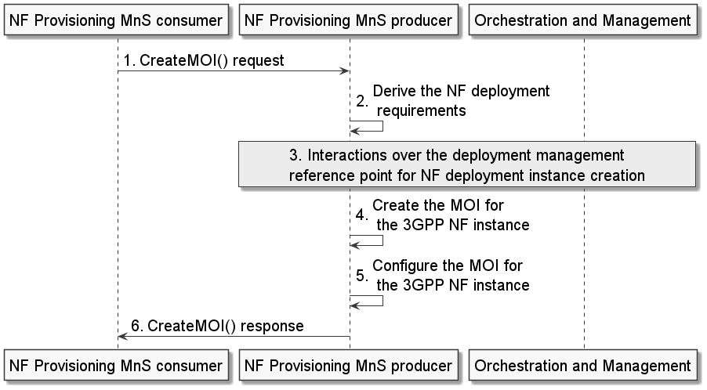
Figure D-1: Example scenario for interaction with orchestration and management entity for 3GPP NF deployment creation procedure

The NF provisioning MnS producer invokes interactions with an orchestration and management entity for the creation of the 3GPP NF instance. Following the completion of the required interactions with the orchestration and management entity, the NF provisioning MnS producer creates the MOI for the 3GPP NF instance and configures the new MOI with corresponding information. The NF provisioning MnS producer sends the createMOI response to the NF provisioning MnS Consumer with the DN of the MOI of the 3GPP NF instance.
Note: If the orchestration and management entity is ETSI NFV MANO, the interactions over xyz reference point are as specified in clause 7.10 of 28.531[7].
Editor’s Note: The term “cloud-native NF” is not yet defined.

End of Change

