**3GPP TSG-SA5 Meeting #157S5-245412**

**14 - 18 October 2024, Hyderabad, India**

**Source: Nokia**

**Title:** **pCR 28.867 Clarify Solution for CCL Clarify Solution for CCL impact assessment**

**Document for: Approval**

**Agenda Item: 6.19.4**

# 1 Decision/action requested

***The group is asked to discuss and agree on the proposal.***

# 2 References

[1] 3GPP TR 28.867-041 “Closed control loop management”.

# 3 Rationale

The CCL scope management solution have been described with textual descriptions. This pCR adds procedure flows to the CCL scope management solution to illustrated procedures described in text

# 4 Detailed proposal

|  |
| --- |
| **Start of modification** |

## 5.8 Use case 8: CCL-impact assessment and resolution

### 5.8.1 Description

#### 5.8.1.1 Overview

Besides having direct conflicts for parameter values, CCLs may also have direct and indirect effects for their goals and metrics, i.e. where actions on one CCL affect the goals and metrics of other CCLs. Impact assessment includes capabilities for evaluating the direct and indirect effects of CCL actions and determining measures for remediation. The scope affected by the actions of the CCL is the impact-scope and is different from the measurement scope, i.e. the scope where the CCLs measure and control scope, i.e. the scope where they act.

The impact scope may be known and bounded or unbounded and thus unknown - see figure 5.8.1.1-1. The bounded scope indicates that the area known by the CCL as the scope where its actions will impact

1, CD. if the impact is strictly in cells A, B, C and Dthen the impact scope is known and bounded. However, if the sE and F, then for the CCL, the true impact scopeis known and thus un.

#### 5.8.1.2 impact on known/bounded impact-scope

For some Closed Control Loops, the expected impact of the action may be known to the Closed Control Loop or coordination functionality governing the CCL. The scope affected by these actions is derived from the (candidate) actions executed by the CCL (or their descriptions). A CCL coordination functionality may wish to evaluate the known impact scope and needs to rely on information from MnS producers of other Closed Control Loops to:

1) determine if there are unwanted outcomes;

2) diagnose if the executed action(s) is/are responsible for those outcomes, especially for the case where multiple Closed Control Loops have concurrently taken actions; and

3) determine what needs to be done to undo the degradation and to avoid it in future.

#### 5.8.1.3 impact on unknown impact-scope

For some CCLs, the impact-scope affected by the actions of a CCL A may not be known a priori. For example, for a CCL A that adjusts transmit power of a cell (e.g. to minimize interference), the exact neighbour cells and related CCLs acting on those cells that shall be affected by any transmit power decrease or increase cannot be explicitly enumerated. Any negative effects cannot be easily anticipated, and most may not be easily resolvable by simple if‑then-else rules. Instead, the MnS producer of a CCL A should interact with MnS producers of the other CLLs or with a coordination functionality to identify actions that lead to negative outcomes and flag them accordingly. Thereby, after the CCL A takes an action on the network:

1) MnS producer of CCL A or the coordination functionality notifies all other CCLs or MnS producers of all other CCLs that an action has been executed that may affect those CCLs. The action is expected to have impact is a specified time, called the impact-time, which depends on the use case. Fr example the impact of load balancing action can be evaluated in a few seconds while the impact of a handover decision can take several minutes or hours. The notification should include the length f this impact time which indicates the time at which an observed impacts should be reported.

2) After a preset monitoring period equivalent to the notified impact time, the MnS producers of the impacted CCLs report (directly or through the coordination functionality) the impact that CCL A had, (i.e. the impact that CCL A's action had had to their performance metrics or goals. The impact may be reported an index say in the range [0,10] where 0 implies an unacceptable action and 10 implies a good action.

3) MnS producer of CCL A or the coordination function derives an appropriate remediation, e.g. by reconfiguring the candidate actions of the acting CCL (i.e. CCL A) or by undoing the action.

### 5.8.2 Potential Requirements

**REQ-CCL-IMPACT-1:** The CCL MnS producer should support a capability enabling an MnS consumer to receive information on the impacts of the CCL on a particular impact-scope and the actions that caused such impacts.

NOTE 1: The MnS consumer may for example be another CCL or a CCL impact coordination function.

NOTE 2: The information enables the MnS consumer to determine if there are unwanted outcomes resulting from actions of the CCL and to propose what needs to be done to undo the degradation.

**REQ-CCL- IMPACT-2:** The CCL MnS producer should support a capability enabling an MnS consumer to notify the MnS producer of the actions of another CCL that may affect the MnS producer's CCL.

NOTE 3: The MnS consumer could for example be a CCL impact coordination function.

NOTE 4: The MnS producer represents the CCL which may be potentially impacted when a CCL A executes an action that may affect the goals or metrics of the MnS producer's CCL.

**REQ-CCL- IMPACT-3:** The CCL MnS producer should support a capability to report to an MnS consumer what the impact that the action had to the goals of the MnS producer's CCL.

NOTE 5: The MnS producer represents impacted CCL or MnF or a coordination function representing the impacted CCL or MnF.

NOTE 6: MnS consumer may for example be a coordination function or an acting CCL that took an action that has impacted the MnS producer's metrics.

NOTE 7: The use of metrics for this requirement is For Further Study.

**REQ-CCL- IMPACT-4:** The CCL MnS producer should support a capability enabling an MnS consumer to propose to MnS producer the appropriate remediation against the noted impact, e.g. the reconfiguration of the candidate actions of the acting CCL.

NOTE 8: MnS consumer may be the CCL impact coordination function or another CCL or management function.

NOTE 9: The MnS producer may be the acting CCL or the impacted CCL.

### 5.8.3 Potential Solutions

#### 5.8.3.1 Solution for detection of actual indirect targets conflicts via impact on unknown or unbounded impact-scope

NOTE: This solution focusses on the requirement on:

- detection of actual indirect targets conflicts.

##### 5.8.3.1.1 Required capabilities and interactions

For impacts on an unknown impact-scope, the CCL that took action or its coordination CCL cannot determine the impact and has to collect that form the affected entities. So:

- The CCL that took action or its coordination CCL should be enabled to notify the affected MnS consumers (e.g. other CCLs) of:

1) the fact that an action has been taken that may affect them;

2) that they need to provide feedback on how impact there has been; and

3) when they need to provide that feedback.

- To enable the affecting CCL to determine how much impact it had on the other CCL, the affected CCLs can provide their evaluation of the impacts as an index that indicates the degree to which the action was good or bad to their objectives.

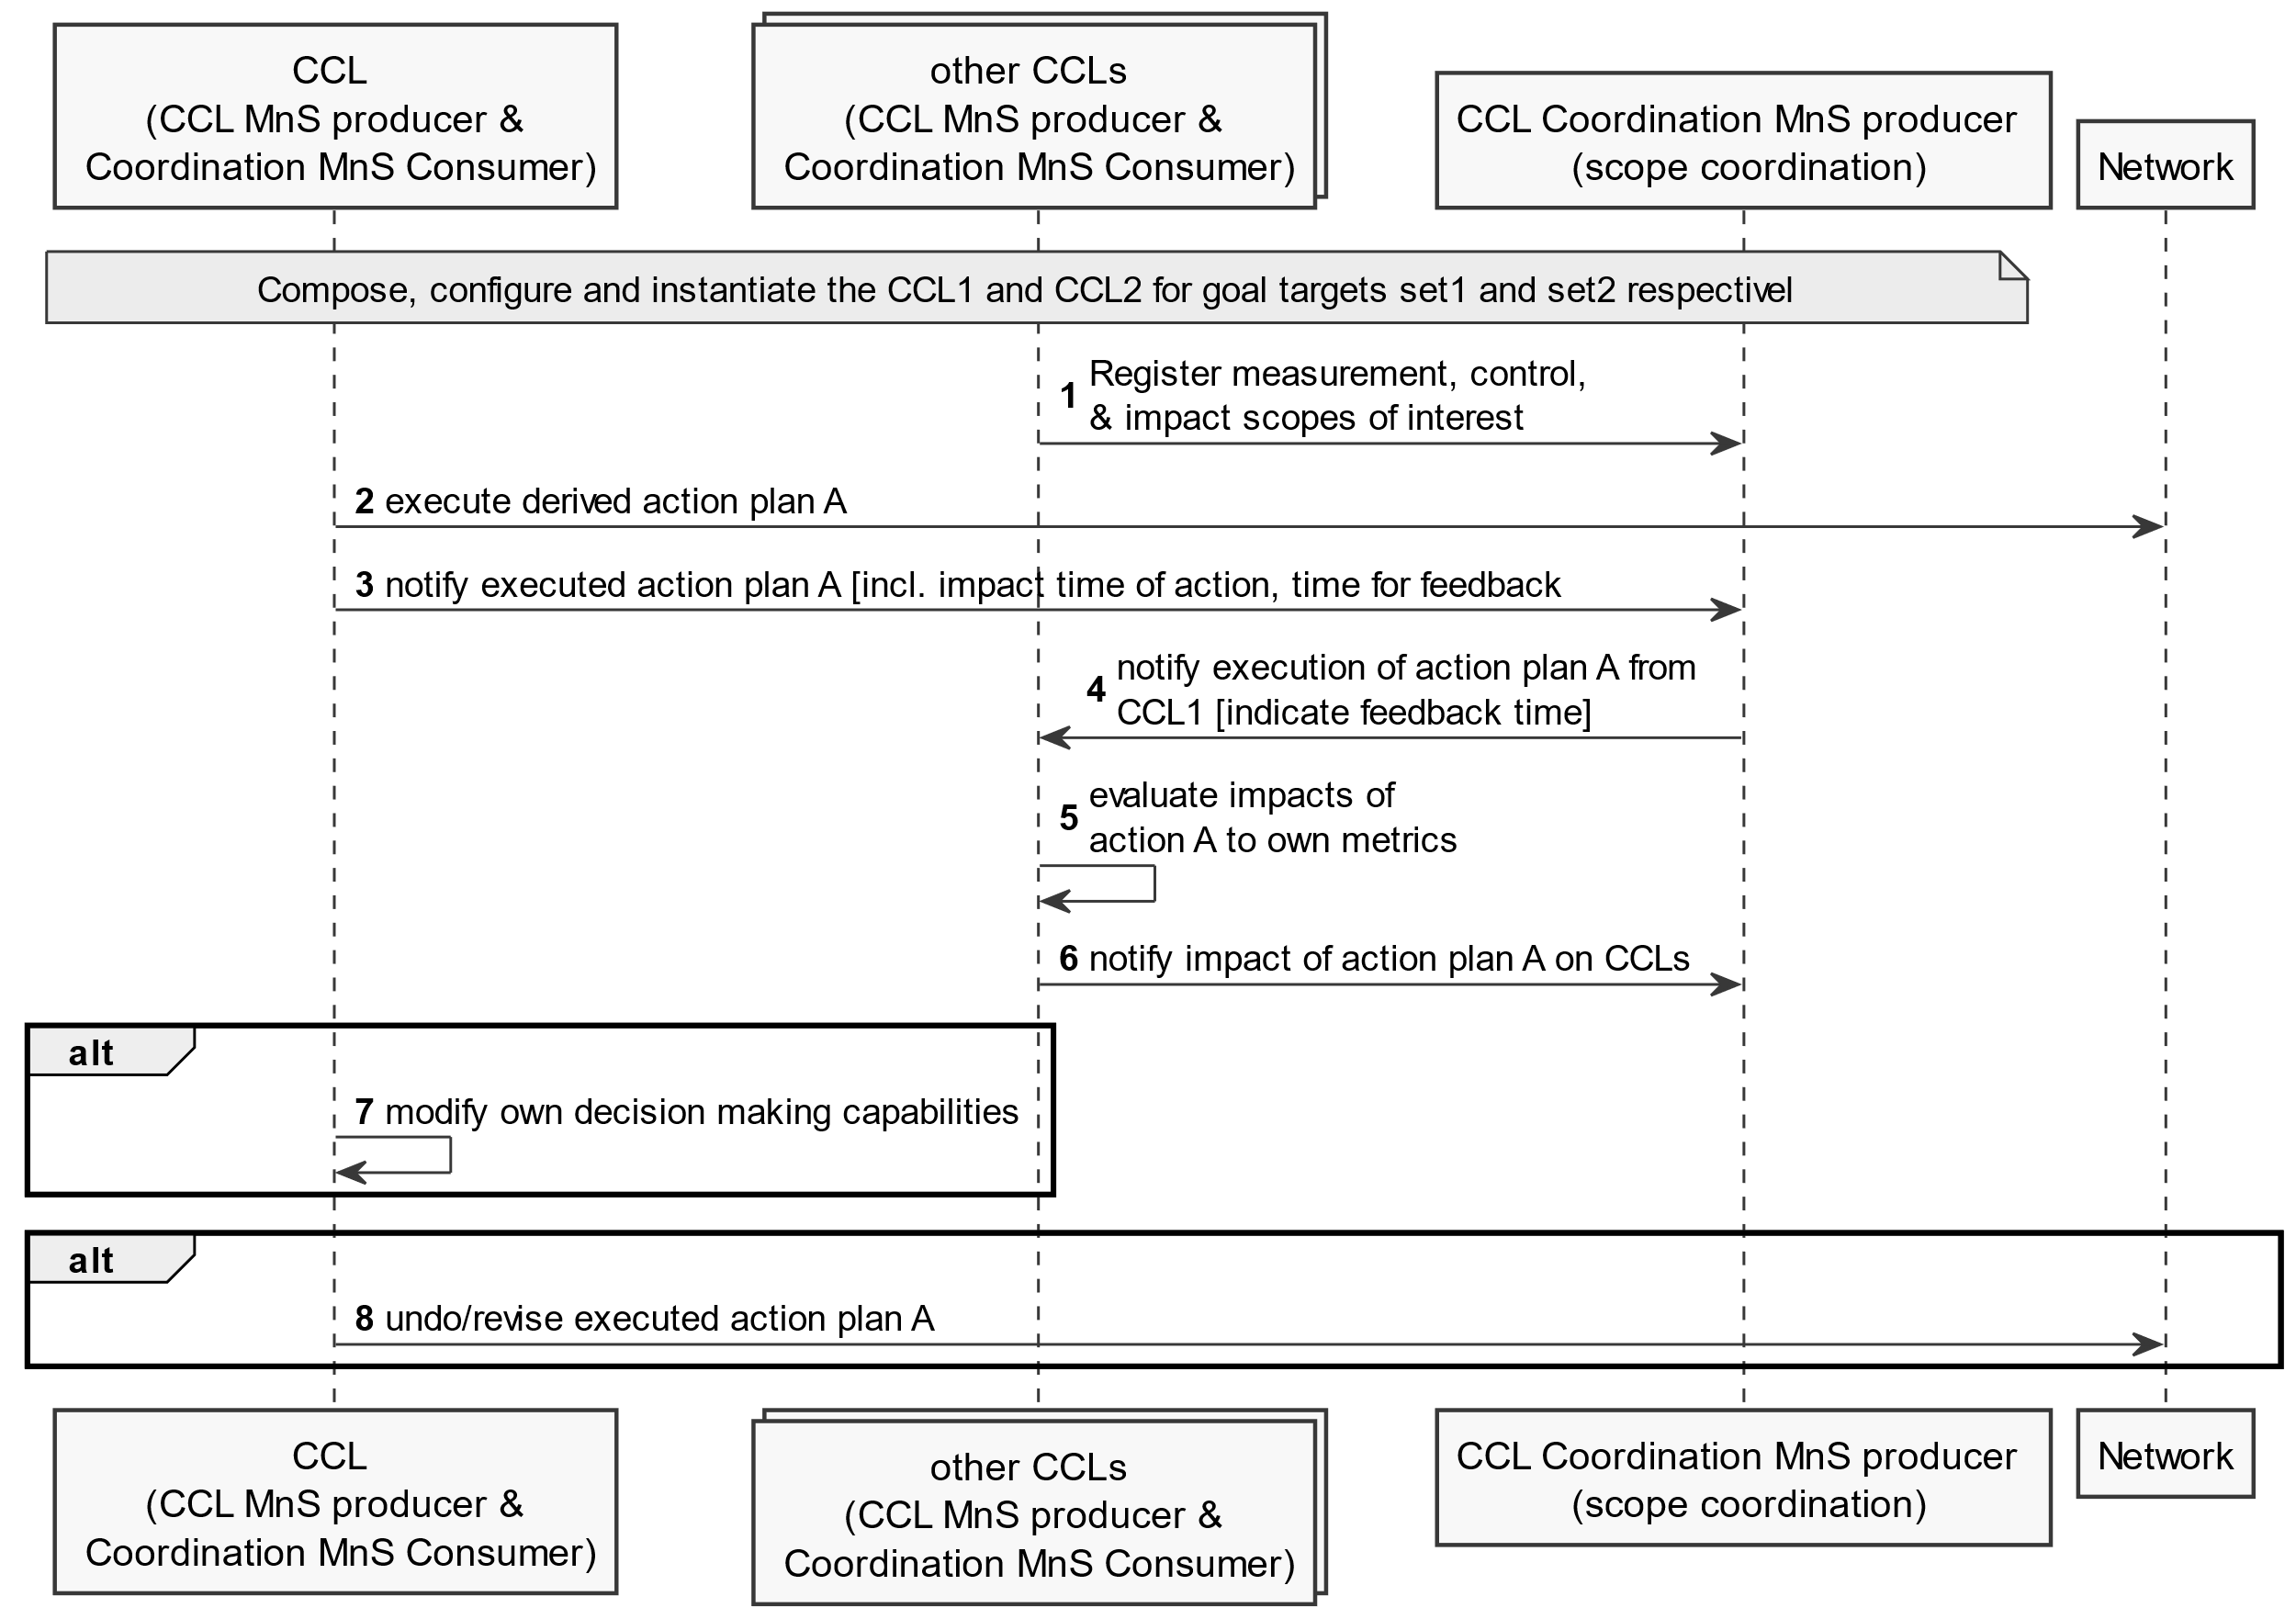

Figure 5.8.3.1.1-1: Detection of actual indirect targets conflicts

##### 5.8.3.1.2 Information objects to realize required capabilities and interactions

- Introduce on the CCL an attribute representing, for each action taken, the time at which any affected MnS consumers (e.g. other CCLs) should provide their evaluation of the impact of the action. The time may be called cCLActionImpactTime. The cCLActionImpactTime should be notifiable, e.g. the coordination CCL or other CCLs which may be affected can subscribe to notifications on the cCLActionImpactTime.

- Introduce on the CCL an attribute representing for each action taken, an index that quantifies the evaluation of the impacts from each affected CCL. The index may be called an Action Quality Indicator (AQI), say in the range [0,10] where "0" indicates that the action was completely unacceptable and should never be reused in that context while "10" indicates that the action had very good outcomes for the reporting CCL. The AQI may be used by a coordination CCL to compute the aggregate impact form multiple affected CCLs and configure the acting CCL with a single AQI value. Based on the aggregate AQI the coordination CCL may also propose a response action, e.g. to reverse the action that was taken.

NOTE: The AQI is specific to each CCL and to each scenario thar the CCL evaluates - since it is used to check how good or bad an action was for that CCL. Accordingly its computation cannot be standardized, only its range can be standardized.

### 5.8.4 Evaluation of solutions

The solution in clause 5.8.3 provided the procedures and infrmation objects for CCL impact assessment and resolution, enabling interactions for evaluating the impact of one CCL on other CCLs as well as for resolution any suchnegative impacts. No conflicting solution for impact assessment and resolution is provided. it is recommended to apply the solution in in clause 5.8.3 as the solution for CCL impact assessment and resolution.

|  |
| --- |
| **Next modifications** |

Annex A:  
PlantUML Code for figures

# A.1 Figure 5.6.3.1-2

@startuml

skinparam ClassStereotypeFontStyle normal

skinparam ClassBackgroundColor White

skinparam shadowing false

skinparam monochrome true

hide members

hide circle

class ManagedEntity <<ProxyClass>>

class CoordinationCCL <<InformationObjectClass>>

class CoordinationProfile <<dataType>>

ManagedEntity "1" *-- "1" CoordinationCCL: <<names>>

CoordinationCCL "1" -- "*" CoordinationProfile

note left of ManagedEntity

Represents the following IOCs:

Subnetwork or

ManagedFunction

end note

note right of CoordinationProfile

Represents the following capabilities:

GoalTargetCoordination

ScopeAssignmentsCoordination

DirectActionsCoordination

IndirectTargetsCoordination

executionTimeCoordination

end note

@enduml

# A.2 Procedures for CCL Management

## A.2.x11 Detection detection of actual indirect targets conflicts via impact on unknown or unbounded impact-scope (Figure 5.8.3.1.1-1)

@startuml Detection detection of actual indirect targets conflicts via impact on unknown or unbounded impact-scope

skinparam Shadowing false

autonumber

skinparam monochrome true

participant "CCL \n (CCL MnS producer & \n Coordination MnS Consumer)" as CL1

collections "other CCLs \n (CCL MnS producer & \n Coordination MnS Consumer)" as CL2

participant "CCL Coordination MnS producer \n (scope coordination)" as xCL

participant "Network" as Net

Note over CL1, xCL: Compose, configure and instantiate the CCL1 and CCL2 for goal targets set1 and set2 respectivel

CL2 -> xCL: Register measurement, control, \n& impact scopes of interest

CL1 -> Net: execute derived action plan A

CL1 -> xCL: notify executed action plan A [incl. impact time of action, time for feedback

xCL -> CL2: notify execution of action plan A from \nCCL1 [indicate feedback time]

CL2 -> CL2: evaluate impacts of \naction A to own metrics

CL2 -> xCL: notify impact of action plan A on CCLs

Alt

CL1 -> CL1: modify own decision making capabilities

end

Alt

CL1 -> Net: undo/revise executed action plan A

end

@enduml

|  |
| --- |
| **End of modifications** |