**3GPP TSG-SA5 Meeting #157S5-245406**

**14 - 18 October 2024, Hyderabad, India**

**Source: Nokia**

**Title:** **pCR 28.867 Avoidance of action-execution-time conflicts**

**Document for: Approval**

**Agenda Item: 6.19.4**

# 1 Decision/action requested

***The group is asked to discuss and agree on the proposal.***

# 2 References

[1] 3GPP TR 28.867-041 “Closed control loop management”.

# 3 Rationale

TR28.867 has studied a use case on CCL conflicts management with a requirement to support a capability to avoid CCL conflicts including action-execution-time conflicts. No solution has been provided for this requirement for action-execution-time conflicts. This pCR adds a solution for Avoidance of action-execution-time conflicts

# 4 Detailed proposal

|  |
| --- |
| **Start of modification** |

# 5. Use Cases

## 5.6 Use case 6: CCL conflicts management

### 5.6.3 Potential Solutions

#### 5.6.3.6 Action-execution-time conflict coordination

##### 5.6.3.6.2 Avoidance of action-execution-time conflicts

###### 5.6.3.6.2.1 Required capabilities and interactions.

In a network with several CCLs, it can be that each CCL focuses on a smaller scope of the network problem space. And thus propose changes that are suboptimal to the full problem space. To support the full problem space, several CCLs may be executed but it is important that their actions do not collide with each other in any one given network scope. The CCLs can be explicitly called to act by the CCL coordination entity which has a wider view of the network problems, the capabilities of the CCLs and their likely impacts. The CCL coordination entity obtains the capabilities of the available CCLs either directly from the CCLs or from a registry on available capabilities. Then in a given problem scenario, the CCL coordination entity receives and evaluates network data and analytics insight. Based on that it diagnoses the network problem(s) to identify the nature of the problem and identifies the CCLs that are best to be triggered and the times or sequences to trigger them to address the problem but without their execution conflicting with one another. The trigger may for example be provided as sequnces configured via the Loop trigger object (see use case 2 in clause 5.2.3)

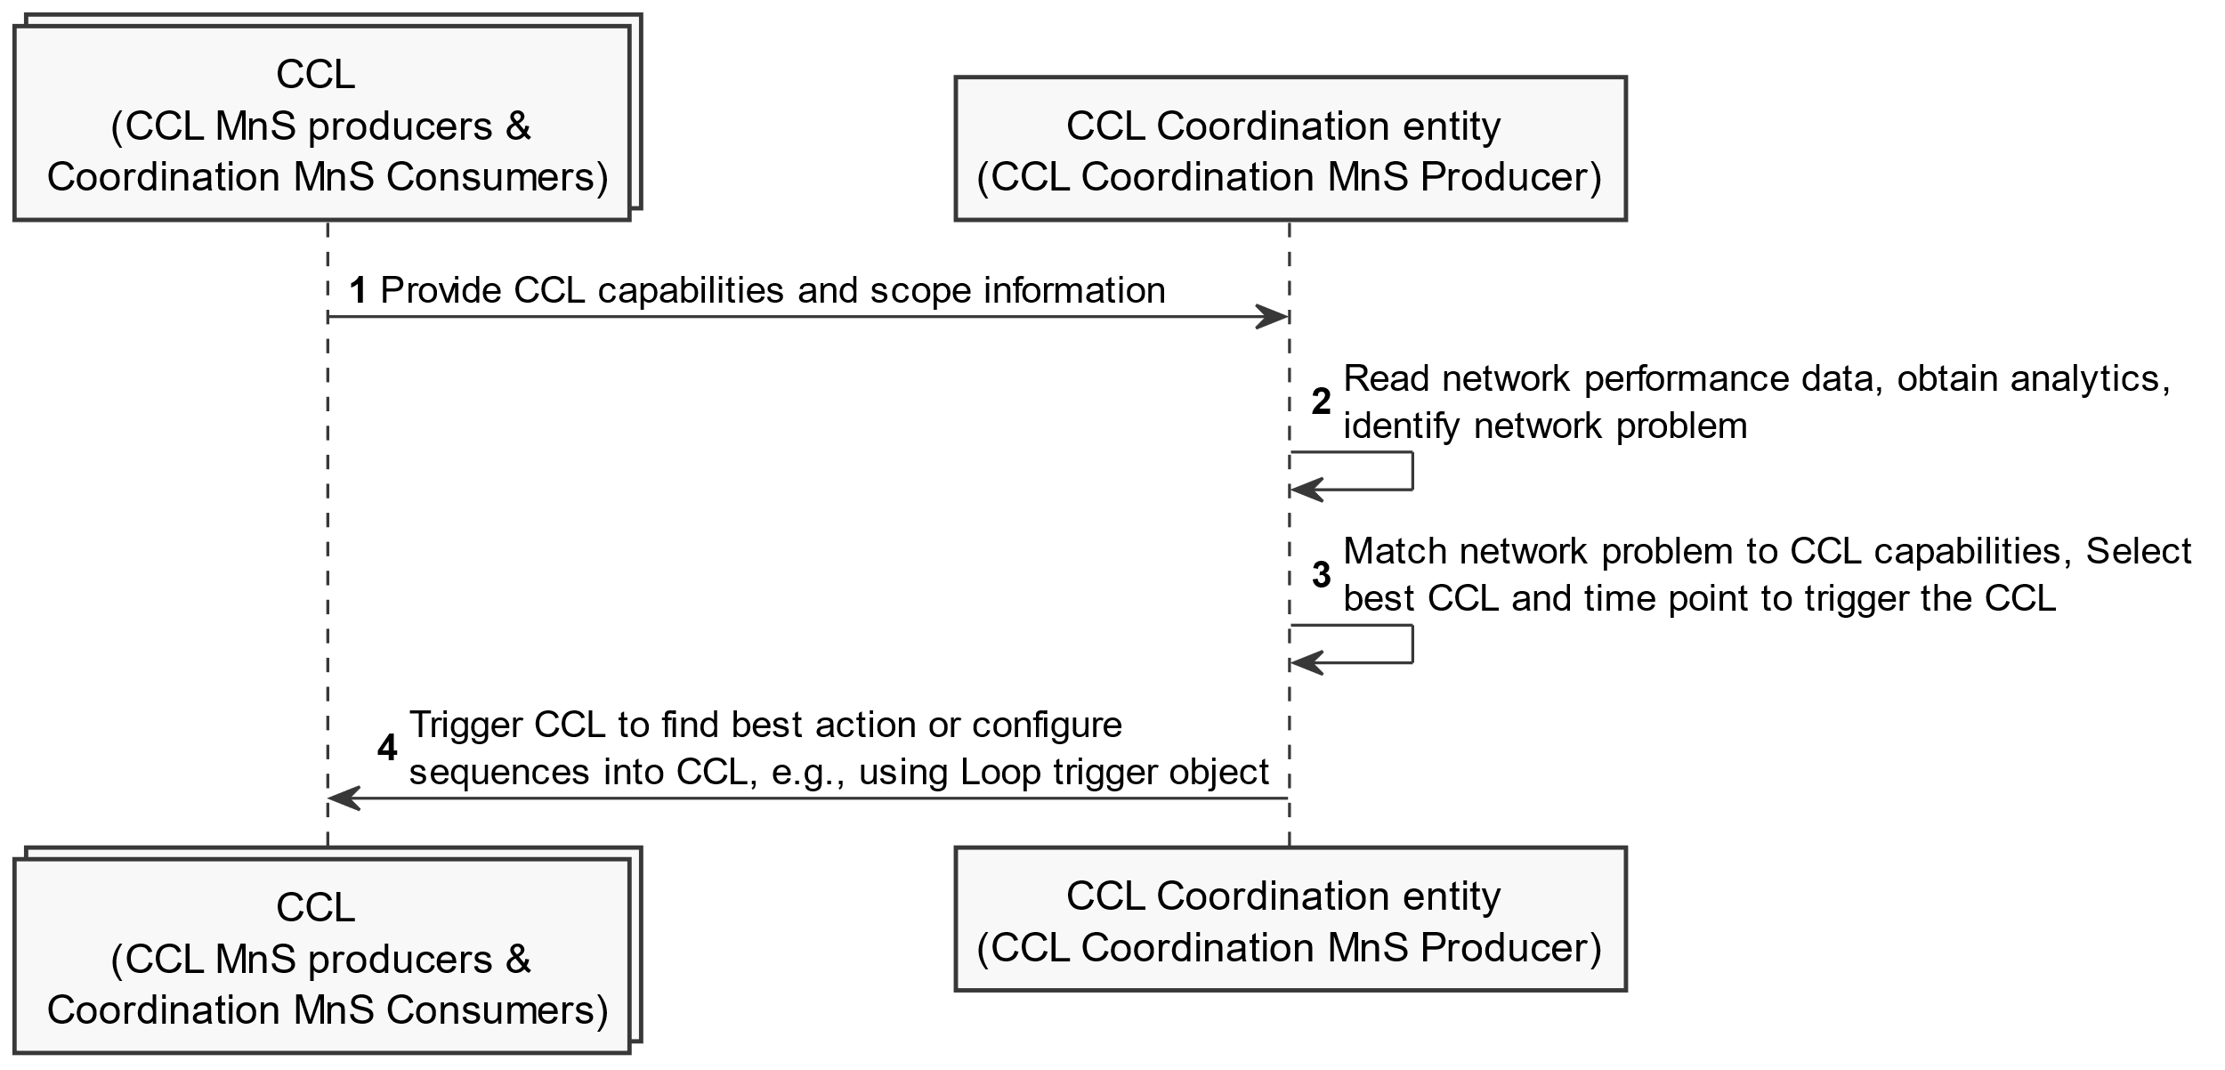

Figure 5.6.3.6.2.1-1: Avoiding action-execution-time conflicts by identifying and triggering the appropriate CCLs

###### 5.6.3.6.2.2 Information objects to realize required capabilities and interactions

- Introduce a datatype and corresponding attribute for a CCL capability registry to hold the capabilities of a set of CCLs. A CCL or any other MnS consumer can write the capabilities of a given CCL into the capability registryto then be used by the CCL coordination entity to identify the right CCL to be scheduled at agiven time.

- Introduce a data type and attribute within the CCL capability registryfor the capabilities of a CCL. This may for example be equivalent to the CCL profile that uidentifies whether the CCL is able to optimize energy efficncy, resolve network faults, assure network slice performance targets, etc.

- The capablites should be notifiable, e.g. can benotified to a CCL coordination entity.

- Introduce on the CCL coordination entity an attribute for a schedule representing the schedule in which a set of CCL are proosed to be executed.

- Introduce on the CCL an attribute for a time for when a CCL may be exeucetd or when it is scheduled to propose actions to a given network scope

|  |
| --- |
| **Next modifications** |

Annex A:  
PlantUML Code for figures

# A.2 Procedures for CCL Management

## A.2.x9 Avoiding action-execution-time conflicts (Figure 5.6.3.6.2.1-1)

@startuml Avoiding action-execution-time conflicts

skinparam Shadowing false

autonumber

skinparam monochrome true

skinparam maxMessageSize 300

collections "CCL \n(CCL MnS producers &\n Coordination MnS Consumers)" as CCLs

participant "CCL Coordination entity \n(CCL Coordination MnS Producer)" as Orch

CCLs -> Orch: Provide CCL capabilities and scope information

Orch -> Orch: Read network performance data, obtain analytics, identify network problem

Orch -> Orch: Match network problem to CCL capabilities, Select best CCL and time point to trigger the CCL

Orch -> CCLs: Trigger CCL to find best action or configure sequences into CCL, e.g., using Loop trigger object

@enduml

|  |
| --- |
| **End of modifications** |